HANOI UNIVERSITY
FACULTY OF INFORMATION TECHNOLOGY
----🙥∙🙧🕮🙥∙🙧----



Wonton POS - Order Management, Payment & Revenue Analytics System for Wonton Noodle Shop
Project Thesis

COURSE NAME: Software Requirements Analysis (61FIT3REQ)
Spring - 2026

- Nguyen Thi Hai My | 2301040126
- Nguyen Dat Vinh | 2301040198
- Vuong Gia Ly | 2301040113
- Nguyen Minh Duc | 2301040048
- Dang Khanh Huyen | 2301040088
- Le Thanh Dat  - Nguyen Dinh Chien  - Nguyen Thien Hieu | 2301040036  2301040025  2301040071
Team Guide: Hoang Ngoc Duy
Task Evaluation

Member | Role | Task + Assessment
Nguyen Thi Hai My | Project Manager + Requirement Analyst | - BRD Ver 0  - Elicitation Notes: Interview  - BRD Ver 2 + 3: 3 Use case specification + Appendix C (ERD)  - Prototype UI: 2 interfaces UI  - Thesis: VI. Requirement Management  - SRS: 1. Introduction -> 2.2 Software Requirement  - 90/100%
Nguyen Dat Vinh | System Analyst | - BRD Ver 0  - Elicitation Notes: Questionaires  - BRD Ver 2 + 3: 5 Use case specification + Appendix C (ERD)  - Prototype UI: 12 interfaces UI  - Thesis: I. Introduction  - SRS: 2.3 Hardware Requirement ->2.4.1 Functional Requirements  - 97/100%
Vuong Gia Ly | Data Analyst | - BRD Ver 0  - BRD Ver 2 + 3: 3 Use case specification + Business Cases + Appendix C(DFD)  - Prototype UI: 2 interfaces UI  - Thesis: II. Literature Review  - SRS: 2.4.2 Non-Functional Requirements ->2.5 User Characteristic  - 89/100%
Nguyen Minh Duc | Business Process Analyst | - BRD Ver 0  - Elicitation Notes: Preparation  - BRD Ver 2 + 3: 3 Use case specification + Appendix C (Data Flow DFD)  - Prototype UI: 2 interfaces UI  - Thesis: IV. Application of Elicitation Techniques  - SRS: 2.6 Constraints ->2.8 Usecase Model Description Usecase 1-13  - 95/100%
Dang Khanh Huyen | User Experience Analyst | - BRD Ver 0  - Elicitation Notes: Observation  - BRD Ver 2 + 3: 3 Use case specification + Appendix C (Class Diagram)  - Prototype UI: 2 interfaces UI  - Thesis: III. Client: Overview, Problem Statement and Requirements  - 90/100%
Le Thanh Dat | Requirement Analyst | - BRD Ver 0  - Elicitation Notes: Meeting  - BRD Ver 2 + 3: 3 Use case specification + Appendix C (Class Diagram)  - Prototype UI: 2 interfaces UI  - Thesis: I. Introduction  - SRS: 2.8 Usecase Model Description Usecase 14 -> 26 + 2.9.1 ERD  - 87/100%
Nguyen Dinh Chien | System Analyst | - BRD Ver 0  - Elicitation Notes: Meeting  - BRD Ver 2 + 3: 3 Use case specification + Appendix C (Data Flow DFD)  - Prototype UI: 2 interfaces UI  - Thesis: VIII. Revision of Project  - 90/100%
Nguyen Thien Hieu | Data Analyst | - BRD Ver 0  - BRD Ver 2 + 3: 3 Use case specification + Appendix C (Class Diagram)  - Prototype UI: 2 interfaces UI  - Thesis: VII. Prototype  - SRS: 2.9.2 Class Diagram + 2.10 Assumption & Dependencies  - 85/100%

Project Thesis

I. Introduction
In recent years, the food service industry has experienced rapid digital transformation as businesses increasingly adopt technology to enhance operational efficiency and improve customer experience. Small and medium-sized restaurants, in particular, are under growing pressure to streamline their workflows, reduce human errors, and remain competitive in a market dominated by digital ordering platforms. As customer expectations continue to evolve toward faster service, convenience, and real-time interaction, traditional manual processes are becoming inadequate and inefficient for daily restaurant operations. This rapid shift has created a highly competitive environment, where businesses must modernize their operations to meet increasing demands.
External food-ordering marketplaces and digital restaurant platforms have raised customer expectations for speed, transparency, and convenience, but many small restaurant businesses still face significant operational and financial challenges inside their own shop workflow. A major challenge lies in their reliance on manual processes for order handling, communication, and revenue tracking. In the case of the wonton noodle shop client, orders are recorded manually on paper or through verbal communication between staff members, which often leads to order inaccuracies, delays, and miscommunication between the cashier and kitchen. Additionally, the absence of a centralized system results in a lack of reliable business data, making it difficult for the owner to analyze sales performance, identify peak hours, or make informed business decisions. These inefficiencies reduce service quality, impact customer satisfaction, and hinder sustainable business growth. The current Wonton POS baseline therefore focuses on Dine-in, Takeaway, and scheduled Pickup operations, while Delivery and third-party logistics integration remain outside the current release scope.
To address these challenges, the client seeks to develop an independent and integrated Point of Sale (POS) system tailored specifically to the operational needs of a wonton noodle restaurant. The proposed solution, known as the Wonton POS – Order Management, Payment & Revenue Analytics System, aims to digitize and automate the entire restaurant workflow. This system is designed to reduce manual errors, improve communication between front-of-house and back-of-house staff, and provide real-time insights into business performance. By establishing an internal ordering channel, the restaurant can reduce dependency on third-party platforms and gain greater control over customer interactions and revenue streams.
This thesis presents the design and development of the Wonton POS system, which consists of two primary components: a Client Web Application and an Admin Web Application. From the customer’s perspective, the system enables users to browse the menu, place orders online, select service types such as dine in, takeaway, or pickup, and complete payments through various methods. Customers can also track their order status in real time and access their order history. In addition, the system allows customers to make table reservations in advance, helping them secure seating and reduce waiting time during peak hours. These features are intended to enhance convenience, improve service efficiency, and increase overall customer satisfaction.
From the administrative perspective, the system provides a comprehensive set of tools to support restaurant management and operations. Staff members can efficiently manage orders, process payments, and coordinate with the kitchen through a digital workflow. Managers are equipped with functionalities to manage menu items, control staff accounts with multiple roles, and oversee table arrangements for dine-in services. In addition, the system offers a revenue analytics dashboard that allows the owner to monitor key business metrics, such as total revenue, best-selling items, and peak operating hours. These insights enable data-driven decision-making and support long-term business growth. These integrated functionalities not only streamline daily operations but also enhance coordination among staff and improve overall service efficiency.
Overall, this project represents more than just a technological solution; it embodies a strategic approach to digital transformation in the restaurant industry. By eliminating inefficient manual processes and reducing dependency on third-party platforms, the Wonton POS system enhances operational autonomy, improves profitability, and enables the restaurant to deliver a more consistent and high-quality customer experience.

II. Literature Review
The rapid digital transformation of the food and beverage industry, particularly within small and medium sized enterprises, has created a dynamic and evolving environment in which technology plays a central role in enhancing operational efficiency and customer experience. In recent years, Point of Sale systems have emerged as one of the most critical technological solutions adopted by restaurants to streamline operations and support business growth. This literature review aims to critically synthesize findings from a range of academic studies, industry reports, and professional resources in order to establish a comprehensive understanding of the key factors influencing the adoption, implementation, and effectiveness of POS systems within restaurant environments.
The review spans multiple interconnected domains that are essential to the successful design and deployment of POS systems. Firstly, it examines the current state of technology adoption within the food and beverage sector, with particular attention to small and medium sized businesses. According to recent industry analysis, while POS systems are widely adopted in Vietnam, many establishments still rely on basic functionalities and lack advanced integrations such as kitchen display systems and analytics tools (B Company, 2025). This indicates that although digital transformation is underway, there remains a significant gap between the capabilities of existing systems and the increasing demands of modern restaurant operations. Such limitations can restrict business growth, reduce operational efficiency, and prevent restaurants from fully leveraging the benefits of digital technologies. This highlights the importance of developing more integrated and scalable solutions that can address these shortcomings.
In addition to adoption trends, the literature also emphasizes the operational impact of POS systems on restaurant performance. Empirical studies demonstrate that POS systems contribute significantly to improving efficiency by automating order processing, reducing manual errors, and enabling better inventory management (IJIRT, 2024; IJCRT, 2020). These improvements are particularly important in fast paced restaurant environments where speed and accuracy are critical to customer satisfaction. Furthermore, the integration of digital systems enhances communication between front of house and kitchen staff, thereby reducing delays and minimizing miscommunication. However, despite these benefits, several challenges remain. Implementation costs, system complexity, and the need for staff training are frequently cited as barriers to adoption, especially for smaller businesses with limited financial and human resources (IJIRT, 2024). This suggests that successful system design must balance advanced functionality with usability and cost effectiveness in order to ensure practical applicability.
Another critical aspect discussed in the literature is the need for customization and adaptability in POS system design. Restaurants often have unique operational requirements depending on their cuisine, service model, and customer base. For instance, restaurants specializing in Asian cuisine may require flexible menu configurations, support for multiple languages, and the ability to manage complex dish variations and toppings (GoSnappy, 2025). This highlights the importance of designing systems that are not only functional but also adaptable to diverse business contexts. A rigid solution may fail to meet specific operational needs, thereby limiting its effectiveness. Therefore, customization emerges as a key design principle that enables systems to better align with real world restaurant operations.
The role of data analytics in enhancing business performance is another major theme explored in the literature. Modern POS systems generate large volumes of transactional data that can be analyzed to uncover valuable insights into sales trends, customer behavior, and operational patterns (NRSPlus, 2024; Shopify, 2025). These insights enable restaurant owners to make informed decisions regarding menu optimization, pricing strategies, and resource allocation. For example, identifying best selling items and peak operating hours can help improve inventory planning and staff scheduling. Moreover, the integration of advanced technologies such as artificial intelligence and business intelligence tools allows for real time reporting and predictive analytics, further enhancing decision making capabilities (Mona Media, 2025; GoFrugal, 2025). This demonstrates that POS systems are no longer merely transactional tools, but have evolved into strategic platforms that enable data driven decision making and support long term business growth.
From a behavioral perspective, the adoption of POS systems is influenced by several psychological and technological factors. Research based on the UTAUT2 model indicates that perceived usefulness, ease of use, and perceived risk significantly affect the intention of restaurant owners to adopt new technologies (AaltoDoc, 2020). This implies that system designers must prioritize user friendly interfaces and reliable performance in order to build trust and encourage adoption. If a system is perceived as complex or risky, businesses may be reluctant to invest in it despite its potential benefits. Therefore, usability and reliability are critical considerations in the design and implementation of POS systems.
Furthermore, clearly defined functional requirements play a vital role in ensuring the effectiveness of POS systems. Industry guidelines emphasize the importance of including core features such as order management, payment processing, inventory tracking, and reporting capabilities (LimeTray, 2025). These features form the foundation of a comprehensive system that supports both daily operations and strategic decision making. The absence of any of these functionalities can significantly reduce the overall value of the system. Therefore, requirement definition must be thorough and aligned with business needs in order to ensure system success.
Collectively, these thematic areas provide a holistic understanding of the challenges and opportunities associated with POS system development in the restaurant industry. By integrating insights related to technology adoption, operational efficiency, customization, data analytics, user behavior, and functional requirements, this review establishes a strong theoretical foundation for the proposed Wonton POS system. The synthesis of these findings highlights the necessity of developing an integrated, user friendly, and data driven solution that can effectively address real world business challenges.
Building upon this theoretical foundation, the project applies several Business Analysis methodologies and techniques to ensure effective requirement elicitation and system design. Requirements elicitation is a critical process that involves gathering, analyzing, and validating stakeholder needs in order to define system requirements accurately. This process is essential because it directly influences the success of the system by ensuring that the final solution aligns with business objectives and user expectations.
In this project, multiple elicitation techniques are employed to capture comprehensive and reliable information. The interview technique is used to gather detailed insights from key stakeholders such as the restaurant owner and staff. This technique is chosen because it allows direct interaction and enables the analyst to explore specific issues in depth. Through structured and semi structured interviews, stakeholders can share their experiences, challenges, and expectations, providing valuable qualitative data that cannot be obtained through other methods (Pegotec, 2025). This approach is particularly useful for understanding complex workflows and identifying hidden problems within the current system.
The observation technique is also applied to examine real world operations within the restaurant environment. This technique is chosen because it provides direct evidence of actual practices, allowing the analyst to identify inefficiencies and communication gaps that may not be explicitly mentioned by stakeholders. By observing how orders are taken, processed, and delivered, the analyst can gain a deeper understanding of operational challenges and validate information obtained through interviews. This combination of observation and interview enhances the accuracy and reliability of the collected data.
In addition to qualitative methods, questionnaires are used to collect feedback from customers. This technique is selected because it enables the collection of data from a larger sample size in a relatively efficient manner. Questionnaires provide quantitative insights into customer preferences, satisfaction levels, and expectations, which are essential for designing user centered features. The use of structured questions allows for easy analysis and comparison of responses, supporting data driven decision making.
Furthermore, stakeholder meetings are conducted to validate requirements and ensure alignment among all parties involved. These meetings serve as a platform for discussion, clarification, and consensus building. This technique is chosen because it helps resolve ambiguities, confirm requirements, and establish a shared understanding of system scope and priorities. Through collaborative discussions, stakeholders can provide feedback, suggest improvements, and agree on final decisions, thereby reducing the risk of misunderstandings and ensuring project success.
In addition to elicitation techniques, several supporting tools are utilized to enhance analysis and communication. Tools such as Use Case modelling, process flow representation, and stakeholder analysis frameworks are applied to visualize system interactions and structure requirements effectively (GetSoftwareService, 2024). These tools are chosen because they improve clarity, facilitate communication, and support collaboration among stakeholders. By representing complex processes in a visual format, these tools help ensure that all stakeholders can easily understand system functionality and requirements.
In conclusion, this literature review provides a comprehensive and in depth understanding of the key factors influencing the development and adoption of POS systems in the restaurant industry. By critically analyzing technology trends, operational benefits, customization requirements, data analytics capabilities, behavioral factors, and Business Analysis methodologies, it highlights the multifaceted nature of digital transformation in this domain. The insights derived from this review form a solid foundation for the subsequent stages of the project, particularly in defining system requirements and designing a solution that effectively addresses both business needs and user expectations.

III. Client: Overview, Problem Statement and Requirements

Overview
The client is a Wonton Noodle Shop, a small to medium-sized restaurant operating in a busy food-service environment. The shop serves customers through three in-scope service models: Dine-in, Takeaway, and scheduled Pickup. The current release intentionally excludes Delivery and third-party delivery-platform integration, even though external platforms have increased customer expectations for faster ordering, transparent order status, and convenient digital payment.
The restaurant handles approximately 150-300 orders per day with a compact team of 4-8 staff members across cashier/front-of-house (FOH), service, kitchen/back-of-house (BOH), and management responsibilities. The business depends on fast table service, accurate takeaway handoff, scheduled pickup readiness, reliable payment confirmation, and daily revenue visibility.

Current Information System
The shop currently does not have an integrated Point of Sale (POS), order management, kitchen display, or analytics system. Orders are commonly written on paper, repeated verbally between FOH and BOH staff, or tracked through separate manual notes. Payment confirmation, order status, table assignment, kitchen progress, refunds, and end-of-shift totals are therefore handled through disconnected manual steps.
This manual information system limits operational control. Staff cannot reliably see the same order state at the same time, kitchen tickets can be delayed or misunderstood, customers have limited visibility after ordering, and managers must reconstruct revenue and exception information after service. The lack of centralized records also makes it difficult to review sales performance, promotion usage, refund cases, 86'd item handling, and staff accountability during busy periods.

Problem Statement
The single core problem is that the Wonton Noodle Shop relies on disconnected manual order, payment, and operational tracking processes, which makes service execution unreliable and prevents management from seeing accurate real-time business information.
Order mistakes, long waiting time, FOH/BOH communication gaps, unclear payment confirmation, weak refund handling, and incomplete revenue reports are treated as impacts of this one underlying problem. Because order creation, kitchen intake, payment status, handoff, and reporting are not controlled in one system, the restaurant cannot consistently protect service quality, customer satisfaction, and financial accuracy during peak operating hours.
To solve this problem, the client needs an integrated Wonton POS system that digitizes the order lifecycle, separates operational order status from financial payment status, supports customer and staff workflows, and gives managers reliable visibility into daily operations without expanding the current scope into Delivery or full procurement accounting.

Requirements
The approved requirement set is written as a full-version capability baseline for the current Wonton POS release. The requirements below use the approved use-case baseline UC-01 to UC-26 while preserving the wider system scope boundary. Delivery, loyalty, payroll, native mobile apps, third-party delivery integration, and full supplier procurement remain outside the current release.

Functional Requirements
Requirement ID | Priority | Functional requirement | Related UC | Acceptance evidence
FR-01 | Critical | The system shall allow Registered and Guest customers to browse the menu, view item details, customize quantity/toppings/notes, and create an online order for an in-scope service model. | UC-01 | Customer can create a valid Dine-in, Takeaway, or Pickup draft/order from the Client WebApp.
FR-02 | Critical | The system shall support online payment for prepaid orders using payment-gateway QR flows and bank-transfer QR with cashier manual confirmation where applicable. | UC-02 | Takeaway/Pickup orders do not enter kitchen operations until payment_status is Paid.
FR-03 | High | The system shall validate scheduled Pickup time slots against operating hours, pickup pause status, and configured slot capacity before accepting a Pickup order. | UC-03 | Invalid or overloaded slots are blocked and valid paid Pickup orders are auto-accepted.
FR-04 | Medium | The system shall allow Registered Customers to view order history and order details including items, totals, order status, payment status, and service model. | UC-04 | Order history is visible only after authentication and supports detail review.
FR-05 | High | The system shall allow Managers to manage menu items, categories, toppings, prices, images, and availability using archive/deactivate behavior where historical data exists. | UC-05 | Menu changes appear on Client WebApp without deleting historical order records.
FR-06 | High | The system shall allow Managers to create, update, deactivate, and assign roles to staff accounts using role-based access control. | UC-06 | Only authorized staff can access role-specific Admin WebApp functions.
FR-07 | High | The system shall provide revenue statistics, top-item views, peak-hour analytics, payment-method filters, and exportable reports for management review. | UC-07 | Manager can review and export revenue/reporting views for selected time ranges.
FR-08 | High | The system shall support table master data and floor-plan visibility for dine-in operations. | UC-08 | Manager can maintain tables and staff can view table status for order assignment.
FR-09 | Critical | The system shall allow FOH/Cashier staff to create in-store Dine-in and Takeaway orders at the counter. | UC-09 | Dine-in orders may remain Unpaid; Takeaway kitchen release requires payment first.
FR-10 | Critical | The system shall allow Cashiers to process counter payments through cash, QR, or supported gateway methods and produce payment/receipt evidence. | UC-10 | payment_status changes to Paid only after valid collection or confirmation.
FR-11 | High | The system shall allow Registered and Guest customers to track order status, with Guest lookup secured by Order Code plus Phone Number. | UC-11 | Customer sees current Pending Confirmation/Cooking/Ready/Completed/Cancelled state.
FR-12 | High | The system shall allow FOH staff to assign, transfer, or attach orders to dine-in tables, including multiple active orders for the same party. | UC-12 | Table assignment/transfer updates order-table linkage without losing active orders.
FR-13 | High | The system shall allow BOH staff to receive kitchen orders through a FIFO kitchen workflow while escalating paid Pickup fulfilment problems to Manager review. | UC-13 | Kitchen can accept eligible orders but cannot directly reject a paid Pickup order.
FR-14 | High | The system shall allow BOH staff to update item or order cooking progress, including grouped/batch updates, until an order becomes Ready. | UC-14 | Kitchen progress updates notify relevant customer/FOH views.
FR-15 | Medium | The system shall allow Registered Customers to rate completed orders within the allowed review window. | UC-15 | Completed orders can receive one valid rating with moderation constraints.
FR-16 | High | The system shall send order and operational notifications to customers and staff when relevant status or exception events occur. | UC-16 | Status changes trigger visible notification history and real-time alerts where available.
FR-17 | Medium | The system shall allow Registered Customers to reorder from Completed past orders while showing menu-drift notices for changed prices, archived items, unavailable toppings, and 86'd items. | UC-17 | Reorder creates a new draft order and never silently changes the final total.
FR-18 | Medium | The system shall allow Managers to create, update, deactivate, validate, and audit promotion codes with usage limits and stacking rules. | UC-18 | Promotion use and failed application attempts remain traceable.
FR-19 | Medium | The system shall provide an operational dashboard for orders, revenue, kitchen load, shift status, and exception alerts. | UC-19 | Manager can drill down from dashboard alerts to related operational screens.
FR-20 | High | The system shall allow FOH/Manager users to monitor and act on active orders, cancellations, payment recovery, overdue handoff, and operational exceptions. | UC-20 | Allowed actions are constrained by order_status, payment_status, role, and approval rules.
FR-21 | High | The system shall support cashier shift closing and end-of-day reconciliation across cash, bank-transfer QR, gateway payments, refunds, Write-off, Comp, and Forfeited buckets. | UC-21 | Shift close identifies unresolved exceptions and records variance reasons/approvals.
FR-22 | High | The system shall support inventory-lite controls for 86'd items, low-stock notes, and manual availability changes without introducing full procurement automation. | UC-22 | New orders are blocked from selecting unavailable items and affected in-flight orders are flagged.
FR-23 | High | The system shall allow FOH staff to confirm actual handoff before an order changes from Ready to Completed. | UC-23 | Completed means the customer actually received the food, not only that cooking finished.
FR-24 | High | The system shall support complaint and operational-exception handling for wrong handoff, missing items, remakes, partial/full refunds, Comp, Write-off, and Manager-approved corrections. | UC-24 | Financial outcomes require approval and flow into reconciliation/audit records.
FR-25 | Medium | The system shall support optional customer account registration, login, logout, profile update, password change, and password recovery while preserving Guest Checkout. | UC-25 | Customers can order as guests or manage account-based history/security features.
FR-26 | Critical | The system shall allow customers to complete checkout by confirming service model, entering guest/profile details, applying valid promotions, and following the correct payment rule. | UC-26 | Checkout routes Dine-in to tracking or prepay-required orders to payment before operations.

Non-Functional Requirements
Requirement ID | Category | Non-functional requirement | Acceptance evidence
NFR-01 | Security | The system shall protect personal and payment-related data using HTTPS/TLS, secure password hashing, authenticated payment interactions, role-based access control, and guest lookup rate limiting. | Customer data, staff access, and payment confirmation cannot be exposed through unauthorized access.
NFR-02 | Privacy | The system shall retain Guest name and phone data only for the required operational/audit period and anonymize guest personal fields after the defined retention period. | Guest lookup remains useful for service follow-up while long-term records are depersonalized.
NFR-03 | Performance | The system shall complete common user actions such as menu browsing, cart update, order creation, and payment-status refresh within approximately 2 seconds under normal load. | Prototype/SRS performance target supports peak-hour usability.
NFR-04 | Availability | The system shall remain available during restaurant operating hours and provide clear fallback/recovery behavior for network, KDS, printer, and payment outages. | Manual recovery can reconcile abnormal states without duplicate kitchen work.
NFR-05 | Data Integrity | The system shall preserve idempotency for payment callbacks, retries, receipt generation, and kitchen-ticket creation. | Duplicate callbacks or retries do not create duplicate orders, receipts, or kitchen tickets.
NFR-06 | Usability | The Client and Admin WebApps shall be responsive, readable, and task-focused on desktop, tablet, and mobile screens. | Customers and staff can complete common workflows without horizontal scrolling or ambiguous labels.
NFR-07 | Traceability | The system shall log sensitive financial and operational changes with actor, role, timestamp, reason, affected amount, and approver where applicable. | Refunds, write-offs, comps, forfeitures, cash variances, and completion corrections are auditable.
NFR-08 | Maintainability | The requirement baseline shall be structured so menu, role, promotion, pickup capacity, and reporting changes can be maintained without changing locked service scope. | Future clarification does not silently reintroduce Delivery or unrelated modules.
NFR-09 | Scalability | The system shall support expected peak restaurant traffic and allow future growth in orders, menu items, staff accounts, and reports without redesigning the core workflow. | The design can support at least 200 concurrent users as a planning target.

Use Case Specification Conversion
The functional requirements are converted into a curated use-case specification set. The thesis and SRS use UC-01 to UC-26 to keep the document reviewable, while the broader system inventory remains a scope-check reference. The conversion below ensures that each major requirement has at least one controlling use case and that operational policies such as manual QR confirmation, 86'd handling, refund control, and shift reconciliation are not left as unstated assumptions.
UC ID | Use case specification | Primary actor | Requirement source | Scope covered
UC-01 | Place Online Order | Customer (Registered / Guest) | FR-01, FR-26 | Client ordering, menu selection, cart creation, service model entry point
UC-02 | Online Payment | Customer | FR-02, FR-10 | Prepayment, gateway QR, bank-transfer QR manual confirmation, retry/idempotency
UC-03 | Schedule Pickup Order | Customer | FR-03 | Pickup slot validation, capacity, auto-accept after valid payment
UC-04 | View Order History | Registered Customer | FR-04 | Post-purchase order list and detail visibility
UC-05 | Manage Menu | Manager | FR-05, FR-22 | Menu/category/topping/availability management, archive/deactivate behavior
UC-06 | Manage Staff | Manager | FR-06 | Staff account lifecycle and multi-role permission control
UC-07 | View Revenue Statistics | Manager | FR-07, FR-21 | Revenue analytics, reports, exports, reconciliation support
UC-08 | Manage Tables | Manager | FR-08 | Dine-in floor plan and table master data
UC-09 | Create In-Store Order | FOH/Cashier | FR-09, FR-12 | Counter POS order creation for Dine-in and Takeaway
UC-10 | Process Payment | Cashier | FR-10, FR-21 | Counter settlement, receipt evidence, cash/QR/gateway handling
UC-11 | Track Order | Customer | FR-11, FR-16 | Registered and Guest order tracking with order code plus phone number
UC-12 | Assign Order to Table | FOH/Cashier | FR-12 | Dine-in table assignment, transfer, and multi-order table handling
UC-13 | Receive Kitchen Orders | BOH Staff | FR-13, FR-22 | Kitchen intake, FIFO, paid Pickup escalation, duplicate-ticket prevention
UC-14 | Update Dish Status | BOH Staff | FR-14 | Cooking progress, grouped updates, Ready transition
UC-15 | Rate Order | Registered Customer | FR-15 | Post-completion customer rating and content constraints
UC-16 | Receive Order Notifications | Customer / Staff | FR-16 | Real-time and history-based order/status notifications
UC-17 | Reorder Past Order | Registered Customer | FR-17 | Completed-order reorder, menu drift, current pricing, unavailable items
UC-18 | Manage Promotions | Manager | FR-18, FR-26 | Promotion setup, validation, usage limits, audit history
UC-19 | View Operational Dashboard | Manager | FR-19 | Daily order, revenue, kitchen load, and exception overview
UC-20 | Manage Active Orders | FOH / Manager | FR-20, FR-24 | Live order monitoring, cancellation, escalation, payment recovery
UC-21 | Close Shift and Reconcile End-of-day | Cashier / Manager | FR-21 | Cash drawer, refund, comp, forfeited, write-off, and variance review
UC-22 | Mark Menu Item as 86'd | BOH / Manager | FR-22 | Inventory-lite availability control and affected-order flagging
UC-23 | Serve and Confirm Handoff | FOH Service / Cashier | FR-23 | Correct table/customer handoff before Completed state
UC-24 | Handle Complaint and Operational Exception | FOH / Manager | FR-24 | Complaint, remake, refund, Comp, Write-off, wrong handoff, no-show handling
UC-25 | Manage Customer Account and Authentication | Customer | FR-25 | Optional registration, login, profile, password, recovery, logout
UC-26 | Complete Checkout and Apply Promotion | Customer | FR-01, FR-18, FR-26 | Checkout identity, service model, promotion application, payment routing

Representative Detailed Use Case Specifications
The following detailed specifications illustrate how the requirement statements are translated into use case format. They emphasize the highest-risk flows for ordering, payment, kitchen intake, menu control, shift reconciliation, and exception handling. The remaining use cases follow the same specification structure in the SRS package.
Field | Specification
ID & Name | UC-01: Place Online Order
Primary Actor | Customer (Registered / Guest)
Description | The customer uses the Client WebApp to browse available menu items, customize an order, select a service model, and create an order request.
Trigger | Customer selects Order Now or opens the menu.
Pre-conditions | The Client WebApp is available, the selected service model is Dine-in, Takeaway, or Pickup, and at least one menu item is Available.
Post-conditions | A valid order or checkout draft is created. Dine-in may continue with payment_status = Unpaid. Takeaway/Pickup must proceed to payment before kitchen release.
Normal Flow | 1. Customer opens menu. 2. System displays categories and available items. 3. Customer selects item, quantity, toppings, and notes. 4. System updates cart and total. 5. Customer selects service model. 6. System routes to checkout/payment rule.
Alternative Flows | Customer adds multiple items; Guest enters name and phone; unavailable item is removed with notice.
Exceptions | Empty cart, item no longer available, invalid service model, or connectivity loss.
Priority | Critical
Field | Specification
ID & Name | UC-02: Online Payment
Primary Actor | Customer (Registered / Guest), Cashier for manual bank-transfer confirmation
Description | The customer pays for a prepaid or voluntarily prepaid order using supported gateway QR methods or bank-transfer QR requiring cashier confirmation.
Trigger | Customer clicks Pay Now or the system requires payment before processing.
Pre-conditions | An order exists, the payable amount is known, and the payment method is available.
Post-conditions | payment_status becomes Paid only after a valid gateway callback or valid cashier manual confirmation. No duplicate order, receipt, or kitchen ticket is created.
Normal Flow | 1. System displays amount and payment methods. 2. Customer selects method. 3. Gateway QR redirects/returns callback, or bank-transfer QR waits for cashier confirmation. 4. System validates result. 5. System updates payment_status and routes the order forward.
Alternative Flows | Dine-in customer skips prepayment and pays later at counter; customer retries failed payment on the same order.
Exceptions | Payment failed, payment timeout, late success after auto-cancel, duplicate callback, or incorrect manual confirmation requiring reconciliation.
Priority | Critical
Field | Specification
ID & Name | UC-05: Manage Menu
Primary Actor | Manager
Description | The Manager maintains menu items, categories, toppings, prices, images, and availability while preserving historical order data.
Trigger | Manager opens Menu Management in the Admin WebApp.
Pre-conditions | Manager is authenticated with Manager permission.
Post-conditions | Menu changes are saved and reflected on customer and POS screens. Items with historical records are archived/deactivated instead of hard-deleted where required.
Normal Flow | 1. Manager opens menu list. 2. System displays item/category/topping records. 3. Manager adds or edits item data. 4. System validates required fields and duplicate names. 5. System saves and refreshes menu availability.
Alternative Flows | Manager marks item unavailable, archives an item, edits price, or updates topping availability.
Exceptions | Duplicate item name, invalid price, attempt to delete category containing active items, or attempt to hard-delete item with historical data.
Priority | High
Field | Specification
ID & Name | UC-13: Receive Kitchen Orders
Primary Actor | BOH Staff
Description | Kitchen staff receives eligible kitchen orders, reviews details, accepts the order, and starts preparation under FIFO and payment-control rules.
Trigger | A valid order reaches kitchen intake.
Pre-conditions | BOH staff is authenticated; the order is eligible for kitchen release; Takeaway/Pickup payment_status is Paid before kitchen intake.
Post-conditions | order_status changes from Pending Confirmation to Cooking. Customer/FOH views are updated. Paid Pickup fulfilment issues are escalated rather than directly rejected by BOH.
Normal Flow | 1. System displays new kitchen orders in FIFO order. 2. BOH reviews items, quantities, notes, and service model. 3. BOH accepts eligible order. 4. System updates order_status to Cooking. 5. System notifies related customer/staff views.
Alternative Flows | BOH handles multiple orders in FIFO order; grouped item preparation is used where appropriate.
Exceptions | Order cancelled before acceptance, KDS connection loss, item becomes 86'd, or paid Pickup cannot be fulfilled and must be escalated to Manager.
Priority | High
Field | Specification
ID & Name | UC-21: Close Shift and Reconcile End-of-day
Primary Actor | Cashier / Manager
Description | Cashier and Manager close a shift by reconciling cash drawer, manual bank-transfer QR, gateway payments, refunds, Comp, Forfeited, Write-off, and unresolved exceptions.
Trigger | Cashier opens Close Shift at end of shift.
Pre-conditions | An open shift exists and the cashier/manager has permission to close or review it.
Post-conditions | Shift is closed only after totals, variances, and unresolved carry-over exceptions are reviewed and recorded with reasons/approvals.
Normal Flow | 1. System displays expected cash and transaction buckets. 2. Cashier enters counted cash. 3. System calculates variance. 4. System lists unresolved exceptions. 5. Manager approves variance or carry-over when required. 6. System locks shift report.
Alternative Flows | Manager reopens a shift with audit reason; unresolved eligible exceptions are handed over to next shift.
Exceptions | Refund Pending, overdue Pickup/Takeaway, Completed+Unpaid Dine-in, unexplained variance, or connectivity issue during close.
Priority | High
Field | Specification
ID & Name | UC-24: Handle Complaint and Operational Exception
Primary Actor | FOH Staff / Manager
Description | Staff records a complaint or operational exception and routes it to remake, substitution, goodwill discount, partial/full refund, Comp, Write-off, or Forfeited decision where applicable.
Trigger | Customer reports an issue or staff detects an exception such as wrong handoff, missing item, or overdue pickup.
Pre-conditions | Related order exists; staff has permission; Manager approval is available for financial outcomes.
Post-conditions | Exception is logged with resolution, reason, approver when required, and financial impact for reconciliation.
Normal Flow | 1. Staff opens related order. 2. Staff selects issue category and enters details. 3. System routes decision by severity and financial impact. 4. Manager approves required outcome. 5. System records resolution and updates order/payment/reporting records.
Alternative Flows | Minor remake without new revenue; partial refund; full refund; Comp; Write-off; Forfeited no-show decision; wrong completion correction.
Exceptions | Financial action without Manager approval, already refunded order, anonymized guest PII, or unresolved case requiring shift handover.
Priority | High

IV. Application of Elicitation Techniques

1. Chosen Techniques
In the development of the Wonton POS system, a combination of elicitation techniques will be applied to gather requirements from stakeholders and ensure that the system is designed to meet the operational needs of the Wonton Noodle Shop. The techniques chosen are:
- Interviews: Structured and semi-structured interviews with key stakeholders such as the restaurant owner, managers, FOH staff, and BOH staff will be conducted. This will allow for in-depth understanding of user needs, pain points, and expectations.
- Observation: Observing the current manual workflows of the restaurant will help identify inefficiencies and gather real-world insights into how the system should be designed to improve operations.
- Questionnaires: Questionnaires will be distributed to customers to gain feedback on their expectations, preferences, and pain points regarding the ordering and payment process. This will help tailor the system to enhance user experience and meet customer demands.
- Workshops/Stakeholder Meetings: Meetings with key stakeholders will be held to validate the requirements and ensure alignment between all parties involved. These will help clarify ambiguities and confirm priorities for system features.

2. Deliverables of Elicitation Techniques and Steps to Perform

Interviews
Deliverables:
  - A detailed understanding of the current pain points and inefficiencies in the restaurant's operations (e.g., order handling, communication between staff, and payment processes).
  - Clear and prioritized system requirements based on the expectations of the restaurant management and staff.
  - Insights into the specific features needed, such as menu management, customer order tracking, and reporting.
Steps to Perform:
Plan:
- Identify key stakeholders to interview ( restaurant owner, FOH and BOH staff, managers).
- Prepare a list of interview questions that cover operational challenges, desired features, and business objectives. The questions should address both high-level system requirements and specific functional needs (What current processes are inefficient? What are the most critical features for the new system?).
Prepare:
- Schedule interviews with stakeholders and ensure they are aware of the purpose of the interview.
- Set up recording tools (with consent) and ensure interview guides are ready.
- Prepare an environment where the stakeholders can speak freely and share their insights.
Conduct:
- Conduct the interviews in a semi-structured manner, allowing for open discussion while still keeping the conversation focused on the set objectives.
- Ask follow-up questions based on responses to gain deeper insights into the challenges faced by staff and management.
Confirm:
- After the interviews, compile the key findings and share them with the interviewees for validation.
- Cross-check the insights with other elicitation methods (e.g., observations) to ensure consistency.
- Adjust and finalize the system requirements based on the feedback received.

Observation
Deliverables:
  - Workflow diagrams illustrating the current order management and operational processes in the restaurant.
  - Identification of inefficiencies and breakdowns in communication, such as delays between FOH and BOH or miscommunication during peak hours.
  - Insights into real-world problems that the system should address, such as order errors or slow payment processing.
Steps to Perform:
Plan:
- Identify the key workflows to observe (e.g., order-taking, communication between FOH and BOH, payment processing).
- Decide the best time to observe, ensuring it represents both typical and peak hours for the restaurant.
- Obtain permission from restaurant management to conduct the observations.
Prepare:
- Create an observation checklist or template to capture key data during the observation (e.g., time taken for each process, number of errors, communication breakdowns).
- Ensure all necessary equipment (e.g., notepads, recording devices) are ready.
Conduct:
- Observe the restaurant staff during their normal operations, taking note of any inefficiencies, delays, or breakdowns in communication.
- Focus on areas where errors commonly occur, such as order entry, payment processing, and kitchen coordination.
- Take detailed notes and, where possible, record video (with permission) to ensure accurate data collection.
Confirm:
- After observation, summarize the findings and share them with stakeholders to confirm that the issues identified are accurate and relevant.
- Use the observations to inform the design of the new system, ensuring that it addresses the inefficiencies and challenges observed.
- Validate that the identified issues are consistent with feedback gathered from other elicitation techniques, such as interviews.

Questionnaires
Deliverables:
Structured feedback on the current customer and staff experiences with the restaurant’s ordering and payment processes.
Insights into customer preferences for online ordering features, such as payment methods, order tracking, and service type (e.g., dine-in, takeaway, pickup).
Data-driven understanding of what features are considered most important for the new POS system (e.g., ease of use, speed, mobile compatibility).
Steps to Perform:
Plan:
- Define the objectives of the questionnaire: to gather feedback on current processes, assess customer preferences, and prioritize features.
- Develop a mix of closed (multiple-choice, Likert scale) and open-ended questions to capture both quantitative and qualitative data.
Prepare:
- Create the questionnaire, ensuring the questions are clear and concise. The questionnaire should address key areas such as customer satisfaction, ordering preferences, and potential pain points.
- Distribute the questionnaire to a representative sample of customers and restaurant staff, ensuring a broad range of responses.
Conduct:
- Distribute the questionnaire via email, in-store kiosks, or restaurant website. Allow enough time for participants to complete the survey.
- Collect responses and ensure the data is organized for analysis.
Confirm:
- Analyze the collected data, identifying trends, common responses, and areas where improvements are needed.
- Share the findings with stakeholders and adjust system requirements based on customer and staff feedback. Use this data to make informed decisions on the system's design.

Meetings
Deliverables:
  - A validated and agreed-upon set of system requirements, reflecting the collective input from all key stakeholders.
  - Finalized project scope, timeline, and priorities, ensuring that the project aligns with the business objectives and user needs.
Steps to Perform:
Plan:
- Schedule workshops with key stakeholders (e.g., restaurant owner, managers, FOH and BOH staff).
- Define the agenda for the workshop, focusing on confirming requirements, discussing use cases, and prioritizing features.
Prepare:
- Prepare materials for the workshop, such as process flow diagrams, use case templates, and requirement documents.
- Ensure that all stakeholders are briefed on the objectives of the workshop and are prepared to provide input.
Conduct:
- Facilitate the workshop, guiding discussions on requirements and confirming the agreed project scope.
- Address any ambiguities or conflicts between stakeholders, encouraging collaborative decision-making.
Confirm:
- Document the decisions made during the workshop and share them with stakeholders for confirmation.
- Finalize the system requirements based on the feedback and ensure that everyone agrees on the project's goals and priorities.

Prepare for Elicitation note
To ensure the success of the elicitation techniques, thorough preparation is essential. This phase ensures that all activities are aligned with project objectives and stakeholders are effectively engaged. The preparation involves the following key components:
Identify Stakeholders: Clearly identify the key stakeholders whose input will be crucial to the success of the project. These include individuals such as the restaurant owner, managers, staff (FOH and BOH), and customers. Ensuring the right people are involved at each stage will help gather relevant and valuable data.
Set Objectives: Clearly define what each elicitation technique is intended to achieve. For example, interviews aim to explore pain points and feature needs, while observation will highlight operational inefficiencies. The objectives for questionnaires might focus on customer expectations for the new system, and workshops will be aimed at aligning stakeholders on key features and project goals.
Create Documentation: Prepare the necessary materials to ensure smooth data collection. This includes:
  - Interview guides: Structured questions that allow you to extract detailed, qualitative information from stakeholders.
  - Observation checklists: Predefined points to guide the observer's focus during workflow observation, ensuring that no critical process is overlooked.
  - Questionnaires: Well-designed surveys with both closed and open-ended questions, ensuring you collect both quantitative and qualitative feedback.
  - Workshop agendas: A structured plan for meetings and workshops to ensure that all necessary topics are covered in the time available.
Coordinate Logistics: Organize and confirm all logistical aspects of the elicitation activities. This includes:
  - Scheduling: Ensure that stakeholders have agreed on dates and times for interviews, workshops, and observation sessions.
  - Tools: Set up tools such as Zoom for remote meetings, Google Docs for capturing live feedback, and recording devices (with consent) for interviews and workshops.
  - Participant Communication: Send clear invitations that explain the purpose of the elicitation session, the expected outcomes, and any preparation required from participants.
Example: Stakeholder Invitation Email
- Subject: "Stakeholder Workshop on POS System Requirements"
- Body: The email would include:
  - Topic: "Discussion on the features and requirements for the new POS system."
  - Date & Time: Clearly mention the scheduled time (e.g., 10:00 AM - 12:00 PM on 15/04/2026).
  - Link to Meeting: Provide the Zoom meeting link.
  - Goals: "To align on the main features of the POS system and ensure we are addressing operational challenges."
  - Expected Results: "We aim to have a validated set of system requirements and prioritize functionalities for development."
Risk Management: Identify potential risks that could impact the elicitation process and plan for them:
  - Requirement Changes Mid-Process: Requirements may evolve over time, so regular check-ins will ensure that any new or modified requirements are appropriately incorporated into the project.
  - Limited Availability of Participants: If key stakeholders are unavailable, offer alternative dates or send follow-up communications to gather their input after the session.
  - Technical Complexity: Some proposed features may require more time or resources than initially expected. Ensure that technical feasibility is evaluated early on with the development team.
  - User Adoption: If users are reluctant to adopt the system, use thorough user testing, continuous feedback loops, and iteration to improve the user experience.

Elicitation Technique Note
Each technique used in the elicitation process has its own specific best practices to ensure maximum effectiveness and accuracy of data collection:
- Interviews:
  - Best Practices: Maintain open communication with stakeholders. Ensure that you actively listen to their insights, concerns, and expectations. Use follow-up questions to delve deeper into specific issues and explore their needs in detail. Always ensure you document key points clearly, either through written notes or recordings.
  - Tip: Start with broad, open-ended questions to allow stakeholders to express their thoughts freely, then gradually narrow down to specific areas.
- Observation:
  - Best Practices: Be unobtrusive and avoid interrupting the staff during their normal workflow. Observe the entire process flow, noting any inefficiencies or bottlenecks that could benefit from automation or system improvement. The key is to gather real data about how current processes are carried out in the absence of a fully functional POS system.
  - Tip: Focus on key activities like order-taking, order transmission between FOH and BOH, payment processing, and customer service to uncover potential areas for system intervention.
- Questionnaires:
  - Best Practices: Design a balanced questionnaire that combines quantitative (e.g., Likert scale, multiple-choice) and qualitative (open-ended) questions. Ensure that the questions are clear, concise, and unbiased. Avoid leading questions to get authentic responses. Keep the survey short and engaging to ensure a high response rate.
  - Tip: Offer incentives or guarantees of confidentiality to encourage participants to be honest in their feedback.
- Meetings/Workshops:
  - Best Practices: Create a collaborative environment where all stakeholders feel comfortable sharing their thoughts and concerns. Facilitate discussions around system requirements, prioritize features, and resolve any conflicts between stakeholders. Use visual aids (e.g., diagrams, flowcharts) to support the discussions and ensure everyone is aligned.
  - Tip: Begin the session with clear goals and agendas, but remain flexible enough to explore any new issues that arise during the discussion.
Additional Tools for Effective Elicitation:
- Real-Time Documentation: Tools such as Google Docs or Google Drive can be used to capture real-time ideas, feedback, and requirements discussed during the session. This ensures all information is accessible to stakeholders after the session and prevents key points from being missed.
- Recording Sessions: If interviews or meetings are held virtually (e.g., via Zoom), recording the session (with consent) ensures that no important details are overlooked. This recording can then be reviewed for clarity and further analysis.
- Screenshots: During workshops or meetings, capturing key moments (e.g., discussions on diagrams or visual references) through screenshots can help preserve important insights and serve as useful references for later stages.
Confirming the Results:
After the elicitation activities, it’s crucial to ensure that all gathered information is validated:
- Documentation: Summarize all the findings from interviews, observations, questionnaires, and meetings in a clear document. Share this with all stakeholders for review and confirmation.
- Follow-up: Send out follow-up emails to stakeholders to validate the documented requirements and make any necessary adjustments before finalizing the system requirements.
- Incorporation into Project: Once the requirements have been validated, they will be formally incorporated into the Functional Requirements Document (FRD) and System Requirements Specification (SRS). These documents will provide the foundation for the development and implementation of the Wonton POS System.

V. Application of Modeling

1. Use Case Diagram for the System
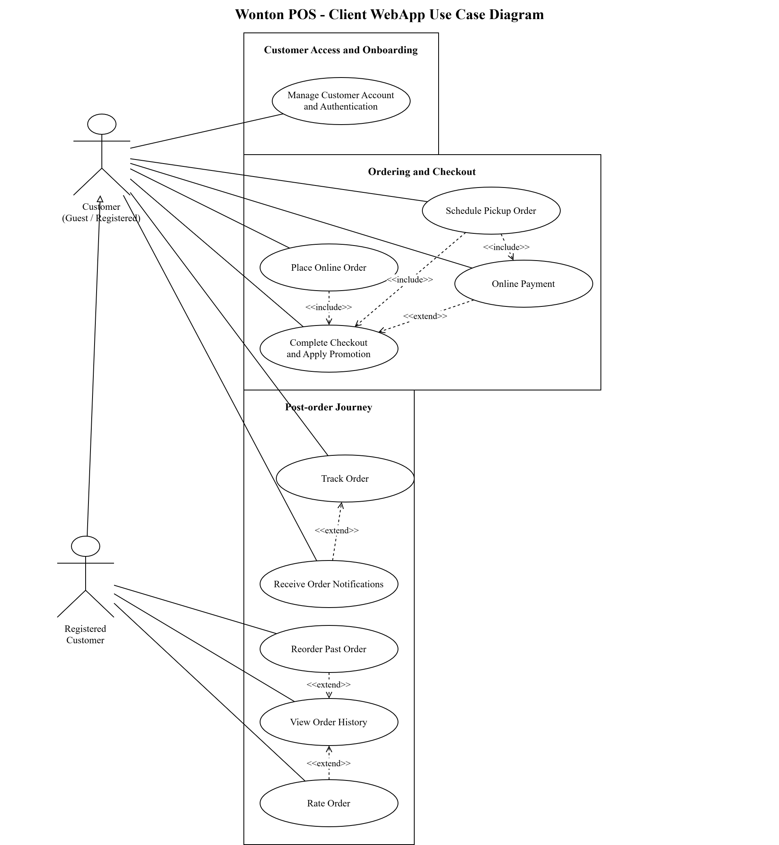
Figure 1a. Wonton POS - Client WebApp Use Case Diagram
The Use Case Diagram illustrates how customers interact with the Wonton POS system throughout the ordering process. It provides an overall view of system functionality and highlights how different features support users across multiple stages.
The diagram is organized into three main phases: Customer Access and Onboarding, Ordering and Checkout, and Post-order Journey. This structure helps clearly represent the user journey from accessing the system to completing and reviewing orders.
In the Customer Access and Onboarding phase, users interact with the system through the Manage Customer Account and Authentication use case. This includes activities such as login, registration, and account management, ensuring secure and personalized access.
In the Ordering and Checkout phase, customers can place orders through the Place Online Order use case. This process includes Complete Checkout and Apply Promotion, indicating that checkout is a required step. Additional functionalities such as Online Payment and Schedule Pickup Order are also integrated into this phase, allowing users to customize their ordering experience.
In the Post-order Journey, customers can track their orders using Track Order, while Receive Order Notifications provides real-time updates. The system also allows users to view past orders through View Order History, which is extended by Reorder Past Order and Rate Order, enabling customers to reorder items and provide feedback.
The diagram also shows relationships between use cases, such as the inclusion of Complete Checkout within the ordering process and extension relationships that represent optional features.
Overall, this diagram provides a clear and structured view of customer interactions, helping stakeholders understand how the system supports the full customer journey.

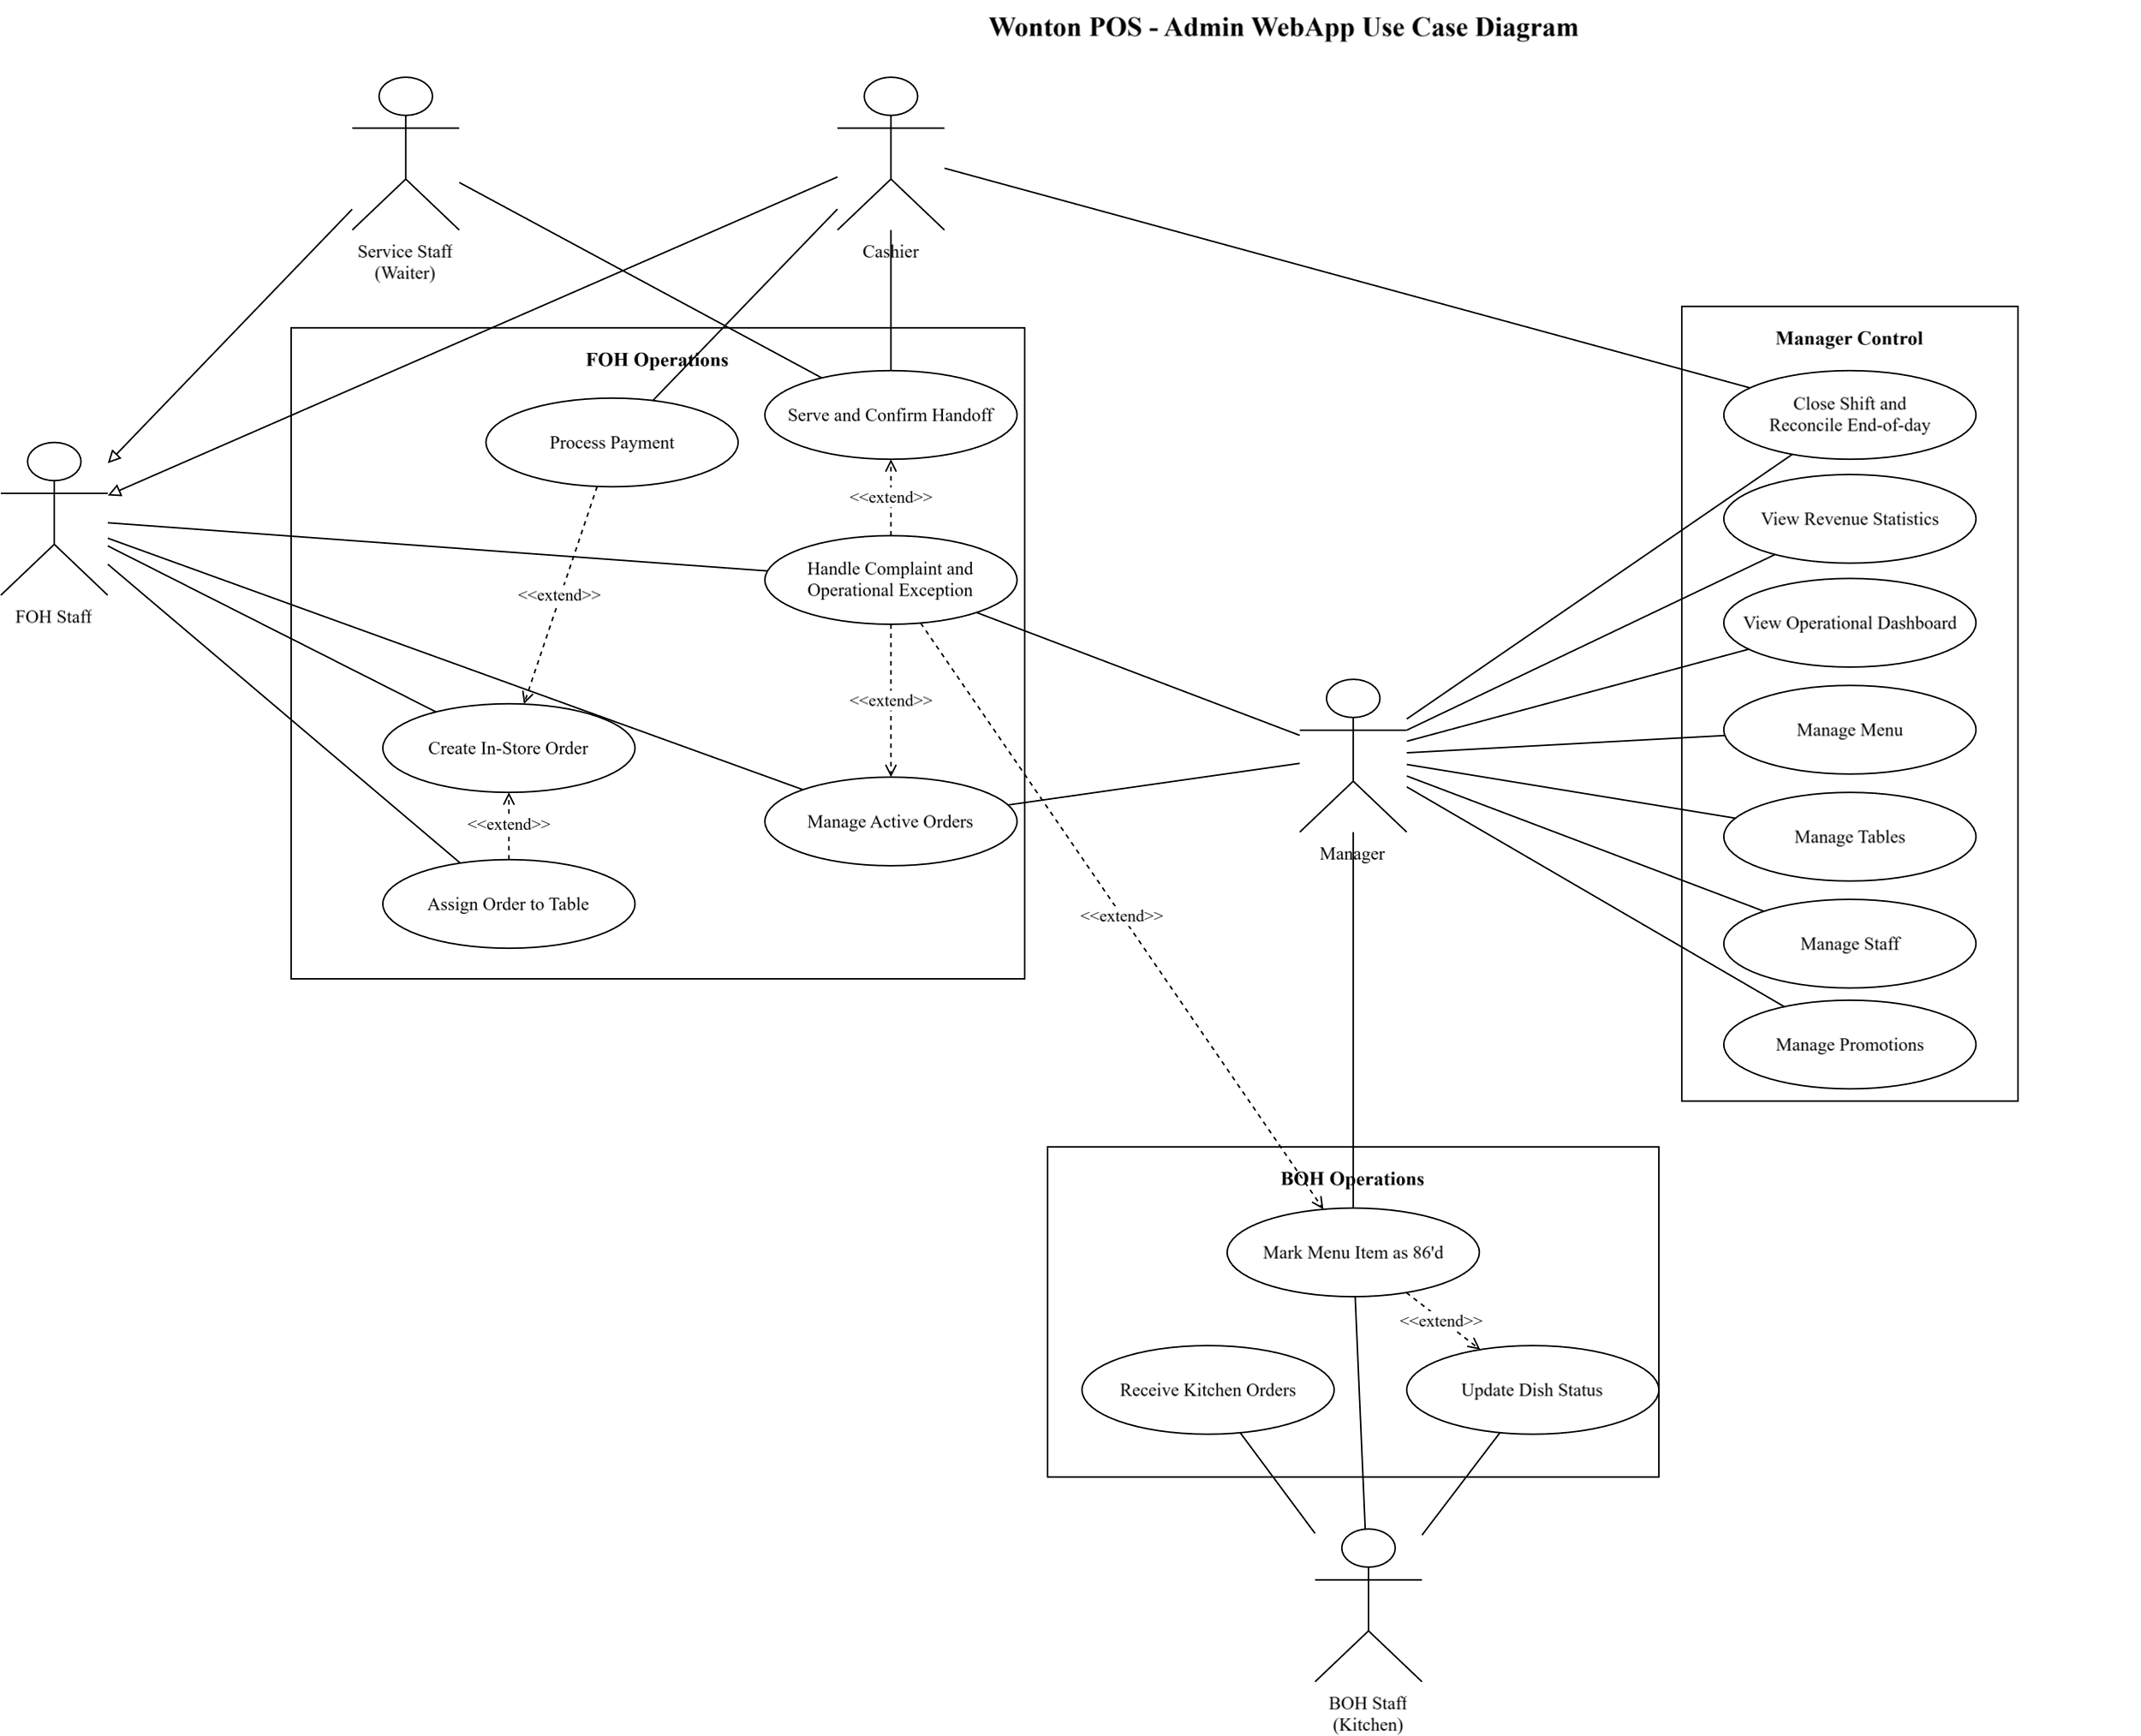
Figure 1b. Wonton POS - Admin WebApp Use Case Diagram
Figure 1b presents a part of the Use Case Diagram focusing on the interactions between FOH Staff, BOH Staff, and Manager within the Wonton POS system. This section highlights operational and management functionalities in the restaurant environment.
The FOH Staff actor is responsible for handling front-of-house activities. They interact with use cases such as Create In-store Order, Process Payment, Assign Order to Table, and Manage Active Orders. These use cases represent the workflow of handling customer orders, from order creation to service completion. In addition, actions such as Serve and Confirm Handoff and Handle Complaints and Operational Exceptions are connected through <<extend>> relationships, indicating that these activities occur only in specific situations.
The BOH Staff actor is associated with kitchen operations. They interact with use cases such as Receive Kitchen Orders and Update Dish Status, which support the preparation and progress tracking of food items. These interactions ensure smooth coordination between the kitchen and service staff.
The Manager actor is responsible for administrative functions. The diagram shows several use cases including Manage Menu, Manage Tables, Manage Staff, Manage Promotions, View Revenue Statistics, and View Operational Dashboard. These functionalities allow the manager to monitor system performance and control business operations effectively.
The relationships between use cases, including <<include>> and <<extend>>, help clarify system behavior by distinguishing between mandatory processes and optional actions. This improves the flexibility and realism of the system.
Overall, Figure 1b provides a clear view of internal operations, illustrating how different staff roles interact with the system to support both daily operations and management activities.

2. Class Diagram for the System
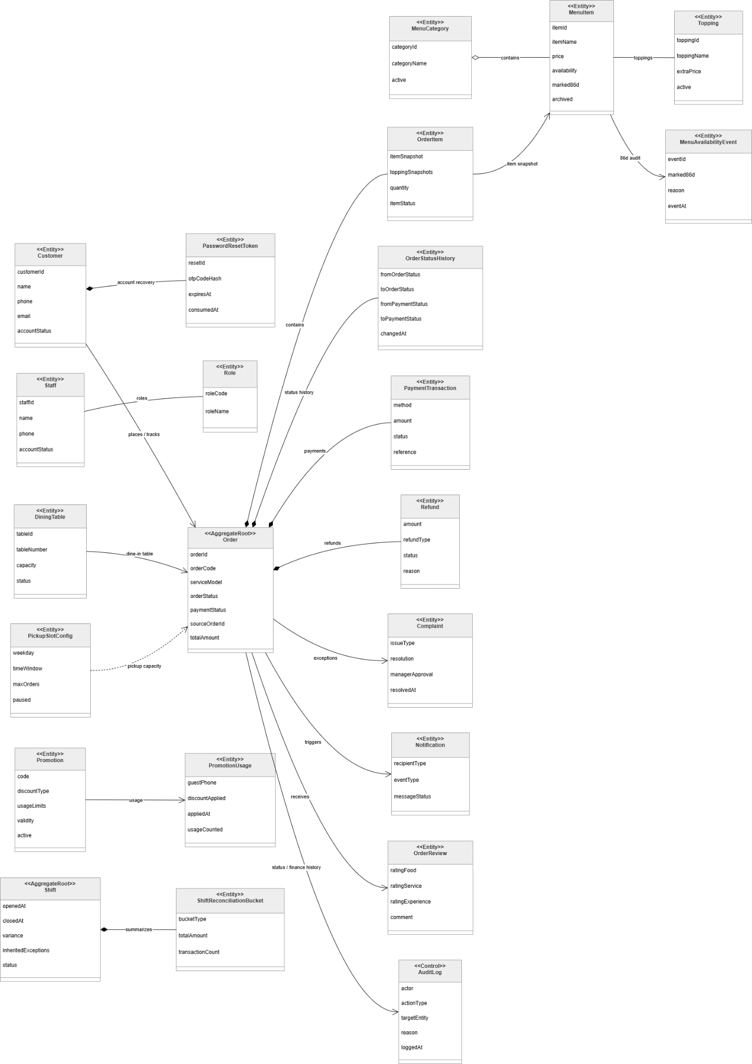

Figure 2. Wonton POS System Class Diagram
The class diagram presents the structural design of the Wonton POS system, illustrating the core entities and their relationships that support restaurant operations such as order processing, menu management, payment handling, and system monitoring. The system is designed using a domain-driven approach, with the Order entity acting as the central aggregate root that connects multiple components.
At the core of the system is the Order class, which represents a customer transaction. It stores essential information such as orderCode, serviceMode, orderStatus, paymentStatus, sourceOrderId, and totalAmount. Each order is associated with multiple OrderItem entities, which capture individual items within the order. The OrderItem class stores itemSnapshot, toppingSnapshots, quantity, and itemStatus, ensuring that product data remains consistent even if the menu changes later.
The menu structure is represented through MenuItem and MenuCategory. Each MenuItem contains attributes such as itemName, price, availability, and status flags like marked86d and archived. Menu items belong to a MenuCategory, allowing the system to organize products efficiently. Additionally, MenuItem is connected to Topping, which supports item customization, and MenuAvailabilityEvent, which tracks availability changes such as marking items as unavailable.
Customer and staff management are handled through separate classes. The Customer class stores user information such as name, phone, email, and accountStatus, and is linked to PasswordResetToken for account recovery functionality. The Staff class represents internal users and is associated with the Role class, which defines access permissions. This structure enables role-based access control and ensures that system actions are restricted based on user responsibilities.
The system also supports dine-in and pickup services. The DiningTable class represents physical tables in the restaurant, allowing orders to be assigned for dine-in scenarios. The PickupSlotConfig class defines time windows, capacity, and availability for pickup orders, enabling efficient scheduling and resource management.
Payment processing is managed through the PaymentTransaction class, which records details such as method, amount, status, and reference. Orders may also be associated with Refund entities, which track refund amount, type, status, and reason. This separation ensures clear financial tracking and supports error handling in transactions.
To support operational monitoring and customer interaction, the system includes several supporting classes. The Notification class manages system messages sent to users, while the OrderReview class allows customers to provide feedback on their experience. The Complaint class handles issues raised during order processing, including resolution and managerial approval.
In addition, the system includes Shift and ShiftReconciliationBucket classes to support staff shift management and financial reconciliation. The AuditLog class records system activities such as user actions, target entities, and timestamps, ensuring traceability and system accountability.
Overall, the class diagram demonstrates a well-structured and scalable design, with clear separation of concerns and strong relationships between entities. By organizing the system around the Order aggregate and supporting it with modular components, the design ensures efficient data management, flexibility, and maintainability for real-world restaurant operations.

3. Entity-Relationship Diagram for the System
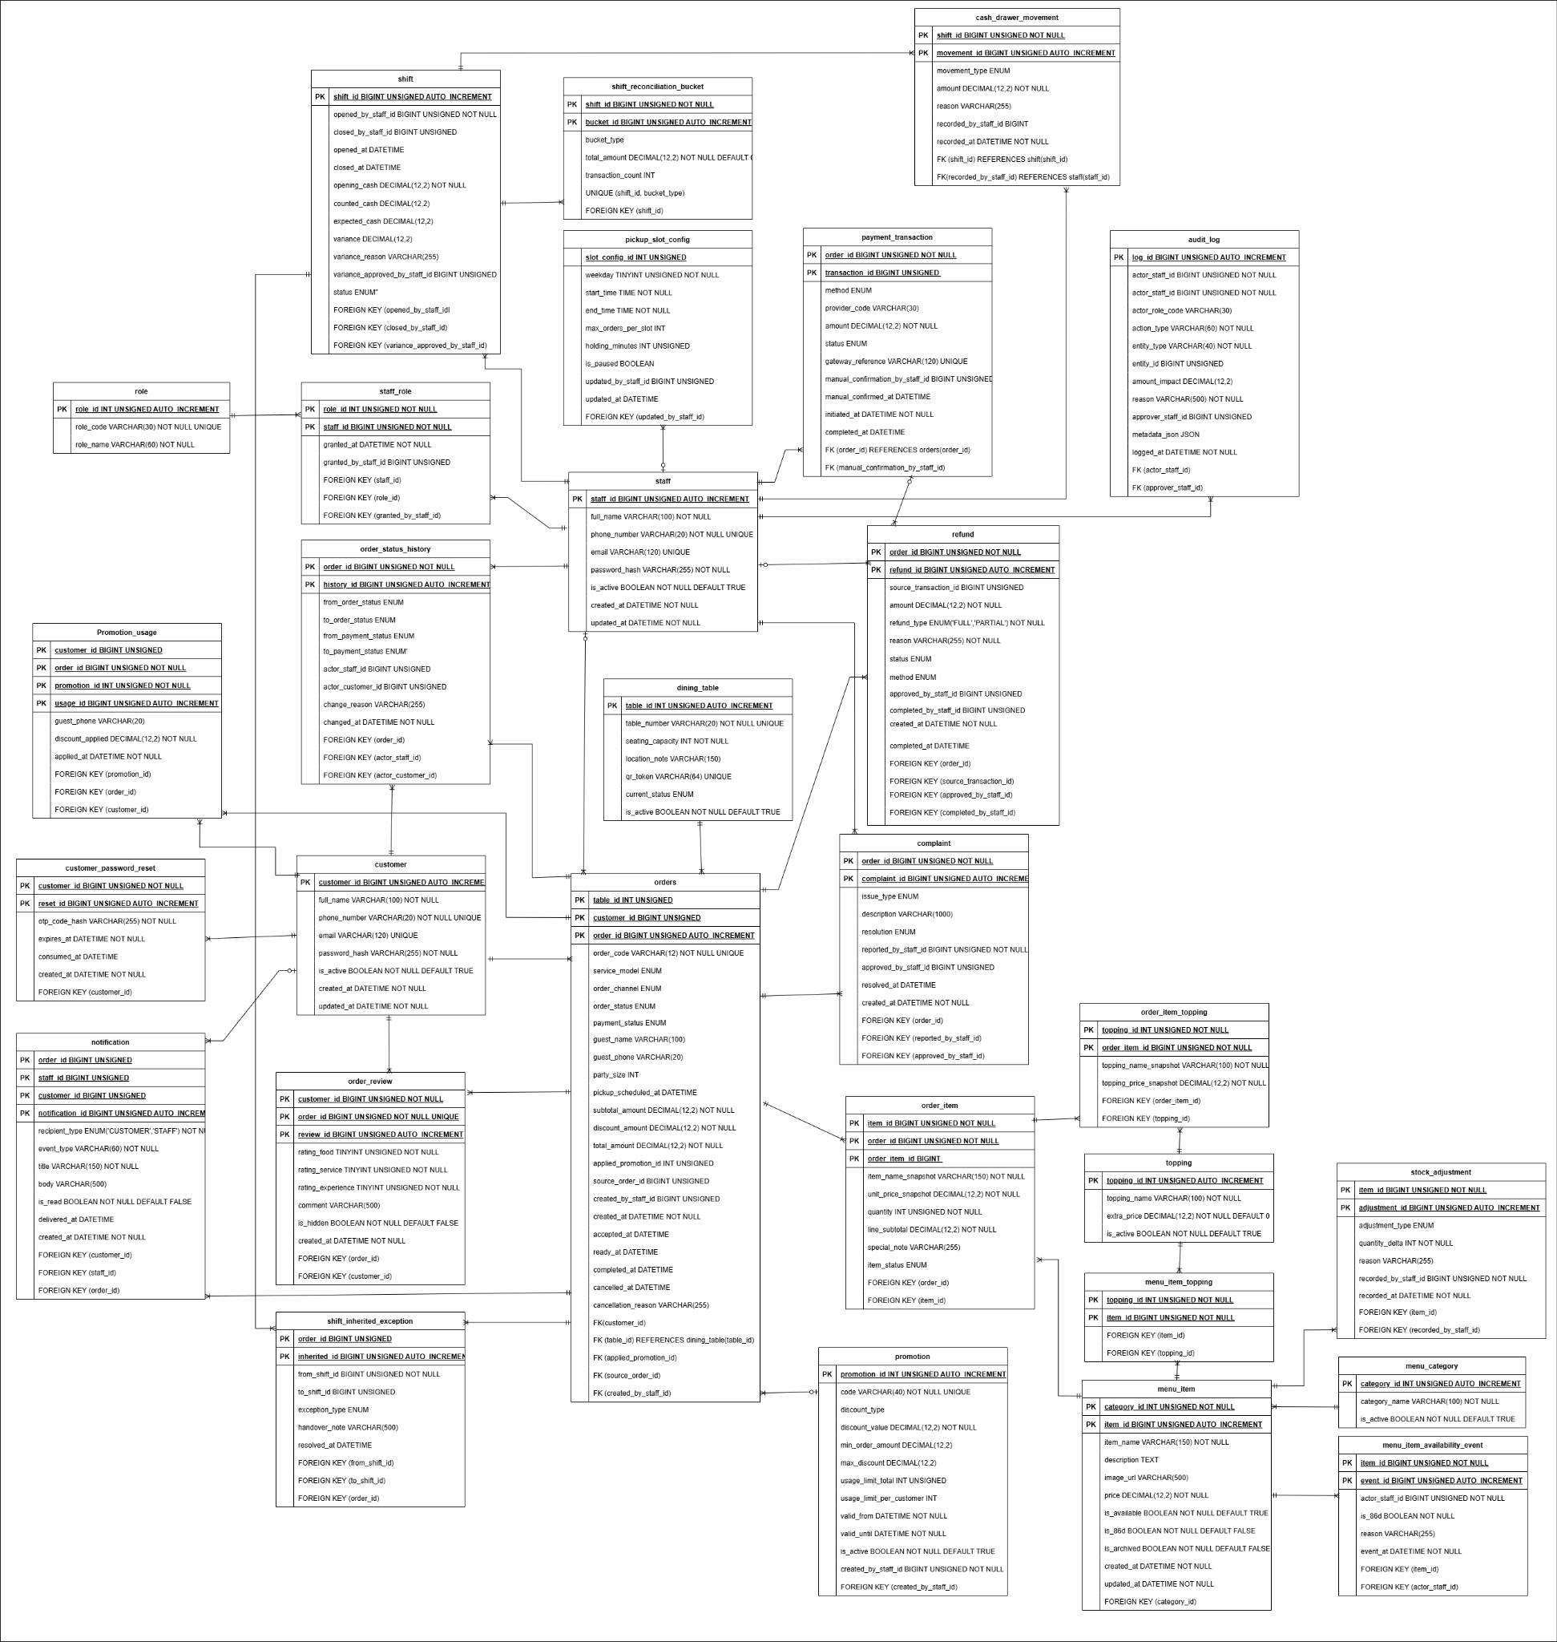
Figure 3. Wonton POS Entity-Relationship Diagram
The diagram represents the Entity-Relationship (ER) model of the Wonton POS system, illustrating the core entities and how they interact to support restaurant operations, including order processing, menu management, staff management, and payment handling.
Order and Transaction Management
At the center of the system is the orders table, which stores all transaction-related information such as order type, status, total amount, timestamps, and customer reference. Each order is associated with multiple order_items, representing individual dishes within the order. These order items are linked to the menu_items table, which contains detailed information about each food item such as name, price, and availability.
Orders are also connected to payments, which store payment method, transaction status, and payment details. This relationship ensures that each order is properly tracked and completed through a corresponding financial transaction.
Menu and Product Management
The menu_items entity plays a key role in representing the restaurant’s offerings. Each item belongs to a menu_category, allowing the system to organize dishes into logical groups for easier navigation and management. Additional customization options may be supported through related entities such as toppings or modifiers, enabling flexible order configurations. This structure allows the system to efficiently manage menu updates, pricing, and availability.
Customer and Account Management
Customer information is stored in the customers table, which includes details such as name, contact information, and account credentials. Customers can place multiple orders, establishing a one-to-many relationship between customers and orders.
In addition, customer-related data such as order history is maintained through this relationship, enabling features like reordering and tracking past transactions.
Staff and Role Management
The system includes a staff entity representing employees such as managers, FOH staff, and BOH staff. Each staff member is associated with a role, which defines their permissions and responsibilities within the system.
This structure supports role-based access control, ensuring that each user can only perform actions relevant to their job function, such as managing orders, updating dish status, or accessing reports.
Table and Service Management
For dine-in services, the dining_tables entity is used to manage table information within the restaurant. Orders can be associated with specific tables, enabling staff to assign and manage dine-in customers effectively. This relationship supports real-time table management and improves service coordination.
Notification and System Support
The system also includes supporting entities such as notifications, which store messages related to order updates and system alerts. These notifications are linked to orders and users, ensuring that customers and staff receive timely updates throughout the order lifecycle.
Overall, the ER diagram presents a well-structured database design that supports both operational processes and management functionalities. By clearly defining relationships between entities, the system ensures efficient data flow, accurate transaction handling, and scalability for future enhancements.

4. Details of Online Tools Applied
During the development of the Wonton POS system, the team used diagrams.net (draw.io) and editable diagram-source tools to prepare clear modelling evidence for the SRS and thesis. Diagrams.net was useful for presentation-oriented editing because it is browser-based, easy to share, and supports familiar UML and database notation. PlantUML and Mermaid sources were also used where structured text-based diagram maintenance was more reliable for version control and repeatable rendering.
The modelling work focused on three diagram types required for the final package: Use Case Diagrams, a Class Diagram, and an Entity-Relationship Diagram. Use Case Diagrams communicate actor interactions and system boundaries; the Class Diagram explains the main domain objects and relationships; and the Entity-Relationship Diagram shows how data is structured for orders, payments, menu items, customers, staff, notifications, and reconciliation.
The tools support exporting diagrams into formats such as PNG, SVG, and PDF, making it practical to insert visuals into the thesis, SRS, and presentation materials. This also helps different team roles review the same model without depending on one workstation or one proprietary editor.
Overall, these modelling tools improved the clarity, organization, and maintainability of the project documentation. They helped the team convert business requirements into visual models that can be understood by stakeholders, reviewers, and future developers.

VI. Requirement Management
Requirement management is necessary because requirement errors are among the most expensive problems to correct after design or implementation has started; requirements management also helps teams document, trace, analyze, prioritize, agree on, verify, and revise requirements across the product lifecycle (IBM, 2025). In the Wonton POS project, a single unclear rule can affect ordering, payment, kitchen preparation, customer communication, and manager reporting at the same time. Therefore, this section focuses on how the team controls approved business needs after elicitation, rather than simply describing how many documents were produced. Supporting documents such as the BRD, SRS, use-case tables, diagrams, and prototype are used only as verification evidence that the same controlled requirement baseline is being represented consistently.
The managed baseline for this thesis is the Wonton POS system for Dine-in, Takeaway, and scheduled Pickup operations across the Client WebApp and Admin WebApp. The baseline is defined by stakeholder needs, business rules, service boundaries, quality expectations, and the current release scope. The key principle is that every requirement must remain understandable, testable, prioritized, owned, and traceable from the original business problem to the final prototype and review evidence.
The Requirement Management Plan (RMP) defines five practical controls for this project: baseline control and use-case traceability, change management, prioritization and effort assessment, requirement risk management, and scope management. This structure follows the requirement-management principle that a plan should define how requirements are collected, analyzed, documented, traced, prioritized, changed, verified, and updated (IBM, 2025). These controls answer the main management questions: what has been approved, what can still change, who reviews a change, which items are more important, what risks may block requirement satisfaction, and what belongs outside the current release.
1. Baseline Control, Status Tracking, and Traceability
Baseline control means that the team treats approved requirements as a managed set, not as loose notes. A requirement is controlled when its purpose, source, priority, owner, status, acceptance condition, and affected workflow are clear. Traceability is still important, but it supports requirement quality rather than dominating the thesis; IBM describes traceability and document updates as part of the requirement-management workflow (IBM, 2025). In other words, the team traces requirements so that the business rule, user workflow, screen behavior, and validation criteria stay consistent.
The status lifecycle used in the project is: Proposed -> Analyzed -> Approved -> Deferred or Rejected -> Updated -> Verified. This lifecycle makes it clear whether a requirement is only an idea, already accepted into the baseline, waiting for later release, or already reflected in the relevant review evidence. No requirement is accepted into the managed baseline unless it has a clear source, priority, owner, acceptance condition, and release decision.
Baseline element | Purpose | Wonton POS application
Business need | Explains why the requirement exists. | Reduce handwritten order mistakes, improve FOH/BOH coordination, and give the owner clearer operational visibility.
Functional requirement | Defines what the system must do for users. | Support menu browsing, checkout, payment control, order tracking, KDS updates, table handling, and exception handling.
Quality requirement | Defines how well the system must perform. | Keep screens usable during peak service, protect customer/payment data, and provide clear status feedback.
Business rule | Defines operational constraints that cannot be ignored. | Takeaway and Pickup must be paid before kitchen preparation; order status and payment status are managed separately.
Requirement status | Shows the current management state of a requirement. | Use Proposed, Analyzed, Approved, Deferred, Rejected, Updated, or Verified to avoid unclear ownership and outdated wording.
Review evidence | Shows that the requirement is represented consistently. | Requirement text, workflow model, prototype screen, and acceptance check should describe the same behavior.

1.1 Requirements Traceability Matrix by Use Case
To make traceability reviewable, the project maintains a use-case-level Requirements Traceability Matrix (RTM). The matrix does not replace the BRD, SRS, detailed use-case specifications, or prototype evidence. Instead, it is a management view that shows whether each approved capability is connected to a business need, a controlled scope area, verification evidence, and an acceptance focus. This aligns with the role of traceability in understanding requirement relationships and change impact (IBM, 2025). This helps the team identify orphan requirements, missing validation evidence, and use cases that may require change review before the baseline is updated.
Use Case / Capability | Requirement Traced | Scope / Source Area | Verification Evidence | Acceptance Focus
UC-01: Place Online Order | Customer can browse menu, configure items, manage cart, and create an order request. | Client ordering; menu-to-cart flow | BRD/SRS functional requirement; Client menu, cart, and order prototype screens | Order captures service model, items, options, totals, and order state without bypassing payment or kitchen rules.
UC-02: Online Payment | Customer can complete supported online payment for orders that require prepayment. | Payment control; Takeaway/Pickup prepayment | Payment flow specification; retry, failure, callback, and refund-status prototype evidence | Payment result is recorded separately from order status; failed, duplicate, and late callbacks are handled consistently.
UC-03: Schedule Pickup Order | Customer can choose a pickup slot and submit a scheduled Pickup order after slot validation. | Pickup service model; capacity and time-slot control | Pickup workflow and checkout prototype evidence | Pickup slot and capacity are checked before acceptance; Pickup orders require payment before kitchen preparation.
UC-04: View Order History | Customer can view past orders and inspect order details after purchase. | Post-order customer visibility | Order history and order-detail prototype screens | Completed, cancelled, refunded, and pending-refund states are visible with enough detail for customer follow-up.
UC-05: Manage Menu | Manager can maintain menu items, categories, toppings, prices, and availability. | Admin menu governance | Admin menu management prototype; menu business rules | Menu changes do not corrupt historical orders; unavailable items are blocked from new orders when required.
UC-06: Manage Staff | Manager can create, update, deactivate, and assign roles to staff accounts. | Admin access control; staff governance | Staff management requirement evidence; role/permission prototype screens | Sensitive actions are restricted by role and inactive staff accounts cannot perform operational work.
UC-07: View Revenue Statistics | Manager can review revenue and operational statistics for business oversight. | Reporting and management visibility | Dashboard/reporting requirements and prototype screens | Revenue figures are derived from valid payment and reconciliation statuses, not only from created orders.
UC-08: Manage Tables | Manager can maintain dine-in tables and table layout/status information. | Dine-in table operations | Table management and floor-layout prototype evidence | Table status supports active dine-in service, including multiple open orders for the same party when applicable.
UC-09: Create In-Store Order | FOH or Cashier can create dine-in or takeaway orders at the counter. | Counter POS; walk-in order flow | Admin POS order-entry prototype and in-store order requirements | Service model is captured correctly; dine-in may pay later while takeaway cannot enter kitchen before payment.
UC-10: Process Payment | Cashier can process counter payments and settlement actions. | Cashier payment and reconciliation control | Counter payment prototype; receipt and settlement requirements | Payment status remains separate from order status; cash/QR results, receipts, refunds, and adjustments remain auditable.
UC-11: Track Order | Customer or guest can track order progress using account access or order code plus phone number. | Customer order visibility; guest lookup | Tracking and guest lookup prototype screens | Valid lookup shows the correct order; mismatched order code or phone number is rejected without leaking order data.
UC-12: Assign Order to Table | FOH can assign, adjust, or transfer orders between dine-in tables. | Dine-in coordination; table-order relationship | Table assignment requirement evidence and prototype screens | Table-order links remain consistent during transfer; active orders stay attached to the correct dining party.
UC-13: Receive Kitchen Orders | BOH can view eligible new orders and begin kitchen processing. | Kitchen intake; KDS queue | KDS intake prototype and kitchen workflow specification | Only eligible orders enter the kitchen queue; queue handling respects service model, payment readiness, and FIFO visibility.
UC-14: Update Dish Status | BOH can update item or order preparation progress until food is ready. | Kitchen execution; item/order status control | KDS status update prototype and dish-status rules | Grouped updates and item-level progress are reflected consistently; ready status is visible to FOH/customer flows.
UC-15: Rate Order | Customer can submit rating and feedback after an order is completed. | Customer feedback and post-service review | Rating page prototype and feedback requirement evidence | Only eligible completed orders can be rated; feedback is linked to the correct order record.
UC-16: Receive Order Notifications | Customer can receive notifications when order status changes. | Customer communication; notification history | Notification center prototype and status-change rules | Relevant status changes generate notifications without changing the source order state incorrectly.
UC-17: Reorder Past Order | Customer can reuse a completed order as the basis for a new order. | Customer lifecycle; repeat purchase | Reorder prototype and menu-drift rules | Price, topping, deleted item, archived item, and 86'd item differences are surfaced before checkout.
UC-18: Manage Promotions | Manager can create, edit, deactivate, and review promotion usage. | Promotion governance; pricing control | Promotion management and usage-audit prototype screens | Validity, usage limit, stacking, cancellation, and failed-application rules are controlled and auditable.
UC-19: View Operational Dashboard | Manager can monitor active orders, revenue snapshot, alerts, and operational indicators. | Manager oversight; daily operations monitoring | Operational dashboard prototype and reporting requirements | Dashboard data reflects current operational state and highlights exceptions that require action.
UC-20: Manage Active Orders | FOH or Manager can monitor, confirm, cancel, or intervene in active orders. | Active operation control; exception prevention | Active orders prototype and operational workflow evidence | Changes respect kitchen timing, payment state, service model, and manager approval for sensitive actions.
UC-21: Close Shift and Reconcile End-of-day | Manager or Cashier can close a shift, reconcile payments, and record differences. | Financial control; shift close and reconciliation | Shift-close and reconciliation prototype screens | Transactions are attributed by event timestamp; exceptions and inherited issues are carried into handover when unresolved.
UC-22: Mark Menu Item as 86'd | Manager or authorized staff can mark menu items temporarily unavailable. | Inventory-lite availability control; menu protection | 86'd availability prototype and audit rules | The item is blocked from new orders; audit trail captures who changed it, when, and why, without assuming full inventory automation.
UC-23: Serve and Confirm Handoff | FOH can serve ready items and confirm correct handoff to the customer or table. | Service completion; dine-in/takeaway handoff | Serve/handoff prototype and ready-to-completed workflow rules | Correct order, table, and customer are confirmed before completion; wrong-handoff correction remains traceable.
UC-24: Handle Complaint and Operational Exception | Staff and Manager can handle complaints, remakes, refunds, wrong handoff, and operational exceptions. | Exception handling; manager correction | Complaint/exception prototype and operational policy evidence | Response, owner, decision, and financial outcome are recorded, including refund, comp, write-off, or forfeited cases where applicable.
UC-25: Manage Customer Account and Authentication | Customer can register, log in, recover password, update profile, change password, and log out. | Customer access and identity control | Authentication, profile, and recovery prototype screens | Account actions validate identity and input correctly while guest checkout remains available for eligible flows.
UC-26: Complete Checkout and Apply Promotion | Customer can finalize checkout, choose service model, enter required details, and apply eligible promotions. | Checkout completion; pricing and service-model selection | Checkout and promotion-application prototype evidence | Service model, customer information, totals, promotion result, and payment requirement are validated before order submission.

The RTM is updated whenever a use case is approved, deferred, changed, or verified. If a use case cannot be traced to a business need, controlled scope area, verification evidence, and acceptance focus, it must be reviewed before remaining in the managed baseline.
2. Change Management
Change management is used to prevent useful feedback from becoming uncontrolled scope creep. The project applies a lightweight Change Control Board approach: new or modified requirements are proposed, analyzed, approved or deferred, and then communicated to the team. This follows the requirement-management view that change management should include impact analysis and requirement revision (IBM, 2025), and the requirements-risk view that scope changes should consider cost, schedule, stakeholder perception, solution quality, and team capacity (ModernAnalyst, n.d.). The change review group includes the BA lead, the owner of the affected requirement evidence, and the project sponsor or designated scope reviewer for scope-sensitive decisions. Decisions are based on business value, scope fit, operational impact, risk, dependency, and available revision effort rather than feature attractiveness alone. The review also considers whether the change affects payment rules, kitchen workflows, reconciliation, prototype evidence, or acceptance conditions.
Step | Control rule | Wonton POS example
1. Propose | Record the requester, reason, affected workflow, and expected value. | A stakeholder asks to clarify guest lookup, bank-transfer confirmation, or pickup no-show handling.
2. Analyze | Review impact on scope, priority, risk, effort, related workflows, and affected evidence owner. | The BA checks whether the change affects payment status, order status, kitchen preparation, reconciliation, promotion, or audit behavior.
3. Decide | Approve, reject, or defer the request through the lightweight review group. | Clarifications inside the current restaurant operations may be accepted; Delivery, loyalty points, procurement, and native apps are deferred.
4. Apply | Update the controlled requirement and the affected evidence together. | A payment-rule change must be reflected in the requirement wording, workflow description, prototype behavior, and validation criteria.
5. Communicate | Inform team members so everyone continues from the same baseline. | Review meetings and document checkpoints are used to prevent parallel versions of the same requirement.

3. Prioritization, Effort Assessment, and Scalability
Prioritization helps the team decide sequencing and review depth. It is not used to silently remove approved requirements. The project applies a simplified MoSCoW and value-risk-effort view. MoSCoW groups requirements into Must, Should, Could, and postponed/future categories, while value-cost-risk methods consider business value, cost, penalty, and risk when ranking requirements (Techcanvass, n.d.). Requirements are considered against business benefit, penalty of not implementing them, risk, dependency, technical difficulty, customer priority, time sensitivity, stability, and policy compliance. Effort assessment is also necessary because one requirement can require analysis, writing, modelling, prototype adjustment, peer review, and revision; requirements effort estimation research highlights that early effort estimates influence later planning decisions and that use cases can support effort reasoning (Kassab and Destefanis, 2015; Rak, Car and Lovrek, 2019).
Priority / effort class | Decision criteria | Wonton POS examples
Must have | Without it, the core restaurant workflow fails. | Ordering, service model selection, Takeaway/Pickup prepayment, kitchen status, order tracking, staff access control, refund status.
Should have | Important for realistic operations and operational completeness. | Reorder, promotion governance, active order monitoring, shift close, 86'd item handling, handoff confirmation, complaint handling.
Could have | Useful for documentation quality or edge-case maturity when time allows. | Additional prototype states, notification-history refinements, report filters, and supporting explanation details.
Won't have now | Outside the baseline or too large for the project timeline. | Delivery integration, loyalty points, supplier procurement, payroll, full accounting ledger, and native mobile application.

Scalability in requirement management means the requirement set can grow without becoming uncontrolled. The project handles this by separating current-release requirements from future-release candidates, keeping ownership clear, and avoiding the trap of treating every useful idea as immediately necessary.
4. Risk Management
Risk management in this section focuses on requirement risks, not only general project risks. Requirements risk management focuses on identifying and managing uncertainties around the recommended solution, while requirements risks are conditions that can affect successful delivery if not controlled (Business Analyst Learnings, 2017). The project classifies requirement-related risks into process, product, technology, elicitation, analysis, specification, and management risks. For Wonton POS, the most important requirement risks are expectation gaps, ambiguous business rules, missing non-functional requirements, unprioritized features, scope creep, and inconsistent interpretation of payment or kitchen workflows.
Requirement Risk Categories
Risk category | Typical cause | Control applied in Wonton POS
Process-related mistakes | Optimistic schedules, fuzzy front end, insufficient planning, or planning to catch up later. | Use a clear baseline, review checkpoints, and done criteria for each major requirement-management block.
Product-related mistakes | Feature creep, requirement gold-plating, or negotiation pressure from different stakeholders. | Use Vision and Scope, MoSCoW priority, and future-release boundaries to keep the product focused.
Technology-related mistakes | Switching tools late or assuming a new tool will solve requirement uncertainty. | Treat prototype tools as evidence only; do not introduce new tooling unless it supports the final deliverable.
Elicitation risks | Expectation gap, unstated requirements, customer distrust, or undiscovered real needs. | Use interviews, observation, questionnaire, meetings, prototype walkthroughs, and what-if questions.
Analysis risks | Requirements are not prioritized or technically difficult features are underestimated. | Check priority, dependency, risk, and effort before accepting a requirement into the baseline.
Specification risks | Ambiguous terminology, unnecessary design constraints, or incomplete requirement statements. | Use clear glossary terms, peer review, measurable wording, and avoid embedding implementation decisions as business requirements.
Management risks | Unable to react to changes, expanding project scope, or unimplemented requirements. | Use change review, impact analysis, version control, ownership, and traceability checks.

Requirement Risk Log
Risk ID | Risk description | Probability / impact | Owner / response | Mitigation / monitoring
RR-01 | Scope expands into Delivery, loyalty, procurement, native apps, or full accounting. | Medium / High | BA lead / avoid and defer | Keep those items outside the current release and record them only as future-release candidates.
RR-02 | Different sections or screens describe inconsistent behavior. | Medium / High | BA lead + evidence owner / reduce | Review requirement wording, workflows, prototype behavior, and acceptance criteria together.
RR-03 | Takeaway or Pickup enters kitchen preparation before valid payment is confirmed. | Medium / High | BA lead + payment workflow owner / avoid | Keep payment-before-kitchen explicit and separate order_status from payment_status.
RR-04 | Operational exceptions such as no-show pickup, refund pending, wrong handoff, 86'd item, complaint, or outage recovery are missed. | Medium / High | Operations workflow owner / reduce | Maintain named alternate and exception flows with manager approval and audit reasons for sensitive corrections.
RR-05 | Prototype screens drift away from the approved requirement baseline. | Medium / Medium | Prototype owner / reduce | Review Client/Admin screens against service models, payment states, account paths, staff operations, and exception scenarios.
RR-06 | Staff adoption is weak because FOH, BOH, or cashier screens are unclear during peak service. | Medium / Medium | UX/prototype owner / reduce | Use role-based views, high-contrast UI, large touch targets, clear status labels, and stakeholder walkthrough feedback.
RR-07 | Guest lookup, staff accounts, or payment-related data are exposed to unauthorized users. | Low / High | Security/RBAC owner / reduce | Apply access control, guest lookup by Order Code + Phone Number, rate limiting, audit logs, and data-retention rules.
RR-08 | Non-functional requirements are neglected because functional workflows receive more attention. | Medium / Medium | Quality requirement owner / reduce | Ask stakeholders to define acceptance criteria for performance, usability, security, availability, and accessibility.

Risk mitigation is documented using probability, condition, consequence, impact, owner, and response. This is consistent with BA-oriented risk guidance that recommends ranking risks by probability and impact, assigning monitoring responsibility, and actively monitoring additional risks as they appear (Business Analyst Learnings, 2017). Responses may reduce risk probability, reduce business impact, transfer review responsibility to the right role, avoid the risk by keeping an item out of scope, or accept low-impact risks with monitoring. The team also checks risky work early, invites review from knowledgeable stakeholders, avoids unfamiliar tools late in the project, and keeps a backup trail for key requirement decisions.
5. Scope Management
Scope management protects Wonton POS from becoming a general restaurant platform. The current project is a focused POS and operations-support system for a wonton noodle shop, not a production deployment commitment. The scope includes product functionality, available team resources, and the timeline for producing a reviewable thesis and requirement package. When the team asks whether a feature is required or worth the effort, the answer must come from the approved Vision and Scope, stakeholder value, risk, dependency, and effort.
Scope category | Included in the Wonton POS baseline | Excluded / future-release boundary
Service models | Dine-in, Takeaway, and scheduled Pickup, including guest checkout and registered customer flows. | Delivery and direct third-party delivery-platform integration.
Customer functions | Menu browsing, cart, checkout, promotion application, payment-status feedback, tracking, notifications, order history, reorder, account management, and rating. | Membership tiers, loyalty points, customer wallet, and native mobile apps.
Admin operations | Menu/category/topping management, staff access control, table management, active orders, KDS updates, 86'd availability, handoff, complaints, pickup exceptions, and outage recovery. | Supplier procurement, full recipe-level inventory automation, payroll, and full accounting ledger.
Financial controls | Counter payment, payment gateway QR, manual bank-transfer confirmation, refund states, write-off/comp/forfeited handling, receipt support, shift close, and reconciliation. | Real banking settlement integration beyond documented gateway/manual-confirmation assumptions.
Project deliverables | Thesis narrative, controlled requirement evidence, specifications, diagrams, requirement management, and prototype evidence. | Production coding, deployment, and operational go-live commitments unless explicitly assigned later.

To keep this boundary enforceable, every functional requirement must map back to an approved business need, workflow, quality expectation, or operational rule. A feature that cannot be traced to the customer journey, Admin operations, kitchen workflow, payment/reconciliation control, or approved exception handling is not added to the current baseline. This keeps the requirement package realistic while still demonstrating a complete understanding of the target restaurant system.

VII. Prototype
This section presents the Figma-presented high-fidelity UI/UX prototype used to validate the Wonton POS requirements before implementation. The prototype deliverable contains 86 user-facing screens, divided into 35 Client WebApp screens and 51 Admin WebApp screens. The screen set demonstrates the in-scope service models (Dine-in, Takeaway, and Pickup), payment-state behavior, kitchen operations, staff workflows, exception handling, and management reporting without introducing Delivery or full procurement functionality into the current release baseline.
In this Business Analysis thesis, the prototype is treated as a Business Analysis artifact rather than a production application. Its purpose is to support stakeholder walkthroughs, requirement validation, UI consistency review, and early confirmation of user journeys, screen states, decision points, and exception-handling behavior before system development begins.

User Interface
The visual design system establishes a consistent interface across customer and staff surfaces. It uses a shared typography style, repeated navigation patterns, stable status badges, role-specific action buttons, and clear visual grouping so that users can recognize the same business concepts across different workflows. The Admin screens use denser layouts for repeated operational work, while the Client screens use a simpler mobile-first structure for quick ordering and tracking.
Prototype surface | Screens | Prototype evidence reviewed | Related requirement / use case validation
Client WebApp | 35 | Authentication, guest checkout, menu browsing, item customization, cart, Dine-in checkout, Takeaway checkout, Pickup checkout, payment states, tracking states, order history, reorder drift, rating, profile, guest lookup, and refund-status views. | UC-01, UC-02, UC-03, UC-04, UC-11, UC-15, UC-16, UC-17, UC-25, UC-26; FR-01, FR-02, FR-03, FR-11, FR-17, FR-25, FR-26; NFR-06.
Admin WebApp | 51 | Admin login, dashboard, active order states, order cancellation, counter order, payment processing, KDS, item-level kitchen view, table management, staff-role screens, menu management, promotion audit, pickup schedule, shift close, 86d availability, handoff, complaints, no-show handling, and outage recovery. | UC-05, UC-06, UC-07, UC-08, UC-09, UC-10, UC-12, UC-13, UC-14, UC-18, UC-19, UC-20, UC-21, UC-22, UC-23, UC-24; FR-05 to FR-24; NFR-04, NFR-05, NFR-07.

Client WebApp Interface
The Client WebApp interface is designed for fast conversion from menu browsing to checkout while preserving the business rules of the restaurant. The screen flow supports optional registration, Guest Checkout, menu search/browse behavior, item customization, cart review, and service-model selection. Checkout screens are separated for Dine-in, Takeaway, and Pickup so that the prototype visibly enforces the rule that Takeaway and Pickup require prepayment while Dine-in can remain unpaid until counter settlement.
The Client screens also model key edge cases instead of showing only a happy path. Payment screens cover waiting, success, failed payment, timeout, bank-transfer pending confirmation, and late-payment/refund recovery. Tracking screens cover Pending Confirmation, Cooking, Ready, Completed, Cancelled, and Dine-in states. Guest lookup screens include success, mismatch, and rate-limit views, which supports both usability and privacy/security requirements.

Admin WebApp Interface
The Admin WebApp interface is optimized for staff who repeat operational tasks under time pressure. Dashboard and active-order screens use status filters and high-density cards/tables so staff can quickly identify live orders, payment problems, overdue handoff, and exceptions. The KDS screens support FIFO kitchen intake and grouped item-level updates, while table screens make dine-in assignment and transfer visible to FOH staff.
Management screens cover menu/category/topping control, staff role management, promotion management, revenue reporting, pickup capacity, 86d availability, shift close/reconciliation, complaint resolution, Pickup no-show handling, and manual outage recovery. These screens demonstrate that the prototype covers not only customer ordering but also the approved operational baseline required for a realistic restaurant POS.

User Experience
The User Experience design focuses on reducing uncertainty for three groups: customers, FOH/Cashier staff, and BOH/Manager users. Customers need a short path from menu to checkout and clear feedback after ordering. Staff need fast, role-specific action surfaces that reduce verbal back-and-forth. Managers need exception and reconciliation screens that make operational and financial decisions traceable.

Customer Journey
The customer journey emphasizes rapid ordering, transparent status feedback, and clear recovery paths. Navigation adapts based on whether the user is authenticated or continuing as a guest. Service-specific checkout logic makes the payment rule visible before the order reaches operations. Reorder screens show menu-drift notices when prices, toppings, archived items, or 86d availability affect a past order, preventing the system from silently changing the customer total. Payment and tracking edge-case screens reduce confusion when payment fails, times out, or requires manual bank-transfer confirmation.

Staff Workflow
The staff journey emphasizes speed, state clarity, and exception control. FOH workflows prioritize active orders, counter payment, table assignment, handoff, and complaint routing. BOH workflows use the KDS to show cooking work in FIFO order and update Cooking/Ready states without requiring per-item micro-management when grouped updates are sufficient. Manager workflows emphasize promotion audit, shift reconciliation, 86d item decisions, Pickup no-show handling, and manual outage recovery so that sensitive actions are not handled informally.

Prototype Validation Against Requirements
The prototype validates the requirement set by showing how the written requirements behave on screen. It checks whether the documented use cases are understandable as user tasks, whether state transitions are visible to the right actor, and whether exception flows have an explicit place in the UI. This is critical because many restaurant POS failures occur not because a feature exists, but because staff cannot find the correct screen or cannot tell which state is financially or operationally safe.
Validation focus | Prototype evidence | Requirement / UC checked
Service-model and checkout control | Separate Dine-in, Takeaway, and Pickup checkout screens; visible prepayment routing for Takeaway/Pickup; Dine-in pay-later behavior. | FR-01, FR-02, FR-03, FR-26; UC-01, UC-02, UC-03, UC-26.
Payment and refund recovery | Payment waiting, success, failure, timeout, bank-transfer pending confirmation, and refund-status screens. | FR-02, FR-10, FR-20, FR-24; UC-02, UC-10, UC-20, UC-24; NFR-05.
Guest and registered customer support | Authentication, registration, forgot password, guest checkout, guest lookup success/error/rate-limit, order history, profile, and reorder screens. | FR-04, FR-11, FR-17, FR-25; UC-04, UC-11, UC-17, UC-25; NFR-01, NFR-02.
Kitchen and handoff operations | KDS order view, KDS item view, Ready queue, handoff confirmation, wrong-handoff/complaint routing. | FR-13, FR-14, FR-23, FR-24; UC-13, UC-14, UC-23, UC-24.
Manager and reconciliation control | Dashboard, active orders, shift close, revenue filters, promotion audit, 86d availability, Pickup no-show, and outage recovery screens. | FR-07, FR-18, FR-19, FR-20, FR-21, FR-22, FR-24; UC-07, UC-18, UC-19, UC-20, UC-21, UC-22, UC-24; NFR-04, NFR-07.
UI/UX quality | Mobile-first Client layouts, dense Admin layouts, role-specific navigation, color/status badges, responsive review, and consistent component patterns. | NFR-03, NFR-06, NFR-08, NFR-09.

Prototype Limitations
The prototype is intentionally limited to Business Analysis validation and presentation. It does not prove production performance, payment-gateway integration, database persistence, automated notification delivery, or real KDS/printer hardware behavior. Those areas remain implementation and testing concerns for a later development phase. Within the approved business scope, the prototype is used to demonstrate that the requirements are visible, reviewable, and understandable as UI/UX workflows.

VIII. Revision of Project
This section records how the Business Analysis work was revised after requirement review, stakeholder-oriented walkthroughs, modelling checks, and prototype inspection. The purpose of the revision is not to add uncontrolled scope, but to make the approved requirement package clearer, more traceable, and easier for stakeholders, designers, developers, and testers to use.

Revision Summary
The main revisions are summarized below. Each revision is linked to a concrete weakness found during review and to the BA value gained after the change.
Area reviewed | Issue found before revision | Revision made | BA rationale | Resulting improvement
Client overview and problem statement | The business problem was too broad and could be read as several separate problems. | The problem framing was consolidated into one core issue: disconnected manual order, payment, and operational tracking. | A single problem statement keeps scope control clear and prevents unrelated features from being justified by separate problem claims. | The client need is now easier to understand, validate, and trace to requirements.
Requirement statements | Functional and non-functional needs were not strong enough as a full-version requirement baseline. | Requirements were rewritten into structured FR/NFR tables with priority, related use cases, and acceptance evidence. | Structured requirements reduce ambiguity and help the SRS, diagrams, prototype, and testing evidence stay aligned. | Each major capability now has clearer business value, verification focus, and ownership in the requirement package.
Use case specification | Some operational flows were implicit, especially payment confirmation, kitchen intake, refund handling, shift close, and exceptions. | The use-case set was mapped to UC-01 through UC-26 and representative detailed use cases were added for high-risk flows. | Use cases translate business statements into actor goals, triggers, preconditions, main flows, alternate flows, and postconditions. | The requirement package now shows how customer, cashier, kitchen, service staff, and manager actions connect end to end.
Business rules and scope boundary | Several rules could be misread, including Delivery, Bank Transfer QR, Takeaway/Pickup payment timing, 86d availability, and refund states. | The baseline was clarified so Delivery remains outside scope, QR confirmation is cashier-controlled, Takeaway/Pickup require prepayment, and order status is separated from payment status. | Clear boundaries prevent scope creep and protect the restaurant workflow from unrealistic assumptions. | Stakeholders can now distinguish current capability, exception handling, and later enhancement candidates.
Modelling and diagrams | The modelling explanation did not fully show why each diagram type was useful for a different analysis question. | The modelling section was organized around use case, class, and entity-relationship diagrams with clearer tool and purpose explanations. | Different models answer different BA questions: actor interaction, process responsibility, domain structure, and data relationships. | The diagrams now provide stronger support for SRS traceability and stakeholder explanation.
Prototype evidence | The prototype explanation risked sounding technical instead of being presented as a BA validation artifact. | The prototype section was reframed as a Figma-presented high-fidelity UI/UX prototype with 35 Client WebApp screens and 51 Admin WebApp screens. | A prototype should help stakeholders review journeys, screen states, role actions, and exception paths before development decisions are made. | The UI evidence now supports requirement validation without exposing internal build details.
Requirement management | Change, risk, and scope control needed to be more explicit and more connected to the requirement baseline. | The management section was expanded with traceability, change-control steps, prioritization, risk categories, risk log, and scope-boundary controls. | Requirement management shows how the approved baseline can be maintained after feedback or new business requests. | The thesis now explains how requirement quality is protected after initial elicitation and analysis.

Lesson Learned
Conducting the Business Analysis work for Wonton POS showed that a strong requirement package must start from an operational problem, not from a list of attractive features. When the problem was narrowed to disconnected manual order, payment, and operational tracking, the requirement set became more coherent and easier to defend.
The team learned that elicitation must combine several viewpoints. Management interviews explained business objectives, while observation of FOH and BOH activities revealed practical bottlenecks such as handwritten tickets, unclear order states, repeated kitchen checks, and payment-confirmation uncertainty. Combining interviews, observation, questionnaires, and meetings produced a more realistic baseline than any single technique could provide.
Another lesson is that visual models must match their audience. Use case diagrams support actor and scope discussion, class and data models support SRS structure, and process-oriented views help stakeholders follow work responsibility. The prototype added another validation layer because stakeholders can inspect checkout, tracking, KDS, staff, and exception screens as user journeys instead of only reading requirement text.
The clearest business-rule lesson was the need to separate order_status from payment_status. Kitchen progress and financial settlement are related but not identical. Keeping them separate makes Dine-in pay-later, Takeaway/Pickup prepayment, pending refund, write-off, comp, forfeited payment, and shift reconciliation easier to explain and control.

Recommendation on Future BA Work
The next BA cycle should validate the prototype with cashiers, kitchen staff, service staff, and the manager during realistic peak-hour scenarios. The review should check whether users can identify the correct screen, understand the order and payment state, complete handoff, handle failed payment, and escalate exceptions without verbal workarounds.
Acceptance criteria should be tightened for high-risk flows such as manual QR confirmation, Takeaway/Pickup prepayment, refund pending, paid no-show Pickup, 86d item handling, order correction, complaint resolution, and shift reconciliation. These criteria should be written so developers and testers can verify behavior without reinterpreting the business rule.
The traceability matrix should be maintained whenever a requirement, use case, diagram, or prototype screen changes. Each approved change should identify the reason, affected actors, affected requirements, affected screens, and expected validation evidence. This will reduce inconsistency between the BRD, SRS, diagrams, and prototype.
Any expansion beyond the approved business baseline, such as Delivery, third-party logistics integration, loyalty, full procurement inventory, payroll, native mobile apps, or accounting modules, should remain a later enhancement candidate until it passes formal scope-change review. This protects the current release from scope creep and keeps the analysis focused on the restaurant operations that were validated.

REFERENCES
B-Company. (2025). Technology Adoption in Vietnam's F&B SMEs: Current Gaps, Challenges and Strategic Solutions. Available at: https://b-company.jp/technology-adoption-in-vietnams-fb-smes-current-gaps-challenges-and-strategic-solutions/ (Accessed: 3 May 2026).
IJIRT. (2024). Enhancing Restaurant Operations through Modern POS Systems. Available at: https://ijirt.org/publishedpaper/IJIRT174275_PAPER.pdf (Accessed: 3 May 2026).
IJCRT. (2020). Conceptual Study of Point of Sale System. Available at: https://ijcrt.org/papers/IJCRT2006464.pdf (Accessed: 3 May 2026).
GoSnappy. (2025). Chinese Restaurant POS System Guide. Available at: https://gosnappy.io/blog/chinese-restaurant-pos-system/ (Accessed: 3 May 2026).
NRSPlus. (2024). POS Data Analysis for Business Growth. Available at: https://nrsplus.com/blog/pos-data-analysis/ (Accessed: 3 May 2026).
Shopify. (2025). Point of Sale Data Analysis Examples. Available at: https://www.shopify.com/blog/point-of-sale-data-analysis (Accessed: 3 May 2026).
Mona Media. (2025). Restaurant Management System and AI Applications. Available at: https://mona.media/restaurant-management-system/ (Accessed: 3 May 2026).
GoFrugal. (2025). Essential Restaurant Management Tools. Available at: https://www.gofrugal.com/blog/essential-restaurant-management-tools/ (Accessed: 3 May 2026).
AaltoDoc. (2020). Intention to Adopt POS Systems in Vietnam Restaurants. Available at: https://aaltodoc.aalto.fi/items/37358780-aab9-4d25-951d-97d1e4ff0ab5 (Accessed: 3 May 2026).
LimeTray. (2025). Restaurant POS System Functional Requirements Checklist. Available at: https://limetray.com/blog/restaurant-pos-system-functional-requirements-checklist/ (Accessed: 3 May 2026).
Pegotec. (2025). Business Analysis for Software Projects. Available at: https://pegotec.net/unveiling-the-secrets-to-successful-business-analysis-for-software-projects/ (Accessed: 3 May 2026).
GetSoftwareService. (2024). Top 10 Business Analysis Tools and Techniques for Effective Project Management. Available at: https://getsoftwareservice.com/top-10-business-analysis-tools-and-techniques-for-effective-project-management/ (Accessed: 3 May 2026).
IBM. (2025). What is Requirements Management? Available at: https://www.ibm.com/topics/what-is-requirements-management (Accessed: 3 May 2026).
Techcanvass. (n.d.). What Are Requirement Prioritization Techniques? Available at: https://techcanvass.com/blogs/requirement-prioritization-techniques.aspx (Accessed: 3 May 2026).
Business Analyst Learnings. (2017). Requirements Risk Management: What's In It For Business Analysts? Available at: https://www.businessanalystlearnings.com/blog/2017/7/4/requirements-risk-management (Accessed: 3 May 2026).
ModernAnalyst. (n.d.). Requirements Risk Management. Available at: https://www.modernanalyst.com/Resources/Articles/tabid/115/ID/212/Requirements-Risk-Management.aspx (Accessed: 3 May 2026).
Kassab, M. and Destefanis, G. (2015). Requirements Effort Estimation: State of the Practice. Available at: https://www.researchgate.net/publication/280557176_Requirements_Effort_Estimation_State_of_The_Practice (Accessed: 3 May 2026).
Rak, K., Car, Z. and Lovrek, I. (2019). Effort Estimation Model for Software Development Projects Based on Use Case Reuse. Journal of Software: Evolution and Process, 31(2), e2119. Available at: https://doi.org/10.1002/smr.2119 (Accessed: 3 May 2026).

