**Spring Data Common**

**Working with Spring Data Repositories**

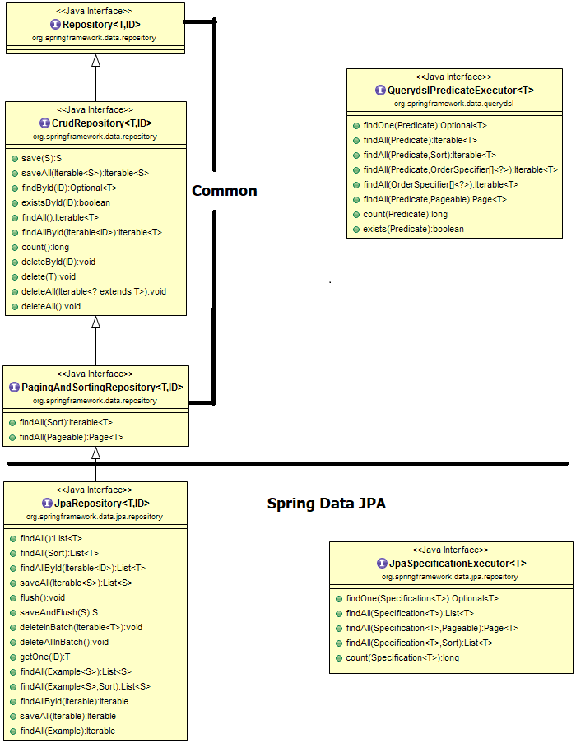

- The intermediate repository interface is annotated with @NoRepositoryBean. Make sure you add that annotation to all repository interfaces for which Spring Data should not create instances at runtime.

-These methods are routed into the base repository implementation of the store of your choice provided by Spring Data (for example, if you use JPA, the implementation is SimpleJpaRepository)

* Defining Query Methods

- Using name method auto genarate SQL:

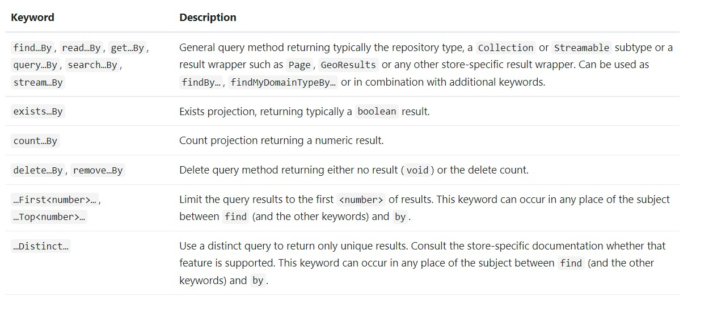

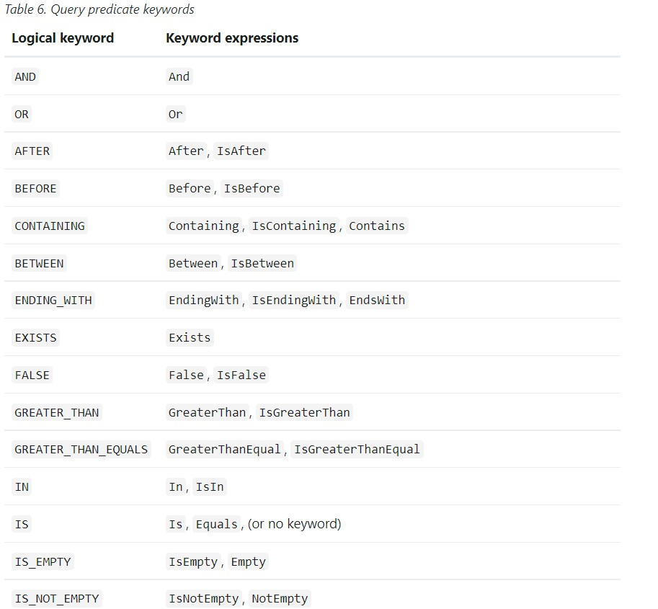

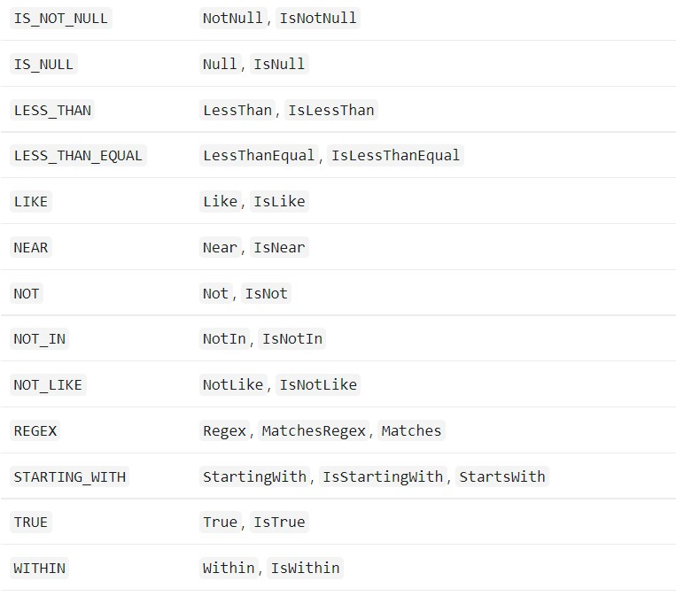

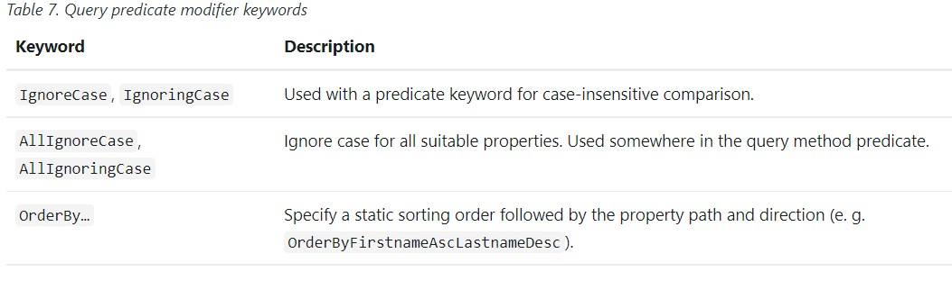

- Using @Query on method

#### *Querydsl Extension

## *Query by Example

## 

## 

## Spring Data JPA

- Spring Data automatically looks up the EntityManagerFactory bean with the name entityManagerFactory in the ApplicationContext

- Default to a single defined PlatformTransactionManager inside the current ApplicationContext

-At runtime, Spring Data JPA will initialize JPA EntityManagerFactory for persistence unit ‘default’. And the actual type of the entityManager object would be LocalContainerEntityManagerFactoryBean which wraps a Hibernate’s Session object.

Alternatively, you can also use the @PersistenceContext annotation:

E.g: Inject: @Autowired **private** EntityManager entityManager;

Or @PersistenceContext **private** EntityManager entityManager; (quản lý bởi container)

Bonus: @PersistenceUnit **private** EntityManagerFactory entityManagerFactory;( quản lý bởi ứng dụng)

EntityManager entityMng = entityManagerFactory.createEntityManager;

** Entity States

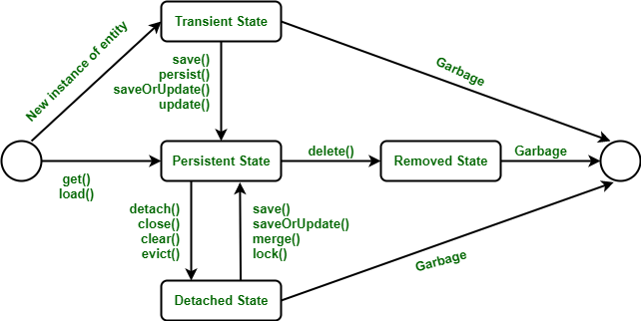

*** Các cách truy vấn

* Using method default of EntityManager Optitions: persist(arg), merge(arg), find(arg), flush(arg), …
* Using Query Method:

+ Define in interface extends Repository<> ….

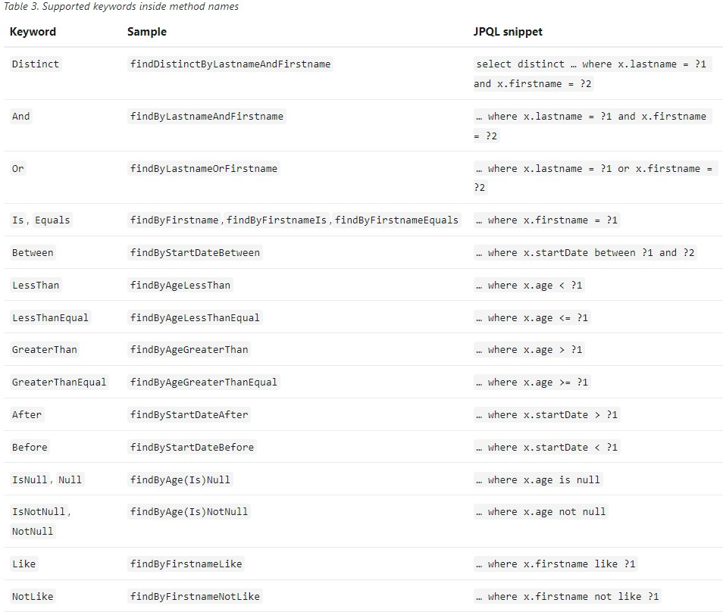

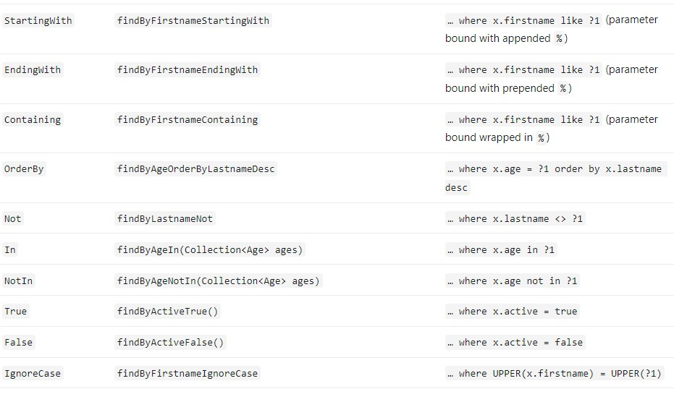

+ Using JPA Named Queries: Declare sql in Class entity with @NamedQuery, then declare name method in interface

+ Using @Query in method in interface, bind parameter using @Param

-Using Stored Procedures (ít sử dụng vì có nhiều hạn chế, ưu là nhanh…)

-Using Specifications (ít sử dụng)

-Using Query by Example (ít sử dụng)