Job Checklist Research
Electrical, Plumbing, Carpentry & Renovation
Research basis for the pre-mobilisation checklist logic in the Site Recon Agent (see track_construction_site_recon_idea.md). Replaces the earlier civil/commercial version with the residential tradie vertical: three of the most common trade job types a homeowner calls a contractor for. For each: what real Victorian regulatory source it comes from, the checklist’s actual structure, the specific trigger/threshold conditions, and what that means for how the agent should represent and resolve it. All text below is paraphrased and restructured from the cited sources, not copied verbatim; the checklist images are original renderings built from that research, not screenshots of the source documents.

1. Electrical Work

What it is / why it’s job type #1
Any licensed electrical work in a home: new circuits, switchboard upgrades, solar/battery installs, general power and lighting work. This is the trade with the cleanest, most binary checklist logic of the three, which makes it a good one to build first.

The real trigger and the key distinction
Trigger: Any licensed electrical work performed in a home

Every piece of electrical work needs a Certificate of Electrical Safety (CES), issued by the licensed electrician or Registered Electrical Contractor who did the work. The checklist logic branches on one distinction:
- Prescribed electrical work — main switchboards and consumer mains cables, renewable energy systems (solar, battery storage), motor/generator installations. This class cannot be energised or left turned on until independently inspected by a Licensed Electrical Inspector, which must happen within 8 business days of the work finishing.
- Non-prescribed work — additional outlets, lighting, general circuit work. No independent inspection required; the electrician tests and self-certifies, and the work is live immediately.

Checklist structure (as it actually exists)
There’s no separate multi-page form here — the CES itself, plus the prescribed/non-prescribed classification, is the checklist. It’s the simplest of the three trades to encode because the branch is binary and the consequence (inspection required or not) is explicit and time-bound.

What the agent needs to know to make a decision
- What kind of electrical work is being done — this alone determines prescribed vs non-prescribed, which determines whether an inspection booking is even a checklist item.
- Whether a CES has been issued — a yes/no the agent tracks, not something it infers.
- If prescribed: has the inspection been booked, and is it within the 8-business-day window — a real deadline the agent can actively track and flag, the same pattern as the BYDA/permit deadlines already researched.

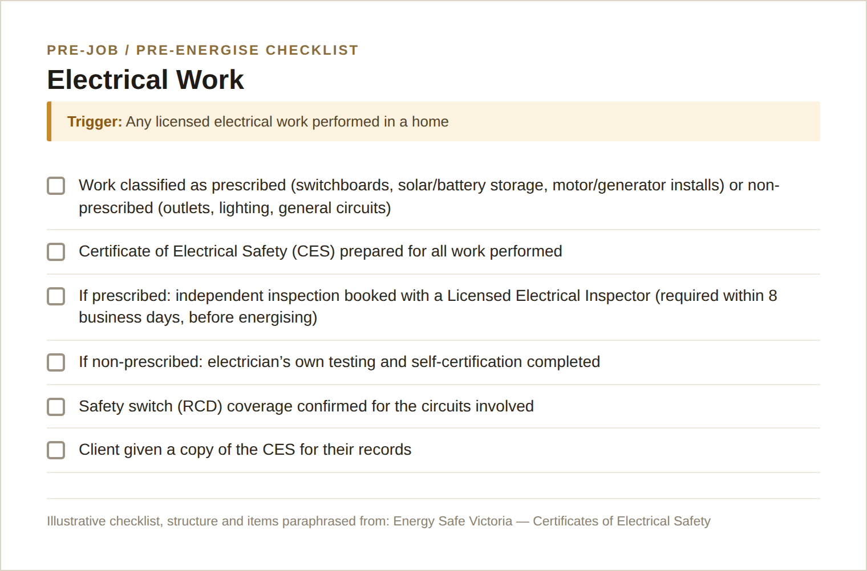
Example: Electrical work pre-job checklist (original rendering based on the sources below).

Sources
- Energy Safe Victoria: Certificates of Electrical Safety
- Energy Safe Victoria: Certificates of Electrical Safety for the community
- Energy Safe Victoria: ESVConnect Certificates of Electrical Safety

2. Plumbing Work

What it is / why it’s job type #2
Any licensed plumbing work: water supply, sanitary, drainage, gasfitting. The checklist logic here is more about paperwork and thresholds than physical risk, which makes it a useful contrast to the electrical checklist.

The real trigger and threshold
Trigger: Any licensed plumbing work (water, sanitary, drainage, gasfitting) performed in a home

A Compliance Certificate is required once plumbing work reaches $750 in value (per Consumer Affairs Victoria’s owner-builder checklist, which lists collecting plumbing certificates for work $750 and over as a completion requirement). Plumbers and gasfitters must also be registered/licensed for the specific class of work they’re doing (water, sanitary, drainage, gasfitting are separately licensed).
Caveat worth flagging to the team: the distinction between when a Compliance Certificate alone is sufficient versus when a full Plumbing Permit is required for more complex "notifiable" work sits in the Plumbing Regulations 2018, administered by the Building and Plumbing Commission (BPC — the plumbing regulator was renamed from the Victorian Building Authority). This detail could not be confirmed from the regulator’s site in the time available; treat the $750 compliance-certificate threshold as solid and the permit-vs-certificate line as needing a follow-up check before it goes on a pitch slide as fact.

Checklist structure (as it actually exists)
Simpler than the excavation/traffic checklists from the civil version: licence verification, a value-based threshold, and a certificate lodged on completion.

What the agent needs to know to make a decision
- Licence class of the plumber/gasfitter doing the work matches the type of work being performed.
- Estimated job value — crosses $750 or not, which determines whether a Compliance Certificate is mandatory.
- Whether the job is complex enough to be "notifiable" — flagged as an open item needing human judgement until the regulation detail is confirmed, rather than the agent guessing.

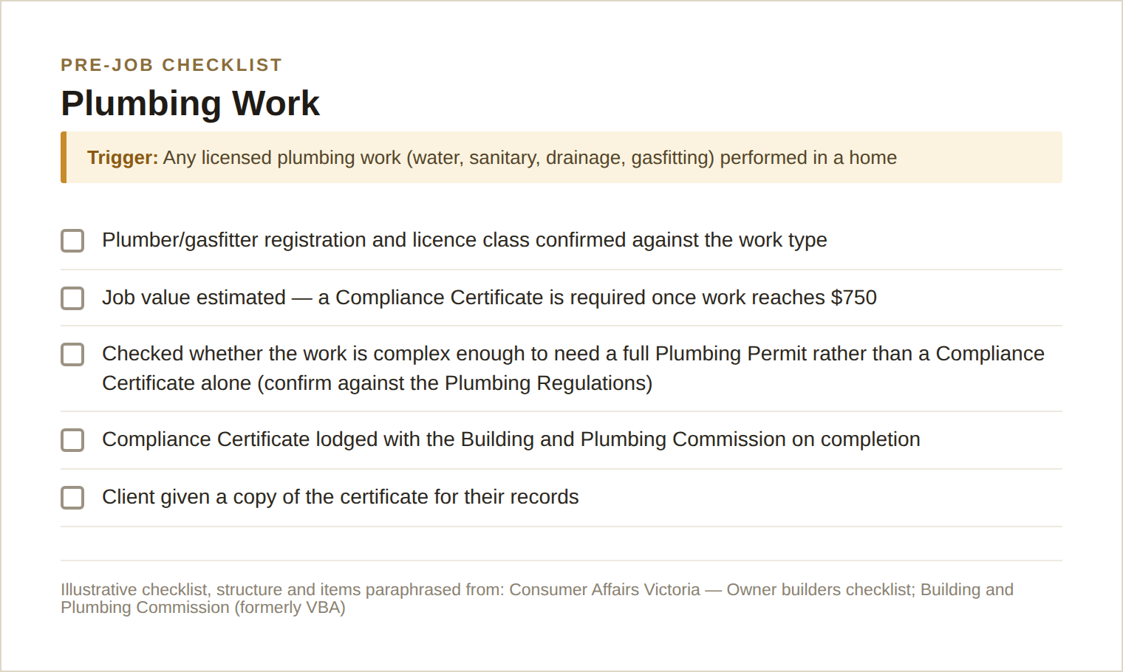
Example: Plumbing work pre-job checklist (original rendering based on the sources below).

Sources
- Consumer Affairs Victoria: Owner builders checklist
- Building and Plumbing Commission (formerly VBA): Plumbers
- Victorian Building Authority: Plumbing compliance certificates protect your work

3. Carpentry & Renovation (Building Work)

What it is / why it’s job type #3
Structural renovation, extension, or building work on an existing home. This is the trade where the checklist has the most steps and the most severe consequence for missing one (asbestos exposure, an invalid permit, an uninsured job).

The real triggers and thresholds
Trigger: Structural renovation, extension or building work on an existing residence

Three separate thresholds stack on top of each other:
- Age of the home: if built or last renovated before 1990, assume asbestos-containing materials are present until tested. Intact, undisturbed asbestos can be left alone; anything the job will disturb or that’s already damaged needs a licensed removalist, not the tradie doing the renovation.
- Job value over $10,000: requires a registered builder, a written major domestic building contract, and current domestic building insurance.
- Job value over $16,000 (for owner-builder projects specifically): requires a Certificate of Consent from the Building and Plumbing Commission before work can start.

Checklist structure (as it actually exists)
Consumer Affairs Victoria’s owner-builder checklist is the closest thing to a single real document here, structured in three phases: before starting (legal advice, insurance, education course, scope of work), during (verify trade licences, written contracts, building surveyor), and on completion (Occupancy Permit or Certificate of Final Inspection, collect all trade certificates). The asbestos guidance is a separate, more procedural checklist from the Asbestos Safety and Eradication Agency: assess presence, leave undisturbed if intact, or run a five-step controlled removal (PPE and containment setup, work-area preparation, safe wetted removal, decontamination, lawful double-wrapped disposal) if it must be disturbed.

What the agent needs to know to make a decision
- Construction year of the property (a lookup, not a judgement call) → whether the asbestos-assumption item even applies.
- Whether the renovation will disturb existing materials in a pre-1990 home — this is where the agent should flag "needs a professional asbestos assessment" rather than assume safety.
- Estimated job value against the $10,000 and $16,000 thresholds → which paperwork (contract, insurance, Certificate of Consent) becomes mandatory.
- Whether a building permit and registered surveyor are already in place — a yes/no/pending state, same pattern as the road-reserve permit in the civil version.

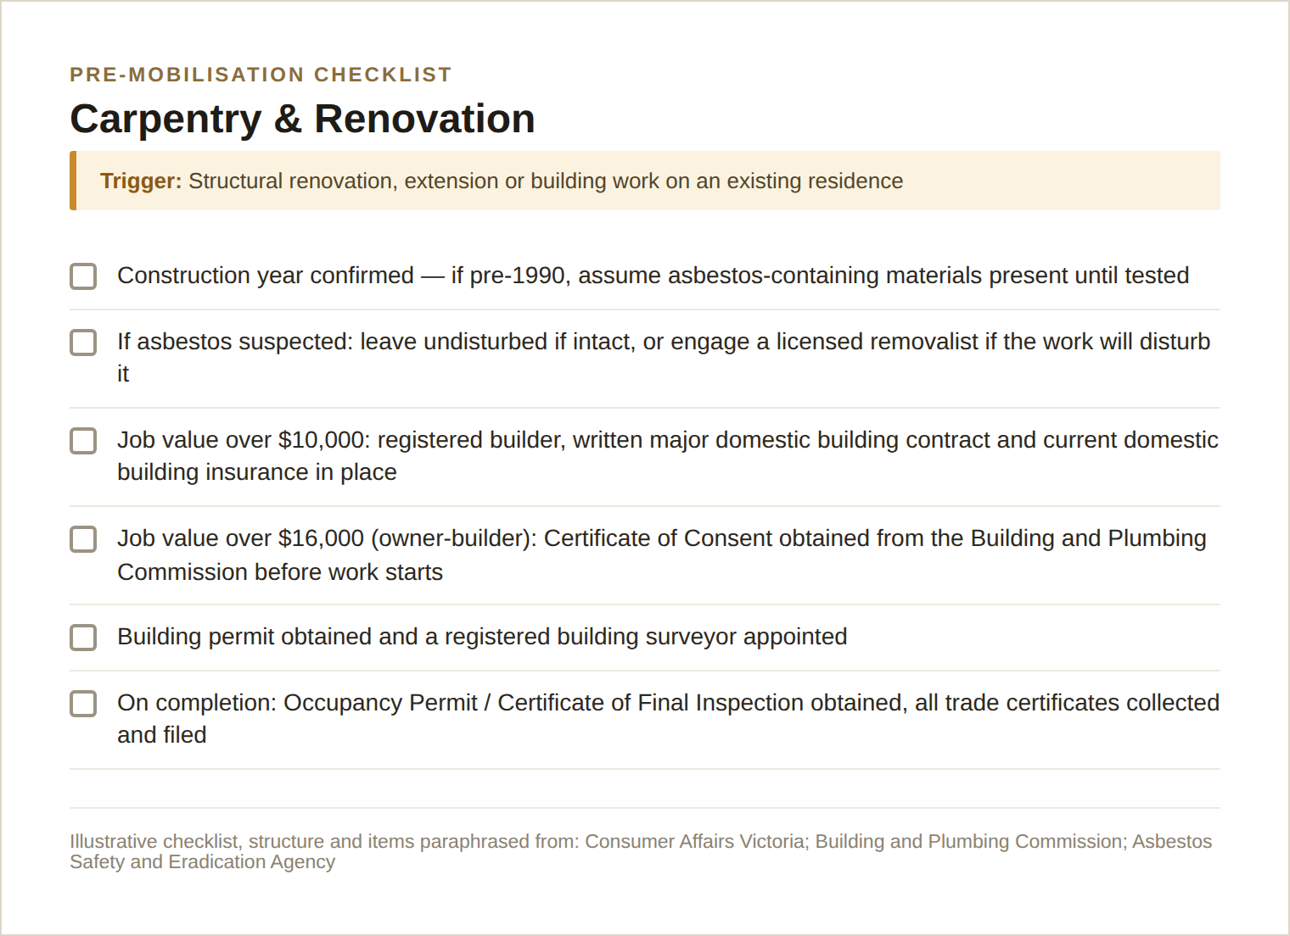
Example: Carpentry and renovation pre-mobilisation checklist (original rendering based on the sources below).

Sources
- Consumer Affairs Victoria: Owner builders checklist
- Victorian Building Authority: Owner-builder eligibility
- Building and Plumbing Commission: Owner-builders FAQs
- Asbestos Safety and Eradication Agency: Householders and home renovators

What This Means for the Agent’s Checklist Design
Same pattern as the civil version, and it still holds for residential trades:
- Every checklist item has a trigger condition (job type, work classification, property age, job value), a resolution method (a certificate/licence check, a value threshold comparison, or "ask a human"), and a status (resolved / pending / flagged / unresolved).
- The residential trades lean more on thresholds and paperwork (dollar values, certificate types, licence classes) than on live external data — a real difference from the civil vertical, where traffic/air-quality/BYDA data did most of the work. That’s a genuine trade-off worth naming to the team: this vertical is easier to encode correctly (fewer live API dependencies) but a less visually rich demo (no satellite view, no live traffic map doing much work).
- Property age (pre/post 1990) is the one item worth treating like an API call even though it’s really just a records lookup — get it wrong and the asbestos branch of the whole checklist is wrong.
- The $750 / $10,000 / $16,000 thresholds are real and citable; the plumbing permit-vs-certificate distinction is the one item flagged as needing validation before it’s stated as fact in a pitch.

