**RMIT University**

**ASSIGNMENT COVER PAGE**

Your assessment will not be accepted unless all fields below are completed

|  |  |
| --- | --- |
| **Subject Code:** | COSC2083 |
| **Subject Name:** | Introduction to Information Technology |
| **Location where you study:** | Saigon South Campus, Ho Chi Minh city, Vietnam |
| **Title of Assignment:** | Introduction to Information Technology Assignment 2 |
| **File(s) submitted**: |  |
| **Student name:** | Bui Hoang Quan  Tran Quang Huy  Le Ti  Huynh Van Khai |
| **Student Email Address:** | s3577543@rmit.edu.vn  s3680599@rmit.edu.vn  s3650990@rmit.edu.vn  s3618637@rmit.edu.vn |
| **Learning Facilitator in charge:** | Thanh Nguyen Ngoc |
| **Assignment due date:** | 29/04/2018 |
| **Date of Submission:** | 29/04/2018 |
| **Number of pages including this one:** | 20 |
| **Word Count:** | 3500 |

Contents

I. Introduction: 3

II. Product Analysis: 3

Part 1: Feasibility and cost 3

Part 2: Competitors and users 7

Part 3: How will the product work 8

Part 4: SWOT Analysis of Smartwatch: 16

III. Conclusion: 17

# I. Introduction:

In this assignment, our group has chosen Apple as the company for us to base our idea on. Since Apple has traditions and experiences in developing smart products such as Iphoe, Iwatch, Ipad, it is the most suitable company that our team can base our designs. Furthermore, as Apple is dominating the smartwatch market (Cakebread,2017) with cutting-edge technologies, designs and features, it is the best company that has the capacity to make our vision reality.

# II. Product Analysis:

## Part 1: Feasibility and cost

In this modern world, the development of any creation will be useful for human and can be the key that opens a new path for humanity. However, we are all curious about the feasibility and the price of the product so that everyone can use it worldwide and enhance the living standard of our life. As for that reason, my team will also prove how realistic this ultimate smartwatch can become. By drawing down to four major aspects: feasibility, the convenience, timeframe and the cost of this invention, we can then convince all our customers about the undeniable demand and how useful this invention can turn out in the near future.

Firstly, we will discuss the utility and the need for this product in a couple years from now on. With lots of pioneer companies like Apple making similar products, a smartwatch is a well-known gadget that appears as a popular trend all around the world nowadays. Therefore, building a product based on those watch along with some improvements is absolutely possible in the near future. Additionally, People nowadays have lots of essential possession which they need to carry every day including license, credit card, cash, and phone. All of them are easy to get lost due to their size despite their importance. Furthermore, by having lots of property, there are even higher chance that we will get ourselves in more danger with all kinds of robber follow around. As for that reason, we need an invention that can combine all of those things above and merge them as one. To answer the demand of humanity, this ultimate smartwatch is a bridge that links the present smartwatch to all others tools and equipment that serve all human’s purposes as it inherits new technologies from the present day. Additionally, we can easily keep it in our protection as it is always attached on our hand so crime will be less of a problem for us to deal with. Currently, companies have already developed and incorporated various functions into smartphones to better serve customer with applications being more and more multifunctional. While in Korea, people have Samsung Pay that can replace credit card and banking service, WeChat in China is an almost omnipotent application that can assist users in every life aspect, not just for communication and payment. As this trend continues, we may see people replace their personal assets (ID, passport) with digital versions for both convenience and security. Therefore, the multifunctional smartwatch will eventually exist in the near future with highly need without any doubt.

Secondly, on our way creating this prototype, many testers have considered of how effectively can it work with existing technology. In our team’s point of view, there is absolutely no suspicion on how this is the connection of various current and future technologies (mobile technology, mobile application, IoT, blockchain and hologram display). For a related creation, we will take Apple watch as an example. According to Apple’s support website, you can make Siri begin a work out which also includes checking your movement with accurate statistics during the exercise by just raising the watch on your wrist. These statistics contain the distance, time and your heartbeat and also the calories that were got rid of during your training. Therefore, the watch possesses the crucial health technology which improves the quality of our standard lives. Another example is that it can also use to make a phone call or text. Base on Ashleigh Macro’s article on Macworld, The watch connected to your iPhone will make and response the phone call within the range of your phone or as long as your watch connects to a network (Said in Apple support). By then, you can choose to answer it through your phone with a built-in speaker and micro or decline it without pulling your phone out in an inappropriate timing such as during a meeting. The technology is now developed further with the watch replacing the phone, being the main means of communication (Appe.com). With the current smartwatch technology, all the basic functions seems to completely resembling smartphone (with operating system, applications). In the near future, we can expect various means of communication in the smartwatch, not just normal messaging or calling, but applications (Skype, Viber) as well. For those reasons, it can be pointed out easily that smartwatch is also linked with the communication technology. Communication is not the only similarity between smartphone and smartwatch. In the future, we can see the border between the two devices getting blurrer with Shell being an example (Dormehl, 2018). As technology, progress, smartwatch’s capacity can be on par with smartphone with similar operating system and applications. The big differences between the two right now are processing capacity (RAM, ROM) and user interface which we are going to stress. As the current watch hardware is now quite small compared to smartphone, it is hard to fit all components (chips, processors) into it like smartphone. However, many companies have invested into bendable smartphone and some have even introduced a prototype (Moxi) using graphene material (Yan, 2016). Thus, we can see that wearable smartphone or smartwatch with better processing capacity is a possibility. For user interface, beside widened screen from graphene, our smartwatch will also incorporate interactive holographic display that functions as a large screen. Currently, Apple already has a patent for this technology, meaning the feasibility of incorporating it is not farway. With all of those sharp evidence drawn out, our new invention inheriting all of those features will surely satisfy all of our guests’ requirements.

Thirdly, an estimated timeframe of this smartwatch getting economical and fully grown enough to be built is also a part which needs elaboration so that all of us can have a more realistic vision of what will happen. In order for us to predict the time of getting the high tech that is great and reasonable enough to build this ultimate smartwatch, I will borrow a timeframe of how the mobile phone turns into a smart one. As stated in Tiger mobile’s “Evolution of mobile phone” article, the mobile phone has spent about 30 years since 1983 when the world got the first portable phone to become a smartphone nowadays. However, we can easily notice that we only need about 10 years to modify the full function cellphone into a smartphone from 1999 to 2007 when Steve Job introduce the phone with screen interaction. As mentioned, the interactive hologram technology device patent is now own by Apple, which means the watch can be technically designed. Moreover, the bendable smartphone is already invented by Moxi in 2016. The difficulties right now are combining the two technologies to create a hologram smartwatch, synchronizing data and applications to suite holographic interface and applying blockchain and IoT applications into the device. While the two formers are not yet widely available, we can already see the third problem being solved (Samsung Pay, WeChat). Considering the speed of our technical evolution, we can apply all it to this smartwatch and complete this creation in less than 10 years and having a price as good as a smartphone nowadays.

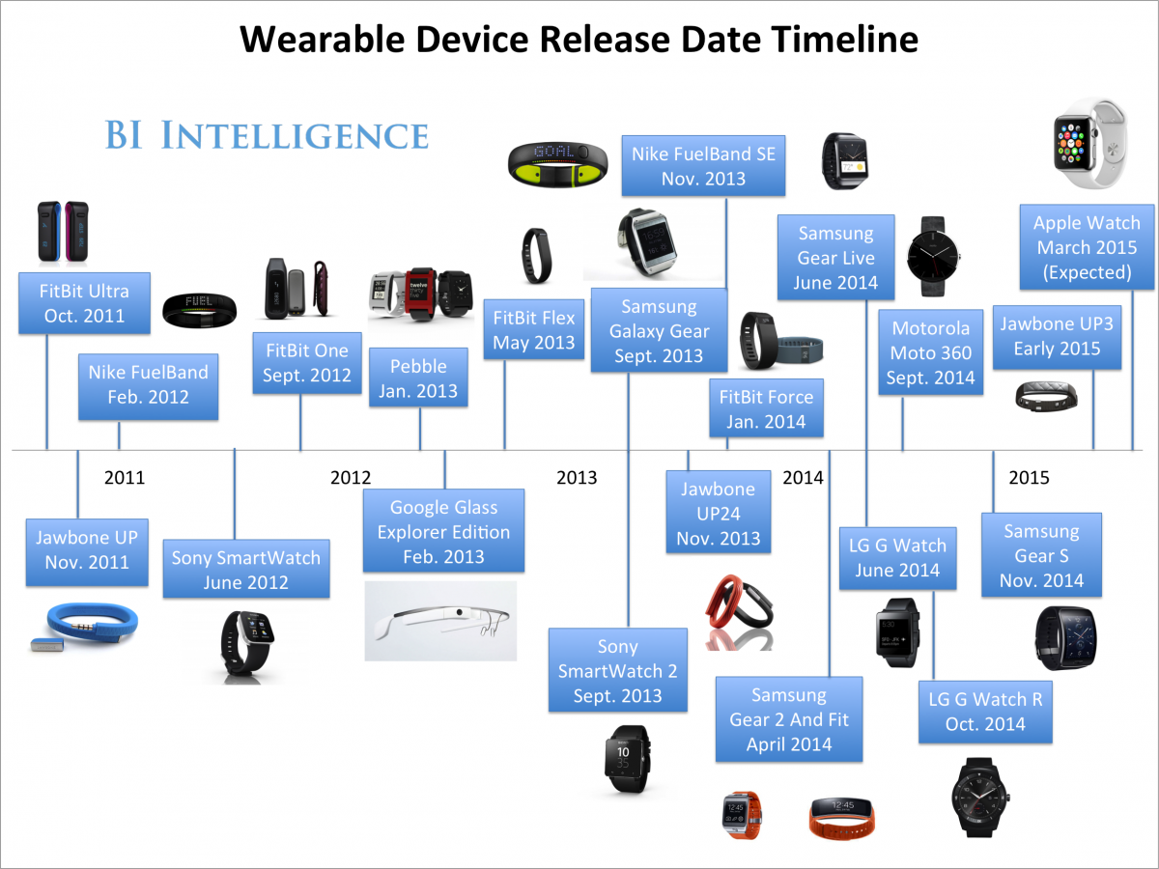

Figure 1- Smartwatch timeline (UK Business Insider)

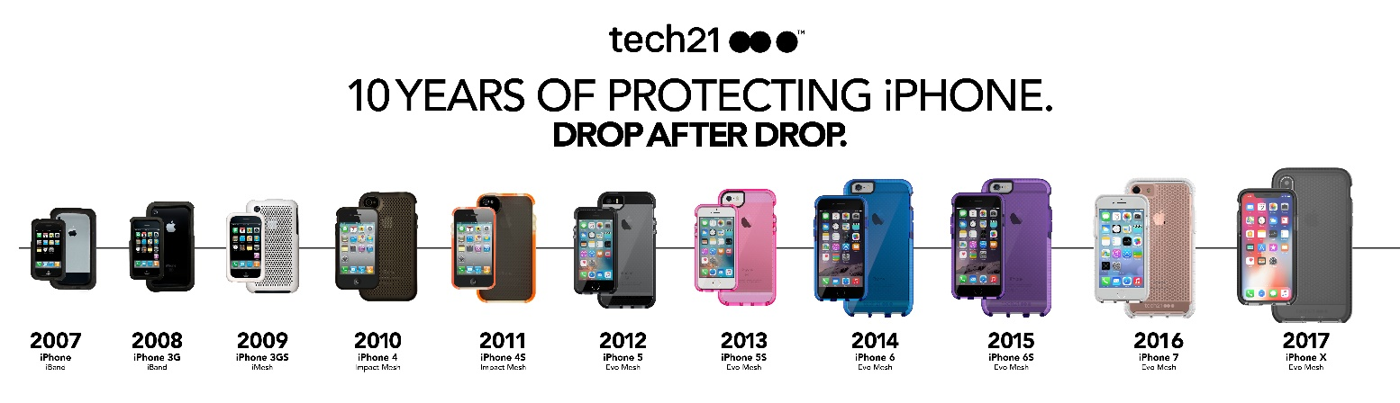

Figure 2- Apple iPhone timeline (Tech21)

Finally, the most important fact of all the invention that we cannot avoid is the cost that getting the prototype become real. Base on Aaron Tilley’s “The Apple Watch Sport Only Costs $83.70 To Make” article on Forbes page, who is also one of the page’s staff, stated that the research firm reported that the Apple watch only costs 83,70$, which is only about one a quarter the watch’s retail price. Also, they stated that the most expensive part of this multi-functional watch is only cost about 21$, which is the OLED display and the ION-X cover glass. After taking it as an example, we can clearly see that the cost of creating the original smartwatch is not too high to create compare to all other technology stuff. However, because this multi-feature watch also merges with other technologies so it might cost higher for us to research the way to integrate all of those complicated technologies in one device. The hologram technology is still in development, and the graphene material price is still high, about $100 per film (Graphenea). As the smartwatch is actually a bendable smartphone, it’s manufacturing process will actually be similar to those of smartphones. Currently, a typical iPhone X costs $370.25 (Jenkins,2017), not accounting manufacturing and software. If we estimate all the smartphone fees, it should be around $450. As our base company is Apple, it would properly cost the same to produce a multifunctional smartwatch. In the future, there might be a chance that every present emerging technology will become mature enough for our project to have a more budget price as the speed of technological shift has been lifted into another height recently. For all reasons stated, there might be a great chance that we will be able to create a multi-functional smartwatch with nearly same price or a little bit higher than the price of the recent smart devices.

In conclusion, with all four aspects from above proved to be achievable in the near future, we have proved that this product will definitely be needed widely because it satisfies all of our customer’s demand for high-tech nowadays. This is the super gadget that all of us need to solve most of our issues within the reach of our hand. This ultimate smartwatch is a new feature that can connect human more than before in the great age of technological revolution.

## Part 2: Competitors and users

Assessing current smart devices and Apple capacity, we believe that our product could succeed. To be more specific, customers need a devices which include every things such as telephone, wallet, watch, camera and so on. This device can make them not easy to forget it. Therefore, we need a technology device combine all of those things above and merge them as one, smartwatch will be their best choice. There are three big technology companies include SamSung, Apple and Sony which are developing fast about smartwatch. Firstly, smartwatch of SamSung - SamSung Gear S with a price around 240$, this device have many features from receiving call, texting message to using sim for 3-4G and connecting wireless, by the way SamSung Gear S can calculate the number of calories which user spend everyday through road and walking time. Second, Apple watch from Apple is sold 349$. This gadget can waterproof and GPS is integrated. By the way, it can support LTE through sim, more than that it can call, receive the call and texting like an iPhone. In addition, Apple watch has camera for video call and software for health. And Finally is Smartwatch SWR50 from SONY with a price 280$, this SONY product has large battery up to 2 day, it can use like a mp3 for music, waterproof ability is good, GPS and compass is integrated. Moreover, apps for texting, social network, news from phone will be synchronized automatically with this smartwatch. Therefore, a smartwatch that inherits all features of a smartwatch like iwatch and develop things which had been never appeared on smartwatch before and the price is adoptable for everyone include normal class or low income people will be became the most desirable product. As a consequences, our smartwatch will make big technology companies recognize a real threat in occupying market share at normal and low class. In addition, smartwatch is becoming global trend so the demand will be large. However, not everyone has the ability to buy smartwatch from big technology companies like Apple and SamSung with a high price out of their ability. In the other hand, our products are expected to break conception about high technology devices belong rich people and bring high technology for everyone even who they are and what they do. Furthermore, another feature which make our smartwatch be different with other existing smartwatch is medical. Our smartwatch can follow and give advices about health for owners based on their calories and blood. This is a special thing which makes our products not to be confused with other smart watches.

## Part 3: How will the product work

Every customer has the same concern on the way the product works. Therefore, the purpose of this part is to guide the customers on the product so they can use it effectively. There are diverse aspects that contain in this device: connection, applications and interface.

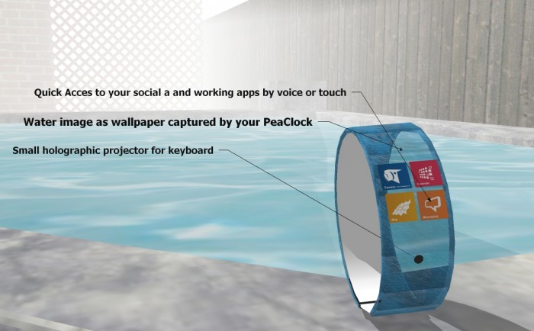

Figure 3- A model smartwatch (Prefundia)

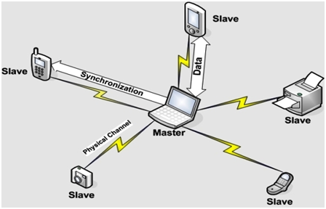Firstly, Wifi a compulsory function because they need Wifi to connect to the Internet which supply the demand of searching/uploading information and entertainment. Thus, we integrated this features into the design of this device. The smart watch will communicate with the signal which is transmitted through the router. The transmitter will release the wifi waves that travel through the air and connect to the receivers. However, this connection is the same as any of other technical devices because it is unable to attach well certainly when both devices separate far apart from each other. Furthermore, it contains 8GB Ram (with the future technology support), Bluetooth and NFC, therefore, the customers can share or store information in a short range. This feature is able to use for every client by turning on these mode as Bluetooth at both devices and then sending the information to any other technical devices such as laptop or mobile phone where keep the data. There is a similarity these aspects so they also turn on the Wi-Fi in order to surf the Internet.

Thanks to Internet, our smartwatch can function as an omnipotent device with the features of cloud computing, IoT and blockchain technology. With the development of such solutions, the watch can store important data such as personal ID, credit/debit card, commuting card and even passport. The perfect examples are the Samsung Pay or Alipay application or WeChat which enables users to do everything from booking services, to social networking, to shopping. With advance technologies, users can do so much more, such as traveling around without stopping to pay, or even storing important information like degrees, passports using blockchain technology. Such applications will enable users to travel seamlessly without being halt. All they need to do is swipe their watch on the scanners and proceed.

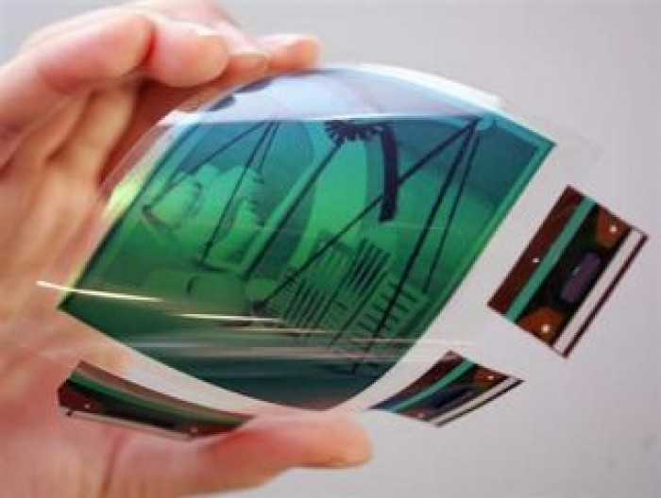All of technological products involve touch screen, and that is quite useful because this allow people to interact with display using fingers. Besides that, the screen made from a thin flexible glass that suit with the watch (graphene).

Figure 4- Graphene material (prefundia.com)

There is a special way to open or interact with the device, users just need to tap on the screen two times to activate it. There are reasons for choosing flexible display. Firstly, it will fit the wrist size of the customers, because the wrist size of each people is differently. In case, the customer is thin so they can roll it a little bit in order to suit to them. There is a big difference of equipment between the smart watch with the original one. The customer does not need to manipulate the strap which adjust the size correctly. It might be more convenient to the customers when they are just simply put the watch on their hand and roll it in a right size for themselves. Secondly, there is a small circle button on the top of the device. Its function is that simulate a laser keyboard so the consumers can utilize to typing or write long sentences.

The customer may curios about where the light laser come from. It emits light from the camera which locate on this technological product. Moreover, it is not only a functional aspect of the camera, it can be utilized to take photos.

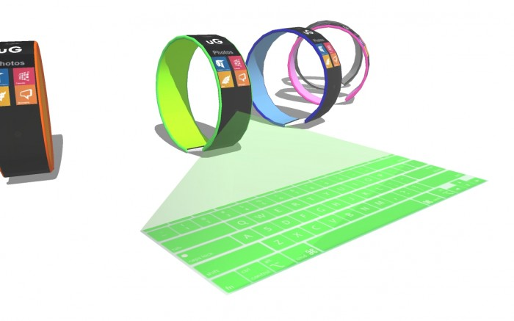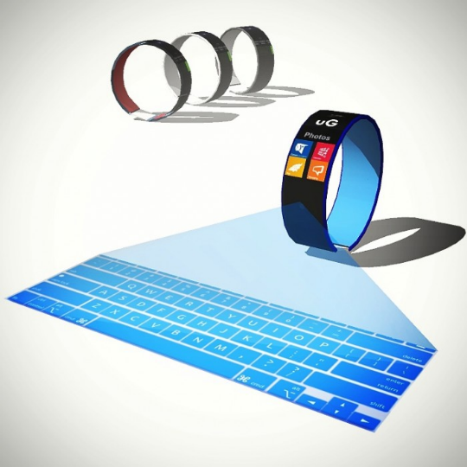

Figure 5&6- Laser keyboard (prefundia.com)

To solve the small user interface problem, the smartwatch will apply the future technology: interactive holographic display. Similar to the laser keyboard, the smartwatch will have a projector to launch a hologram screen upon activating. Users can interact, navigate and operate on the hologram screen just like they do on the touch screen. The function can be turned on via a button or a screen.

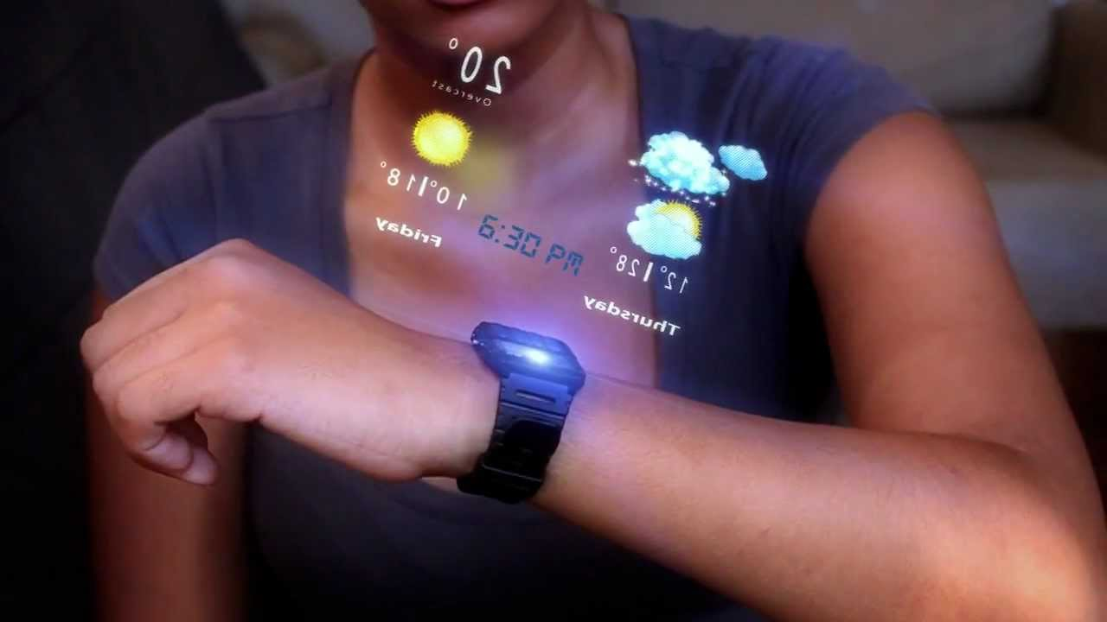

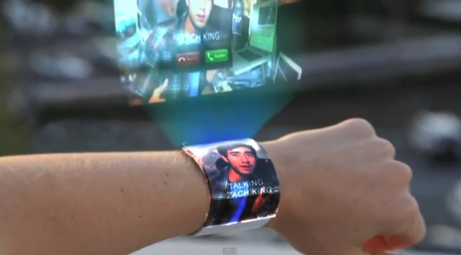

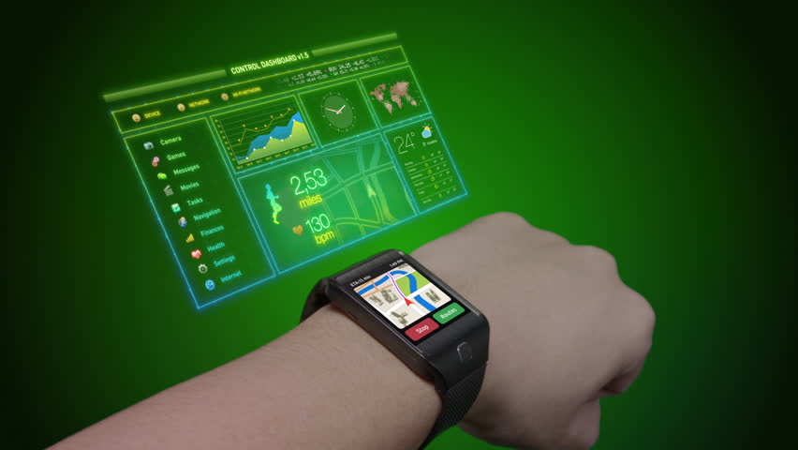

Figure 7,8,9- Hologram display (youtube.com and google.com)

There is another helpful function assist the customers with their exercise process. They can set up the running application right on the device thanks to sensor chips which can track the number of footstep through their activities. People usually move their arms when they are running, it is natural reflex of human. This movement create an oscillation while they are doing exercise. The chips can track the movement, then it will announce the lost calories to users. GPS is also crucial as it can show the location of the customers and even present a map on the screen of the device if the owners need to find the direction.

People may not see clearly on current smartwatches because their screens are quite small compared to other devices such as mobile phone or tablet. However, with the application of graphene material, bendable and wearable wide, high-resolution screen is a possibility. Along with holographic display, the screen can be a means of interaction.

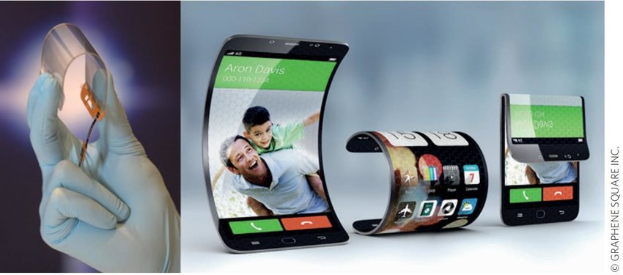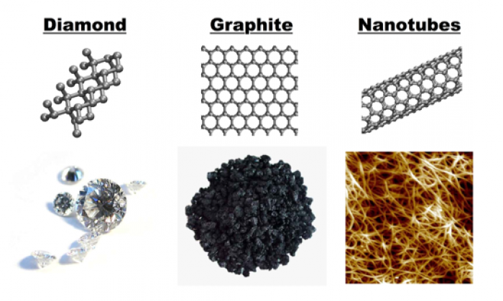

Figure 10&11- Graphene material and screens (ResearchGate.net)

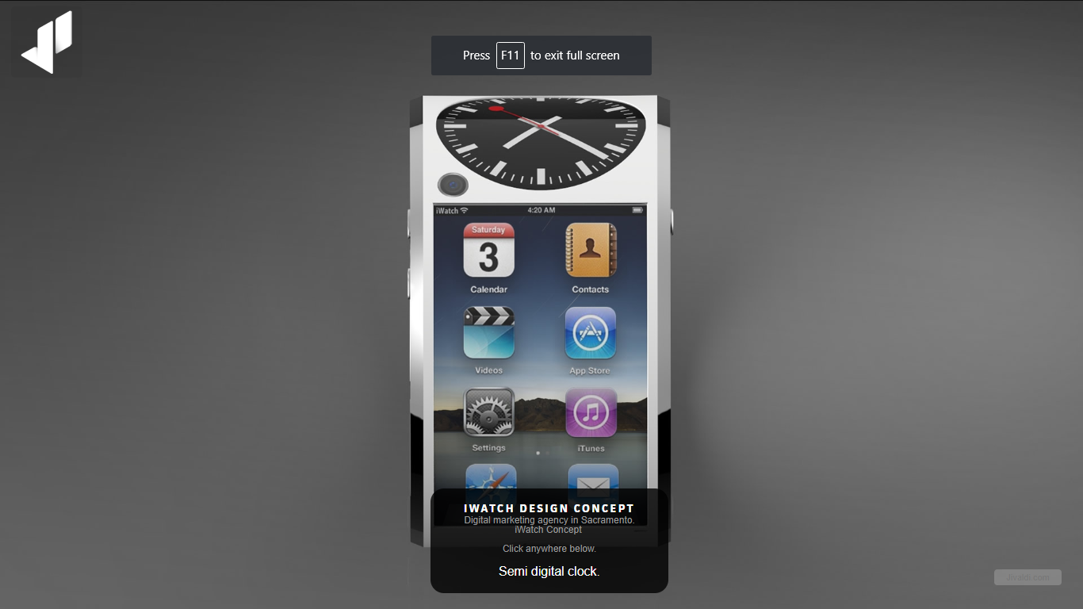

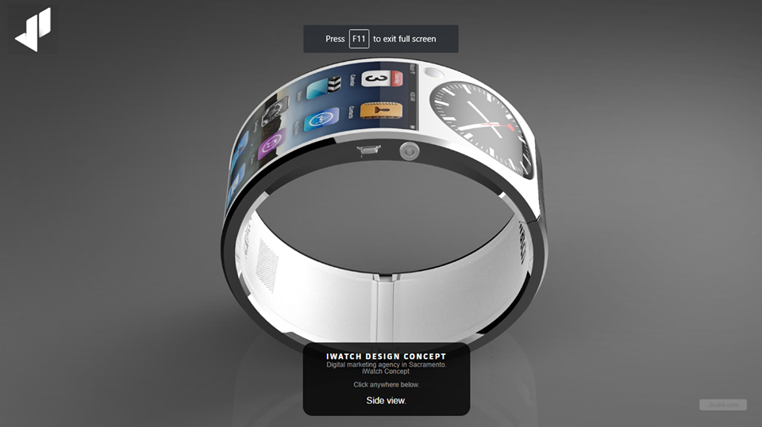

Figure 12&13- Smartwatch prototype

People may worry about the battery because this watch contains many functions inside it. It is annoying because the users have to charge their devices many times. The longest smartphone battery life in 2018 is 16 hours 46 minutes (Michaels, 2018) while that of the smartwatch is 30 days (Shafee, 2017). Thus, it would be the best if we can combine smartphone’s functions with smartwatch long battery life so regular charging would not be so annoying. Our product will incorporate several technologies to address this issue. First, we suggest using solar charging technology which is still in development. However, the possibility of it is high with one company build a solar smartwatch called Lunar (Kickstarter, 2017). The second solution is adding power saving mode seen regularly in many current devices. This technology is easily available as it is already installed in many devices. Third, wireless charging is becoming popular since it charges technical devices faster. Users just need to put the device on the charger instead of plugging a chain of cable into the device. The energy will be transferred through electromagnetic induction, converted into electricity and feed to the receiver. This charger is portable and very convenient as it can save time for the customers. However, manufacturer should also make a different charger for the smartwatch. A small hole is designed on the watch’s back where the users can put the cable to receive energy. Combining all mentioned solutions, our smartwatch would be able to sustain a sufficient battery life to make users comfortable.

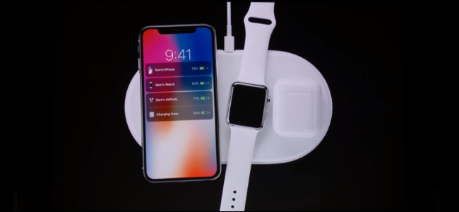

Figure 14- Wireless charger

Finally, the manufacturer wants to protect customer’s devices at high level. People often forget to take their watch off before washing their hand or taking shower. Sometimes, people may carelessly drop their device into liquid substances which may damage the equipment, even completely break it if serious. Thus, our smartwatch use IP68 standard material (Levenson,2018). This allow electronic technology equipment to prevent water seeping into the itself, and to stay working in liquid environment. Therefore, consumers will feel more comfortable and they do not need to worry when their electronic devices are influenced by liquid.

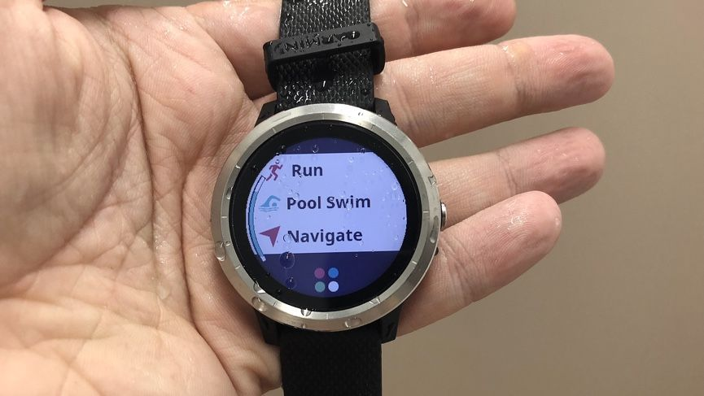

Figure 15- Waterproof watch

## Part 4: SWOT Analysis of Smartwatch:

Our smartwatch aims to be an omnipotent device which incorporate everything from smartphone, watch, mini computer to wallet, credit card, personal id, passport. It is a device with high processing capacity, memory and innovative user interface. However, the device still contains several flaws that need attention.

|  |  |
| --- | --- |
| Strength | Weakness |
| -Innovative technologies (interactive holographic screen, big data and blockchain)  -Technological conveniences (multipurpose functions, all-in-one device: banking, commuting cards, ID, passport incorporated)  -Security (financial safety, information safety, surveillance equipment connected by IoT)  -Engaging user interface (3D holographic interactive screen).  - Durability (basically like a bendable smartphone but made from stronger, more flexible and more sensitive material)  - Attached to users almost all the time (little risk of being lost) | - Constraint battery life to sustain many functions.  - Initial high prices due to new technologies, new components not readily available.  - Lack of applicable material for creating and assembling components.  - Internet infrastructure slow to keep up with the network demand and development  - Lack of technological infrastructure to store, process and transmit data.  - Small cameras compared to smartphones’ or cameras in an inappropriate angle that is not easy to take photos. |
| Opportunities | Threats |
| - More durable material developed (graphene), hence better quality.  - The development of interactive holographic display  - Internet of Things developing rapidly  - The invention and application of blockchain technology.  - The development of big data technology  - The rapid development of Industry 4.0 in international community.  - The trend of governments to build smart countries/cities.  - The development of RFID, fast mobile network (4G, 5G) | - Security risks (important personal,financial, health data can be hacked or stolen)  - Data power abuse (companies and governments with information can take advantages of customers)  - Smartphones still dominating the current market with regular users and high quality cameras. |

# III. Conclusion:

In conclusion, based on the current and future technology trends as well as the demand of society, we believe that our smartwatch is a product that would be born out of necessity and creativity. It will embody the perspective of a better, more developed and more comfortable life.

IV. Reference list:

Apple Support. (2018). “*Work out with your Apple Watch”*. [online] Available at: <https://support.apple.com/en-us/HT204523> [Accessed 23 Apr. 2018].

Apple Support. (2018). “*How to use your Apple Watch without your iPhone nearby”*. [online] Available at: <https://support.apple.com/en-gb/HT205547> [Accessed 25 Apr. 2018].

Agarwal, T. (2017). “*Bluetooth Basics - How Bluetooth Works: Applications and Advantages”*. [online] ElProCus - Electronic Projects for Engineering Students. Available at: <https://www.elprocus.com/how-does-bluetooth-work/> [Accessed 24 Apr. 2018].

Bouvier, E. (n.d.). “*A Large Scale Interactive Holographic Display”*. [online] https://pdfs.semanticscholar.org. Available at: <https://pdfs.semanticscholar.org/47b6/48509f1bc0242987cf17049a726ac28ec89d.pdf> [Accessed 22 Apr. 2018].

Cakebread, C. (2017). “*One chart shows Apple dominating the smartwatch market”*. [online] Business Insider Australia. Available at: <https://www.businessinsider.com.au/apple-watches-are-dominating-the-wearable-marketcharts-2017-9> [Accessed 21 Apr. 2018].

Horst Krah, C. (2011). “*US8847919B2 - Interactive holographic display device - Google Patents”*. [online] Patents.google.com. Available at: <https://patents.google.com/patent/US8847919B2/en> [Accessed 23 Apr. 2018].

Hoffman, C. (2017). “*How Does Wireless Charging Work?”*. [online] Howtogeek.com. Available at: <https://www.howtogeek.com/162483/no-more-cables-how-wireless-charging-works-and-how-you-can-use-it-today/> [Accessed 23 Apr. 2018].

McCann, A. (2012). “*Okay, but how do touch screens actually work? » Scienceline”*. [online] Scienceline. Available at: <http://scienceline.org/2012/01/okay-but-how-do-touch-screens-actually-work/> [Accessed 23 Apr. 2018].

Macro, A. (2017). “*How to make and take calls on Apple Watch*. [online] Macworld UK”. Available at: <https://www.macworld.co.uk/how-to/apple/guide-phone-calls-on-apple-watch-3607555/> [Accessed 23 Apr. 2018].

Oled-info.com. (2018). “*Flexible OLED | OLED-Info*.” [online] Available at: <https://www.oled-info.com/flexible-oled> [Accessed 23 Apr. 2018].

Prefundia.com. (2017). “*#uGear - the first smartwatch with holographic keyboard and graphene adaptable body | Prefundia*.” [online] Available at: <http://prefundia.com/projects/view/ugear-the-first-smartwatch-with-holographic-keyboard-and-graphene-adaptable-body/3203/> [Accessed 23 Apr. 2018].

Sawh, M. (2018). “*The best waterproof fitness trackers and watches for swimming*.” [online] Wareable. Available at: <https://www.wareable.com/fitness-trackers/the-best-waterproof-fitness-trackers-796> [Accessed 20 Apr. 2018].

Square. (2017). “*What Are Mobile Payments? And How to Use Them*.” [online] Available at: <https://squareup.com/guides/mobile-payments> [Accessed 23 Apr. 2018].

Thomas J., W. (2016).”*Interactive three-dimensional holographic displays: seeing the future in depth” [online] Available at:* <http://citeseerx.ist.psu.edu/viewdoc/download?doi=10.1.1.7.5610&rep=rep1&type=pdf> [Accessed 23 Apr. 2018].

TigerMobiles(2016). “*Evolution of the Mobile Phone - From Simple To Smart*.” [online] Available at: <https://www.tigermobiles.com/evolution/#fourthPhone> [Accessed 25 Apr. 2018].

Tilley, A. (2015). “*The Apple Watch Sport Only Costs $83.70 To Make”* [online] Forbes.com. Available at: <https://www.forbes.com/sites/aarontilley/2015/04/30/the-apple-watch-only-costs-83-70-to-make/#480e0d502f08> [Accessed 24 Apr. 2018].

Wang, G. (2016). “*Field reconstruction of holograms for interactive free space true three dimensional display”*. [online] Available at: <https://arxiv.org/ftp/arxiv/papers/1706/1706.03231.pdf> [Accessed 22 Apr. 2018].

WHITNEY, L. (2015). “*Lenovo teases smartwatch, virtual keyboard and smart shoes”*. [online] CNET. Available at: <https://www.cnet.com/news/lenovo-teases-smartwatch-virtual-keyboard-and-smart-shoes/> [Accessed 24 Apr. 2018].

Woodford, C. (2017). “*How does Wi-Fi wireless Internet work?”*. [online] Explain that Stuff. Available at: <http://www.explainthatstuff.com/wirelessinternet.htm> l [Accessed 23 Apr. 2018].

Yamaguchi, M. (2017). “*Full-Parallax Holographic Light-Field 3-D Displays and Interactive 3-D Touch - IEEE Journals & Magazine”*. [online] Ieeexplore.ieee.org. Available at: <https://ieeexplore.ieee.org/document/7831483/> [Accessed 23 Apr. 2018].

A, J 2017, 'The iPhone X Costs $999. Here’s How Much Apple Spends to Make One', *Time*, viewed May 28, 2018, <<http://time.com/money/5014941/iphone-x-cost-price/>>.

Bimber, O, Zeidler, T, Grundhöfer, A, Wetzstein, G, Moehring, M, Knoedel, S & Hahne, U 2005, *Interacting with augmented holograms*, viewed May 28, 2018.

N.A 2018, *Graphene Price*, viewed May 28th, <<https://www.graphenea.com/collections/buy-graphene-films>>.