**RMIT University**

**ASSIGNMENT COVER PAGE**

Your assessment will not be accepted unless all fields below are completed

|  |  |
| --- | --- |
| **Subject Code:** | COSC2083 |
| **Subject Name:** | Introduction to Information Technology |
| **Location where you study:** | Saigon South Campus, Ho Chi Minh city, Vietnam |
| **Title of Assignment:** | Introduction to Information Technology Assignment 2 |
| **File(s) submitted**: |  |
| **Student name:** | Bui Hoang Quan  Tran Quang Huy  Le Ti  Huynh Van Khai |
| **Student Email Address:** | s3577543@rmit.edu.vn  s3680599@rmit.edu.vn  s3650990@rmit.edu.vn  s3618637@rmit.edu.vn |
| **Learning Facilitator in charge:** | Thanh Nguyen Ngoc |
| **Assignment due date:** | 29/04/2018 |
| **Date of Submission:** | 29/04/2018 |
| **Number of pages including this one:** | 20 |
| **Word Count:** | 3500 |

Contents

I. Introduction: 3

II. Product Analysis: 3

Part 1: Feasibility and cost 3

Part 2: Competitors and users 7

Part 3: How will the product work 8

Part 4: SWOT Analysis of Smartwatch: 16

III. Conclusion: 17

# I. Introduction:

In this assignment, our group has chosen Apple as the company for us to base our idea on. Since Apple has traditions and experiences in developing smart products such as the iPhone, iWatch, and iPad, it is the most suitable company that our team can base our designs on. Furthermore, as Apple is dominating the smartwatch market (Cakebread, 2017), with cutting-edge technologies, designs, and features, it is the best company that has the capacity to make our vision a reality.

# II. Product Analysis:

## Part 1: Feasibility and cost

In this modern world, the development of any creation will be useful for humanity and can be the key that opens a new path for humanity. However, we are all curious about the feasibility and the price of the product so that everyone can use it worldwide and enhance the living standard of our lives. As for that reason, my team will also prove how realistic this ultimate smartwatch can become. By focusing on four key aspects: feasibility, convenience, timeframe, and cost, we can then demonstrate to all our customers the undeniable demand and potential usefulness of this invention in the near future.

Firstly, we will discuss the utility and the need for this product in a couple of years from now on. With lots of pioneering companies like Apple making similar products, a smartwatch is a well-known gadget that appears as a popular trend all around the world nowadays. Therefore, building a product based on those watches, along with some improvements, is absolutely possible in the near future. Additionally, people nowadays have lots of essential possessions that they need to carry every day, including licenses, credit cards, cash, and phones. All of them are easy to get lost due to their size in spite of their importance. Furthermore, by having lots of property, there is even a higher chance that we will get ourselves in more danger with all kinds of robbers following around. As for that reason, we need an invention that can combine all of those things above and merge them as one. To answer the demands of humanity, this ultimate smartwatch is a bridge that links the present smartwatch to all other tools and equipment that serve all human's purposes as it inherits new technologies from the present day. Additionally, we can easily keep it in our possession as it is always attached to our hand, so crime will be less of a problem for us to deal with. Currently, companies have already developed and incorporated various functions into smartphones to better serve customers with applications being more and more multifunctional. While in Korea, people have Samsung Pay that can replace credit cards and banking services, WeChat in China is an almost omnipotent application that can assist users in every aspect of their lives, not just for communication and payments. As this trend continues, we may see people replace their personal assets (ID, passport) with digital versions for both convenience and security. Therefore, the multifunctional smartwatch will eventually exist in the near future with highly need without any doubt.

Secondly, on our way to creating this prototype, many testers have considered how effectively it can work with existing technology. "In our team's point of view, there is absolutely no suspicion on how this is the connection of various current and future technologies." (mobile technology, mobile application, IoT, blockchain and hologram display). For a related creation, we will take the Apple Watch as an example. According to Apple's support website, you can make Siri begin a workout which also includes checking your movement with accurate statistics during the exercise by simply raising the watch on your wrist. These statistics contain the distance, time, and your heartbeat, as well as the calories that were burned during your training. Therefore, the watch possesses the crucial health technology that improves the quality of our standard lives. Another example is that it can also be used to make a phone call or text. Based on Ashleigh Macro's article on Macworld, the watch connected to your iPhone will make and respond to phone calls within the range of your phone or as long as your watch connects to a network (Said in Apple support). By then, you can choose to answer it through your phone with a built-in speaker and microphone or decline it without pulling your phone out in an inappropriate timing such as during a meeting. The technology has now been developed further with the watch replacing the phone, being the main means of communication (Apple). (com). With the current smartwatch technology, all the basic functions seem to completely resemble smartphones (with operating system, applications). In the near future, we can expect various means of communication in the smartwatch, not just normal messaging or calling, but applications (Skype, Viber) as well. For those reasons, it can be easily pointed out that smartwatches are also linked with communication technology. Communication is not the only similarity between smartphones and smartwatches. In the future, we can see the border between the two devices getting blurrier with Shell being an example (Dormehl, 2018). As technology advances, progress in smartwatches' capacity can be on par with smartphones with similar operating systems and applications. The big differences between the two right now are processing capacity (RAM) and user interface, which we are going to stress. As the current watch hardware is now quite small compared to smartphones, it is hard to fit all components (chips, processors) into it like smartphones. However, many companies have invested in bendable smartphones, and some have even introduced prototype models (Moxi) using graphene material (Yan, 2016). Thus, we can see that a wearable smartphone or smartwatch with better processing capacity is a possibility. For user interface, besides the widened screen from graphene, our smartwatch will also incorporate an interactive holographic display that functions as a large screen. Currently, Apple already has a patent for this technology, meaning the feasibility of incorporating it is not far-off. With all of those sharp features drawn out, our new invention inheriting all of those features will surely satisfy all of our guests' requirements.

Thirdly, an estimated timeframe for when this smartwatch will become economically viable and fully grown enough to be mass-produced is also a factor that needs to be taken into account so that we can have a more realistic view of what will happen. In order for us to predict the time of getting the high-tech smartwatch that is great and reasonable enough to build, I will borrow a timeframe of how the mobile phone turns into a smart one. As stated in Tiger mobile's "Evolution of mobile phone" article, the mobile phone has spent about 30 years since 1983 when the world got its first portable phone to become a smartphone today. However, we can easily notice that we only needed about 10 years to modify the full-function cellphone into a smartphone from 1999 to 2007 when Steve Jobs introduced the phone with screen interaction. As mentioned, the interactive hologram technology device patent is now owned by Apple, which means the watch can be technically designed. Moreover, the bendable smartphone was invented by Moxi in 2016. The difficulties right now are combining the two technologies to create a hologram smartwatch, synchronizing data and applications to suit the holographic interface, and applying blockchain and IoT applications into the device. While the two former are not yet widely available, we can already see the third problem being solved (Samsung Pay, WeChat). Considering the speed of our technical evolution, we can apply all of it to this smartwatch and complete this creation in less than 10 years and have a price as good as a smartphone nowadays.

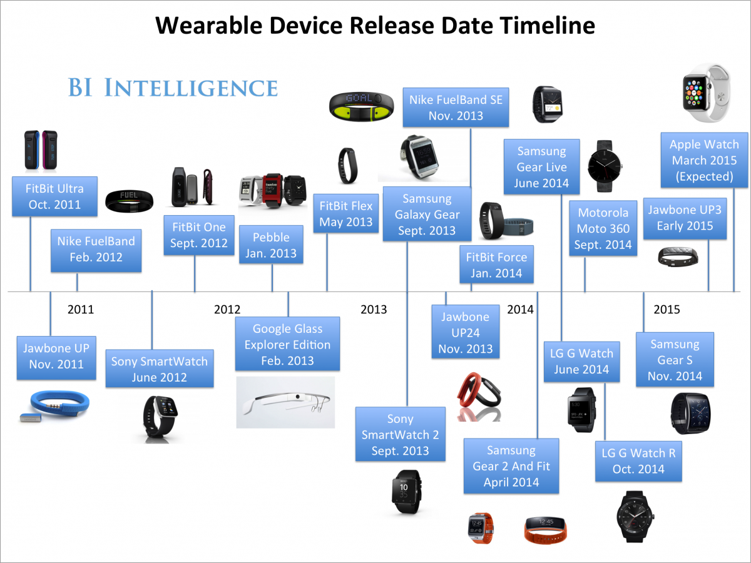

Figure 1- Smartwatch timeline (UK Business Insider)

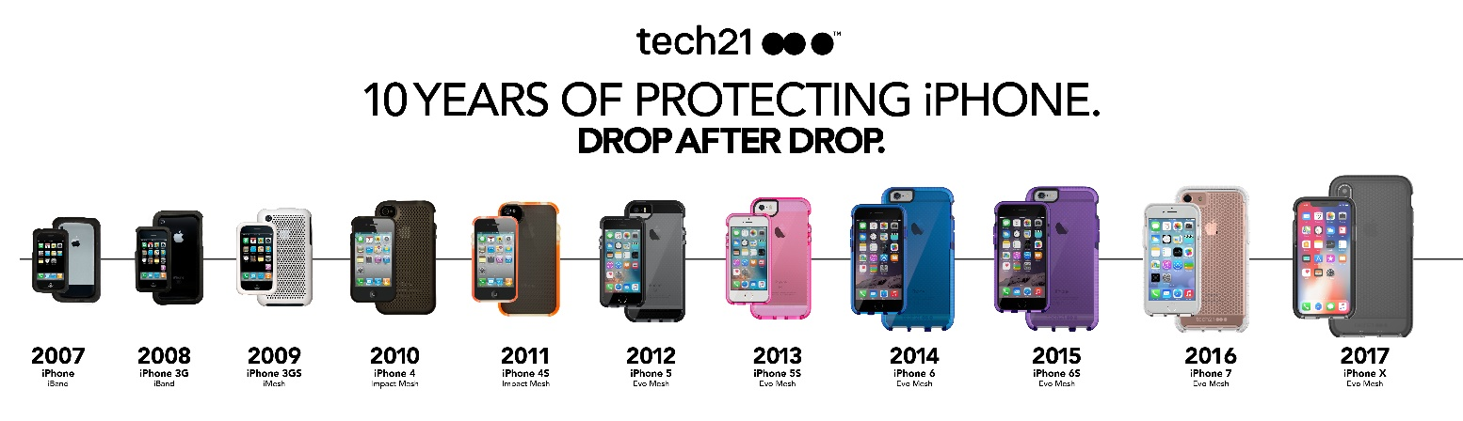

Figure 2- Apple iPhone timeline (Tech21)

Finally, the most important fact of all is that the invention that we cannot avoid is the cost of getting the prototype to become real. Base on Aaron Tilley’s “The Apple Watch Sport Only Costs $83.” 70 to make” article on Forbes page, who is also one of the page’s staff, stated that the research firm reported that the Apple watch only costs $83.70, which is only about one quarter the watch’s retail price. Also, they stated that the most expensive part of this multi-functional watch is only cost about $21, which is the OLED display and the ION-X cover glass. After taking it as an example, we can clearly see that the cost of creating the original smartwatch is not too high compared to all other technology stuff. However, because this multi-feature watch also merges with other technologies, it might cost higher for us to research the way to integrate all of those complicated technologies in one device. The hologram technology is still in development, and the graphene material price is still high, around $100 per film (Graphenea). As the smartwatch is actually a bendable smartphone, its manufacturing process will be similar to those of smartphones. Currently, a typical iPhone X costs $370. 25 (Jenkins, 2017), not accounting for manufacturing and software. If we estimate all the smartphone fees, it should be around $450. As our base company is Apple, it would properly cost the same to produce a multifunctional smartwatch. In the future, there might be a chance that every present emerging technology will have matured enough for our project to have a more budget-friendly price as the speed of technological shift has been lifted to another height recently. For all the reasons stated, there might be a great chance that we will be able to create a multi-functional smartwatch with nearly the same price or a little bit higher than the price of the recent smart devices.

In conclusion, with all four aspects having been proven to be achievable in the near future, we have demonstrated that this product will undoubtedly be in high demand because it meets all of our customers' current needs for high-tech products. This is the super gadget that all of us need to solve most of our issues within the reach of our hands.

## Part 2: Competitors and users

Assessing current smart devices and Apple capacity, we believe that our product could succeed. To be more specific, customers need a device that includes everything they need, such as a phone, wallet, watch, camera, and so on. This device can make them less likely to forget it. Therefore, we need a technology device that combines all of those things above and merges them as one, and a smartwatch will be their best choice. Firstly, the Samsung Gear S smartwatch - priced around $240 - boasts many features, including receiving calls, texting messages, and using a SIM for 3-4G connectivity, as well as wireless connectivity. Additionally, the Samsung Gear S can calculate Second, the Apple watch from Apple is sold for $349$. This gadget can be waterproof and has GPS integration. By the way, it can support LTE through a sim, and it can make and receive calls and texts just like an iPhone. Additionally, the Apple watch has a camera And finally, the Smartwatch SWR50 from Sony is available for $280. This Sony product boasts a large battery that can last up to 2 days, it can also be used as an MP3 player for music, it has good waterproof capabilities, and it comes with integrated G Moreover, apps for texting, social networking, and news from your phone will be synchronized automatically with this smartwatch. Therefore, a smartwatch that inherits all features of a smartwatch like the iWatch and develops new features that have never appeared on a smartwatch before, and the price is adoptable for everyone, including normal class or low-income people, will become the most desirable product. As a consequence, our smartwatch will make big technology companies recognize a real threat in occupying market share at normal and low-end classes. In addition, smartwatch is becoming a global trend, so the demand will be large. However, not everyone has the ability to buy a smartwatch from big technology companies like Apple and Samsung with a high price out of their reach. In the other hand, our products are expected to break conceptions about high technology devices belonging to rich people and bring high technology for everyone, regardless of who they are and what they do. Our smartwatch can follow and give advice about health for owners based on their calories and blood pressure. This is a special feature that sets our products apart from other smartwatches.

## Part 3: How will the product work

Every customer has the same concern about how the product works. Therefore, the purpose of this part is to guide customers on how to use the product effectively. There are various aspects that are included in this device: connectivity, applications, and interface.

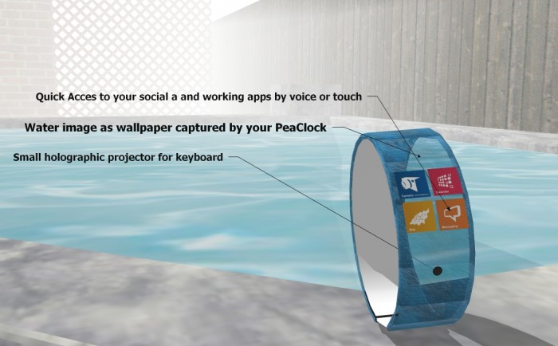

Figure 3- A model smartwatch (Prefundia)

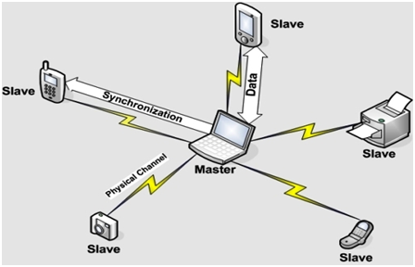Firstly, Wi-Fi is a compulsory function because they need Wi-Fi to connect to the Internet, which supplies the demand for searching/uploading information and entertainment. Thus, we integrated these features into the design of this device. The smart watch will communicate with the signal that is transmitted through the router. The transmitter will release the Wi-Fi waves that travel through the air and connect to the receivers. However, this connection is the same as any other technical device because it is unable to attach well certainly when both devices are separated far apart from each other. Furthermore, it comes with 8GB of Ram (compatible with future technology), Bluetooth, and NFC, therefore, customers can easily share or store information in a short range. This feature is able to be used by every client by turning on these modes as Bluetooth at both devices and then sending the information to any other technical devices such as laptops or mobile phones where the data will be kept. There is a similarity between these aspects, so they also turn on the Wi-Fi in order to surf the Internet.

Thanks to the Internet, our smartwatch can function as an omnipotent device with the features of cloud computing, IoT, and blockchain technology. With the development of such solutions, the watch can store important data such as personal ID, credit/debit card, commuting card, and even pass The perfect examples are the Samsung Pay or Alipay application, or WeChat, which enables users to do everything from booking services to social networking to shopping. With advanced technologies, users can do so much more, such as traveling around without stopping to pay or even storing important information like degrees or passports using blockchain technology. Such applications will enable users to travel seamlessly without being halted. All they need to do is swipe their watch on the scanners and proceed.

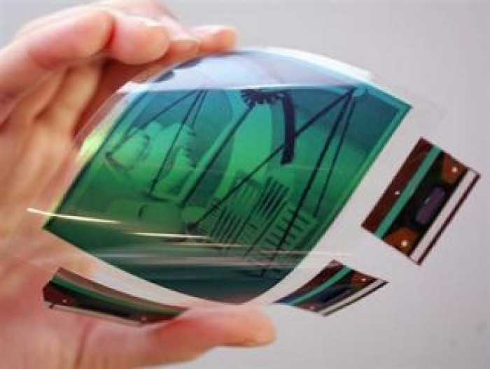All of our technological products involve touch screens, and that is quite useful because it allows people to interact with the display using their fingers. Besides that, the screen is made from a thin, flexible glass that suits with the watch (graphene).

Figure 4 - Graphene material (prefundia. (com)

There is a special way to open or interact with the device, users just need to tap on the screen two times to activate it. There are reasons for choosing a flexible display. Firstly, it will fit the wrist size of the customers, as each person's wrist size is different. In case, the customer is thin, so they can roll it a little bit in order to suit them. There is a big difference in equipment between the smart watch with the original one. The customer does not need to manipulate the strap to adjust the size correctly. It might be more convenient for customers when they simply put the watch on their wrist and roll it into the right size for themselves.Secondly, there is a small circular button on the top of the device. Its function is to simulate a laser keyboard, so consumers can use it for typing or writing long sentences.

The customer may be curious about where the light laser comes from. It emits light from the camera, which is located on this technological product. Moreover, it's not only a functional aspect of the camera, it can also be used to take photos.

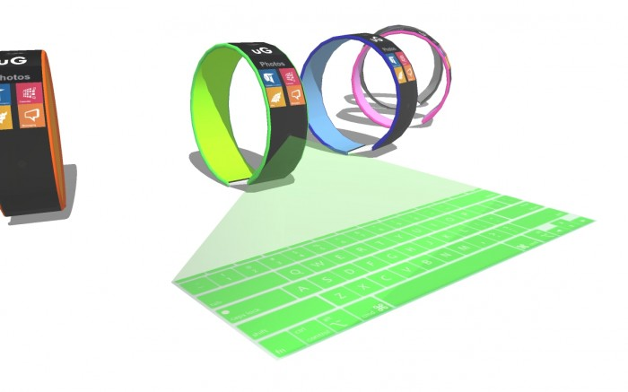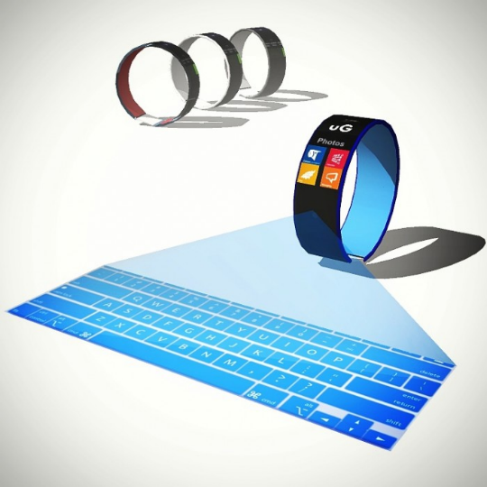

Figure 5&6 - Laser keyboard (pre-funded.) (com)

To solve the small user interface problem, the smartwatch will apply the future technology: interactive holographic display. Similar to the laser keyboard, the smartwatch will have a projector to launch a hologram screen upon activating. Users can interact, navigate, and operate on the hologram screen just like they do on the touch screen. The function can be turned on via a button or a screen.

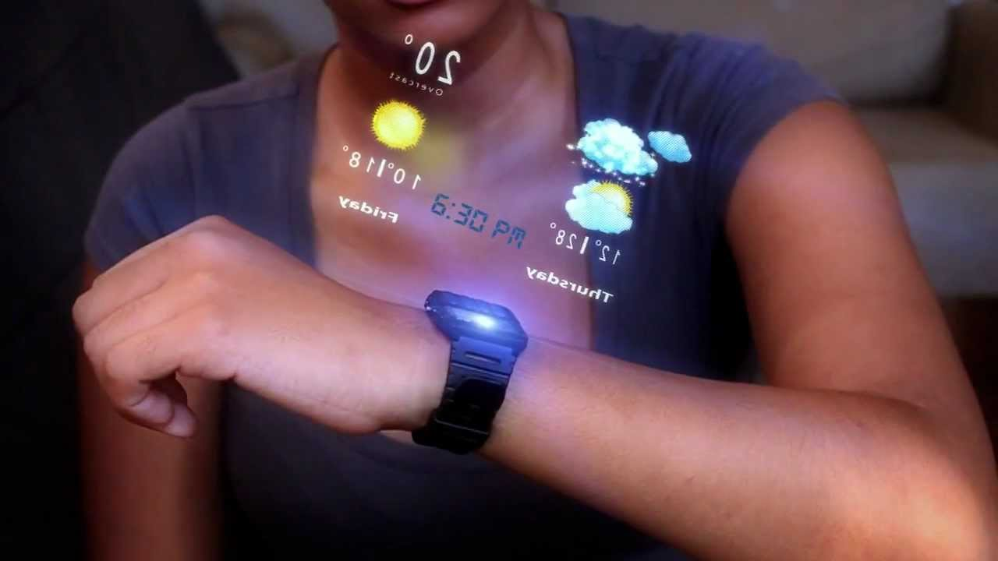

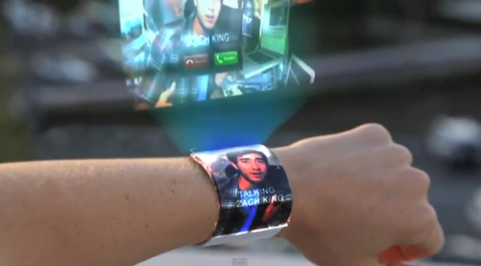

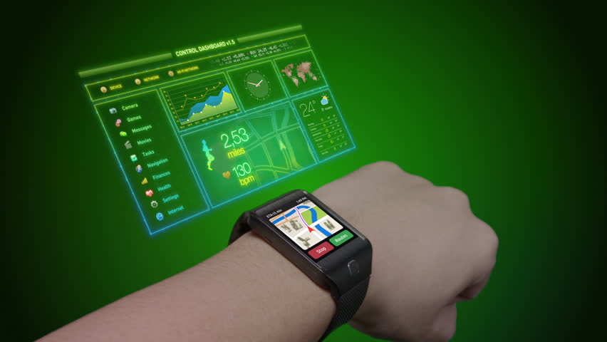

Figure 7, 8, 9 - Hologram Display (YouTube) Come and Google. (com)

There is another helpful function that assists customers with their exercise process. They can set up the running application right on the device thanks to sensor chips that can track the number of footsteps through their activities. People usually move their arms when they are running, which is a natural reflex of the human body. This movement creates an oscillation while they are doing exercise. The chips can track the movement, then it will announce the lost calories to users. GPS is also crucial as it can show the location of customers and even provide a map on the screen of the device if the owners need to find directions.

People may not see clearly on current smartwatches because their screens are quite small compared to other devices such as mobile phones or tablets. However, with the application of graphene material, bendable and wearable wide, high-resolution screens are a possibility. Along with holographic displays

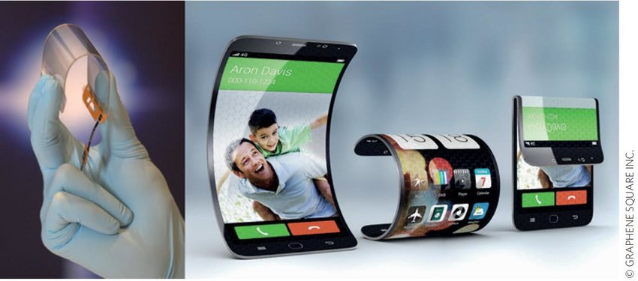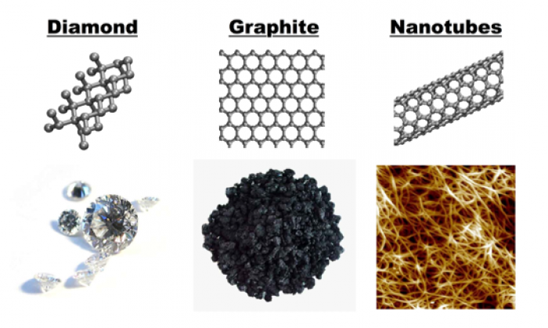

Figure 10&11 - Graphene material and screens (ResearchGate.) The correct English is:

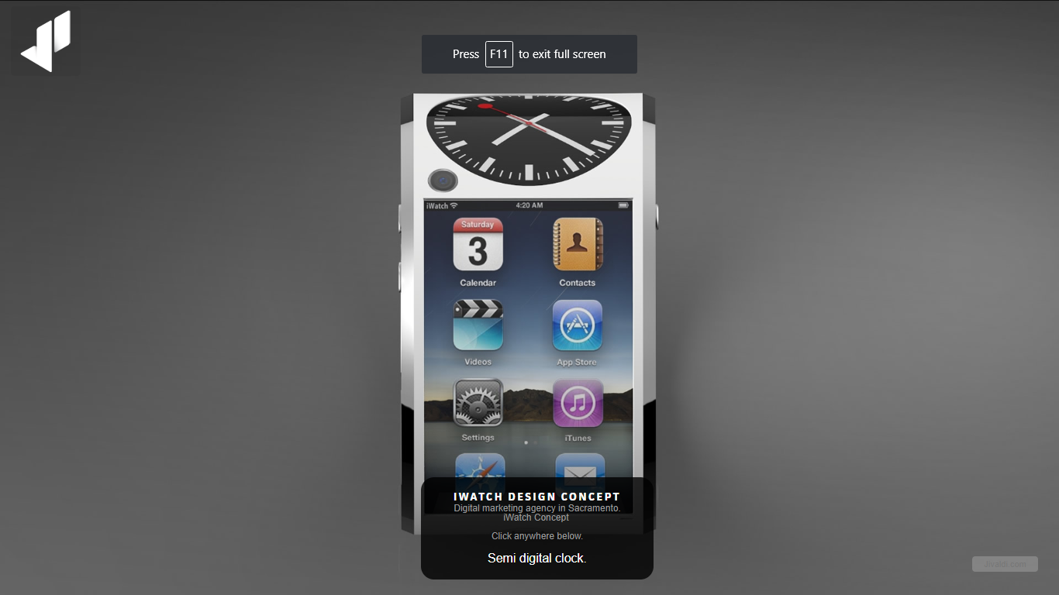

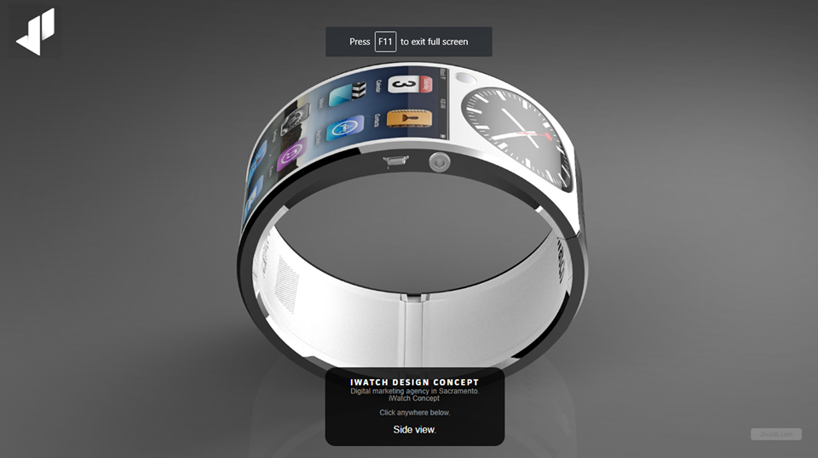

Figure 12&13- Smartwatch prototype

People may worry about the battery because this watch contains many functions inside it. It is annoying because users have to charge their devices many times. The longest smartphone battery life in 2018 is 16 hours 46 minutes (Michaels, 2018) while that of the smartwatch is 30 days (Shafee, 2017). Thus, it would be best if we could combine smartphone functions with smartwatch long battery life, so regular charging wouldn't be so annoying. Our product will incorporate several technologies to address this issue. First, we suggest using solar charging technology, which is still in development. However, the possibility of it is high with one company building a solar-powered smartwatch called Lunar (Kickstarter, 2017). The second solution is adding a power-saving mode that is seen regularly in many current devices. This technology is easily available as it is already installed in many devices. Third, wireless charging is becoming popular since it charges technical devices faster. Users just need to place the device on the charger instead of plugging a chain of cables into the device. The energy will be transferred through electromagnetic induction, converted into electricity, and fed to the receiver. This charger is portable and very convenient, as it can save time for the customers. However, the manufacturer should also make a different charger for the smartwatch. A small hole is designed on the watch's back where users can put the cable to receive energy. Combining all mentioned solutions, our smartwatch would be able to sustain a sufficient battery life to make users comfortable.

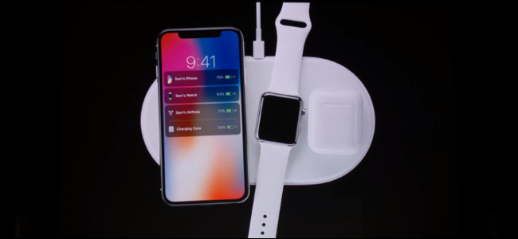

Figure 14- Wireless charger

Finally, the manufacturer wants to protect customers' devices at a high level. People often forget to take their watch off before washing their hands or taking a shower. Sometimes, people may carelessly drop their device into liquid substances, which may damage the equipment or even completely break it if the damage is severe. Thus, our smartwatch uses IP68 standard material (Levenson,2018). This allows electronic technology equipment to prevent water from seeping into it, and to stay working in liquid environments. Therefore, consumers will feel more comfortable knowing that their electronic devices are not influenced by liquid.

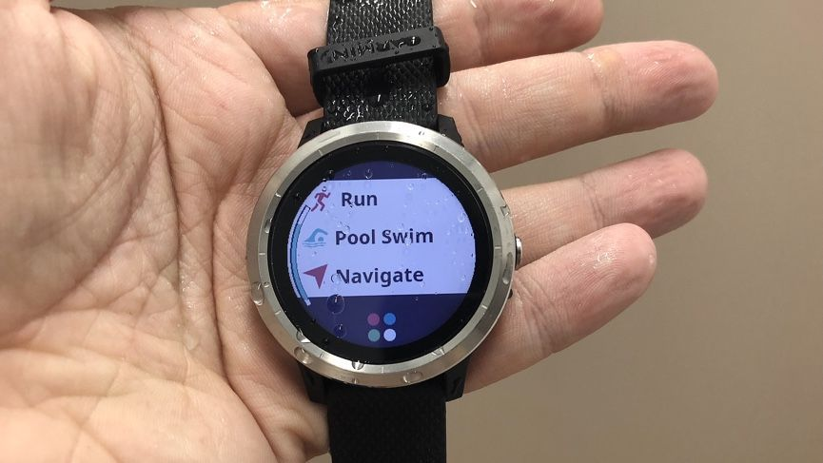

Figure 15- Waterproof watch

## Part 4: SWOT Analysis of Smartwatch:

Our smartwatch aims to be an all-powerful device, incorporating everything from a smartphone, watch, mini computer, to wallet, credit card, personal ID, and passport. It is a device with high processing capacity, memory, and innovative user interface. However, the device still contains

|  |  |
| --- | --- |
| Strength | Weakness |
| -Innovative technologies (interactive holographic screen, big data and blockchain)  -Technological conveniences (multipurpose functions, all-in-one device: banking, commuting cards, ID, passport incorporated)  -Security (financial safety, information safety, surveillance equipment connected by IoT)  Engaging user interface (3D holographic interactive screen).  - Durability (basically like a bendable smartphone but made from stronger, more flexible and more sensitive material)  - Attached to users almost all the time (little risk of being lost) | Constrain battery life to sustain many functions.  Initial high prices due to new technologies and new components not readily available.  - Lack of available materials for creating and assembling components.  - Internet infrastructure slow to keep up with the network demand and development  - Lack of technological infrastructure to store, process, and transmit data.  Small cameras compared to smartphones are or cameras in an inappropriate angle that is not easy to take photos. |
| Opportunities | Threats |
| More durable material (graphene) has been developed, resulting in better quality.  - The development of interactive holographic display  - Internet of Things developing rapidly  The invention and application of blockchain technology.  - The development of big data technology  The rapid development of Industry 4.0 in the international community.  The trend of governments is to build smart countries/cities.  - The development of RFID, fast mobile network (4G, 5G) | - Security risks (important personal,financial, health data can be hacked or stolen)  - Data power abuse (companies and governments with information can take advantages of customers)  Smartphones continue to dominate the current market, with regular users and high-quality cameras. |

# III. Conclusion:

In conclusion, based on current and future technology trends as well as societal demand, we believe that our smartwatch is a product that will emerge from the need for innovation and creativity. It will embody the principles of a better, more developed, and more comfortable life.

IV. Reference list:

Apple Support. (2018). “*Work out with your Apple Watch”*. [online] Available at: <https://support.apple.com/en-us/HT204523> [Accessed 23 Apr. 2018].

Apple Support. (2018). “*How to use your Apple Watch without your iPhone nearby”*. [online] Available at: <https://support.apple.com/en-gb/HT205547> [Accessed 25 Apr. 2018].

Agarwal, T. (2017). “*Bluetooth Basics - How Bluetooth Works: Applications and Advantages”*. [online] ElProCus - Electronic Projects for Engineering Students. Available at: <https://www.elprocus.com/how-does-bluetooth-work/> [Accessed 24 Apr. 2018].

Bouvier, E. (n.d.). “*A Large Scale Interactive Holographic Display”*. [online] https://pdfs.semanticscholar.org. Available at: <https://pdfs.semanticscholar.org/47b6/48509f1bc0242987cf17049a726ac28ec89d.pdf> [Accessed 22 Apr. 2018].

Cakebread, C. (2017). “*One chart shows Apple dominating the smartwatch market”*. [online] Business Insider Australia. Available at: <https://www.businessinsider.com.au/apple-watches-are-dominating-the-wearable-marketcharts-2017-9> [Accessed 21 Apr. 2018].

Horst Krah, C. (2011). “*US8847919B2 - Interactive holographic display device - Google Patents”*. [online] Patents.google.com. Available at: <https://patents.google.com/patent/US8847919B2/en> [Accessed 23 Apr. 2018].

Hoffman, C. (2017). “*How Does Wireless Charging Work?”*. [online] Howtogeek.com. Available at: <https://www.howtogeek.com/162483/no-more-cables-how-wireless-charging-works-and-how-you-can-use-it-today/> [Accessed 23 Apr. 2018].

McCann, A. (2012). “*Okay, but how do touch screens actually work? » Scienceline”*. [online] Scienceline. Available at: <http://scienceline.org/2012/01/okay-but-how-do-touch-screens-actually-work/> [Accessed 23 Apr. 2018].

Macro, A. (2017). “*How to make and take calls on Apple Watch*. [online] Macworld UK”. Available at: <https://www.macworld.co.uk/how-to/apple/guide-phone-calls-on-apple-watch-3607555/> [Accessed 23 Apr. 2018].

Oled-info.com. (2018). “*Flexible OLED | OLED-Info*.” [online] Available at: <https://www.oled-info.com/flexible-oled> [Accessed 23 Apr. 2018].

Prefundia.com. (2017). “*#uGear - the first smartwatch with holographic keyboard and graphene adaptable body | Prefundia*.” [online] Available at: <http://prefundia.com/projects/view/ugear-the-first-smartwatch-with-holographic-keyboard-and-graphene-adaptable-body/3203/> [Accessed 23 Apr. 2018].

Sawh, M. (2018). “*The best waterproof fitness trackers and watches for swimming*.” [online] Wareable. Available at: <https://www.wareable.com/fitness-trackers/the-best-waterproof-fitness-trackers-796> [Accessed 20 Apr. 2018].

Square. (2017). “*What Are Mobile Payments? And How to Use Them*.” [online] Available at: <https://squareup.com/guides/mobile-payments> [Accessed 23 Apr. 2018].

Thomas J., W. (2016).”*Interactive three-dimensional holographic displays: seeing the future in depth” [online] Available at:* <http://citeseerx.ist.psu.edu/viewdoc/download?doi=10.1.1.7.5610&rep=rep1&type=pdf> [Accessed 23 Apr. 2018].

TigerMobiles(2016). “*Evolution of the Mobile Phone - From Simple To Smart*.” [online] Available at: <https://www.tigermobiles.com/evolution/#fourthPhone> [Accessed 25 Apr. 2018].

Tilley, A. (2015). “*The Apple Watch Sport Only Costs $83.70 To Make”* [online] Forbes.com. Available at: <https://www.forbes.com/sites/aarontilley/2015/04/30/the-apple-watch-only-costs-83-70-to-make/#480e0d502f08> [Accessed 24 Apr. 2018].

Wang, G. (2016). “*Field reconstruction of holograms for interactive free space true three dimensional display”*. [online] Available at: <https://arxiv.org/ftp/arxiv/papers/1706/1706.03231.pdf> [Accessed 22 Apr. 2018].

WHITNEY, L. (2015). “*Lenovo teases smartwatch, virtual keyboard and smart shoes”*. [online] CNET. Available at: <https://www.cnet.com/news/lenovo-teases-smartwatch-virtual-keyboard-and-smart-shoes/> [Accessed 24 Apr. 2018].

Woodford, C. (2017). “*How does Wi-Fi wireless Internet work?”*. [online] Explain that Stuff. Available at: <http://www.explainthatstuff.com/wirelessinternet.htm> l [Accessed 23 Apr. 2018].

Yamaguchi, M. (2017). “*Full-Parallax Holographic Light-Field 3-D Displays and Interactive 3-D Touch - IEEE Journals & Magazine”*. [online] Ieeexplore.ieee.org. Available at: <https://ieeexplore.ieee.org/document/7831483/> [Accessed 23 Apr. 2018].

A, J 2017, 'The iPhone X Costs $999. Here’s How Much Apple Spends to Make One', *Time*, viewed May 28, 2018, <<http://time.com/money/5014941/iphone-x-cost-price/>>.

Bimber, O, Zeidler, T, Grundhöfer, A, Wetzstein, G, Moehring, M, Knoedel, S & Hahne, U 2005, *Interacting with augmented holograms*, viewed May 28, 2018.

N.A 2018, *Graphene Price*, viewed May 28th, <<https://www.graphenea.com/collections/buy-graphene-films>>.