Markov decision process

Iteration k

Sk in S

Ak in a

R(Sk, Ak): reward for taking action Ak in state Sk.

P(Sk+1|Sk,Ak): probability of moving to Sk+1 from Sk when action Ak is taken

Value Iteration Algorithm

Q(s,a): expected total reward for taking action a in state s

V(s): maximum expected total reward starting from state s (value function)

V(s) = max(a) Q(s,a)

Steps:

Q value calculation:

Calculates the sum of probabilities multiplied by the sum of immediate rewards and discounted future values for each possible next state.

Correct English in the following text:

This implementation finds the action with the highest Q-value for a given state. If there are ties, it breaks them arbitrarily by choosing the first action with the maximum Q-value.

Utility: sum of reward (of random path)

Policy: connect path to action, yields random path

Discount: save for the future

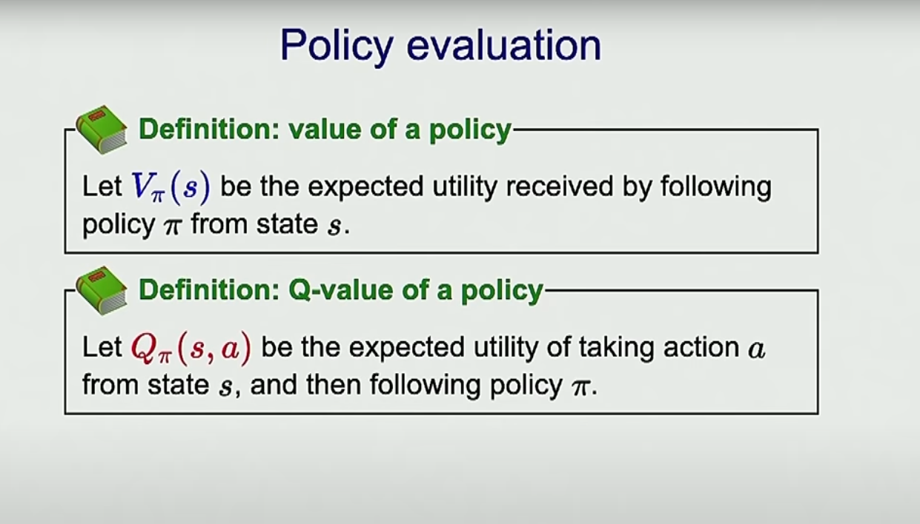

# Q1:

_ set all states to 0

_ loop over all states, get possible action for each state

_ No more action to take, set max value to 0

_Else calculate the q-values for each action in current state, pick the maximum Q value among those values and set that to max value, then stores it in a dictionary

_ Run the loop again, the utility value for each state is updated with the maxmum q value calculated

First loop updating q value based on current policy, second loop updates utility value based on the newly calculated q values

Q value:

Calculates the sum of probabilities multiplied by the sum of immediate rewards and discounted future values for each possible next state.

# Q2: bridge

Refer to the specification, it states that noise means how often an agent ends up in an unintended successor state, which is a probability. Therefore, lowering the accuracy to the intended action to 0.0 is the best way.

# Q3: Policies

a/

# Prefer the close exit (+1), risking the cliff (-10)

# prefer the close exit => focus on immediate rewards => discount to be close to 0 for shorterm focus

No information about moving random, and no need to explore the map => noise not important => noise to 0.0.

1. Risking the cliff - no worries about the fall.

1. And does not require going further => Living reward will not be important => 0.0.

return answerDiscount, answerNoise, answerLivingReward

b/

# Prefer the close exit (+1), but avoiding the cliff (-10)

# prefer the close exit => focus on immediate rewards => discount to be close to 0 for shorterm focus

1. Avoid the cliff.

Need to explore map is already provided in Noise => livingReward can be 0.0.

c/

# Prefer the distant exit (+10), risking the cliff (-10)

# prefer the distant exit => focus on long term reward => discount to be higher and closer to 1

No information about moving random, and no need to explore the map => noise to default => 0.0.

1. Telling the needs to explore a map for long-term reward => set livingReward higher than 0.0.

d/

# Prefer the distant exit (+10), avoiding the cliff (-10)

# prefer the distant exit => focus on long term reward => discount to be higher and closer to 1

1. Avoid the cliff.

1. Telling the needs to explore a map for long-term reward => set livingReward higher than 0.0.

e/

# Avoid both exits and the cliff

No need to win => discount not important => 0.0

needs to avoid cliff and exits => the need to explore is high => more noise to close 1

answerLivingReward = 0.9

is even higher => close to 1

# Q 4:

Model free learning , AI makes own policy by interacting with environment without needing a model beforehand

Q learning = model free learning tech that can be used to find the optiomal policy by using a q function

Computevaluefromqvalue: get q value for each action, then calculate the max q value

ComputeActionFromQValue: store all the action that have same max q value , then pick out a random one

Update: compute temperal difference error, which is difference between the observed reward and the future rewards based on the q values of the next state

Blends current q value with the new information, scaled by learning rate

# Q5:

GetAction: Simulate coin flip with a success probability given by epsilon, if successful randomly select action computed from q value

Use epsilon greedy strat, choose a random option if coinflip unsuccessful, else take the action with highest q value

# Q 6:

# the problem is:

1. # Epsilon is about exploration and exploitation: => Epsilon to 0.0 to be the best because lower the epsilon => more exploitation.

1. Learning rate is about map adaptation and stable learning, which can vary from 0.0 to 1.0.

After trying cases for epsilon = 0.0 and learning from 0.0 to 1, the program can't ...

# => NOT POSSIBLE

# Q7:

Epsilon is positive during training, so Pacman will play poorly even after having learned a good policy: this is because he occasionally makes a random exploratory move into a ghost. As a benchmark, it should take between 1,000 and 1,400 games before Pac-Man's rewards for a 100 episode segment become positive, reflecting that he's started winning more than losing. By the end of training, it should remain positive and be fairly high (between 100 and 350).

def __init__(self, epsilon=0.0): 05) gamma=0. 8, alpha = 0.

"""

These default parameters can be changed from the command line of the Pacman.py program.

For example, to change the exploration rate, try:

python pacman.py -p PacmanQLearningAgent -a epsilon=0.1

alpha - learning rate

epsilon - exploration rate

gamma - discount factor

NumTraining - number of training episodes, i.e. no learning after these many episodes.

# Q8:

First we calculate the approximate q value using the given formula

Then we calculate the difference vector and using that to calculate the weight

# Script:

Bayes' Theorem: is a principle that describes how to update the probabilities of hypotheses given evidence.

Bayesian networks are a graphical tool for applying Bayes' theorem to complex problems involving multiple variables and their dependencies.

Alcohol is the parent node of both heartburn and stomach cancer because it causes both. Stomach cancer is a parent node of heartburn because it does cause heartburn, but heartburn is not a parent node of stomach cancer.

Correct English in the following text:

Lastly, the probability of getting heartburn from drinking alcohol and having cancer. With a 90% chance of heartburn while drinking alcohol and a 60% chance if you only drink alcohol, and an 80% chance if you only have cancer, there is also a 30% chance of getting a heartburn for none of the reasons listed.

Hardworking have no parent node but it causes stress, and stress can cause gastritis, drinking problem and heartburm