SOFTWARE REQUIREMENT SPECIFICATION
Urban Wine ExPress System
– Hanoi, September 2026 –
Table of Contents
Version 1.0 approved 1
I. Record of Changes 3
II. Software Requirement Specification 4
1. Requirement Overview 4
1.1 Context Diagram 4
1.2 User Requirements 5
1.3 System Functionalities 7
2. Functional Specifications 9
2.1 <<Feature/Workflow Name>> 9
2.2 Common Functions 12
2.3 Patron Feature 14
4. Non-Functional Requirements 17
4.1 External Interfaces 17
4.2 Quality Attributes 17
5. Requirement Appendix 17
5.2 Common Requirements 17
5.3 Application Messages List 17
5.4 Other Requirements… 18

I. Record of Changes
Date | A*  M, D | In charge | Change Description
*A - Added M - Modified D - Deleted

II. Software Requirement Specification

1. Requirement Overview

1.1 Context Diagram
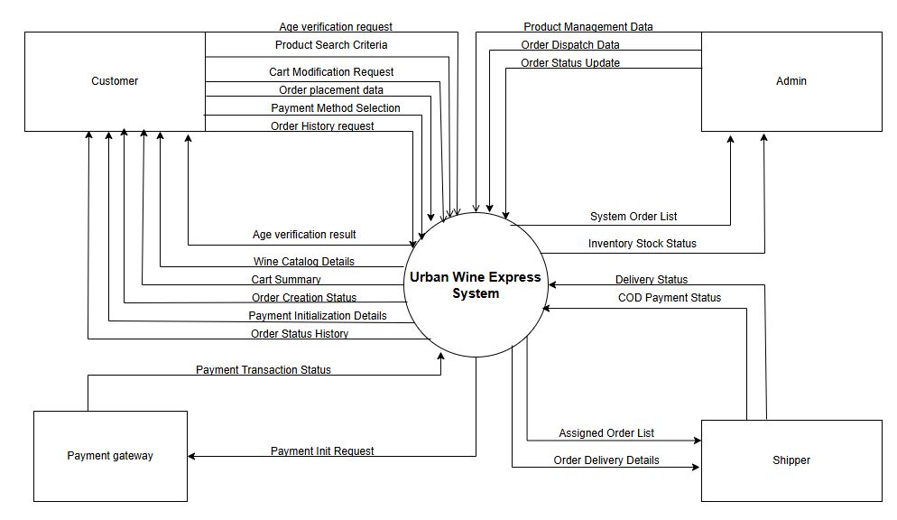

1.2 User Requirements

1.2.1 Actors
# | Actor | Description
1 | Customer (Visitor/Buyer) | A person who visits the website to browse, search, and buy wine. They verify that they are 18 years or older, manage items in their shopping cart, enter delivery address details, select a payment method (VietQR, VNPay, or COD), and track their order history and status.
2 | Admin  (Store Manager) | The store manager who runs the website and business operations. They log in to manage wine products (CRUD details, price, and stock), approve pending orders, assign delivery tasks to shippers, and view inventory stock alerts.
3 | Shipper  (Delivery Person) | Internal delivery staff who delivers wine to local customers. They log in to view their assigned orders, check customer contact and address information, collect cash for COD orders, and update the delivery status (COMPLETED or CANCELLED).
4 | Payment Gateway (External System) | An external automated payment system (such as VietQR or VNPay Sandbox). It receives payment initialization requests from the website, processes transactions, and sends real-time Webhook IPN notifications (SUCCESS or FAILED) back to the system.

1.2.2 Use Cases
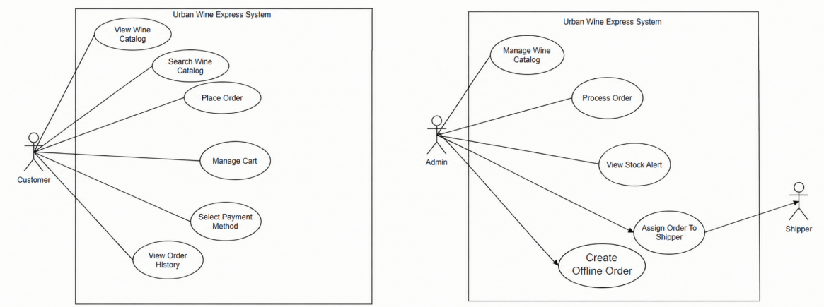

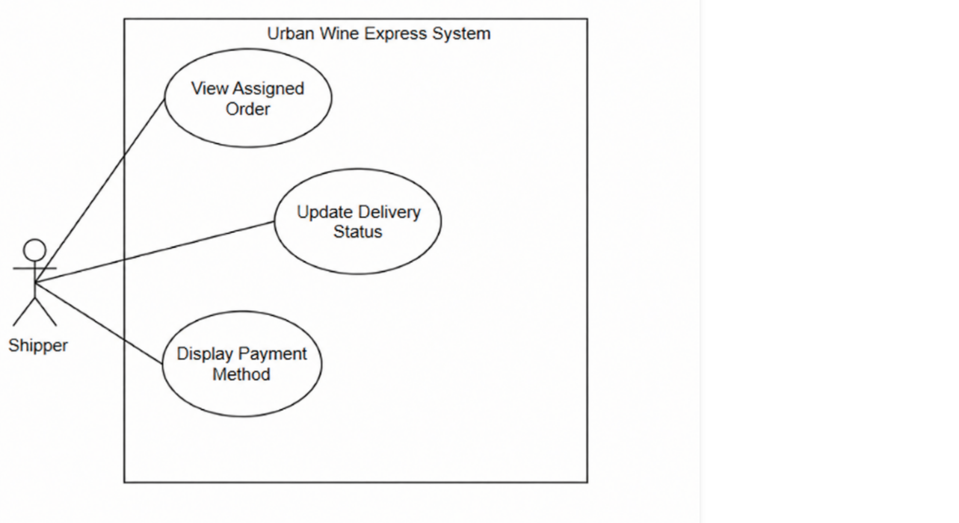
In which
ID | Feature | Use Case | Description
01 | Product Catalog | View Wine Catalog | Allows customers to browse available wines and view product details such as alcohol content (ABV), origin, vintage, price, and stock status.
02 | Product Catalog | Search Wine Catalog | Allows customers to search for specific wines and apply filters by price range, alcohol percentage (ABV), origin country, and wine type.
03 | Cart Operations | Manage Cart | Allows customers to add wine products to their shopping cart, update item quantities, or remove items before checkout.
04 | Checkout | Place Order | Allows customers to enter delivery address, recipient contact information, and submit a new wine purchase order.
05 | Payment | Select Payment Method | Allows customers to choose an intended payment method (VietQR dynamic, VNPay gateway, or Cash on Delivery) to initialize payment.
06 | Order Tracking | View Order History | Allows logged-in customers to view their past orders, check order details, and track real-time delivery status.
07 | Wine Catalog | Manage Wine Catalog | Allows the store manager (Admin) to add new wine items, edit product information (price, ABV, origin), update stock quantities, or delete products.
08 | Order Processing | Process Order | Allows Admin to review pending customer orders, approve them for processing, or cancel orders with an attached reason.
08.1 | Prepaid Order Rejection | Process Order | Allows the Store Administrator to reject an order that has already been paid online. Upon rejection, the system automatically issues a full refund to the customer's original payment method, updates the payment status to 'Refunded', restores the ordered items back to the available product inventory, records a mandatory cancellation reason, and notifies the customer.
09 | Order Delivery | Assign Order to Shipper | Allows Admin to select processed orders and assign them to an available delivery person (Shipper).
10 | Inventory Control | View Stock Alert | Allows Admin to monitor low-stock and out-of-stock wine items to ensure timely inventory replenishment.
11 | Delivery Operations | View Assigned Order | Allows shippers to log in and view a list of delivery tasks and order details assigned to them by the Admin.
12 | Delivery Operations | Update Delivery Status | Allows shippers to mark an order as completed or cancelled, and record cash collection for COD orders.
13 | Payment Operations | Display Payment Method | Allows shippers to display a VietQR code or payment details on their mobile app screen for customers to scan and pay upon delivery.

1.2.3 Business rules
ID | Category | Rule Definition
BR-01 | Constraints | Age Verification: Customers must verify that they are 18 years or older before browsing wine products or placing orders.
BR-02 | Constraints | Delivery Scope: The system only accepts and processes delivery orders with addresses located within the designated inner-city area.
BR-03 | Computations | Order Total Calculation: Total order amount = Sum of (wine item unit price * quantity) + inner-city delivery fee.
BR-04 | Constraints | Order Cancellation Rights: Customers can cancel an order directly on the system only when the order status is PENDING (Awaiting Approval). When the status is PROCESSING or SHIPPING, cancellation must be requested through and approved by the Store Manager (Admin).
BR-05 | Constraints | Product Management Authority: Only Store Managers (Admin) have permission to add new wines, edit product details, update prices, and adjust inventory stock quantities.
BR-06 | Action Enablers | Low Stock Alert: When the stock quantity of a wine product reaches or falls below the minimum threshold, the system automatically sets the stock status to LOW_STOCK and displays an alert to the Admin.
BR-07 | Constraints | Online Payment Confirmation: For online payments (VietQR or VNPay), an order is updated to PROCESSING status only after the system receives a real-time successful payment confirmation from the payment gateway.
BR-08 | Constraints | Shipper Order Access: Shippers can only view order details and update the delivery status of orders that are assigned to their own account.
BR-09 | Action Enablers | COD Payment Settlement: When a Shipper updates a Cash on Delivery (COD) order status to COMPLETED (Delivery Successful), the system automatically updates the payment status to PAID.
BR-10 | Constraints/action enable | If an order that has already been paid online is rejected by the Store Administrator or cancelled, the system must automatically issue a full refund to the customer's original payment method, update the payment status to 'Refunded', restore the ordered items back to the available product inventory, and record a mandatory cancellation reason.

1.2.4 Main work flow

1.2.4.1 Order to Cash
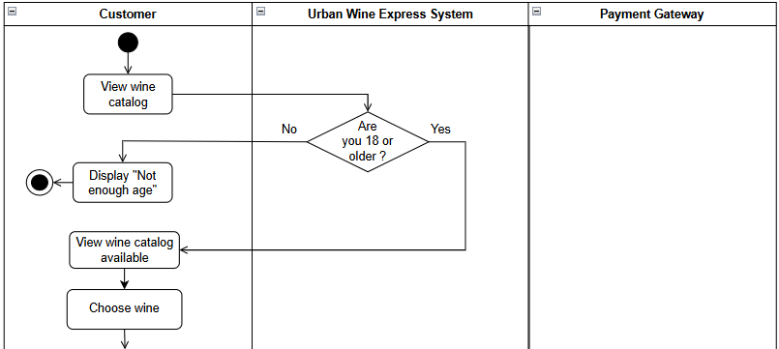

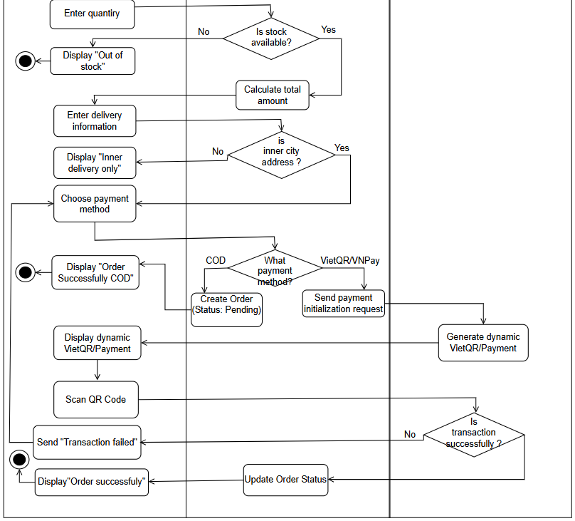

1.2.4.2 Fulfilments & Delivery
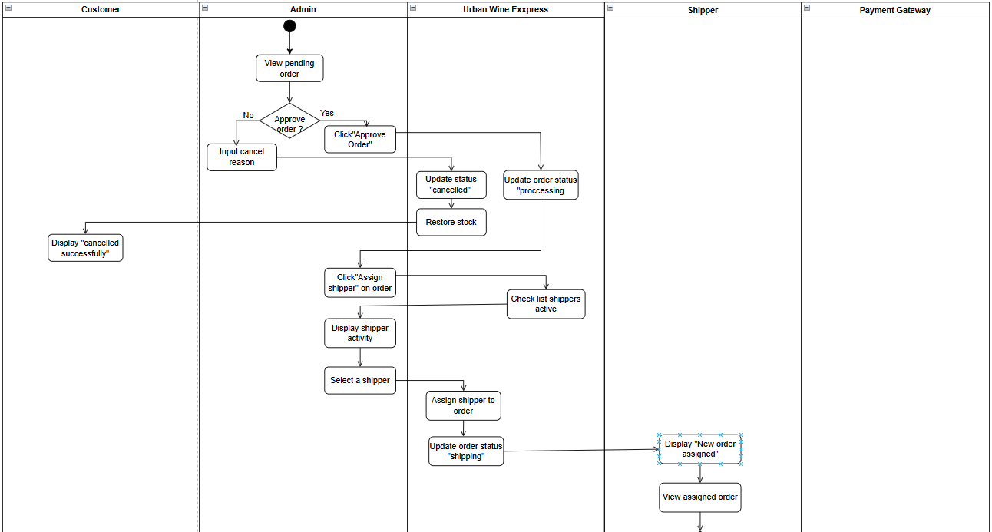
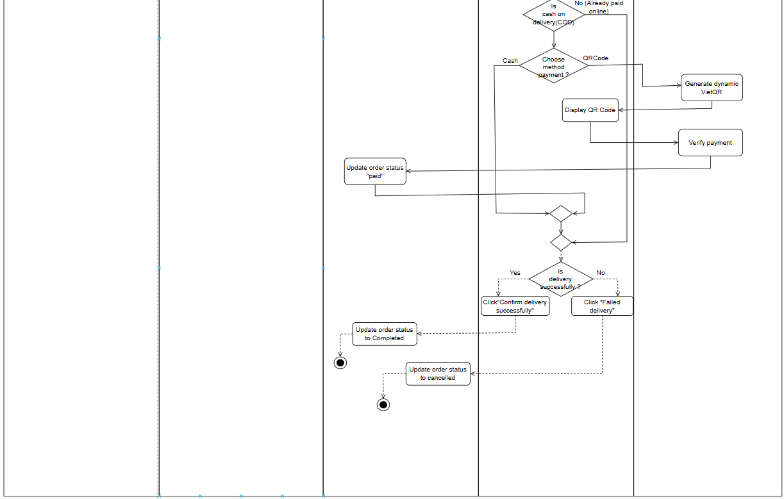

1.2.5 State Machine Diagram

1.2.5.1 Order lifecycle & exception handling
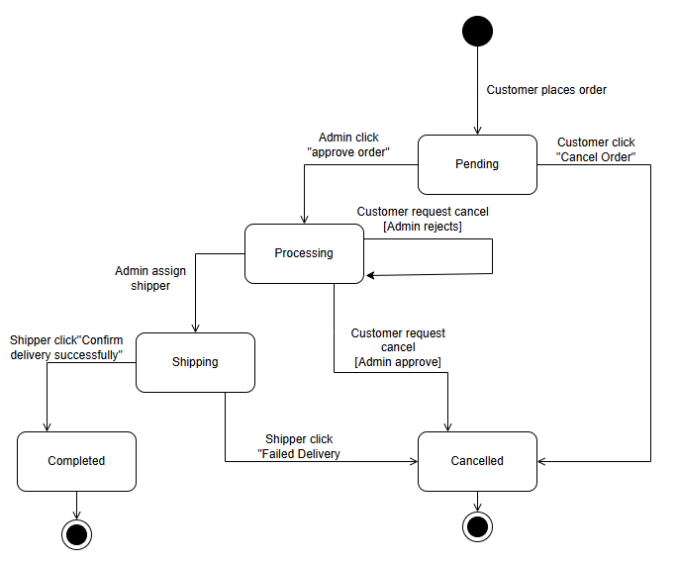

1.2.5.2 Payment transaction lifecycle
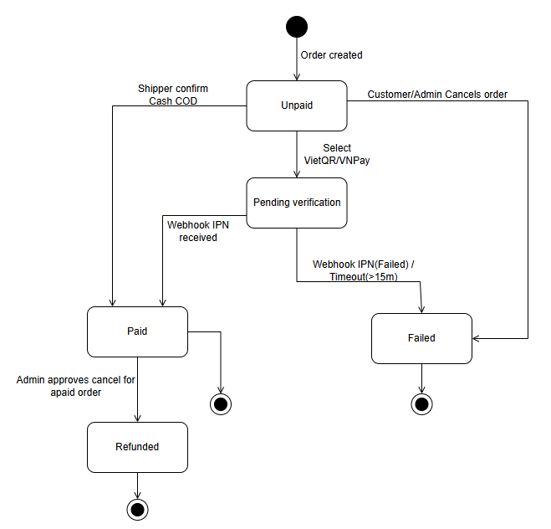

1.3 System Functionalities

1.3.1 Screens Flow

1.3.1.1 Screen flow of guest & customer
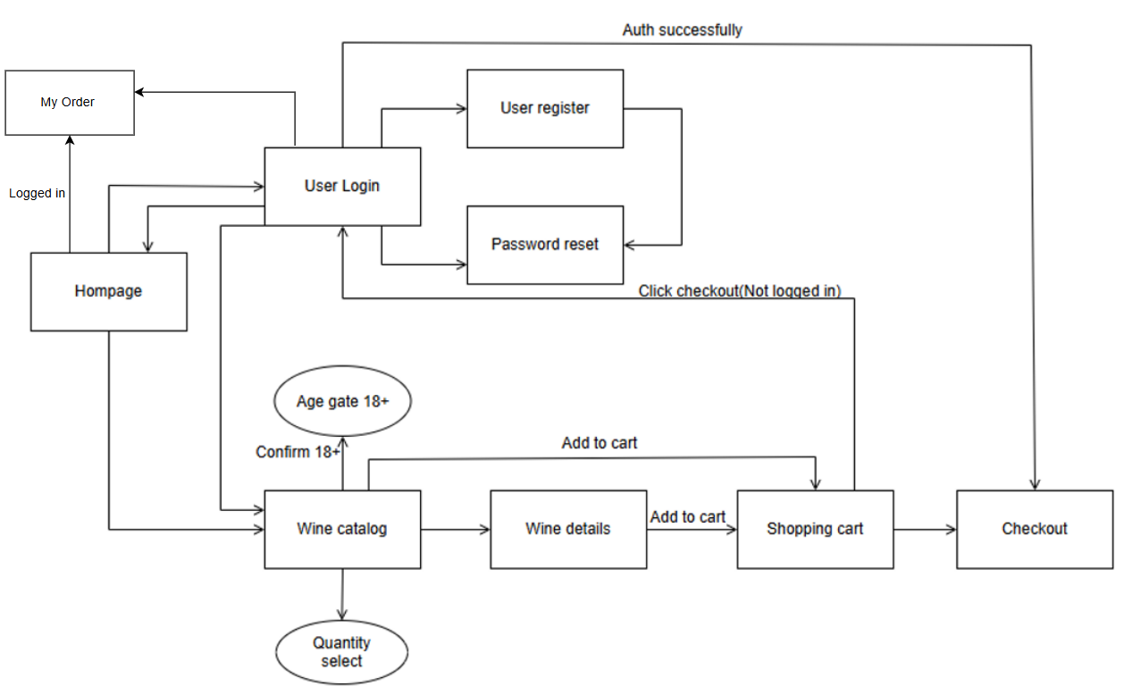

1.3.1.2 Screen flow of admin
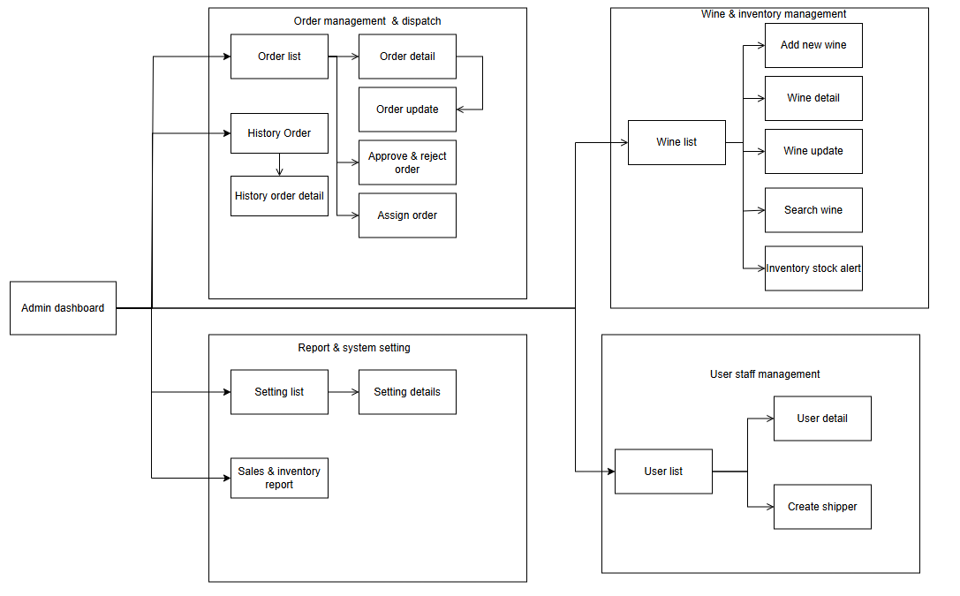

1.3.1.3 Screen flow of shipper
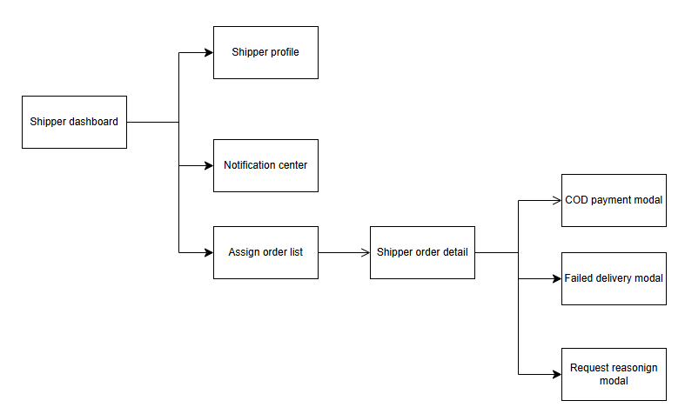

1.3.2 Screen Descriptions

1.3.2.1 Screen description of guest & customer
# | Feature | Screen | Description
1 | Age Gate Verification | Age Verification Modal | A mandatory age-check pop-up requiring visitors to confirm they are 18 years of age or older before browsing wine products or placing orders.
2 | Product Catalog | Public Wine Catalog Page | Displays available wine products with key details including alcohol content, origin country, vintage year, price, and real-time availability status (In Stock, Low Stock, Out of Stock).
3 | Product Catalog | Wine Details Page | Shows detailed wine specifications, tasting notes, grape variety, bottle size, and a quantity selector aligned with available store inventory, alongside an 'Add to Cart' button.
4 | Product Catalog | Wine Search & Filter Panel | Enables customers to search wines by keyword and filter by price range, alcohol percentage, wine category (Red, White, Sparkling, Fortified), and country of origin.
5 | Cart Operations | Shopping Cart Page | Displays selected wines, unit prices, quantity controls, subtotal calculation, and clear notifications if the requested quantity exceeds store availability.
6 | Authentication | User Login / Register / Reset Pages | Provides user-friendly forms for customer account login, registration, and password recovery, automatically returning users back to checkout if triggered during a purchase.
7 | Checkout | Order Submit / Checkout Page | Captures recipient name, contact phone number, and delivery address in Hanoi, calculating total charges including shipping fees based on store delivery policies.
8 | Payment | Payment Selection & QR Display Screen | Allows customers to choose between dynamic VietQR transfer, e-wallet/gateway, or Cash on Delivery (COD), displaying a dynamic QR code pre-filled with the exact payment amount for instant mobile banking scanning.
9 | Order Tracking | My Orders List & Order Details Page | Displays order history for logged-in customers with real-time status updates (Pending Approval, Processing, Out for Delivery, Completed, Cancelled) and enables order cancellation requests in accordance with store policies.

1.3.2.2 Screen description of admin
# | Feature | Screen | Description
1 | Store Operations | Admin Dashboard | The main control center displaying store performance summaries, key operational metrics, quick management shortcuts, low-stock warnings, and pending order alerts.
2 | Order Processing | Orders List Page | Displays all customer orders across all operational stages (Pending Approval, Processing, Out for Delivery, Completed, Cancelled) with multi-criteria filtering and status search.
3 | Order Processing | Admin Order Detail Page | Provides a comprehensive breakdown of an order, including item lists, financial totals (subtotal, shipping fee, tax, total), order activity timeline, and action buttons to approve or cancel orders.
4 | Order Dispatch | Assign Shipper Modal | A pop-up dialog launched from the Order Detail page displaying available on-duty delivery staff and their current active task load, enabling manual order dispatching.
5 | Product Management | Wine Catalog & Update Pages | Provides full management capabilities for wine inventory, allowing store managers to add new products, update prices, edit product details (alcohol content, origin, vintage), and adjust available stock quantities.
6 | Inventory Control | Inventory Stock Alerts Page | Monitors stock health by listing wine products that are running low or out of stock, prompting managers to replenish inventory.
7 | User & Staff Oversight | User List & Staff Management Pages | Displays customer account information, manages account activation or suspension, and enables creating internal courier accounts with appropriate system access roles.
8 | System Configuration | Settings & Sales Reports Pages | Allows configuring operational parameters (delivery fees, free-shipping thresholds, payment timeout limits) and generates sales reports and inventory analytics.

1.3.2.3 Screen description of shipper
# | Feature | Screen | Description
1 | Task Management | Shipper Dashboard (Home Hub) | Mobile home screen featuring header shortcuts to Profile and Notifications, along with a prominently pinned card for the active order currently out for delivery.
2 | Shift Management | Shipper Profile Page | Displays driver credentials, completed delivery statistics, and current shift status (On Duty / Off Duty). Automatically closes the shift at the end of business hours, retaining any pending orders in the driver's assignment list for fulfillment on the next working day.
3 | Communications | Notification Center Page | Displays personal system alerts, including new order assignments, dispatch request responses, instant payment confirmation alerts, and order cancellation notifications from store managers.
4 | Delivery Operations | Assigned Orders List Page | Lists all tasks assigned by store management, highlighting active deliveries at the top and showing recipient details, delivery address, order total, and payment status (Paid vs Unpaid COD).
5 | Task Execution | Shipper Order Detail Page | The primary delivery workspace at the customer doorstep, displaying ordered items, total cash to collect, a one-tap phone button to call the customer, and action buttons for COD payment, delivery failure, or transfer request.
6 | COD Settlement | COD Payment Modal | A pop-up window enabling the courier to confirm physical cash collection or generate a dynamic VietQR code on-screen with the exact order amount for instant customer scanning and automatic payment verification.
7 | Exception Handling | Failed Delivery Modal | A pop-up window allowing the driver to select a delivery failure reason (customer unreachable or refused delivery), updating the order status to Cancelled and automatically returning the items to store inventory.
8 | Shift Exception | Request Reassign Modal | A pop-up window allowing the courier to report an emergency issue (vehicle breakdown) and request store management to transfer the delivery task to another active courier.

1.3.5 Entity Relationship Diagram
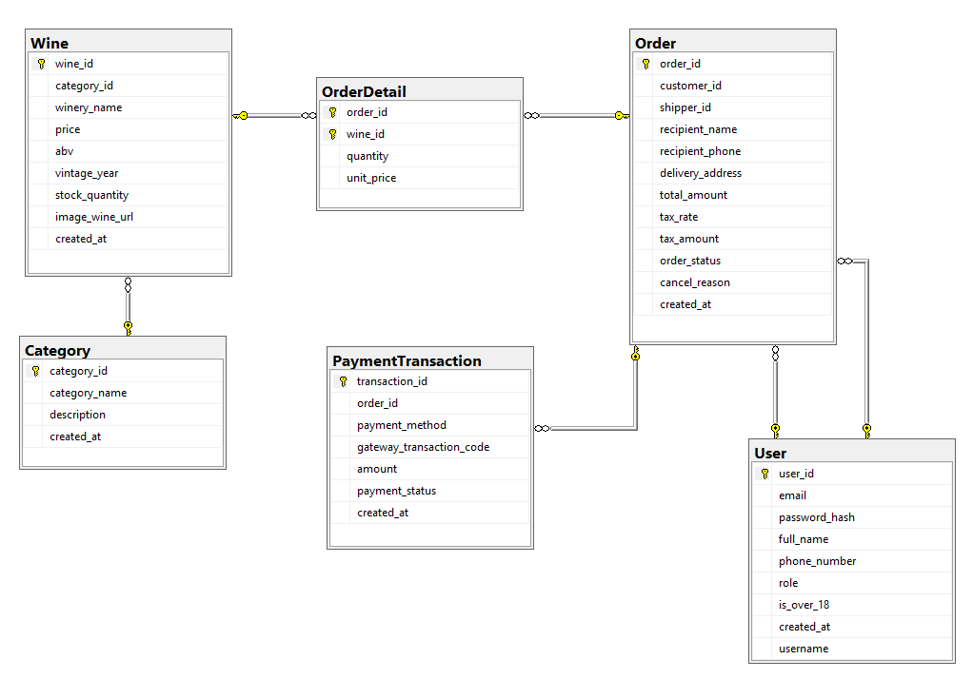
Entities Description
# | Entity | Description
1 | User | Stores account information for Customers, Store Administrators, and Delivery Shippers, including contact details, login credentials, and legal age verification (18+)
2 | Category | Classifies wine products into distinct groups (such as Red, White, or Sparkling Wine) to support product browsing and filtering
3 | Wine | Contains information for each wine bottle in the store, including winery origin, price, alcohol percentage, vintage year, stock quantity, and product image.
4 | Order | Tracks customer wine purchases from placement to delivery, including delivery address, recipient contact info, order status, VAT tax, and cancellation reason.
5 | Order Detail | Captures line items within an order, linking specific wine products with purchased quantities and unit prices at checkout.
6 | PaymentTransaction | Records payment attempts and status for orders, supporting methods like dynamic VietQR, online gateways, and cash on delivery.

2. Use Case Specifications
Template
UC ID and Name: | UC_1.1.1 Create New Blog Post
Created By:

Primary Actor:
Trigger:
Description:
Preconditions:
Postconditions:
Normal Flow
Alternative Flows:
Exceptions:
Priority:
Frequency of Use:
Business Rules:

2.1 Use case detail (Admin)

2.1.1 Manage wine catalog
UC ID and Name: | UC_2.1.1 Manage wine catalog
Created By: | VinhNT | Secondary actor
Primary Actor: | Admin | none
Trigger: | Admin requests to manage the store's wine product catalog
Description: | Allows the Store Manager to view all wine items, create new wine products, update product details (such as unit price, alcohol percentage, vintage, origin, description, and inventory stock), and toggle the sales status of products (active or inactive/hidden) without permanently deleting records from the database.
Preconditions: | PRE-1: Admin is logged into the system with valid administrative privileges.
Postconditions: | POST-1: Wine product information, stock quantities, or active status are updated in the database.  POST-2: Active products and their updated details are immediately reflected in the customer-facing catalog, while inactive products are hidden from customer browsing
Normal Flow | View Catalog and Update Wine Information:  1. Admin requests to view the administrative wine catalog.  2. System validates admin permissions and displays the list of all wine products along with their details (winery name, category, unit price, alcohol percentage, vintage year, stock quantity, and current status: Active or Inactive).  3. Admin selects a wine product and requests to edit its information.  4. Admin provides updated information (such as adjusted price, newly received stock quantity, or modified description).  5. System validates the submitted data (E1).  6. System saves the changes to the database and displays an update success notification to the Admin.
Alternative Flows: | Add a new wine product:  1. At step 2 of the normal flow, Admin requests to add a new wine product to the catalog.  2. Admin provides the required product details (winery name, product category, unit price, alcohol percentage, vintage year, initial stock quantity, and image link).  3. System validates the submitted data (E1, E2).  4. System stores the new wine product in the database with status set to Active and displays a creation success notification.  5. Return to step 2 of the normal flow.  Toggle product sales status (Hide or Reactivate):  1. At step 2 of the normal flow, Admin selects a wine product and requests to change its sales status (deactivate/hide an active product, or reactivate a previously hidden product).  2. System updates the product status accordingly in the database.  3. System notifies Admin of the successful status change: inactive products are immediately hidden from customer search and browsing, while past order records and transaction histories remain fully preserved.  4. Return to step 2 of the normal flow.
Exceptions: | E1: Invalid product data entered:  1. At step 5 of the normal flow or step 3 of the Add new product flow, if the Admin leaves required fields empty or enters negative values for price or stock quantity, the system rejects the submission.  2. System displays an invalid data warning message and prompts the Admin to correct the highlighted fields.  E2: Duplicate wine product information:  1. At step 3 of the Add new product flow, if the new wine matches an existing active product record, the system rejects the creation.  2. System displays a duplicate item warning and advises the Admin to update the existing product's stock rather than creating a duplicate entry.
Priority: | Must have
Frequency of Use: | Medium
Business Rules: | BR-05: Product Management Authority (Only users with the Admin role have permission to add, edit details, adjust prices, manage stock, and toggle the status of wine products)

2.1.2 Process Order
UC ID and Name: | UC_2.1.2 Process Order
Created By: | VinhNT | Secondary actor
Primary Actor: | Admin | none
Trigger: | Admin requests to view orders requiring processing or receives a newly placed order in the system.
Description: | Allows the Store Manager to view pending customer orders, review recipient and ordered item details, approve valid orders to proceed to packaging, reject orders with an attached reason, or review cancellation requests submitted by customers.
Preconditions: | PRE-1: Admin is logged into the system with valid administrative privileges.  PRE-2: The system has at least one order requiring attention (in PENDING status or PROCESSING status with a cancellation request)
Postconditions: | POST-1: Order status is updated accordingly in the database (to PROCESSING if approved, or to CANCELLED if rejected).  POST-2: If an order is cancelled, corresponding product quantities are automatically restored to inventory stock.  POST-3: If a cancelled order was prepaid online, system records the refund status and triggers the customer refund process.
Normal Flow | Approve pending order:  1. Admin requests to view the list of pending orders.  2. System validates admin permissions and displays orders in PENDING status (including order reference code, creation date/time, recipient name, inner-city delivery address, grand total, and payment method) (E1).  3. Admin selects a specific order to view its full details.  4. System displays full order information: list of ordered wines, quantities, unit prices, subtotal, VAT tax, delivery fee, and customer contact details.  5. Admin verifies delivery information and confirms order approval (see Alternative Flows to reject an order or review cancellation requests).  6. System updates order status to PROCESSING, records approval timestamp, sends a confirmation notification to the customer, and readies the order for shipper assignment.
Alternative Flows: | Reject order with a reason:  1. At step 5 of the normal flow, Admin determines the order cannot be fulfilled (due to an unreachable customer, invalid address, or operational issue) and requests to reject the order.  2. Admin provides a cancellation reason (E2).  3. System updates order status to CANCELLED, stores the cancellation reason, automatically restores all item quantities to inventory stock, and sends a cancellation notice with the reason to the customer.  4. Return to step 2 of the normal flow.  Review customer cancellation request:  1. At step 1 of the normal flow, Admin receives a notification that an order in PROCESSING status has a cancellation request from the customer.  2. Admin reviews order details and the customer's stated cancellation reason.  3a. If packaging and dispatch have not occurred and Admin approves cancellation: Admin confirms approval. Then, the system updates order status to CANCELLED, automatically restores item quantities to inventory stock, records refund status (if prepaid online), and notifies the customer.  3b. If items are already packaged and Admin rejects cancellation: Admin confirms rejection. Then, the system retains PROCESSING status to continue delivery and notifies customer of rejection.  4. Return to step 2 of the normal flow
Exceptions: | E1: No orders requiring processing:  1. At step 2, if no orders are in PENDING status or have pending cancellation requests, system displays an empty order list message.  E2: Missing cancellation reason:  1. At step 2 of the Reject order flow, if Admin does not provide a cancellation reason, system rejects the action.  2. System displays a warning prompting Admin to provide a reason before saving.
Priority: | Must have
Frequency of Use: | High
Business Rules: | BR-04: Order Cancellation Rights (Customers can cancel directly only when order status is PENDING; cancellation for PROCESSING orders must be reviewed and approved by the Store Manager).  BR-07: Online payment orders are updated to PROCESSING status only after receiving real-time payment confirmation from the Payment Gateway.

2.1.3 View Stock Alert
UC ID and Name: | UC_2.1.3 View Stock Alert
Created By: | VinhNT | Secondary actor
Primary Actor: | Admin | none
Trigger: | Admin requests to check the list of low-stock wine products in the store.
Description: | Allows the Admin to view wine items whose inventory stock has reached or fallen below the configured minimum threshold, helping the store plan inventory replenishment in time.
Preconditions: | PRE-1: Admin is logged into the system with valid administrative privileges.
Postconditions: | POST-1: System displays the list of low-stock wine products along with their current available stock quantities.
Normal Flow | View low-stock wine list:  1. Admin requests to check inventory stock alerts.  2. System checks the stock quantity of all wine products and displays items that have quantities less than or equal to the minimum threshold (E1).  3. For each item in the list, the system displays product details including: wine name, category, and current available stock quantity.  4. Admin may choose a specific wine item to update its stock quantity (see Navigate to stock update flow), or end the review
Alternative Flows: | Navigate to stock update:  1. At step 4 of the normal flow, Admin selects a low-stock wine item to add inventory.  2. System redirects to the wine catalog management function (connecting directly to UC-07 Manage Wine Catalog) for Admin to enter the new stock quantity.  3. After Admin saves the updated stock successfully and the quantity exceeds the minimum threshold, the system automatically removes that item from the low-stock alert list
Exceptions: | E1: No items are low in stock:  1. At step 2, if all wine products have safe stock levels (higher than the minimum threshold), the system displays a message indicating that inventory is stable and no items require restocking.  2. Admin acknowledges the notification and terminates the use case.
Priority: | Should have
Frequency of Use: | Daily or periodically at the beginning of each store shift.
Business Rules: | BR-06: Low Stock Alert (When the stock quantity of a wine product reaches or falls below the minimum threshold, the system automatically marks it as low stock and alerts the Admin).

2.1.4 Assign order to Shipper
UC ID and Name: | UC_2.1.4 Assign order to shipper
Created By: | VinhNT | Secondary actor
Primary Actor: | Admin | Shipper
Trigger: | Admin requests to assign a delivery task for a packaged order, or receives an order reassignment request from a shipper.
Description: | Allows the Store Manager to select an order that is ready for dispatch, view active delivery staff, and assign the order to an available shipper; also allows reassigning an order to a different shipper if a transit issue occurs.
Preconditions: | PRE-1: Admin is logged into the system with valid administrative privileges.  PRE-2: The selected order is in PROCESSING status (approved and ready for delivery) or in SHIPPING status with a pending reassignment request.
Postconditions: | POST-1: The order is formally linked with the assigned shipper in the database.  POST-2: Order status is updated to SHIPPING (for first-time assignment).  POST-3: System sends an assignment notification to the assigned shipper's mobile account.
Normal Flow | Assign order to an active shipper:  1. Admin selects an order that is ready for delivery and requests to assign a shipper.  2. System validates order readiness and displays the list of shippers currently on active shift, including their current active delivery workload (E1).  3. Admin selects an appropriate shipper and confirms the assignment.  4. System checks that the selected shipper has not exceeded the allowed order capacity limit (E2).  5. System links the shipper to the order, updates order status to SHIPPING, sends a new delivery task notification to the shipper's mobile device, and displays an assignment success notification to the Admin.
Alternative Flows: | Reassign order due to transit issue:  1. At step 1 of the normal flow, Admin receives a reassignment request from a shipper who encountered an issue on the road (such as vehicle breakdown).  2. Admin selects the affected order and requests to reassign it.  3. System displays the list of other active shippers.  4. Admin selects a replacement shipper and confirms the change.  5. System updates the order with the new shipper, sends a new delivery task notification to the replacement shipper, and sends a task revocation notice to the previous shipper.
Exceptions: | E1: No shippers currently on active shift:  1. At step 2, if no shippers are currently logged in with active shift status, the system notifies the Admin that no delivery staff are available.  2. Admin acknowledges the notification, keeps the order in PROCESSING status, and defers assignment until staff become available.  E2: Selected shipper reached maximum order limit:  1. At step 4, if the chosen shipper already holds the maximum number of assigned orders allowed by store policy, the system rejects the assignment.  2. System displays a workload capacity warning and prompts the Admin to select another shipper.
Priority: | Must have
Frequency of Use: | High
Business Rules: | BR-08: Shipper Order Access (Shippers can only view order details and update delivery status for orders assigned to their own account)

2.1.5 Create Offline Order
UC ID and Name: | UC_2.1.5 Create Offline Order
Created By: | VinhNT | Secondary actor
Primary Actor: | Admin | Payment gateway
Trigger: | A walk-in customer brings wine bottles to the store desk to buy directly, or requests staff to prepare an offline takeaway order.
Description: | Allows store staff to quickly create an offline retail order for an anonymous walk-in customer (requiring no user account, phone number, or delivery address), verify real-time store inventory, calculate grand total with 10% VAT tax (zero shipping fee), process cash payment with change calculation or on-site QR transfer, deduct inventory stock immediately, and complete the order for immediate customer takeaway.
Preconditions: | PRE-1: Staff is logged into the system with valid administrative privileges.  PRE-2: The walk-in customer meets the legal age requirement of 18 years or older.
Postconditions: | POST-1: A new order record is stored in the database with status COMPLETED, payment status PAID, and channel type OFFLINE without mandatory customer identity data.  POST-2: Inventory quantities for purchased wine items are deducted immediately in the database to synchronize with online stock.  POST-3: System records sales revenue and prints a retail receipt for the offline customer to take away.
Normal Flow | Create offline order and process cash payment:  1. Staff requests to create a new offline order. System initializes an anonymous offline retail order with zero delivery fee and no required user account.  2. Staff searches or selects the wine items along with requested quantities.  3. System verifies real-time stock availability for each selected wine item (E1).  4. System calculates the total amount (including wine items total and fixed 10% VAT tax, with zero delivery fee) and displays the order summary.  5. Staff selects cash payment as requested by the customer (see Alternative Flow for bank transfer).  6. Customer provides physical cash. Staff receives the money and inputs the tendered cash amount into the system (E2).  7. System calculates and displays the change amount to return to the customer.  8. Staff confirms the cash transaction is complete.  9. System records the offline order in COMPLETED status and PAID payment status, immediately deducts the purchased quantities from store inventory, prints the receipt, and displays a success notification so staff can hand over the wine and change to the customer.
Alternative Flows: | Pay via dynamic bank transfer QR code (VietQR):  1. At step 5 of the normal flow, customer requests to pay by bank transfer QR code.  2. Staff selects the on-site digital payment option.  3. System sends a payment initialization request to the Payment Gateway with the offline order reference and exact amount due.  4. Payment Gateway generates a dynamic VietQR code and returns it to the system.  5. System presents the dynamic VietQR code for the customer to scan.  6. Customer scans the code and confirms the transfer in their banking app (E3, E4).  7. Payment Gateway verifies transaction success and sends a real-time confirmation (Webhook IPN) to the system.  8. System updates offline order status to COMPLETED, updates payment status to PAID, stores the bank transaction reference, immediately deducts inventory stock in the database, prints the receipt, and displays success notification for wine handover.
Exceptions: | E1: Insufficient offline stock quantity:  1. At step 3 of the normal flow, if a selected wine item has available stock lower than the requested quantity, system displays an insufficient stock alert.  2. Staff informs the customer and adjusts the quantity to available stock or removes the item.  E2: Tendered cash is less than grand total:  1. At step 6 of the normal flow, if the entered cash amount is less than the required grand total, system rejects order completion.  2. Staff requests remaining money from the customer or adjusts item quantities.  E3: QR bank transfer transaction failed:  1. At step 6 of the Alternative Flow, if payment fails due to bank network error, insufficient funds, or customer cancellation, Payment Gateway sends a failure notice.  2. System records the failed attempt, preserves order line items, and allows staff to generate a new QR code or switch to cash payment.  E4: QR payment session timeout:  1. At step 6 of the Alternative Flow, if confirmation is not received within the timeout window, the dynamic VietQR code expires.  2. System displays session expiration, keeps line items intact without canceling the order, and allows staff to request a new payment code or switch to cash.
Priority: | Must have
Frequency of Use: | High
Business Rules: | BR-01: Customer Age Verification (Customers purchasing wine must be 18 years of age or older).  BR-03: Order Total Calculation (Offline order total includes item price subtotal and 10% VAT tax, with zero delivery fee).  BR-05: Catalog & Inventory Permissions (Only staff and managers have permission to create offline orders and trigger immediate inventory deduction).

2.2.Use case detail(Customer)

2.2.1 View wine catalog
UC ID and Name: | UC 2.2.1 View wine catalog
Created By: | VinhNT | Secondary actor
Primary Actor: | Customer | None
Trigger: | Customer requests to view the wine catalog.
Description: | Allows customers to browse available wine products, view products by category, and view detailed information for a specific wine to make purchasing decisions.
Preconditions: | PRE-1: Customer has confirmed being 18 years of age or older. (If not confirmed, see (E1))
Postconditions: | POST-1: System displays the list of available wine products.  POST-2: System displays detailed information of the selected wine product.
Normal Flow | 1. Customer requests to view the wine catalog.  2. System verifies age confirmation condition and displays the catalog of wine products with basic information for each product (including image, winery name, category, unit price, alcohol percentage, and stock availability) (E2).  3. Customer requests to filter the catalog by a specific product category.  4. System displays products belonging to the selected category.  5. Customer selects a specific wine product to view details.  6. System displays detailed information of the selected product (including origin, grape variety, vintage year, alcohol percentage, description, and available stock quantity) and allows the customer to specify the quantity to purchase.
Alternative Flows: | None
Exceptions: | E1: Customer has not confirmed being 18 years of age or older  1.At step 2, if the system determines the customer has not confirmed being 18 years of age or older, the system prompts the customer to verify age before proceeding.  2.1. If customer indicates under 18 years of age, system displays an access restriction message and terminates the use case.  2.2. If customer confirms being 18 years of age or older, system records verification and returns to step 2 of the normal flow.  E2: Wine product is out of stock  1.At step 2 or step 6, if a wine product has an available stock quantity of zero, system marks the product status as out of stock and disables the direct purchase option for that product.
Priority: | Must Have
Frequency of Use: | High
Business Rules: | BR-01:User must enough age (18+) can access in system  BR-05: Only active wine products are displayed.

2.2.2 Search wine catalog
UC ID and Name: | UC_2.2.2 Search wine catalog
Created By: | VinhNT | Secondary actor
Primary Actor: | Customer | None
Trigger: | Customer requests to search or filter wine products in the catalog.
Description: | Allows customers to search for wine products by keyword and apply filtering criteria (price range, alcohol percentage, origin country, category) to find suitable products.
Preconditions: | PRE-1: Customer is logged into the system.  PRE-1: Customer is logged into the system.
Postconditions: | POST-1: System displays the list of wine products matching the search query or filter criteria.
Normal Flow | Search and Filter Wine Products:  1. Customer requests to search for wine products by providing a search keyword (wine name or winery brand).  2. System checks preconditions and displays matching wine products with basic information (including image, product name, winery, category, unit price, alcohol percentage, and stock availability) (E1, E2, E3).  3. Customer may specify one or more filter criteria (such as price range, alcohol percentage, origin country, or wine category) to narrow results.  4. System updates and displays wine products that match both the keyword and selected filter criteria (E2, E3).  5. Customer selects a product to view details or proceed to purchase.
Alternative Flows: | Search without filter criteria:  1. At step 3, if the customer does not specify any filter criteria or clears all selected criteria, the system displays all available wine products matching the keyword (or all active catalog items if no keyword is provided).  2. Return to step 5 of the normal flow.
Exceptions: | E1: Customer has not confirmed being 18 years of age or older  1. At step 2, if the system determines the customer has not confirmed being 18 years of age or older, the system prompts the customer to verify age before proceeding.  2a. If customer indicates under 18 years of age, system displays an access restriction message and terminates the use case.  2b. If customer confirms being 18 years of age or older, system records verification and returns to step 2 of the normal flow.  E2: No matching wine products found  1. At step 2 or step 4, if no wine products match the keyword or filter criteria, system displays a "No results found" notification and prompts the customer to adjust criteria.  E3: Wine product in results is out of stock  1. If a wine product in the search results has an available stock quantity of zero, system marks the product status as out of stock and disables the direct purchase option for that product.
Priority: | Should have
Frequency of Use: | High
Business Rules: | BR-05: Only active wine products are displayed

2.2.3 Place Order
Ccc | UC_2.2.3 Place Order
Created By: | VinhNT | Secondary actor
Primary Actor: | Customer | None
Trigger: | Customer requests to place an order from the shopping cart.
Description: | Allows customers to provide recipient details and an inner-city delivery address, review the order total summary (including product prices, VAT tax, and delivery fee), and confirm the creation of a new wine purchase order.
Preconditions: | PRE-1: Customer is logged into the system.  PRE-2: Customer has confirmed being 18 years of age or older.  PRE-3: Customer shopping cart contains at least one valid item
Postconditions: | POST-1: A new order record is created in the system with status PENDING and payment status UNPAID.  POST-2: Available stock quantities for ordered products are temporarily reserved according to the order.  POST-3: Ordered items are cleared from the customer shopping cart.  POST-4: Customer is prompted to select a payment method.
Normal Flow | Place Order:  1. Customer requests to checkout and place an order from the shopping cart.  2. System verifies product stock availability (E1) and prompts customer for delivery information.  3. Customer provides recipient contact details (name, phone number) and delivery address.  4. System validates whether the delivery address is located within the supported inner-city area (E2).  5. System calculates the order total amount (including wine items total, 10% VAT tax, and inner-city delivery fee) and displays the order summary for customer review.  6. Customer reviews the summary and confirms the order request.  7. System creates and stores the new order record with status PENDING and payment status UNPAID, reserves the ordered stock quantities, clears the shopping cart, and forwards the customer to payment method selection (E3).
Alternative Flows: | None
Exceptions: | E1: Don’t enough product stock:  1. At step 2, if one or more items in the cart exceed available stock quantity, system notifies customer that the requested quantity is unavailable or out of stock.  2. Customer must adjust item quantities or remove out-of-stock items before proceeding.  E2: Delivery address outside inner-city area:  1. At step 4, if the provided delivery address is outside the supported inner-city boundary, system notifies customer that delivery is not supported for this location.  2. Customer provides a valid inner-city address or cancels the order request.  E3: Customer cancels order placement:  1. At any point before step 7, customer chooses to cancel the checkout process.  2. System terminates the ordering process, keeps cart items unchanged, and ends the use case.
Priority: | Must have
Frequency of Use: | High
Business Rules: | BR-01: Customers must be 18 years or older to order wine.  BR-02: System only accepts and processes delivery addresses within the inner-city area.  BR-03: Order total amount includes product price total, VAT tax, and inner-city delivery fee.

2.2.4 Manage cart
UC ID and Name: | UC_2.2.4 Manage cart
Created By: | VinhNT | Secondary actor
Primary Actor: | Customer | None
Trigger: | Customer requests to add a wine product to the shopping cart or requests to view current cart contents.
Description: | Allows customers to manage selected items intended for purchase, including adding new wine items, viewing current cart contents, updating item quantities, or removing items before proceeding to checkout.
Preconditions: | PRE-1: Customer is logged into the system.  PRE-2: Customer has confirmed being 18 years of age or older. (If not confirmed, see E1)
Postconditions: | POST-1: Customer shopping cart is updated with the latest items, quantities, and subtotal amounts
Normal Flow | Add Wine and Manage Cart:  1. Customer selects a wine product, specifies the desired quantity, and requests to add it to the shopping cart.  2. System verifies product stock availability (E2).  3. System records the product and quantity in the customer shopping cart (if the item is already present, the system increments its quantity).  4. System automatically recalculates the cart subtotal and displays the updated cart contents to the customer.  5. Customer may request to modify item quantities, remove items (see Alternative Flows), or proceed to place an order.
Alternative Flows: | Update item quantity in cart:  1. Customer requests to change the quantity of an item currently in the cart.  2. System checks the new requested quantity against available stock (E2).  3. System updates the item quantity in the cart.  4. Return to step 4 of the normal flow.  Remove item from cart:  1. Customer requests to remove a specific item from the cart.  2. System removes the item from the customer shopping c.  3. Return to step 4 of the normal flow.
Exceptions: | E1: Customer has not confirmed being 18 years of age or older  1. At step 1, if the system determines the customer has not confirmed being 18 years of age or older, system prompts the customer to verify age before proceeding.  2a. If customer indicates under 18 years of age, system displays an access restriction message and terminates the use case.  2b. If customer confirms being 18 years of age or older, system records verification and resumes adding the item to the cart.  E2: Requested quantity exceeds available stock  1. At step 2 of the normal flow or step 2 of the Update item quantity flow, if the requested quantity exceeds available inventory, system notifies the customer of insufficient stock.  2. System retains the previous cart quantity (or adjusts to the maximum available stock) and prompts the customer to enter a valid quantity.
Priority: | Must have
Frequency of Use: | High
Business Rules: | BR-01: Customers must verify that they are 18 years or older before ordering wine.  BR-03: Cart subtotal is calculated as the sum of (unit price * item quantity).

2.2.5 Select payment method
UC ID and Name: | UC_2.2.5 Select payment method
Created By: | VinhNT | Secondary actor
Primary Actor: | Customer | Payment Gateway
Trigger: | Customer requests to choose a payment method after completing order delivery information.
Description: | Allows customers to select their preferred payment method (Cash on Delivery - COD, or Online Payment via dynamic VietQR / VNPay). For COD orders, the system reserves items and deducts available stock immediately upon confirmation. For online payments, items are awarded on a first-paid, first-served basis; if a payment fails or times out, items remain safely in the customer's cart without holding stock.
Preconditions: | PRE-1: Customer is logged into the system.  PRE-2: Customer has confirmed being 18 years of age or older.  PRE-3: Order has been initialized with valid inner-city delivery details and is in UNPAID status.
Postconditions: | POST-1: Selected payment method is recorded in the order transaction record.  POST-2 (COD Order): Order is confirmed in PENDING status, product stock is deducted, and ordered items are cleared from the customer's cart.  POST-3 (Online Order): Upon successful payment confirmation, order payment status is updated to PAID, order status changes to PROCESSING, stock is deducted, and purchased items are cleared from the cart.
Normal Flow | Cash on Delivery (COD):  1. System prompts customer to choose a payment method.  2. Customer selects Cash on Delivery (COD) (see Alternative Flow for online payment).  3. System performs a real-time check of available product inventory (E1).  4. System confirms the order in PENDING status, deducts the corresponding inventory stock, clears the purchased items from the shopping cart, and displays an order confirmation notification to the customer.
Alternative Flows: | Online Payment (VietQR / VNPay):  1. At step 2 of the normal flow, customer selects the online payment method.  2. System performs a real-time check of available product inventory to ensure items are still in stock (E1).  3. System sends a payment initialization request to the Payment Gateway.  4. Payment Gateway generates payment details (dynamic VietQR code or online payment screen) and presents them to the customer.  5. Customer scans the QR code and confirms the payment transaction (E2, E3).  6. Payment Gateway verifies transaction success and sends a real-time confirmation notification to the system.  7. System updates order status to PROCESSING, updates payment status to PAID, stores the transaction reference code, deducts corresponding product inventory in the database, clears the purchased items from the customer's shopping cart, and displays an order success notification.
Exceptions: | E1: Items out of stock due to earlier completion by another customer:  1. At step 3 of the normal flow or step 2 of the Alternative Flow, if one or more items in the order have been purchased by other customers and stock is insufficient, the system rejects the checkout request.  2. System notifies the customer that the items are out of stock, keeps the items in the shopping cart for visibility, and prompts the customer to adjust item quantities before retrying.  E2: Online payment transaction failed:  1. At step 5 of the Alternative Flow, if the payment fails (bank error, insufficient balance, or customer cancellation), Payment Gateway sends a failure notice to the system.  2. System records the failed payment attempt, leaves product stock unchanged, keeps items in the customer's cart, and displays an error message allowing the customer to retry or switch payment methods.  E3: Online payment session expired (15-minute timeout):  1. At step 5 of the Alternative Flow, if payment confirmation is not received within the 15-minute limit, the current payment session and QR code expire.  2. System notifies the customer of the session expiration, does not lock inventory stock, retains items in the customer's cart, and allows the customer to request a new payment code when ready.
Priority: | Must have
Frequency of Use: | High
Business Rules: | BR-01: Customers must verify that they are 18 years or older before ordering wine.  BR-07: Online payment orders are updated to PROCESSING only after receiving real-time payment confirmation from the Payment Gateway

2.2.6 View Order History
UC ID and Name: | UC_2.2.6 View Order History
Created By: | VinhNT | Secondary actor
Primary Actor: | Customer | None
Trigger: | Customer requests to view past order history or track order delivery progress.
Description: | Allows logged-in customers to view all their past orders, check line items and total amounts, track real-time delivery status, cancel orders (or request cancellation) based on hierarchical rules, or complete payment for previously unpaid orders
Preconditions: | PRE-1: Customer is logged into the system with a valid account
Postconditions: | POST-1: System displays the list of past orders belonging to the customer.  POST-2: System displays complete details of the selected order.  POST-3: If an order is successfully cancelled, order status is updated to CANCELLED and items are automatically restored to inventory stock.
Normal Flow | View Order History and Details:  1. Customer requests to view their order history.  2. System validates account credentials and displays the list of past orders sorted by newest first (including order reference code, creation date, grand total, order status, and payment status) (E1).  3. Customer selects a specific order to view its details.  4. System displays full order information: recipient contact, delivery address, purchased wine items (item name, unit price, quantity), subtotal, VAT tax, delivery fee, grand total, current operational status (PENDING, PROCESSING, SHIPPING, COMPLETED, or CANCELLED), and payment method/status.  5. Customer may choose to cancel the order (see cancellation flows), resume payment for an unpaid order (see Resume payment flow), or return to the order list.
Alternative Flows: | Cancel order in PENDING status:  1. At step 4 of the normal flow, if the order is in PENDING status, customer requests to cancel the order and provides a cancellation reason.  2. System verifies PENDING status, updates order status to CANCELLED, automatically restores item quantities to inventory stock, and notifies customer of successful cancellation.  Request cancellation for order in PROCESSING status:  1. At step 4 of the normal flow, if the order is in PROCESSING status, customer submits a cancellation request with a reason.  2. System records the cancellation request and notifies the Store Manager (Admin) for review and decision.  3. System notifies customer that the request has been submitted and is awaiting Admin review.  Resume payment for unpaid order:  1. At step 4 of the normal flow, if the order payment status is UNPAID (due to prior payment failure or session timeout), customer requests to pay for this order.  2. System checks real-time inventory stock availability (E2).  3. System redirects to payment method selection and verification (connects to UC-05 Select Payment Method)
Exceptions: | E1: Customer has no past orders:  1. At step 2, if the customer has not placed any orders, system displays a "No orders found" message and suggests browsing the wine catalog.  E2: Items in unpaid order are out of stock upon payment retr  1. At step 2 of the Resume payment flow, if items in the order have been sold out to other customers, system rejects the payment request.  2. System notifies customer that items are out of stock and advises cancelling the old order to create a new order with available items.
Priority: | Should have
Frequency of Use: | Medium to High
Business Rules: | BR-04: Order Cancellation Rights (Customers can cancel directly only when order status is PENDING; cancellation for PROCESSING or SHIPPING orders must be requested through and approved by the Store Manager).

2.2.7 Create Account For Customer (Precondition)
UC ID and Name: | UC_2.2.7 Register Customer Account
Created By: | VinhNT | Secondary actor
Primary Actor: | Customer/Guest | Email Service (SMTP)
Trigger: | Customer requests to create a new customer account
Description: | Allows a new customer to register an account using personal contact details, verify that they meet the legal drinking age (18+), and confirm their email via a verification code
Preconditions: | PRE-1: Customer has a valid email address to receive verification codes
Postconditions: | POST-1: A new customer account is created and activated in the system.  POST-2: Customer is recognized as authenticated and can use personalized store features.
Normal Flow | Register Customer Account:  1. Customer requests to create a new account.  2. System prompts for registration details.  3. Customer provides full name, phone number, email address, password, and date of birth.  4. System validates the submitted information, verifies that the customer is at least 18 years old (E1), and checks that the email address is not already registered (E2).  5. System generates a temporary verification code and sends it to the customer's email address via Email Service.  6. System prompts the customer to enter the verification code.  7. Customer provides the received verification code.  8. System confirms the verification code (E3).  9. System creates the new customer account, records the legal age confirmation, and logs the customer into the system
Alternative Flows: | None
Exceptions: | E1: Customer is under 18 years old:  1. At step 4, if the customer's calculated age is under 18, system notifies that users must be 18 years or older to register.  2. System terminates the registration request.  E2: Email address already registered:  1. At step 4, if the email address already exists in the system, system notifies that the email is already in use.  2. System advises the customer to sign in or recover their password.  E3: Invalid or expired verification code:  1. At step 8, if the verification code is incorrect or has expired, system notifies the customer of the error.  2. Customer may re-enter the code, request a new code, or cancel the request.
Priority: | Must have
Frequency of Use: | High
Business Rules: | BR-01: Age Verification (Customers must be 18 years or older to register and purchase wine products).

2.3 Use case detail (Shipper)

2.3.1 View assign order
UC ID and Name: | UC_2.3.1 View assign order
Created By: | VinhNT | Secondary actor
Primary Actor: | Shipper | none
Trigger: | Shipper receives a new delivery assignment notification or requests to view the assigned delivery list.
Description: | Allows delivery staff to view the list of orders assigned to their account by the Store Manager and view full order details (recipient contact, delivery address, wine items, and amount to collect) to prepare and deliver orders to customers.
Preconditions: | PRE-1: Shipper is logged into the system with a valid staff account.  PRE-2: Shipper account is currently on an active work shift.
Postconditions: | POST-1: System displays the list of orders currently assigned to the shipper.  POST-2: System displays complete details of the selected order for delivery and payment collection.
Normal Flow | View assigned orders and order details:  1. Shipper requests to view the list of assigned orders.  2. System validates staff account permissions and retrieves orders assigned to this shipper (E1).  3. System displays the list of assigned orders, highlighting active deliveries, including: order reference code, delivery address, grand total to collect, and payment method (prepaid online or cash on delivery).  4. Shipper selects a specific order to view its full details.  5. System displays comprehensive order details: recipient name, delivery phone number, detailed address, list of wine items (item name, quantity), grand total, delivery notes, and current payment status.  6. Shipper verifies the product list in the system against the physical goods and is ready to deliver to the custom.
Alternative Flows: | None
Exceptions: | E1: No orders assigned:  1. At step 2, if the shipper currently has no assigned orders or all prior assigned orders are completed, the system displays a message stating that no new delivery tasks are assigned.  2. Shipper acknowledges the notification and ends the use case
Priority: | Must have
Frequency of Use: | High
Business Rules: | BR-08: Shipper Order Access (Shippers can only view details and update statuses for orders officially assigned to their own account)

2.3.2 Update delivery status
UC ID and Name: | UC_2.3.2 Update delivery status
Created By: | VinhNT | Secondary actor
Primary Actor: | Shipper | none
Trigger: | Shipper arrives at the customer delivery address and finishes delivering the order, or cannot contact the customer, or the customer refuses the delivery
Description: | Allows the delivery staff to update an order to completed delivery status (automatically settling payment for COD orders) or report a failed delivery with a stated reason (which automatically cancels the order and restores wine items to inventory stock).
Preconditions: | PRE-1: Shipper is logged into the system with a valid staff account.  PRE-2: The selected order is in SHIPPING status and is assigned to this shipper account.
Postconditions: | POST-1 (Delivery Success): Order status is updated to COMPLETED in the database; if it is a COD order, payment status is updated to PAID; inventory stock remains unchanged.  POST-2 (Delivery Failed): Order status is updated to CANCELLED; the system automatically restores ordered product quantities back into store inventory; system records refund status if the order was prepaid online.
Normal Flow | Confirm successful delivery:  1. Shipper selects an active delivery order and requests to confirm successful delivery to the customer.  2. System verifies staff permissions for this order (E1).  3. System checks the order payment method. If the order is Cash on Delivery (COD), the system updates the payment status to PAID.  4. System updates the order status to COMPLETED, records the completion timestamp, and keeps inventory stock unchanged.  5. System sends a delivery success notification to the customer and the Store Manager, and updates the shipper assigned task list.
Alternative Flows: | Report failed delivery:  1. At step 1 of the normal flow, shipper cannot complete the delivery (due to an unreachable customer after multiple calls or customer refusal) and requests to report delivery failure.  2. Shipper provides a reason for delivery failure (E2).  3. System verifies the request, updates the order status to CANCELLED, and records the failure reason.  4. System automatically triggers the inventory restocking action to return all ordered wine quantities back to store inventory.  5. If the order was prepaid online, system automatically updates the transaction status to pending refund (REFUNDED) for the customer.  6. System sends cancellation and restock notices to the Store Manager, customer, and shipper to conclude the delivery workflow.
Exceptions: | E1: Order not assigned to this shipper:  1. At step 2, if the order has been reassigned to another shipper or is not linked to this shipper account, system rejects the action.  2. System displays an access permission error message and terminates the use case.  E2: Missing failure reason:  1. At step 2 of the Report failed delivery flow, if the shipper does not provide a reason, system rejects saving the status.  2. System prompts the shipper to select or enter a reason before confirming.
Priority: | Must have
Frequency of Use: | High
Business Rules: | BR-04: Order Cancellation Rights (Orders in SHIPPING status that fail delivery are updated to CANCELLED and items are automatically restored to inventory stock).  BR-08: Shipper Order Access (Shippers can only view and update orders officially assigned to their own account).  BR-09: COD Payment Settlement (When a shipper updates a COD order to COMPLETED, system automatically sets the payment status to PAID).

2.3.3 Display payment method
UC ID and Name: | UC_2.3.4 Display payment method
Created By: | VinhNT | Secondary actor
Primary Actor: | Shipper | Payment gateway
Trigger: | Shipper arrives at the delivery destination for a Cash on Delivery (COD) order, and the customer requests to pay by scanning a bank transfer QR code.
Description: | Allows the delivery staff to request and present an online payment transfer code (dynamic VietQR with exact order amount and reference details) for on-site scanning by the customer; system automatically updates the payment to completed upon receiving confirmation from the payment gateway.
Preconditions: | PRE-1: Shipper is logged into the system with a valid staff account.  PRE-2: The selected order is in SHIPPING status, assigned to this shipper, and has a Cash on Delivery payment type in UNPAID status.
Postconditions: | POST-1: Payment transaction is verified by the Payment Gateway with real-time success confirmation sent to the system.  POST-2: Order payment status is updated to PAID in the database.  POST-3: Shipper is ready to complete the delivery hand-off
Normal Flow | Display dynamic VietQR and verify on-site payment:  1. Shipper selects an unpaid COD order and requests on-site online payment generation as requested by the customer.  2. System validates order assignment permissions and confirms the required collection amount (E1).  3. System sends a payment initialization request to the Payment Gateway with the order code and exact amount.  4. Payment Gateway generates the dynamic VietQR data and returns payment details to the system.  5. System presents the dynamic VietQR code and collection amount for customer scanning.  6. Customer scans the QR code and authorizes payment via banking application (E2, E3).  7. Payment Gateway verifies transaction success and sends a real-time confirmation notification (Webhook IPN) to the system.  8. System records the transaction reference, updates order payment status to PAID, and notifies the shipper of successful payment to proceed with item handover.
Alternative Flows: | Switch to direct cash payment:  1. Before an online transaction completes, if the customer decides to pay with physical currency, shipper cancels the QR payment request.  2. System terminates the current QR payment session and keeps the order in UNPAID status.  3. Shipper collects physical cash directly from the customer and proceeds to confirm delivery completion in the delivery update workflow.
Exceptions: | E1: Order already prepaid online:  1. At step 2, if the order was already paid online during checkout (amount to collect is zero), system rejects generating a new payment code.  2. System notifies the shipper that the order is already settled and instructs them to hand over goods without collecting payment.  E2: Customer bank transfer transaction failed:  1. At step 6, if the transfer fails due to network error, insufficient customer funds, or cancellation in the banking app, Payment Gateway sends a failure notice to the system.  2. System records the failed attempt, leaves the order status intact, and displays a transaction error message.  3. Shipper can request a new payment code for a retry or switch to direct cash collection.  E3: QR payment session timeout:  1. At step 6, if payment confirmation is not received within the timeout window, the dynamic VietQR code expires.  2. System notifies the shipper of expiration, does not cancel the order, and does not return items to inventory.  3. Shipper requests a new VietQR code for the customer or proceeds with cash collection.
Priority: | Must have
Frequency of Use: | High
Business Rules: | BR-08: Shipper Order Access (Shippers can only request payment codes for orders assigned to their own account).  BR-09: COD Payment Settlement (Upon successful payment confirmation, payment status is automatically updated to PAID).

3.Functional Specification

1.Main Storefront Page
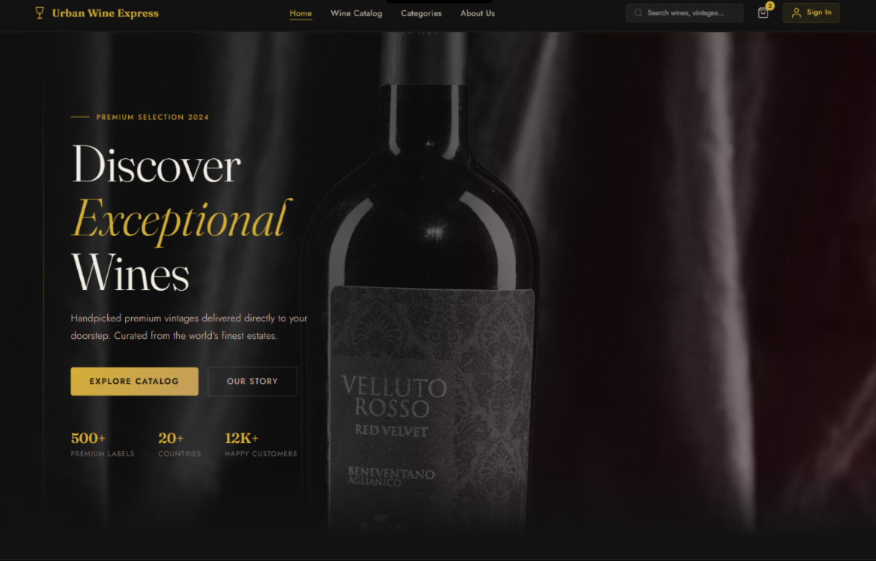
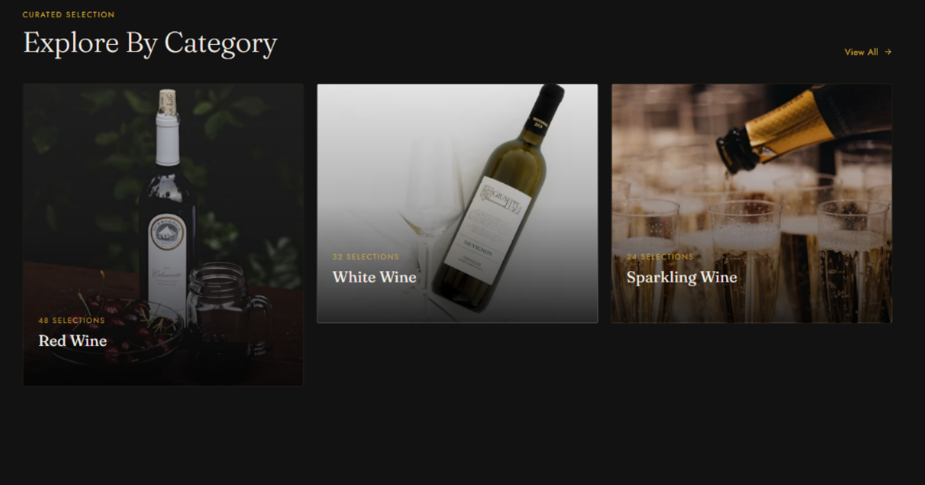
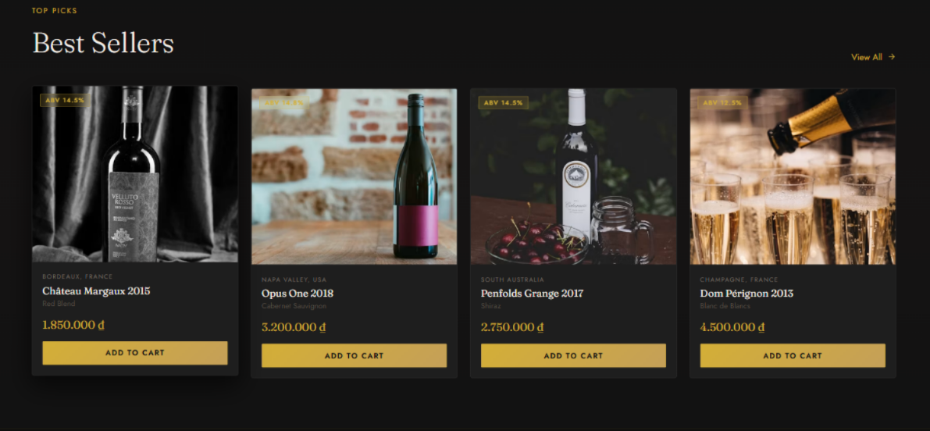
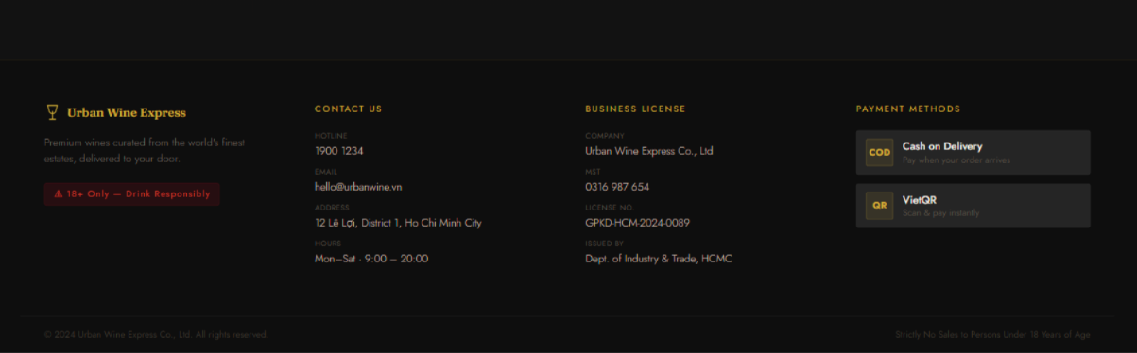

2.Authentication

2.1 Login for customer
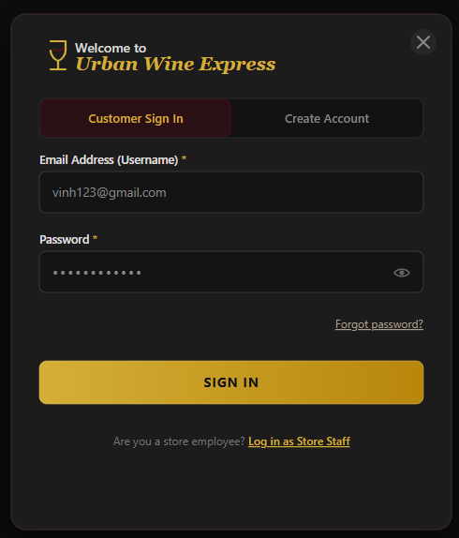

2.2 Forgot password
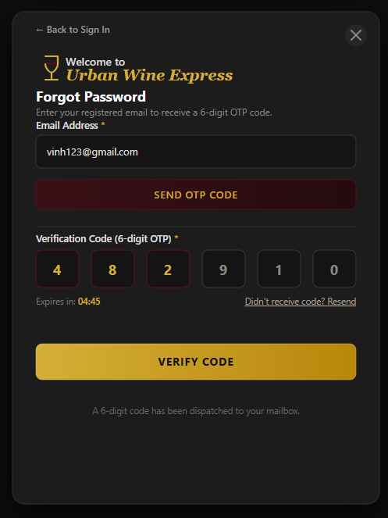

2.3 Verified OTP Successfully
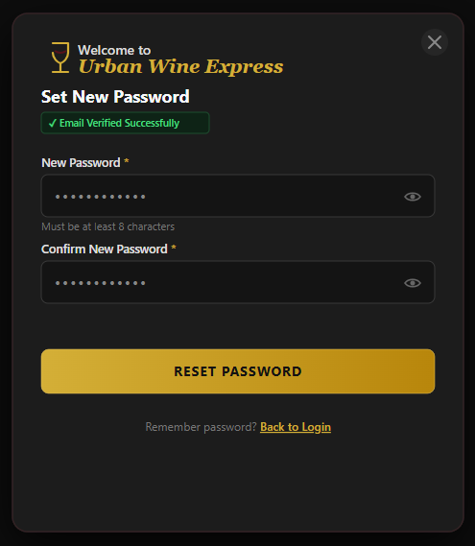

2.4 Create account for customer
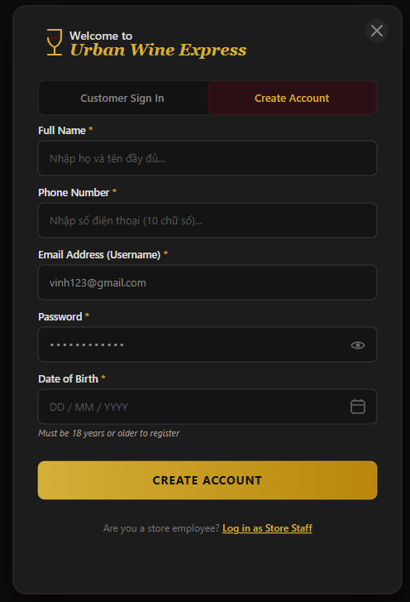

2.5 Login for staff
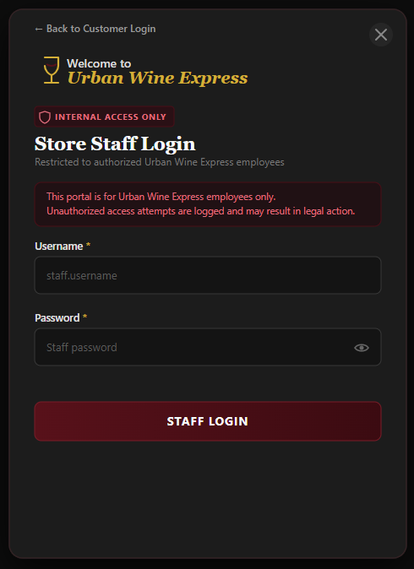

3.Screen of Customer

3.1Wine Catalog Page
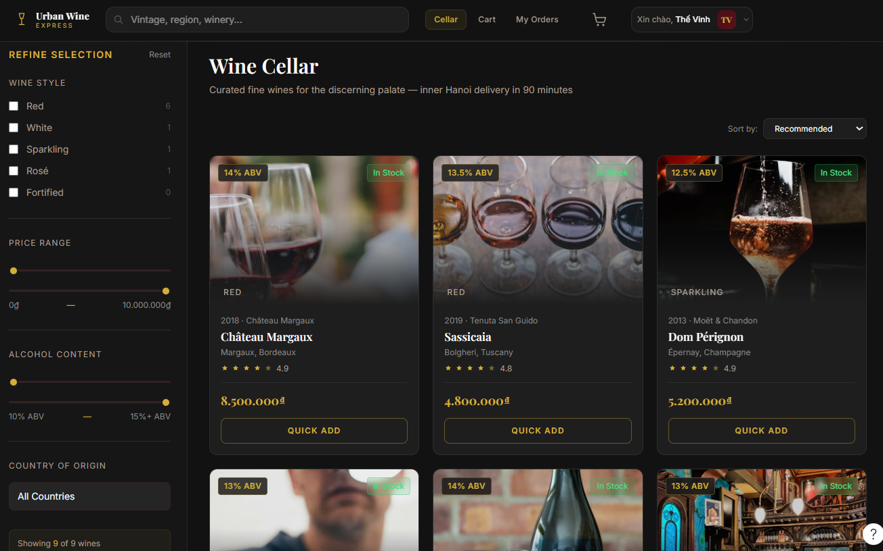

4. Quantity Select Modal
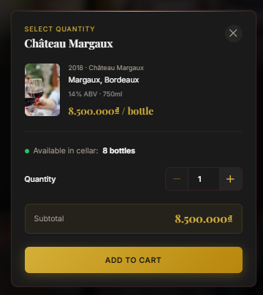

5. Wine Details Page
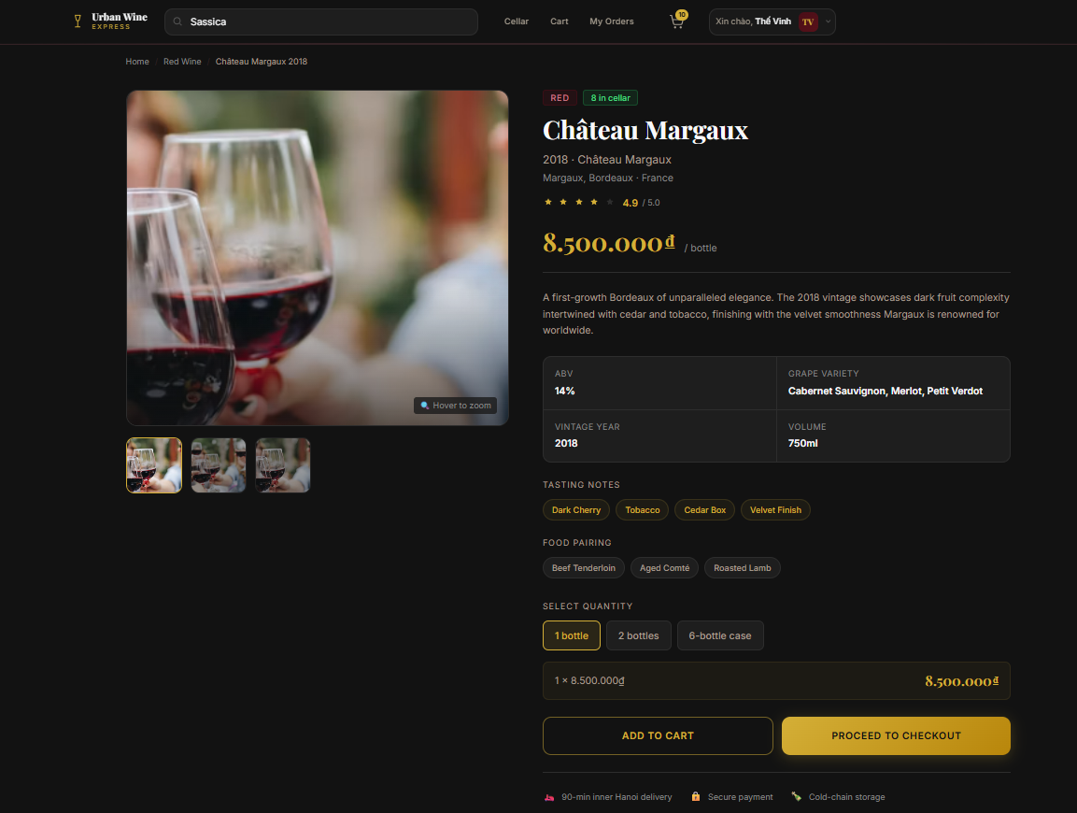

6. Shopping Cart Page
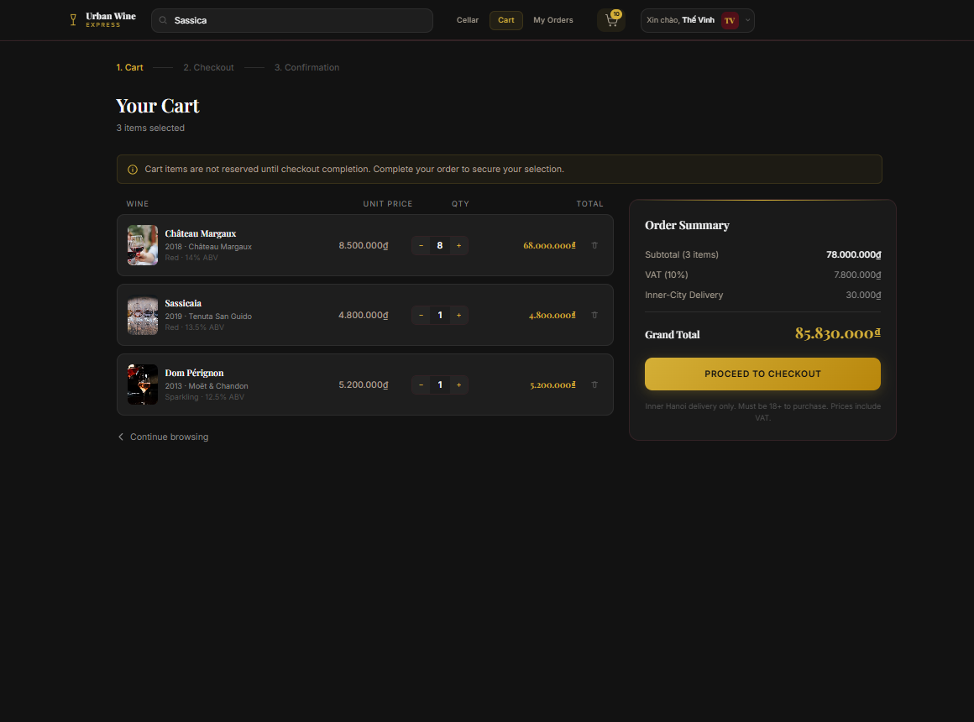

7.1 Checkout Page (SHIP COD)
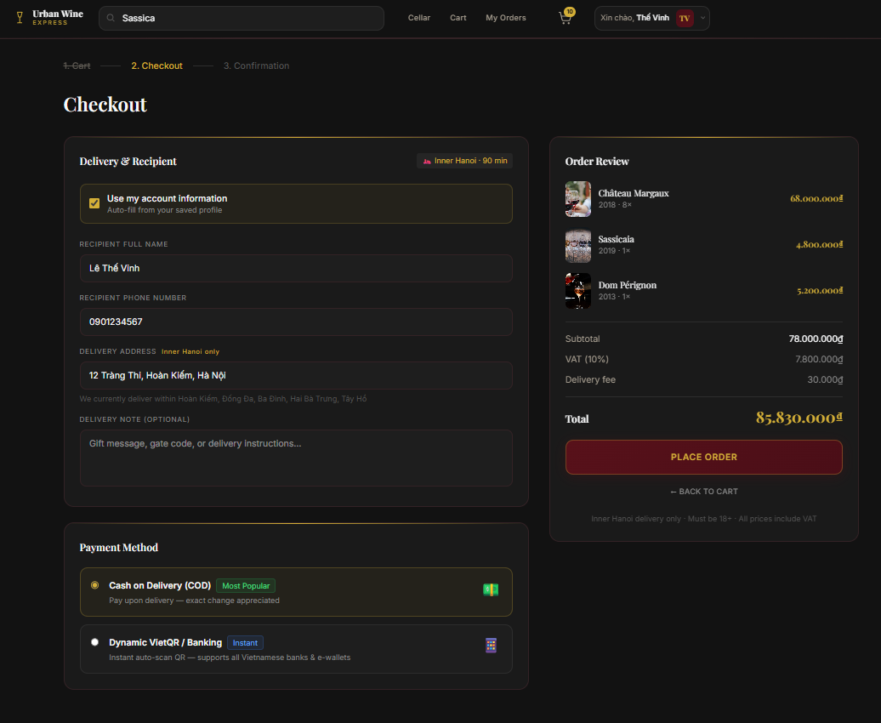

7.2 Checkout Page (VietQR)

7.2 Checkout Page (Place Order Successfully)
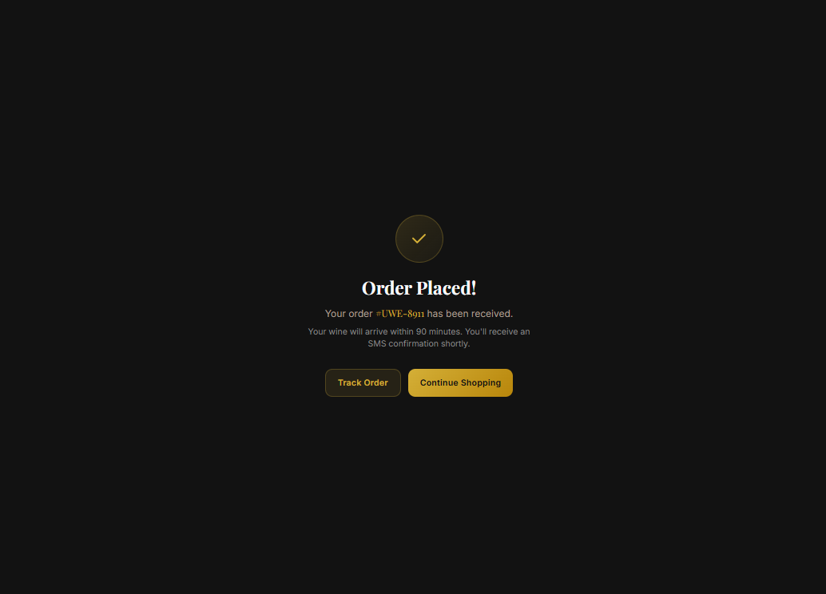

8.My Order Page

8.1 My Order Page (Status : All Order)
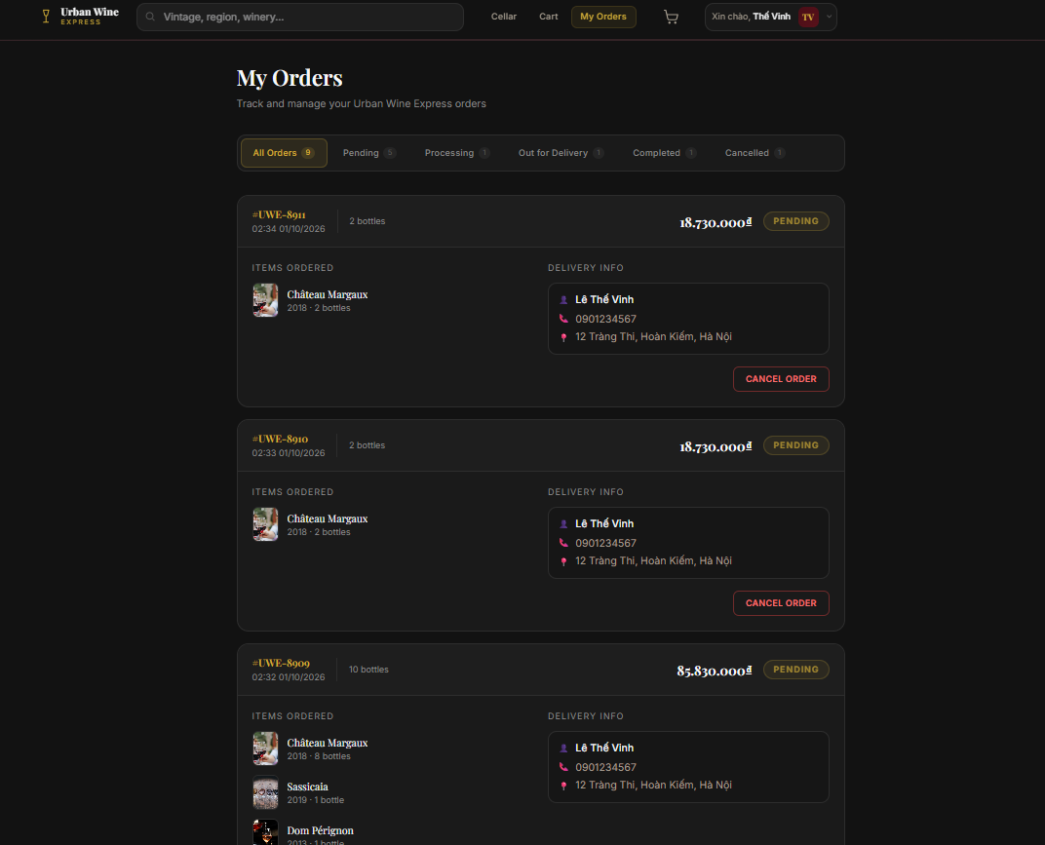

8.2 My Order Page (Status :Pending)
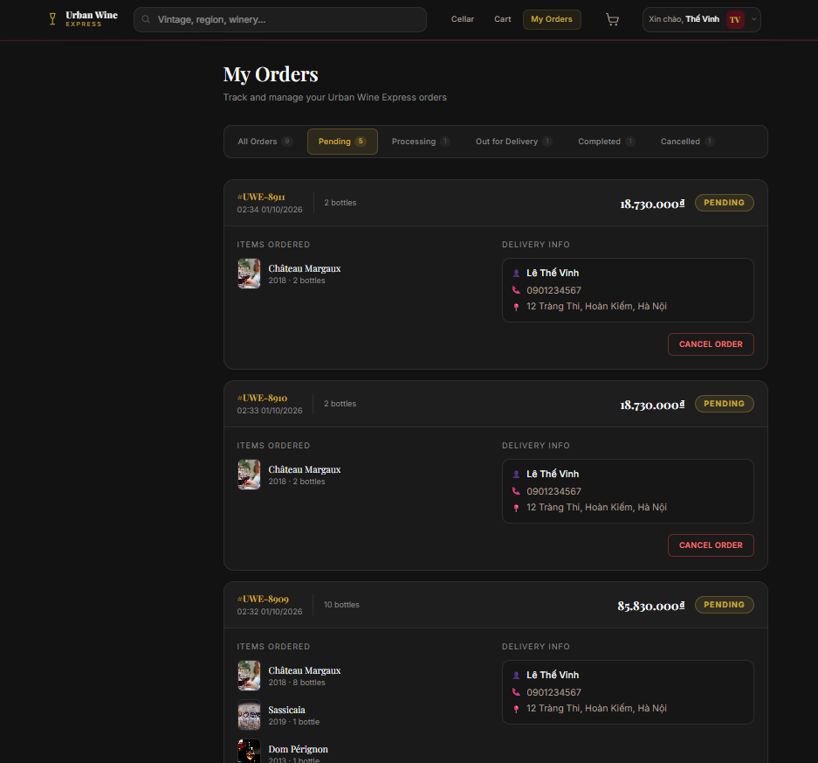

8.3 My Order Page (Status :Processing)
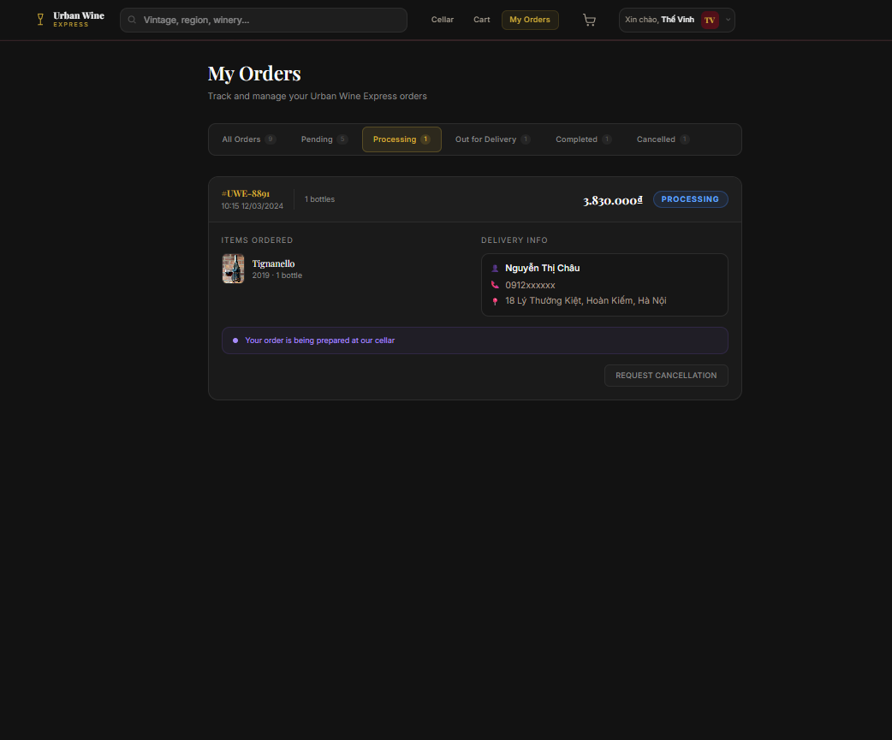

8.4 My Order Page (Status :Out for delivery)
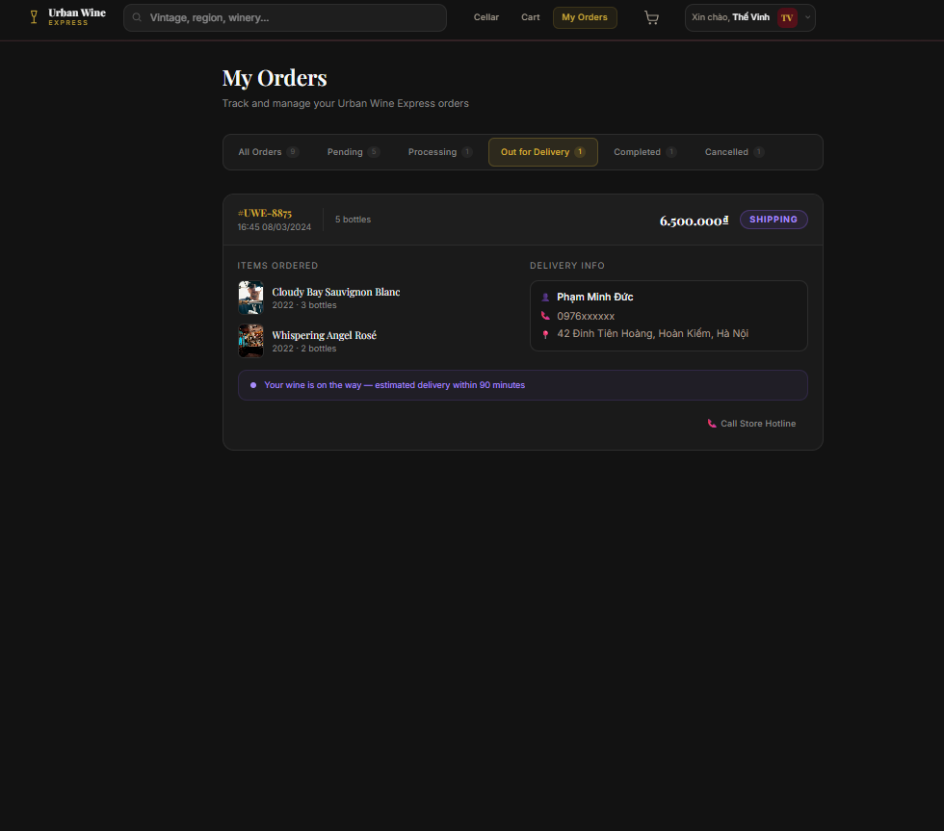

8.5 My Order Page (Status :Completed)
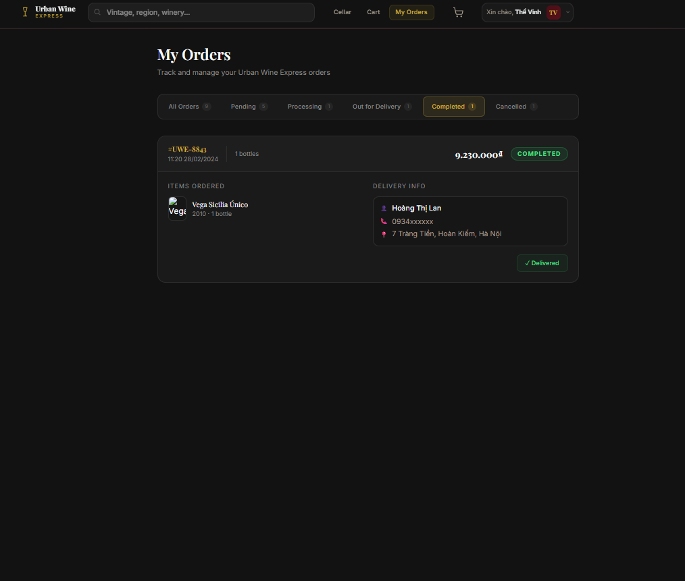

8.6 My Order Page (Status :Cancelled)
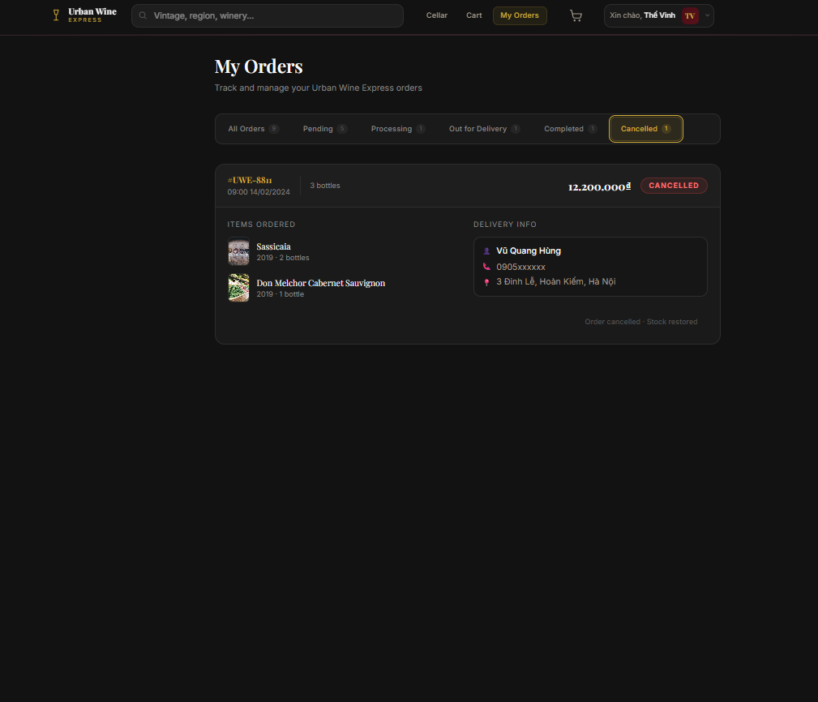

4.Screen of Admin

4.1 Admin dashboard
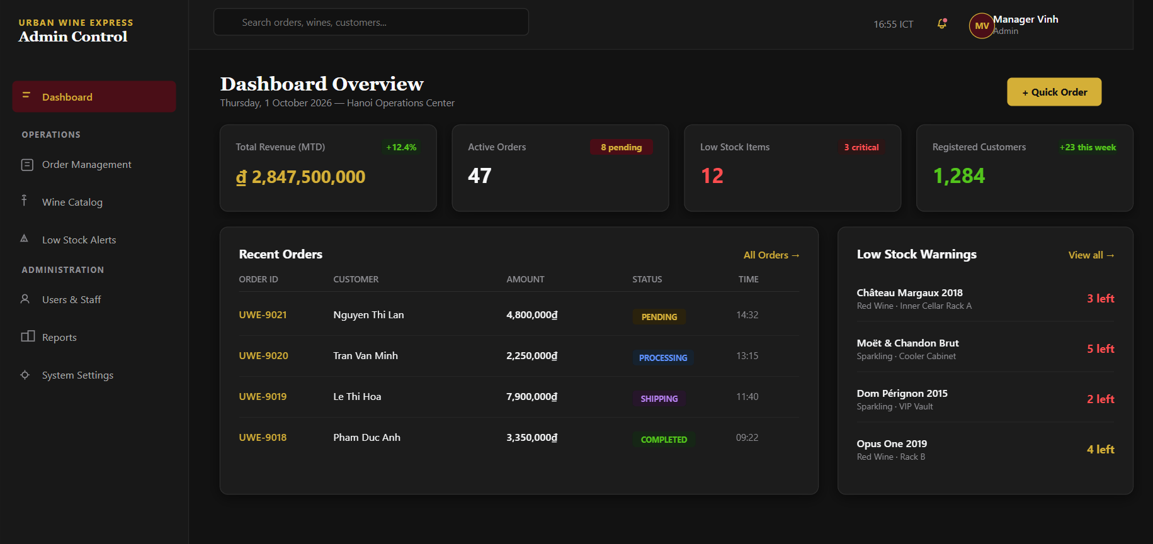

4.2 Order Management
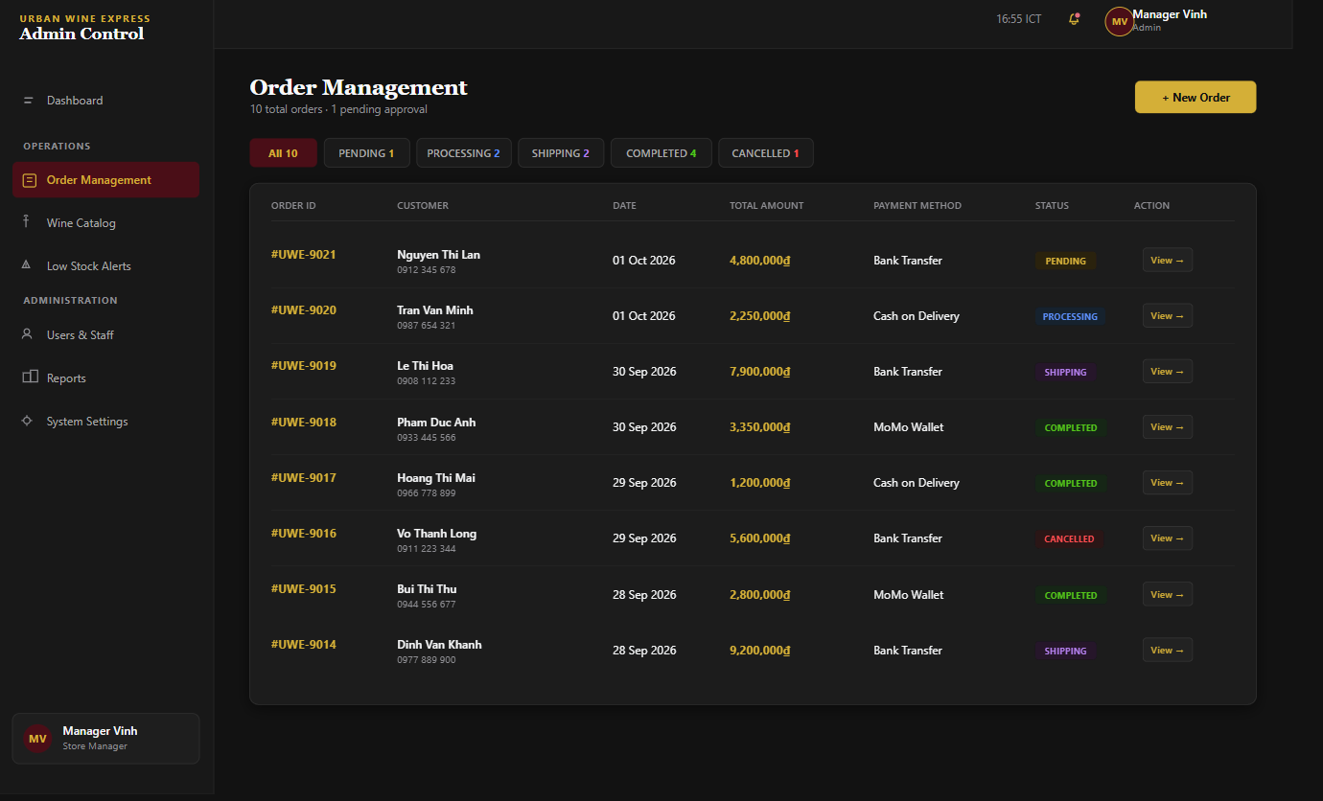

4.2.1Create New Order
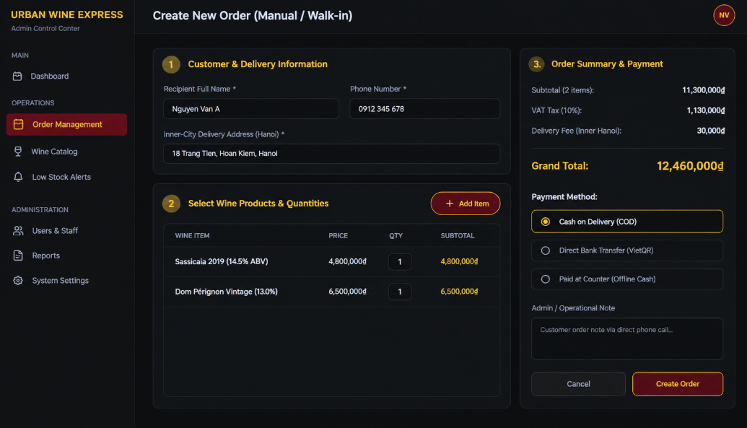

4.3 Wine catalog
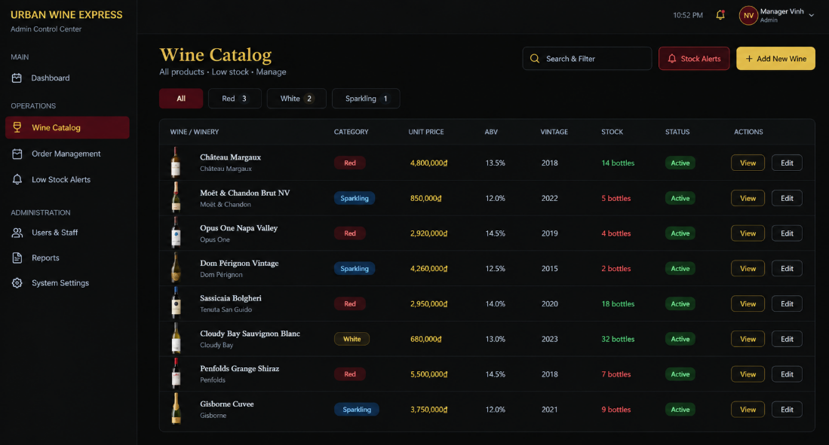

4.3.1Add new wine
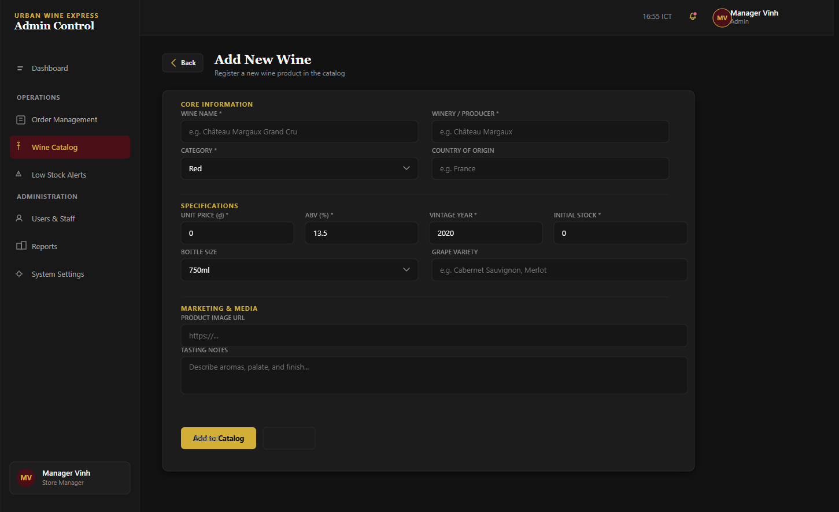

4.4 Low stock alert
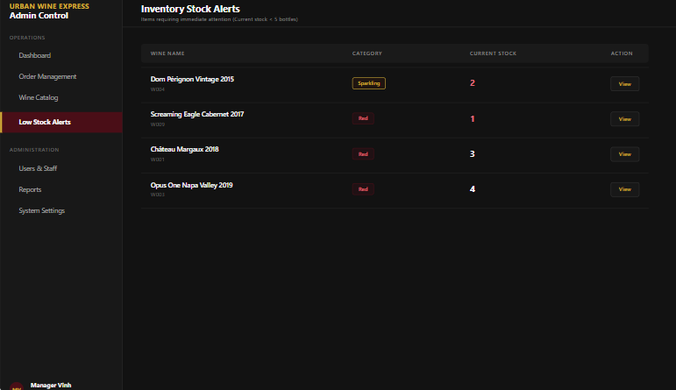

4.5 User & Staff

4.5.1 User List
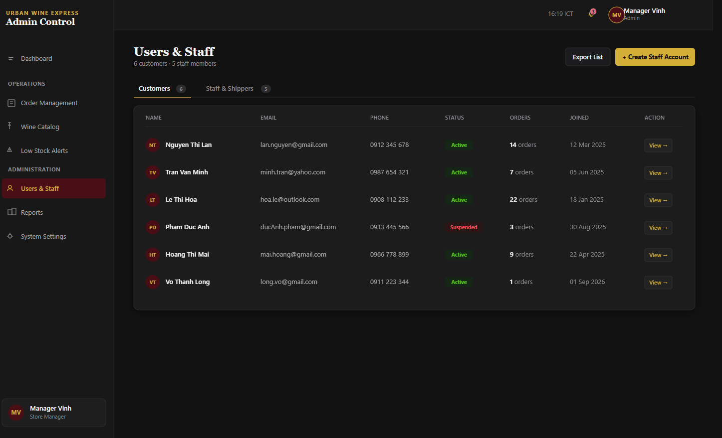

4.5.2 Shipper List
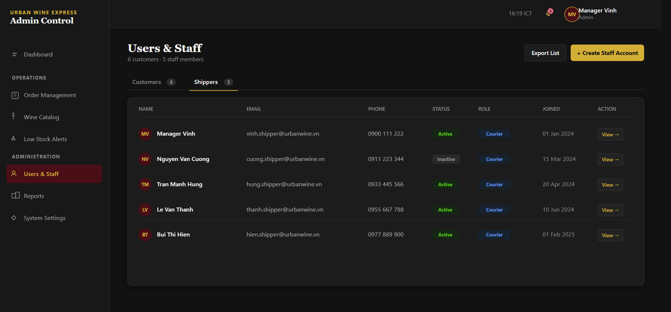

4.5.3 Create Staff Account
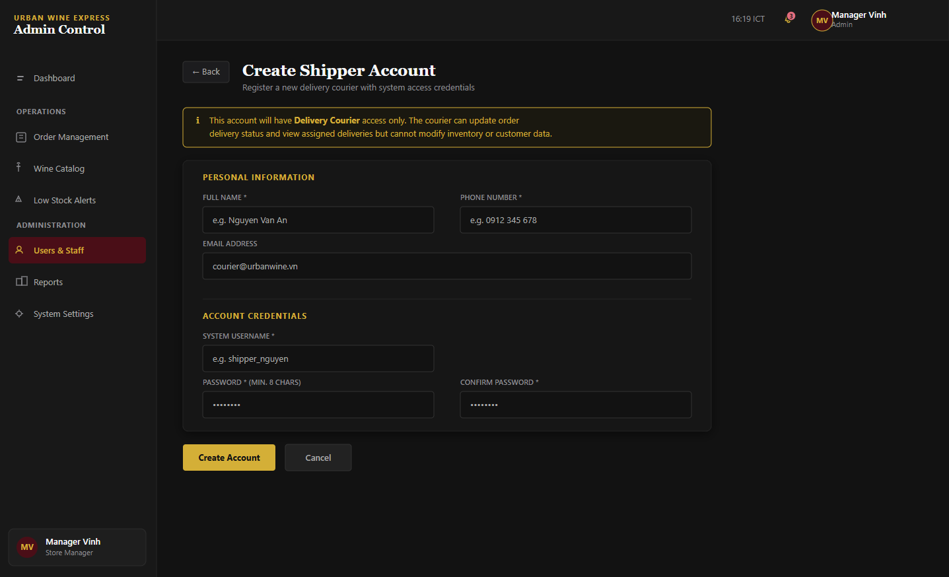

5.Screen of Shipper

5.1 Shipper Dashboard
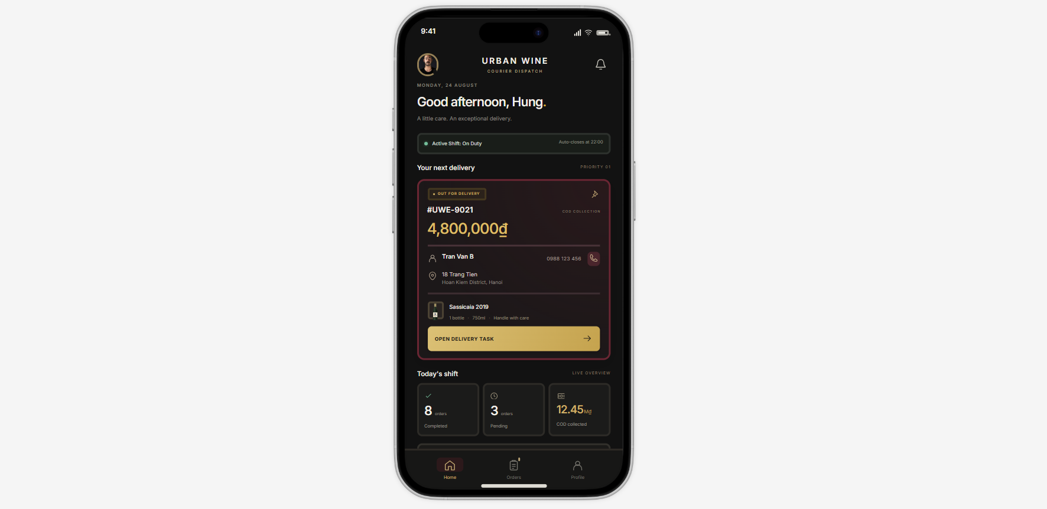
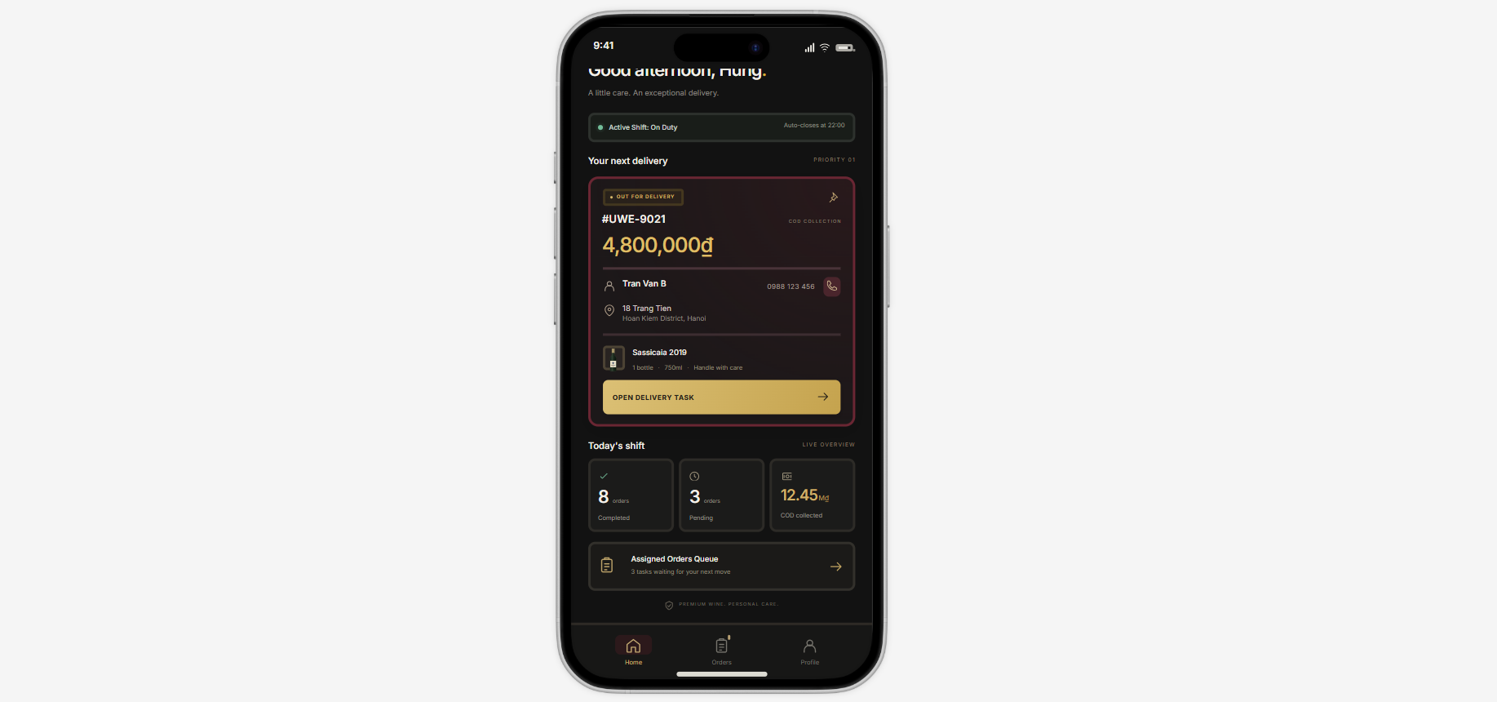

5.2 Shipper Profile
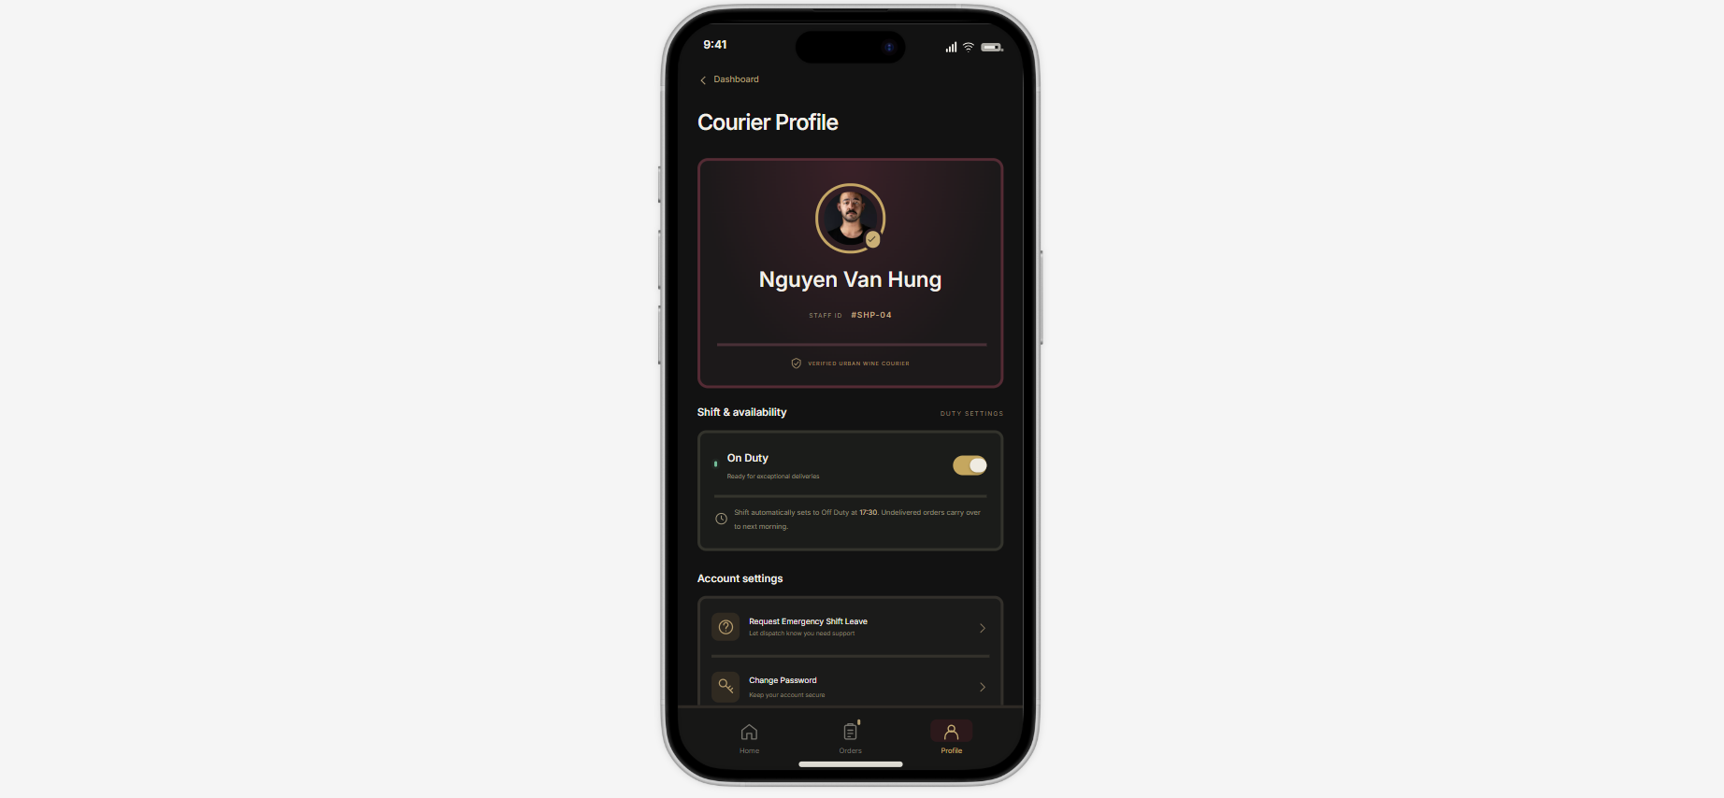

5.3 Notification Center

5.3.1 Status All
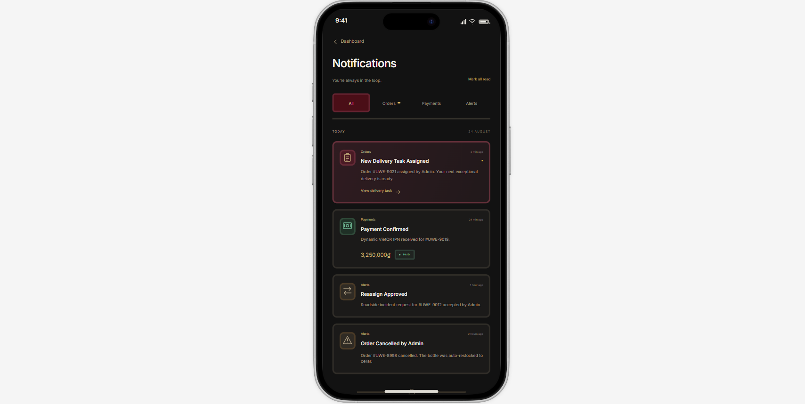

5.3.1 Status Order
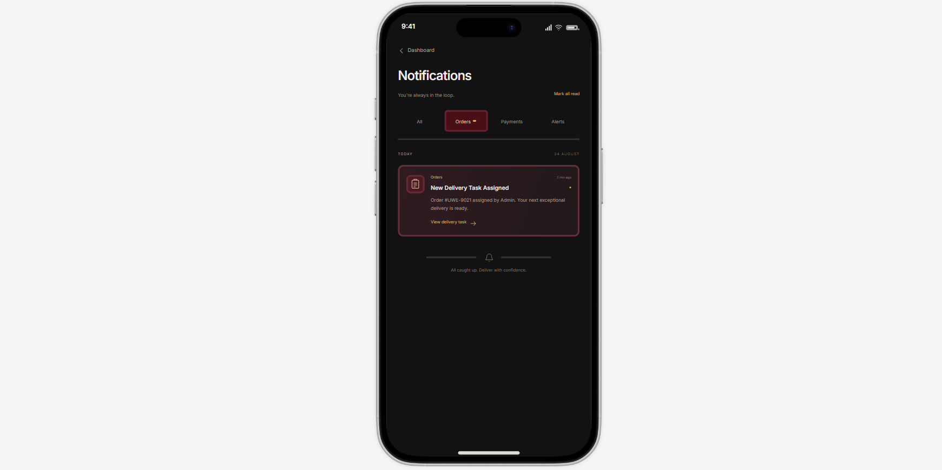

5.3.1 Status Payment
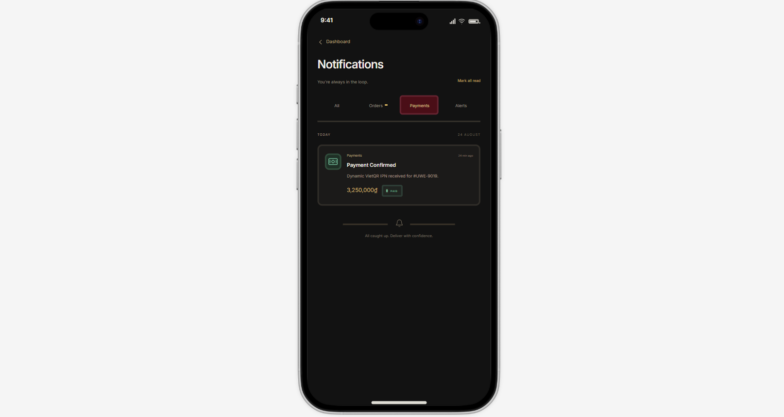

5.3.1 Status Alert
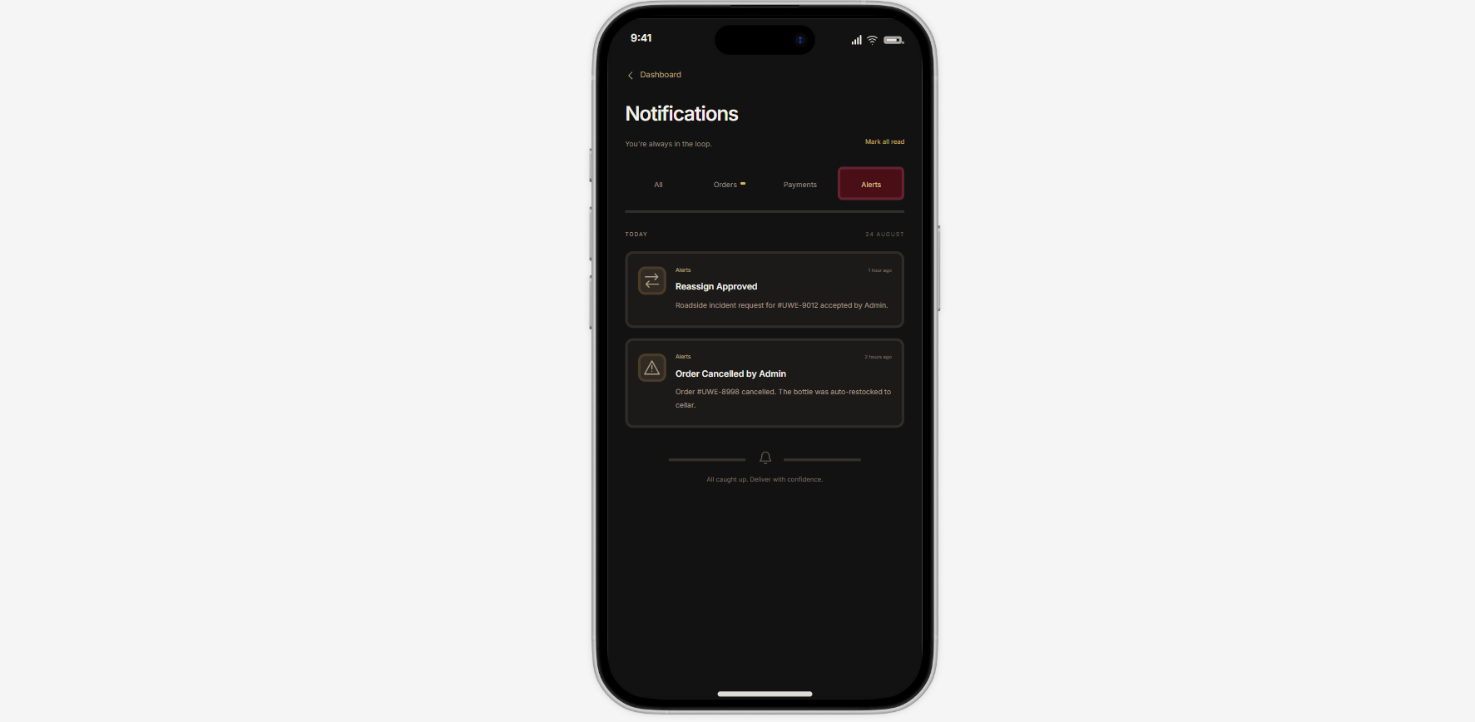

5.4 Assign Order List
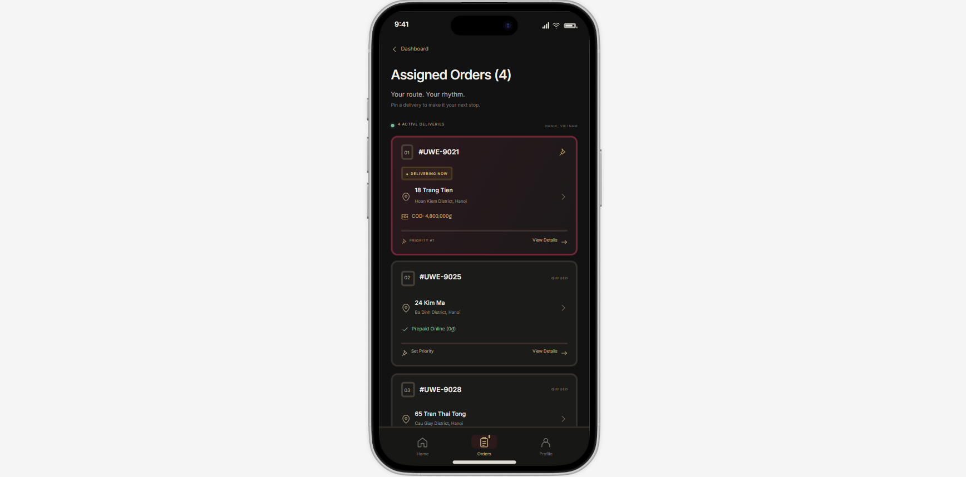

5.5 Shipper Order Detail
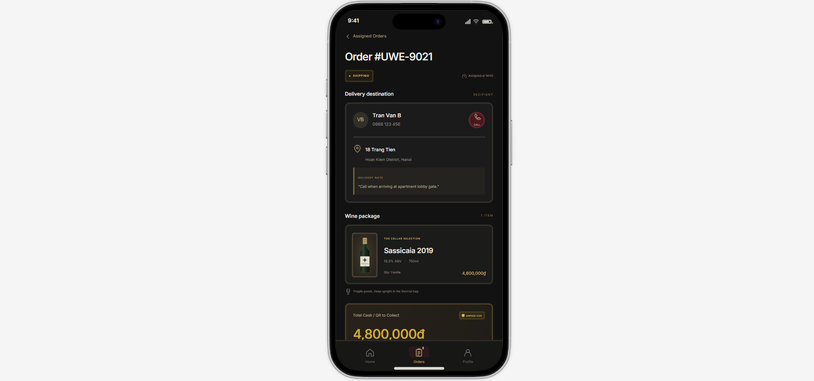
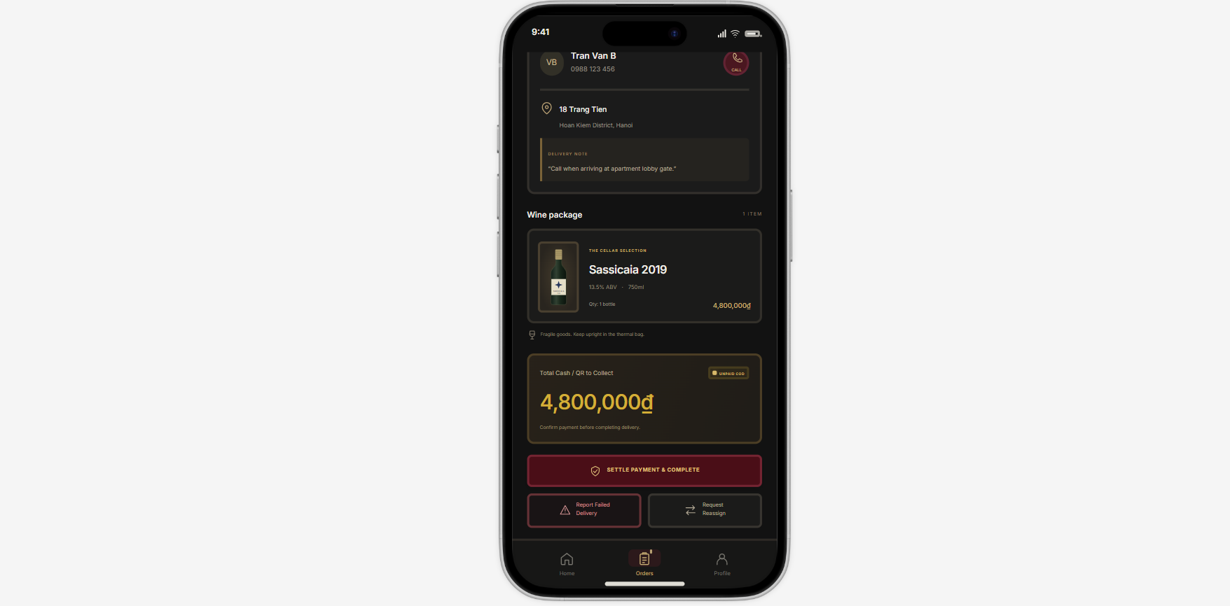

5.6 COD Payment Modal
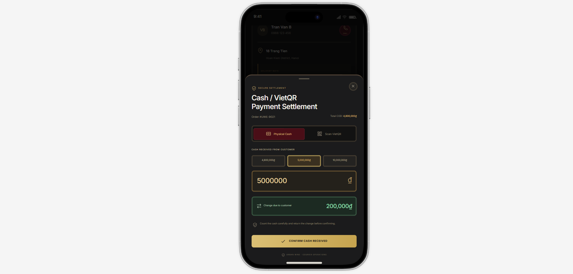

5.7 Scan QR Code

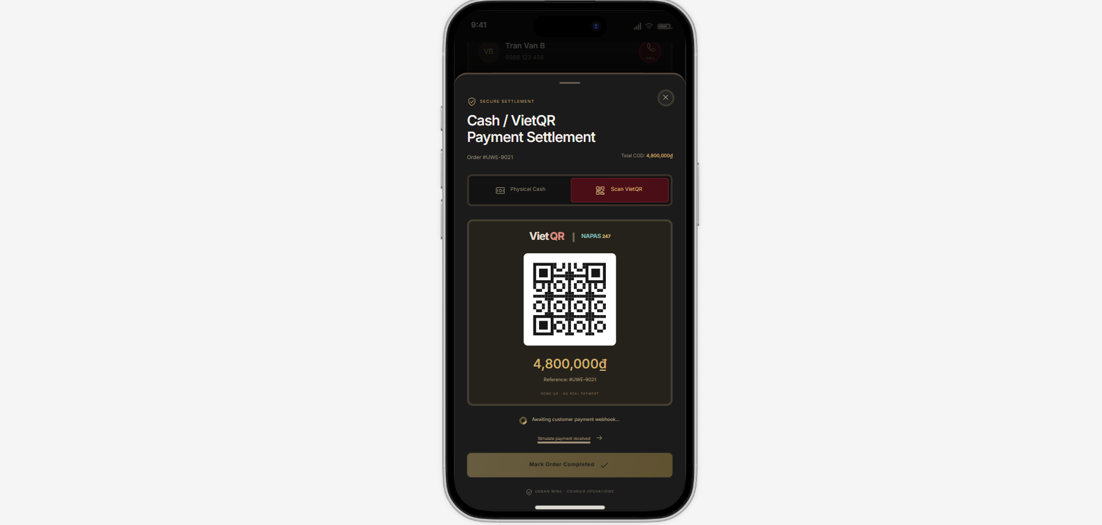

5.8 Failed Delivery Modal
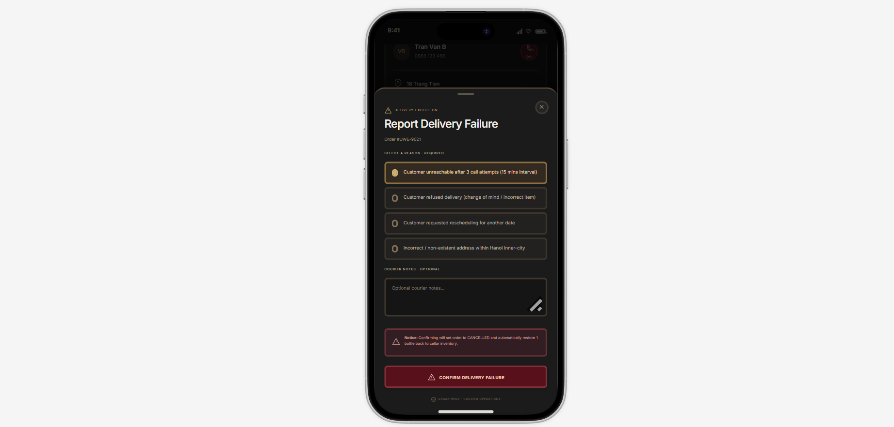

5.9 Request Reassign Modal
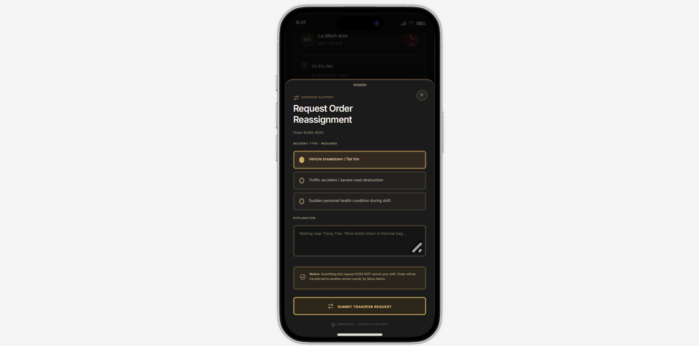

5. Request emergency shift leave
