BDA501 - BIG DATA ANALYTICS

Individual Assignment 2
Distributed BigEarthNet Processing with Apache Spark
HDF5-Direct Feature Engineering and Three-Class Evaluation
Student | Tran Phan Vinh Hoang
Report date | 27 September 2026

Executive overview
This report presents an Apache Spark workflow executed on a bounded BigEarthNet-S2 subset stored in four HDF5 shards. The run covers 52,607 patches from Austria, Finland, Ireland and Lithuania and preserves the official train/validation/test split (25,291 / 13,884 / 13,432). Spark executors read the HDF5 image arrays, derive eleven spectral summary features, and expose the resulting table for SQL analysis and three-class classification.
The feature stage completed with 52,607 input rows, 52,607 output rows and zero recorded errors in 76.136 seconds. Three independent NumPy recomputations matched the Spark output exactly. On the three-class test subset, the training-derived rule achieved 0.817 accuracy and 0.858 macro-F1; the reduced five-feature centroid reached 0.809 accuracy and 0.853 macro-F1.
Run at a glance | Value
Patches | 52,607
Countries | 4
Observed labels | 18
Features per patch | 11
Feature-stage errors | 0
Best test macro-F1 | 0.858 (rule)
Scope note: the supplied run is HDF5-direct. It does not demonstrate large-scale packing of the original per-band TIFF files. Environment topology and HDFS configuration values were not present in the supplied artifacts, so this report does not invent them.

1. Data scope and implemented pipeline

The assignment is based on BigEarthNet-S2 v2.0 and requires at least 50,000 patches from at least three countries. The implemented run satisfies that processing scale with four countries and 52,607 patches.
Item | Run value
Selected countries | Austria, Finland, Ireland, Lithuania
Total patches | 52,607
Train | 25,291
Validation | 13,884
Test | 13,432
Observed land-cover labels | 18
Main source format | HDF5
Host data path | D:\BigEarthNet-partial
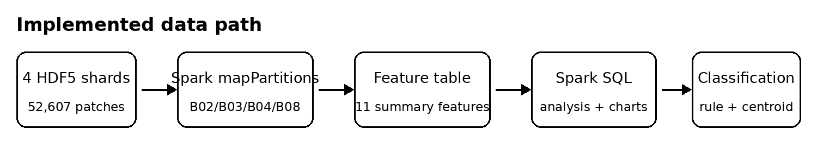
Figure 1. Implemented data path. Image decoding and feature computation remain on Spark executors.

2. Step 1 - Ingestion and storage

The main processing path reads four HDF5 shards directly. This avoids materialising tens of thousands of small TIFF files and allows an executor to reuse an open shard handle for multiple rows in the same partition.
The assignment also asks for measured small-file packing, HDFS file/byte counts, block size and replication. The supplied artifacts only state that a small TIFF packing pilot exists; they do not provide its measured before/after counts or HDFS configuration. The report therefore treats TIFF packing as a pilot concept rather than claiming a full 50,000-patch storage result.
Before submission, add the actual Spark/Hadoop deployment mode, Spark version, worker cores and memory, HDFS block size, replication factor, and hdfs dfs -count/-du evidence if those outputs exist.

3. Step 2 - Distributed feature engineering

The hdf5_features.py stage uses Spark mapPartitions. Each executor opens the required HDF5 shard once for a partition, reads the indexed image row, selects the 10 m bands B02 (Blue), B03 (Green), B04 (Red) and B08 (NIR), and emits a row with an explicit schema. This design avoids a driver-side image loop.
For each band, the pipeline computes mean and standard deviation. It then derives three additional descriptors:
NDVI = mean((B08 - B04) / (B08 + B04 + 1e-6))
NDWI = mean((B03 - B08) / (B03 + B08 + 1e-6))
brightness = (mean_B02 + mean_B03 + mean_B04 + mean_B08) / 4
The resulting row contains eleven features: eight band statistics plus NDVI, NDWI and brightness.

3.1 Validation

Validation check | Result
Input rows | 52,607
Output rows | 52,607
Error rows | 0
Countries | 4
Official splits | 3
Elapsed time | 76.136 s
Independent NumPy checks | 3 / 3 exact matches
The one-to-one input/output count and zero error rows show that the executor stage completed for the full selected subset. The three NumPy checks reported a maximum absolute difference of 0.0, providing a direct correctness check for sampled patches.

3.2 Feature design rationale

NDVI separates photosynthetically active vegetation from low-NIR surfaces, while NDWI is useful for water-related contrast. Mean B08 and brightness capture overall NIR and reflectance level, and band standard deviations retain a limited measure of within-patch variation. These are compact features that work well with SQL and centroid models, although they discard spatial texture.

4. Step 3 - Spark SQL analysis
The feature table contains 52,607 patches, four countries and 18 observed labels. BigEarthNet annotations are multi-label, so label-frequency analysis is performed after exploding the label array; the resulting label counts do not sum to the number of patches.
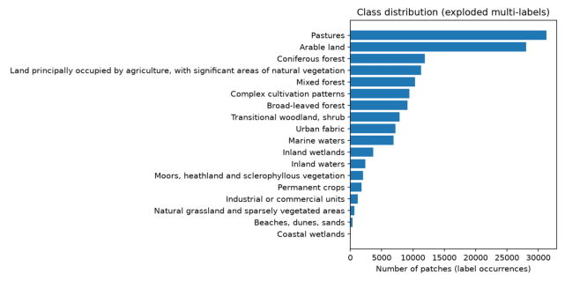 | 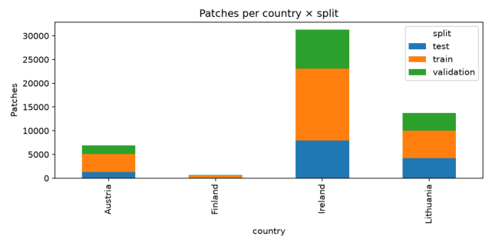
Figure 2. Spark SQL outputs: exploded class distribution (left) and country x official split counts (right).

4.1 Class imbalance
Pastures is the most frequent label and Arable land is second, while several classes form a long low-frequency tail. This imbalance is important for Step 4: a model can appear reasonable on accuracy while failing minority classes, so macro-F1 is reported alongside accuracy.

4.2 Geographic imbalance and split integrity
The selected population is geographically uneven. Ireland contributes the largest share of this four-country subset, while Finland contributes the smallest. The plot also shows that the official train, validation and test groups are retained rather than replaced with a random split.
The supplied artifacts show these three charted SQL analyses. Additional SQL query outputs requested by the assignment should be added from the real result files if available; no values from another student were used to fill the gap.

4.3 Mean NDVI by country
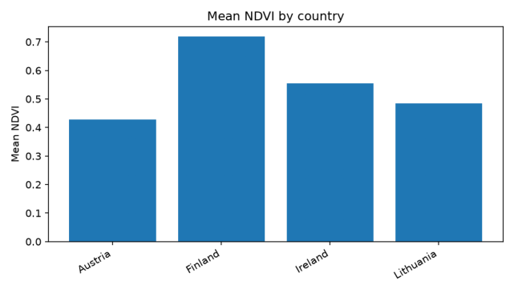
Figure 3. Mean NDVI by country for the selected four-country subset.
The plotted group means show clear differences: Finland is highest at about 0.72, followed by Ireland at about 0.55, Lithuania at about 0.48 and Austria at about 0.43. These are descriptive summaries of the selected patches and should not be interpreted as a causal country effect.

4.4 What the SQL stage contributes
- It verifies the scale and composition of the feature table before modelling.
- It exposes both class imbalance and country imbalance, two factors that affect interpretation of aggregate scores.
- It produces compact, reproducible summaries directly from Spark SQL rather than exporting the full feature table for local analysis.
- The class-frequency and country-level results provide context for why macro-F1 and the official split are important in Step 4.
The SQL stage therefore acts as more than a visualisation step: it is a data-quality and modelling-context check between distributed feature engineering and classification.

5. Step 4 - Three-class classification
The prepared task contains Pastures, Arable land and Marine waters. The task rows are 16,835 train, 7,551 validation and 6,371 test. Training statistics are used for the rule thresholds and feature standardisation; validation is used to choose the reduced feature variant; the reported model scores are from the official test subset.

5.1 Model definitions
Majority baseline. Every row is predicted as Pastures, the largest test class. This provides a deliberately weak reference for both accuracy and macro-F1.
Training-derived rule. Training class means are ordered along NDVI and cuts are placed between neighbouring means. The supplied training statistics show strong spectral ordering: Marine waters has mean NDVI -0.252, Arable land 0.479, and Pastures 0.725.
Nearest centroid. Features are standardised with training-set means and standard deviations; one centroid is computed per class; prediction selects the nearest centroid in standardised feature space. The reduced variant uses NDWI, mean B08, NDVI, brightness and std B08.
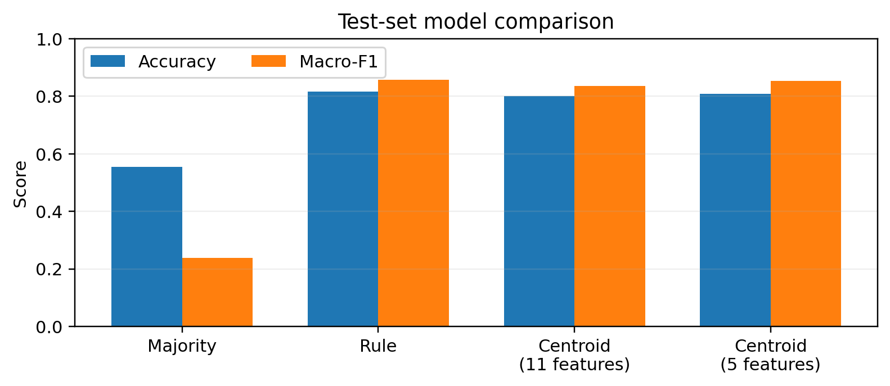
Figure 4. Test-set accuracy and macro-F1 for the four evaluated baselines/models.
Model | Accuracy | Macro-F1
Majority class | 0.554 | 0.238
Training-derived rule | 0.817 | 0.858
Centroid - 11 features | 0.800 | 0.837
Centroid - 5 features | 0.809 | 0.853

5.2 Reduced feature choice and per-class behaviour
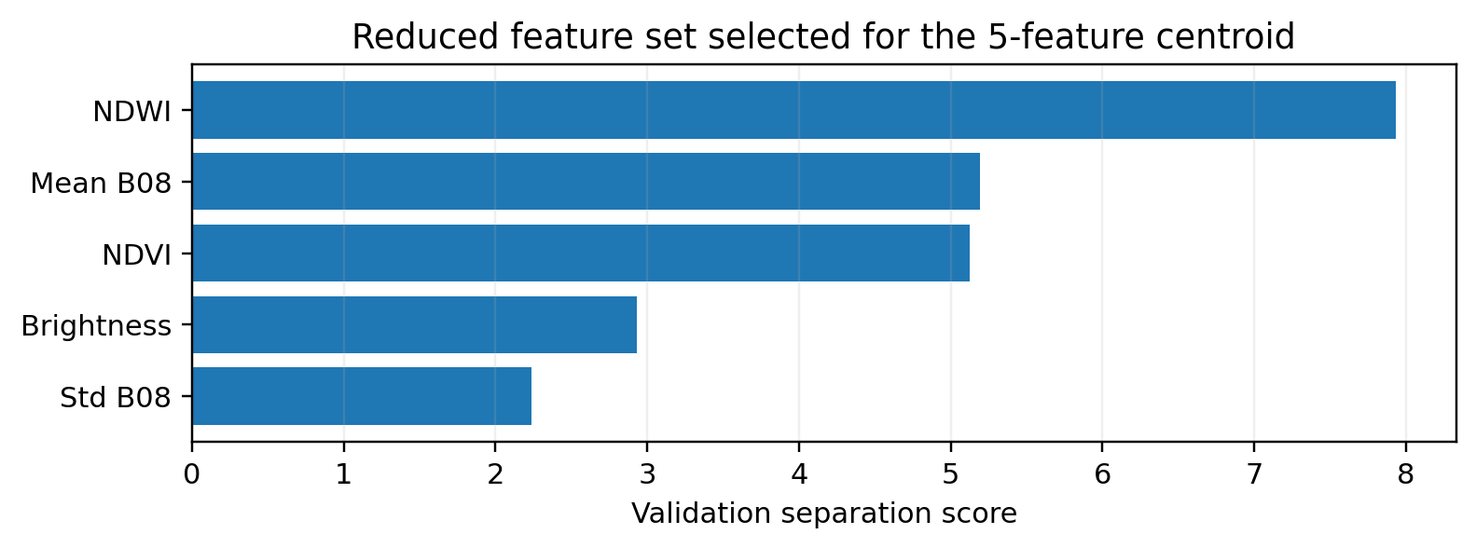
Figure 5. Validation separation scores for the five features used by the reduced centroid.
Model | Class | Precision | Recall | F1
Rule | Pastures | 0.793 | 0.905 | 0.846
Rule | Arable land | 0.852 | 0.695 | 0.766
Rule | Marine waters | 0.955 | 0.972 | 0.963
Centroid - 11 | Pastures | 0.770 | 0.912 | 0.835
Centroid - 11 | Arable land | 0.855 | 0.648 | 0.737
Centroid - 11 | Marine waters | 0.905 | 0.972 | 0.938
Centroid - 5 | Pastures | 0.831 | 0.823 | 0.827
Centroid - 5 | Arable land | 0.776 | 0.784 | 0.780
Centroid - 5 | Marine waters | 0.929 | 0.972 | 0.950

Marine waters is the easiest class for all three non-majority models because its spectral statistics are far from the vegetation classes. The main overlap is between Pastures and Arable land. The reduced centroid trades some Pastures recall for a substantial increase in Arable land recall (0.784 vs 0.648), which lifts macro-F1 above the full centroid.
A complete off-diagonal confusion matrix is not reconstructed because the supplied artifacts contain per-class TP/FP/FN values but not the unique pairwise misclassification counts.

6. Discussion
Three conclusions are supported by the run. First, a simple training-derived spectral rule is highly competitive for these three classes. This is plausible because water and vegetated land differ strongly in NDVI and NIR behaviour, and the chosen classes have clearly ordered training means.
Second, using all eleven summary features does not automatically improve a distance-based classifier. The five-feature centroid reaches 0.853 macro-F1, compared with 0.837 for the full centroid. The reduced representation appears to remove weak or redundant dimensions and produces more balanced behaviour between Pastures and Arable land.
Third, the model should be interpreted as a compact spectral baseline. Patch-level means and standard deviations discard spatial texture, edges and local patterns inside each 120 x 120 image. A richer image model could exploit information that the centroid representation cannot see.

7. Limitations and reproducibility
- The main path uses HDF5 arrays instead of demonstrating full-scale packing of original per-band TIFF files.
- Cluster topology/version, HDFS block and replication evidence, partition-count timing comparisons and Spark UI screenshots were not present in the supplied artifacts.
- The supplied metrics include per-class TP/FP/FN, but not enough pairwise counts to reconstruct a unique full confusion matrix.
- All reported classification metrics use the supplied official test subset; the reduced feature set is identified from validation separation rather than test performance.
For reproducibility, submit the scripts that produce the feature table, SQL outputs and Step 4 metrics together with dependency information and exact run commands. The report should be updated with any missing runtime/HDFS evidence from the actual project outputs rather than estimating it.

AI acknowledgement
Generative AI was used to help reorganise and polish the written report. Dataset counts, timings, feature definitions and evaluation metrics in this document come from the supplied project artifacts and were not copied from another student's report.

