**ASSIGNMENT 1 FRONT SHEET**

|  |  |  |  |
| --- | --- | --- | --- |
| **Qualification** | **BTEC Level 5 HND Diploma in Computing** | | |
| **Unit number and title** | Unit 30: Application Development | | |
| **Submission date** |  | **Date Received 1st submission** |  |
| **Re-submission Date** |  | **Date Received 2nd submission** |  |
| **Student Name** |  | **Student ID** |  |
| **Class** |  | **Assessor name** |  |
| **Student declaration**  I certify that the assignment submission is entirely my own work and I fully understand the consequences of plagiarism. I understand that making a false declaration is a form of malpractice. | | | |
|  |  | **Student’s signature** |  |

**Grading grid**

|  |  |  |  |  |  |
| --- | --- | --- | --- | --- | --- |
| P1 | P2 | P3 | M1 | M2 | D1 |
|  |  |  |  |  |  |

|  |  |  |
| --- | --- | --- |
| **❒ Summative Feedback: ❒ Resubmission Feedback:** | | |
| **Grade:** | **Assessor Signature:** | **Date:** |
| **Lecturer Signature:** | | |

Software Requirements Specification

for

Manage management system

Prepared by

Tran Dang Khoa GCD17291 [khoatdgcd17291@fpt.edu.vn](mailto:khoatdgcd17291@fpt.edu.vn)

Instructor: Hoang Nhu Vinh

Course: Application Development

Date:

1. **Introduction**

Now that the technology is rapidly being developed, FPT Co. wants to create the company's ongoing study environment. A framework that manages the "Training" operation for the company's internal training program should be created. This method can be used for managing trainee accounts, managing teachers, managing groups of courses, managing courses, managing subjects, assigning subjects to courses, assigning teachers to subjects, assigning trainees to courses. This is a scheme that the university uses, we have three roles in this system, an administrator, training staff and a trainer.

* 1. **Purpose**

This documentation includes the program specifications, functional and non-functional, of FPT Co. Web application training to ensure that the software provider and FPT Co. agree on the features needed in the construction of the software framework. In addition, SRS also includes analytical models that include the comprehensive design and development of the software framework, such as use case diagrams, entity relationship diagrams, data flow diagrams, etc).

Through this table, we can clearly define the role defined by assigning member assignments:

|  |  |  |
| --- | --- | --- |
| No. | Student | Functions |
| 1 | Tran Dang Khoa |  |
| 2 | Pham Ngoc Hien |  |

* 1. **Scope**

FPT Co. Training Web-Application is an enterprise software devoted to the management of "Training" practices for the company's internal training program. The HR department uses this method to manage trainee accounts, manage trainers, manage groups of classes, manage lessons, manage subjects, assign topics to classes, assign trainers to topics, assign trainees to lessons.

The system maintains a continuous study atmosphere in the FPT Co. by improving the HR department's management training activities, including: an administrator, training personnel, teacher and trainees, divided into 4 positions in the system. Trainer and trainee positions will be influenced by administrator monitoring of training personnel.

* 1. **Intended Audience and Document Overview**

Individuals directly involved in the creation of FPT Co are the intended audience of this text. Web-application Instruction. Both major stakeholders, including the construction team, the owner of the project, the client of the project, the senior project consultant (Mr. Hoang Nhu Vinh), and everyone assessing the project. It is not appropriate to read this document sequentially, and users are encouraged to move to any section they find important. A quick summary of each section of the document below to assist the intended audience in locating the section they need.

**Part 1**- Introduction

This section included six small sections explaining the purpose of the SRS documentation and defining the nature of the protected product. Furthermore, a brief description of FPT Co. Web-Application training and its aim, including specific goals , objectives, benefits and objectives. It also defines the intended audiences in the content of this section and suggested the reading order for the audience; in addition, the meanings, acronyms and abbreviations; adequate major document conventions and references are also provided

**Part 2**- Definition Overall

A summary of the meaning and origin of FPT Co is the main content of this section. Internet application preparation, as well as a simple diagram that showed the main part of the framework, was shown. In addition, via the list given, it also provides a review of the key features of the system; the details of the issue that will restrict the choice available to developers, and a list of any presumed factors that might influence the requirement states in the SRS..

**Part 3**- Clear demands

Readers were curious about how FPT Co. This section, which covers data structures and flow patterns used by the system in the analytical model, such as use case diagram, entity relationship diagram , data flow diagram, as well as use case definition, should be consulted by the training Web-application organizes and handles data. In addition, this section covers all the specifics related to the graphical user interface framework, including some FPT Co preliminary mockup screens. Web-application Instruction. For a preliminary preview of what the final product would look like, readers may view this section.

**Part 4**- Other non - functional needs

The following parts provide a list of performance criteria for FPT Co. Web application training under different features or functions; defining the actual machine timing relationships. In addition , it includes a list of specifications related to potential damages or ham that may occur in the use of the system and safety certificates that need to be met, as well as providing precautions or steps that need to be taken, measures that need to be avoided, and a summary of certain additional system quality characteristics.

**Part 5**- Additional Criteria

A list of some other specifications not addressed elsewhere in the SRS is included in this section.

* 1. **Definitions, Acronyms and Abbreviations**

|  |  |  |
| --- | --- | --- |
| No. | Abbreviations/ Terms | Explanation |
| 1 | SRS | Software Requirement Specification |
| 2 | SC | Screen |
| 3 | UC | Use Case |
| 4 | C.R.U.D | Create/ Read/ Update/ Delete a record in database |
| 5 | PF | Product Feature |
| 6 | CO | Constraints |
| 7 | AS | Assumption |
| 8 | DE | Dependencies |
| 9 | UI | User Interfaces |
| 10 | SI | Software Interfaces |
| 11 | CI | Communication Interfaces |
| 12 | PE | Performance Requirement |
| 13 | SE | Security Requirement |

**Table 1** Definitions, Acronyms and Abbreviations table

* 1. **Document Conventions**

The IEEE formatting specifications are followed in this paper. Use font size 11 of Time New Roman for text in the paper. For remarks, use italics. The text of the paper should be single-spaced. For names in Parts and Subsections that obey the SRS- pattern (Nang, n.d.).

* 1. **References and Acknowledgments**

|  |  |  |
| --- | --- | --- |
| **No.** | **Name** | **Description** |
| **1** | Software Requirements Specification Template | A template that document followed |

**Table 2** References and Acknowledgment table.

1. **Overall Descriptions**
   1. **Product Overview**

FPT. Co Training Web-Applications is a modern framework that manages the "Training" operation for the company's internal training program to create the ongoing research atmosphere in the company. The context diagram in Figure 1 shows external entities and interfaces between systems.

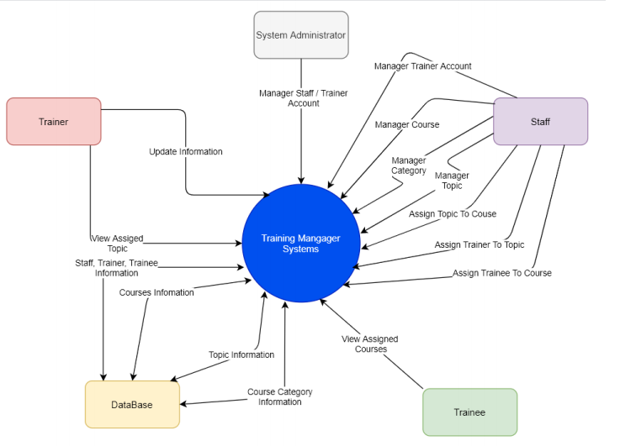

**Figure** 1 illustrates the external entities and system interfaces

* 1. **Product Functionality**

FPT Co. Training Web-application provides users with the following features / functions based on the rights of each user listed, such as **Figure 1**.

|  |  |
| --- | --- |
| **User types** | **Product Functionality** |
| **General functions** | PF-1: Log as identified accounts (depends on the type of accounts, each account has the clearly appropriate user rights).  PF-2: Log out |
| **Administrator** | PF-3: Manage Training Staff accounts (C.R.U.D)  PF-4: Manage Trainer accounts (C.R.U.D) |
| **Trainer** | PF-16: View trainer personal profile  PF-17: View topics that trainer is assigned  PF-18: View course which have a topic trainer is assigned |

**Table** 3 FPT Co. Training Web-application functionality

* 1. **Design and Implementation Constraints**

The difficulty of product creation is shown in the following table:

|  |  |
| --- | --- |
| **Design and Implementation Constraints ID** | **Descriptions** |
| **CO-1** | It is important to make the database available to internal sources for queries. For other teams to update the system or work on it, the client would like the database to be able to be easily updated in the future. |
| **CO-2** | Features in a web application, security features, and security must be enabled by the design to counter this dependency on the web. |

**Table 4** Design and Implement Constraints of FPT Co. Training Web-application.

* 1. **Assumptions and Dependencies**

|  |  |
| --- | --- |
| **Assumptions and Dependencies ID** | **Description** |
| **AS-1** | Users have a given account can login |
| **DE-1** | Using MS­SQL depends upon a Microsoft Windows operating system. |
| **DE-2** | Free Microsoft account |
| **DE-3** | Free Azure account |

**Table 5** Assumptions and Dependencies.

1. **Specific Requirements**
   1. **Product Perspective**

This application functions separately, provides a single place for FPT Co the staffs, trainers and trainees. Search, manage and authorize individuals, including help for the management of trainee accounts, manage trainers, manage course categories, manage courses, manage topics, assign topic to course, assign a trainer to a topic, assign a trainee to a course.

* 1. **Actors and Use Cases Descriptions**
     1. **Use cases**
* **Use case Administrator Role**

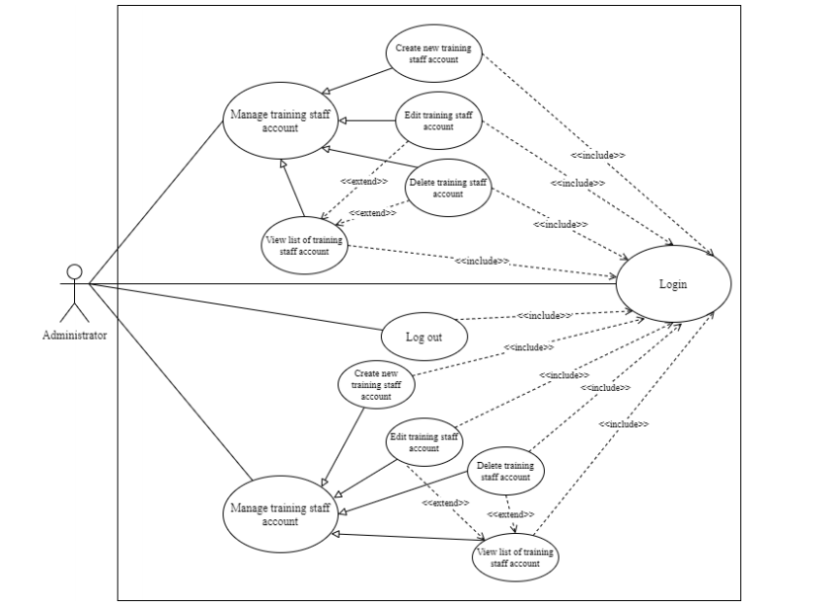

**Figure 2** Use case Administrator role.

* **Use case Trainer role**

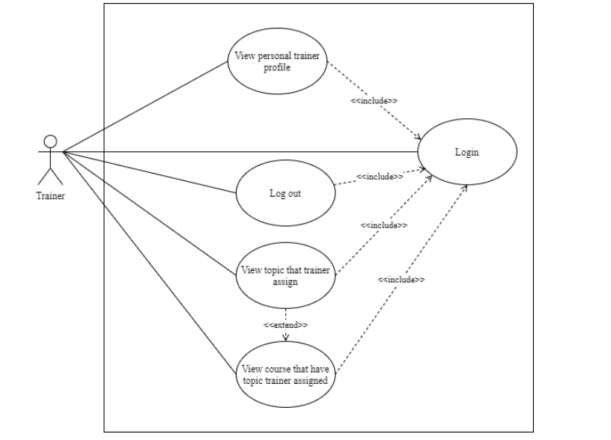

**Figure 3** Use case Trainer role.

* + 1. **Brief Description**

FPT Co. The use of the Training Web application helps the organization to monitor the training activities in the company.

* + 1. **Actor Descriptions**

|  |  |  |
| --- | --- | --- |
| **No.** | **Actor Name** | **Definition & Interest** |
| **1** | **Administrator** | The administrator is the person who will have the authority to train the staff and the account trainer |
| **2** | **Training Staff** | Training staff is a person or department that will run scheduled training activities, arrange training programs such as courses, topics, trainer, trainee suitable for each course category, and they have rights to manage a trainee's account. For trainer, they only have the right to update / edit the trainer profile. |
| **3** | **Trainer** | The trainer is the individual who teaches the trainees skills or knowledge. They run training sessions, observe instruction, and provide lab and assignment-based feedback. They will use this system to display and track their work on the schedule. |
| **4** | **Trainee** | The trainee is the person enrolled in a trainee program within the FPT Co education program. They will use this system to display their study program and track it. |

* + 1. **Use case Description**

|  |  |  |  |
| --- | --- | --- | --- |
| No. | Code | Name | Brief Description |
| 1 | UC01 | Login | Enable the actor to log into the system. |
| 2 | UC02 | Log out | Enable the actor to log out of the system. |
| 3 | UC03 | Validation user AD | Allows permission for access relative to the AD system. |
| 4 | UC04 | Check account AD/ Training staff/ trainer /trainee | Allows actor to define access against the system AD / Training Staff or Trainer, trainee. |
| 5 | UC05 | View details Training Staff/ trainer accounts | Allows the actor to view the details information of user. |
| 6 | UC06 | View list of training staff/ trainer account | Allows the actor to view a list of training staff/ trainer accounts. |
| 7 | UC07 | Add new training staff/ trainer accounts | Allows the actor to create a new account. |
| 8 | UC08 | Check user AD | Allows to define users compared to AD system. |
| 9 | UC09 | Edit/ Update training staff accounts | Allows the actor to update or edit a training staff information. |
| 10 | UC10 | Check user AD or Training staff | Allows to define users compared to Ad system or Training staff. |
| 11 | UC11 | Edit/ Update trainer accounts | Allows the actor to update or edit the trainer information. |
| 12 | UC12 | Delete training staff/ trainer account | Allows the actor to remove or delete a account form the system. |
| 13 | UC13 | Check account Training Staff | Allows actor to define access permission compared with the Training Staff system. |
| 14 | UC14 | Assign a Trainer to the Topic | Allows actor to add a existed trainer to a topic. |
| 15 | UC15 | View list of trainees | Allows the actor to view a list of trainee accounts |
| 16 | UC16 | Check account Training Staff or trainer | Allows actor to define access permission compared with the Training Staff or trainer system |
| 17 | UC17 | View details trainees | Allows the actor to view a trainees details information. |
| 18 | UC18 | Add new trainee | Allows the actor to create a new trainee. |
| 19 | UC19 | Check account Training Staff | Allows to define access permission compared with the Training Staff system. |
| 20 | UC20 | Edit/ Update trainee | Allows the actor to update or edit the trainees information. |
| 21 | UC21 | Delete trainee | Allows the actor to delete or remove a exist trainee from the system. |
| 22 | UC22 | Check account Training Staff | Allows actor to define access permission compared with the Training Staff system. |
| 23 | UC23 | Assign a Trainee to the Course | Allows actor to add a existed trainee to a course |
| 24 | UC24 | View details category | Allows the actor to view a category details information. |
| 25 | UC25 | Add new category | Allows the actor to create a new category |
| 26 | UC26 | Check account Training Staff | Allows to define access permission compared with the Training Staff system. |
| 27 | UC27 | Edit/ Update category | Allows the actor to update or edit the category information. |
| 28 | UC28 | Delete category | Allows the actor to delete or remove a exist category from the system. |
| 29 | UC29 | Check account Training Staff / Trainer/ Trainee | Allows actor to define access permission compared with the Training Staff / Trainer or Trainee system |
| 30 | UC30 | View details course | Allows the actor to view a course details information. |
| 31 | UC31 | Check account Training Staff | Allows actor to define access permission compared with the Training Staff system. |
| 32 | UC32 | View list of course | Allows the actor to view list of courses. |
| 33 | UC33 | Add new course | Allows the actor to create a new course. |
| 34 | UC34 | Check account Training Staff | Allows to define access permission compared with the Training Staff system. |
| 35 | UC35 | Edit/ Update course | Allows the actor to update or edit the course information |
| 36 | UC36 | Delete course | Allows the actor to delete or remove a exist course from the system. |
| 37 | UC37 | Check account Training Staff | Allows actor to define access permission compared with the Training Staff system. |
| 38 | UC38 | Assign a Course to the Category | Allows actor to add a existed course to a category. |
| 39 | UC39 | Check account Training Staff / Trainer/ Trainee | Allows actor to define access permission compared with the Training Staff / Trainer or Trainee system. |
| 40 | UC40 | View details topic | Allows the actor to view a topic details information |
| 41 | UC41 | Check account Training Staff | Allows actor to define access permission compared with the Training Staff system. |
| 42 | UC42 | View list of topics | Allows the actor to view list of topic |
| 43 | UC43 | Add new topic | Allows the actor to create a new topic. |
| 44 | UC44 | Check account Training Staff | Allows to define access permission compared with the Training Staff system. |
| 45 | UC45 | Edit/ Update topic | Allows the actor to update or edit the topic information. |
| 46 | UC46 | Delete topic | Allows the actor to delete or remove a exist topic from the system. |
| 47 | UC47 | Check account Training Staff | Allows actor to define access permission compared with the Training Staff system. |
| 48 | UC48 | Assign a Topic to the Course | Allows actor to add a existed topic to a course. |

**Table 6** Use case description.

* + 1. **Use case & Actor mapping**

|  |  |  |  |  |
| --- | --- | --- | --- | --- |
| Use Case/ Actor | Admin | Training Staff | Trainer | Trainee |
| UC01: Login |  |  |  |  |
| UC02: Log out |  |  |  |  |
| UC05: View details Training Staff/ trainer accounts |  |  |  |  |
| UC06: View list of training staff/ trainer account |  |  |  |  |
| UC07: Add new training staff/ trainer accounts |  |  |  |  |
| UC09: Edit/ Update training staff accounts |  |  |  |  |
| UC11: Edit/ Update trainer accounts |  |  |  |  |
| UC12: Delete training staff/ trainer account |  |  |  |  |
| UC14: Assign a Trainer to the Topic |  |  |  |  |
| UC15: View list of trainees |  |  |  |  |
| UC17: View details trainees |  |  |  |  |
| UC18: Add new trainee |  |  |  |  |
| UC20: Edit/ Update trainee |  |  |  |  |
| UC21: Delete trainee |  |  |  |  |
| UC23: Assign a Trainee to the Course |  |  |  |  |
| UC24: View details category |  |  |  |  |
| UC25: Add new category |  |  |  |  |
| UC27: Edit/ Update category |  |  |  |  |
| UC28: Delete category |  |  |  |  |
| UC30: View details course |  |  |  |  |
| UC32: View list of course |  |  |  |  |
| UC33: Add new course |  |  |  |  |
| UC35: Edit/ Update course |  |  |  |  |
| UC36: Delete course |  |  |  |  |
| UC38: Assign a Course to the Category |  |  |  |  |
| UC40: View details topic |  |  |  |  |
| UC42: View list of topics |  |  |  |  |
| UC43: Add new topic |  |  |  |  |
| UC45: Edit/ Update topic |  |  |  |  |
| UC46: Delete topic |  |  |  |  |
| UC48: Assign a Topic to the Course |  |  |  |  |

* + 1. **Use cases Specification**

**UC01: Login**

**Use Case Description**

|  |  |  |  |
| --- | --- | --- | --- |
| **Name** | **Login** | **Code** | **UC01** |
| **Description** | Permit actor log into the system | | |
| **Actor** | Administrator/ Training Staff/ Trainer/ Trainee | **Trigger** | Actors press Login button |
| **Pre-condition** |  |  |  |
| **Post condition** | Turn to the Homepage | | |

**Activities:**

|  |  |  |  |
| --- | --- | --- | --- |
| **Actor** | | **System** | |
| **Main Flow: Login successful** | | | |
| **1** | Actor enter your username / password and click the Login button on the homepage. |  |  |
|  |  | **2** | Check that the username / password is correct then go to the corresponding default role page |

**Business Rules:**

|  |  |  |
| --- | --- | --- |
| **Rule No.** | **Rule** | **Description** |
|  |  |  |

**System Message:**

|  |  |
| --- | --- |
| **MS01** | “Your Username and / or Password are incorrect. Please check and try again. ” The message notifies when the actor entered the wrong username / password |

**UC02: Log out**

**Use Case Description**

|  |  |  |  |
| --- | --- | --- | --- |
| **Name** | **Log out** | **Code** | **UC02** |
| **Description** | Permit actor log out from the system. | | |
| **Actor** | Administrator/ Training Staff/ Trainer/ Trainee | **Trigger** | Actors press Log out link |
| **Pre-condition** |  |  |  |
| **Post condition** | Turn to the Homepage | | |

**Activities:**

|  |  |  |  |
| --- | --- | --- | --- |
| **Actor** | | **System** | |
| **Main Flow: Log out successful** | | | |
| **1** | Actor click the Log out link on the bar which on top in the Homepage |  |  |
|  |  | **2** | Return to Homepage |

**Business Rules:**

|  |  |  |
| --- | --- | --- |
| **Rule No.** | **Rule** | **Description** |
|  |  |  |

**System Message:**

|  |  |
| --- | --- |
|  |  |

**UC05: View detail training staff/ trainer account**

**Use Case Description**

|  |  |  |  |
| --- | --- | --- | --- |
| **Name** | View detail training staff/ trainer account | **Code** | **UC05** |
| **Description** | Permit actor to view details of a training staff/ trainer account. | | |
| **Actor** | Administrator With trainer role, they only can see their personal profile. | **Trigger** | Actor click on the link [Details]. |
| **Pre-condition** | Actor has logged into the system. | | |
| **Post condition** | Successfully view detail training staff/ trainer account. | | |

**Activities:**

|  |  |  |  |
| --- | --- | --- | --- |
| **Actor** | | **System** | |
| **Main Flow: View details training staff/ trainer account successfully** | | | |
| **1** | From the user information management page, the actor clicks on the [account name] link. |  |  |
|  |  | **2** | Load user information on the User Information page and display. |

**Business Rules:**

|  |  |  |
| --- | --- | --- |
| **Rule No.** | **Rule** | **Description** |
|  |  |  |

**System Management:**

**N/A**

**UC06: View list of training staff/ trainer accounts**

**Use Case Description**

|  |  |  |  |
| --- | --- | --- | --- |
| **Name** | View list of training staff/ trainer accounts | **Code** | **UC06** |
| **Description** | Permit actor to view list of training staff/ trainer account. | | |
| **Actor** | Administrator | **Trigger** | Actor click on the link [Trainer] or [Training Staff] on the bar |
| **Pre-condition** | Actor has logged into the system. | | |
| **Post condition** | Successfully view list of training staff/ trainer account | | |

**Activities:**

|  |  |  |  |
| --- | --- | --- | --- |
| **Actor** | | **System** | |
| Main Flow: View list of training staff/ trainer accounts successfully | | | |
| **1** | From the user information management page, the actor clicks on the [Trainer] or [Training Staff] link. |  |  |
|  |  | **2** | Load list of trainer/ training staff on the Trainer/ Training Staff page and display. |

**Business Rules:**

|  |  |  |
| --- | --- | --- |
| **Rule No.** | **Rule** | **Description** |
|  |  |  |

**System Management:**

**N/A**

**UC07: Add new training staff/ trainer account**

**Use Case Description**

|  |  |  |  |
| --- | --- | --- | --- |
| **Name** | Add new training staff/ trainer account | **Code** | **UC07** |
| **Description** | Permit actor to add a new trainer/ training staff account | | |
| **Actor** | Administrator | **Trigger** | Actor click the [Register] link on the bar. |
| **Pre-condition** | Actor has logged into the system | | |
| **Post condition** | Add new training staff/ trainer account successfully. | | |

**Activities:**

|  |  |  |  |
| --- | --- | --- | --- |
| **Actor** | | **System** | |
| **Main Flow: Add new training staff/ trainer account successfully** | | | |
| **1** | From the any screen, the actor selects the [Register] link. |  |  |
|  |  | **2** | Load page Add new user information |
| **3** | Enter the required information. |  |  |
|  |  | **4** | Validation of information entered. |
| **5** | Correct incorrect information (if the validation system is not correct). |  |  |
|  |  | **6** | Save new user information in the database, notify successful. |

**Business Rules:**

|  |  |  |
| --- | --- | --- |
| **Rule No.** | **Rule** | **Description** |
|  |  |  |

**System Message:**

|  |  |
| --- | --- |
|  |  |

**UC09: Edit/ update training staff account**

**Use Case Description**

|  |  |  |  |
| --- | --- | --- | --- |
| **Name** | Edit/ update training staff account | **Code** | **UC09** |
| **Description** | Permit actor updates information of a training staff account | | |
| **Actor** | Administrator | **Trigger** | The actor click link [Edit] |
| **Pre-condition** | Actor has logged into the system. | | |
| **Post condition** | Edit training staff account successfully | | |

**Activities:**

|  |  |  |  |
| --- | --- | --- | --- |
| **Actor** | | **System** | |
| **Main Flow: Edit training staff account successfully** | | | |
| **1** | From the Training staff screen, actor click on the [Edit] link |  |  |
|  |  | **2** | Load user information on the Training staff Information page and display. |
| **3** | Update the necessary information and press the button Save button |  |  |
|  |  | **3** | Validation of information entered |
| **4** | Correct the input if the validation is not correct |  |  |
|  |  | **5** | Edit information on the user to the database, notify it successfully |

**Business Rule:**

|  |  |  |
| --- | --- | --- |
| **Rule No.** | **Rule** | **Description** |
|  |  |  |

**System Messages:**

**N/A**

**UC11: Edit/ update trainer account**

**Use Case Description**

|  |  |  |  |
| --- | --- | --- | --- |
| Name | Edit/ update trainer account | Code | UC11 |
| Description | Permit actor updates information of a trainer account | | |
| Actor | Administrator or Training staff | Trigger | The actor click link [Edit] |
| re-condition | Actor has logged into the system. | | |
| Post condition | Edit trainer account successfully. | | |

**Activities:**

|  |  |  |  |
| --- | --- | --- | --- |
| **Actor** | | **System** | |
| **Main Flow: Edit trainer account successfully** | | | |
| **1** | From the Trainer screen, actor click on the [Edit] link |  |  |
|  |  | **2** | Load user information on the Trainer Information page and display. |
| **3** | Update the necessary information and press the button Save button |  |  |
|  |  | **3** | Validation of information entered. |
| **4** | Correct the input if the validation is not correct |  |  |
|  |  | **5** | Edit information on the user to the database, notify it successfully |

**Business Rule:**

|  |  |  |
| --- | --- | --- |
| **Rule No.** | **Rule** | **Description** |
|  |  |  |

**System Messages:**

**N/A**

**UC12: Delete training staff/ trainer account**

**Use Case Description**

|  |  |  |  |
| --- | --- | --- | --- |
| **Name** | Delete training staff/ trainer account | **Code** | **UC12** |
| **UC12** | Permit actor delete training staff/ trainer account | | |
| **Actor** | Administrator | **Trigger** | Actor click link **[Delete]** |
| **Pre-condition** | Actor has logged into the system. | | |
| **Post condition** | Delete training staff/ trainer account successfully. | | |

**Activities:**

|  |  |  |  |
| --- | --- | --- | --- |
| **Actor** | | **System** | |
| **Main Flow: Delete training staff/ trainer account successfully** | | | |
| **1** | From the Training staff/ Trainer screen, click the [Delete] link |  |  |
|  |  | **2** | Delete the user information from the database, successfully notify and return to the user management page. |

**Business Rules:**

|  |  |  |
| --- | --- | --- |
| **Business Rules.** | **Rule** | **Description** |
|  |  |  |

**System Message:**

**N/A**

**UC14: Assign trainer to a topic**

**Use Case Description**

|  |  |  |  |
| --- | --- | --- | --- |
| **Name** | Assign trainer to a topic | **Code** | **UC14** |
| **Description** | Permit actor to assign a Trainer into a Topic | | |
| **Actor** | Training Staff | **Trigger** | Actor click on the [Topicname] link |
| **Pre-condition** | Actor has logged into the system. | | |
| **Post condition** | Successfully assign trainer to a topic. | | |

**Activities:**

|  |  |  |  |
| --- | --- | --- | --- |
| **Actor** | | **System** | |
| **Main Flow: Assign trainer to a topic successfully** | | | |
| **1** | From the Topic page, the actor clicks on the [topicname] link. |  |  |
|  |  | **2** | Load topic information on the Topic Information page and display. |
| **3** | Update the ID trainer in the TrainerID box |  |  |
|  |  | **4** | Validation of information entered |
| **5** | Correct the input if the validation is not correct |  |  |
|  |  | **6** | The information of topics will edit in the database, notify successful. |

**Business Rules:**

|  |  |  |
| --- | --- | --- |
| **Rule No.** | **Rule** | **Description** |
|  |  |  |

**System Management**

**N/A**

**UC15: View list of trainee**

**Use Case Description**

|  |  |  |  |
| --- | --- | --- | --- |
| **Name** | View list of trainee accounts | **Code** | **UC15** |
| **Description** | Permit actor to view list of trainee account | | |
| **Actor** | Training staff | **Trigger** | Actor click on the link [Trainee] on the bar |
| **Pre-condition** | Actor has logged into the system. | | |
| **Post condition** | Successfully view list of trainee accounts. | | |

**Activities:**

|  |  |  |  |
| --- | --- | --- | --- |
| **Actor** | | **System** | |
| **Main Flow: View list of trainee accounts successfully** | | | |
| **1** | From the user information management page, the actor clicks on the [Trainee] link. |  |  |
|  |  | **2** | Load list of trainee on the Trainee page and display. |

**Business Rules:**

|  |  |  |
| --- | --- | --- |
| **Rule No.** | **Rule** | **Description** |
|  |  |  |

**System Management**

**N/A**

**UC17: View details trainee**

**Use Case Description**

|  |  |  |  |
| --- | --- | --- | --- |
| **Name** | View details trainee | **Code** | **UC17** |
| **Description** | Permit actor to view details of a trainee | | |
| **Actor** | Training Staff/ Trainee | **Trigger** | Actor click on the link [Details] of a user. |
| **Pre-condition** | Actor has logged into the system.  If actor is Trainees, they only view their profile information. | | |
| **Post condition** | Successfully view trainees details | | |

**Activities:**

|  |  |  |  |
| --- | --- | --- | --- |
| Actor | | System | |
| Main Flow: View details trainee successfully | | | |
| **1** | From the Trainee page, the actor clicks on the [Details] link. |  |  |
|  |  | **2** | Load trainee information’s on the Trainee Information page and display. |

**Business Rules:**

|  |  |  |
| --- | --- | --- |
| **Rule No.** | **Rule** | **Description** |
|  |  |  |

**System Management**

**N/A**

**UC18: Add new trainee accounts**

**Use Case Description**

|  |  |  |  |
| --- | --- | --- | --- |
| **Name** | Add new trainee account | **Code** | **UC18** |
| **Description** | Permit actor to add a new trainees | | |
| **Actor** | Training Staff | **Trigger** | Actor click the [Register] link on the bar in the Trainee screen. |
| **Pre-condition** | Actor has logged into the system. | | |
| **Post condition** | Add new trainee account successfully. | | |

**Activities:**

|  |  |  |  |
| --- | --- | --- | --- |
| **Actor** | | **System** | |
| **Main Flow: Add new trainee account successfully** | | | |
| **1** | From the Trainee screen, the actor selects the [Register] link. |  |  |
|  |  | **2** | Load page Add new trainee information |
| **3** | Enter the required information |  |  |
|  |  | **4** | Validation of information entered. |
| **5** | Correct incorrect information (if the validation system is not correct). |  |  |
|  |  | **6** | Save new trainee information in the database, notify successful. |

**Business Rules:**

|  |  |  |
| --- | --- | --- |
| **Rule No.** | **Rule** | **Description** |
|  |  |  |

**System Message:**

|  |  |
| --- | --- |
|  |  |

**UC20: Edit/ update trainee account**

**Use Case Description**

|  |  |  |  |
| --- | --- | --- | --- |
| **Name** | Edit/ update trainee account | **Code** | **UC20** |
| **Description** | Permit actor updates information of an trainee | | |
| **Actor** | Training Staff | **Trigger** | The actor click link [Edit] |
| **Pre-condition** | Actor has logged into the system. | | |
| **Post condition** | Edit trainee information’s successfully | | |

**Activities:**

|  |  |  |  |
| --- | --- | --- | --- |
| **Actor** | | **System** | |
| **Main Flow: Edit trainee information’s successfully** | | | |
| **1** | From the Trainee screen, actor click on the [Edit] link |  |  |
|  |  | **2** | Load trainee information on the Trainee Information page and display. |
| **3** | Update the necessary information and press the link [Save] |  |  |
|  |  | **4** | Validation of information entered. |
| **5** | Correct the input if the validation is not correct |  |  |
|  |  | **6** | Edit information on the trainee to the database, notify it successfully |

**Business Rule:**

|  |  |  |
| --- | --- | --- |
| **Rule No.** | **Rule** | **Description** |
|  |  |  |

**System Messages :**

**N/A**

**UC21: Delete trainee account**

**Use Case Description**

|  |  |  |  |
| --- | --- | --- | --- |
| **Name** | Delete trainee account | **Code** | **UC21** |
| **Description** | Permit actor delete an trainee account | | |
| **Actor** | Training Staff | **Trigger** | Actor click link [Delete] |
| **Pre-condition** | Actor has logged into the system. | | |
| **Post condition** | Delete trainee account successfully. | | |

**Activities:**

|  |  |  |  |
| --- | --- | --- | --- |
| **Actor** | | **System** | |
| **Main Flow: Delete Trainee account successfully** | | | |
| 1 | From the Trainee screen ,click the [Delete] link |  |  |
|  |  | 2 | Delete the trainee information from the database, successfully notify and return to the Trainee page |

**Business Rules:**

|  |  |  |
| --- | --- | --- |
| **Rule No.** | **Rule** | **Description** |
|  |  |  |

**System Message**

**N/A**

**UC23: Assign a trainee to course**

**Use Case Description**

|  |  |  |  |
| --- | --- | --- | --- |
| **Name** | Assign a trainee to course | **Code** | **UC23** |
| **Description** | Permit actor to assign a Trainee into a Course | | |
| **Actor** | Training Staff | **Trigger** | Actor click on the link [Details] of a trainee. |
| **Pre-condition** | Actor has logged into the system. | | |
| **Post condition** | Successfully assign a trainee to course. | | |

**Activities:**

|  |  |  |  |
| --- | --- | --- | --- |
| **Actor** | | **System** | |
| **Main Flow: Assign a trainee to course successfully** | | | |
| 1 | From the Trainee page, the actor clicks on the [Details] link. |  |  |
|  |  | 2 | Load trainee information on the trainee information page and display |
| 3 | Update the course id in the Course ID box |  |  |
|  |  | 4 | Validation of information entered |
| 5 | Correct the input if the validation is not correct |  |  |
|  |  | 6 | The information of trainees will edit in the database, notify successful. |

**Business Rules:**

|  |  |  |
| --- | --- | --- |
| **Rule No** | **Rule** | **Description** |
|  |  |  |

**System Management**

**N/A**

**UC24: View details course categories**

**Use Case Description**

|  |  |  |  |
| --- | --- | --- | --- |
| **Name** | View details course categories | **Code** | **UC24** |
| **Description** | Permit actor to view details of a course category | | |
| **Actor** | Training Staff | **Trigger** | Actor click on the link [Details] of a course category |
| **Pre-condition** | Actor has logged into the system | | |
| **Post condition** | Successfully view detail of a course category. | | |

**Activities:**

|  |  |  |  |
| --- | --- | --- | --- |
| **Actor** | | **System** | |
| **Main Flow: View details a category successfully** | | | |
| **1** | From the category information management page, the actor clicks on the [Details] link. |  |  |
|  |  | **2** | Load category information on the Course Information page and display |

**Business Rules:**

|  |  |  |
| --- | --- | --- |
| **Rule No.** | **Rule** | **Description** |
|  |  |  |

**System Management**

**N/A**

**UC25: Add new course category**

**Use Case Description**

|  |  |  |  |
| --- | --- | --- | --- |
| **Name** | Add new course category | **Code** | **UC25** |
| **Description** | Permit actor to add a new category | | |
| **Actor** | Training Staff | **Trigger** | Actor click the [Create] link on the Course category screen. |
| **Pre-condition** | Actor has logged into the system | | |
| **Post condition** | Add a new course category successfully. | | |

**Activities:**

|  |  |  |  |
| --- | --- | --- | --- |
| **Actor** | | **System** | |
| **Main Flow: Add a new category successfully** | | | |
| **1** | From the Course category screen, the actor selects the [Create] link. |  |  |
|  |  | **2** | Load page Add new course category information |
| **3** | Enter the required information. |  |  |
|  |  | **4** | Validation of information entered. |
| **5** | Correct incorrect information (if the validation system is not correct). |  |  |
|  |  | **6** | Save new course category information in the database, notify successful |

**Business Rules:**

|  |  |  |
| --- | --- | --- |
| **Rule No.** | **Rule** | **Description** |
|  |  |  |

**System Message:**

|  |  |
| --- | --- |
|  |  |

**UC27: Edit/ Update course category**

**Use Case Description**

|  |  |  |  |
| --- | --- | --- | --- |
| **Name** | Edit/ update course category | **Code** | **UC27** |
| **Description** | Permit actor updates information of a course category | | |
| **Actor** | Training Staff | **Trigger** | The actor click link [Edit] |
| **Pre-condition** | Actor has logged into the system | | |
| **Post condition** | Edit a course category successfully. | | |

**Activities:**

|  |  |  |  |
| --- | --- | --- | --- |
| **Actor** | | **System** | |
| **Main Flow: Edit category successfully** | | | |
| **1** | From the Course category screen, actor click on the [Edit] link |  |  |
|  |  | **2** | Load category information on the Course category Information page and display. |
| **3** | Update the necessary information and press the link [Save] |  |  |
|  |  | **4** | Validation of information entered. |
| **5** | Correct the input if the validation is not correct |  |  |
|  |  | **6** | Edit information on the category to the database, notify it successfully |

**Business Rule:**

|  |  |  |
| --- | --- | --- |
| **Rule No.** | **Rule** | **Description** |
|  |  |  |

**System Messages**

**N/A**

**UC28: Delete course category**

**Use Case Description**

|  |  |  |  |
| --- | --- | --- | --- |
| **Name** | Delete a course category | **Code** | **UC28** |
| **Description** | Permit actor to remove a course category | | |
| **Actor** | Training Staff | **Trigger** | Actor click on the link [Delete] of a category.. |
| **Pre-condition** | Actor has logged into the system. | | |
| **Post condition** | Successfully delete a course category | | |

**Activities:**

|  |  |  |  |
| --- | --- | --- | --- |
| **Actor** | | **System** | |
| **Main Flow: Delete a course category successfully** | | | |
| **1** | From the Course category page, the actor clicks on the [Delete] link. |  |  |
|  |  | **2** | Delete the course category information from the database, successfully notify and return to the Course category page. |

**Business Rules:**

|  |  |  |
| --- | --- | --- |
| **Rule No.** | **Rule** | **Description** |
|  |  |  |

**System Management**

**N/A**

**UC30: View detail course**

**Use Case Description**

|  |  |  |  |
| --- | --- | --- | --- |
| Name | View details of a course | Code | UC30 |
| Description | Permit actor to view details information of a course. | | |
| Actor | Training Staff/ Trainer/ Trainee | Trigger | Actor click on the link [Details] of a course. |
| Pre-condition | Actor has logged into the system.   * With Trainer role, they only see the course that contained the topic trainer is assigned * Whit Trainee role, they only see the course that they is enrolled | | |
| Post condition | Successfully view course details | | |

**Activities:**

|  |  |  |  |
| --- | --- | --- | --- |
| **Actor** | | **System** | |
| **Main Flow: View details course successfully** | | | |
| **1** | From the Course page, the actor clicks on the [Details] link. |  |  |
|  |  | **2** | Load course information on the Course information’s page and display |

**Business Rules:**

|  |  |  |
| --- | --- | --- |
| **Rule No.** | **Rule** | **Description** |
|  |  |  |

**System Management**

**N/A**

**UC32: View list of courses**

**Use Case Description**

|  |  |  |  |
| --- | --- | --- | --- |
| **Name** | View list of courses | **Code** | **UC32** |
| **Description** | Permit actor to view list of courses | | |
| **Actor** | Training staff | **Trigger** | Actor click on the link [Course] on the bar. |
| **Pre-condition** | Actor has logged into the system | | |
| **Post condition** | Successfully view list of courses. | | |

**Activities:**

|  |  |  |  |
| --- | --- | --- | --- |
| **Actor** | | **System** | |
| **Main Flow: View list of courses successfully** | | | |
| **1** | From the Homepage page, the actor clicks on the [Courses] link. |  |  |
|  |  | **2** | Load list of trainee on the Courses page and display. |

**System Management**

**N/A**

**UC33: Add new course**

**Use Case Description**

|  |  |  |  |
| --- | --- | --- | --- |
| **Name** | Add new course | **Code** | **UC33** |
| **Description** | Permit actor to add a new course. | | |
| **Actor** | Training Staff | **Trigger** | Actor click the [Create] link on the Course screen. |
| **Pre-condition** | Actor has logged into the system. | | |
| **Post condition** | Add new course successfully. | | |

**Activities:**

|  |  |  |  |
| --- | --- | --- | --- |
| **Actor** | | **System** | |
| **Main Flow: Add new course successfully** | | | |
| **1** | From the course screen, the actor selects the [Create] link. |  |  |
|  |  | **2** | Load page Add new course information |
| **3** | Enter the required information. |  |  |
|  |  | **4** | Validation of information entered. |
| **5** | Correct incorrect information (if the validation system is not correct). |  |  |
|  |  | **6** | Save new course information in the database, notify successful |

* 1. **Entity Relationship Diagram**

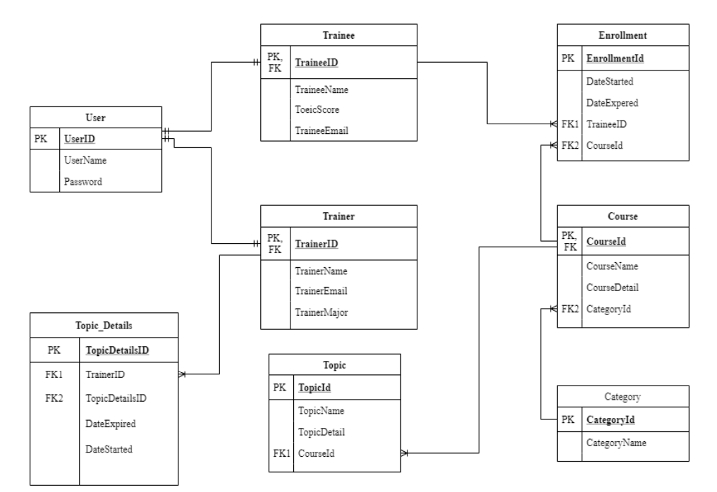

**Figure 4** Entity Relationship Diagram of FPT Co. Training Web- application.

* 1. **Data Flow Diagram**
     1. **Data flow diagram for Administrator role**

They have the right to handle training staff and trainer accounts with the role of administrator, as shown in Figure 5 & 6.

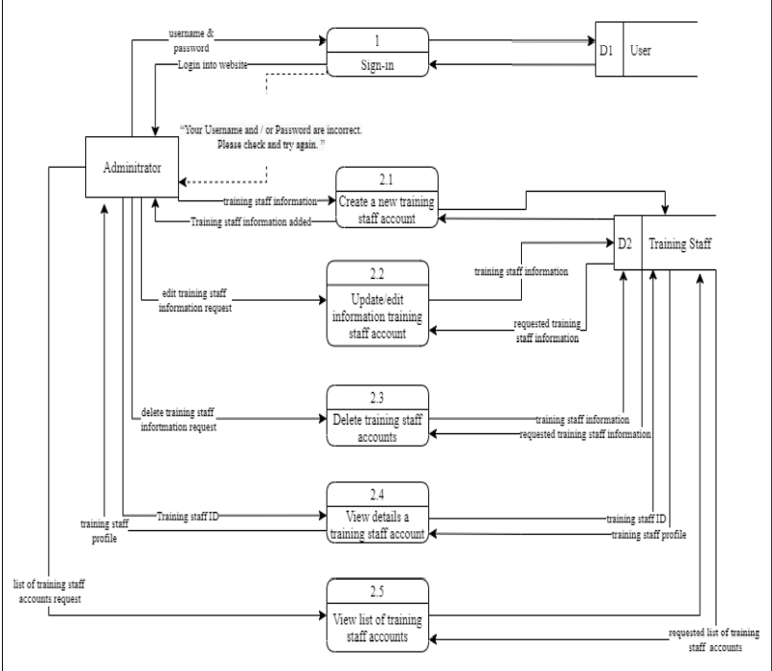

**Figure 5** Training Staff accounts Management

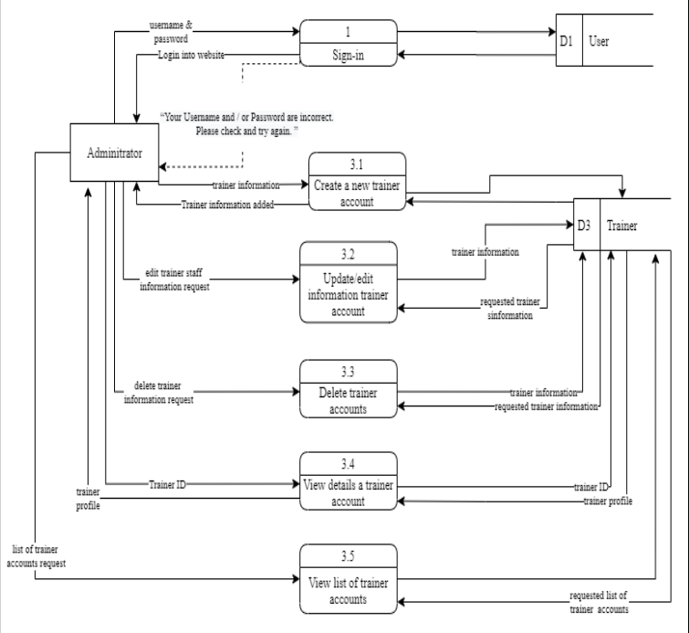

**Figure 6** Trainer accounts Management

* + 1. **Data flow diagram for Trainer** **role**

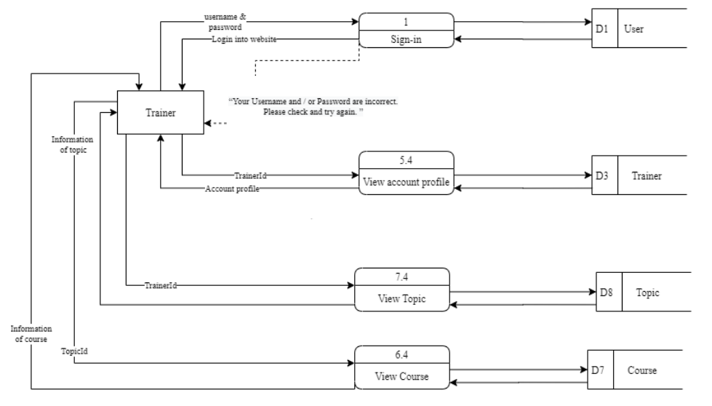

**Figure 7** Data flow diagram for trainer role.

* 1. **Screen mockup**
  2. **External Interface Requirement**
     1. **User Interfaces**

**UI-1:** In addition to the use of mouse and keyboard combinations, the web application enables full navigation using the keyboard.

* + 1. **Hardware Interface**

No hardware interface was defined at all.

* + 1. **Software Interface**

**SI-1:** Database- The system shall communicate with a database through a programmatic interface for the following operations:

* **SI-1.1:** To manage trainers, trainees, courses, topics.
* **SI-1.2:** To allow trainers track their works
* **SI-1.3:** To allow trainees track their training program
  + 1. **Communication Interface**
* **CI-1:** The system shall send email message to inform the system of the registration.
* **CI-2:** The system shall send a notification the user of new email messages, instant messages, or calendar event invites.
* **CI-3:** The system shall send an email message to announce when enjoy a course or topics.

1. **Other Non-functional Requirements**
   1. **Performance Requirements**

**PE-1:** Query response takes no longer than 10s to load onto the screen after the query is sent by the user.

**PE-2:** All system-generated web pages must be completely downloadable over a 30Kbps modem link in no more than 10 seconds.

* 1. **Safety and Security Requirements**

**SE-1:** The user is expected to log into the system via the accounts given by the administrators.

**SE-2:** The system allows only FPT.Co members to create or edit accounts that are on the list of approved administrators.

**SE-3:** All network transactions that involve financial information or personally identifiable information shall be encrypted.

**SE-4:** The system shall permit users who are not training staff or administrators to view only their own information, not the information of other users.

* 1. **Software quality Attributes**

There were no software quality attributes identified