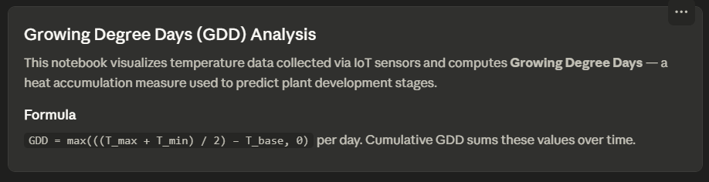
Here's an interactive Jupyter-style notebook visualizing GDD data! Here's what each cell does:
Cell 1 — loads and previews your temperature.csv with 10 days of sample data (min/max temps per day).
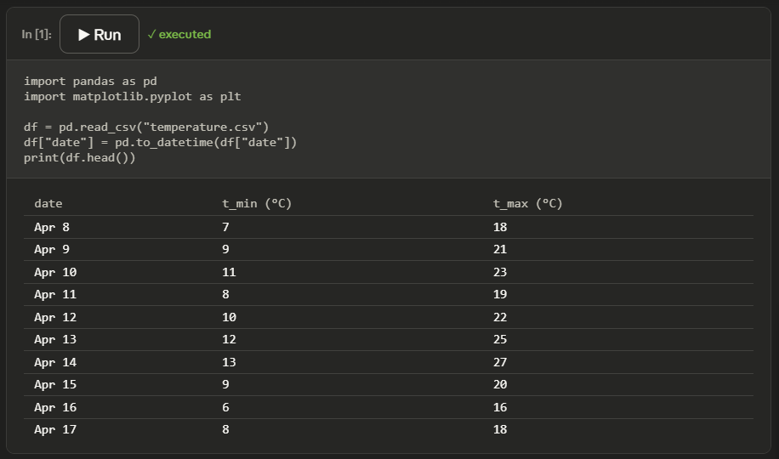
Cell 2 — calculates GDD using the formula ((T_max + T_min) / 2) − T_base, clamped at 0. Use the T_base slider to change the base temperature for your plant species — common values are 10°C (corn), 6°C (wheat), or 4°C (some cool-season crops). The charts and stats update live.
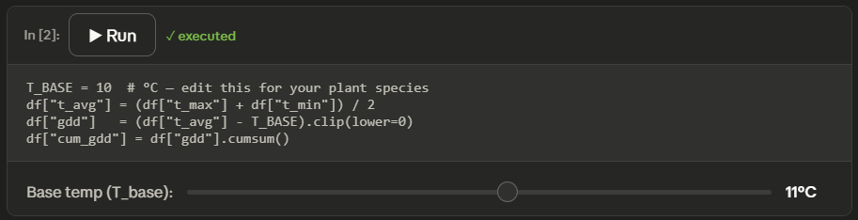
Cell 3 — plots both charts:
- Top: daily min/max temperature with the T_base threshold line
- Bottom: cumulative GDD bar chart
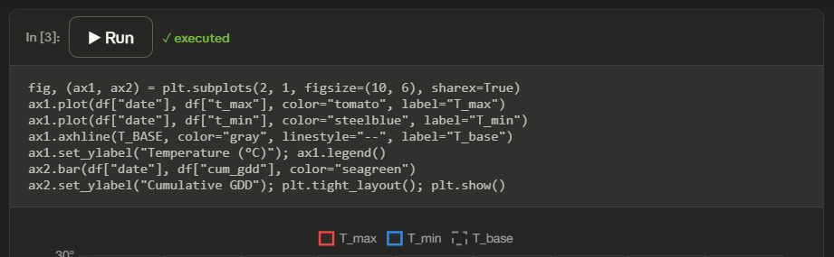
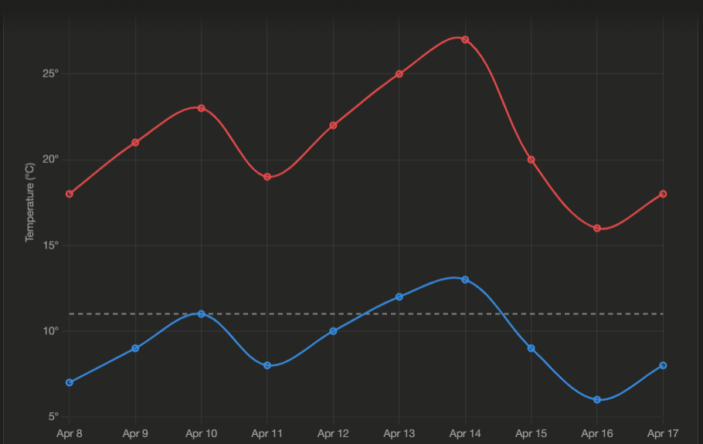
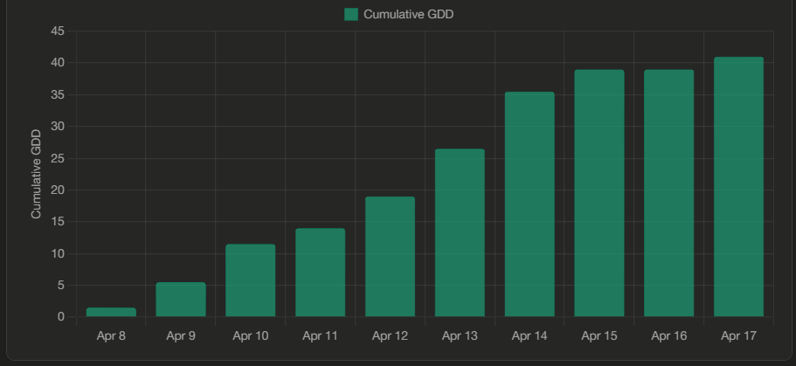
Cell 4 — prints summary stats: total GDD accumulated, mean daily GDD, and how many days were above the base threshold.
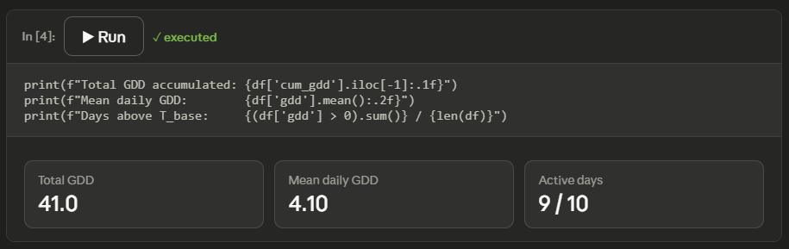
To use this with your real data, make sure your temperature.csv has date, t_min, and t_max columns, then run through the cells in order in Jupyter with jupyter notebook gdd.ipynb.

