Here's an interactive soil moisture calibration tool! Here's how to use it:
Adding samples — for each soil sample you collect, enter three values: the raw sensor reading (0–1023), the wet weight in grams, and the dry weight in grams. The gravimetric moisture percentage is calculated automatically using the formula from your image. You'll see a live preview of the moisture % as you type the weights.
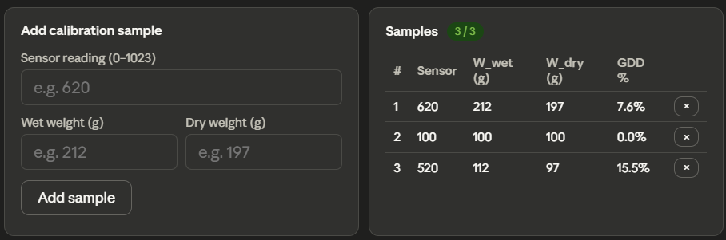

The calibration graph — once you have 2 or more samples, a scatter plot appears with a best-fit line (shown in orange dashes). The graph plots sensor reading on the x-axis against moisture % on the y-axis. The R² value shows how well the line fits your data — closer to 1.0 is better.
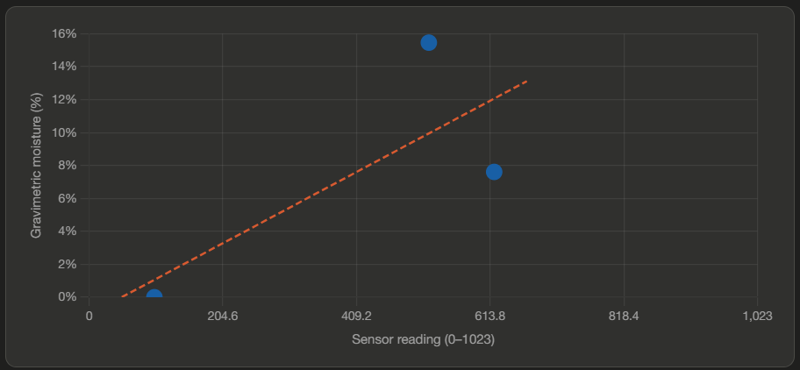

Converting readings — once the line is fitted, use the "Convert a sensor reading" section at the bottom. Type any sensor reading (0–1023) and it instantly shows the estimated gravimetric moisture percentage.
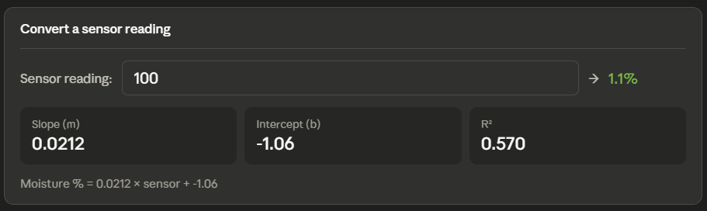
For the rubric:
- 1 sample: meets "needs improvement"
- 2 samples: meets "adequate" (line can be fitted)
- 3+ samples: meets "exemplary" — the badge turns green when you hit 3

