|  |
| --- |
| **DIGITAL SYSTEM DESIGN LABORATORY** |
| **LAB 3** |

**IMPLEMENTATION OF BASIC COMBINATION LOGIC CIRCUIT USING VHDL**

### I. LAB OBJECTIVES

### This Lab experiments are intended to implement Basic Combination Logic and Sequential Circuit in VHDL. Students are require to write test bench to simulate the given example code and Top level module to implement these codes in DE2-115 FPGA Kit.

### a) For each experiment write the VHDL Code in three method ( dataflow, behavior and gate level)

### b) For each model, write the Top Level VHDL Code to implement the these modules in DE2-FPGA Kit

### (Show implementation results in Lab report)

### c) Analyze the FPGA implementation results for these model

### II. PROCEDURE

### II.1 LAB EXPERIMENT 1 : WRITE VHDL CODE TO IMPLEMENT ALL LOGIC GATES IN FPGA KIT.

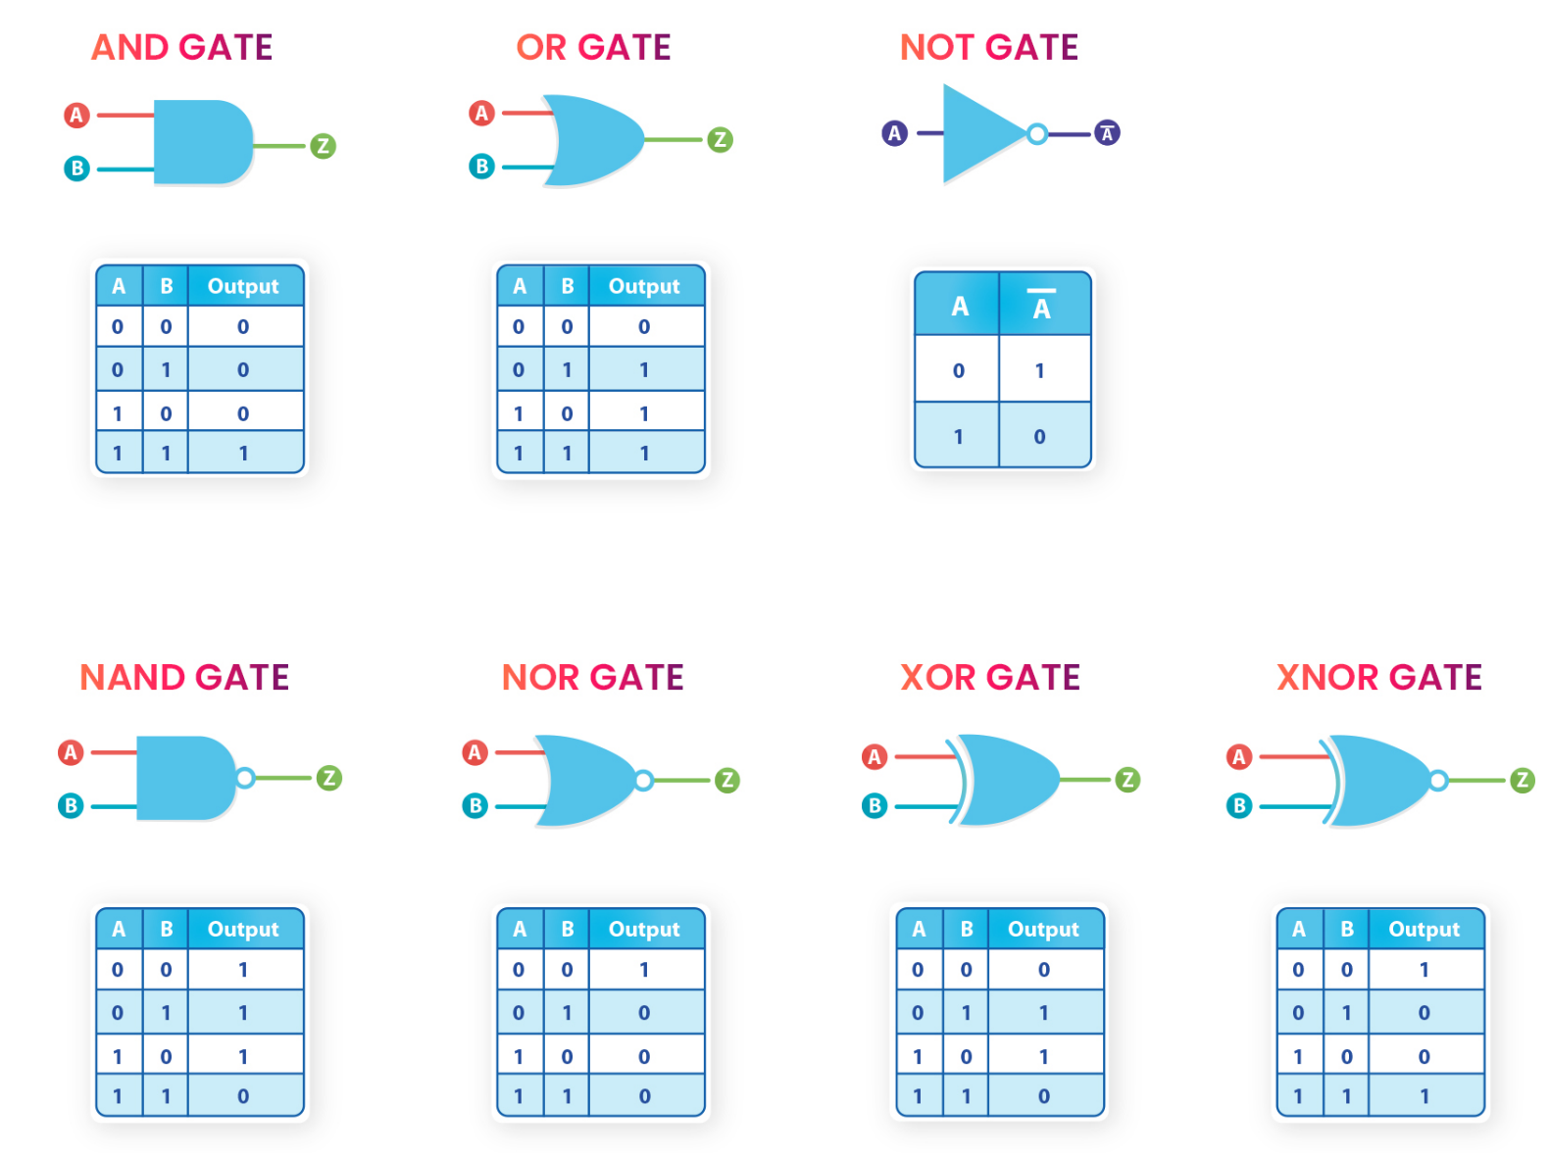

LIBRARY IEEE;

USE IEEE.STD_LOGIC_1164.ALL;

ENTITY and_test IS

PORT (SW: IN STD_LOGIC_VECTOR(15 DOWNTO 0);

LEDR: OUT STD_LOGIC_VECTOR(15 DOWNTO 0); -- red LEDs

LEDG: OUT STD_LOGIC_VECTOR(7 DOWNTO 0)); -- Green LEDs

END and_test;

ARCHITECTURE Structure OF and_test IS

COMPONENT my_gates

PORT ( A: in std_logic;

B: in std_logic;

Y_AND: out std_logic;

Y_OR: out std_logic;

Y_NOT_A: out std_logic;

Y_NAND: out std_logic;

Y_NOR: out std_logic;

Y_XOR: out std_logic;

Y_XNOR: out std_logic

);

END COMPONENT;

BEGIN

LEDR <= SW;

DUT: my_gates PORT MAP (SW(1),SW(0),LEDG(6),LEDG(5),LEDG(4),LEDG(3),LEDG(2),LEDG(1),LEDG(0));

END Structure;

library ieee;

use ieee.std_logic_1164.all;

entity my_gates is

port( A: in std_logic;

B: in std_logic;

Y_AND: out std_logic;

Y_OR: out std_logic;

Y_NOT_A: out std_logic;

Y_NAND: out std_logic;

Y_NOR: out std_logic;

Y_XOR: out std_logic;

Y_XNOR: out std_logic

);

end my_gates;

architecture dataflow of my_gates is

begin

Y_AND <= A and B;

Y_OR <= A or B;

Y_NOT_A <= not A;

Y_NAND <= A nand B;

Y_NOR <= A nor B;

Y_XOR <= A xor B;

Y_XNOR <= A xnor B;

end dataflow; 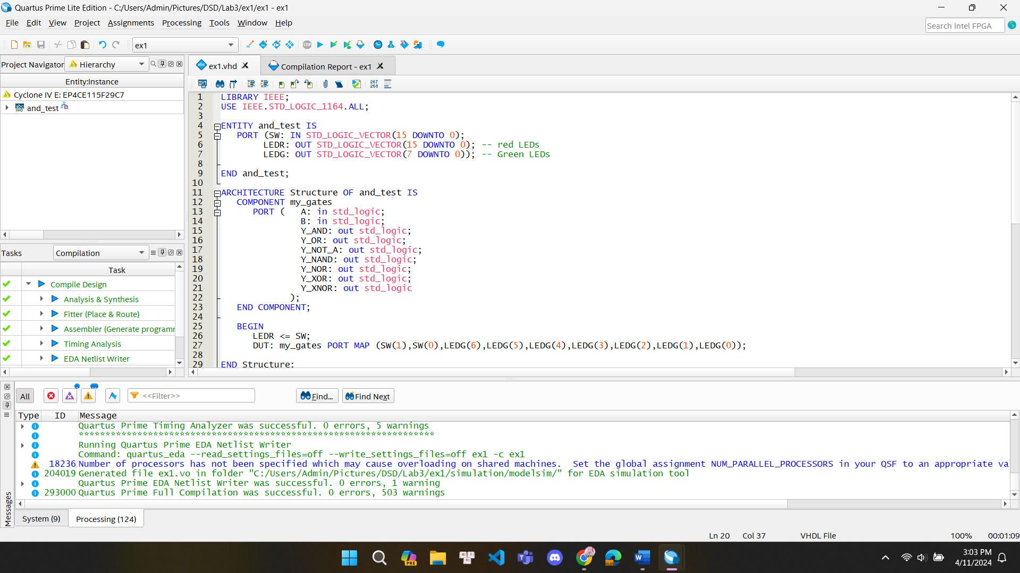

**II.2 LAB EXPERIMENT 2 : WRITE VHDL CODE TO IMPLEMENT THE HALF ADDER CIRCUIT IN FPGA KIT:**

LIBRARY IEEE;

USE IEEE.STD_LOGIC_1164.ALL;

ENTITY ex2 IS

PORT (SW: IN STD_LOGIC_VECTOR(15 DOWNTO 0);

LEDR: OUT STD_LOGIC_VECTOR(15 DOWNTO 0); -- red LEDs

LEDG: OUT STD_LOGIC_VECTOR(7 DOWNTO 0)); -- Green LEDs

END ex2;

ARCHITECTURE Structure OF ex2 IS

COMPONENT test

PORT ( A: in std_logic;

B: in std_logic;

SUM: out std_logic;

Carry: out std_logic

);

END COMPONENT;

BEGIN

LEDR <= SW;

DUT: test PORT MAP (SW(1),SW(0),LEDG(1),LEDG(0));

END Structure;

library ieee;

use ieee.std_logic_1164.all;

entity test is

port( A: in std_logic;

B: in std_logic;

SUM: out std_logic;

Carry: out std_logic

);

end test;

architecture dataflow of test is

begin

SUM <= A xor B;

Carry <= A and B;

end dataflow;

**II.3 EXPERIMENT 3: WRITE VHDL CODE TO SIMULATE AND IMPLEMENT THE FULL ADDER CIRCUIT IN FPGA KIT:**

LIBRARY IEEE;

USE IEEE.STD_LOGIC_1164.ALL;

ENTITY ex3 IS

PORT (SW: IN STD_LOGIC_VECTOR(15 DOWNTO 0);

LEDR: OUT STD_LOGIC_VECTOR(15 DOWNTO 0); -- red LEDs

LEDG: OUT STD_LOGIC_VECTOR(7 DOWNTO 0)); -- Green LEDs

END ex3;

ARCHITECTURE Structure OF ex3 IS

COMPONENT test

PORT ( A: in std_logic;

B: in std_logic;

C: in std_logic;

SUM: out std_logic;

Carry: out std_logic

);

END COMPONENT;

BEGIN

LEDR <= SW;

DUT: test PORT MAP (SW(2),SW(1),SW(0),LEDG(1),LEDG(0));

END Structure;

library ieee;

use ieee.std_logic_1164.all;

entity test is

port( A: in std_logic;

B: in std_logic;

C: in std_logic;

SUM: out std_logic;

Carry: out std_logic

);

end test;

architecture dataflow of test is

begin

SUM <= (A xor B) xor C;

Carry <= ((A xor B) and C) or (A and B);

end dataflow;

**Structural style**

LIBRARY IEEE;

USE IEEE.STD_LOGIC_1164.ALL;

ENTITY ex1 IS

PORT (SW: IN STD_LOGIC_VECTOR(15 DOWNTO 0);

LEDR: OUT STD_LOGIC_VECTOR(15 DOWNTO 0); -- red LEDs

LEDG: OUT STD_LOGIC_VECTOR(7 DOWNTO 0) -- Green LEDs

);

END ex1;

ARCHITECTURE Structure OF ex1 IS

COMPONENT Full_adder

PORT ( A: in std_logic;

B: in std_logic;

Cin: in std_logic;

S: out std_logic;

C: out std_logic);

END COMPONENT;

BEGIN

LEDR <= SW;

DUT: Full_adder PORT MAP (SW(2),SW(1),SW(0),LEDG(1),LEDG(0));

END Structure;

library IEEE;

use IEEE.STD_LOGIC_1164.all;

entity Full_adder is

port(A,B,Cin : in STD_LOGIC;

S, C:out STD_LOGIC);

end Full_adder;

architecture struct_Full of Full_adder is

signal X,Y,Z :std_logic;

component my_AND_gate

port( A: in std_logic;

B: in std_logic;

Y: out std_logic

);

end component;

component my_OR_gate

port( A: in std_logic;

B: in std_logic;

Y: out std_logic

);

end component;

component my_XOR_gate

port( A: in std_logic;

B: in std_logic;

Y: out std_logic

);

end component;

begin

X1: my_XOR_gate port map(A,B,X);

X2: my_XOR_gate port map(X,Cin,S);

A1: my_AND_gate port map(X,Cin,Y);

A2: my_AND_gate port map(A,B,Z);

A3: my_OR_gate port map(Y,Z,C);

end struct_Full;

library ieee;

use ieee.std_logic_1164.all;

entity my_AND_gate is

port( A: in std_logic;

B: in std_logic;

Y: out std_logic

);

end my_AND_gate;

architecture df_and of my_AND_gate is

begin

Y <= A and B;

end df_and;

library ieee;

use ieee.std_logic_1164.all;

entity my_OR_gate is

port( A: in std_logic;

B: in std_logic;

Y: out std_logic

);

end my_OR_gate;

architecture df_or of my_OR_gate is

begin

Y <= A or B;

end df_or;

library ieee;

use ieee.std_logic_1164.all;

entity my_XOR_gate is

port( A: in std_logic;

B: in std_logic;

Y: out std_logic

);

end my_XOR_gate;

architecture df_xor of my_XOR_gate is

begin

Y <= A xor B;

end df_xor;

**II.4 EXPERIMENT 4 :WRITE VHDL CODE TO IMPLEMENT 2:1 MULTIPLEXER CIRCUIT IN FPGA KIT :**

LIBRARY IEEE;

USE IEEE.STD_LOGIC_1164.ALL;

ENTITY ex4 IS

PORT (SW: IN STD_LOGIC_VECTOR(15 DOWNTO 0);

LEDR: OUT STD_LOGIC_VECTOR(15 DOWNTO 0); -- red LEDs

LEDG: OUT STD_LOGIC_VECTOR(7 DOWNTO 0) -- Green LEDs

);

END ex4;

ARCHITECTURE Structure OF ex4 IS

COMPONENT my_gates

PORT (I0: IN STD_LOGIC;

I1: IN STD_LOGIC;

Sel: IN STD_LOGIC;

Y: OUT STD_LOGIC

);

END COMPONENT;

BEGIN

LEDR <= SW;

DUT: my_gates PORT MAP (SW(0),SW(1),SW(2),LEDG(1));

END Structure;

library ieee;

use ieee.std_logic_1164.all;

ENTITY my_gates IS

PORT (I0: IN STD_LOGIC;

I1: IN STD_LOGIC;

Sel: IN STD_LOGIC;

Y: OUT STD_LOGIC

);

END my_gates;

ARCHITECTURE dataflow OF my_gates IS

BEGIN

Y<=(((NOT Sel) AND I0) OR (I1 AND Sel));

END dataflow;

**STRUCTURAl  
library ieee;**

**use ieee.std_logic_1164.all;**

**entity my_gates is**

**port (**

**I0 : in std_logic;**

**I1 : in std_logic;**

**Sel : in std_logic;**

**Y : out std_logic**

**);**

**end my_gates;**

**architecture dataflow of my_gates is**

**begin**

**Y <= (((not Sel) and I0) or (I1 and Sel));**

**end dataflow;**

**library ieee;**

**use ieee.std_logic_1164.all;**

**entity ex4 is**

**port (**

**SW : in std_logic_vector(15 downto 0);**

**LEDR : out std_logic_vector(15 downto 0); -- red LEDs**

**LEDG : out std_logic_vector(7 downto 0) -- Green LEDs**

**);**

**end ex4;**

**architecture Structure of ex4 is**

**component my_gates**

**port (**

**I0 : in std_logic;**

**I1 : in std_logic;**

**Sel : in std_logic;**

**Y : out std_logic**

**);**

**end component;**

**begin**

**LEDR <= SW;**

**DUT : my_gates port map (I0 => SW(0), I1 => SW(1), Sel => SW(2), Y => LEDG(1));**

**end Structure;  
**

**II.5 EXPERIMENT 5 : WRITE VHDL CODES TO IMPLEMENT 4:1 MULTIPLEXER CIRCUIT IN FPGA KIT:**

**II.6 EXPERIMENT 6 : WRITE VHDL CODE TO IMPLEMENT 2 to 4 DECODER CIRCUIT IN FPGA KIT:**

**II.7 EXPERIMENT 7 : WRITE VHDL CODE TO IMPLEMENT 8 TO 3 ENCODER WITH PRIORITY CIRCUIT IN FPGA KIT:**

**II.8 EXPERIMENT 8 : WRITE VHDL CODES TO IMPLEMENT 1 TO 8 DEMULTIPLEXER CIRCUIT IN FPGA KIT:**

**II.9 EXPERIMENT 9 : WRITE VHDL CODES TO IMPLEMENT N-BIT COMPARATOR CIRCUIT IN FPGA KIT WITH FOLLOWING VHDL REFERENED CODE**

library ieee;

use ieee.std_logic_1164.all;

entity Comparator is

generic(n: natural :=4);

port( A: in std_logic_vector(n-1 downto 0);

B: in std_logic_vector(n-1 downto 0);

less: out std_logic;

equal: out std_logic;

greater: out std_logic

);

end Comparator;

architecture behv of Comparator is

begin

process(A,B)

begin

if (A>B) then

less <= '0';

equal <= '0';

greater <= '1';

elsif (A=B) then

less <= '0';

equal <= '1';

greater <= '0';

else

less <= '1';

equal <= '0';

greater <= '0';

end if;

end process;

end behv;

**II.10 EXPERIMENT 10 : WRITE VHDL CODES TO IMPLEMENT N-BIT ALU CIRCUIT IN FPGA KIT WITH FOLLOWING VHDL REFERENED CODE**

library ieee;

use ieee.std_logic_1164.all;

use ieee.std_logic_unsigned.all;

use ieee.std_logic_arith.all;

entity ALU is

generic(N: natural :=4);

port( A: in std_logic_vector(N-1 downto 0);

B: in std_logic_vector(N-1 downto 0);

Op: in std_logic_vector(2 downto 0);

Res: out std_logic_vector(N-1 downto 0)

);

end ALU;

architecture behv of ALU is

begin

process(A,B,Op)

begin

case Op is

when "000" =>

Res <= A + B;

when "001" =>

Res <= A - B;

when "010" =>

Res <= not A ;

when "011" =>

Res <= not (A and B);

when “100” =>

Res <= not (A or B);

when “101” =>

Res <= A and B;

when “110” =>

Res <= A or B;

when “111” =>

Res <= A exor B;

end case;

end process;

end behv;

**IV. LAB REPORT GUIDELINES**

Students write up a report on the Verilog HDL implementation experiment projects created in this lab. The lab report should include Circuit Schematics, Truth Table, Verilog Module Codes, Verilog test bench codes, Top level module to implement the required circuit in FPGA KIT and evidences of data output evidences to validate the experiments (The Captured Screens, Photo of FPGA Kit implementation results).