ISO 27001 Risk & Compliance Analytics System

End-to-End GRC Analytics Project Documentation
Technologies: SQL / MySQL • Power BI • DAX • Relational Data Modelling
Author
Pranav Aggarwal
MCA | Data Analytics | Cybersecurity | GRC

Project Overview

The ISO 27001 Risk & Compliance Analytics System is an end-to-end Governance, Risk, and Compliance (GRC) analytics solution designed to provide a centralized view of organizational information-security risks, assets, controls, audit findings, compliance status, risk ownership, and assessment trends.
The solution combines a structured relational database, analytical SQL, Power BI data modeling, DAX measures, interactive visualizations, and systematic data validation. The final output is a three-page Power BI dashboard that moves from executive-level security posture to detailed risk and control analysis and finally to operational risk information.

Problem Statement

Organizations following information-security frameworks such as ISO 27001 must continuously monitor risks, assets, security controls, audits, findings, and remediation activities. When this information is distributed across multiple relational tables and analyzed manually, it becomes difficult to identify critical risks, understand departmental exposure, monitor control compliance, and track unresolved findings.
This project addresses the problem by creating a centralized analytics solution that transforms structured GRC data into management-ready insights through SQL and Power BI.

Objectives

- Design a structured relational database for GRC data.
- Maintain departments, assets, risks, controls, audits, findings, and assessment data.
- Analyze risk severity using likelihood, impact, and risk scores.
- Identify critical and high-priority risks.
- Analyze departmental risk exposure.
- Track security-control implementation and compliance.
- Monitor audit findings and remediation status.
- Analyze historical risk assessments and risk-score changes.
- Create DAX-based KPIs and an interactive Power BI dashboard.
- Validate Power BI results against SQL calculations.
- Perform primary-key, referential-integrity, category, and risk-score validation.

Solution Architecture

The project follows an end-to-end analytics pipeline from relational data storage to analytical SQL, dimensional modeling, DAX calculations, and interactive reporting.

Layer | Purpose
Relational Database | Stores departments, assets, risks, controls, audits, findings, and assessment data.
SQL Analysis | Performs joins, aggregations, CTEs, window functions, ranking, historical comparisons, and validation.
Power BI Model | Connects dimension and fact tables using controlled relationships.
DAX | Calculates KPIs, compliance metrics, risk metrics, and historical indicators.
Dashboard | Provides three interactive analytical pages for executive, analytical, and operational use.

Database Design

The relational database organizes GRC information into connected entities. The Power BI analytical model uses dimension and fact tables to support filtering, aggregation, and controlled cross-filtering.

Entity | Analytical Role
Departments | Organizational grouping for assets and risk analysis.
Assets | Organizational assets associated with risks and controls.
Risks | Risk identity, severity, likelihood, impact, score, ownership, and status.
Controls | Security-control definitions and attributes.
Audits | Audit-level information.
Audit Findings | Audit observations, severity, status, and remediation information.
Asset-Control | Control assessment/compliance information associated with assets.
Risk-Control | Relationships between risks and controls, including effectiveness.
Risk Assessment History | Historical assessment dates and risk scores.

SQL Analysis

SQL was used for data exploration, analytical calculations, relationship-based analysis, historical comparisons, ranking, and data-quality validation.
- SELECT, WHERE, GROUP BY, ORDER BY and aggregate functions.
- INNER JOIN and LEFT JOIN for relational analysis.
- CASE expressions and conditional aggregation.
- Common Table Expressions (CTEs).
- Window functions including ROW_NUMBER(), RANK(), DENSE_RANK(), and LAG().
- Risk ranking within departments.
- Historical risk-score comparisons.
- Audit findings and control compliance analysis.

Representative ranking logic
ROW_NUMBER() OVER (PARTITION BY department_name ORDER BY risk_score DESC)
Risk-score change was analyzed as current assessment score minus the previous assessment score, using LAG() to access the previous assessment.

DAX & KPI Layer
DAX measures were created for reusable dashboard KPIs including Total Assets, Total Risks, Critical Risks, High Risks,
Total Controls, Total Findings, Open Findings, Compliant Controls, Non-Compliant Controls, Control Compliance %, Critical Findings, Closed Findings, Average Risk Score, Critical Risk %, High + Critical Risks, Overdue Findings, Risk Score Change, and Control Effectiveness %.
Measure | Purpose
Total Assets | Distinct count of organizational assets.
Total Risks | Distinct count of identified risks.
Critical / High Risks | Counts risks by severity.
Average Risk Score | Average score across the risk population.
Total / Open / Closed Findings | Finding population and status metrics.
Measure | Purpose
Compliant / Non-Compliant Controls | Control compliance counts.
Control Compliance % | Compliant controls divided by total assessments.
Risk Score Change | Difference between current and previous assessment score.

Power BI Dashboard

The final Power BI solution contains three interactive pages. The pages are separated by decision-making level so the dashboard avoids unnecessary repetition.

Page 1 — Executive Overview
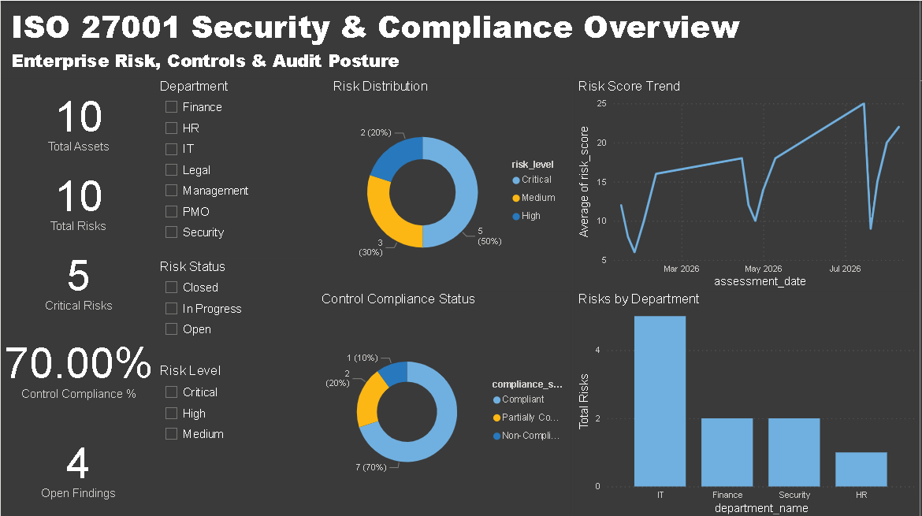
Provides a high-level view of the organization's security and compliance posture.
- Total Assets, Total Risks, Critical Risks, Control Compliance %, and Open Findings.33
- Risk Distribution and Control Compliance Status.
- Average Risk Score Trend.
- Risks by Department.
- Department, Risk Level, and Risk Status slicers.

Page 2 — Risk & Control Analysis

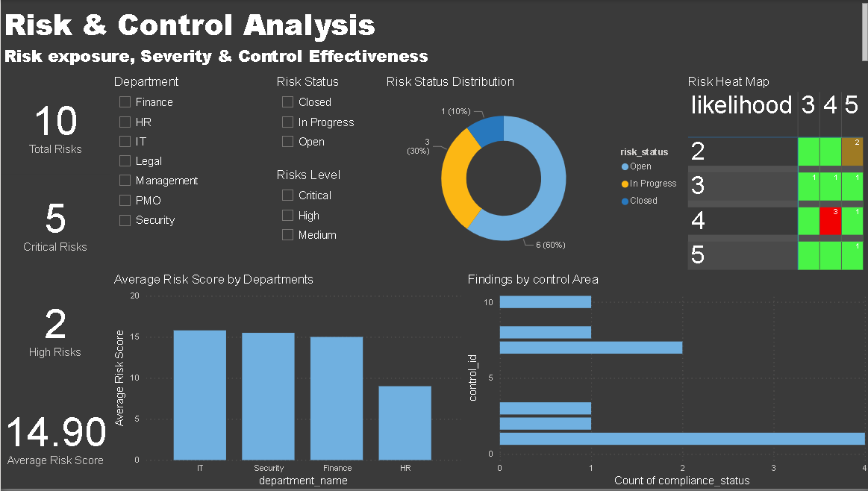
Provides deeper analysis of risk severity and control performance.
- Total Risks, Critical Risks, High Risks, and Average Risk Score.
- Risk Status Distribution.
- Risk Severity analysis.
- Likelihood × Impact risk heat map.
- Average Risk Score by Department.
- Department, Risk Level, and Risk Status slicers.

Page 2.1 — Risk Heat Map

Implemented as a Power BI Matrix using likelihood on rows, impact on columns, count of risk IDs as values, and conditional color formatting to highlight concentrations of risks across likelihood-impact combinations.

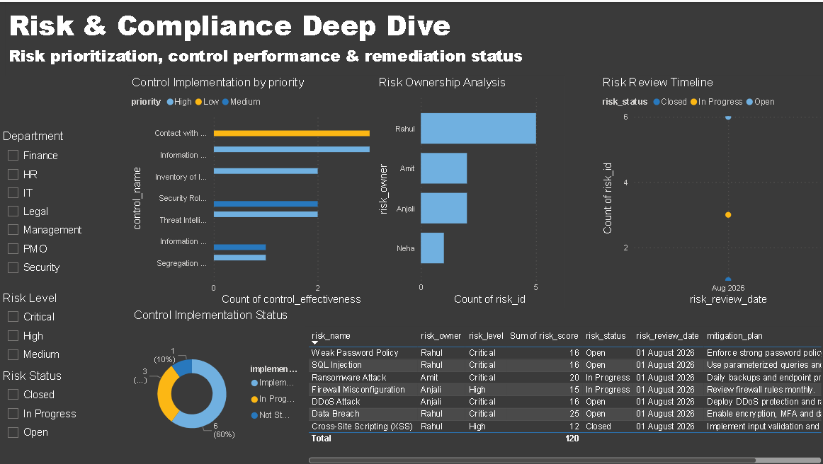
Page 3 — Risk & Compliance Deep Dive

Provides operational-level analysis of ownership, reviews, controls, and high-priority risks.
- Risk Ownership Analysis.
- Risk Review Timeline.
- Control Implementation Status.
- Control Implementation by Priority.
- High & Critical Risk Details table.
- Department, Risk Level, and Risk Status slicers.

Data Validation & Testing

The project was validated at database, SQL, and Power BI levels before finalization.
Validation | Result
Primary-key duplicate checks | Passed — no duplicates identified for tested major IDs.
Referential-integrity checks | Passed — no orphan records identified in tested relationships.
Risk score consistency | Passed — risk score is consistent with likelihood × impact.
Category validation | Passed — key risk, status, and compliance categories were checked.
SQL vs Power BI KPI comparison | Passed — dashboard values matched SQL calculations.
Power BI slicer/interactions | Passed — filters dynamically update relevant visuals.

Validated KPI Results

Metric | Validated Result
Total Assets | 10
Total Risks | 10
Critical Risks | 5
High Risks | 2
Average Risk Score | 14.90
Open Findings | 4
Compliant Controls | 7
Non-Compliant Controls | 3
Control Compliance | 70%

Business Recommendations

- Prioritize critical risks: Critical and high risks should receive the highest priority during risk treatment and remediation planning.
- Focus on high-risk departments: Departments with higher average risk scores should receive additional assessment and control review.
- Improve control compliance: The 70% compliance level indicates that non-compliant controls require review, ownership, deadlines, and remediation.
- Reduce open audit findings: Open findings should be tracked with clear owners, target dates, status updates, and escalation.
- Monitor risk trends: Increasing risk scores should trigger investigation into control degradation, threats, vulnerabilities, or insufficient mitigation.
- Strengthen risk ownership: Critical risks should have clear ownership and remediation responsibility.
- Improve control implementation: Incomplete controls should be prioritized according to risk severity, business impact, and priority.
- Establish continuous monitoring: Periodic refreshes and management reviews should keep risk and compliance information current.

Project Findings

The validated analysis produced the following key findings:
- 10 total risks were identified.
- 5 risks are Critical and 2 are High.
- Critical risks represent 50% of the identified risk population.
- 70% control compliance was validated: 7 compliant assessments out of 10 total control assessments.
- 4 audit findings remain Open, requiring continued remediation monitoring.
- Department-level analysis shows that risk exposure is not evenly distributed.
- The likelihood-impact heat map highlights concentrations across severity dimensions.
- Risk ownership analysis provides visibility into remediation responsibility distribution.
- Control implementation analysis highlights areas requiring additional attention.
- Risk review analysis supports continuous monitoring of assessment activity.

Skills Demonstrated

Area | Skills
Data Analytics | Data modeling, validation, KPI development, analytical storytelling, dashboard design.
SQL | Relational design, joins, aggregations, CTEs, window functions, ranking, historical analysis, validation.
Power BI | Data modeling, relationships, slicers, cross-filtering, conditional formatting, heat maps, dashboard design.
DAX | CALCULATE, DIVIDE, DISTINCTCOUNT, COUNTROWS, AVERAGE, FILTER, ALL, variables, filter context.
GRC / Cybersecurity | Risk assessment, scoring, controls, compliance, audit findings, ownership, remediation, ISO 27001 concepts.

Future Enhancements

- Automated data ingestion from GRC, asset management, vulnerability-management, or SIEM platforms.
- Automated alerts for critical risks, overdue findings, non-compliant controls, and upcoming reviews.
- Predictive analytics for risk escalation, finding closure probability, control failure probability, or future risk scores.
- Automated compliance scoring against ISO 27001, NIST CSF, SOC 2, or CIS Controls.
- Near-real-time risk and compliance monitoring.
- Role-based dashboard access for executives, risk managers, security teams, auditors, and control owners.
- Automated remediation workflows with owners, deadlines, escalations, and completion tracking.
- Integration with ticketing, cloud-security, SIEM, vulnerability-management, and asset-management platforms.

Conclusion

The ISO 27001 Risk & Compliance Analytics System demonstrates an end-to-end approach to transforming structured cybersecurity and compliance data into actionable business intelligence.
By combining relational database design, SQL analysis, Power BI data modeling, DAX calculations, interactive visualizations, risk heat maps, and systematic validation, the project provides a centralized view of organizational risk, control implementation, compliance, audit findings, ownership, and remediation priorities.
The three-page dashboard supports executive security posture, detailed risk and control analysis, and operational risk-level investigation. The project demonstrates practical application of Data Analytics, SQL, Power BI, DAX, Business Intelligence, GRC, Cybersecurity, and ISO 27001 concepts in a single end-to-end solution.

Author
Pranav Aggarwal
MCA | Data Analytics | Cybersecurity | GRC

