1. Objective
To establish the procedure for identifying, validating, and coding IT prepaid expenses. This process ensures that the R2R Team receives accurate Cost Center, General Ledger (GL), and Profit Center information to create the correct amortization schedules in Blackline.

2. Applicable SoX Controls, Policies and Regulations
Management Review & Approval: All accounting classification data (Cost Center/GL/Profit Center) assigned to the invoices must be reviewed and approved by VMO Leadership before being released to the R2R team for amortization entry.

3. Service Level Agreement (SLA)
- The validation and return of the data file to the EBS team should ideally occur within 2 business days of receipt, pending leadership review availability.

4. Frequency and Expected Process Time
- Frequency: Monthly
- Expected Process Time: Approximately 15 to 30 minutes for data validation, plus variable time for leadership review.

5. Responsibilities (Fill in considering positions and areas, not personal names)
- Responsible: IT Financial Management Associate
- Approver: VMO Leadership
- Consulted: R2R Team
- Informed: N/A

6. Systems
- Microsoft Excel
- Microsoft Outlook

7. Data in and out
Specify data entering and exiting the process. Define the data sources (Data In) and the output or destinations (Data Out) to ensure proper tracking and management throughout the procedure.
Input:  Data in:  - Excel file listing transactions/invoices;  - "S4 IT Purchase Orders [Year]" spreadsheet  Data Sources:  - Microsoft Outlook  - Microsoft Excel | Output:  Data Out:  - Populated Excel file containing validated Cost Center, GL Account, and Profit Center for each invoice;  - Email confirmation to EBS to proceed with Blackline entry.  Data Sources:  - Microsoft Outlook;  - Microsoft Excel
8. Procedure
*Yellow-highlighted cells indicate conditional fields. If the condition stated in the block header does not apply, disregard all steps in that block
1 | Receive Amortization Request and open PO spreadsheet
1.1 | Receive an email from the EBS Team containing a file of invoices posted in SAP that exceed the $100,000 threshold.  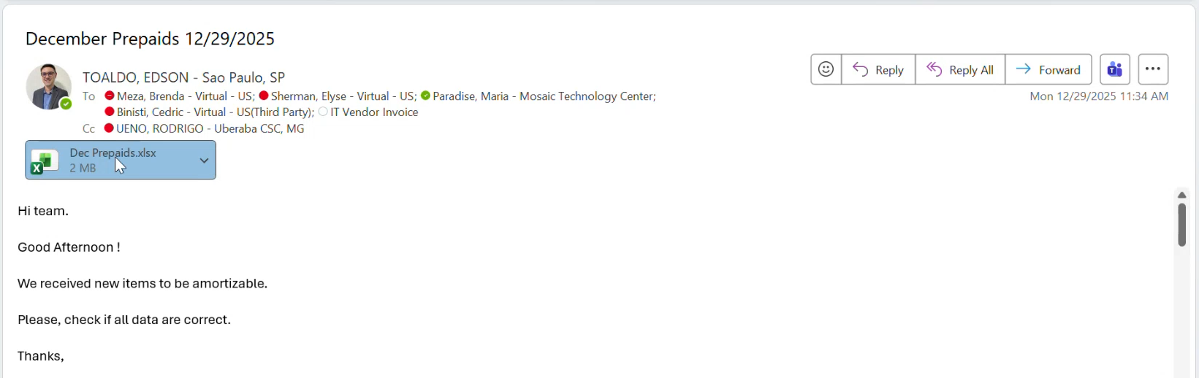
1.2 | Open the "S4 IT Purchase Orders [Year]" file. This is the manual entry master file managed by the VMO team containing all PO details.  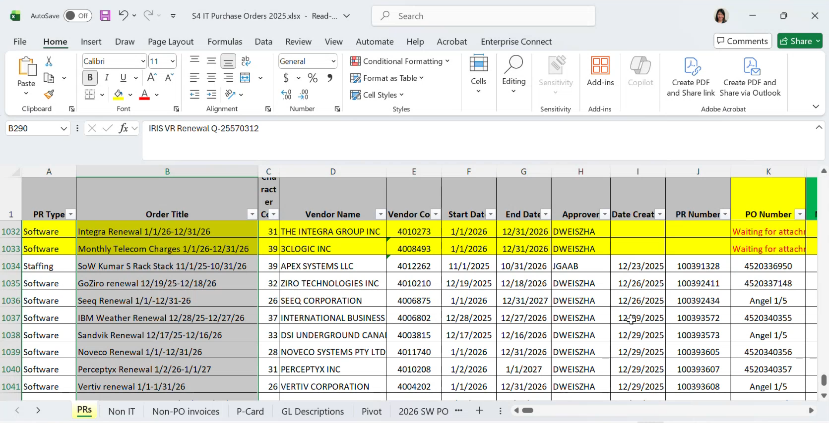
2 | Validate Accounting Strings
2.1 | Open the spreadsheet received by the R2R team  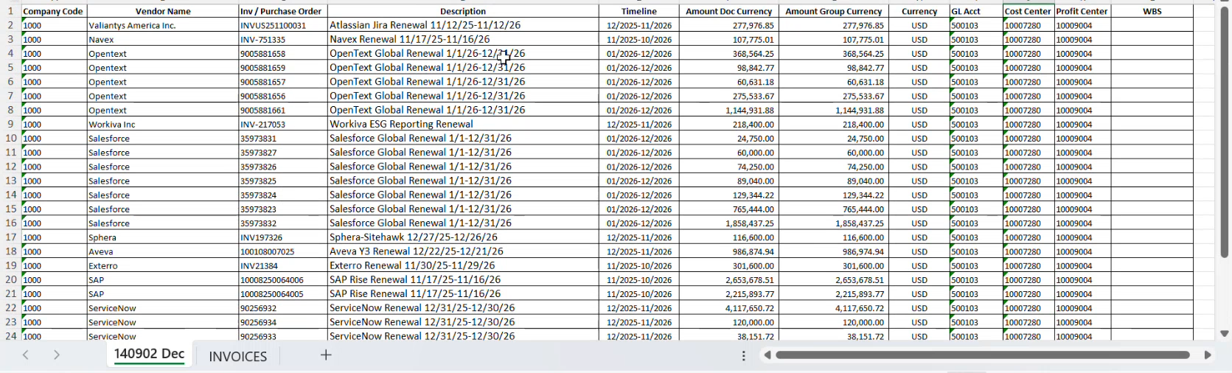
2.2 | In the "S4 IT Purchase Orders [Year]" file , locate the specific Purchase Order (PO) related to the invoice.  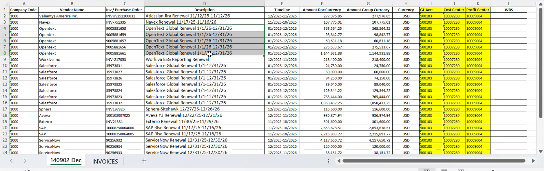  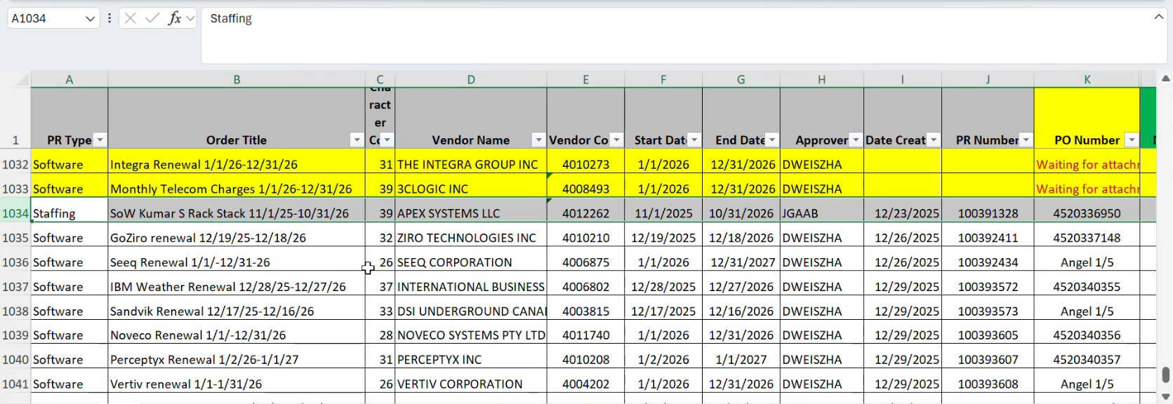
2.3 | Verify the "Amortization" column (Column T) to confirm where the expense was settled.  The allocation codes follow the rule below:  - The 8 digits in the middle represent the Cost Center (E.g. 10007280)  - The 6 digits on the right represent the GL Account (E.g. 500103)  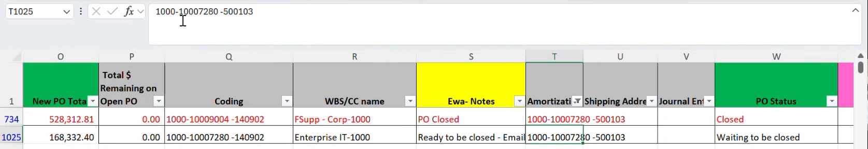
3 | Populate Invoices File
3.1 | In the file received from R2R, populate the following required columns based on "S4 IT Purchase Orders [Year]" spreadsheet  • Column I: GL Account.  • Column J: Cost Center (or WBS if applicable).  • Column K: Profit Center (10009004)  Note: Ensure distinction between Cost Center and WBS Element; they are interchangeable but mutually exclusive for settlement.  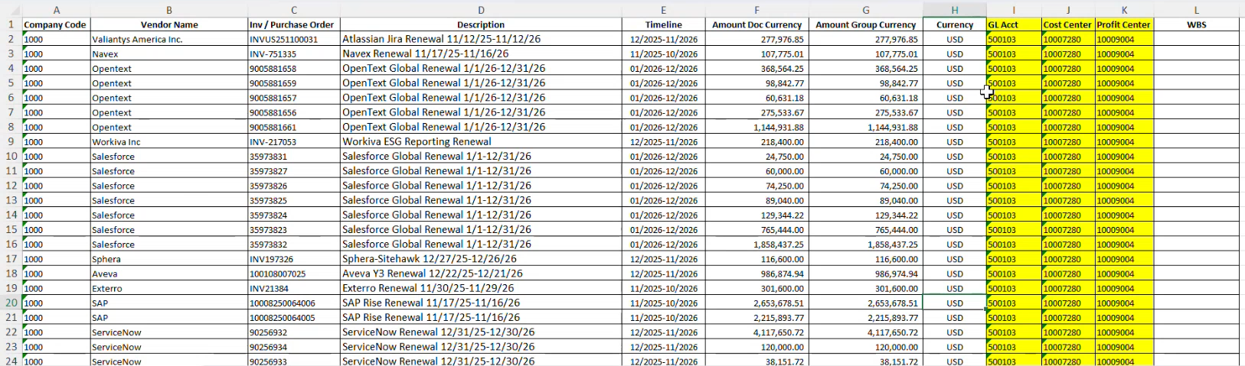
4 | Partial Invoice Check
4.1 | Review the invoice amount against the total PO value. Be aware that suppliers may post partial invoices (e.g., $200k invoice on a $400k PO).  Note: Ensure the R2R team is aware if the invoice represents only a portion of the total amortization required for the PO.
5 | Review and Final Submission
5.1 | Email the completed file to VMO Leadership for review and await confirmation/alignment from all leadership members.
5.2 | Once approved, reply to the R2R Team attaching the finalized file with the coding data.
5.3 | The R2R team will then create the prepaid amortization in Blackline.

9. Revision
Version | Date | Changes
1 | 01/08/2026 | Document Creation
2 | MM/DD/YYYY | Description
3 | MM/DD/YYYY | Description

