**Introduction to Google Ads Campaign Performance Analysis**

**Explanatory Data Analysis:**

Provided with Three Data Sets

1.AdPerformance Metrics dataset--->•Google Ad Performance data

2.ProductDetails dataset---->•Details of the Items and their categorizations at different levels

3.CampaignDetails dataset---->•Campaign level information

**On Analysing the Product Details Dataset:**

1.solely from Home Category

2.Subcategories of Home Category

**Unique Products from the Category (Home) Solely – 5907**

**Unique Products from the Sub-Categories (Home) – 18897**

Total.No of unique products comes from the category of 2nd level - **92**

Total.No of unique products comes from the category of 4th level - **497**

Total.No of unique products comes from the category of 3rd level = **233**

Total.No of unique products comes from the category of 5th level = **740**

We have 91 subcategories under Product_level_2:

**Top 10 Level_2 categories:**

home & garden **19451**

baby & kids **732**

fashion & beauty **536**

electronics & tools **536**

sports & fitness **480**

office equipment **379**

pet supplies **163**

shelving storage **91**

luggage 83

arts & crafts 80

**Top 10 Level_3rd Category**

Furniture 7164

living room furniture 2797

decor 1890

bedroom furniture 1796

kitchen & dining 1615

patio furniture & accessories 1245

lighting & ceiling fans 735

heating 300

kids furniture 287

**Top 10 Level4 Categories:**

kitchen & dining furniture 2762

living room furniture 1979

bedroom furniture 1488

beds 1059

home dcor 1015

office furniture 804

patio seating 614

lamps & shades 494

tv stands & entertainment centers 392

patio sets 384

game & recreation room furniture 347

coffee tables 318

end & side tables 267

**Top 5th level Categories:**

kitchen & dining room furniture 1802

beds 1540

home office furniture 522

end tables 422

**Insights From Part 1:**

* Total Unique Products : 24613

* Total Number of products solely from Home Category :5907

* Total Number of products comes as sub category of Home: 18897

Total no.of products falls under Level-2 : 23,102

Total no.of products falls under level-3 : 22,588

Total no.of products falls under level-4: 20,780

Total no.of products falls under level-5:16,199

Top Subcategory in level-2 with count: *home and garden ---> 19451

Top Subcategory in level-3 with count: *Furniture ---> 7164

Top Subcategory in level-4 with count: *kitchen & dining furniture ----> 2762

Top Subcategory in level-5with count: *Kitchen dining Rome furniture ----> 18020

**Part 2:**

To Calculate the Return (Profit) Formula: Total Conversation value/Total Cost

Total Cost: $247614.27

Return:4.7

#RoAS = (Total conv_value / Total cost)

#Using the values provided, we can calculate the RoAS as:

#RoAS = (1188007.85 / 247614) = 4.8

#This means that for every dollar spent on advertising, earning $4.8 in conversion value. This is a good RoAS, as a ratio of 1 or more typically indicates a profitable advertising campaign.

**Comparing ROAS (Returns on Ad Spent) across the**

**months:**

Analysing at the following Levels:

1.Campaign

2.productcategory

3.Item

Months:

*August

*September

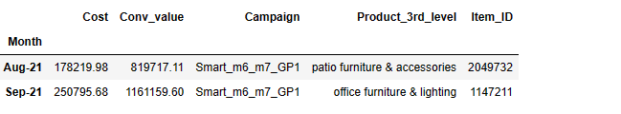

Amount Spent for the Month of August - 178220

Amount Spent for the Month of September -250795

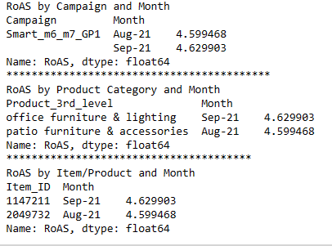

**Part 2 Insights:**

* Amount Spent for the Month of August - 178220

* Amount Spent for the Month of September -250795

* RoAS in August -- 4.59

* RoAS in September -- 4.62

* In August ,the most profitable products from Level3 category are from patio furniture & accessories

* In September ,the most profitable products from Level3 category are from office furniture & lighting

* Smart_m6_m7_GP1 Campaign returns more profit

**Part -3**

**Identify the Top and Bottom 10 Product Categories (Level 5) in terms of ad performance.**

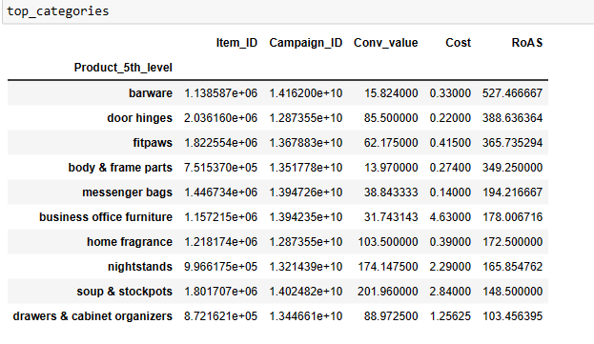

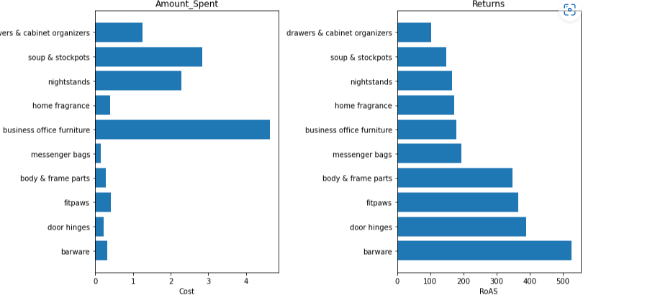

**Bottom Categories:**

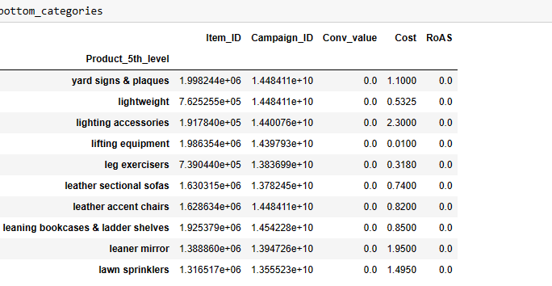

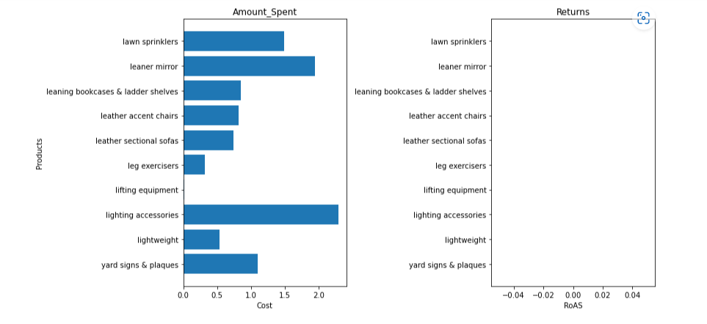

I grouped the Top 1o and Bottom 10 Product categories based on Total returns (i.e)Ad Performance the profit generated by the product. A low RoAS value indicates that the advertising spend on those product categories is not generating sufficient returns.

**Part -4**

**Is Click Type a significant factor that drives RoAS performance?**

We have Two types of click types

1. Shopping -online -TypeA

2.Shopping – Coupon -TypeB

RoAS for Type A: 4.687627644663613

RoAS for Type B: 31.78716155817325

The Drastic difference in Returns is because the Changes in the number of click types in both the category.So im using the t-test to get the p-valve to see the significant difference among the click types.

We then use the ttest_ind function to perform the two-sample t-test,

specifying equal_var=False to indicate that we want to perform a

Welch's t-test, which does not assume equal variances between the two groups.

The function returns the t-statistic and p-value, which we use to determine whether

the difference in RoAS is statistically significant. If the p-value is less than 0.05,

we conclude that there is a statistically significant difference in RoAS between the two click types.

Here Im going to Analyze the relationship between the RoAS and Other Features

A linear regression model is a statistical model that is used to

analyze the relationship between a dependent variable and one or more independent variables

here im going to analyze the relationship between Return in total to other features like Clicks,Impressions,etc.

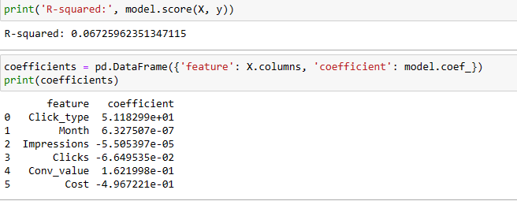

R-squared (R²) is a statistical measure that represents the proportion of the variance in the dependent variable that is explained by the independent variable(s) in a regression model. It ranges from 0 to 1, where 0 indicates that the model explains none of the variance in the dependent variable, and 1 indicates that the model explains all of the variance in the dependent variable.

In our case, the R² value is 0.06725962351347115, which means that only about 6.73% of the variance in the dependent variable is explained by the independent variable(s) in the regression model. This indicates that there may be other factors that are affecting the dependent variable that are not captured by the independent variable(s) in the model.

Im conculding that the other factors contributing less for the Return on ad other than cost,conversation_values.

**Part -5**

I personally suggests some of the Useful metrics to enhance Campaign performance other than the existing metrics in data. ¶

1.Total Visits and Unique Visits (other than Impressions).

2.Returning Visitors--Returning visits will help you find how many users came back to your website after an initial visit. This metric can help you see how effective your web content is when building audiences and is essential to tracking brand health.

3.Session Duration--This metric calculates how long a user spends on your site during a single browsing session. As they jump from page to page, you can estimate how long they spent reading and/or interacting with the page. The timer will stop when a user exits the page or idles for a pre-determined amount of time.

4.Keyword rankings--Marketers should pay close attention to how well key pages rank for certain keywords in their preferred search engine. Many people won’t go past the first page when conducting a Google search, so keeping a close eye on rankings is essential to driving continued traffic

5.Error in Url/website- So i personally went through this.So for any Campaign it is neccessary to check the URls

6.Unsubscribe rate