Sistema de Oficina Mecânica
Diagrama de classe

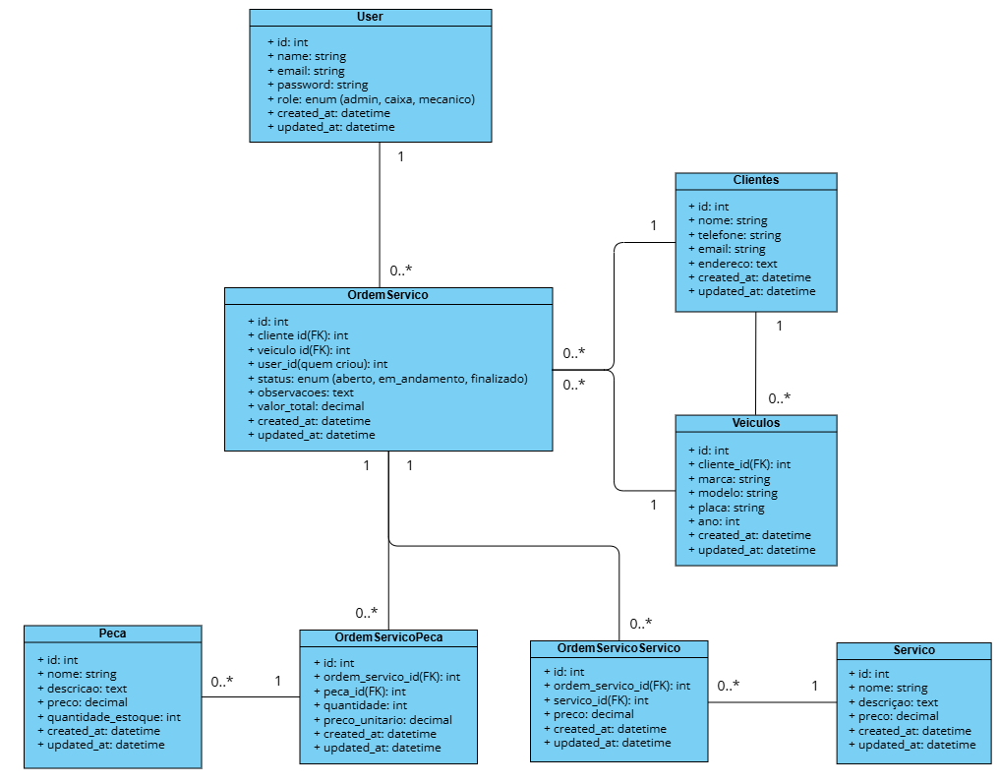

Migrações
User
public function up(): void
{
Schema::create('users', function (Blueprint $table) {
$table->id();
$table->string('name');
$table->string('email')->unique();
$table->timestamp('email_verified_at')->nullable();
$table->string('password');
$table->enum('role', ['admin', 'caixa', 'mecanico'])->default('mecanico');
$table->rememberToken();
$table->timestamps();
});
}

Clientes
public function up(): void
{
Schema::create('clientes', function (Blueprint $table) {
$table->id();
$table->string('nome');
$table->string('telefone')->nullable();
$table->string('email')->nullable();
$table->text('endereco')->nullable();
$table->timestamps();
});
}

Veículos
public function up(): void
{
Schema::create('veiculos', function (Blueprint $table) {
$table->id();
$table->foreignId('cliente_id')->constrained()->cascadeOnDelete();
$table->string('marca');
$table->string('modelo');
$table->string('placa')->unique();
$table->year('ano')->nullable();
$table->timestamps();
});
}

Peças
public function up(): void
{
Schema::create('pecas', function (Blueprint $table) {
$table->id();
$table->string('nome');
$table->text('descricao')->nullable();
$table->decimal('preco', 10, 2);
$table->integer('quantidade_estoque')->default(0);
$table->timestamps();
});
}

Serviços
public function up(): void
{
Schema::create('servicos', function (Blueprint $table) {
$table->id();
$table->string('nome');
$table->text('descricao')->nullable();
$table->decimal('preco', 10, 2);
$table->timestamps();
});
}

Ordem Serviço
public function up(): void
{
Schema::create('ordem_servicos', function (Blueprint $table) {
$table->id();

$table->foreignId('cliente_id')->constrained()->restrictOnDelete();
$table->foreignId('veiculo_id')->constrained()->restrictOnDelete();
$table->foreignId('user_id')->constrained()->restrictOnDelete();

$table->enum('status', ['aberto', 'em_andamento', 'finalizado'])->default('aberto');
$table->text('observacoes')->nullable();
$table->decimal('valor_total', 10, 2)->default(0);

$table->timestamps();
});
}

Ordem Serviço Serviço
public function up(): void
{
Schema::create('ordem_servico_servico', function (Blueprint $table) {
$table->id();

$table->foreignId('ordem_servico_id')->constrained()->cascadeOnDelete();
$table->foreignId('servico_id')->constrained()->restrictOnDelete();

$table->decimal('preco', 10, 2);

$table->timestamps();
});
}

Ordem Serviço Peça
public function up(): void
{
Schema::create('ordem_servico_peca', function (Blueprint $table) {
$table->id();

$table->foreignId('ordem_servico_id')->constrained()->cascadeOnDelete();
$table->foreignId('peca_id')->constrained()->restrictOnDelete();

$table->integer('quantidade');
$table->decimal('preco_unitario', 10, 2);

$table->timestamps();
});
}

