List of Requirement stage Collaboration Diagrams in eProcurement System and members assigned to perform use case realization (Analysis) report.

Use Cases for eProcurement System | Assigned To | Completion Date
The below use cases are mainly related to Buyer as an Actor. There are some which are triggered by Supplier
Quotation Request List Screen | Rahul
Quotation Request Details Screen | Rahul
Quotation Request Create Screen | Rahul
Quotation Request Process Screen (by Supplier) | Ei Ei
Purchase Order Acknowledgement Confirm Screen | Hnin
Material Shortage List Screen | Hnin
Material Shortage Item Detail Screen | Hnin
Purchase Expediting Process Screen | Hong Yu
Purchase Expediting Acknowledgement Confirm Screen | Hong Yu
The below use cases are more related to Supplier as an Actor.
Purchase Order Acknowledge Screen | Ei Ei
Purchase Expediting Acknowledge Screen | Ei Ei
Purchase Contract Acknowledge Screen | Ei Ei
Delivery Order Create Screen | Rahul
Goods Rejection Enquire/Print Screen | Rahul
Goods Rejection Acknowledge Screen | Rahul
The below use cases are used by Supplier and Buyer. Here grouping is based on function like Contract and Quotation.
Purchase Contract List Screen | Martin
Purchase Contract Details Screen | Martin
Purchase Order List Screen | Hong Yu
Purchase Order Details Screen | Hong Yu
Purchase Order Header Text Screen | Hong Yu
Purchase Order Item Line Text Screen | Hong Yu
Purchase Order Services Screen | Chetan
Purchase Order Subcontract Components Screen | Chetan
The below use cases are for User Management.
User Login | Soe Wai Lin
User Profile Maintenance | Soe Wai Lin
User Password Maintenance | Soe Wai Lin
User Registration | Soe Wai Lin
The below use cases are mainly for Warehouse user.
Delivery Order Enquiry Screen | Vinss
Delivery Order Details Screen | Vinss
Goods Rejection Enquire/Print Screen (by Supplier) | Vinss
Goods Rejection Acknowledge Screen (by Supplier) | Vinss

Use Cases for eProcurement System | Assigned To | Completion Date
The below use cases are interface related.
Interface Schedule Screen | Chetan
Activity Log Screen | Chetan

Quotation Request List Screen

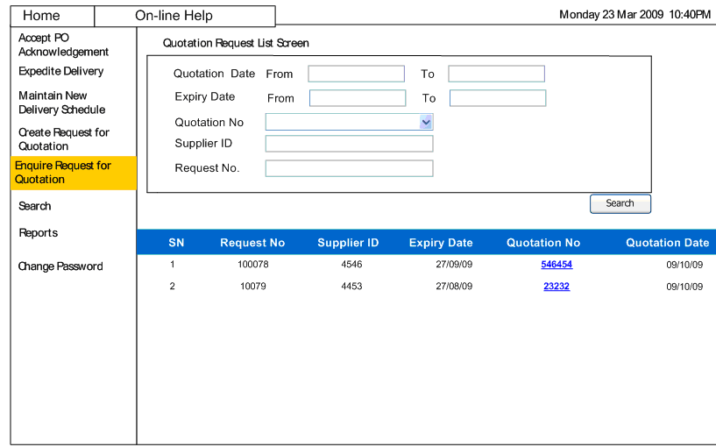

Quotation Request Details Screen

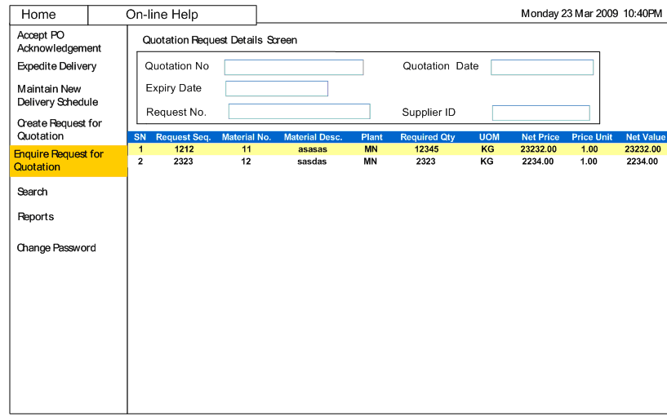

Create Quotation Request Screen

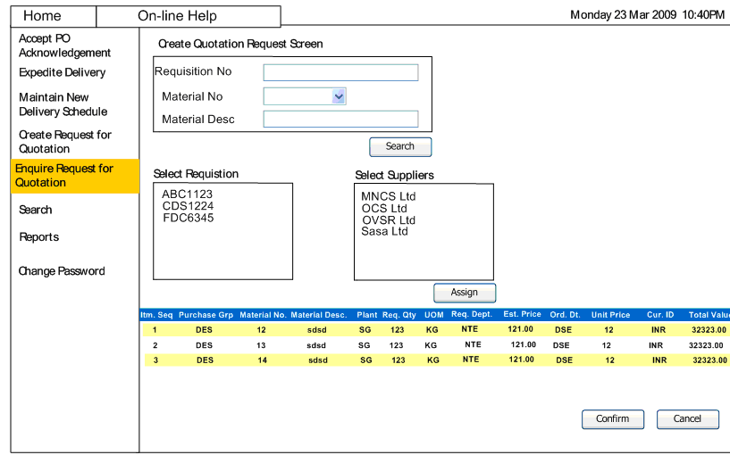

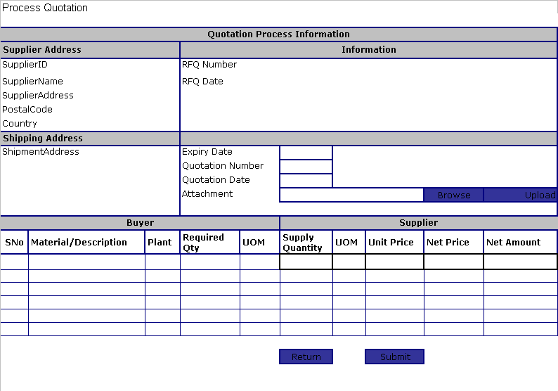

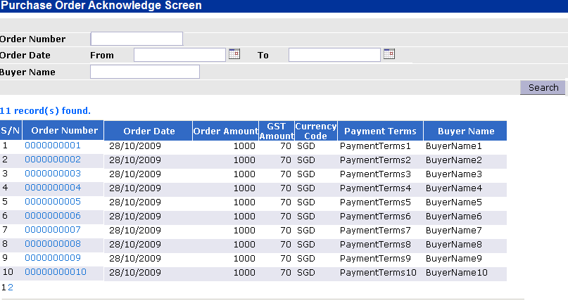

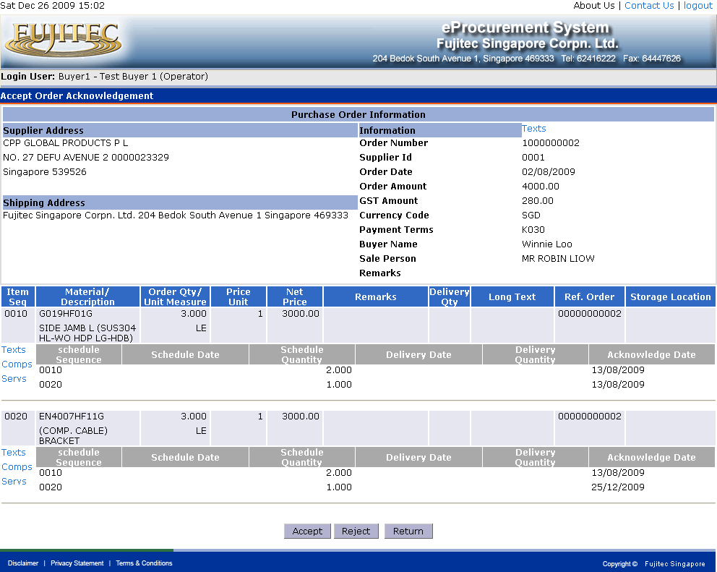

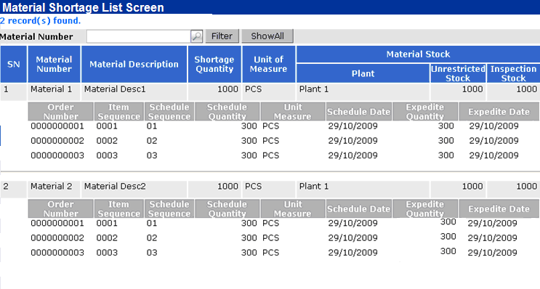

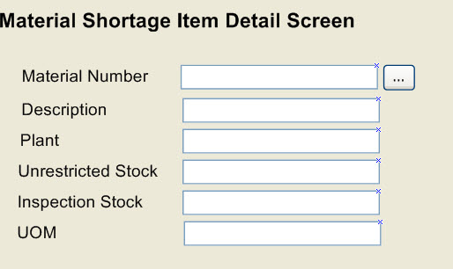

Purchase Expediting Process Screen
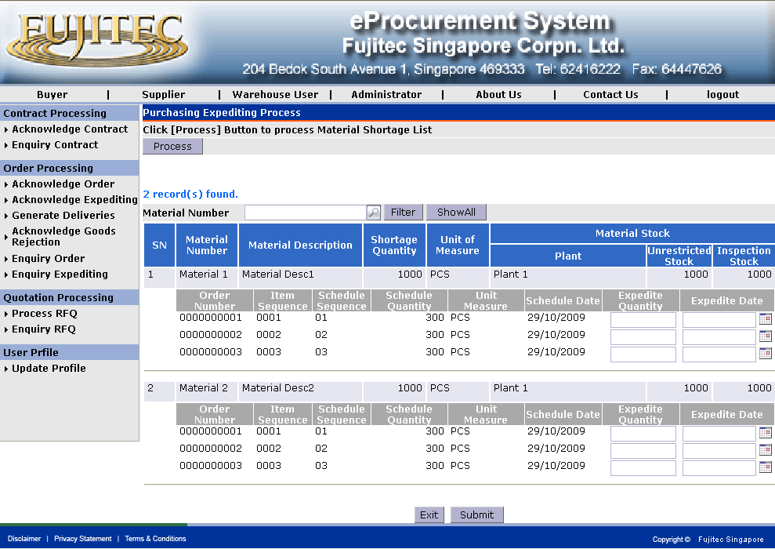
Purchase Expediting Acknowledgement Confirm Screen
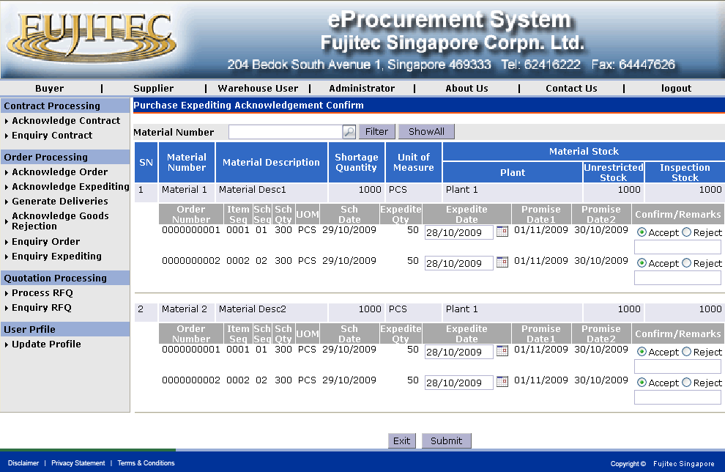

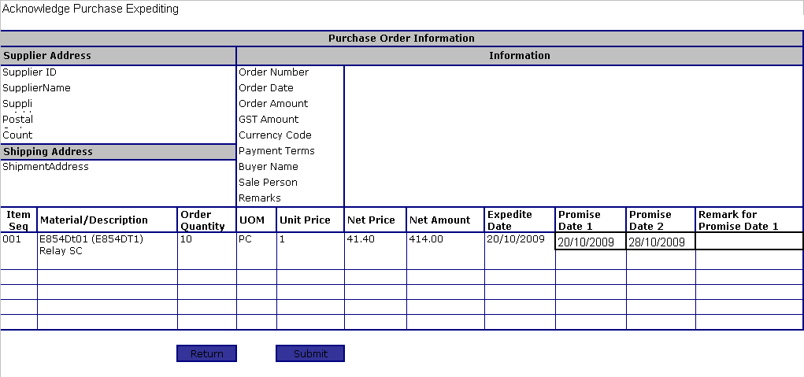

Acknowledge Purchase Contract
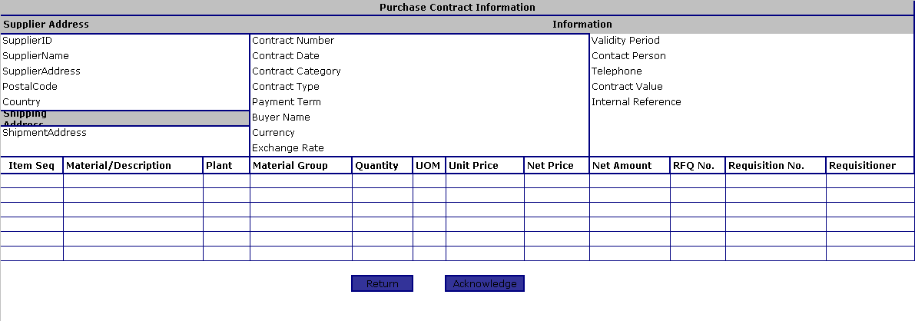

Goods Rejection Enquire/Print Screen

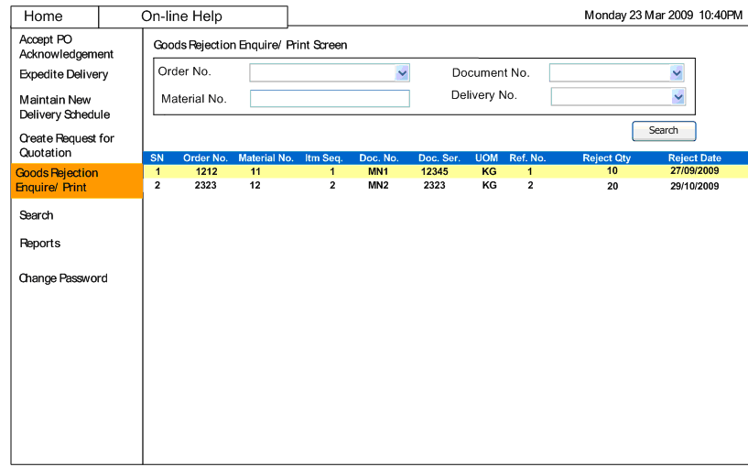

Goods Rejection Acknowledge Screen

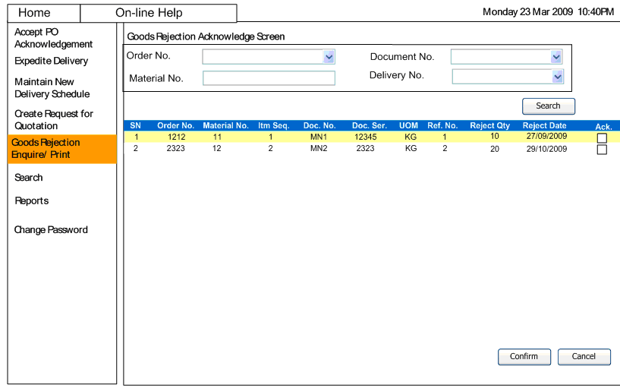

Purchase Contract List Screen
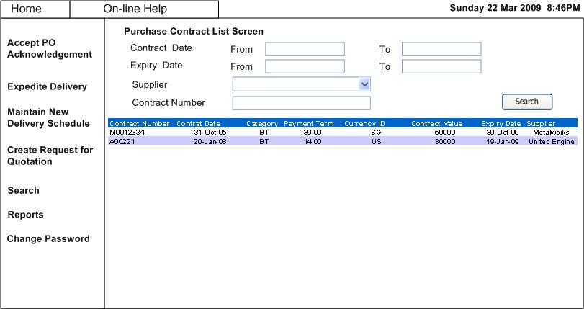

Purchase Contract Details Screen
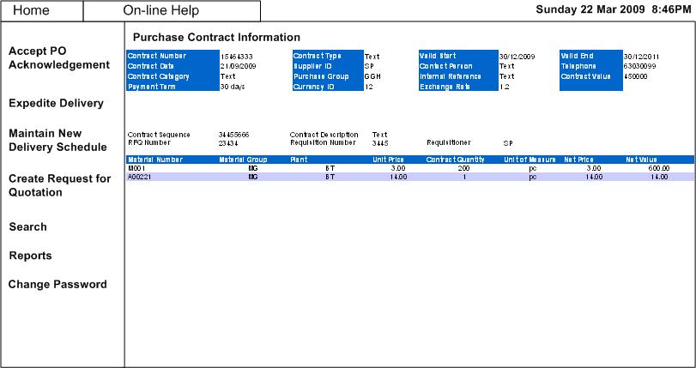

Purchase Order List Screen
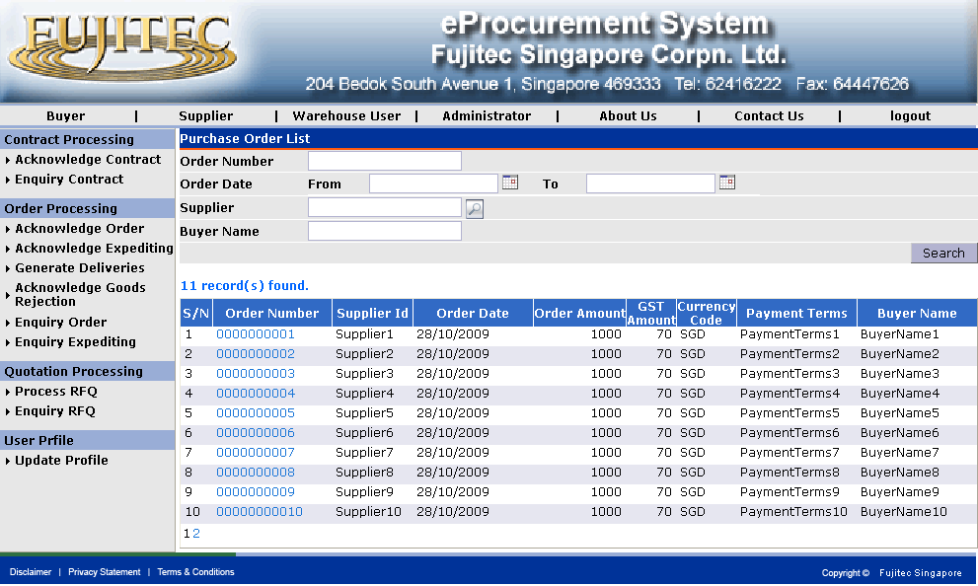
Purchase Order Details Screen
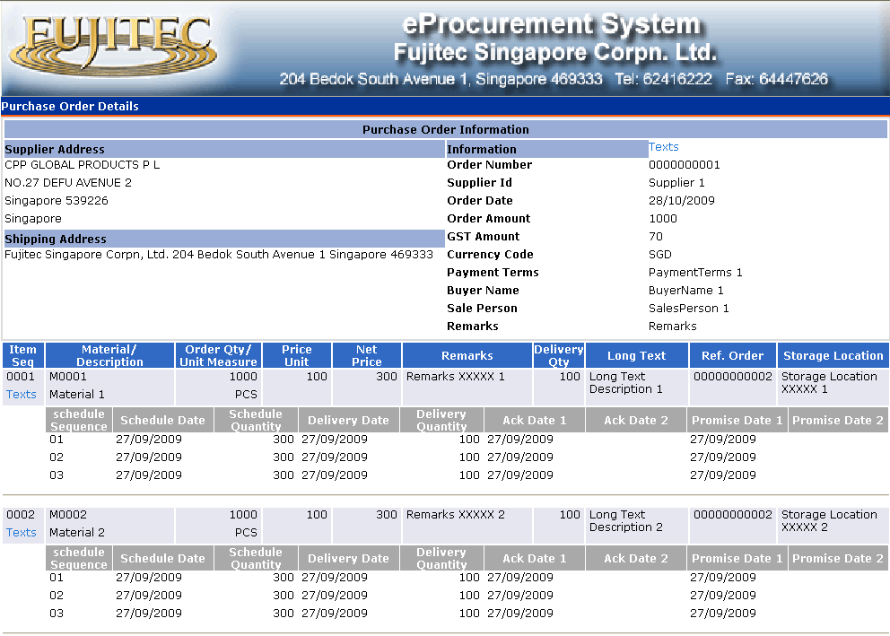
Purchase Order Header Text Screen
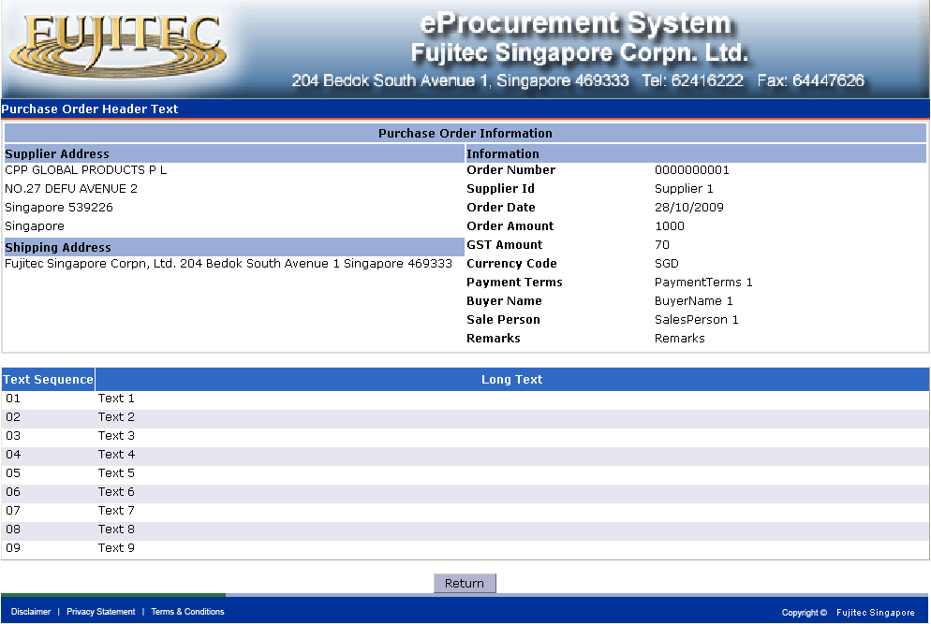
Purchase Order Item Line Text Screen
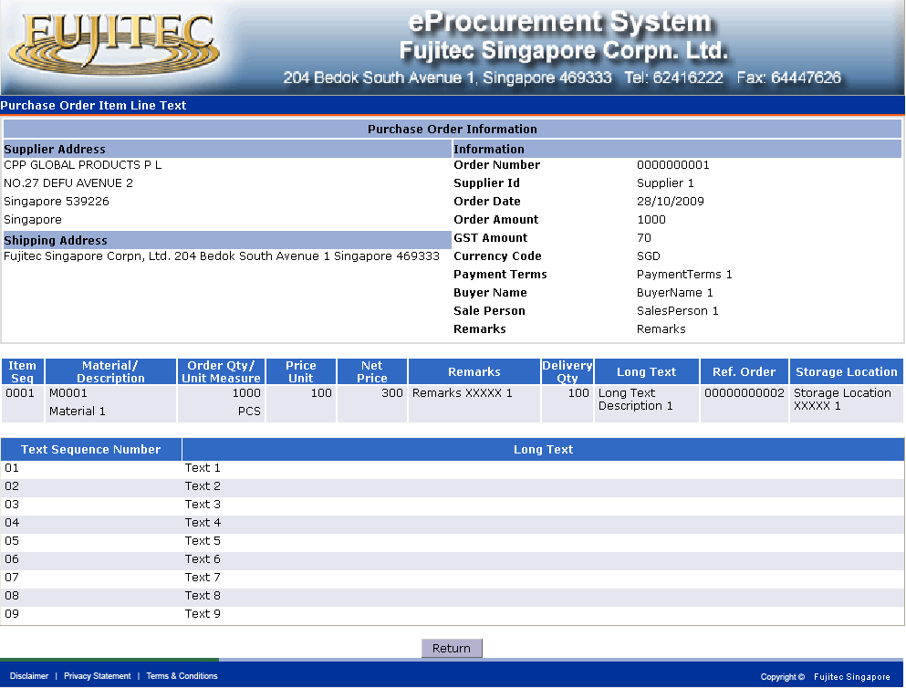

Purchase order – Service Item Screen

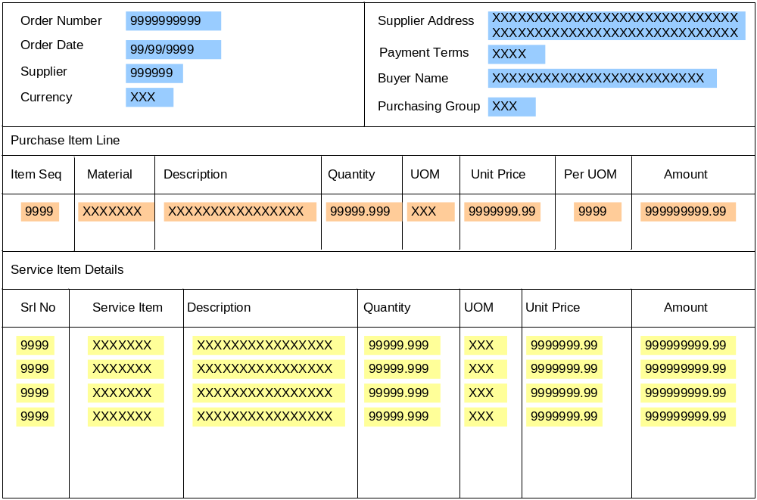

Purchase Order – Subcontract Material Components

