eProcurement System
Application Environment and Setup

Table Content

1 Application Development Environment 2
1.1 Visual Studio 2005 2
1.2 Visual Studio 2003 2
2 Application Layering 3
2.1 Presentation Layer 4
2.2 Presentation View Controller 4
2.3 Business Logic Layer 6
2.4 Data Access Layer 6
2.5 Entity Model 7
2.6 Email Notification 8
3 Application Database 9
4 Application Project Structure 9
5 Installation Procedure 11
5.1 Database Installation 11
5.2 Web Application Deployment 12
5.3 eProcurement Interface 12
5.3.1 SAP Connection Configuration 14
5.3.2 eProcurement Database Connection Configuration 14
5.4 Email Notification 14
6 Execution of Web Application 15

eProcurement Application Information and Setup

Application Development Environment

eProcurement System is a web application which developed using Microsoft .NET Platform. The eProcurement .NET project uses following versions of IDE for development:

Visual Studio 2005

The version 2005 of visual studio .NET is being used to design and develop the codes for eProcurement Web Site i.e. web pages (.aspx) and code behind web pages (C#). The classes for business logic, data access layer, entity model layer and eProcurement interface layer is developed using C# programming language.

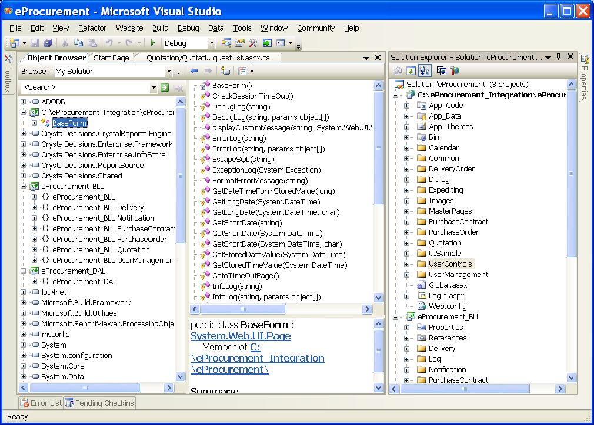

Visual Studio 2003

The version 2003 of visual studio .NET is being used to design and develop the SAP client interface, as SAP .NET connector provided by SAP works with .NET 2003 version.

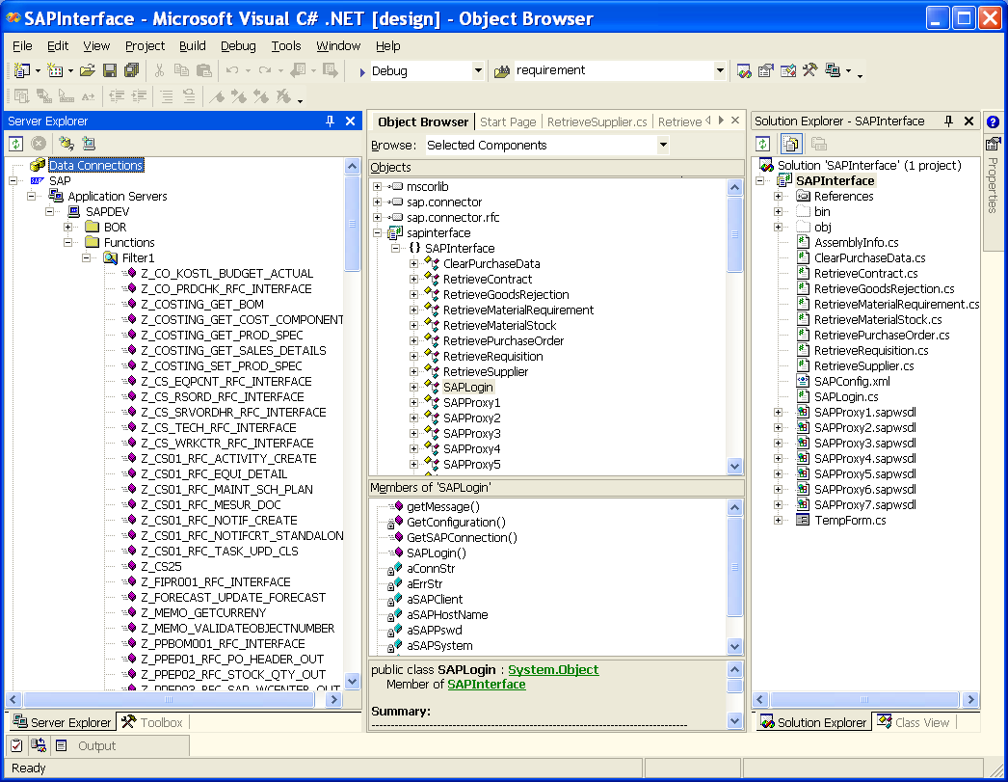

Application Layering
The eProcurement application architecture is made up of following layers:

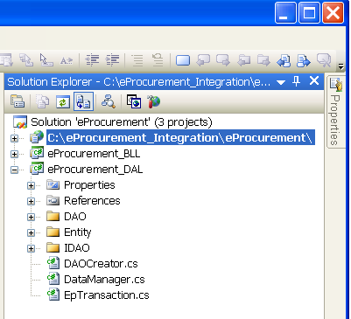

Presentation Layer

This is a UI Layer which is developed using web pages (.aspx) and web controls from .NET WEB control libraries. Please refer to the below screen capture for the project related to eProcurement presentation layer (web pages).

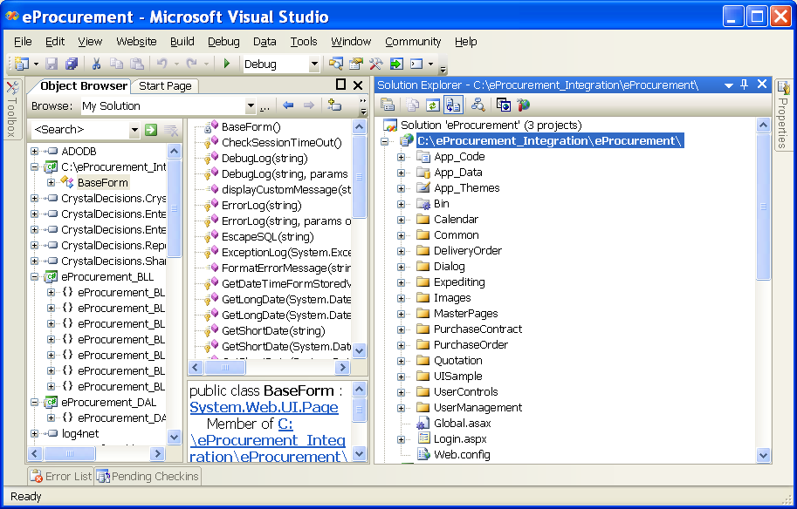

Presentation View Controller

This view controller layer is the code behind the web pages (.aspx) is developed using .NET libraries in C#. This layer communicates with the business logic layer to send the messages to the Data Access layer to create the instances of the entities from eProcurement in order to display the requested information by the client browser through internet.

Below is the sample screen capture for the view controller the C# code behind for individual web page.
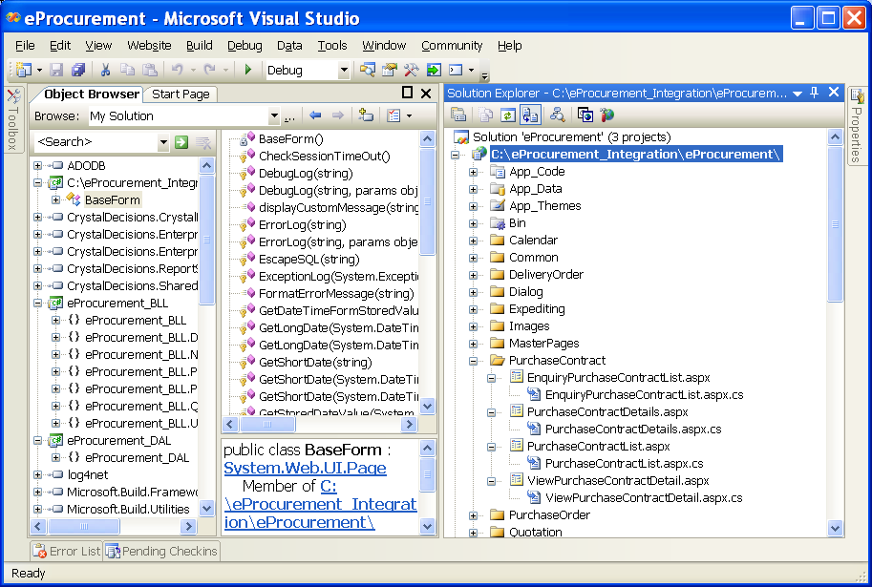

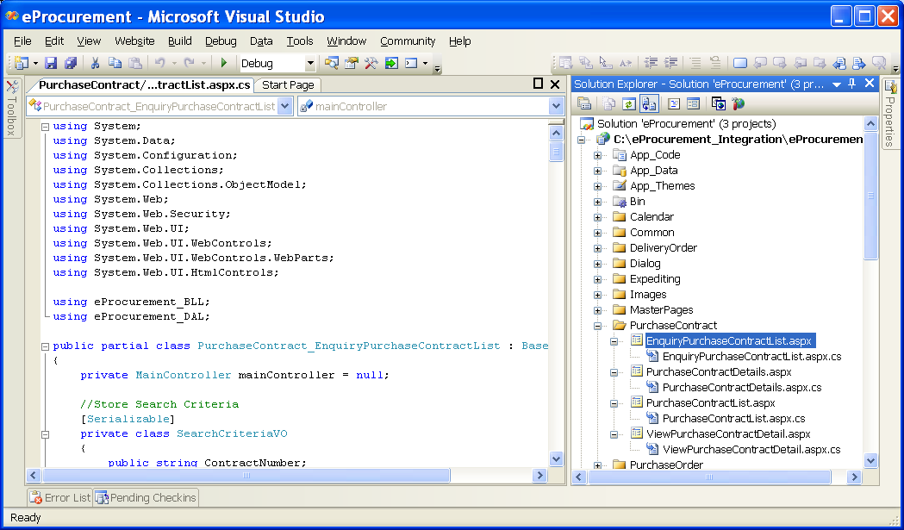

Business Logic Layer

The business logic layer which is also referred to controller layer is developed using .NET C# and its libraries. This layer is mainly governing the controlling of the application and manages the request and provides an bridge between the view controller components and data access layer for any requested information. Below is the sample screen capture of the Business Logic Layer → example Main Controller

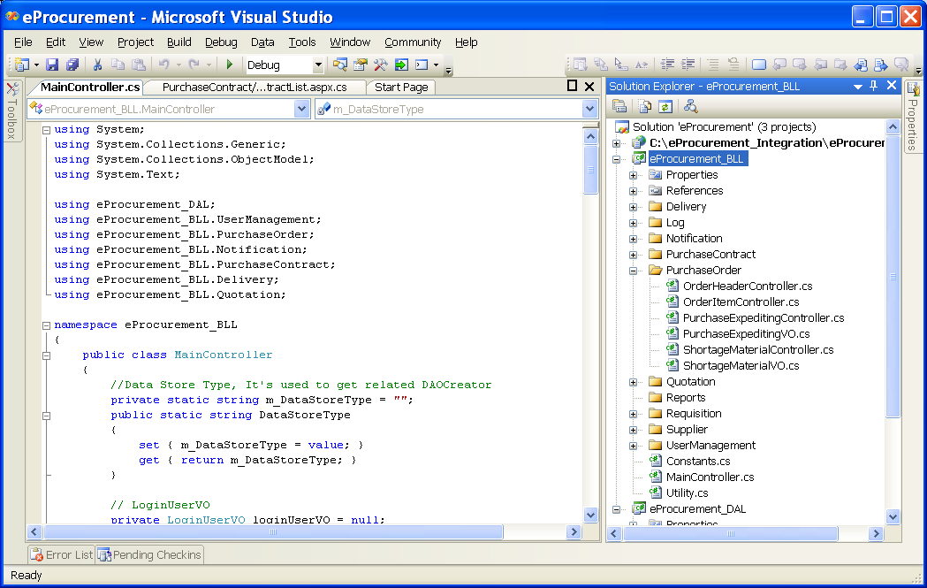

Data Access Layer

The data access layer which is also referred to DAO (Data Access object) layer developed using .NET C# and its libraries. The main feature of this DAO is the Data Manager class which controls the database transaction and manages all the DAO instance request of retrieval, insert, update and delete through transaction commit and rollback. This is a customized Transaction control which manages data insert, update and delete to the multiple tables within one transaction. This layer consists of various DAO classes built for managing the various table updates. Below is the screen capture for the data access layer showing the DAO classes → example →Purchase OrderHeaderDAO.cs

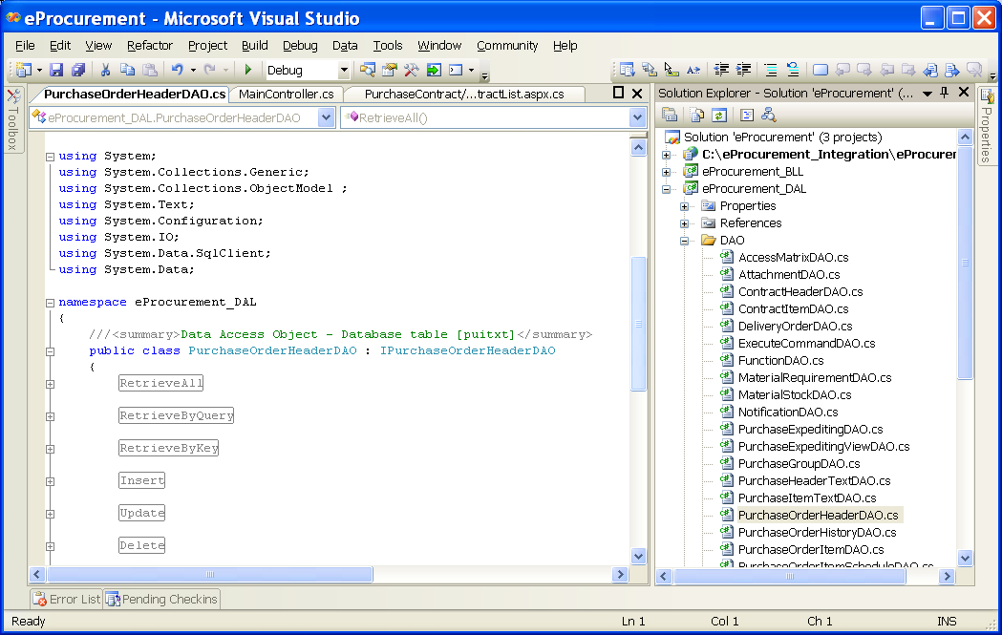

Entity Model

This layer consists of classes defining the individual entities residing with the eProcurement Application. These entity classes are developed using C# and mostly contains the attributes of the entities and setter and getter methods i.e. set and get property value. For Example the entities in eProcurement are: Supplier, Purchase Order, Purchase Contract, Purchase Requisition, Material Stock, and Request for Quotation (RFQ), Quotation, and User etc.

Below is the screen capture showing the Entity models defined in the eProcurement System.

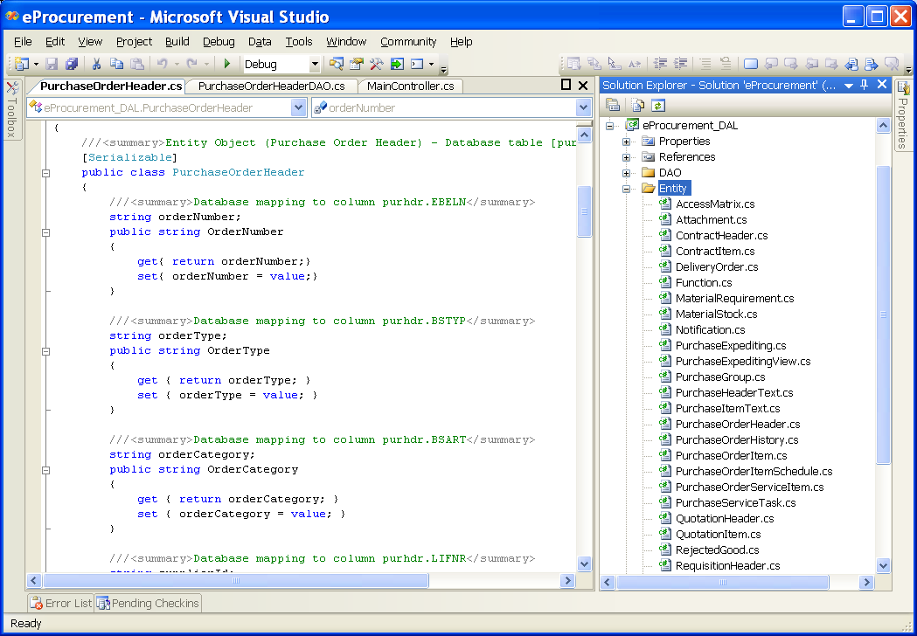

Email Notification

This application is deployed to process all the notification created during synchronization and updates through web site about eProcurement information such as new purchase orders, contracts, amendments, expediting of purchase orders etc. This application will consolidate and send the individual recipient a mail with attachment about the notification of any changes or new additions.

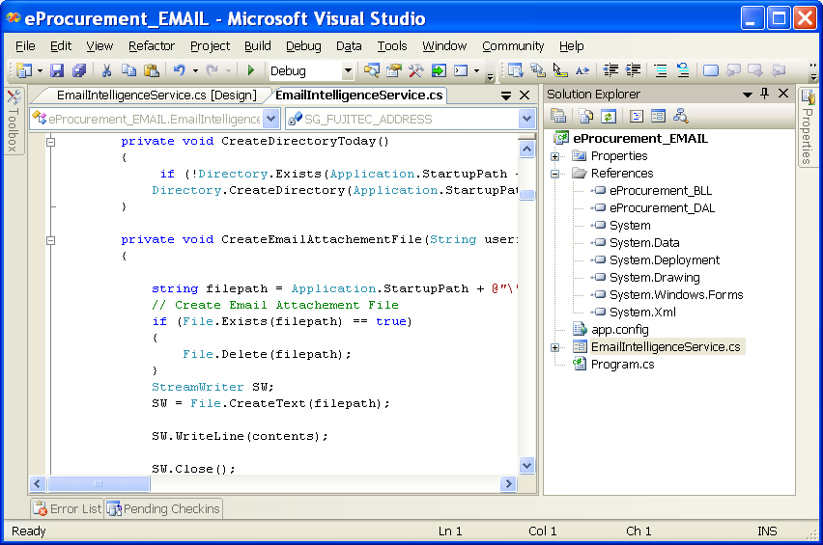

Application Database

The eProcurement database is designed in Microsoft SQL Server 2005. The name of the database is “eProcurement”. The database files will be available under database folder of the application in the CD. The files are MDF and LDF. The administrator needs to copy the MDF file into the SQL application server by creating appropriate folder “eProcurement” at the root folder example C:\eprocurement.

Invoke the enterprise SQL Manager from the SQL server and attach the database by giving appropriate path as mentioned in above paragraph.

Below is the screen capture showing the SQL Server 2005 Environment with eProcurement Database Loaded.
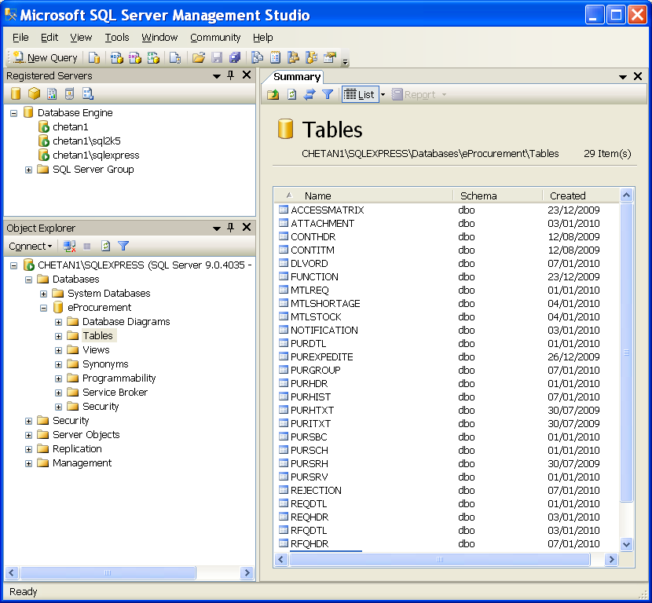

Application Project Structure

The eProcurement application consists of one project solution with following projects for various layers discussed above

[1] eProcurement (Web site) → Presentation
[2] eProcurement_BLL → Business Logic Layer
[3] eProcurement_DAL → Data Access Layer & Model Entities
[4] eProcurement_Intelligence → Creation of Notification and sending Emails
[5] eProcurement_SAP → Interface Layer of eProcurement Application
[6] SAP Inetrface → SAP client Interface middle layer to communicate to remote SAP R/3 System

Folder Structure

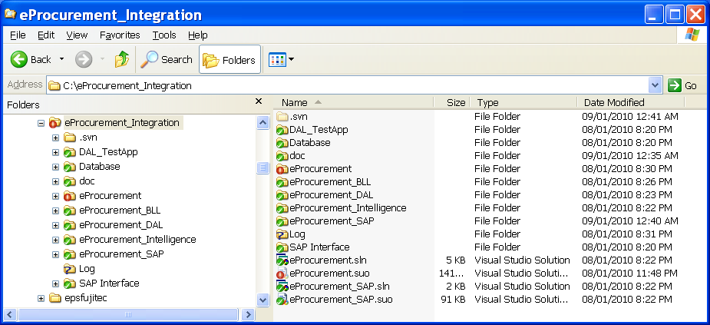

Folders | Description
eProcurement | Presentation → Web pages and scripts, images, utilities, code behind of Web pages (classes) etc
eProcurement_BLL | Business Logic Layer → Controllers classes
eProcurement_DAL | Data Access layer → DAO, IDAO, Entity classes
eProcurement_SAP | Client Side Interface for synchronization consists of all interface controller classes
SAP_Interface | SAP Client Interface → Remote Function calls to access the SAP R/3 System, Consists of SAP Connection, SAP .NET Connector Libraries and Client interface classes
eProcurement_Intelligence | Email Notification Application related classes

Installation Procedure

Database Installation

The eProcurement database is designed in Microsoft SQL Server 2005. The name of the database is “eProcurement”. The database files will be available under database folder of the application in the CD. The files are MDF and LDF. The administrator needs to copy the MDF file into the SQL application server by creating appropriate folder “eProcurement” at the root folder example C:\eprocurement.

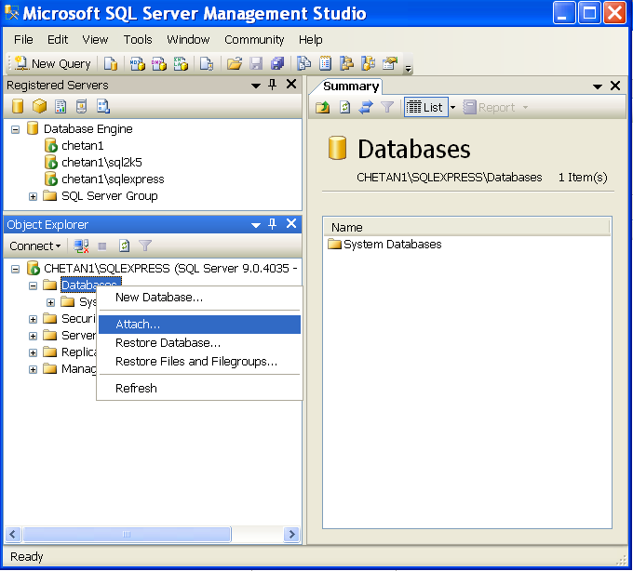

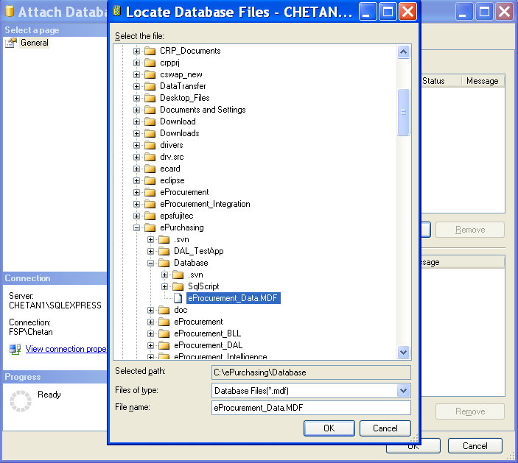

Web Application Deployment

To install the eProcurement system, open the solution file into visual studio 2005 IDE and execute the project publishing option. It will request for the IIS server to publish the eProcurement web application.

eProcurement Interface

This is a windows application which is required to be deployed on the windows server within the company’s network (Local Area Network). This application can be either schedule as a job or can be executed as normal windows application to execute the interface between SAP and eProcurement system to synchronize the relevant information.

Below is the screen capture for the eProcurement → SAP Client Interface and eProcurement_SAP projects respectively.
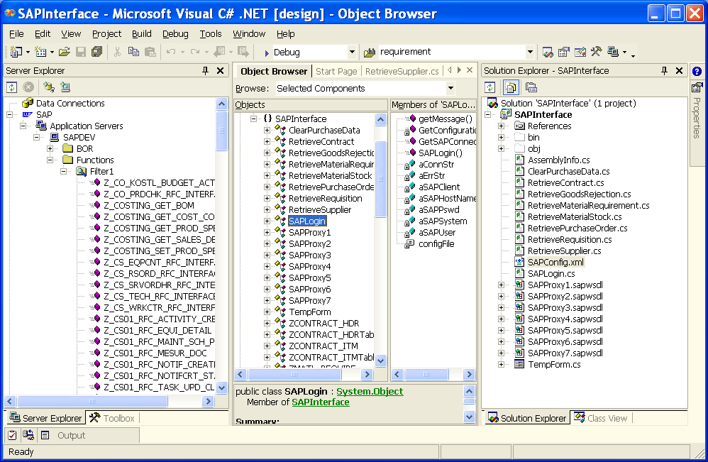

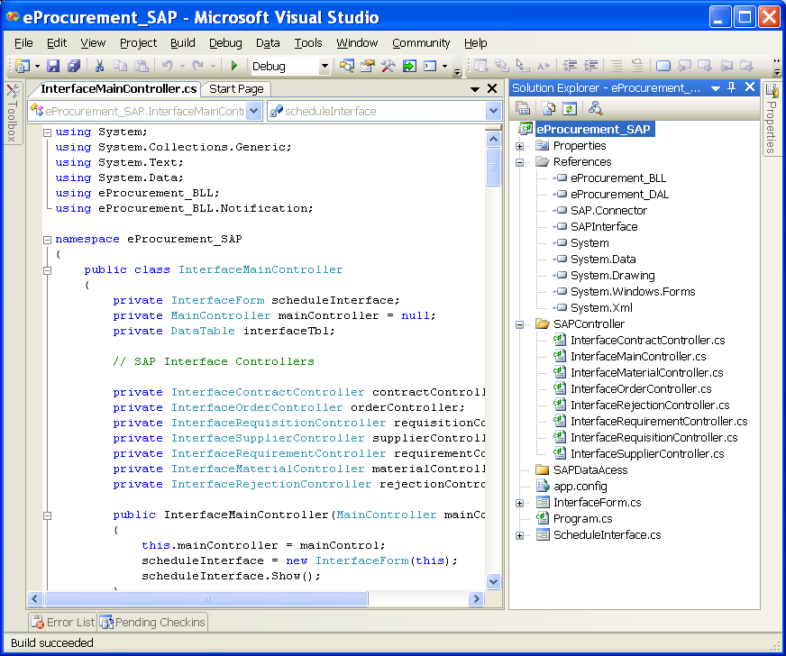

SAP Connection Configuration

During the deployment following config.xml file needs to configured and copied into the application folder on the server. This config.xml file contains details about the SAP connectivity i.e. SAP Hostname, SAP system Number (or ID), SAP Client ID, SAP User Profile and SAP User Password.

<?xml version="1.0" encoding="utf-8" ?>
<SAPCONNECTION>
<SAPHOST>SAPPR3</SAPHOST>
<SAPSYSTEM>00</SAPSYSTEM>
<SAPCLIENT>330</SAPCLIENT>
<SAPUSER>SAPADMIN</SAPUSER>
<SAPPASSWORD>XXXXXXXX</SAPPASSWORD>
</SAPCONNECTION>

eProcurement Database Connection Configuration

In the eProcurement interface application, under the application folder there is a file with name app.config. Open this file and set the appropriate name of the Data Source equivalent to → SQL Server Instance Name and database as “eProcurement” under the tag “connectionstring”. Once done, please save the file.

Important Note: As this an interface to the SAP R/3 System, this application will not execute as this requires connecting to SAP R/3 system.

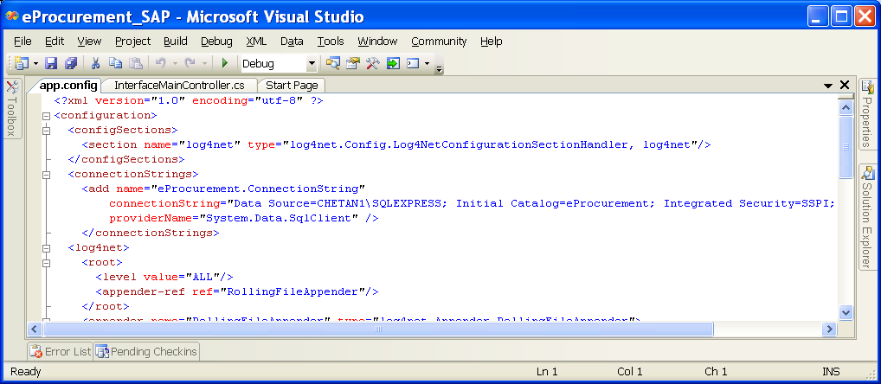

Email Notification

This is a windows application which is required to be deployed on the windows server within the company’s network (LAN). This application can be scheduled to run at specified interval of day. This application will consolidate all the notification messages by recipient and notification type and send as attachment to the recipient’s mail id using the company’s SMTP gateway server

Execution of Web Application

To access the web site you need to execute the appropriate URL in the web browser (Internet Explorer →IE or Mozilla FireFox). It will ask to enter the user Id and password.

Following are the users that can be used to access the website for checking purpose

Buyer Login

USER ID | PASSWORD | USER ROLE
BuyerAdmin | 123456 | Administrator
BuyerOper | 123456 | Operator
BuyerVwer | 123456 | Viewer

Supplier Login

USER ID | PASSWORD | USER ROLE
SupplierAd | 123456 | Administrator
SupplierOp | 123456 | Operator
SupplierVw | 123456 | Viewer

Warehouse User Login

USER ID | PASSWORD | USER ROLE
WHOperator | 123456 | Operator
WHViewer | 123456 | Viewer

To execute the eProcurement Interface for Database Synchronization → use below user but provided access to SAP is also present (i.e. you have connected to the SAP Environment of Fujitec Company)

USERID → sysusr PASSWORD → sysusr

