Function List, Access Matrix
Tow new table added
Table Name: FUNCTION (Function)
Column Name | Primary Key | Column Description | Data Type | Length | Allow NULL
FUNCID | Yes | Function Id | VARCHAR | 6 | No
FUNCNAM |  | Function Name | VARCHAR | 50 | No
Table Name: ACCESSMATRIX (Role Function Access Matrix)
Column Name | Primary Key | Column Description | Data Type | Length | Allow NULL
USRROLE | Yes | User Role  Administrator/Viewer/Operator | VARHCAR | 15 | No
PROFTYP | Yes | Profile TYPE  Buyer/Supplier/WHUser/System | VARCHAR | 10 | No
FUNCID | Yes | Function Id | VARCHAR | 6 | No

Function
FUNCID | FUNCNAM
B-0001 | Accept/Reject Purchase Order Acknowledgement
S-0001 | Acknowledge Purchase Order

Access Matrix
USRROLE | PROFTYP | FUNCID
Operator | Buyer | B-0001
Operator | Supplier | S-0001

Notes: The draft document was already sent to Chetan for confirmation. After conformed, I will insert the records to DB.

How to generate left-side menu dynamically?
All the menu are defined at Menu.xml under eProcurement\App_Data\Menu.xml
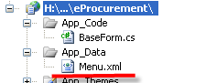
Structure is as follow:
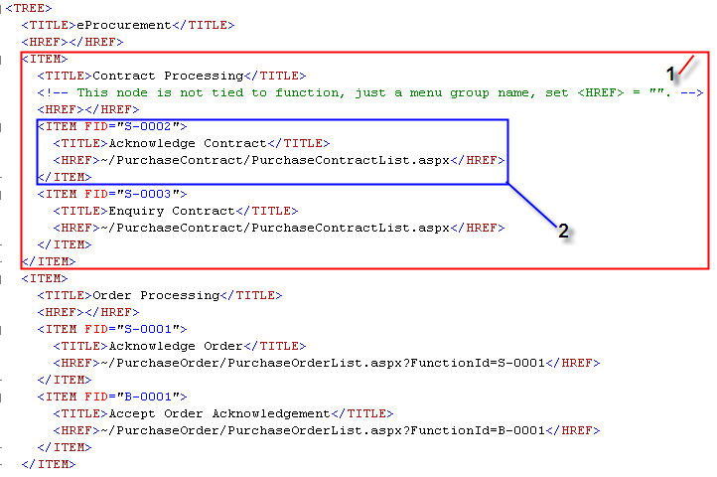
It supports 2 levels hierarchy menu:
1st level is Menu Group (1 in above diagram) , like

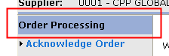

XML: no value in <HREF> node.
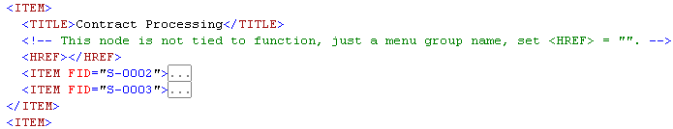

2nd level is Actual Menu (2 in above diagram), like

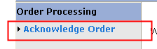
XML
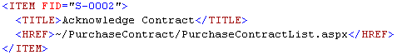
FID: the related function id for this function. If this function is tied to multiple functions, set FID = "F001,F002,F003".
HREF: the url for related page.

Notes: not all the function are defined in the Menu.xml. Some function like Print function are embedded function in the page.

In MasterPageWithMenu.cs, the program will generate the dynamic menu based on login user role, profile and Menu.xml.

How to keep login user info?
After user login, the LoginUserVO will be created and stored into session.
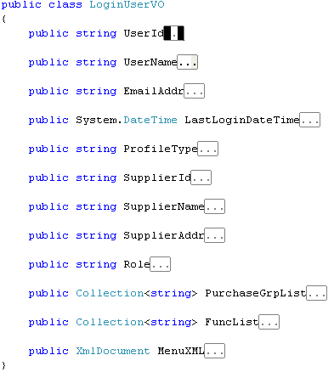

How to control access right in the page?
In order to prohibit user to access page through entering url in browser. Each page is related 1 or more than 1 function.
- All the web page should inherit from BaseForm. The baseform provides some common functions, and access control functions.
- The following code will help you check the access right. If you don’t have access right for this function, will redirect to login page.
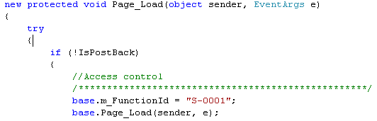
If the web page is related to more than 1 functions
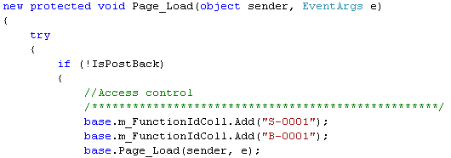

DAO Factory
We implemented the Factory Pattern for DAO. After that we can not call DAO directly. We need to get DAO through DAOCreator.
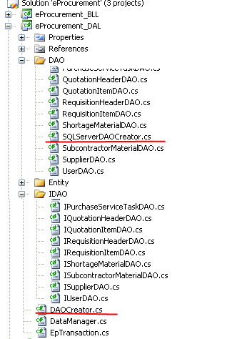
DAOCreator is abstract factory class
In IDAO folder,
- includes all the abstract DAO Class
In DAO folder,
- Includes all the DAO Class that inherited from abstract DAO Class and implemented by SQL SERVER
- SQLSERVERDAOCreator is concrete factory Class

Notes: For add new DAO, please add new abstract DAO in IDAO folder and new DAO in DAO folder, and then update DAOCreator and SQLSERVERDAOCreator (under DAO folder) accordingly.

How to use DAO factory?
In web.config: define data store type
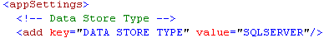

In Global.asax
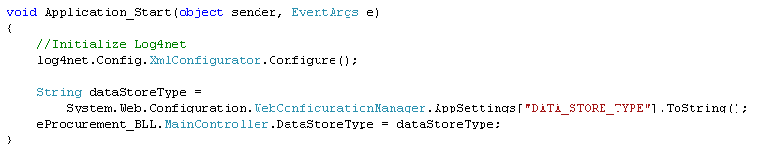
The maincontroller will in charge of creating DAO factory
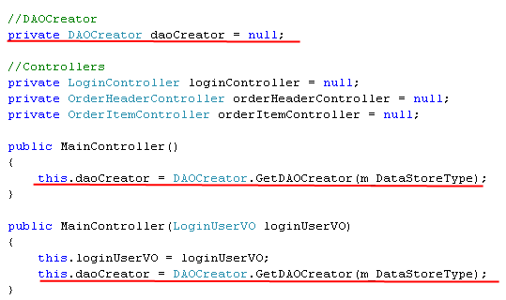
Call DAO method
Notes: Details please refer to how to use maincontroller.

How to use maincontroller?
Last meeting, we decide webpage can not instantiate controller, all the controller must be instantiated by maincontroller.
Maincontroller
Notes: When instantiate individual controller, pass this to the constructor of controller
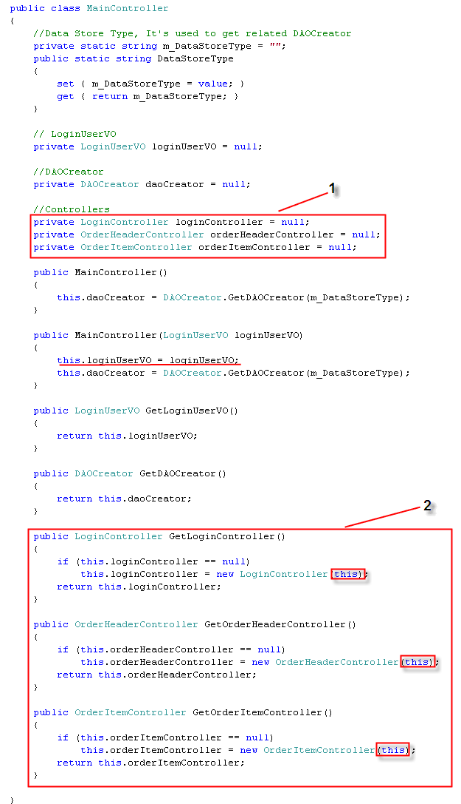
In each webpage:
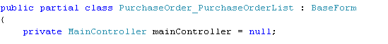
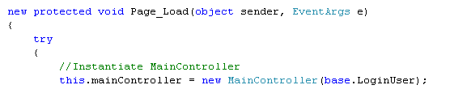
After user login, the LoginUserVO object is generated and stored in session. While instantiating maincontroller, we pass the LoginUserVO to the constructor of maincontroller. In maincontroller can retrieve login user info from LoginUserVO such user id (for update by), supplier id (for retrieve order which belong to this supplier).

Individual Controller
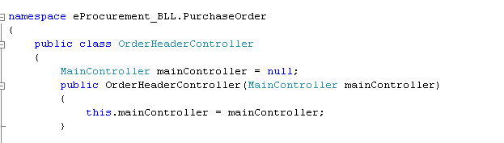

Call the method of Individual Controller

Call DAO

