TABLE OF CONTENTS

1. Introduction 1
2. Master Pages 1
2.1 The master page with left-hand menu and navigation bar 1
2.2 The master page without left-hand menu and navigation bar 3
3. CSS Styles 4

Introduction
The objective of this document is to guide developers on how to build the standard UI for eProcurement system.

Master Pages
Currently we have two master pages. The one with left-hand menu and navigation bar is used for list screen; the other one without left-hand menu and navigation bar is used for details screen.

The master page with left-hand menu and navigation bar
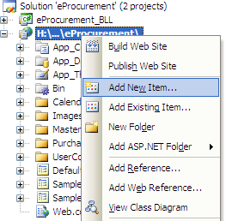

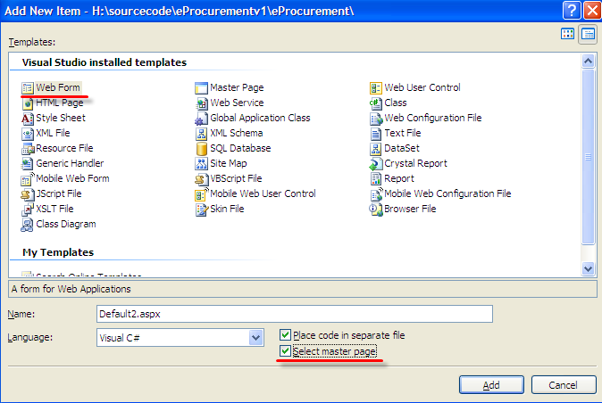

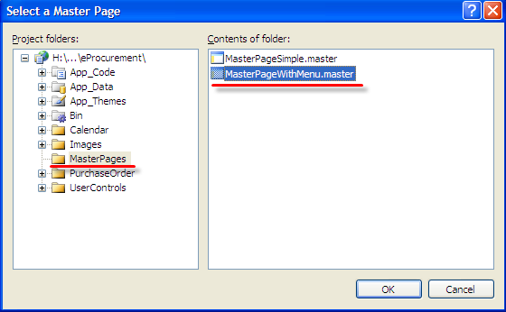

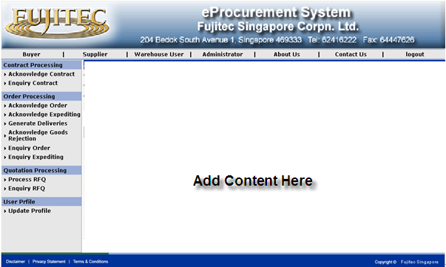

The master page without left-hand menu and navigation bar
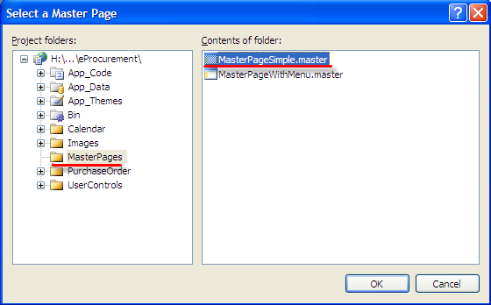

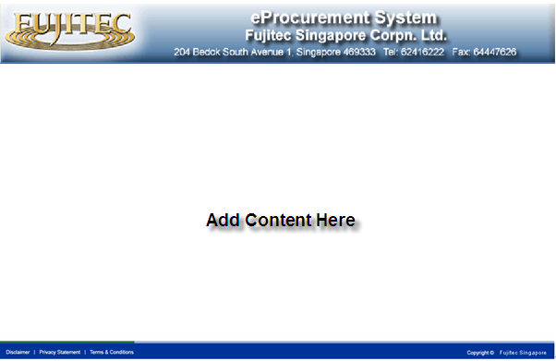

CSS Styles
No need to modify. Automatically CSS Style applied by App_Skin: Label, TextBox, DropDownList, Button

No need to modify. Automatically CSS Style applied by App_Skin: GridView.HeaderStyle
GridView.PagerStyle
GridView.AlternatingRowStyle

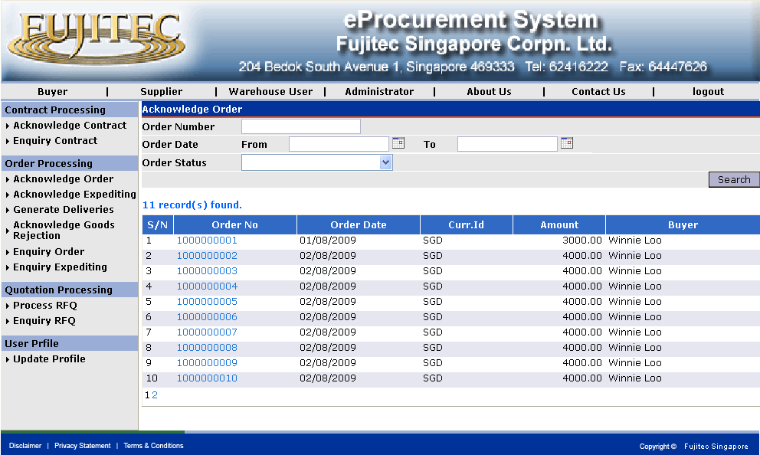
Label control in GridView to aviod AppSkin style. Please modfiy to Inline style to CssClass="". Refer to Code 1
Screen Caption: CssClass=" navigation" .
Refer to Code 2
Search Panel: Id = “GreyTable”
Refer to Code 3

Code 1
Code 2
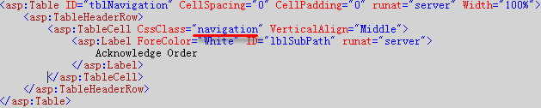
Code 3

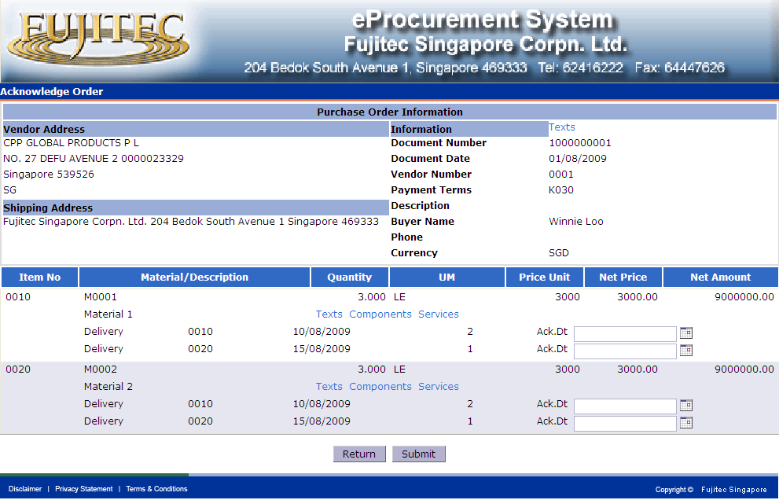

Section Caption: CssClass=" DetailsTableCaption" .
Refer to Code 1

Code 1

