PROTOTYPES SCREEN PROJECT
Update 20/12/2024
By Vinicius Andrade

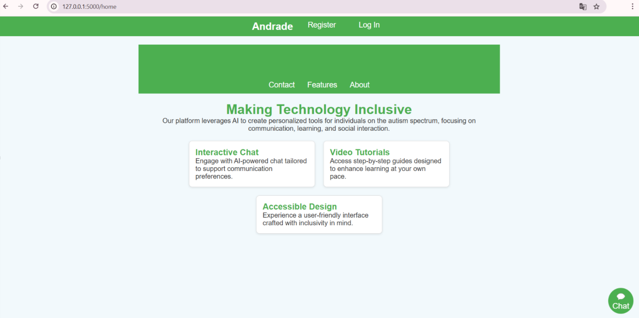Figura 1: ChatBot button

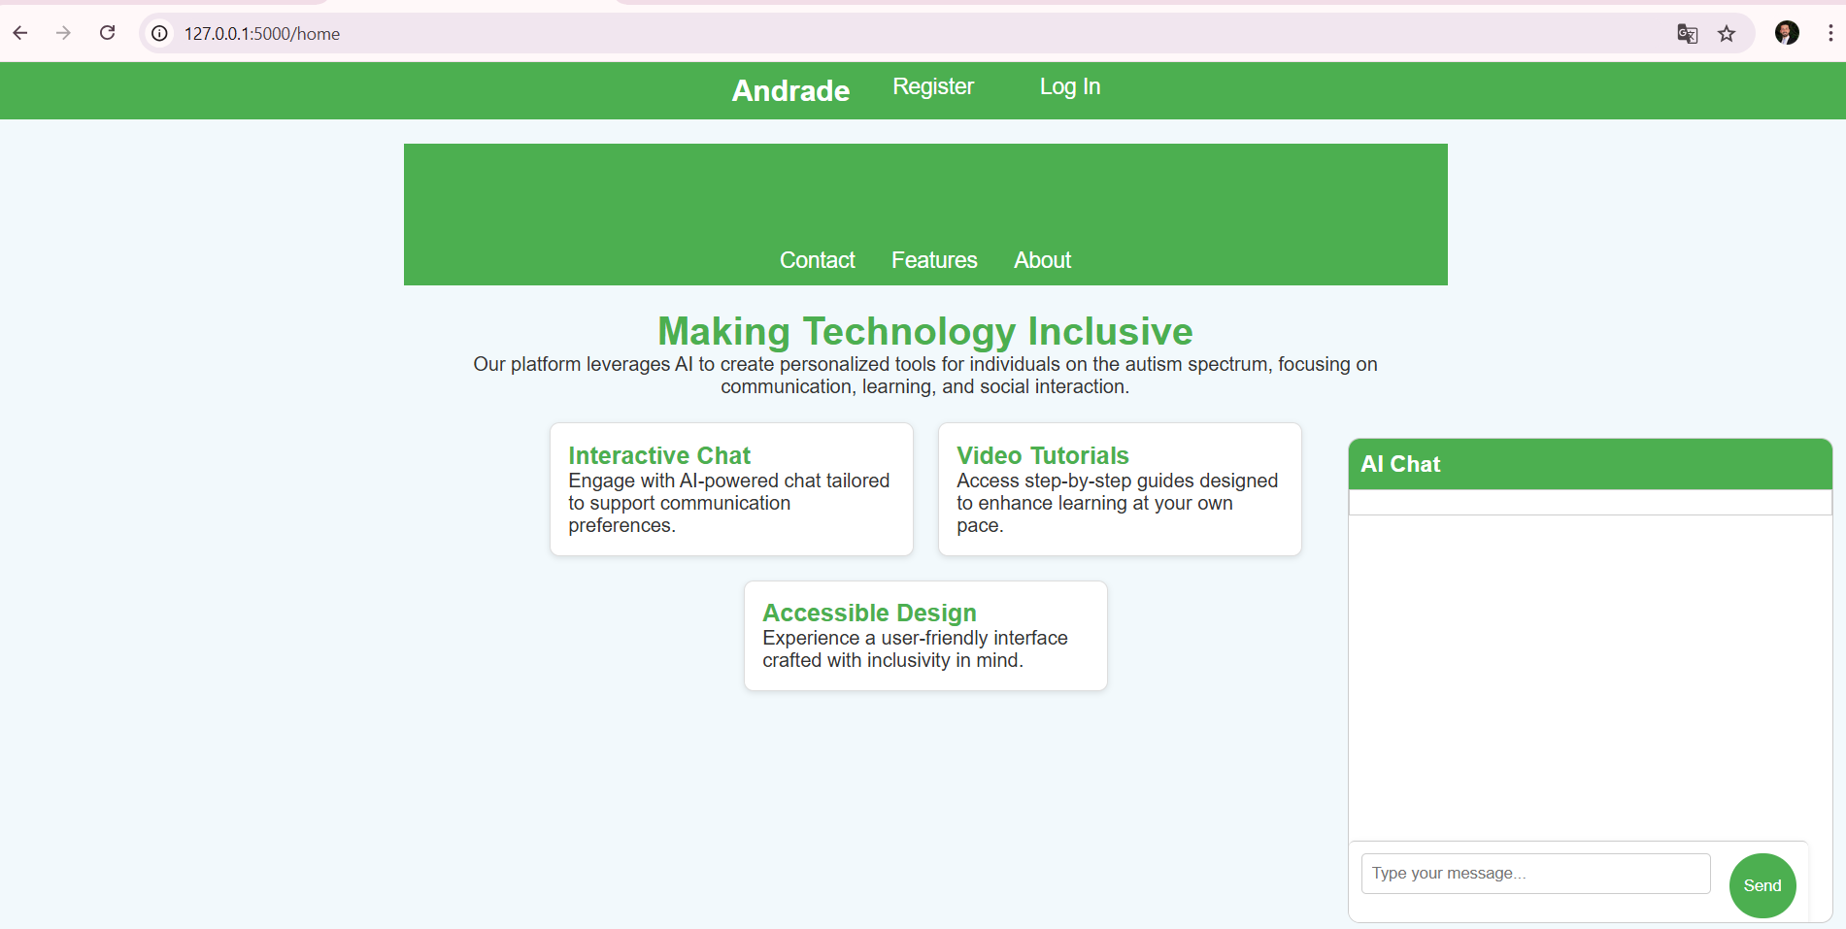Figura 2: AI Chat window

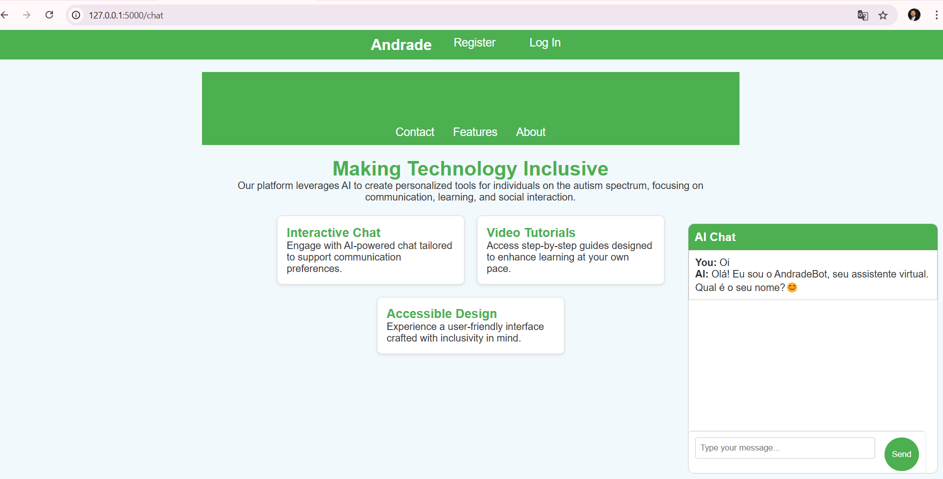Figura 3: AI Chat interacting with the user

