PROTOTYPES SCREEN PROJECT
Update 18/12/2024
By Vinicius Andrade

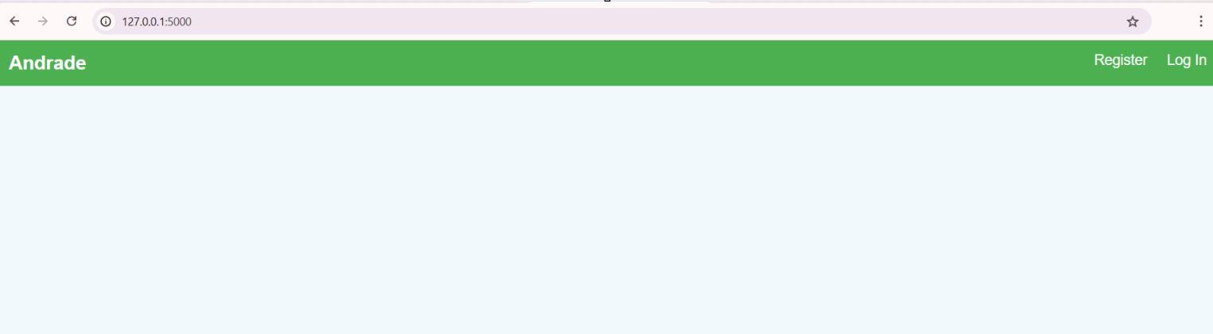Figura 1: First Screen

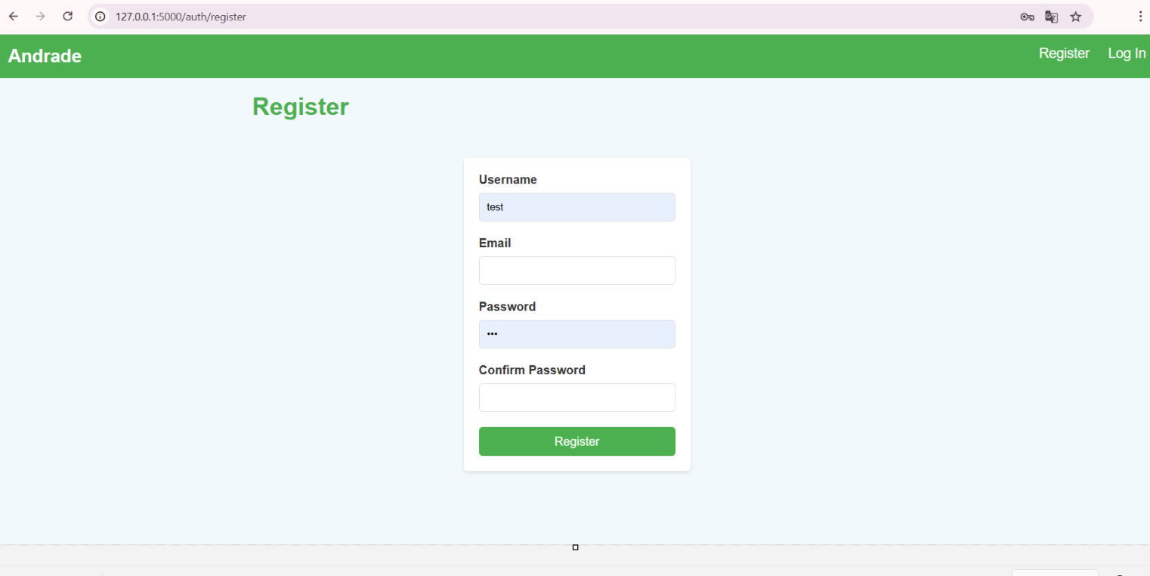Figura 2: Register Page

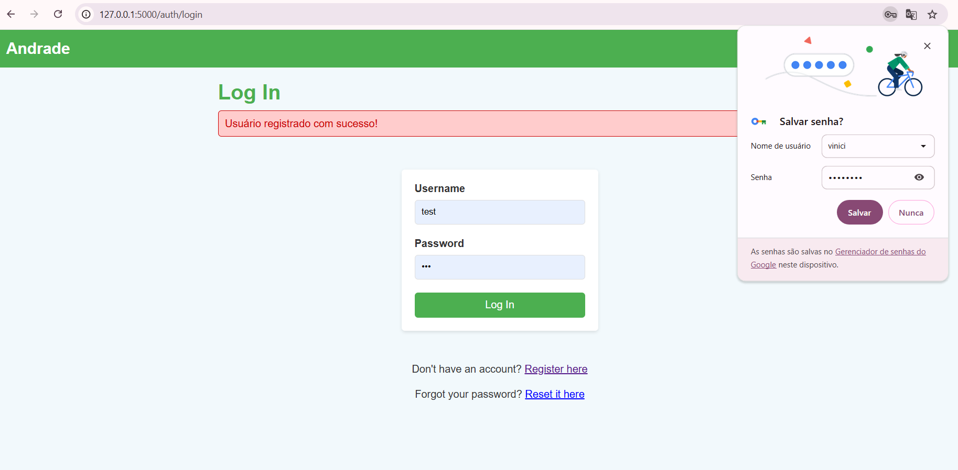Figura 3: The user has been registered successfully

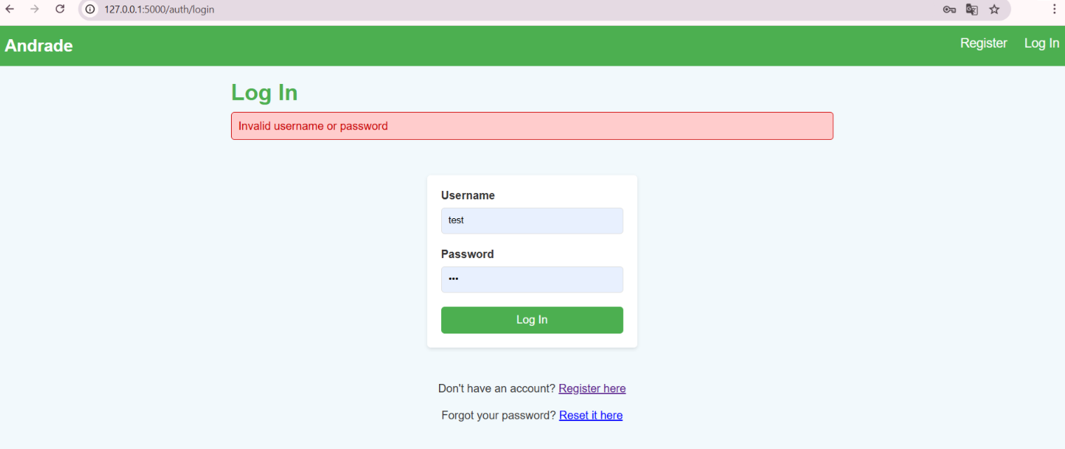Figura 4: Log In Page when invalid username or password

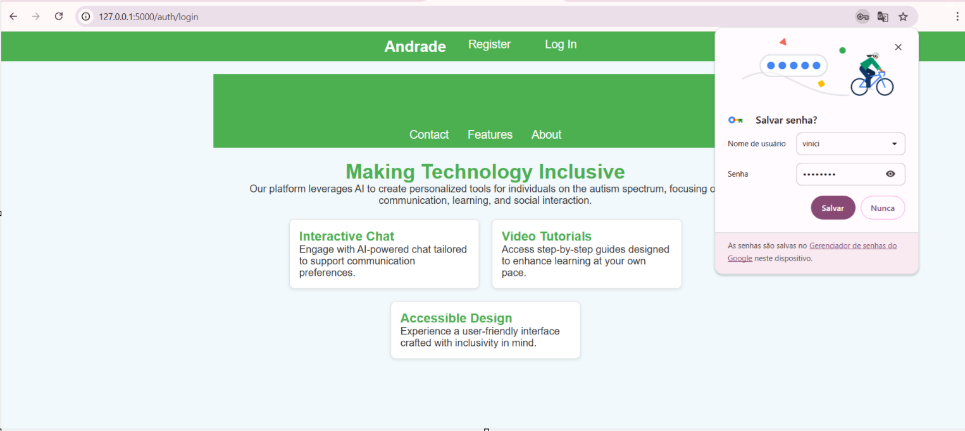Figura 5: HomePage after logging in successfully

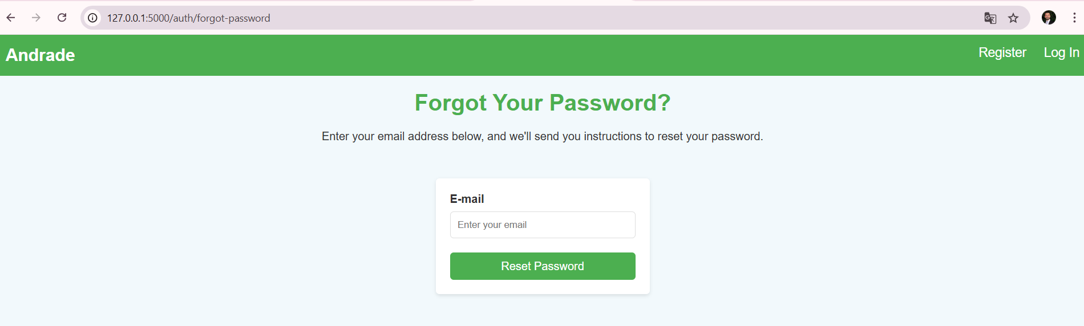Figura 6: Forgot Password Page

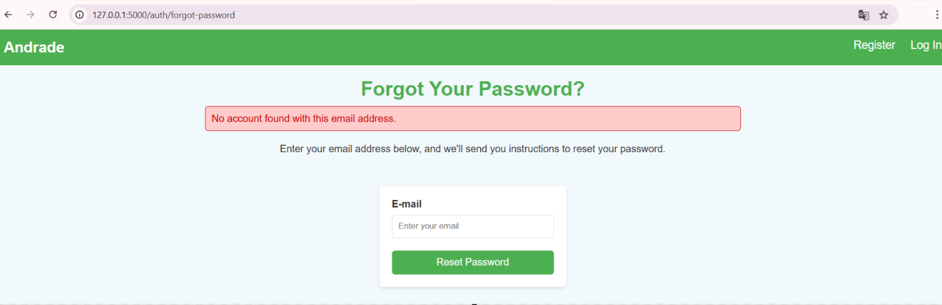Figura 7: Forgot password when No account found with the E-mail address

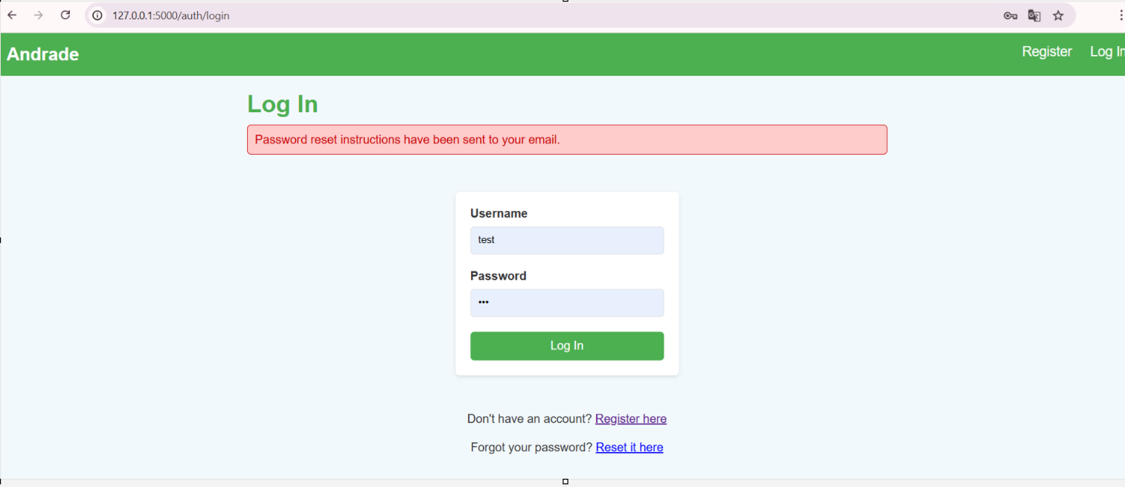Figura 8: Log In Page after enter email valid to reset password

