|  |  |  |  |  |  |  |  |  |
| --- | --- | --- | --- | --- | --- | --- | --- | --- |
| A | B | C | X  OR  (a+b+c) | Y  XNOR  (a (·) c) | Z  AND  (a*b*c) | S1  AND  (X * Y) | S2  OR  (Y’ + Z) | S  OR  !(S1 + S2) |
| 0 | 0 | 0 | 0 | 1 | 0 | 0 | 0 | 1 |
| 0 | 0 | 1 | 1 | 0 | 0 | 0 | 1 | 0 |
| 0 | 1 | 0 | 1 | 1 | 0 | 1 | 0 | 0 |
| 0 | 1 | 1 | 1 | 0 | 0 | 0 | 1 | 0 |
| 1 | 0 | 0 | 1 | 0 | 0 | 0 | 1 | 0 |
| 1 | 0 | 1 | 1 | 1 | 0 | 1 | 0 | 0 |
| 1 | 1 | 0 | 1 | 0 | 0 | 0 | 1 | 0 |
| 1 | 1 | 1 | 1 | 1 | 1 | 1 | 1 | 0 |

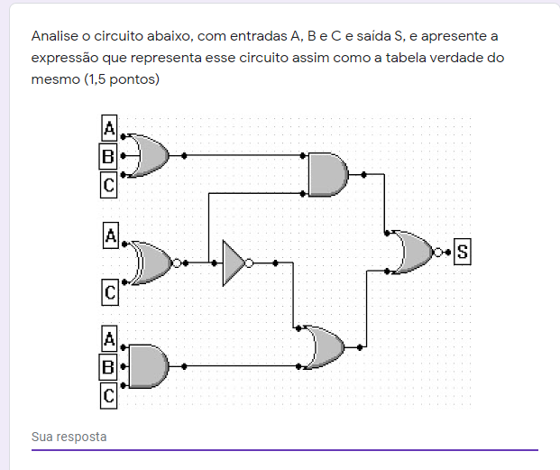

**(·) = XNOR**

**S = !(S1 + S2)**

**S = !((X*Y) + (Y’ + Z))**

**S = !([ (A+B+C)*(A (·) C) ] + [ (A (·) C)’ + (A+B+C) ])**

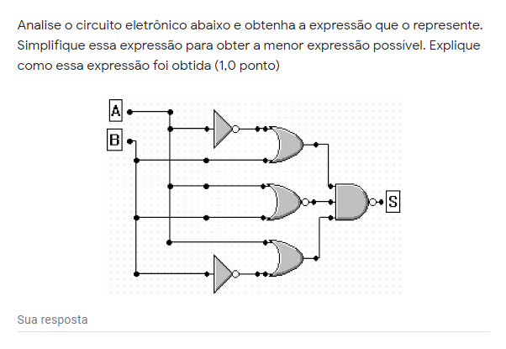

|  |  |  |  |  |  |
| --- | --- | --- | --- | --- | --- |
| A | B | X  OR  (A’ + B) | Y  OR  !(A + B) | Z  OR  (A + B’) | S  AND  !(X*Y*Z) |
| 0 | 0 | 1 | 1 | 1 | 0 |
| 0 | 1 | 1 | 0 | 0 | 1 |
| 1 | 0 | 0 | 0 | 1 | 1 |
| 1 | 1 | 1 | 0 | 1 | 1 |

**S = !(X*Y*Z)**

**S = !( (A’+B) * (A+B)’ * (A+B’) )**

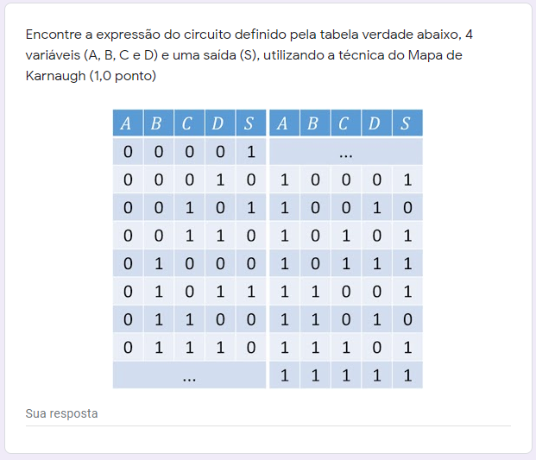

|  |  |  |  |  |  |
| --- | --- | --- | --- | --- | --- |
|  | **C’** | | **C** | |  |
| **A’** | 1 | 0 | 0 | 1 | **B’** |
| 0 | 1 | 0 | 0 | **B** |
| **A** | 1 | 0 | 1 | 1 |
| 1 | 0 | 1 | 1 | **B’** |
|  | **D’** | **D** | | **D’** |  |

**S = AC + AD’ + B’D’ + A’C’B**