Imagem | Nome | HP | Exp | Summon | Convince
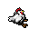 | Chicken | 15 | 0 | 220 | 220
 | Rabbit | 15 | 0 | 220 | 220
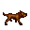 | Dog | 20 | 0 | 220 | 220
 | Sheep | 20 | 0 | 250 | 250
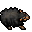 | Black Sheep | 20 | 0 | 250 | 250
 | Parrot | 25 | 0 | 250 | 250
 | Flamingo | 25 | 0 | 250 | 250
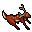 | Deer | 25 | 0 | 260 | 260
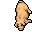 | Pig | 25 | 0 | 255 | 255
 | Seagull | 25 | 0 | 250 | 250
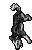 | Husky | 140 | 0 | 420 | 420
 | Silver Rabbit | 15 | 0 | 220 | 220
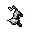 | Cat | 20 | 0 | 220 | 220
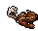 | Squirrel | 20 | 0 | 220 | 220
 | Penguin | 33 | 1 | 290 | 290
 | Skunk | 20 | 3 | 200 | 200
 | Badger | 23 | 5 | 200 | 200
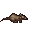 | Rat | 20 | 5 | 200 | 200
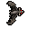 | Bat | 30 | 10 | 250 | 250
 | Cave Rat | 30 | 10 | 250 | 250
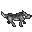 | Wolf | 25 | 18 | 255 | 255
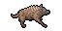 | Hyaena | 60 | 20 | 275 | 275
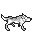 | Winter Wolf | 30 | 20 | 260 | 260
 | Panda | 80 | 23 | 300 | 300
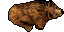 | Bear | 80 | 23 | 300 | 300
 | Polar Bear | 85 | 28 | 315 | 315
 | Crab | 55 | 30 | 305 | 305
 | Lion | 80 | 30 | 320 | 320
 | Crocodile | 105 | 40 | 350 | 350
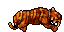 | Tiger | 75 | 40 | 420 | 420
 | Rotworm | 65 | 40 | 0 | 305
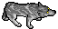 | War Wolf | 140 | 55 | 0 | 420
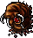 | Carrion Worm | 145 | 70 | 0 | 0
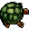 | Tortoise | 185 | 90 | 0 | 445
 | Dire Penguin | 173 | 120 | 0 | 0
 | Thornback Tortoise | 300 | 150 | 0 | 490
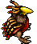 | Terror Bird | 300 | 150 | 490 | 490
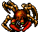 | Blood Crab | 290 | 160 | 505 | 505
 | Elephant | 320 | 160 | 500 | 500
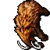 | Mammoth | 320 | 160 | 0 | 500

Insetos, anfíbios e criaturas venenosas
Imagem | Nome | HP | Exp | Summon | Convince
 | Butterfly | 2 | 0 | 0 | 0
 | Green Frog | 25 | 0 | 250 | 250
 | Snake | 15 | 10 | 205 | 205
 | Spider | 20 | 12 | 210 | 210
 | Bug | 29 | 18 | 250 | 250
 | Azure Frog | 60 | 20 | 0 | 305
 | Coral Frog | 60 | 20 | 0 | 0
 | Crimson Frog | 60 | 20 | 0 | 0
 | Orchid Frog | 60 | 20 | 0 | 0
 | Poison Spider | 26 | 22 | 270 | 270
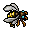 | Wasp | 35 | 24 | 280 | 280
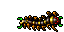 | Centipede | 70 | 30 | 335 | 335
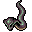 | Cobra | 65 | 30 | 275 | 275
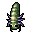 | Larva | 70 | 44 | 355 | 355
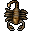 | Scorpion | 45 | 45 | 310 | 310
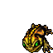 | Toad | 135 | 60 | 400 | 400
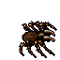 | Tarantula | 225 | 120 | 485 | 485
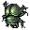 | Scarab | 320 | 120 | 395 | 395
 | Slime | 150 | 160 | 0 | 0
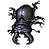 | Ancient Scarab | 1000 | 720 | 0 | 0
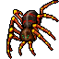 | Giant Spider | 1300 | 900 | 0 | 0
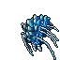 | Crystal Spider | 1250 | 900 | 0 | 0
 | Defiler | 3650 | 2500 | 0 | 0
 | Son of Verminor | 8500 | 5900 | 0 | 0

Plantas
Imagem | Nome | HP | Exp | Summon | Convince
 | Spit Nettle | 150 | 25 | 0 | 0
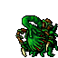 | Carniphila | 255 | 150 | 0 | 0

Bárbaros
Imagem | Nome | HP | Exp | Summon | Convince
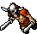 | Barbarian Skullhunter | 135 | 85 | 0 | 450
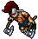 | Barbarian Headsplitter | 100 | 85 | 0 | 450
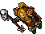 | Barbarian Brutetamer | 145 | 115 | 0 | 0
 | Barbarian Bloodwalker | 305 | 195 | 0 | 590

Piratas
Imagem | Nome | HP | Exp | Summon | Convince
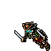 | Pirate Skeleton | 190 | 85 | 0 | 0
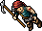 | Pirate Marauder | 210 | 125 | 0 | 490
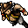 | Pirate Cutthroat | 325 | 175 | 0 | 495
 | Pirate Ghost | 275 | 250 | 0 | 0
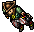 | Pirate Buccaneer | 425 | 250 | 0 | 595
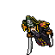 | Pirate Corsair | 675 | 350 | 0 | 775

Outros humanos
Imagem | Nome | HP | Exp | Summon | Convince
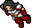 | Smuggler | 130 | 48 | 390 | 390
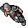 | Wild Warrior | 135 | 60 | 420 | 420
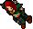 | Amazon | 110 | 60 | 390 | 390
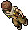 | Nomad | 160 | 60 | 420 | 420
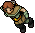 | Bandit | 245 | 65 | 450 | 450
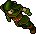 | Poacher | 90 | 70 | 0 | 530
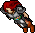 | Valkyrie | 190 | 85 | 450 | 450
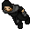 | Novice Of The Cult | 285 | 100 | 0 | 0
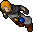 | Dark Apprentice | 225 | 100 | 0 | 0
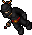 | Assassin | 175 | 105 | 0 | 450
 | Witch | 300 | 120 | 0 | 0
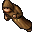 | Dark Monk | 190 | 145 | 0 | 480
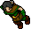 | Hunter | 150 | 150 | 0 | 530
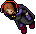 | Dark Magician | 325 | 185 | 0 | 0
 | Monk | 240 | 200 | 600 | 0
 | Acolyte Of The Cult | 390 | 300 | 0 | 0
 | Adept Of The Cult | 430 | 400 | 0 | 0
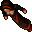 | Priestess | 390 | 420 | 0 | 0
 | Enlightened Of The Cult | 700 | 500 | 0 | 0
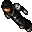 | Necromancer | 580 | 580 | 0 | 0
 | Ice Witch | 540 | 580 | 0 | 0
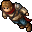 | Hero | 1400 | 1200 | 0 | 0
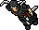 | Black Knight | 1800 | 1600 | 0 | 0
 | Warlock | 3500 | 4000 | 0 | 0
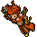 | Fury | 4100 | 4000 | 0 | 0

Anões
Imagem | Nome | HP | Exp | Summon | Convince
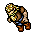 | Dwarf | 90 | 45 | 320 | 320
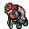 | Dwarf Soldier | 135 | 70 | 360 | 360
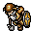 | Dwarf Guard | 245 | 165 | 650 | 650
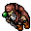 | Dwarf Geomancer | 400 | 245 | 0 | 0

Elfos
Imagem | Nome | HP | Exp | Summon | Convince
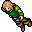 | Elf | 100 | 42 | 320 | 320
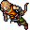 | Elf Scout | 160 | 75 | 360 | 360
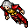 | Elf Arcanist | 220 | 175 | 0 | 0

Primatas
Imagem | Nome | HP | Exp | Summon | Convince
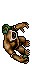 | Sibang | 225 | 105 | 0 | 0
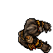 | Kongra | 340 | 115 | 0 | 0
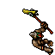 | Merlkin | 230 | 145 | 0 | 0

Lagartos
Imagem | Nome | HP | Exp | Summon | Convince
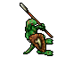 | Lizard Sentinel | 265 | 110 | 0 | 560
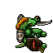 | Lizard Templar | 410 | 155 | 0 | 0
 | Lizard Snakecharmer | 325 | 210 | 0 | 0

Minotauros
Imagem | Nome | HP | Exp | Summon | Convince
 | Minotaur | 100 | 50 | 330 | 330
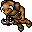 | Minotaur Archer | 100 | 65 | 390 | 390
 | Minotaur Mage | 155 | 150 | 0 | 0
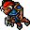 | Minotaur Guard | 185 | 160 | 550 | 550

Chakoyas
Imagem | Nome | HP | Exp | Summon | Convince
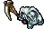 | Chakoya Toolshaper | 80 | 40 | 0 | 305
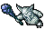 | Chakoya Tribewarden | 68 | 40 | 0 | 305
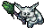 | Chakoya Windcaller | 84 | 48 | 0 | 305

Goblinóides
Imagem | Nome | HP | Exp | Summon | Convince
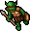 | Goblin | 50 | 25 | 290 | 290
 | Dworc Venomsniper | 80 | 30 | 0 | 300
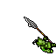 | Dworc Fleshhunter | 85 | 35 | 0 | 300
 | Dworc Voodoomaster | 80 | 50 | 0 | 300

Orcs
Imagem | Nome | HP | Exp | Summon | Convince
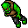 | Orc | 70 | 25 | 300 | 300
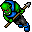 | Orc Spearman | 105 | 38 | 310 | 310
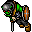 | Orc Warrior | 125 | 50 | 360 | 360
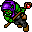 | Orc Shaman | 115 | 110 | 0 | 0
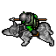 | Orc Rider | 180 | 110 | 0 | 490
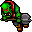 | Orc Berserker | 210 | 195 | 590 | 590
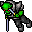 | Orc Leader | 450 | 270 | 640 | 640
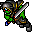 | Orc Warlord | 950 | 670 | 0 | 0

Trolls
Imagem | Nome | HP | Exp | Summon | Convince
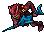 | Island Troll | 50 | 20 | 290 | 290
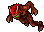 | Troll | 50 | 20 | 290 | 290
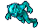 | Frost Troll | 55 | 23 | 300 | 300
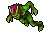 | Swamp Troll | 55 | 25 | 320 | 320
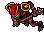 | Troll Champion | 75 | 30 | 340 | 340

Gigantes
Imagem | Nome | HP | Exp | Summon | Convince
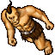 | Cyclops | 260 | 150 | 490 | 490
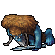 | Frost Giant | 270 | 150 | 0 | 490
 | Frost Giantess | 275 | 150 | 490 | 490
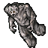 | Stone Golem | 270 | 160 | 590 | 590
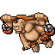 | Cyclops Drone | 325 | 200 | 0 | 525
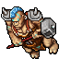 | Cyclops Smith | 435 | 255 | 0 | 695
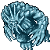 | Ice Golem | 385 | 295 | 0 | 0
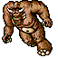 | Behemoth | 4000 | 2500 | 0 | 0

Criaturas marinhas
Imagem | Nome | HP | Exp | Summon | Convince
 | Quara Mantassin Scout | 220 | 100 | 0 | 0
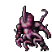 | Quara Constrictor Scout | 450 | 200 | 0 | 0
 | Quara Constrictor | 450 | 250 | 0 | 670
 | Quara Mantassin | 800 | 400 | 0 | 480
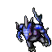 | Quara Predator Scout | 890 | 400 | 0 | 0
 | Water Elemental | 550 | 450 | 0 | 0
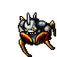 | Quara Pincher Scout | 775 | 600 | 0 | 0
 | Massive Water Elemental | 1250 | 800 | 0 | 0
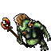 | Quara Hydromancer Scout | 1100 | 800 | 0 | 0
 | Quara Hydromancer | 1100 | 800 | 0 | 0
 | Quara Pincher | 1800 | 1200 | 0 | 0
 | Quara Predator | 2200 | 1600 | 0 | 0

Mortos-vivos
Imagem | Nome | HP | Exp | Summon | Convince
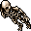 | Skeleton | 50 | 35 | 300 | 300
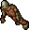 | Ghoul | 100 | 85 | 450 | 450
 | Ghost | 150 | 120 | 0 | 0
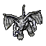 | Gargoyle | 250 | 150 | 0 | 0
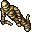 | Mummy | 240 | 150 | 0 | 0
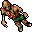 | Crypt Shambler | 330 | 195 | 0 | 580
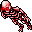 | Demon Skeleton | 400 | 240 | 620 | 620
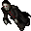 | Vampire | 475 | 305 | 0 | 0
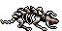 | Bonebeast | 515 | 580 | 0 | 0
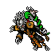 | Lich | 880 | 900 | 0 | 0
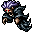 | Banshee | 1000 | 900 | 0 | 0
 | Spectre | 1350 | 1350 | 0 | 0
 | Lost Soul | 8500 | 2500 | 0 | 0
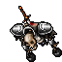 | Betrayed Wraith | 4200 | 3000 | 0 | 0
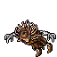 | Blightwalker | 8900 | 3350 | 0 | 0

Criaturas mágicas
Imagem | Nome | HP | Exp | Summon | Convince
 | Gazer | 120 | 90 | 0 | 0
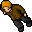 | Stalker | 120 | 90 | 0 | 0
 | Beholder | 260 | 170 | 0 | 0
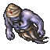 | Blue Djinn | 330 | 215 | 0 | 0
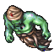 | Green Djinn | 330 | 215 | 0 | 0
 | Elder Beholder | 500 | 280 | 0 | 0
 | Marid | 550 | 325 | 0 | 0
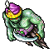 | Efreet | 550 | 325 | 0 | 0
 | Braindeath | 1225 | 985 | 0 | 0
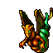 | Serpent Spawn | 3000 | 2000 | 0 | 0

Dragões
Imagem | Nome | HP | Exp | Summon | Convince
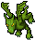 | Dragon Hatchling | 380 | 185 | 0 | 0
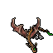 | Wyvern | 795 | 515 | 0 | 0
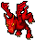 | Dragon Lord Hatchling | 750 | 645 | 0 | 0
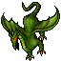 | Dragon | 1000 | 700 | 0 | 0
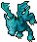 | Frost Dragon Hatchling | 800 | 745 | 0 | 0
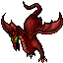 | Dragon Lord | 1900 | 2100 | 0 | 0
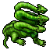 | Hydra | 2250 | 2100 | 0 | 0
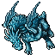 | Frost Dragon | 1900 | 2100 | 0 | 0
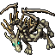 | Undead Dragon | 8350 | 5100 | 0 | 0

Demônios
Imagem | Nome | HP | Exp | Summon | Convince
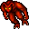 | Fire Devil | 200 | 110 | 530 | 530
 | Fire Elemental | 280 | 220 | 690 | 690
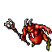 | Diabolic Imp | 1950 | 1950 | 0 | 0
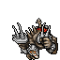 | Destroyer | 3700 | 2000 | 0 | 0
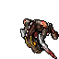 | Nightmare | 2700 | 2150 | 0 | 0
 | Hellfire Fighter | 3800 | 2200 | 0 | 0
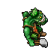 | Plaguesmith | 8250 | 3000 | 0 | 0
 | Phantasm | 3950 | 3300 | 0 | 0
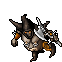 | Dark Torturer | 7350 | 3500 | 0 | 0
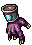 | Hand of Cursed Fate | 10500 | 3850 | 0 | 0
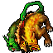 | Hellhound | 7500 | 4350 | 0 | 0
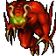 | Demon | 8200 | 6000 | 0 | 0
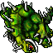 | Juggernaut | 20000 | 6500 | 0 | 0

Faraós
Imagem | Nome | HP | Exp | Summon | Convince
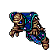 | Dipthrah | 4500 | 2900 | 0 | 0
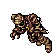 | Omruc | 3000 | 2950 | 0 | 0
 | Thalas | 6000 | 2950 | 0 | 0
 | Vashresamun | 4000 | 2950 | 0 | 0
 | Morguthis | 6000 | 3000 | 0 | 0
 | Mahrdis | 2800 | 3050 | 0 | 0
 | Ashmunrah | 6000 | 3100 | 0 | 0
 | Rahemos | 3700 | 3100 | 0 | 0

Bosses
Imagem | Nome | HP | Exp | Summon | Convince
 | Mr. Punish | 0 | 0 | 0 | 0
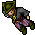 | Deadeye Devious | 0 | 0 | 0 | 0
 | Dracola | 35000 | 0 | 0 | 0
 | The Imperor | 0 | 0 | 0 | 0
 | The Plasmother | 0 | 0 | 0 | 0
 | The Handmaiden | 0 | 0 | 0 | 0
 | Countess Sorrow | 0 | 0 | 0 | 0
 | Munster | 58 | 23 | 0 | 0
 | Apprentice Sheng | 155 | 100 | 0 | 0
 | The Horned Fox | 300 | 200 | 0 | 0
 | General Murius | 550 | 300 | 0 | 0
 | Dharalion | 380 | 380 | 0 | 0
 | Fernfang | 400 | 400 | 0 | 0
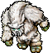 | Yeti | 950 | 460 | 0 | 0
 | Lethal Lissy | 1400 | 500 | 0 | 0
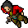 | Ron the Ripper | 1500 | 500 | 0 | 0
 | The Evil Eye | 1200 | 500 | 0 | 0
 | Brutus Bloodbeard | 1200 | 500 | 0 | 0
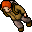 | Man in the Cave | 485 | 555 | 0 | 0
 | Necropharus | 1000 | 700 | 0 | 0
 | Grorlam | 3000 | 1600 | 0 | 0
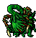 | Tiquanda's Revenge | 2000 | 1755 | 0 | 0
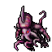 | Thul | 0 | 1800 | 0 | 0
 | The Old Widow | 3200 | 2800 | 0 | 0
 | Fluffy | 4500 | 3550 | 0 | 0
 | Bones | 9500 | 3750 | 0 | 0
 | Minishabaal | 0 | 4000 | 0 | 0
 | Demodras | 4500 | 4000 | 0 | 0
 | Orshabaal | 20000 | 10000 | 0 | 0
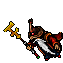 | Ferumbras | 15000 | 12000 | 0 | 0

Desafios da Arena no nível Greenhorn
Imagem | Nome | HP | Exp | Summon | Convince
 | Frostfur | 65 | 35 | 0 | 0
 | Bloodpaw | 100 | 50 | 0 | 0
 | Bovinus | 150 | 60 | 0 | 0
 | Achad | 185 | 70 | 0 | 0
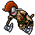 | Colerian the Barbarian | 265 | 90 | 0 | 0
 | The Hairy One | 325 | 115 | 0 | 0
 | Axeitus Headbanger | 365 | 140 | 0 | 0
 | Rocky | 390 | 190 | 0 | 0
 | Cursed Gladiator | 435 | 215 | 0 | 0
 | Orcus the Cruel | 435 | 215 | 0 | 0

Desafios da Arena no nível Scrapper
Imagem | Nome | HP | Exp | Summon | Convince
 | Avalanche | 630 | 305 | 0 | 0
 | Kreebosh the Exile | 700 | 350 | 0 | 0
 | The Dark Dancer | 845 | 435 | 0 | 0
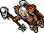 | The Hag | 1020 | 510 | 0 | 0
 | Slim | 1025 | 580 | 0 | 0
 | Grimgor Guteater | 1160 | 670 | 0 | 0
 | Drasilla | 1320 | 700 | 0 | 0
 | Spirit of Earth | 1430 | 800 | 0 | 0
 | Spirit of Water | 1400 | 850 | 0 | 0
 | Spirit of Fire | 2280 | 950 | 0 | 0

Desafios da Arena no nível Warlord
Imagem | Nome | HP | Exp | Summon | Convince
 | Webster | 1750 | 1200 | 0 | 0
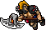 | Darakan the Executioner | 0 | 1600 | 0 | 0
 | Norgle Glacierbeard | 0 | 2100 | 0 | 0
 | The Pit Lord | 0 | 2500 | 0 | 0
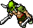 | Svoren the Mad | 0 | 3000 | 0 | 0
 | The Masked Marauder | 0 | 3500 | 0 | 0
 | Gnorre Chyllson | 0 | 4000 | 0 | 0
 | Fallen Mooh'tah Master Ghar | 0 | 4400 | 0 | 0
 | Deathbringer | 10000 | 5100 | 0 | 0
 | The Obliverator | 0 | 6000 | 0 | 0

Triangle of Terror
Imagem | Nome | HP | Exp | Summon | Convince
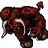 | Morgaroth | 60000 | 15000 | 0 | 0
 | Ghazbaran | 60000 | 15000 | 0 | 0

The Ruthless Seven
Imagem | Nome | HP | Exp | Summon | Convince
 | Apocalypse | 0 | 0 | 0 | 0
 | Infernatil | 0 | 0 | 0 | 0
 | Verminor | 0 | 0 | 0 | 0

