AI Zoom Clone - SQL Schema Diagram
Visual database sketch with tables, relationships, feature links, and API touchpoints
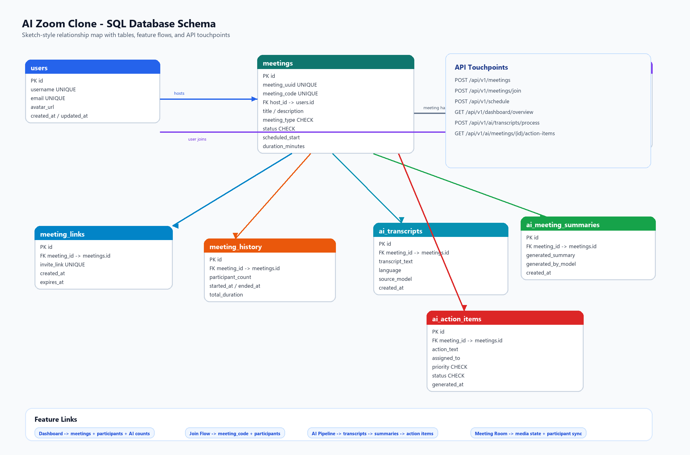
Reading guide: meetings is the central table; users host/join; AI artifacts attach to meetings as durable generated knowledge.

Feature-to-Table Map
Feature | Primary Tables | Backend API Links | Why It Matters
Dashboard | meetings, participants, ai_transcripts, ai_meeting_summaries | GET /api/v1/dashboard/overview | Shows meeting health, participant activity, and AI usage at a glance.
Instant Meeting | meetings, meeting_links, participants, meeting_history | POST /api/v1/meetings | Creates a live room, invite code, host participant, and history row.
Join Meeting | meetings, meeting_links, participants | POST /api/v1/meetings/join | Validates codes, expired links, duplicate joins, and participant state.
Scheduling | meetings, meeting_links | POST /api/v1/schedule | Persists future meetings and feeds upcoming dashboard sections.
AI Summary | ai_transcripts, ai_meeting_summaries | POST /api/v1/ai/summaries/generate | Keeps generated recaps auditable and linked to source meetings.
AI Action Items | ai_transcripts, ai_action_items | POST /api/v1/ai/action-items/generate | Turns meeting discussion into persisted tasks with owner and priority.
Transcript Intelligence | ai_transcripts, ai_meeting_summaries, ai_action_items | POST /api/v1/ai/transcripts/process | One workflow stores transcript, summary, and extracted tasks.
Media State | participants | PATCH /api/v1/participants/{id} | Synchronizes mic/camera state without overbuilding streaming infrastructure.

Interview Talking Points
• The schema is normalized around real product concepts, not CRUD screens.
• Meeting-owned records cascade so cleanup is predictable.
• AI tables are separate because generated artifacts can be regenerated and compared by model.
• Indexes match actual API access patterns: join code lookup, dashboard filtering, and latest AI artifact retrieval.
• SQLite keeps the assignment deployable while preserving a design that can migrate to PostgreSQL.

