**Lab Assignment 2:**

**Exercise 3 – A pipeline technique to eliminate data hazards** One way of dealing with “data hazard” is to get the CPU to “speed up” the availability of operands to pipelined instructions. One such method is called “operand forwarding”, a kind of short‐cut by the hardware. To demonstrate this check the box titled **Enable operand forwarding** and run the above code again.

Has the bubble in Exercise 4 disappeared or burst?

Bubble is disappeared now

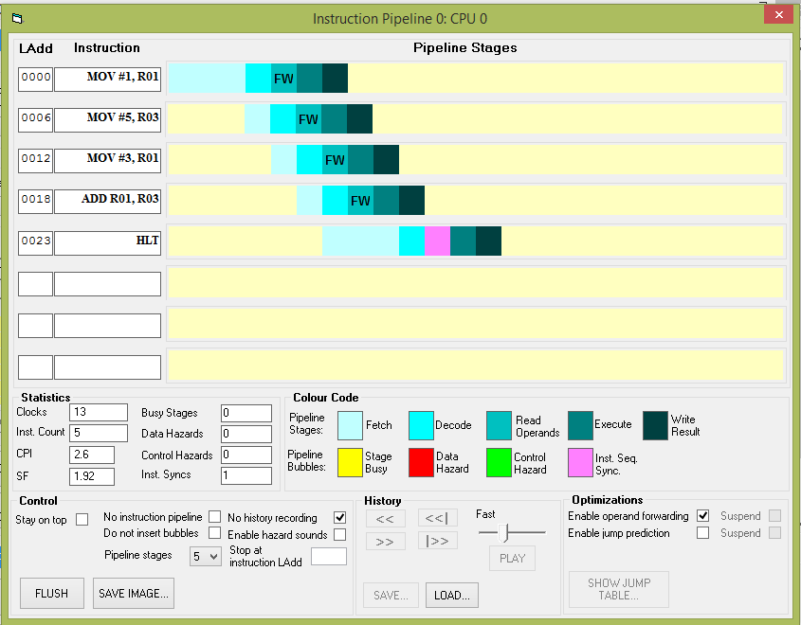

**2018HW86621**

The simulator keeps a count of the pipeline hazards it detects as the instructions go through the pipeline. These can be seen near the bottom of the pipeline window. Make a note of the following values

|  |  |
| --- | --- |
| CPI (Clocks Per Instruction) | 2.6 |
| SF (Speed‐up Factor) | 1.92 |
| Data Hazards | 0 |

Has there been an improvement?

There is no significant difference in the CPI, SF, and Execution time. Whereas the Data hazard has been removed