Software Manual

Smart House Device

2014

# **Software Description**

The Smart House software version 1.5 was created with future technology in mind, this software is designed to bring any house to life.

**Description**

This software solution has at its core the “Raspberry Pi” (the brain), it will connect to the household electricity supply as well as an interconnected RF sensor system placed throughout the house. The brain monitors and control internet access on the local WiFi network. Access to management of services

can be obtained through the use of a browser based management panel via a dedicated IP

address. Radio frequency Identification tags (RFID) will be use to identify individuals and

monitor their movement as they go about their day to day lives. The brain collects information such as individual movement, individual activity and through the use of time stamps builds each individual's “Home Activity”. This can be used to dynamic control lighting or electrical devices.

The brain will ideally monitor all devices connected to the local network. Access groups can be created so users can be given limited privilege. Children can be monitored within the household and limits can be set on TV time, access to kitchen equipment and even set time limits on internet access.

**Benefits and Value**

Convenience

Having a smart home gives users remote access to systems including heating and cooling systems, music and other devices throughout their home.

Security

Child Safety

## Accessibility

Elderly or young family members a smart home may feature accessibility technologies. Systems can do things like control lights, lock doors, operate a telephone or use a computer. Home automation allows an individual to set a schedule for automatic tasks.

Efficiency

Smart homes offer energy-efficiency. Lights can shut off automatically when no one is in a room, or prepare for a family's arrival in the evening by turning on lights, heat or cooling systems units.

**System Requirements:**

Hardware:

Device: Raspberry Pi

Attachments: RFIF Reader

Mini WIFI Dongle

8 way relay Switch

Infrared Transmitter

Software:

Raspberian –Jessie

Python 2.7

Apache 2.4.10

PHP 5.6.0

MySQL 5.6.21

# 

# **Installation**

This page describes how to set up your machine and resources to enable the proper functionality of this software solution.

1. Set up the machine with these services:

* Linux
* Apache
* MySQL and
* PHP

### 

### Install Apache

To start off we will install Apache.

1. Open up the Terminal (*Applications > Accessories > Terminal*).

2. Copy/Paste or type the following line of code into Terminal and then press enter:

*sudo apt-get install apache2*

3. The Terminal will then ask you for you're password, type it and then press enter.

### Testing Apache

To make sure everything installed correctly we will now test Apache to ensure it is working properly.

1. Open up any web browser and then enter the following into the web address:

*http://localhost/*

You should see a folder entitled *apache2-default/*. Open it and you will see a message saying "It works!" , congrats to you! or something like that!

### Install PHP

In this part we will install PHP 5.

Step 1. Again open up the Terminal (*Applications > Accessories > Terminal*).

Step 2. Copy/Paste or type the following line into Terminal and press enter:

*sudo apt-get install php5 libapache2-mod-php5*

Step 3. In order for PHP to work and be compatible with Apache we must restart Apache. Type the following code in Terminal to do this:

*sudo /etc/init.d/apache2 restart*

### Test PHP

To ensure there are no issues with PHP let's give it a quick test run.

Step 1. In the terminal copy/paste or type the following line:

*sudo gedit /var/www/testphp.php*

This will open up a file called *testphp.php*.

Step 2. Copy/Paste this line into the phptest file:

*<?php phpinfo(); ?>*

Step 3. Save and close the file.

Step 4. Now open you're web browser and type the following into the web address:

*http://localhost/testphp.php*

(It will show you the page that has all information about your php. If you have prior experience of installing php in some other OS, you must have seen this page.)

Congrats you have now installed both Apache and PHP!

### Install MySQL

To finish this guide up we will install MySQL.

Step 1. Once again open up the amazing Terminal and then copy/paste or type this line:

*sudo apt-get install mysql-server*

Step 2 (optional). In order for other computers on your network to view the server you have created, you must first edit the "Bind Address". Begin by opening up Terminal to edit the *my.cnf* file.

*gksudo gedit /etc/mysql/my.cnf*

Change the line

*bind-address = 127.0.0.1*

And change the *127.0.0.1* to your IP address.

(In Linux Mint 11, terminal itself asked to the set password, But if it doesn't follow the step 3.)

Step 3. This is where things may start to get tricky. Begin by typing the following into Terminal:

*mysql -u root*

Following that copy/paste or type this line:

*mysql> SET PASSWORD FOR 'root'@'localhost' = PASSWORD('yourpassword');*

(Make sure to change *yourpassword* to a password of your choice.)

Step 4. We are now going to install a program called phpMyAdmin which is an easy tool to edit your databases. Copy/paste or type the following line into Terminal:

*sudo apt-get install libapache2-mod-auth-mysql php5-mysql phpmyadmin*

After that is installed our next task is to get PHP to work with MySQL. To do this we will need to open a file entitled *php.ini*. To open it type the following:

*gksudo gedit /etc/php5/apache2/php.ini*

Now we are going to have to uncomment the following line by taking out the semicolon (*;*).

Change this line:

*;extension=mysql.so*

To look like this:

*extension=mysql.so*

Now just restart Apache and you are all set!

*sudo /etc/init.d/apache2 restart*

If you get a 404 error upon visiting<http://localhost/phpmyadmin>: You will need to configure apache2.conf to work with Phpmyadmin.

*sudo gedit /etc/apache2/apache2.conf*

Include the following line at the bottom of the file, save and quit.

*Include /etc/phpmyadmin/apache.conf*

Then just restart Apache

*sudo /etc/init.d/apache2 restart*

2. Phyton(2.7) will need the following to execute the software code:

* RP.GPIO

*A module to control Raspberry Pi GPIO channels*

*This package provides a class to control the GPIO on a Raspberry Pi.*

*sudo apt-get update sudo apt-get -y install python-rpi.gpio*

* SPI(SPIlib 0.10)

*A small library to use the SPIdev linux interface*

SPIlib is a thin wrapper to interact with SPI devices using the Linux "SPIdev" interface

3.For network configuration and compatibility install:

* Host APD
* DHCP Server firmware wifi

*Open a**root console:*

*# nano /etc/apt/sources.list*

*replaces text with*

*Deb* [*http://http.Debian.net/debian/*](http://http.debian.net/debian/) *whezzy main contrib non-free*

*Run sudo apt-get update*

*apt-get install zd1211-firmware*

*PHYSICAL SETUP:*

*RFID-reader connection to gpio pins.*

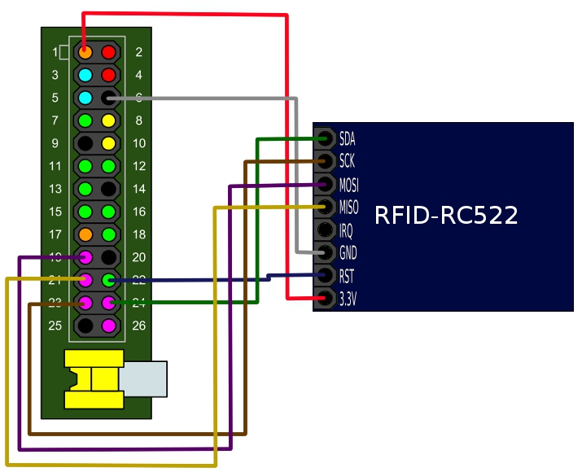

GPIO board pins numbering and description.

