**Project**

The main project folder is [[directlineproject](https://github.com/Vinisha23/DirectLine/tree/master/directlineproject)](https://github.com/GoogleCloudPlatform/java-docs-samples/blob/master/storage/xml-api/cmdline-sample/src/main/java/StorageSample.java)

**Download BDD Framework**

* This test is based on Java, Cucumber-JVM, build using Maven and Page Object Methodology
* You must also be able to work with [GitHub](https://help.github.com/articles/set-up-git) repositories.
* Clone repository

git clone https://github.com/Vinisha23/DirectLine.git

**Setup Instructions**

* **Prerequisites:**
  + Install the latest version of [Java](https://java.com/) and [Maven](https://maven.apache.org/download.html).
  + Set the java and the Maven path in the environment variables

**Eclipse Instructions**

* **Prerequisites:**
  + Install [Eclipse](http://www.eclipse.org/downloads/), the [Maven plugin](http://eclipse.org/m2e/), and optionally the [GitHub plugin](http://eclipse.github.com/).
* Run
  + Right-click on project
  + Run As > Java Application
  + If asked, type "StorageSample" and click OK

**Ways to run tests**

* Run using runner class from “directlineproject/src/test/java/CucumberRunnerTest.java”
* Run feature by right clicking and running each file from “/directlineproject/src/test/resources/Feature”

**Refactor suggestions**

## At the moment there is only one page class “[directlineproject](https://github.com/Vinisha23/DirectLine/tree/master/directlineproject)/[src](https://github.com/Vinisha23/DirectLine/tree/master/directlineproject/src)/[main](https://github.com/Vinisha23/DirectLine/tree/master/directlineproject/src/main)/[java](https://github.com/Vinisha23/DirectLine/tree/master/directlineproject/src/main/java)/[Pages](https://github.com/Vinisha23/DirectLine/tree/master/directlineproject/src/main/java/Pages)/****InsurancePage.java”**** where I have added couple of reusable methods but this can be created into a separate Helper class

**Manual Testing Observations**

* On the “<https://covercheck.vwfsinsuranceportal.co.uk/>” page , “Enter Reg” text field doesn’t seem to have field validations on maximum character limit - tested till 300 characters
* When tested with valid Reg number provided, noticed that spaces entered between the reg number are all trimmed out – for eg: “OV 1 2 U Y Y” returns valid number as below:

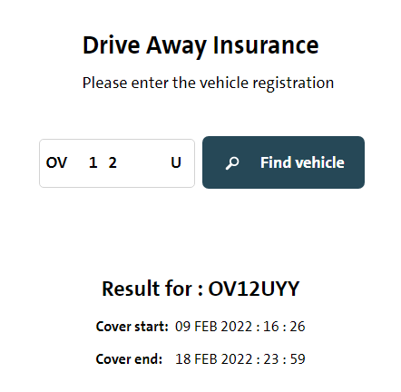

* Few of the positive and negative test scenarios are covered in automation tests.