**COVID-19 using Cognos**

**Phase 3: Development Part 1**

In this part you will begin building your project by loading and preprocessing the dataset.

Start building the COVID-19 cases analysis using IBM Cognos for visualization.

Define the analysis objectives and obtain the COVID-19 cases and deaths data file.

Process and clean the data to ensure its accuracy and reliability.

**1. Define Analysis Objectives:**

Begin by clearly defining the objectives of your analysis. What specific insights or questions are you trying to address with the COVID-19 data? This will guide your entire project.

**2. Obtain COVID-19 Data:**

To obtain COVID-19 cases and deaths data, you can explore various data sources. Many government health agencies, such as the CDC or WHO, provide COVID-19 datasets. Alternatively, you can look for reputable sources like Johns Hopkins University's COVID-19 Data Repository.

**3. Data Preprocessing:**

Data obtained from various sources may require preprocessing to ensure accuracy and reliability. Steps you may need to perform include:

- Data Cleaning: Remove duplicates, missing values, and outliers.

- Data Integration: Combine data from different sources if necessary.

- Data Transformation: Convert data into a suitable format for analysis.

- Data Validation: Check for consistency and correctness.

**4. Data Loading in Cognos:**

Cognos typically supports various data sources. You can load your preprocessed data into Cognos using the appropriate connectors or import options.

**5. Data Modeling:**

Define the data model within Cognos. This involves selecting the data fields you'll be working with, setting up relationships, and creating calculated fields if needed.

**6. Visualization in Cognos:**

With your data in Cognos, start creating visualizations to represent your COVID-19 data. This can include charts, graphs, tables, and other visual components that effectively communicate the insights you want to share.

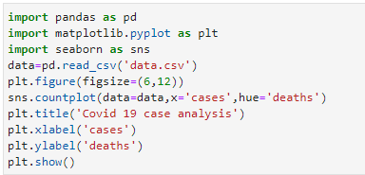

Output:

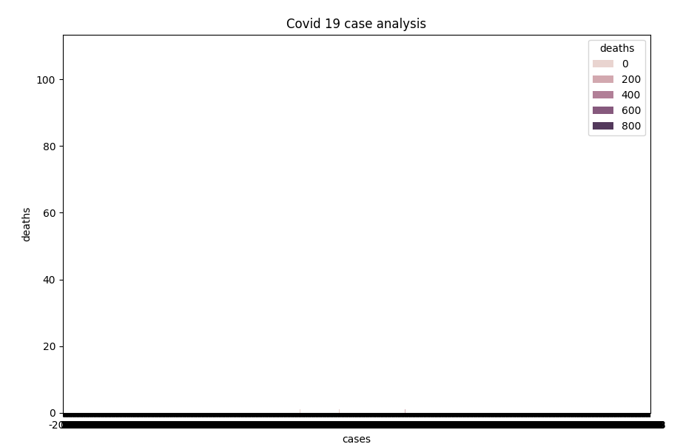

**7. Dashboard Creation:**

Assemble your visualizations into dashboards or reports within Cognos. Dashboards provide a consolidated view of the data and make it easier for users to interact with the analysis.

**8. Interactivity and Filters:**

Enhance user interaction by adding filters and parameters that allow users to explore the data based on their preferences.

**9. Testing and Validation:**

Test your analysis thoroughly to ensure accuracy, and validate the results against your objectives.

**10. Documentation:**

Document the steps you've taken, data sources, transformations, and assumptions made during the analysis. This documentation is important for transparency and future reference.

11. Sharing and Collaboration:

Share your analysis with relevant stakeholders or team members, and collaborate to refine the analysis based on feedback.

12. Monitoring and Maintenance:

COVID-19 data is dynamic, so consider setting up mechanisms to update your analysis as new data becomes available.