Q1 .
Design a Web Form that displays a personalized welcome message along with the current server date and time on a Label control when the page loads.

WP01.aspx :-
<%@ Page Title="Contact" Language="C#" MasterPageFile="~/Site.Master" AutoEventWireup="true" CodeBehind="Contact.aspx.cs" Inherits="WebApplication01.Contact" %>

<asp:Content ID="BodyContent" ContentPlaceHolderID="MainContent" runat="server">
<main aria-labelledby="title">
<h2 id="title"><%: Title %>.</h2>
<h3>Your contact page.</h3>
<address>
One Microsoft Way<br />
Redmond, WA 98052-6399<br />
<abbr title="Phone">P:</abbr>
425.555.0100
</address>

<address>
<strong>Support:</strong> <a href="mailto:Support@example.com">Support@example.com</a><br />
<strong>Marketing:</strong> <a href="mailto:Marketing@example.com">Marketing@example.com</a>
</address>
</main>
</asp:Content>

WP02.aspx.cs :-

using System;
using System.Collections.Generic;
using System.Linq;
using System.Web;
using System.Web.UI;
using System.Web.UI.WebControls;

namespace WebApplication01
{
public partial class Wp01 : System.Web.UI.Page
{
protected void Page_Load(object sender, EventArgs e)
{
lbtext.Text =
"welcome to asp.net programing" + DateTime.Now.ToString();
}
}
}

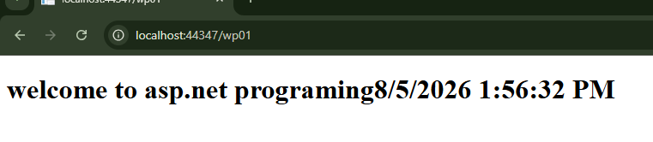
OUTPUT :

Q2 .
Design a Web Form with a Textbox for the visitor's name and a Button. On click, display a customized greeting (e.g., "Hello, <Name>! Welcome to ASP.NET.") on a Label control.
Wp02.aspx:-

<%@ Page Language="C#" AutoEventWireup="true" CodeBehind="wp02.aspx.cs" Inherits="WebApplication01.wp02" %>

<!DOCTYPE html>

<html xmlns="http://www.w3.org/1999/xhtml">
<head runat="server">
<title></title>
</head>
<body>
<form id="form1" runat="server">
<div>
<h1>
greeting
</h1>
<asp:Label ID="lbltxt" runat="server" text=" enter your name :"/>
<asp:TextBox ID="lblname" runat="server"/> <br />
<asp:Button ID="Btnsubmit_click" onClick="btnsubmit_click" runat="server" Text="greet mee" Height="26px" Width="88px" />
<br />
<asp:Label ID="lblresult" runat="server"/>
</div>
</form>
</body>
</html>

Wp02.aspx.cs:-

using System;
using System.Collections.Generic;
using System.Linq;
using System.Web;
using System.Web.UI;
using System.Web.UI.WebControls;

namespace WebApplication01
{
public partial class wp02 : System.Web.UI.Page
{
protected void Page_Load(object sender, EventArgs e)
{ }
protected void btnsubmit_click(object sender, EventArgs e)
{
lblresult.Text = "welcome " + lblname.Text;
}
}
}

OUTPUT:-
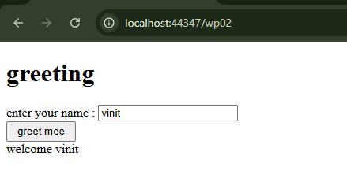

Q3 .
Build a simple on-screen Calculator that accepts two numeric values and performs Addition, Subtraction, Multiplication and Division based on the operation chosen by the user, with the result shown on a Label.

Wp03.aspx :-
<%@ Page Language="C#" AutoEventWireup="true" CodeBehind="wp03.aspx.cs" Inherits="WebApplication01.Calculator" %>

<!DOCTYPE html>
<html>
<head runat="server">
<title>Simple Calculator</title>
</head>
<body>
<form id="form1" runat="server">
<div>
<h2>Simple Calculator</h2>

<asp:Label ID="lblNum1" runat="server" Text="Number 1: "></asp:Label>
<asp:TextBox ID="txtNum1" runat="server"></asp:TextBox>
<br /><br />

<asp:Label ID="lblNum2" runat="server" Text="Number 2: "></asp:Label>
<asp:TextBox ID="txtNum2" runat="server"></asp:TextBox>
<br /><br />

<asp:Label ID="lblOperation" runat="server" Text="Operation:"></asp:Label>
<asp:RadioButtonList ID="rblOperation" runat="server" Height="119px" Width="94px">
<asp:ListItem Text="Add" Value="Add"></asp:ListItem>
<asp:ListItem Text="Subtract" Value="Subtract"></asp:ListItem>
<asp:ListItem Text="Multiply" Value="Multiply" Selected="True"></asp:ListItem>
<asp:ListItem Text="Divide" Value="Divide"></asp:ListItem>
</asp:RadioButtonList>
<br />

<asp:Button ID="btnCalculate" runat="server" Text="Calculate" OnClick="btnCalculate_Click" />
<br /><br />

<asp:Label ID="lblResult" runat="server" Font-Bold="True" ForeColor="Green"></asp:Label>
</div>
</form>
</body>
</html>

Wp03.aspx.cs :-
using System;
using System.Collections.Generic;
using System.Linq;
using System.Web;
using System.Web.UI;
using System.Web.UI.WebControls;

namespace WebApplication01
{
public partial class Calculator : System.Web.UI.Page
{
protected void Page_Load(object sender, EventArgs e)
{
}

protected void btnCalculate_Click(object sender, EventArgs e)
{
double num1, num2;

// Validate user inputs are numeric values
if (!double.TryParse(txtNum1.Text, out num1) || !double.TryParse(txtNum2.Text, out num2))
{
lblResult.Text = "Please enter valid numeric values.";
lblResult.ForeColor = System.Drawing.Color.Red;
return;
}

lblResult.ForeColor = System.Drawing.Color.Green;
string operation = rblOperation.SelectedValue;

switch (operation)
{
case "Add":
lblResult.Text = $"Result: {num1} + {num2} = {num1 + num2}";
break;

case "Subtract":
lblResult.Text = $"Result: {num1} - {num2} = {num1 - num2}";
break;

case "Multiply":
lblResult.Text = $"Result: {num1} * {num2} = {num1 * num2}";
break;

case "Divide":
if (num2 == 0)
{
lblResult.Text = "Error: Cannot divide by zero.";
lblResult.ForeColor = System.Drawing.Color.Red;
}
else
{
lblResult.Text = $"Result: {num1} / {num2} = {num1 / num2}";
}
break;

default:
lblResult.Text = "Please select a valid operation.";
break;
}
}
}
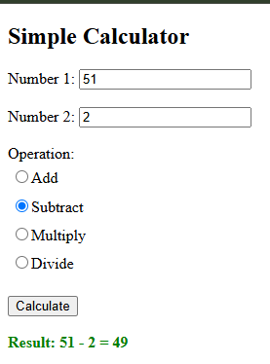
}

OUTPUT:-

Q4 .
Create a menu-driven Numeric Utility using a RadioButtonList (Factorial, Sum of Series, Fibonacci up to N terms, Prime Check). Based on the selected option and an input number, compute and display the result.

Wp04.aspx:-
<%@ Page Language="C#" AutoEventWireup="true" CodeBehind="wp04.aspx.cs" Inherits="WebApplication01.wp04" %>

<!DOCTYPE html>

<html xmlns="http://www.w3.org/1999/xhtml">
<head runat="server">
<title></title>
</head>
<body>
<form id="form1" runat="server">
<div>
<h2>Numeric Utility</h2>

<asp:Label ID="lblChoose" runat="server" Text="Choose an operation:"></asp:Label>
<asp:RadioButtonList ID="rblOperation" runat="server">
<asp:ListItem Text="Factorial" Value="Factorial"></asp:ListItem>
<asp:ListItem Text="Sum of Series (1 to N)" Value="Sum"></asp:ListItem>
<asp:ListItem Text="Fibonacci (N terms)" Value="Fibonacci"></asp:ListItem>
<asp:ListItem Text="Prime Check" Value="Prime"></asp:ListItem>
</asp:RadioButtonList>
<br />

<asp:Label ID="lblInput" runat="server" Text="Enter a number: "></asp:Label>
<asp:TextBox ID="txtNumber" runat="server"></asp:TextBox>
<br /><br />

<asp:Button ID="btnCompute" runat="server" Text="Compute" OnClick="btnCompute_Click" />
<br /><br />

<asp:Label ID="lblResult" runat="server" Font-Bold="True" ForeColor="Blue"></asp:Label>
</div>
</form>
</body>
</html>

Wp04.aspx.cs :-
using System;
using System.Collections.Generic;
using System.Linq;
using System.Web;
using System.Web.UI;
using System.Web.UI.WebControls;

namespace WebApplication01
{
public partial class wp04 : System.Web.UI.Page
{
protected void Page_Load(object sender, EventArgs e)
{
}

protected void btnCompute_Click(object sender, EventArgs e)
{
// 1. Check if the user selected a radio button
if (rblOperation.SelectedIndex == -1)
{
lblResult.Text = "Please select an operation first.";
lblResult.ForeColor = System.Drawing.Color.Red;
return;
}

// 2. Check if the input is a valid positive number
int n;
if (int.TryParse(txtNumber.Text, out n) == false || n < 0)
{
lblResult.Text = "Please enter a valid positive integer.";
lblResult.ForeColor = System.Drawing.Color.Red;
return;
}

// Reset result color to green for success
lblResult.ForeColor = System.Drawing.Color.Green;
string selectedOp = rblOperation.SelectedValue;

// 3. Perform the chosen math operations
switch (selectedOp)
{
case "Factorial":
long fact = 1;
for (int i = 1; i <= n; i++)
{
fact = fact * i;
}
lblResult.Text = n + "! (Factorial) = " + fact;
break;

case "Sum":
int sum = 0;
for (int i = 1; i <= n; i++)
{
sum = sum + i;
}
lblResult.Text = "Sum of Series (1 to " + n + ") = " + sum;
break;

case "Fibonacci":
string fibResult = "";
int a = 0, b = 1;
for (int i = 0; i < n; i++)
{
fibResult = fibResult + a + (i == n - 1 ? "" : ", ");
int next = a + b;
a = b;
b = next;
}
lblResult.Text = "Fibonacci (" + n + " terms) = " + fibResult;
break;

case "Prime":
bool isPrime = true;
if (n <= 1) isPrime = false;

for (int i = 2; i < n; i++)
{
if (n % i == 0)
{
isPrime = false;
break; // Stop loop early if a factor is found
}
}

if (isPrime == true)
lblResult.Text = n + " is a Prime number.";
else
lblResult.Text = n + " is NOT a Prime number.";
break;
}
}
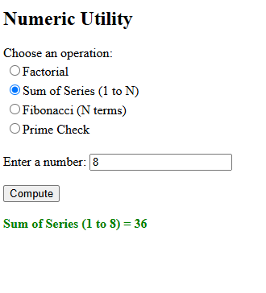
}
}

OUTPUT :-

Q5 . Create a String Utility tool using a RadioButtonList (Reverse String, Convert to Uppercase, Count Characters, Check Palindrome). Validate that the input string is not left empty before processing

Wp05.aspx :-
<%@ Page Language="C#" AutoEventWireup="true" CodeBehind="wp05.aspx.cs" Inherits="WebApplication01.wp05" %>

<!DOCTYPE html>
<html>
<head runat="server">
<title>String Utility</title>
</head>
<body>
<form id="form1" runat="server">
<div>
<h2>String Utility</h2>

<asp:Label ID="lblChoose" runat="server" Text="Choose an operation:"></asp:Label>
<asp:RadioButtonList ID="rblOperation" runat="server">
<asp:ListItem Text="Reverse String" Value="Reverse"></asp:ListItem>
<asp:ListItem Text="Convert to Uppercase" Value="Upper"></asp:ListItem>
<asp:ListItem Text="Count Characters" Value="Count"></asp:ListItem>
<asp:ListItem Text="Check Palindrome" Value="Palindrome"></asp:ListItem>
</asp:RadioButtonList>
<br />

<asp:Label ID="lblInput" runat="server" Text="Enter a string: "></asp:Label>
<asp:TextBox ID="txtInputString" runat="server"></asp:TextBox>
<br /><br />

<asp:Button ID="btnProcess" runat="server" Text="Process" OnClick="btnProcess_Click" />
<br /><br />

<asp:Label ID="lblResult" runat="server" Font-Bold="True" ForeColor="Green"></asp:Label>
</div>
</form>
</body>
</html>

Wp05.aspx.cs :-
using System;
using System.Collections.Generic;
using System.Linq;
using System.Web;
using System.Web.UI;
using System.Web.UI.WebControls;

namespace WebApplication01
{
public partial class wp05 : System.Web.UI.Page
{
protected void Page_Load(object sender, EventArgs e)
{
}

protected void btnProcess_Click(object sender, EventArgs e)
{
// 1. Validation Check: Ensure a radio button is selected
if (rblOperation.SelectedIndex == -1)
{
lblResult.Text = "Please select an operation first.";
lblResult.ForeColor = System.Drawing.Color.Red;
return;
}

// 2. Validation Check: Ensure text box is not empty
string input = txtInputString.Text.Trim();
if (input == "")
{
lblResult.Text = "Please enter a string before processing.";
lblResult.ForeColor = System.Drawing.Color.Red;
return;
}

lblResult.ForeColor = System.Drawing.Color.Green;
string selectedOp = rblOperation.SelectedValue;

switch (selectedOp)
{
case "Reverse":
string reversed = "";
for (int i = input.Length - 1; i >= 0; i--)
{
reversed = reversed + input[i];
}
lblResult.Text = "Reversed String: " + reversed;
break;

case "Upper":
string upperText = input.ToUpper();
lblResult.Text = "Uppercase String: " + upperText;
break;

case "Count":
int totalChars = input.Length;
lblResult.Text = "Total Characters: " + totalChars;
break;

case "Palindrome":
// A string is a palindrome if it reads the same backwards
string rev = "";
for (int i = input.Length - 1; i >= 0; i--)
{
rev = rev + input[i];
}

// Compare ignoring lower/uppercase differences
if (input.ToLower() == rev.ToLower())
{
lblResult.Text = "'" + input + "' is a Palindrome.";
}
else
{
lblResult.Text = "'" + input + "' is NOT a Palindrome.";
}
break;
}
}
}
}

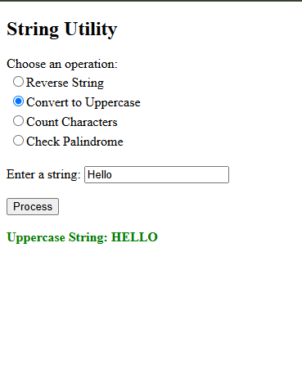
OUTPUT :-

Q6 . Design an Image Gallery page using a RadioButtonList of at least four options (e.g., Blue Hills, Sunset, Winter, Garden). The corresponding image should load dynamically based on the selection, with "Blue Hills" selected by default.

Wp06.aspx :-
<%@ Page Language="C#" AutoEventWireup="true" CodeBehind="wp06.aspx.cs" Inherits="WebApplication01.wp06" %>

<!DOCTYPE html>
<html>
<head runat="server">
<title>Image Gallery Selector</title>
</head>
<body>
<form id="form1" runat="server">
<div>
<h2>Image Gallery Selector</h2>

<asp:Label ID="lblChoose" runat="server" Text="Select an image:"></asp:Label><br />

<!-- AutoPostBack="true" updates the page instantly without a button click -->
<asp:RadioButtonList ID="rblImages" runat="server" AutoPostBack="true" OnSelectedIndexChanged="rblImages_SelectedIndexChanged">
<asp:ListItem Text="Blue Hills" Value="blue_hills.jpg" Selected="True"></asp:ListItem>
<asp:ListItem Text="Sunset" Value="sunset.jpg"></asp:ListItem>
<asp:ListItem Text="Winter" Value="winter.jpg"></asp:ListItem>
<asp:ListItem Text="Garden" Value="garden.jpg"></asp:ListItem>
</asp:RadioButtonList>
<br /><br />

<!-- Image control to display the selected picture -->
<asp:Image ID="imgGallery" runat="server" Height="200px" Width="300px" /><br /><br />

<asp:Label ID="lblDisplay" runat="server" Font-Italic="True"></asp:Label>
</div>
</form>
</body>
</html>

Wp06.aspx.cs:-
using System;
using System.Collections.Generic;
using System.Linq;
using System.Web;
using System.Web.UI;
using System.Web.UI.WebControls;

namespace WebApplication01
{
public partial class wp06 : System.Web.UI.Page
{
protected void Page_Load(object sender, EventArgs e)
{
if (!IsPostBack)
{
UpdateImage();
}
}

protected void rblImages_SelectedIndexChanged(object sender, EventArgs e)
{
UpdateImage();
}

private void UpdateImage()
{
string imageName = rblImages.SelectedValue;
imgGallery.ImageUrl = "~/images/" + imageName;
lblDisplay.Text = "Displaying: " + rblImages.SelectedItem.Text;
}
}
}

OUTPUT:-
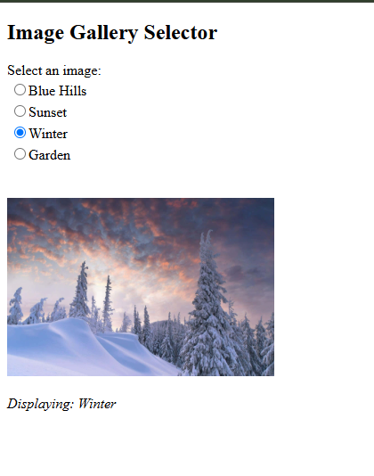

Q7 . Design a Visitor Registration Form capturing First Name, Last Name, Birth Date, Address and Country, and display the captured details on a Label after validation:
(a) First Name and Last Name must not exceed 20 characters
(b) Birth Date field must use an appropriate TextMode
(c) Address must be a multi-line TextBox
(d) a six-digit numeric Pincode is mandatory
(e) Country must be selected from a DropDownList populated dynamically with at least 10 countries.
Wp07.aspx :-
<%@ Page Language="C#" AutoEventWireup="true" CodeBehind="wp07.aspx.cs" Inherits="wp07" %>

<!DOCTYPE html>
<html>
<head runat="server">
<title>Visitor Registration</title>
<style>
body {
font-family: sans-serif;
margin: 30px;
}

.row {
margin-bottom: 12px;
}

.row label {
display: block;
margin-bottom: 4px;
font-weight: bold;
}

.result-box {
margin-top: 20px;
padding: 15px;
border: 1px solid green;
background-color: #f4fff4;
font-weight: bold;
color: green;
display: inline-block;
}

.error {
color: red;
font-weight: bold;
}
</style>
</head>
<body>
<form id="form1" runat="server">
<h2>Visitor Registration Form</h2>

<asp:Label ID="lblError" runat="server" CssClass="error"></asp:Label>
<br />
<br />

<div class="row">
<label>First Name:</label>
<asp:TextBox ID="txtFirstName" runat="server"></asp:TextBox>
</div>

<div class="row">
<label>Last Name:</label>
<asp:TextBox ID="txtLastName" runat="server"></asp:TextBox>
</div>

<div class="row">
<!-- (b) Birth Date field using appropriate Date TextMode -->
<label>Birth Date:</label>
<asp:TextBox ID="txtBirthDate" runat="server" TextMode="Date"></asp:TextBox>
</div>

<div class="row">
<!-- (c) Address using a MultiLine TextBox -->
<label>Address:</label>
<asp:TextBox ID="txtAddress" runat="server" TextMode="MultiLine" Rows="4" Columns="40"></asp:TextBox>
</div>

<div class="row">
<label>Pincode:</label>
<asp:TextBox ID="txtPincode" runat="server"></asp:TextBox>
</div>

<div class="row">
<!-- (e) Country DropDownList populated from backend -->
<label>Country:</label>
<asp:DropDownList ID="ddlCountry" runat="server"></asp:DropDownList>
</div>

<br />
<asp:Button ID="btnSubmit" runat="server" Text="Submit" OnClick="btnSubmit_Click" />

<br />
<br />
<!-- Output label container matching the visual summary format -->
<asp:Panel ID="pnlOutput" runat="server" Visible="false">
<div class="result-box">
<asp:Label ID="lblDisplay" runat="server"></asp:Label>
</div>
</asp:Panel>
</form>
</body>
</html>

WP07.aspx.cs :-
using System;
using System.Collections.Generic;
using System.Linq;
using System.Web;
using System.Web.UI;
using System.Web.UI.WebControls;

public partial class wp07 : System.Web.UI.Page
{
protected void Page_Load(object sender, EventArgs e)
{
// Populating countries by writing the name only ONCE
if (!IsPostBack)
{
ddlCountry.Items.Add("Select Country");
ddlCountry.Items.Add("India");
ddlCountry.Items.Add("United States");
ddlCountry.Items.Add("United Kingdom");
ddlCountry.Items.Add("Canada");
ddlCountry.Items.Add("Australia");
ddlCountry.Items.Add("Germany");
ddlCountry.Items.Add("Japan");
ddlCountry.Items.Add("France");
ddlCountry.Items.Add("Brazil");
ddlCountry.Items.Add("South Africa");
}
}

protected void btnSubmit_Click(object sender, EventArgs e)
{
lblError.Text = "";
pnlOutput.Visible = false;

// 1. Check if any box is empty or if default country is selected
if (txtFirstName.Text == "" || txtLastName.Text == "" || txtBirthDate.Text == "" ||
txtAddress.Text == "" || txtPincode.Text == "" || ddlCountry.SelectedValue == "Select Country")
{
lblError.Text = "All fields are mandatory!";
return;
}

// 2. Validate character lengths (Max 20)
if (txtFirstName.Text.Length > 20 || txtLastName.Text.Length > 20)
{
lblError.Text = "Names cannot exceed 20 characters.";
return;
}

// 3. Validate 6-digit numeric Pincode
string pin = txtPincode.Text;
int checkNum;
if (pin.Length != 6 || !int.TryParse(pin, out checkNum))
{
lblError.Text = "Pincode must be a 6-digit number.";
return;
}

// 4. Output the result line directly onto the screen label
lblDisplay.Text = "Registration Successful! " + txtFirstName.Text + " " + txtLastName.Text +
" | DOB: " + txtBirthDate.Text + " | " + pin + ", " + ddlCountry.SelectedValue;

pnlOutput.Visible = true;
}
}

OUTPUT :-
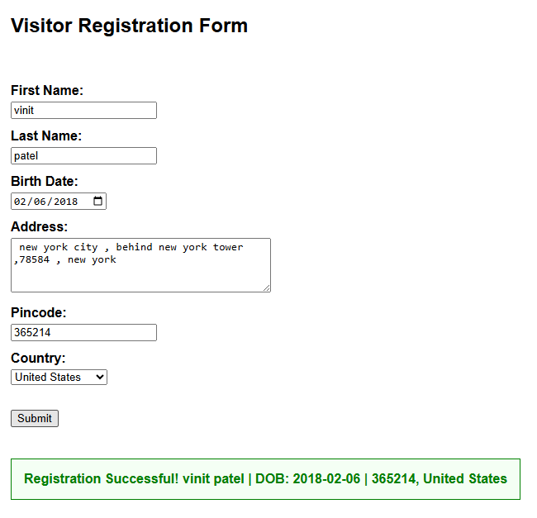

Q8 . Design a Digital Greeting Card Generator. On clicking "Generate", display a styled greeting card (using Bootstrap classes) with the entered message, restricting the greeting text to a maximum of 15 characters.

Wp08.aspx :-
<%@ Page Language="C#" AutoEventWireup="true" CodeBehind="wp08.aspx.cs" Inherits="WebApplication01.wp08" %>

<!DOCTYPE html>
<html>
<head runat="server">
<title>Digital Greeting Card Generator</title>

<!-- References your project's local Bootstrap file -->
<link href="Content/bootstrap.min.css" rel="stylesheet" />
</head>
<body>
<form id="form1" runat="server">
<div class="container mt-4" style="max-width: 500px;">
<h2>Digital Greeting Card Generator</h2>
<br />

<asp:Label ID="lblGreeting" runat="server" Text="Greeting Text:"></asp:Label><br />
<asp:TextBox ID="txtGreeting" runat="server" MaxLength="15" CssClass="form-control" Width="300px"></asp:TextBox>
<br />

<asp:Button ID="btnGenerate" runat="server" Text="Generate" OnClick="btnGenerate_Click" CssClass="btn btn-secondary btn-sm" />
<br /><br />

<asp:Panel ID="pnlCard" runat="server" Visible="false" CssClass="card border-primary text-center" Style="max-width: 350px; border-radius: 10px;">
<div class="card-body">
<h5 class="card-title text-primary fw-bold border-bottom pb-2">Digital Greeting Card</h5>
<h3 class="card-text text-success my-3">
<asp:Label ID="lblCardText" runat="server"></asp:Label>
</h3>
<p class="card-text text-muted small">Best Wishes!</p>
</div>
</asp:Panel>

<asp:Label ID="lblError" runat="server" ForeColor="Red" Font-Bold="True" class="mt-2 d-block"></asp:Label>
</div>
</form>
</body>
</html>

Wp08.aspx.cs :-
using System;
using System.Collections.Generic;
using System.Linq;
using System.Web;
using System.Web.UI;
using System.Web.UI.WebControls;

namespace WebApplication01
{
public partial class wp08 : System.Web.UI.Page
{
protected void Page_Load(object sender, EventArgs e)
{
}

protected void btnGenerate_Click(object sender, EventArgs e)
{
string message = txtGreeting.Text.Trim();

// 1. Validation Check: Ensure text box is not empty
if (message == "")
{
lblError.Text = "Please enter greeting text first.";
pnlCard.Visible = false;
return;
}

// 2. Security Check: Enforce the 15-character constraint on the server-side as well
if (message.Length > 15)
{
lblError.Text = "Text cannot exceed 15 characters.";
pnlCard.Visible = false;
return;
}

// Reset error text if everything is fine
lblError.Text = "";

// 3. Set card text and make the styled card panel visible
lblCardText.Text = message;
pnlCard.Visible = true;
}
}
}

OUTPUT :-
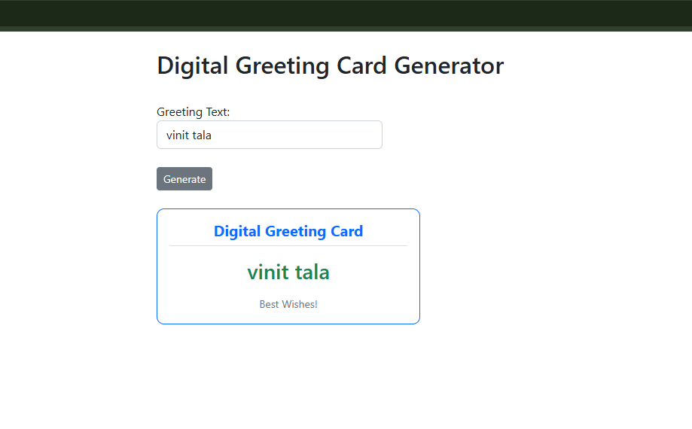

Q9 . Design a Student class with fields RollNo, Name, Sub1 (ASP.NET), Sub2 (MVC.NET), Sub3 (PHP), Sub4 (Servlet), Sub5 (Django), Total, Percentage and Grade. Implement methods to compute Total, Percentage and Grade using the criteria: >90 = A+, 80–90 = A, 70–80 = B+, 60–70 = B, 50–60 = C+, 40–50 = C, else F. Validate that every field is mandatory and each subject mark lies between 0 and 100.
Wp09.aspx :-
<%@ Page Language="C#" AutoEventWireup="true" CodeBehind="wp09.aspx.cs" Inherits="wp09" %>

<!DOCTYPE html>
<html>
<head runat="server">
<title>Student Calculator</title>
<style>
body { font-family: sans-serif; margin: 30px; }
.row { margin-bottom: 8px; }
.row label { display: inline-block; width: 140px; }
.result { margin-top: 20px; padding: 15px; border: 1px solid green; background-color: #f4fff4; width: 350px; }
.error { color: red; font-weight: bold; }
</style>
</head>
<body>
<form id="form1" runat="server">
<h2>Student Result Calculator</h2>

<asp:Label ID="lblError" runat="server" CssClass="error"></asp:Label>
<br /><br />

<div class="row">
<label>Roll Number:</label>
<asp:TextBox ID="txtRoll" runat="server"></asp:TextBox>
</div>
<div class="row">
<label>Student Name:</label>
<asp:TextBox ID="txtName" runat="server"></asp:TextBox>
</div>
<div class="row">
<label>ASP.NET Marks:</label>
<asp:TextBox ID="txtSub1" runat="server"></asp:TextBox>
</div>
<div class="row">
<label>MVC.NET Marks:</label>
<asp:TextBox ID="txtSub2" runat="server"></asp:TextBox>
</div>
<div class="row">
<label>PHP Marks:</label>
<asp:TextBox ID="txtSub3" runat="server"></asp:TextBox>
</div>
<div class="row">
<label>Servlet Marks:</label>
<asp:TextBox ID="txtSub4" runat="server"></asp:TextBox>
</div>
<div class="row">
<label>Django Marks:</label>
<asp:TextBox ID="txtSub5" runat="server"></asp:TextBox>
</div>
<br />
<asp:Button ID="btnSubmit" runat="server" Text="Calculate Result" OnClick="btnSubmit_Click" />

<br /><br />
<asp:Panel ID="pnlOutput" runat="server" CssClass="result" Visible="false">
<h3>Student Result</h3>
<b>Roll Number:</b> <asp:Label ID="lblRoll" runat="server"></asp:Label><br />
<b>Student Name:</b> <asp:Label ID="lblNm" runat="server" ForeColor="Green"></asp:Label><br /><br />

<b>ASP.NET Marks:</b> <asp:Label ID="lblM1" runat="server"></asp:Label><br />
<b>MVC.NET Marks:</b> <asp:Label ID="lblM2" runat="server"></asp:Label><br />
<b>PHP Marks:</b> <asp:Label ID="lblM3" runat="server"></asp:Label><br />
<b>Servlet Marks:</b> <asp:Label ID="lblM4" runat="server"></asp:Label><br />
<b>Django Marks:</b> <asp:Label ID="lblM5" runat="server"></asp:Label><br /><br />

<b>Total:</b> <asp:Label ID="lblTot" runat="server"></asp:Label> / 500<br />
<b>Percentage:</b> <asp:Label ID="lblPer" runat="server"></asp:Label>%<br />
<b>Grade:</b> <asp:Label ID="lblGrd" runat="server"></asp:Label>
</asp:Panel>
</form>
</body>
</html>

Wp09.aspx.cs :-
using System;
using System.Collections.Generic;
using System.Linq;
using System.Web;
using System.Web.UI;
using System.Web.UI.WebControls;

public partial class wp09 : System.Web.UI.Page
{
protected void Page_Load(object sender, EventArgs e)
{
//if (!IsPostBack)
//{
// return;
//}
}

protected void btnSubmit_Click(object sender, EventArgs e)
{
lblError.Text = "";
pnlOutput.Visible = false;

// 1. Check empty values
if (txtRoll.Text == "" || txtName.Text == "" || txtSub1.Text == "" ||
txtSub2.Text == "" || txtSub3.Text == "" || txtSub4.Text == "" || txtSub5.Text == "")
{
lblError.Text = "All fields are mandatory!";
return;
}

// 2. Safe Conversion (Validates numbers cleanly)
int roll;
if (!int.TryParse(txtRoll.Text, out roll))
{
lblError.Text = "Please enter a valid numeric Roll Number.";
return;
}

string name = txtName.Text;

double m1, m2, m3, m4, m5;
if (!double.TryParse(txtSub1.Text, out m1) || !double.TryParse(txtSub2.Text, out m2) ||
!double.TryParse(txtSub3.Text, out m3) || !double.TryParse(txtSub4.Text, out m4) ||
!double.TryParse(txtSub5.Text, out m5))
{
lblError.Text = "All subject marks must be valid numbers.";
return;
}

// 3. Validation limits
if (m1 < 0 || m1 > 100 || m2 < 0 || m2 > 100 || m3 < 0 || m3 > 100 || m4 < 0 || m4 > 100 || m5 < 0 || m5 > 100)
{
lblError.Text = "Marks must be between 0 and 100!";
return;
}

// 4. Calculations
double total = m1 + m2 + m3 + m4 + m5;
double percentage = (total / 500) * 100;
string grade = "";

if (percentage > 90)
grade = "A+";
else if (percentage >= 80)
grade = "A";
else if (percentage >= 70)
grade = "B+";
else if (percentage >= 60)
grade = "B";
else if (percentage >= 50)
grade = "C+";
else if (percentage >= 40)
grade = "C";
else
grade = "F";

// 5. Link values to frontend elements
lblRoll.Text = roll.ToString();
lblNm.Text = name;
lblM1.Text = m1.ToString();
lblM2.Text = m2.ToString();
lblM3.Text = m3.ToString();
lblM4.Text = m4.ToString();
lblM5.Text = m5.ToString();

lblTot.Text = total.ToString();
lblPer.Text = percentage.ToString("0.00");
lblGrd.Text = grade;

pnlOutput.Visible = true;
}

}
OUTPUT :-
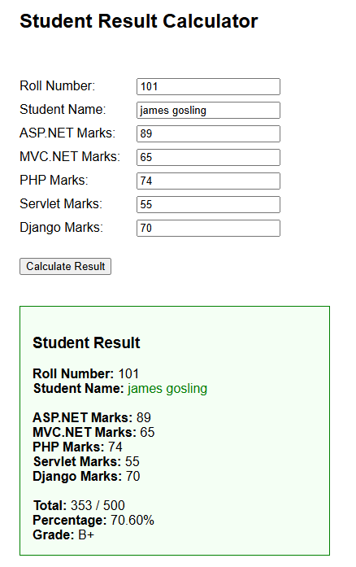
Q10 . Create a Web Form that logs the sequence of ASP.NET Page Life-Cycle events (Page_Init, Page_Load, Page_PreRender, Page_Unload) into a ListBox/Label each time the page is requested and on every postback, to visually trace the life cycle.
Wp10.aspx
<%@ Page Language="C#" AutoEventWireup="true" CodeBehind="wp10.aspx.cs" Inherits="WebApplication01.wp10" %>

<!DOCTYPE html>
<html>
<head runat="server">
<title>ASP.NET Page Life Cycle</title>
<style>
body { font-family: sans-serif; margin: 30px; }
h2 { font-size: 22px; }
.btn { padding: 4px 10px; margin-bottom: 15px; }
.list-box { font-family: monospace; font-size: 14px; padding: 5px; }
</style>
</head>
<body>
<form id="form1" runat="server">
<h2>ASP.NET Page Life Cycle</h2>

<asp:Button ID="btnPostback" runat="server" Text="Generate Postback" CssClass="btn" OnClick="btnPostback_Click" />
<br />

<asp:ListBox ID="lstEvents" runat="server" Width="320px" Height="220px" CssClass="list-box"></asp:ListBox>
</form>
</body>
</html>

Wp10.aspx.cs :-
using System;
using System.Collections.Generic;
using System.Linq;
using System.Web;
using System.Web.UI;
using System.Web.UI.WebControls;
namespace WebApplication01
{
public partial class wp10 : System.Web.UI.Page
{
protected void Page_Init(object sender, EventArgs e)
{
lstEvents.Items.Add("Page_Init");
}
protected void Page_Load(object sender, EventArgs e)
{
lstEvents.Items.Add("Page_Load");
}
protected void btnPostback_Click(object sender, EventArgs e)
{
// Triggers postback tracking loop
}
protected void Page_PreRender(object sender, EventArgs e)
{
lstEvents.Items.Add("Page_PreRender");
}
protected void Page_Unload(object sender, EventArgs e)
{
// Unload stage cleanup handles memory destruction
}
}
}
OUTPUT :-
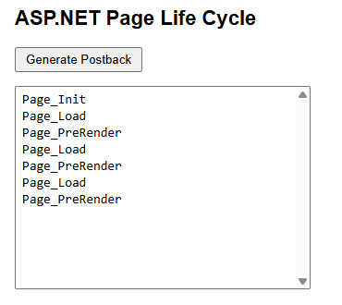

Q11 . Create two content pages sharing one Master Page with a common header, navigation menu and footer. Each content page should display page-specific data in its own ContentPlaceHolder.

Wp11.master :-
<%@ Master Language="C#" AutoEventWireup="true" CodeBehind="wp11.master.cs" Inherits="WebApplication02.wp11" %>

<!DOCTYPE html>
<html lang="en">
<head runat="server">
<meta charset="utf-8" />
<title>Student Portal</title>
<style>
body { font-family: Arial, sans-serif; margin: 0; padding: 0; }
.custom-header { background-color: #2c3e50; color: white; text-align: center; padding: 25px; margin: 0; }
.custom-nav { background-color: #34495e; padding: 12px; text-align: center; }
.custom-nav a { color: #bdc3c7; margin: 0 15px; text-decoration: none; font-size: 16px; font-weight: bold; }
.custom-nav a:hover { color: white; text-decoration: underline; }
.custom-content { padding: 30px; min-height: 400px; }
.custom-footer { background-color: #2c3e50; color: white; text-align: center; padding: 15px; font-size: 14px; margin-top: 20px; }
</style>
<asp:ContentPlaceHolder ID="head" runat="server"></asp:ContentPlaceHolder>
</head>
<body>
<form id="form1" runat="server">

<!-- Header -->
<div class="custom-header">
<h1>Student Information Portal</h1>
</div>

<!-- Navigation Bar -->
<div class="custom-nav">
<a href="wp11_home.aspx">Home</a>
<a href="wp11_courses.aspx">Courses</a>
</div>

<!-- Dynamic Area where child pages inject text -->
<div class="custom-content">
<asp:ContentPlaceHolder ID="MainContent" runat="server">
</asp:ContentPlaceHolder>
</div>

<!-- Footer -->
<div class="custom-footer">
Copyright &copy; 2026 Student Information Portal
</div>

</form>
</body>
</html>
Wp11_home.aspx :-
<%@ Page Title="Home" Language="C#" MasterPageFile="~/wp11.Master" AutoEventWireup="true" CodeBehind="wp11_home.aspx.cs" Inherits="WebApplication02.wp11_home" %>

<asp:Content ID="Content2" ContentPlaceHolderID="MainContent" runat="server">
<style>
.feature-box {
background-color: #eef9eef4;
border: 1px solid #a4d8b2;
padding: 15px;
width: 320px;
margin-top: 15px;
}
.feature-box b { color: black; font-size: 15px; }
.feature-box ul { margin-top: 8px; padding-left: 20px; }
</style>

<h2>Welcome to the Home Page</h2>
<p>This page provides general information about the student portal.</p>

<div class="feature-box">
<b>Portal Features</b>
<ul>
<li>Student Information</li>
<li>Course details</li>
<li>Academic updates</li>
</ul>
</div>
</asp:Content>

Wp11_course.aspx :-
<%@ Page Title="Courses" Language="C#" MasterPageFile="~/wp11.Master" AutoEventWireup="true" CodeBehind="wp11_courses.aspx.cs" Inherits="WebApplication02.wp11_courses" %>

<asp:Content ID="Content2" ContentPlaceHolderID="MainContent" runat="server">
<h2>Available Courses</h2>
<p>Check out our web programming track modules below:</p>

<table border="1" cellpadding="8" style="border-collapse: collapse; width: 400px; border-color: #ccc; margin-top: 15px;">
<tr style="background-color: #f2f2f2; font-weight: bold; text-align: left;">
<th>Course ID</th>
<th>Course Name</th>
</tr>
<tr>
<td>CS01</td>
<td>ASP.NET Web Forms</td>
</tr>
<tr>
<td>CS02</td>
<td>MVC.NET Architecture</td>
</tr>
<tr>
<td>CS03</td>
<td>PHP & Django Frameworks</td>
</tr>
</table>
</asp:Content>

OUTPUT :-
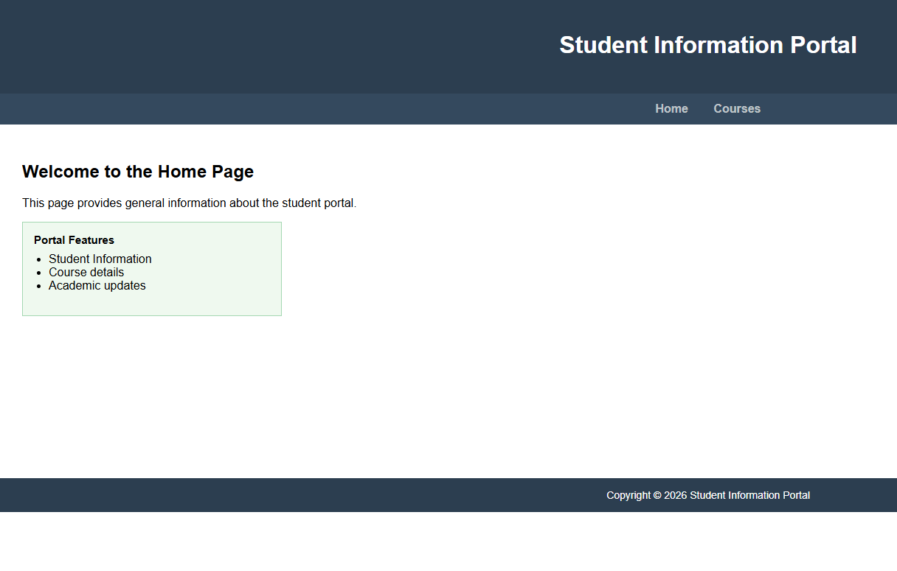
Q12 . Design a two-page demo that passes a piece of data (e.g., selected product name) from Page A to Page B using three different techniques in separate buttons: QueryString, Session, and ViewState/Cross-Page Posting. Display which technique was used and the value received on Page B.

Wp12A.aspx :-
<%@ Page Language="C#" AutoEventWireup="true" CodeBehind="wp12A.aspx.cs" Inherits="WebApplication01.wp12A" %>

<!DOCTYPE html>
<html>
<head runat="server">
<title>Page A</title>
</head>
<body>
<form id="form1" runat="server">
<h2>Page A - Select Product</h2>

<asp:DropDownList ID="ddlProducts" runat="server">
<asp:ListItem>Laptop</asp:ListItem>
<asp:ListItem>Smartphone</asp:ListItem>
<asp:ListItem>Headphones</asp:ListItem>
</asp:DropDownList>
<br /><br />

<asp:Button ID="btnQS" runat="server" Text="Send Using QueryString" OnClick="btnQS_Click" /><br /><br />
<asp:Button ID="btnSession" runat="server" Text="Send Using Session" OnClick="btnSession_Click" /><br /><br />
<asp:Button ID="btnCross" runat="server" Text="Send Using Cross-Page Posting" PostBackUrl="~/wp12B.aspx" />
</form>
</body>
</html>

Wp12A.aspx.cs:-
using System;
using System.Collections.Generic;
using System.Linq;
using System.Web;
using System.Web.UI;
using System.Web.UI.WebControls;

namespace WebApplication01
{
public partial class wp12A : System.Web.UI.Page
{
protected void Page_Load(object sender, EventArgs e)
{
}

protected void btnQS_Click(object sender, EventArgs e)
{
// Appends data directly to the URL string
Response.Redirect("wp12B.aspx?prod=" + ddlProducts.SelectedValue + "&tech=QueryString");
}

protected void btnSession_Click(object sender, EventArgs e)
{
// Saves data inside server session variables
Session["prod"] = ddlProducts.SelectedValue;
Session["tech"] = "Session";
Response.Redirect("wp12B.aspx");
}
}
}

Wp12B.aspx :-
<%@ Page Language="C#" AutoEventWireup="true" CodeBehind="wp12B.aspx.cs" Inherits="WebApplication01.wp12B" %>

<!DOCTYPE html>
<html>
<head runat="server">
<title>Page B</title>
</head>
<body>
<form id="form1" runat="server">
<h2>Page B - Received Product</h2>

<div style="background-color: #eef9ee; border: 1px solid green; padding: 15px; width: 300px;">
<p>Technique Used: <b><asp:Label ID="lblTech" runat="server"></asp:Label></b></p>
<p>Product Received: <b><asp:Label ID="lblProd" runat="server"></asp:Label></b></p>
</div>
<br />
<a href="wp12A.aspx">Back to Page A</a>
</form>
</body>
</html>

Wp12B.aspx.cs:-
using System;
using System.Collections.Generic;
using System.Linq;
using System.Web;
using System.Web.UI;
using System.Web.UI.WebControls;
namespace WebApplication01
{
public partial class wp12B : System.Web.UI.Page
{
protected void Page_Load(object sender, EventArgs e)
{
// 1. Check if QueryString values exist in URL line
if (Request.QueryString["prod"] != null)
{
lblProd.Text = Request.QueryString["prod"];
lblTech.Text = Request.QueryString["tech"];
}
// 2. Check if Session variables exist in server memory
else if (Session["prod"] != null)
{
lblProd.Text = Session["prod"].ToString();
lblTech.Text = Session["tech"].ToString();
Session.RemoveAll(); // Clear memory after showing it
}
// 3. Handle Cross-Page Posting by looking back at Page A directly
else if (PreviousPage != null)
{
DropDownList ddl = (DropDownList)PreviousPage.FindControl("ddlProducts");
if (ddl != null)
{
lblProd.Text = ddl.SelectedValue;
lblTech.Text = "Cross-Page Posting";
}
}
}
}
}

OUTPUT :-
