RISC-V Product Development Hackathon:



**Stage 1-Product Idea Submission Form**

1. **Product Title : INVIANO (INVISIBLE PIANO)**

* **Children Toy**

1. **What does your product do?**

* Music – “INVIANO’’ is an innovative Invisible musical toy made for kids and adults (additionally for young blind musicians and handicapped people(**fingerless**).
* INVIANO is a touchless/keyless instrument (piano), which produces musical sounds by waving our hand.
* Sensors records the hand gesture, generating corresponding musical note (frequency) using a microcontroller.
* INVIANO has educational and therapeutic potential, fostering inclusivity and creativity in music.

1. **What all interfaces of the board will be used in the product ?**

* GPIO - Digital I/O pins
* PWM
* Timer
* Arithmetic Block(Multiplier & Divider)

1. **Does the product utilise sensors?**

* Yes

1. **If "Yes" for above question, then list your sensors here**

* Ultrasonic sensor (7 units)

1. **Draw a Block diagram of the product.**

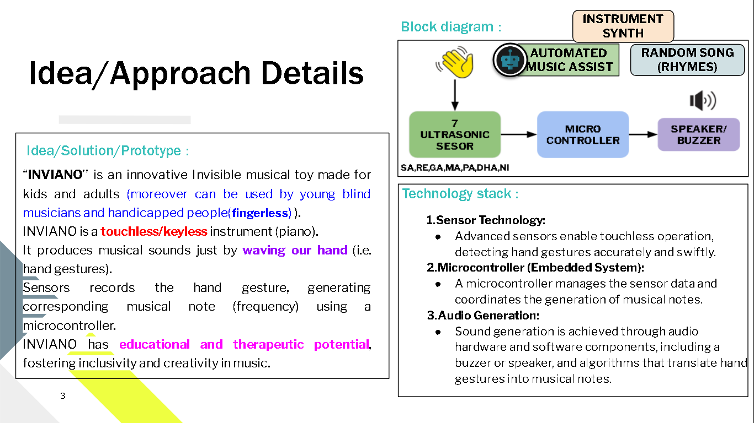

1. **Upload the Algorithm flowchart of the product.**

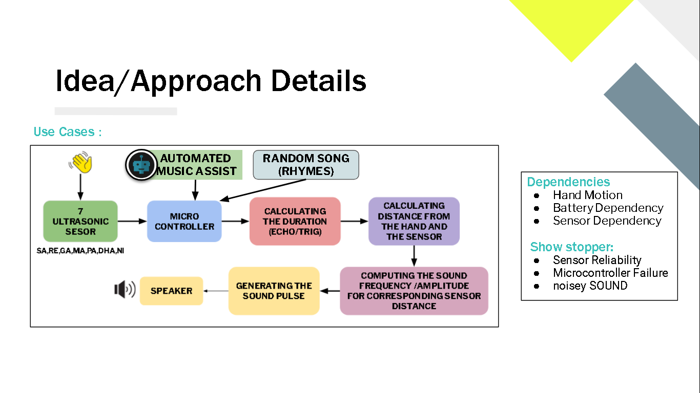

1. **Explain the algorithm of the product in bullet points.**

* Initialize the microcontroller, ultrasonic sensor, and buzzer.
* Define variables for distance and musical notes.
* Calibrate the ultrasonic sensor for accurate measurements.
* In the main loop:
* Measure the distance between the sensor and the user's hand.
* Map distances to musical notes.
* Use the buzzer to play the corresponding note.
* Monitor hand position and gestures.
* Provide user feedback through LEDs or messages.
* Implement an exit mechanism for the musical mode.
* Safely shut down the system when not in use.

1. **Draw a Rough sketch of the final product.**

|  |  |
| --- | --- |
|  |  |

1. **Upload the rough sketch of the Internal product (With all connection of components with the board and the product).**

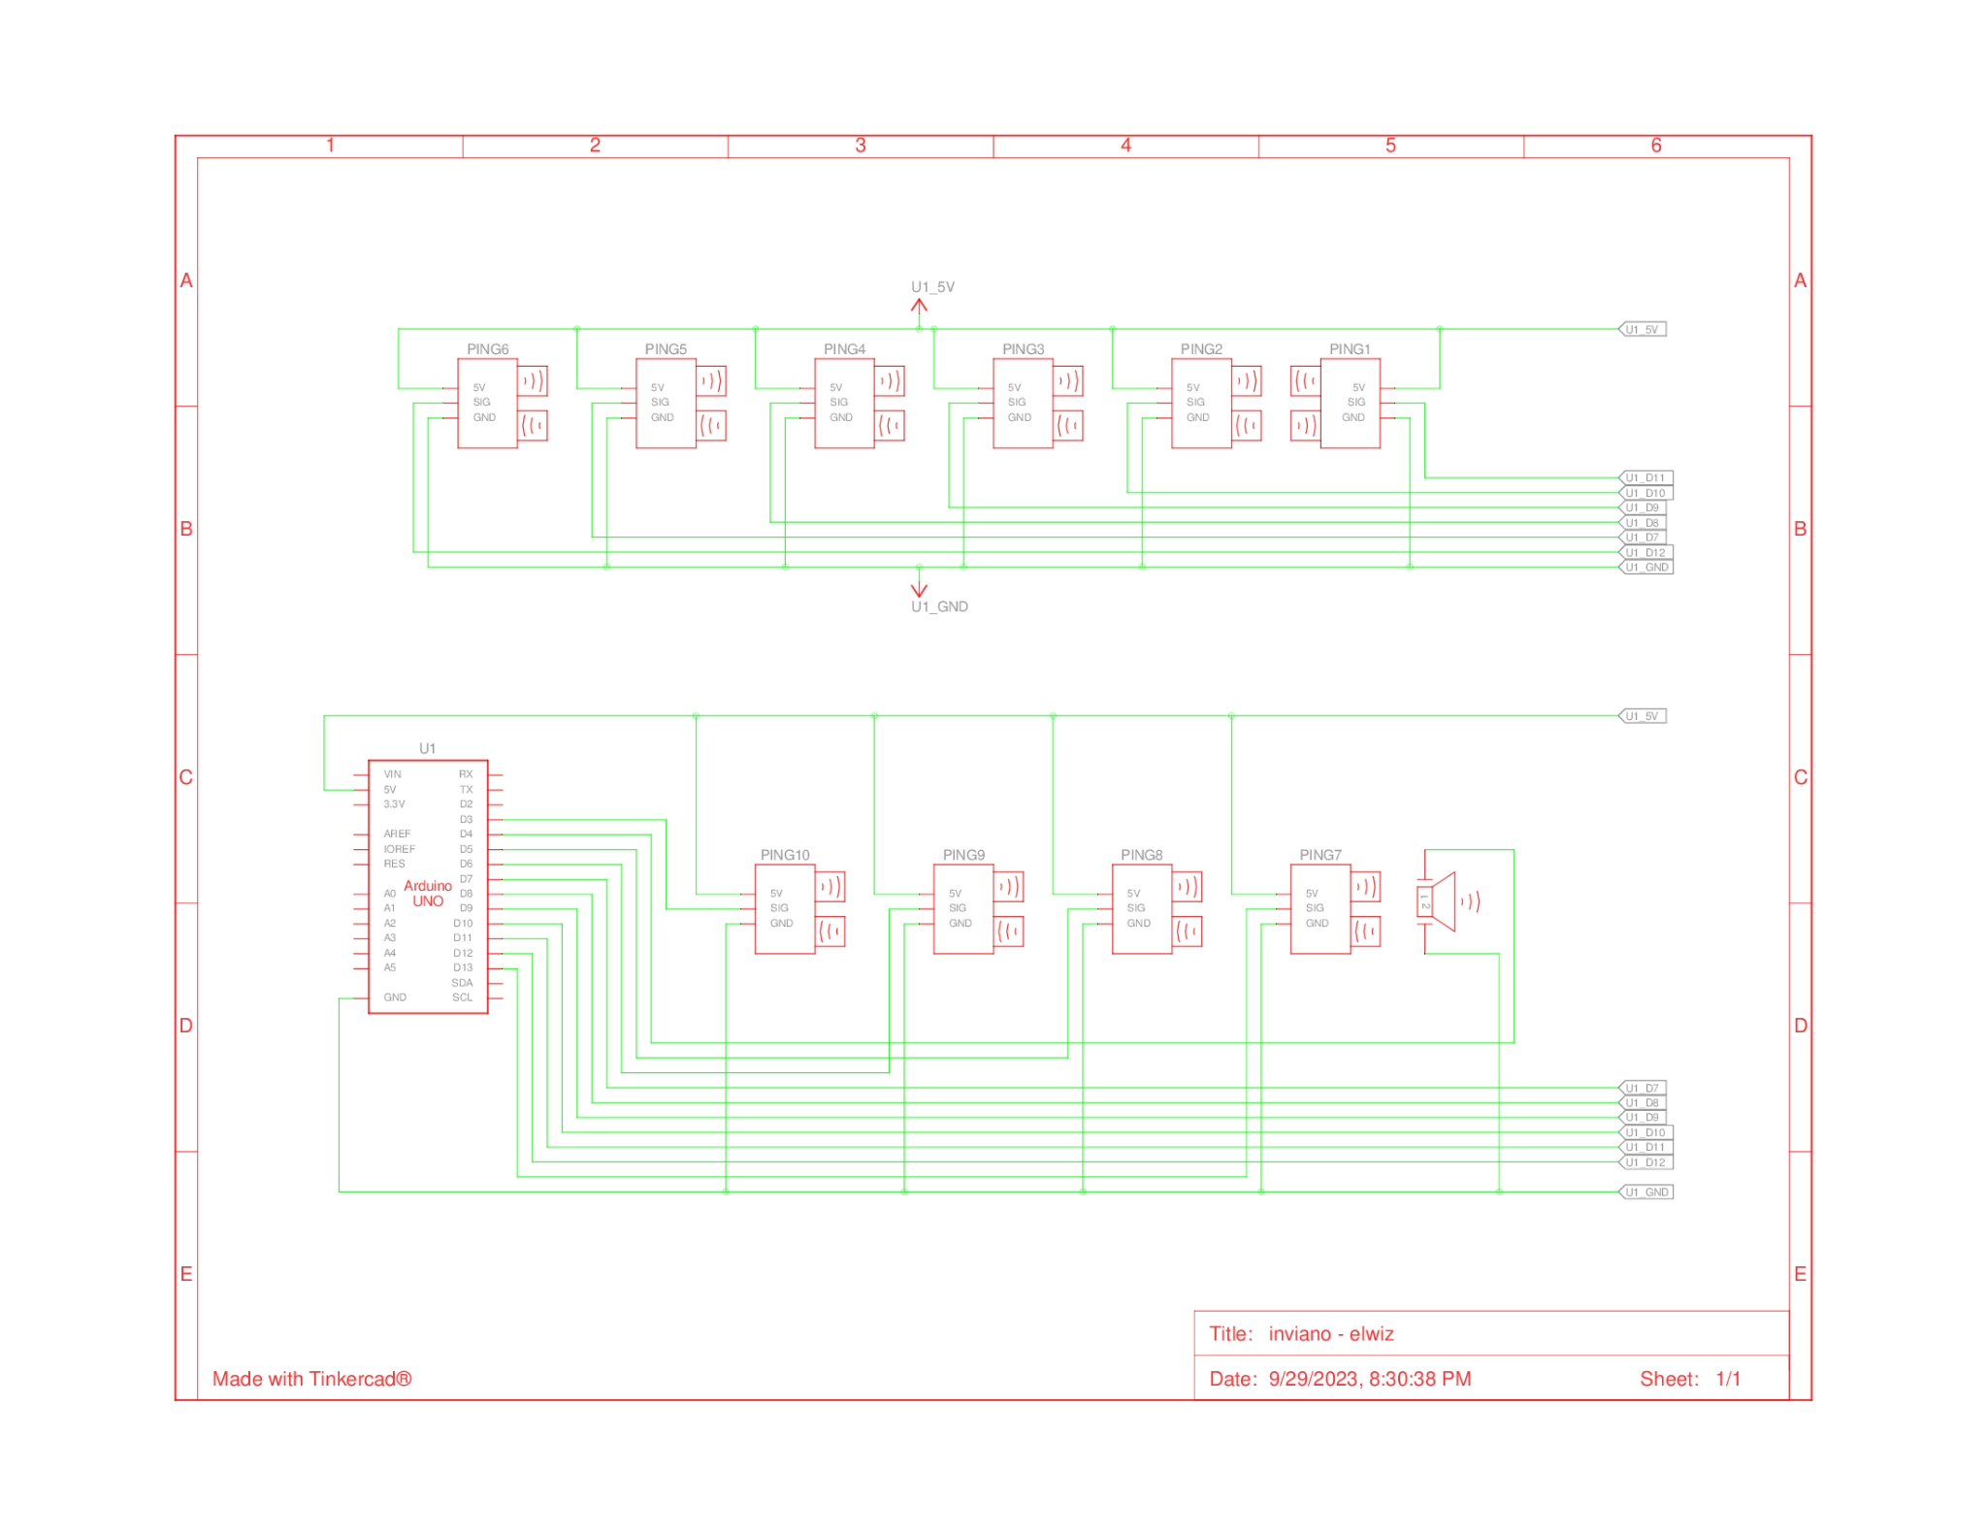

* The Ultrasonic sensor is connected to the VSDSquadron utilizing the GPIO pins for generation of triggering pulse for Ultrasonic sensor and receiving the echo signal back from the sensor.
* Based on the calculation of the distance of the gestures, a particular frequency of melody will be sent to the buzzer from the microcontroller.

1. **Product - Market - Category:**

|  |  |
| --- | --- |
| **Kids :** Age 2 to 13  **Adult:** above 13 | **Focus :** kids/adult toy market  **Elegency:** 10 ultrasonic sensor + speaker + μc - simple cost effective toy |

**11. 1 Idea/Solution/Prototype:**

* “INVIANO’’ is an innovative Invisible musical toy made for kids and adults (moreover it can be used by **young blind musicians and handicapped people**(fingerless)).
* INVIANO is a **touchless**/keyless instrument (piano).
* It produces musical sounds just by **waving our hand** (i.e., hand gestures).
* Sensors record the hand gesture, generating corresponding musical notes (frequency) using a microcontroller.(piano,drum,violin..etc)
* INVIANO has **educational** and **therapeutic potential**, fostering inclusivity and creativity in music.

**11.2 Technology stack:**

**1.Sensor Technology:** Advanced sensors enable touchless operation, detecting hand gestures accurately and swiftly.

**2.Microcontroller (Embedded System):** A microcontroller manages the sensor data and coordinates the generation of musical notes.

**3.Audio Generation/synth:**Sound generation is achieved through audio hardware and software components, including a buzzer or speaker, and algorithms that translate hand gestures into musical notes.

|  |  |  |
| --- | --- | --- |
| **Dependencies**   * Hand Motion * Battery Dependency * Sensor Dependency | **Show stopper**   * Sensor Reliability * Microcontroller Failure * noisy sound | **Features Included**   * Speaking assistant (Text to speech) * One octave RANDOM - Song Play mode (rhymes) * Instrument synth. * Gesture controlled on/off |

1. **BoM list (excluding the board) with cost.**

|  |  |  |  |
| --- | --- | --- | --- |
| **Component name** | **Quantity Required** | **Unit price**  **₹** | **Total Price**  **(Unit price*Quantity) ₹** |
| **Ultrasonic sensor** | **10** | **60** | **600** |
| **Piezoelectric buzzer** | **2** | **30** | **60** |
| **Jumper wire(M-M,M-F,F-F)** | **Few** | **-** | **-** |
|  |  | **Total** | **660** |

**12.1 Cost Analysis :**

For our product the Bill of Materials (BOM) stays around ₹500 - ₹600 which can be further reduced using an effective model and bulk manufacturing. The main components of INVIANO includes Ultrasonic sensors, Microcontroller, Low pass filter, Buzzer (Speakers). Including this we could expect a rather very negligible cost of the software part.

1. **Team details**

|  |  |  |  |  |  |  |  |
| --- | --- | --- | --- | --- | --- | --- | --- |
| **Name** | **University**  **/Organisation** | **Age** | **Sex** | **Current Semester** | **Current Address** | **Do you need accommodation if the Demo is to done in Bangalore** | **Role in Product Development** |
| Vinit Kumar | B,S,A crescent institute of science and technology | 21 | male | 7th sem | 4/21, Perumal Kovil.St, Vandalur, Chennai - 600048 | Yes | Hardware Implementation |
| Zumana begum I | B,S,A crescent institute of science and technology | 18 | female | 3rd sem | No:19,adam nagar,5th street,nagelkeni,chrompet-600044 | Yes | Software Implementation |