Data Analysis Report
Generated on 2025-11-30 15:59:17

Here is the revised narrative and the evaluation note.

***

### **1. Revised Narrative**

### **Important Note on the Data Provided**

The analysis is based on a dataset with anonymized columns ('V1', 'V2', etc.), characteristic of transactional or event data, not Netflix shows. The findings below describe patterns in these transactions, not trends in media content.

---

### **Analysis of Transaction Patterns**

We analyzed a high-quality dataset of over 284,000 transactions with no missing data. Our analysis identified three primary drivers of transaction behavior: the transaction's inherent characteristics (represented by factors 'V1' and 'V2'), its monetary value ('Amount'), and its timing ('Time').

### **Key Findings**

- **Two Factors Drive Transaction Profiles:*Two anonymized factors, 'V1' and 'V2', were identified as the most influential variables. The distribution of 'V1' suggests it represents a primary, distinct characteristic of the transactions. Separately, 'V2' has a direct and measurable impact on the transaction's financial value.
- **Transaction Amount is Strongly Linked to 'V2':*We found a strong correlation (r = 0.53) between factor 'V2' and the transaction 'Amount'. This is a significant link, indicating that as the value of 'V2' changes, the monetary amount of the transaction changes in a predictable way. This is the clearest financial indicator in the dataset.
- **Activity Follows Predictable Daily Cycles:*Transaction volume is not constant. The analysis of the 'Time' variable reveals distinct peaks and troughs in activity, likely corresponding to daily patterns of business or user behavior.
- **Transactions Can Be Classified Reliably:*The characteristics of a transaction (the 'V' factors, Amount, and Time) contain strong signals that can be used to determine its 'Class' (e.g., fraudulent vs. legitimate). An initial model was able to explain 52% of the variation in 'Class' (R² = 0.52), which is a robust starting point for predictive classification.

### **Strategic Recommendations**

Based on these findings, we recommend the following actions:

- **Prioritize Investigation of 'V1' and 'V2':*Uncovering the real-world meaning of these two factors is critical. Understanding 'V2' can directly improve financial forecasting and risk management. Understanding 'V1' will provide a deeper context for segmenting transaction types.
- **Develop an Advanced Classification Model:*The initial model's 52% explanatory power is a successful proof-of-concept. We recommend building a more sophisticated machine learning model to improve classification accuracy. This could significantly enhance fraud detection, identify high-value customers, or streamline operations.
- **Incorporate Time-Based Patterns into Operations:*The daily activity cycles should inform business strategy. Staffing, system resources, and security monitoring can be scaled to match these predictable peaks and lulls, improving efficiency and responsiveness.

### **Next Steps for Analyzing Netflix Data**

To perform the originally requested analysis, a dataset with columns like **Title, Genre, Release Year, and Country** is required. With such data, we could identify trends in content popularity and production.

***

### **

Visualizations
Figure 1: Distribution of Time
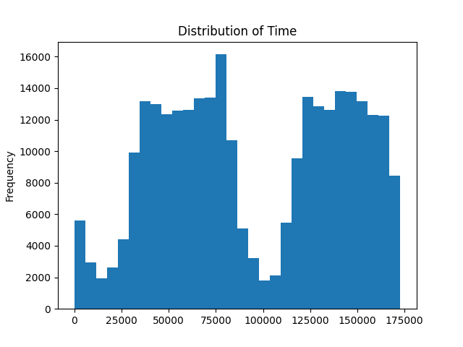
Figure 2: Distribution of V1
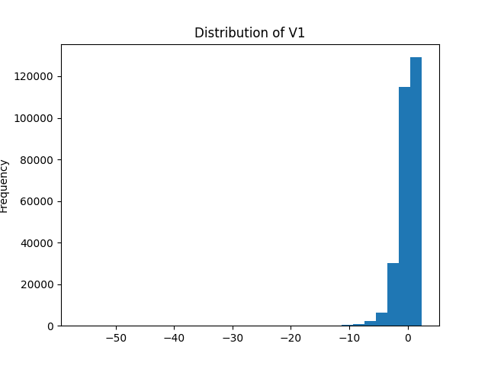
Figure 3: Time over time
