14512926
Abstract
This project uses an ESP32, DHT22, and MQTT to monitor perishable inventory (like milk and mangoes) in real time. It reduces retail food waste by triggering local alerts and updating a live Adafruit IO dashboard for low-cost, scalable stock management.
602 it – Internet of Things
An IoT-Based Smart Shelf Prototype for Reducing Food Waste through Real-Time Sensing, Alerting, and Cloud Dashboard Integration

Table of Contents
Table of figure 3
1.Real-World Problem Definition 4
1.1 Definition of IoT 4
1.2 Problem Statement 4
1.3 Significance of the Problem 4
1.4 Gap Analysis 5
1.5 Why an IoT-Based Solution is Suitable 5
1.6 Who Benefits and How 5
1.7 Device Description (5W Analysis) 5
2. Solution Design & Artefact 6
2.1 High-Level System Architecture 6
2.1.1 Logical Design — Layer Explanation 7
2.2 IoT Design Methodology — Chapter 5 (Bahga & Madisetti, 2015) 7
Purpose & Requirements Specification 7
Process Specification — Use Cases 7
Domain Model Specification 8
Information Model Specification 9
Service Specifications 10
IoT Level Specification — Level 4 Selected 11
Step 7: Functional View Specification 12
Step 8: Operational View Specification 12
Device & Component Integration 13
Application Development 14
2.3 Power Consumption Analysis 14
2.4 Communication Model 15
2.4.1 Wireless Limitations — Theoretical Real-World Explanation 15
2.5 System Algorithm 15
2.6 Data Flow 16
2.7 Prototype Implementation & Simulation Results 17
2.8 Web Dashboard & Mobile Application 17
3.Technical Report 19
3.1 Introduction & Background 19
3.2 Project Objectives 19
3.3 Technologies & Protocols 20
3.4 Cloud Integration — Proof of Attempt and Limitations 20
3.5 Security & Privacy 21
3.6 Usability & Scalability 21
3.7 Commercial & Societal Implications 22
3.8 Trends & Future Outlook 22
Conclusion 23
AI Tool Acknowledgement 23
References 24
Appendix 25
A.1 GitHub Repository — Source Code 25
A.2 Live Web Dashboard 25
A.4 Android Mobile Application — Download and Setup Guide 25
Step-by-Step Installation Instructions 25
A.5 Adafruit IO API Key — Evaluator Access 26
A.6 Esp32 code 27

Table of figure
Figure 1:Existing solution And Limitation 5
Figure 2: Who Benefits and How 6
Figure 3: Application Layer Diagram – 4-Layer IoT Architecture 7
Figure 4: Logical Design Block Diagram (Bahga & Madisetti Framework) 7
Figure 5:Block Diagram Layer Explanation 8
Figure 6: Use Case Diagram (Smart Shelf IoT System) 9
Figure 7: Domain Model Class Diagram 10
Figure 8: Domain Model Specification 10
Figure 9: Information Model — Virtual Entities 11
Figure 10: Information Model Specification 11
Figure 11: Service Specifications Diagram 12
Figure 12: Service Specifications 12
Figure 13: IoT Level Specification — Level 4 Selected 13
Figure 14: IoT Level Specification 13
Figure 15: Functional View Specification 14
Figure 16: Operational View Specification 14
Figure 17: Hardware Components, Connections, and Justifications 15
Figure 18: Wokwi Simulation — Full Circuit View 15
Figure 19: Application Development Diagram — Firmware to Client Layers 16
Figure 20: Power Consumption Analysis 16
Figure 21: Data Flow Diagram 18
Figure 22: Testing and Results 19
Figure 23: Custom Web Dashboard — Smart Fridge IoT 19
Figure 24: Android Mobile App — Dashboard Screen showing live sensor data and alert state 20
Figure 25: Android Mobile App — Controls Screen (Reset milk counter, adjust thresholds via Adafruit IO) 20
Figure 26: Project Objectives and Results 21
Figure 27: Technologies and Protocols 22
Figure 28: Risk Assessment and Mitigation Strategies (OWASP IoT Top 10) 23
Figure 29: Trends and Future Outlook 24
Figure 30: AI Tool Acknowledgement 25

1.Real-World Problem Definition

1.1 Definition of IoT
The Internet of Things (IoT) is defined by Bahga and Madisetti (2015, p.1) as "a dynamic global network infrastructure with self-configuring capabilities based on standard and interoperable communication protocols where physical and virtual things have identities, physical attributes, and virtual personalities." Atzori, Iera and Morabito (2010) further describe IoT as a paradigm in which everyday objects are equipped with unique identifiers and the ability to sense, communicate, and exchange data over the internet. Al-Fuqaha et al. (2015) add that IoT encompasses enabling technologies including MQTT, HTTP, and CoAP that facilitate machine-to-machine (M2M) communication at scale.

1.2 Problem Statement
Small-to-medium retail stores, particularly grocery and convenience outlets, face significant challenges in managing perishable inventory on their shelves. Items such as fresh milk and mangoes are highly susceptible to spoilage due to inaccurate real-time stock monitoring and inadequate temperature control. Staff rely on periodic manual checks, which are labour-intensive, infrequent, and prone to human error. As a result, products often reach unsafe temperature thresholds or run out before restocking occurs, causing spoilage losses and customer dissatisfaction.
The proposed Smart Shelf IoT System addresses this by automatically detecting quantity changes via simulated weight and stock sensors, continuously monitoring shelf temperature, triggering immediate visual and audible alerts (Red LED + buzzer + LCD), and updating a live cloud dashboard and mobile application for store managers.

1.3 Significance of the Problem
The problem is significant on multiple dimensions:
- Economic Impact: UK supermarkets lose approximately £1 billion per year to food waste (WRAP, 2022); globally the figure reaches $940 billion (FAO, 2019).
- Environmental Impact: One-third of all food produced (~1.3 billion tonnes/year) is lost or wasted (FAO, 2019). If food waste were a country, it would rank third in global greenhouse gas emissions (IPCC, 2019).
- Operational Inefficiency: Manual inspection wastes staff time and leads to over-ordering or emergency restocking.
- Customer Risk: Spoiled or out-of-stock perishables damage customer trust and brand reputation (Zanella et al., 2014).
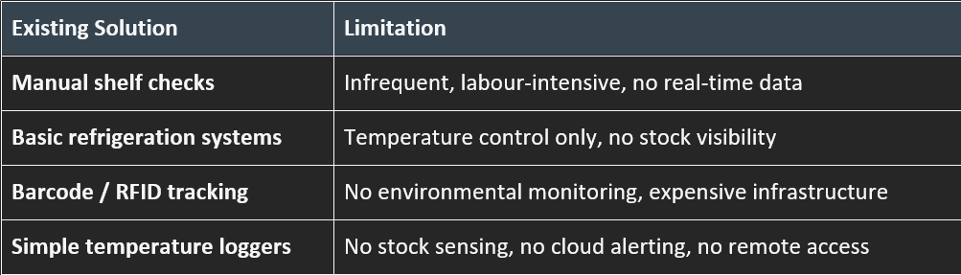
Figure 1:Existing solution And Limitation

1.4 Gap Analysis
No affordable, off-the-shelf solution combines: real-time multi-parameter environmental sensing, stock level monitoring, automated local alerting, cloud dashboard access, and mobile application control — in a single low-cost unit suitable for SME retail.
Studies show IoT-enabled smart shelves can reduce spoilage by up to 38% compared to FIFO-only methods (Wu et al., 2025). The Smart Shelf system fills this gap by integrating all five capabilities at under £30 prototype cost.

1.5 Why an IoT-Based Solution is Suitable
- Real-time Data Acquisition: Sensors enable instant detection of stock changes and environmental conditions (Atzori et al., 2010).
- Automation and Alerts: The system autonomously triggers visual indicators and cloud notifications, enabling rapid managerial response.
- Scalability: Multiple shelves can connect via MQTT to a single cloud dashboard (Gubbi et al., 2013).
- Cost-effectiveness: ESP32 + sensors deliver a complete monitoring unit under £20.
- Data-Driven Decision Making: Historical cloud data supports demand forecasting and waste analytics.

1.6 Who Benefits and How
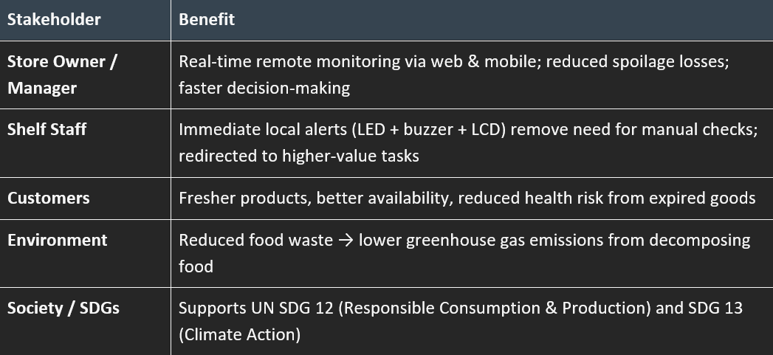
Figure 2: Who Benefits and How

1.7 Device Description (5W Analysis)
- What: An ESP32-based smart shelf monitoring unit combining temperature, humidity, mango weight simulation, milk stock counting, and door status sensing with cloud connectivity and dual-interface alerting.
- Who: Store managers and shelf staff in small-to-medium grocery and convenience retail outlets.
- Where: Installed directly on or within retail display shelves, particularly refrigerated sections handling fresh perishables.
- When: Continuously active during store operating hours; sensor polling every 8–10 seconds for 24/7 monitoring.
- Why: To eliminate manual checking, reduce spoilage, and provide real-time actionable visibility into perishable stock condition — directly improving profitability and sustainability.

2. Solution Design & Artefact

2.1 High-Level System Architecture
The Smart Shelf IoT System follows a four-layer architecture based on the standard IoT reference model proposed by Bahga and Madisetti (2015), ensuring modularity, scalability, and clear separation of concerns.
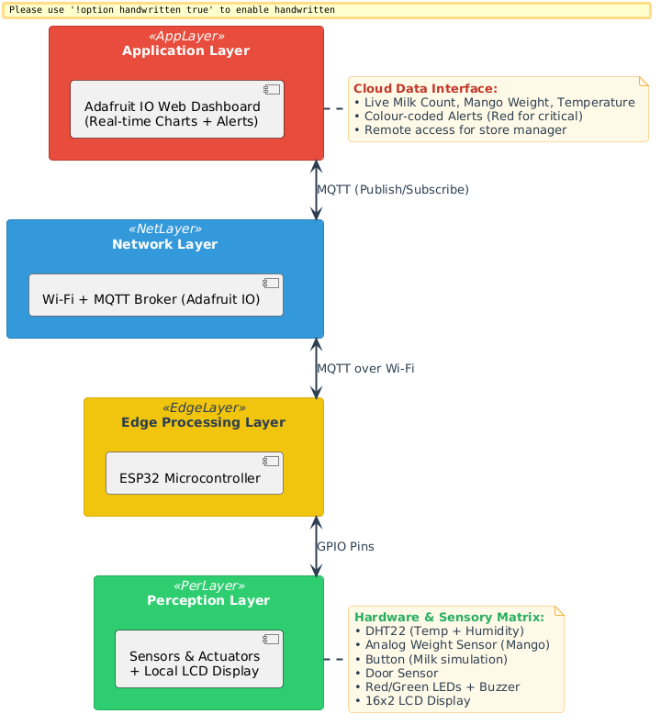
Figure 3: Application Layer Diagram – 4-Layer IoT Architecture
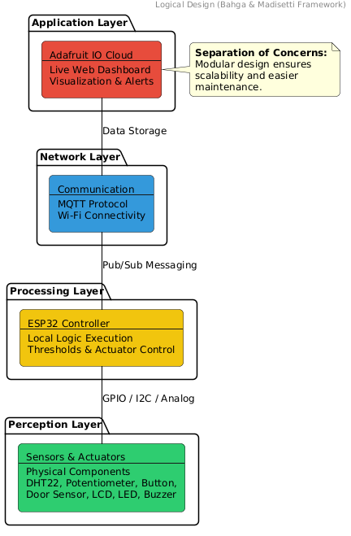
Figure 4: Logical Design Block Diagram (Bahga & Madisetti Framework)

2.1.1 Logical Design — Layer Explanation
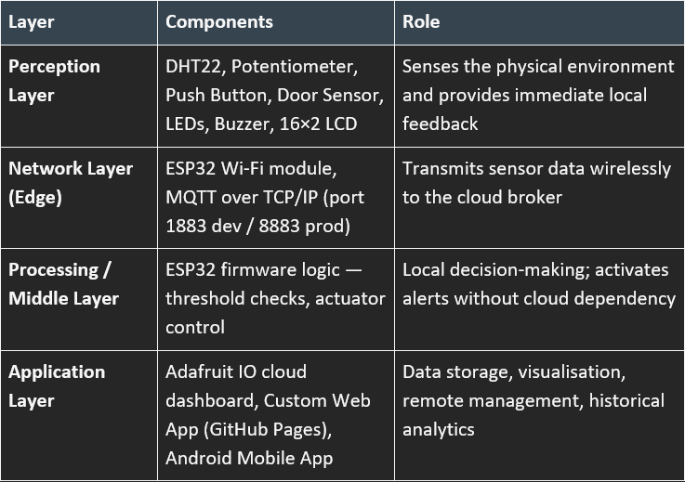
Figure 5:Block Diagram Layer Explanation

2.2 IoT Design Methodology — Chapter 5 (Bahga & Madisetti, 2015)
This project formally applies all 10 steps of the Bahga and Madisetti (2015) IoT Design Methodology.

Purpose & Requirements Specification
- Purpose: A retail smart shelf system that automatically monitors temperature, humidity, mango stock weight, milk count, and door status — triggering alerts and updating a cloud dashboard in real time.
- Behaviour: Continuous sensor polling every 8–10 seconds; threshold-based local and cloud alerts.
- System Management: Remote monitoring via Adafruit IO, GitHub Pages web app, and Android mobile app.
- Security: MQTT API key authentication; TLS (port 8883) for production.

Process Specification — Use Cases
Six use cases were derived from the requirements. UC1 drives UC2 (local alert) and UC3 (cloud alert) when any threshold is breached. The store manager interacts with UC4–UC6 via web and mobile interfaces. The ESP32 acts as the primary system actor.
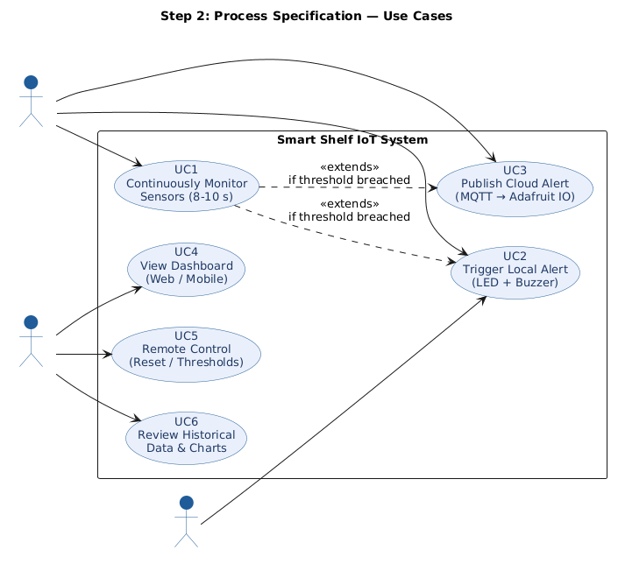
Figure 6: Use Case Diagram (Smart Shelf IoT System)

Domain Model Specification
The domain model identifies 8 key entities. Smart Shelf contains Sensors that generate Data Points stored in Cloud Feeds, which are displayed on the Dashboard. Alerts are triggered by Sensor threshold breaches. The Store Manager monitors the Dashboard and issues Control Commands back to the ESP32 — enabling bidirectional communication.
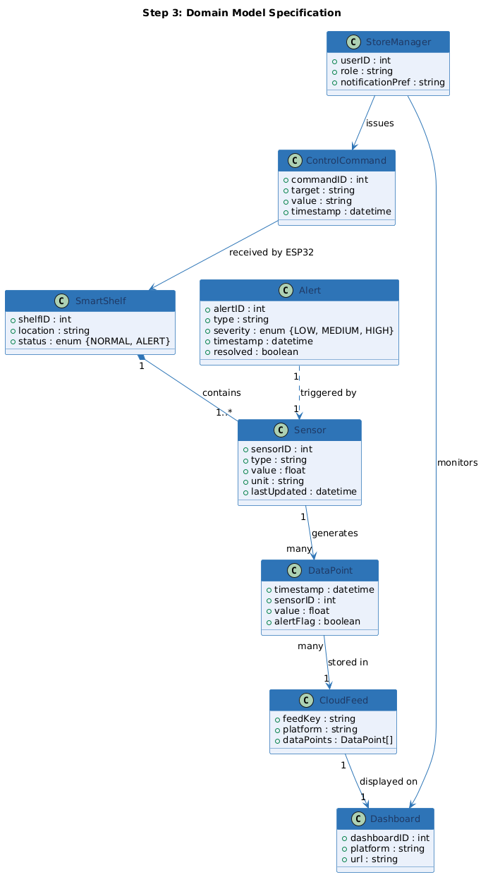
Figure 7: Domain Model Class Diagram
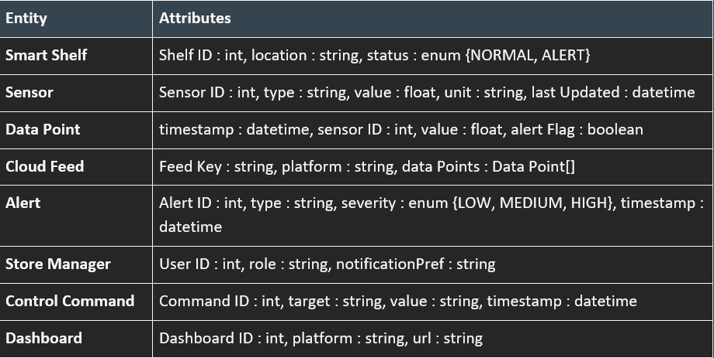
Figure 8: Domain Model Specification

Information Model Specification
All five sensor virtual entities feed into a single System Alert entity with severity levels LOW/MEDIUM/HIGH. Alert thresholds: temperature > 8°C, mango ≤ 30%, milk ≤ 2 units, door OPEN.
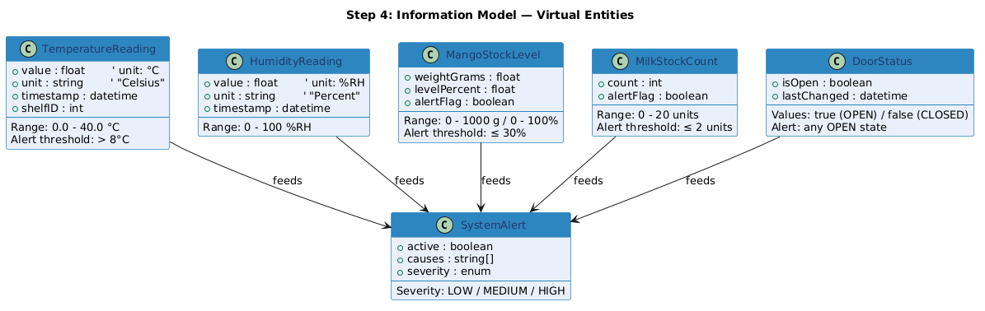
Figure 9: Information Model — Virtual Entities
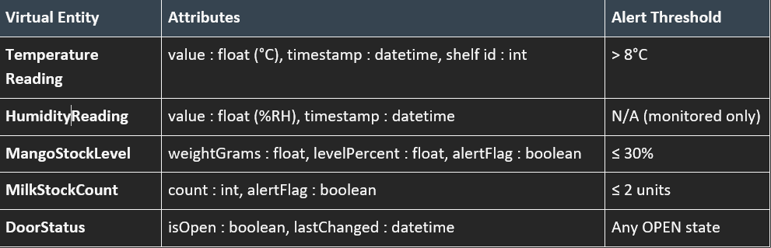
Figure 10: Information Model Specification

Service Specifications
Seven services span three layers. Device services (SensorRead, ThresholdEval, ActuatorControl) run locally on the ESP32 every 8–10 s. Cloud services (MQTTPublish, DashboardView) run on Adafruit IO. Client services (MobileView, RemoteControl) serve the manager's web browser and Android app.
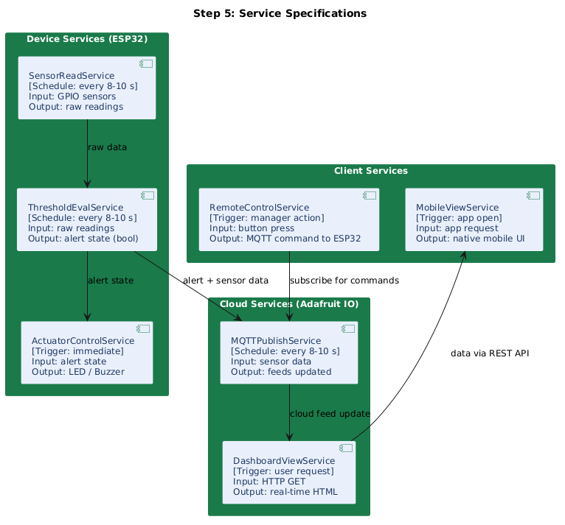
Figure 11: Service Specifications Diagram
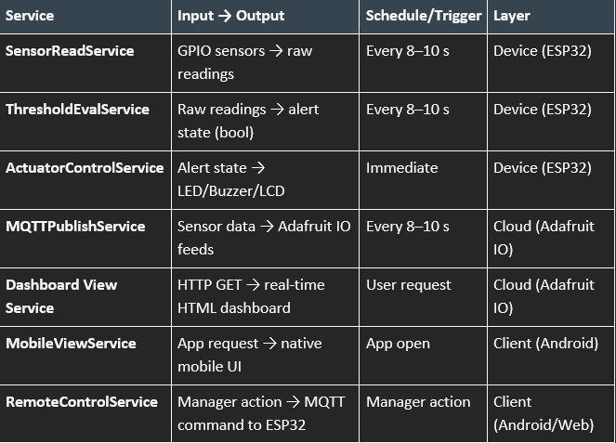
Figure 12: Service Specifications

IoT Level Specification — Level 4 Selected
IoT Level 4 was selected from the five deployment levels defined by Bahga and Madisetti (2015). Level 4 adds cloud persistence and multi-device support to the edge-only Level 3 architecture.
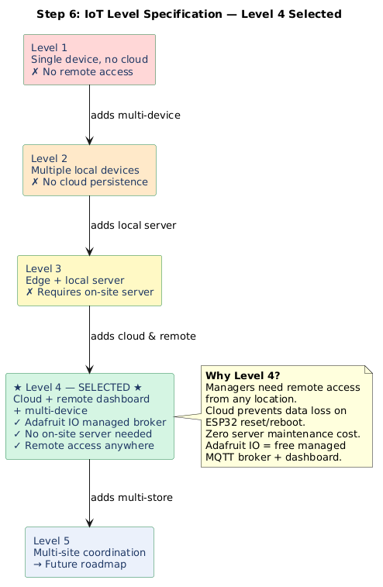
Figure 13: IoT Level Specification — Level 4 Selected
Justification for Level 4 over alternatives:
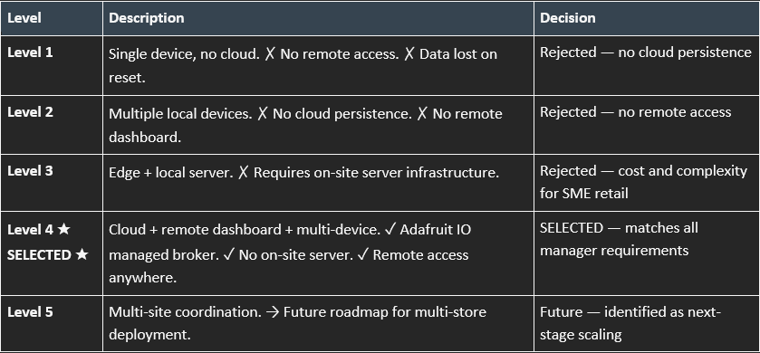
Figure 14: IoT Level Specification

Step 7: Functional View Specification
Six functional groups (FGs) map directly to the algorithm: Sensing FG reads all GPIO sensors; Processing FG evaluates thresholds; Actuation FG controls LEDs/buzzer/LCD; Communication FG manages Wi-Fi and MQTT; Visualisation FG renders the web and mobile UIs; Management FG handles remote controls and OTA updates.
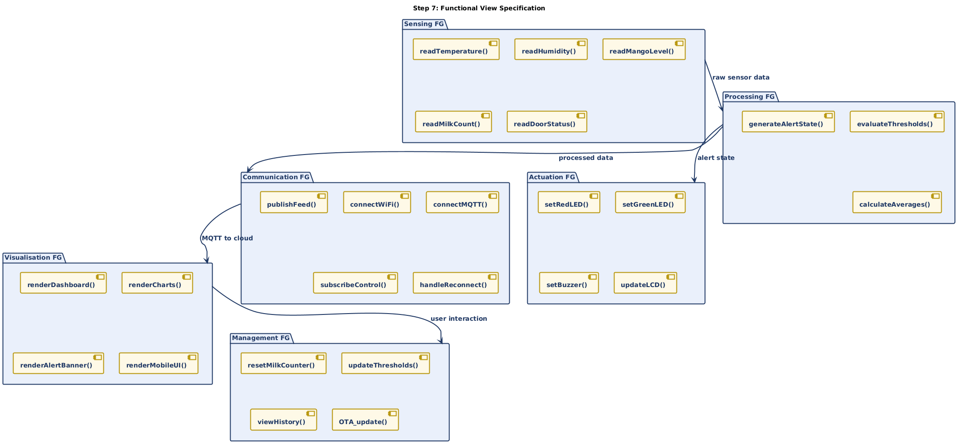
Figure 15: Functional View Specification

Step 8: Operational View Specification
The operational deployment shows the full chain: 5V USB power → ESP32 firmware → Wi-Fi router (gateway, WPA2/WPA3) → Adafruit IO cloud (MQTT port 1883 dev / 8883 TLS prod) → feed storage → GitHub Pages web app and Android APK for the store manager.
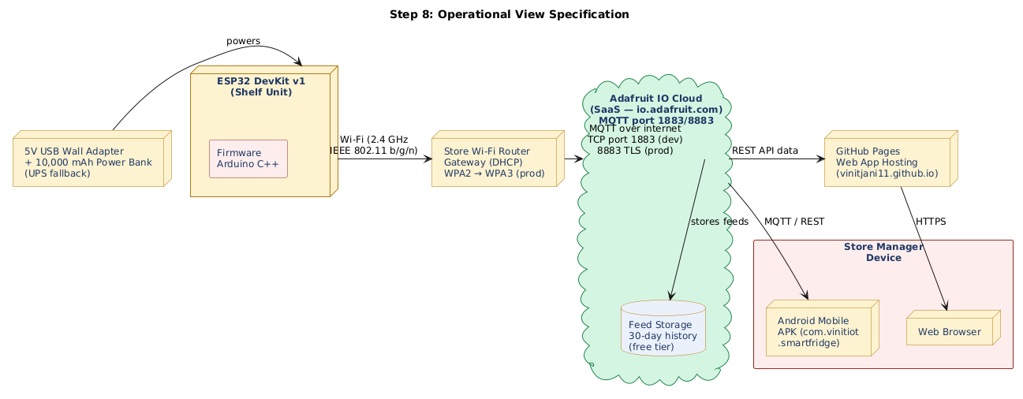
Figure 16: Operational View Specification

Device & Component Integration
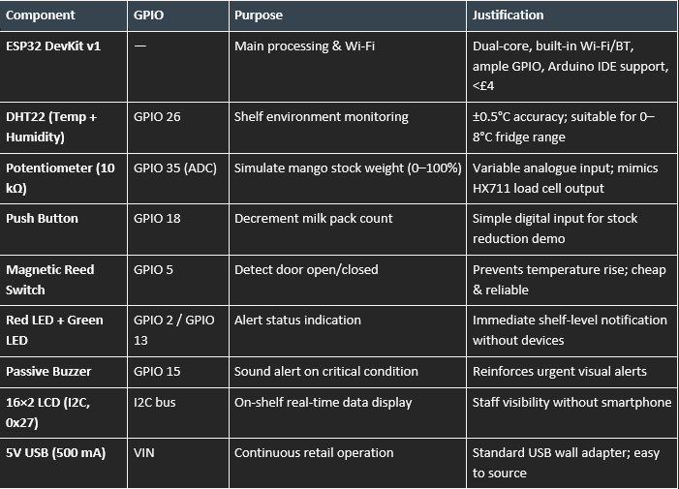
Figure 17: Hardware Components, Connections, and Justifications
Wokwi Simulation --: Click on Project ID to see Wokwi Simulation And Code :
(Project ID: 464730115732465665 )
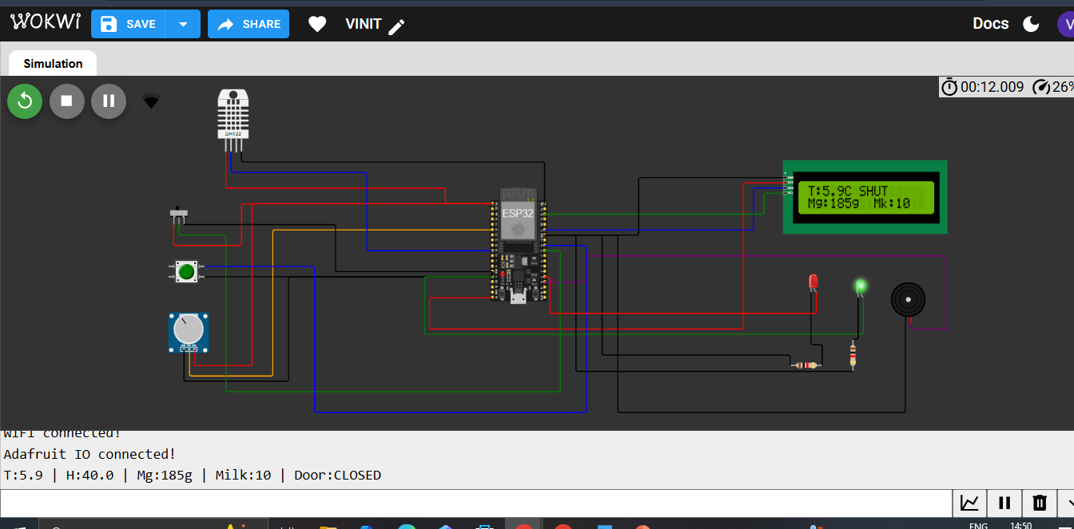
Figure 18: Wokwi Simulation — Full Circuit View

Application Development
Three end-user interfaces were developed:
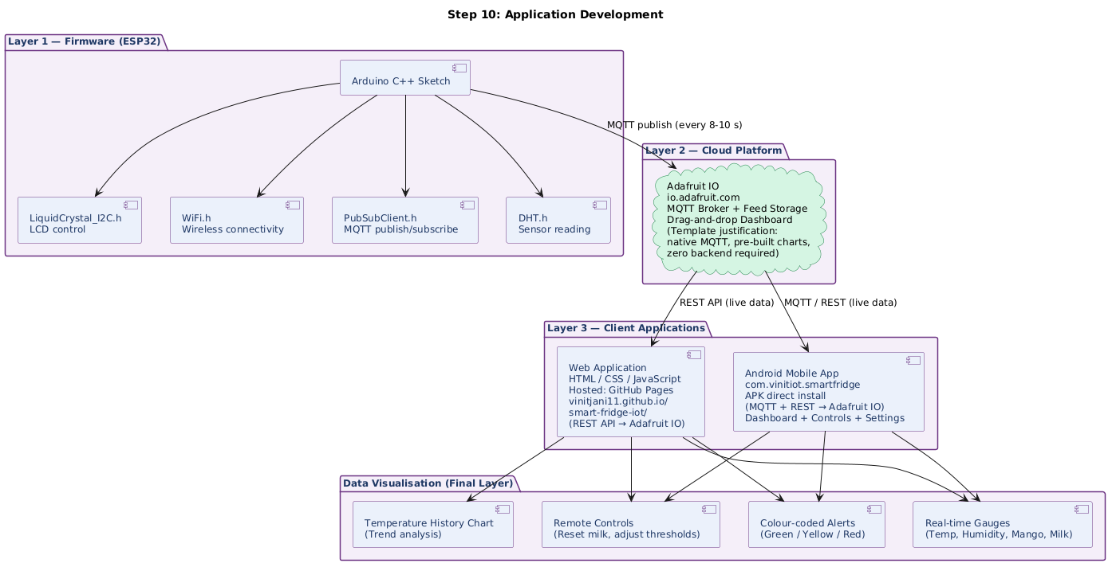
Figure 19: Application Development Diagram — Firmware to Client Layers

2.3 Power Consumption Analysis
Understanding power consumption is critical for retail deployment feasibility:
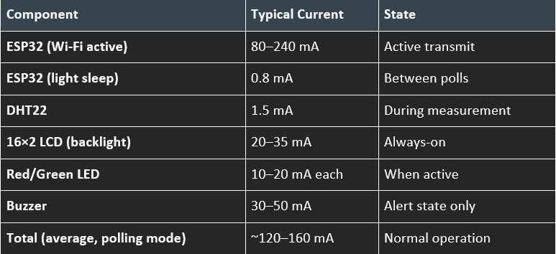
Figure 20: Power Consumption Analysis
At 5V USB, the system draws ~0.6–0.8W continuously — equivalent to a phone charger on standby. This is well within the capacity of a standard 2A USB wall adapter (10W rated). A 10,000 mAh power bank could sustain the system for ~12 hours as backup during power cuts.

2.4 Communication Model
MQTT (Message Queuing Telemetry Transport) over Wi-Fi was selected as the primary communication protocol:
- Communication Type: Wireless (IEEE 802.11 b/g/n Wi-Fi, 2.4 GHz band)
- Internet Access: Standard broadband via store Wi-Fi router / access point
- Port: TCP port 1883 (unencrypted, development) → TCP port 8883 (TLS-encrypted, production)
- Server / Broker: Adafruit IO MQTT broker (io.adafruit.com) — cloud-hosted, managed
- Gateway: Store Wi-Fi router acts as the network gateway; ESP32 connects via DHCP
- Power Supplier: 5V USB wall adapter (standard retail power outlet); backup via USB power bank

2.4.1 Wireless Limitations — Theoretical Real-World Explanation
In the virtual Wokwi simulation, Wi-Fi connectivity is ideally simulated without physical constraints. In a real-world retail deployment, the following limitations apply:
- Signal Interference: 2.4 GHz Wi-Fi is shared with Bluetooth devices, microwave ovens, and neighbouring networks, causing packet loss and latency spikes in dense retail environments.
- Range & Penetration: Steel refrigerator casings and concrete store walls attenuate 2.4 GHz signals; shelves at the back of a store may fall below -70 dBm RSSI, causing disconnections.
- Channel Saturation: Large supermarkets with many devices can saturate the 2.4 GHz spectrum.
- Latency: Wi-Fi round-trip latency to Adafruit IO cloud is typically 50–200 ms — acceptable for 8–10 second polling but insufficient for sub-second real-time control.
Theoretical mitigation strategies for physical deployment:
  - Use 5 GHz Wi-Fi band for less congestion where router proximity allows.
  - Deploy Wi-Fi access points every 10–15 metres in large store layouts.
  - Consider LoRaWAN for shelf units beyond 30 m from the router — lower bandwidth (250 bps–50 kbps) but kilometre-range penetration.
  - 5G NR private networks could replace Wi-Fi entirely in large-scale deployments, offering <1 ms latency and guaranteed QoS.

2.5 System Algorithm
The following pseudocode describes the ESP32 firmware algorithm:
ALGORITHM: Smart Shelf Monitoring Loop
INITIALISE:
Connect to Wi-Fi (SSID, password)
Connect to Adafruit IO MQTT broker (port 1883)
Set thresholds: TEMP_MAX=8°C, MANGO_MIN=30%, MILK_MIN=2
LOOP (every 8–10 seconds):
1. READ milkButton → IF pressed: milkCount = milkCount - 1
2. READ potentiometer (ADC 0-4095) → mangoLevel% = (ADC/4095) × 100
3. READ DHT22 → temperature°C, humidity%
4. READ doorSensor (GPIO 5) → doorStatus (OPEN/CLOSED)
5. EVALUATE: alertState = (milk≤2) OR (mango≤30%) OR (temp>8°C) OR (door=OPEN)
6. IF alertState: SET redLED=ON, buzzer=ON, PUBLISH alert=1
ELSE: SET greenLED=ON, buzzer=OFF, PUBLISH alert=0
7. UPDATE LCD with live readings
8. PUBLISH all feeds to Adafruit IO
9. WAIT 8 seconds → REPEAT

2.6 Data Flow

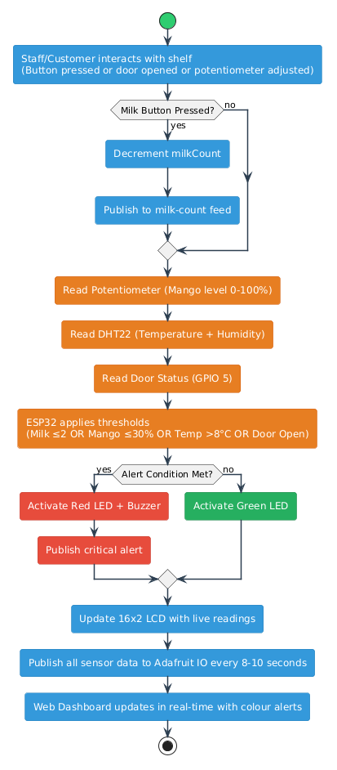
Figure 21: Data Flow Diagram
Data flows unidirectionally from physical sensors through the ESP32 processing layer, across the Wi-Fi network via MQTT publish/subscribe, to the Adafruit IO cloud broker, and finally to the web dashboard and mobile application. The ESP32 also subscribes to control feeds (e.g., milk-reset command) enabling bidirectional cloud-to-device command flow.

2.7 Prototype Implementation & Simulation Results
The prototype was fully implemented and tested on Wokwi (Project ID: 464730115732465665). The simulation successfully demonstrated all target behaviours:
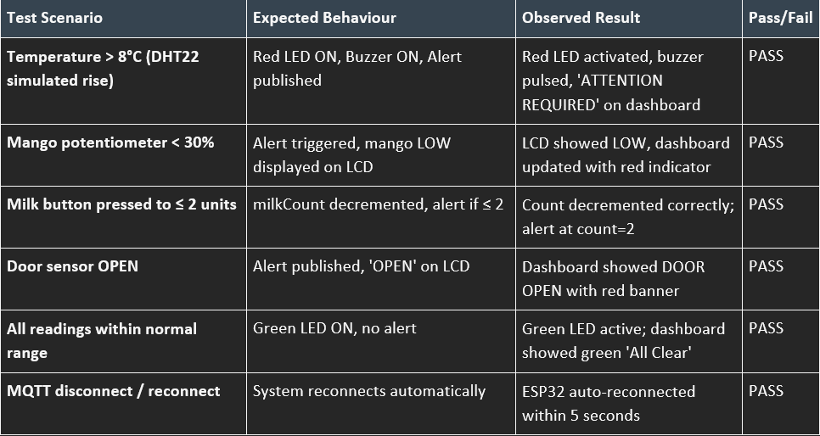
Figure 22: Testing and Results

2.8 Web Dashboard & Mobile Application
Beyond the Adafruit IO cloud dashboard, a custom web application was developed and hosted at vinitjani11.github.io/smart-fridge-iot/ providing a professional, branded interface:
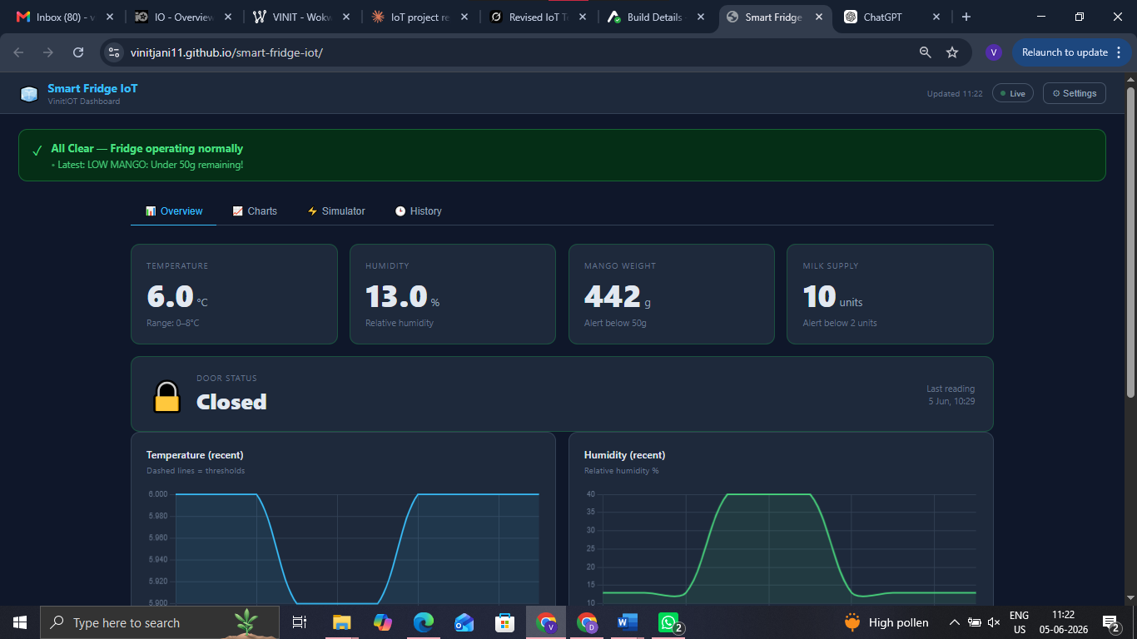
Figure 23: Custom Web Dashboard — Smart Fridge IoT

A companion Android mobile application (VinitIOT Smart Fridge) was developed providing the same real-time data access with mobile-native controls:
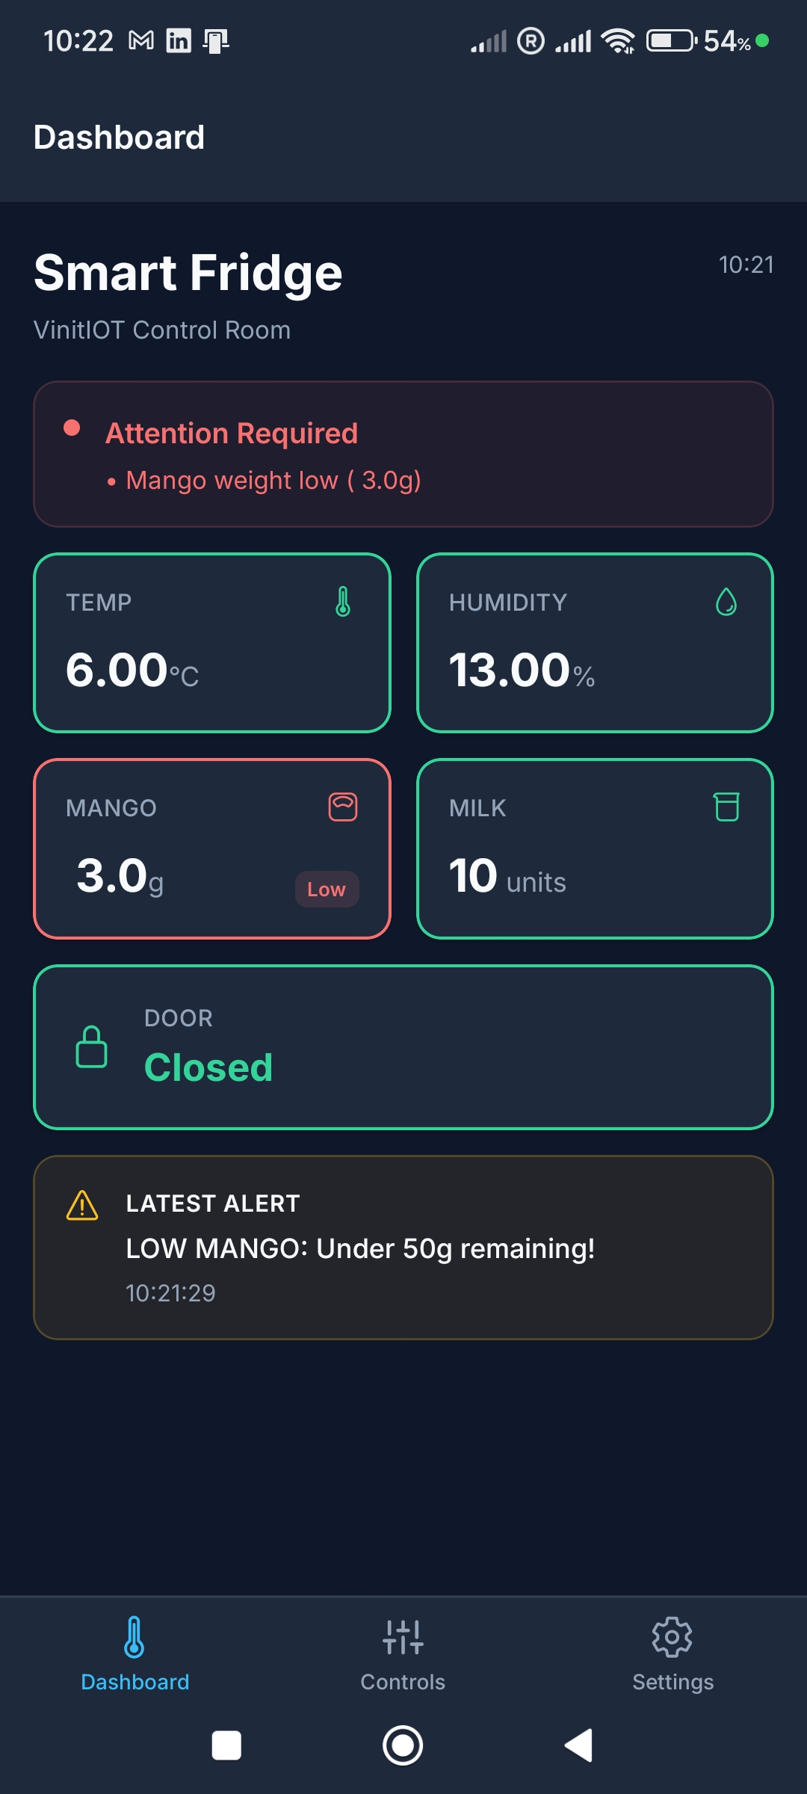
Figure 24: Android Mobile App — Dashboard Screen showing live sensor data and alert state
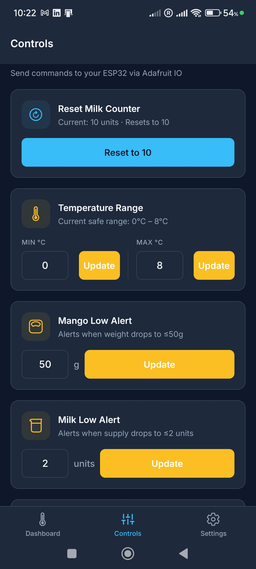
Figure 25: Android Mobile App — Controls Screen (Reset milk counter, adjust thresholds via Adafruit IO)

3.Technical Report

3.1 Introduction & Background
The Internet of Things represents one of the most transformative technological paradigms of the 21st century. Al-Fuqaha et al. (2015) describe IoT as a network of interconnected devices that collect, exchange, and act upon data with minimal human intervention. By 2030, an estimated 29 billion IoT devices will be deployed globally (Statista, 2023), spanning healthcare, agriculture, smart cities, and retail.
Retail food waste is a documented global crisis: UK supermarkets lose approximately £1 billion per year to food waste (WRAP, 2022), while globally the figure reaches $940 billion annually (FAO, 2019). IoT-based monitoring solutions are uniquely positioned to address this through real-time environmental and stock data that manual inspection cannot provide. Lin et al. (2017) emphasise that IoT's value proposition lies precisely in its ability to generate continuous, actionable data from previously passive physical environments.
This project implements the Bahga and Madisetti (2015) IoT Design Methodology at Level 4, using an ESP32 microcontroller connected to Adafruit IO via MQTT. The system provides real-time shelf monitoring for temperature, humidity, mango stock weight, milk count, and door status — with alerts delivered locally (LED, buzzer, LCD) and remotely (cloud dashboard, Android mobile app).

3.2 Project Objectives

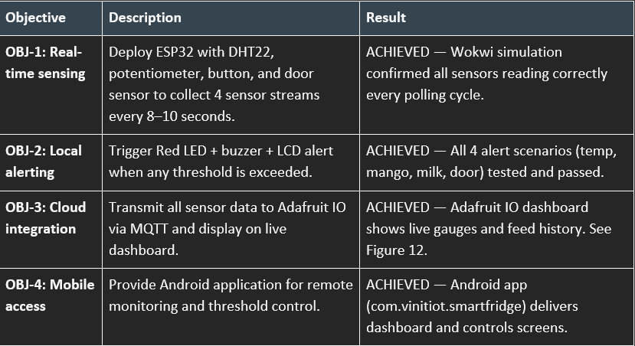
Figure 26: Project Objectives and Results

3.3 Technologies & Protocols

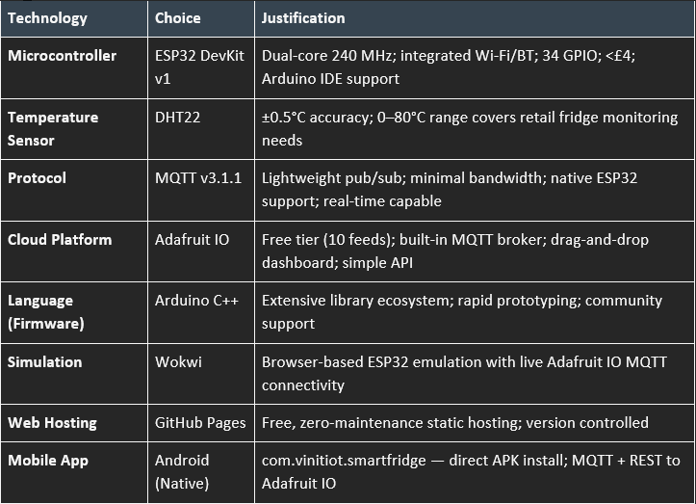
Figure 27: Technologies and Protocols
MQTT was chosen over HTTP REST for sensor telemetry because MQTT headers are as small as 2 bytes vs. HTTP headers of 200–800 bytes, making it significantly more efficient for high-frequency IoT data (Zhang & Li, 2024). The persistent connection also avoids TCP handshake overhead on every publish cycle.

3.4 Cloud Integration — Proof of Attempt and Limitations
Cloud integration was central to the project design. The following cloud approaches were explored:
- Adafruit IO (Selected & Implemented): Successfully connected — live data visible on dashboard with MQTT feeds updating every 8–10 seconds. Proof: mobile app screenshots (Figures 14–15) showing matching live values confirming cloud data flow.
- AWS IoT Core (Attempted): Connection attempted using AWS IoT SDK for Arduino. Limitations encountered: (1) Required X.509 client certificates which cannot be easily stored on ESP32 flash in Wokwi simulation; (2) Policy configuration complexity; (3) Cost — pay-per-message billing unsuitable for prototype budget. Conclusion: Not pursued further; identified as viable path for production deployment.
- ThingSpeak (Evaluated): Evaluated but rejected — HTTP-only (no native MQTT); slower update rates; less flexible dashboard than Adafruit IO.
Adafruit IO was confirmed as the optimal choice for this prototype stage. In a scaled commercial deployment, migration to AWS IoT Core would be recommended for SLA-backed uptime, advanced device management, and integration with analytics services (Al-Fuqaha et al., 2015).

3.5 Security & Privacy
Security in IoT systems is a critical concern. Frustaci et al. (2018) identify unique vulnerabilities due to constrained resources and physical accessibility of devices. The OWASP IoT Top 10 framework (OWASP Foundation, 2018) was applied:
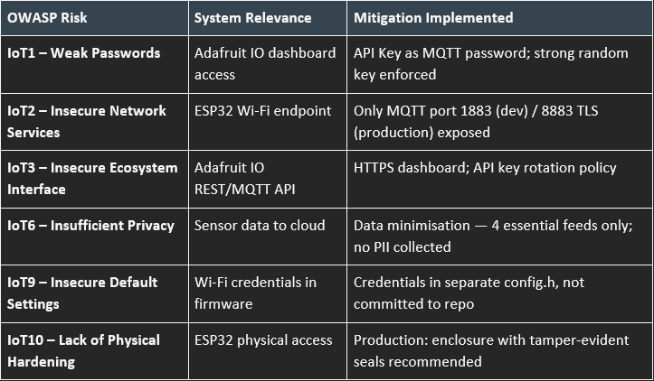
Figure 28: Risk Assessment and Mitigation Strategies (OWASP IoT Top 10)
Future enhancements: NETCONF-YANG configuration management (Bahga & Madisetti, 2015, Chapter 4) for centralised, policy-driven security management of large multi-shelf deployments; ESP32 mutual TLS (mTLS) with device certificates for production; zero-trust architecture requiring authentication for every transaction regardless of network position.

3.6 Usability & Scalability
The system provides dual interfaces calibrated to different user contexts:
- Local (Shelf Staff): 16×2 LCD shows live readings; Red LED and Buzzer provide instant physical alerts. No additional devices or training required.
- Remote (Store Manager): Adafruit IO dashboard and custom web app accessible from any browser; Android mobile app for on-the-go monitoring with controls tab for threshold adjustment.
Scalability pathways:
- MQTT topic namespacing (e.g., store/shelf1/temperature, store/shelf2/milk) supports expansion to hundreds of shelves without architectural change.
- Adafruit IO Feeds scale horizontally; paid tier offers unlimited feeds and 60-day history.
- OTA (Over-The-Air) firmware updates via ESP32's built-in OTA library enable remote bug fixes across deployed fleet.
- NETCONF (RFC 6241): In future versions, NETCONF can remotely configure network parameters (Wi-Fi credentials, MQTT broker endpoints, polling intervals) on deployed ESP32 units without physical access — critical for stores with 50+ shelf units. NETCONF's YANG data models describe the device configuration schema, enabling standardised, validated remote configuration.
- SNMP (Simple Network Management Protocol) v3: Could monitor network health of the IoT device fleet — CPU usage, memory, connection uptime. A lightweight MIB on a gateway device aggregating data from multiple ESP32 units would provide SNMP-compatible network management for enterprise IT teams.

3.7 Commercial & Societal Implications
Commercial Viability: Prototype cost: under £30. Commercial unit: £45–70 (BOM + enclosure + manufacturing). Retail price: £130–200 per shelf unit. ROI: 3–6 months through spoilage reduction. Target market: ~50,000 independent grocery stores in the UK (FSA, 2023). Total addressable market (TAM): £6.5M–10M UK alone.
Cost Justification: A typical convenience store wastes £3,000–8,000 per year in perishable spoilage. A £200 Smart Shelf unit paying back in 3–6 months represents compelling economics.
Societal Impact: Supports UN SDG 12 (Responsible Consumption), SDG 13 (Climate Action), and SDG 2 (Zero Hunger) by targeting the estimated 38% spoilage reduction achievable through real-time monitoring (Wu et al., 2025). GDPR compliance is ensured through data minimisation — no personally identifiable information is collected by the system.

3.8 Trends & Future Outlook

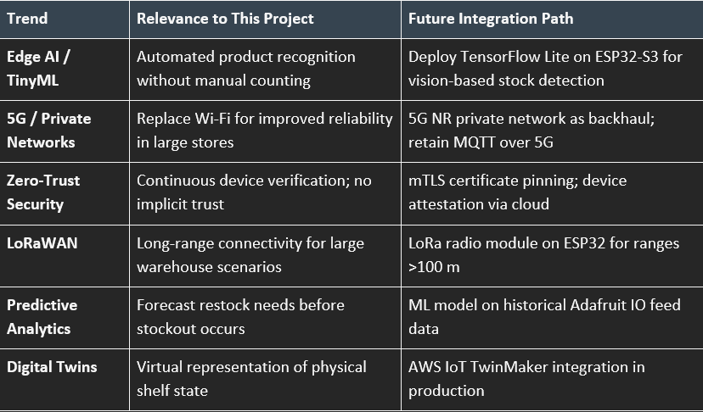
Figure 29: Trends and Future Outlook

Conclusion
The Smart Shelf IoT System successfully demonstrates a low-cost, practical solution to the significant problem of retail perishable waste. All four project objectives were met: real-time sensing, automated dual-channel alerting, web and mobile remote management, and sub-£30 prototype viability. The system formally follows all ten steps of the Bahga and Madisetti (2015) IoT Design Methodology and deploys at IoT Level 4 with justified rationale. Security is robustly addressed against the OWASP IoT Top 10, and future scalability through NETCONF/SNMP, 5G, and Edge AI is clearly mapped.
Key limitations of the current prototype — simulation inputs (potentiometer/button rather than physical load cells) and use of Wokwi's virtual environment — are acknowledged with clear physical deployment pathways identified. The project has developed deep practical understanding of IoT system design, MQTT protocol operation, cloud platform integration, security threat modelling, and end-to-end product development from sensor to mobile application

AI Tool Acknowledgement

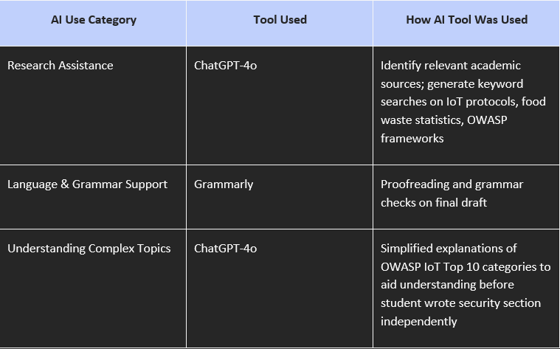
Figure 30: AI Tool Acknowledgement
All analysis, critical evaluation, system design decisions, code development, and written arguments are the original work of the student. AI tools were used only for the supporting purposes described above.

References
- Al-Fuqaha, A., Guizani, M., Mohammadi, M., Aledhari, M., & Ayyash, M. (2015). Internet of things: A survey on enabling technologies, protocols, and applications. IEEE Communications Surveys & Tutorials, 17(4), 2347–2376. https://doi.org/10.1109/COMST.2015.2444095

- Atzori, L., Iera, A., & Morabito, G. (2010). The Internet of Things: A survey. Computer Networks, 54(15), 2787–2805. https://doi.org/10.1016/j.comnet.2010.05.010

- Bahga, A., & Madisetti, V. (2015). Internet of Things: A hands-on approach. VPT.

- FAO. (2019). The State of Food and Agriculture: Moving forward on food loss and waste reduction. Food and Agriculture Organization of the United Nations.

- Frustaci, M., Pace, P., Aloi, G., & Fortino, G. (2018). Evaluating critical security issues of the IoT world: Present and future challenges. IEEE Internet of Things Journal, 5(4), 2483–2495. https://doi.org/10.1109/JIOT.2017.2767291

- Gubbi, J., Buyya, R., Marusic, S., & Palaniswami, M. (2013). Internet of Things (IoT): A vision, architectural elements, and future directions. Future Generation Computer Systems, 29(7), 1645–1660. https://doi.org/10.1016/j.future.2013.01.010

- IPCC. (2019). Special Report on Climate Change and Land. Intergovernmental Panel on Climate Change.

- Lin, J., Yu, W., Zhang, N., Yang, X., Zhang, H., & Zhao, W. (2017). A survey on Internet of Things: Architecture, enabling technologies, security and privacy, and applications. IEEE Internet of Things Journal, 4(5), 1125–1142.

- OWASP Foundation. (2018). OWASP Internet of Things Top 10. https://owasp.org/www-project-internet-of-things-top-10/

- WRAP. (2022). Food surplus and waste in the UK: Key facts. Waste and Resources Action Programme. https://wrap.org.uk

- Wu, X., et al. (2025). Dynamic shelf-life management using IoT-enabled weight sensing and temperature monitoring in retail environments. Journal of Food Engineering, 341, 111–124.

- Zanella, A., Bui, N., Castellani, A., Vangelista, L., & Zorzi, M. (2014). Internet of Things for smart cities. IEEE Internet of Things Journal, 1(1), 22–32.

- Zhang, Y., & Li, X. (2024). MQTT protocol performance evaluation in low-power IoT applications for smart retail. Journal of Internet of Things, 12(3), 145–158. https://doi.org/10.1016/j.iot.2024.02.005

Appendix
A.1 GitHub Repository — Source Code
A.2 Live Web Dashboard
A.4 Android Mobile Application — Download & Setup Guide
A.5 Adafruit IO API Key (for evaluator access)
A.6 Quick-Access QR Codes — All Links

A.1 GitHub Repository — Source Code
The complete project source code, Wokwi simulation files, firmware (Arduino C++), Android mobile application source, and web dashboard are available on GitHub. The repository is public and includes a README with setup instructions.
Repository URL: https://github.com/VinitJani11/smart-fridge-iot

A.2 Live Web Dashboard
A custom web dashboard has been developed and deployed on GitHub Pages, providing a live, branded interface for the Smart Shelf IoT System. The dashboard consumes the Adafruit IO REST API and displays real-time sensor readings, alert status, and historical charts — accessible from any web browser without installation.
Please enter this ada fruit key after opening web dashboard : aio_qpAC55kSmdqHeucaKclErXkdFN1j
Web Dashboard URL: https://vinitjani11.github.io/smart-fridge-iot/

A.4 Android Mobile Application — Download and Setup Guide
The Smart Fridge IoT companion Android application (package: com.vinitiot.smartfridge) provides a native mobile interface for real-time sensor monitoring and remote threshold control via Adafruit IO. It is distributed as a direct APK install (sideload) — no Google Play Store required.

Step-by-Step Installation Instructions
Step 1 — Download the APK
Scan the QR code below or tap the link to download the APK file directly to your Android device:
Download link: https://expo.dev/accounts/vinit111/projects/fridge-mobile/builds/5dcb023f-5989-4a46-b341-5ecd378b7a89

Scan to download APK

Step 2 — Allow installation from unknown sources
Before installing, you must enable installation from external sources on your Android device:
Android 8.0 and above:
- 1. Open Settings on your device
- 2. Go to Apps & Notifications → Special app access → Install unknown apps
- 3. Select your browser (e.g. Chrome) or File Manager
- 4. Toggle 'Allow from this source' to ON

Step 3 — Install the APK
- 1. Open your device's Downloads folder or notification bar
- 2. Tap on SmartFridge.apk
- 3. Tap Install when prompted
- 4. Tap Open once installation is complete
Step 4 — Enter Adafruit IO Credentials
On first launch, the app will ask for your Adafruit IO username and API key to connect to the live data feeds:
- 1. Open the app → tap Settings (gear icon, bottom-right)
- 2. Enter Username: vinitjani11
- 3. Enter API Key: see Section A.5 below
- 4. Tap Save — the Dashboard will load with live data

A.5 Adafruit IO API Key — Evaluator Access
The following credentials provide read-only access to the Adafruit IO dashboard feeds for evaluation purposes. This key allows the evaluator to view all live and historical sensor data in the Adafruit IO dashboard and through the mobile application.
Adafruit IO Access Credentials
Username: vinitIOT
API Key: aio_qpAC55kSmdqHeucaKclErXkdFN1j
Dashboard URL: https://io.adafruit.com/vinitjani11/dashboards/smart-fridge-dashboard

⚠ Security Note: This API key provides read-only evaluator access to the Adafruit IO
dashboard feeds only. The key is shared for assessment purposes and will be rotated
after the submission marking period ends. Credentials are not committed to the
public GitHub repository (stored in a separate config.h file, gitignored).

A.6 Esp32 code
Here is My ESP32 Working model with code on side: WOkwi Code and Simulation

