1. List out 5 files in your system which consuming most of the disk space.

1. Create one common folder in such way that anyone can create files inside that independently and should not be able to delete other users files from that common folder.

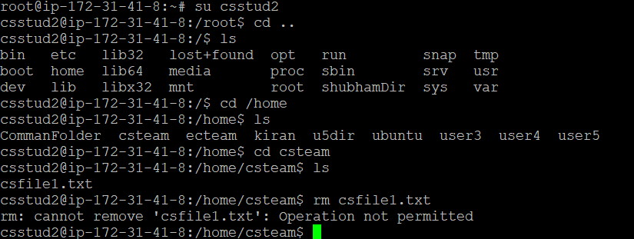

1. switch to root user

$sudo su –

3. create group

$groupadd csteam

$groupadd ecteam

4.make directory

$mkdir home/csdir

$mkdir home/ecdir

5.change the owners of created groups

$chown root:csteam /home/csteam

$chown root:csteam /home/ecteam

6.change the permission for the directories

$chmod 770 /home/csteam

$chmod 700 /home/ecteam

7.adding setgroup id

$chmod 2770 /home/csteam

$chmod 2770 /home/csteam

8. creating users

$useradd -s /bin/bash/ csstud1

$useradd -s /bin/bash/ csstud2

$useradd -s /bin/bash/ ecstud1

$useradd -s /bin/bash/ ecstud2

9. adding sticky bit to the csteam directory

$chmod +t /home/csteam

10.adding the users to the group

$usermod -a -G csteam csstud1

$usermod -a -G csteam csstud2

$usermod -a -G csteam ecstud1

$usermod -a -G csteam ecstud2