1. List out highest priority process in the system

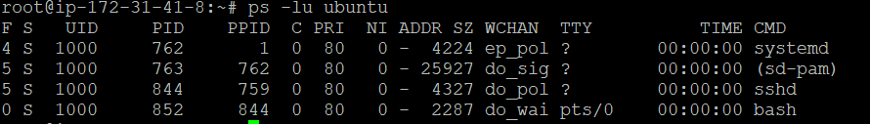

2) Open terminal with 2 tabs or sessions  
    a)  run command "vmstat 1"  
    b) switch to another tab,  pause  running vmstat command for few seconds and resume it again  
  
use appropriate SIGNALS to do this activity.

