PROJECT REPORT
Link → Video Downloader
A Web-Based Video Extraction and Download Utility

Technology Stack
Python · Flask · yt-dlp · ffmpeg · HTML5 · CSS3 · JavaScript
Academic Year 2026

Table of Contents

1. Abstract
This project presents the design and implementation of a locally-hosted web application that allows a user to download video content from a URL. The application accepts a link to a video hosted on a supported platform, retrieves metadata (title, thumbnail, uploader, and available resolutions) without downloading the full file, and then performs the download in the background while reporting live progress to the browser. The system is built with Flask on the backend and vanilla HTML/CSS/JavaScript on the frontend, and relies on the open-source yt-dlp library for content extraction and ffmpeg for merging separate video and audio streams into a single output file.
The primary objective of the project is to demonstrate a clean, layered web application architecture — separating the HTTP layer, business logic, and third-party integration into distinct modules — along with sound engineering practices such as input validation, structured logging, automated testing, and background job processing.

2. Introduction

2.1 Motivation
Users frequently want to save a copy of a video they have the right to access — for example, their own uploaded content, educational material, or content explicitly shared with permission for offline use. Doing this typically requires either a native platform feature (often unavailable) or a third-party desktop application. This project explores building a lightweight, self-hosted, browser-based alternative that a user runs entirely on their own machine, keeping full control over the process.

2.2 Objectives
- Accept a video URL from the user and validate it before processing.
- Retrieve and display metadata (title, uploader, thumbnail, available qualities) prior to download.
- Allow the user to select a target resolution and initiate a background download.
- Report live download progress to the browser without a page reload.
- Merge separate video and audio streams into a single playable file.
- Apply sound software engineering practices: layered architecture, input validation, logging, automated tests, and automatic cleanup of old files.

2.3 Scope
The application is designed for local, single-user use (e.g. running on a personal computer via `python run.py`). It is not intended, in its current form, to be deployed as a public multi-user internet service. The final section of this report (Future Scope) discusses what would be required to extend it into a production, multi-user deployment.

3. Technology Stack
The table below summarizes the technologies used in each layer of the application and the rationale for each choice.
Layer | Technology | Purpose
Backend Framework | Flask 3.1 | Lightweight WSGI web framework used to expose the REST-style API and serve the frontend.
Extraction Engine | yt-dlp | Open-source library that extracts video metadata and stream URLs from supported platforms.
Media Processing | ffmpeg | Merges separately-downloaded video and audio streams into a single output file.
Frontend | HTML5 / CSS3 / JavaScript (ES6) | Single-page UI; communicates with the backend via the Fetch API.
Testing | pytest | Automated unit and route-level tests.
Concurrency | Python threading | Background download execution and periodic disk cleanup.

4. System Architecture
The application follows a layered architecture that separates concerns into four distinct areas: the presentation layer (browser), the HTTP layer (Flask routes), the service layer (business logic and third-party integration), and shared state (the in-memory job store). This separation means the extraction engine (yt-dlp) could be replaced without any change to route code, and routes remain thin enough to be easily tested.
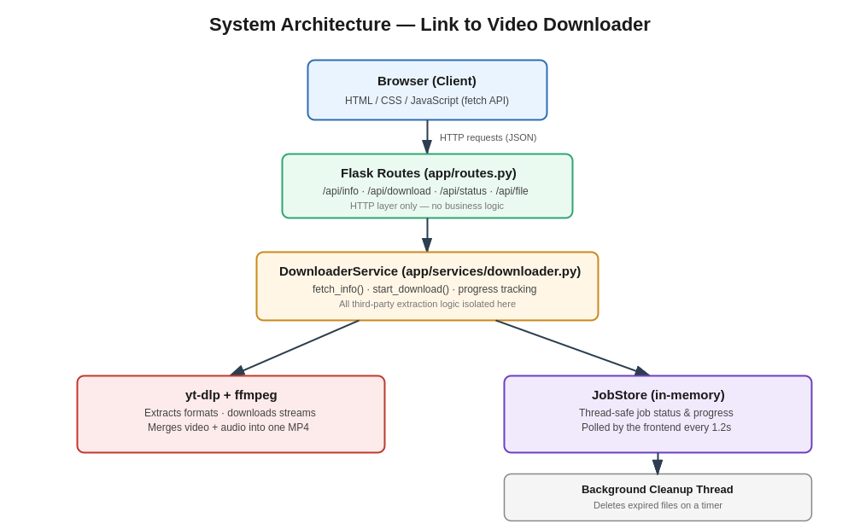

4.1 Request Flow
- The browser sends a POST request to /api/info with the pasted URL.
- The Flask route validates the request shape and delegates to DownloaderService.fetch_info().
- DownloaderService calls yt-dlp in metadata-only mode and returns title, thumbnail, uploader, and quality options.
- On clicking Download, the browser calls /api/download; the route starts a background thread and returns a job_id immediately.
- The browser polls /api/status/<job_id> every 1.2 seconds until the job status becomes done or error.
- Once done, the browser requests /api/file/<job_id>, which streams the completed file to the user.

4.2 Design Decisions
- Application Factory Pattern: create_app() builds the Flask instance, enabling isolated app instances for testing.
- Service Layer Isolation: only downloader.py imports yt-dlp directly, keeping the dependency contained.
- Thread-Safe Job Store: a lock-protected in-memory dictionary tracks job state across threads.
- Background Cleanup: a daemon thread periodically removes files older than a configurable retention window, preventing unbounded disk growth.

5. Module Description
Module | Responsibility
config.py | Environment-based configuration (development / testing / production).
app/__init__.py | Application factory: builds the Flask app, wires logging, registers the blueprint.
app/routes.py | HTTP endpoints; translates requests into service calls and results into JSON.
app/services/downloader.py | Wraps yt-dlp for metadata extraction and background downloading.
app/services/job_store.py | Thread-safe in-memory tracking of job status and progress.
app/services/cleanup.py | Background thread that deletes expired downloaded files.
app/utils/validators.py | URL validation and filename sanitization.
app/static/ | Frontend CSS and JavaScript.
app/templates/index.html | Single-page UI template.
tests/test_app.py | Automated pytest suite.

6. Implementation Highlights

6.1 Metadata Extraction
Before any download begins, the service queries yt-dlp in metadata-only mode to build a de-duplicated list of available resolutions:
ydl_opts = {"quiet": True, "no_warnings": True, "skip_download": True}
with yt_dlp.YoutubeDL(ydl_opts) as ydl:
info = ydl.extract_info(url, download=False)

6.2 Background Download with Progress Reporting
Each download runs on a daemon thread so the initiating HTTP request returns immediately. A progress hook passed to yt-dlp updates the shared JobStore, which the frontend polls:
def progress_hook(event):
if event.get("status") == "downloading":
job_store.update(job_id, progress=event.get("_percent_str"))

6.3 Resolution Selection
The user's chosen height is translated into a yt-dlp format selector string that picks the best available video stream at or below that resolution, paired with the best audio stream:
format_selector = f"bestvideo[height<={height}]+bestaudio/best[height<={height}]"

6.4 Input Validation
All URLs are validated for a valid scheme and host before being passed to yt-dlp, and any metadata used to build filenames is sanitized to strip filesystem-unsafe characters — since video titles are untrusted third-party input.

7. Testing
The project includes an automated pytest suite covering input validation and route-level error handling. Tests avoid making real network calls to third-party platforms, keeping the suite fast, deterministic, and safe to run in any environment.

7.1 Test Coverage Summary
- URL validation: accepts well-formed http(s) URLs, rejects empty/malformed input.
- Filename sanitization: strips unsafe characters, truncates overly long names, falls back safely.
- /api/health: returns a 200 OK liveness response.
- /: renders the main page successfully.
- /api/info and /api/download: return 400 for missing or malformed URLs.
- /api/status and /api/file: return 404 for unknown job IDs.

7.2 Result
All 17 automated tests pass:
$ pytest -v
======================== 17 passed in 0.40s =========================

8. Screenshots
The application successfully fetching metadata and completing a download from a pasted link:
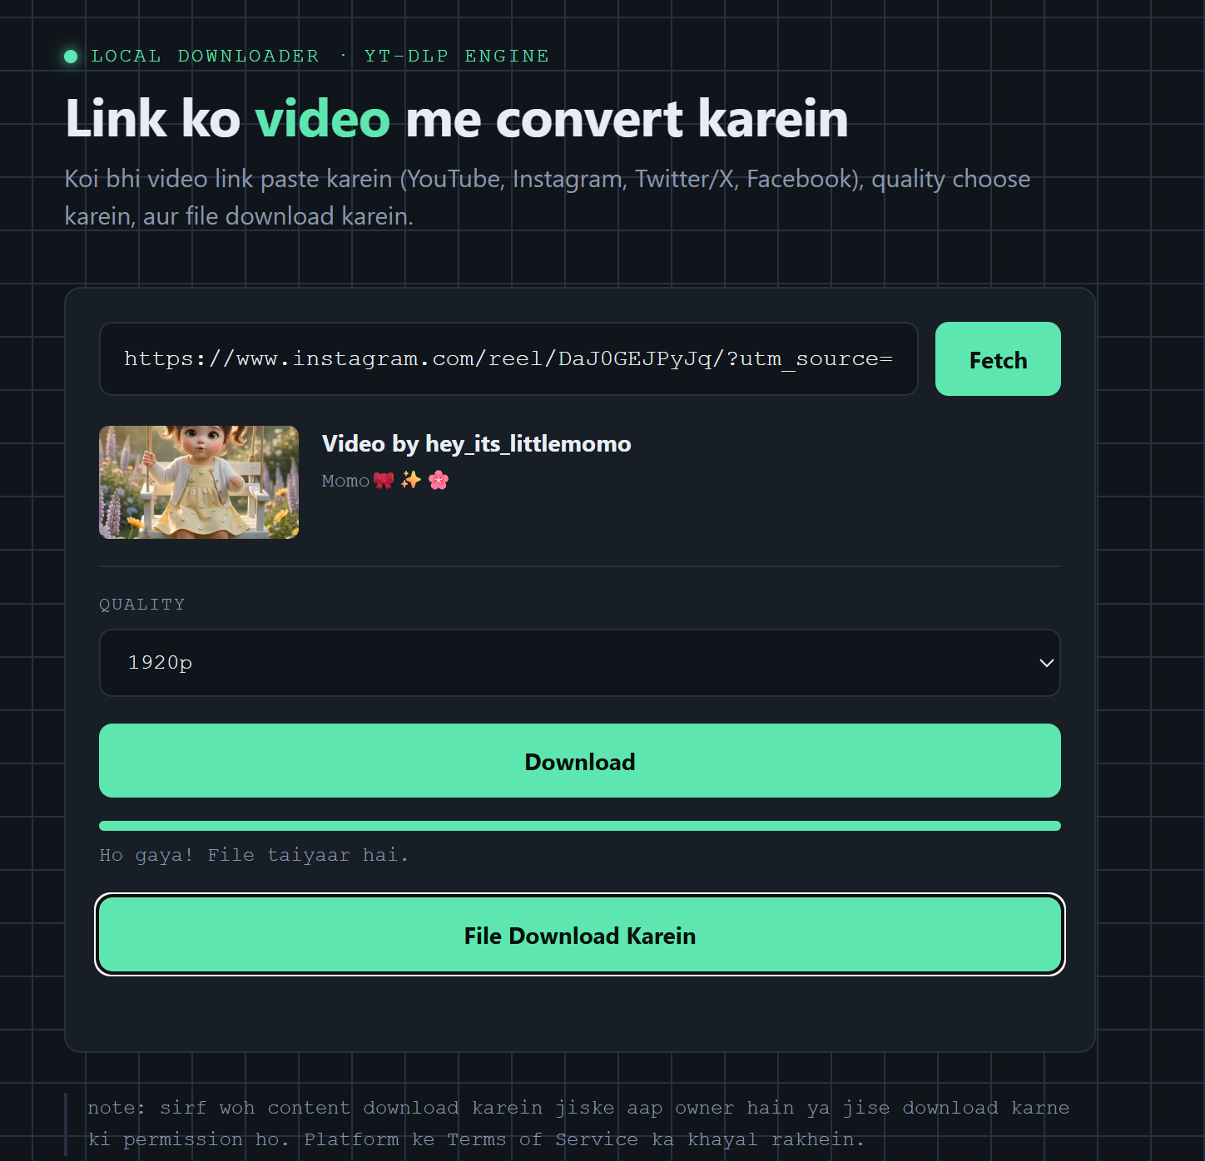
Figure 2 — Fetched video metadata and a completed download, ready to save.

9. Challenges Faced
- Merging separate video and audio streams requires ffmpeg to be present on the system PATH; the application surfaces a clear error when it is missing rather than failing silently.
- Different platforms expose different metadata shapes; the quality-selection logic had to tolerate missing height or codec fields gracefully.
- Background downloads needed thread-safe state sharing between the download thread and the HTTP request thread handling status polls, solved with a lock-protected job store.
- Preventing unbounded disk usage from completed downloads required a background cleanup mechanism rather than manual deletion.

10. Future Scope
- Replace the in-memory JobStore with Redis to support multiple worker processes.
- Add user accounts and per-user download history.
- Support audio-only (MP3) extraction as an additional output option.
- Add a WebSocket-based progress channel instead of polling.
- Containerize the application (Docker) with ffmpeg pre-installed for simpler deployment.
- Add rate limiting and request throttling if ever exposed beyond localhost.

11. Conclusion
This project successfully demonstrates a complete, layered web application for extracting and downloading video content from a URL. Beyond satisfying the functional requirement of 'link in, video file out', the implementation emphasizes maintainable software design: a clear separation between HTTP handling, business logic, and third-party integration; validated input; structured logging; automatic resource cleanup; and an automated test suite. These practices mirror patterns used in production-grade web services and make the codebase straightforward to extend, test, and reason about.

12. References
- Flask Documentation — https://flask.palletsprojects.com/
- yt-dlp Project — https://github.com/yt-dlp/yt-dlp
- FFmpeg Documentation — https://ffmpeg.org/documentation.html
- pytest Documentation — https://docs.pytest.org/

