Assignment – 1
(Using “float” property in CSS)
Batch: ICT (H3)
Roll Number: 23BIT089

Task One:
(index.html)
<!doctype html>
<html lang="en">
<head>
<meta charset="UTF-8" />
<meta name="viewport" content="width=device-width, initial-scale=1.0" />
<title>First Task</title>
<link rel="preconnect" href="https://fonts.googleapis.com" />
<link rel="preconnect" href="https://fonts.gstatic.com" crossorigin />
<link
href="https://fonts.googleapis.com/css2?family=Open+Sans:ital,wght@0,300..800;1,300..800&display=swap"
rel="stylesheet"
/>
<link rel="stylesheet" href="styles.css" />
</head>
<body>
<div><h1>Float one</h1></div>
<div>
<p>
In this task, you need to float the two elements with a class of float1
and float2 left and right, respectively. The text should then appear
between the two boxes, as in the image below.
</p>
</div>
<div class="mainBox">
<div class="float1">One</div>
<div class="float2">Two</div>
<p>The two boxes should float to either side of this text.</p>
</div>
</body>
</html>

(styles.css)
* {
margin: 0;
padding: 0;
box-sizing: border-box;
font-family: "Open Sans", sans-serif;
}

body {
display: flex;
flex-direction: column;
gap: 2rem;
padding: 5rem;
justify-content: center;
width: 60%;
}

.mainBox {
border: 1px solid #3232324a;
border-radius: 5px;
height: auto;
padding: 2rem;
}

.mainBox p {
font-size: 1.4rem;
}

.mainBox div {
font-size: 1.4rem;
}

.float1 {
float: left;
height: 200px;
width: 200px;
padding: 1.5rem;
border-radius: 5px;
background-color: #cfe8dc;
margin: 10px;
}
.float2 {
float: right;
height: 200px;
width: 200px;
padding: 1.5rem;
border-radius: 5px;
background-color: #cfe8dc;
margin: 10px;
}
(output)
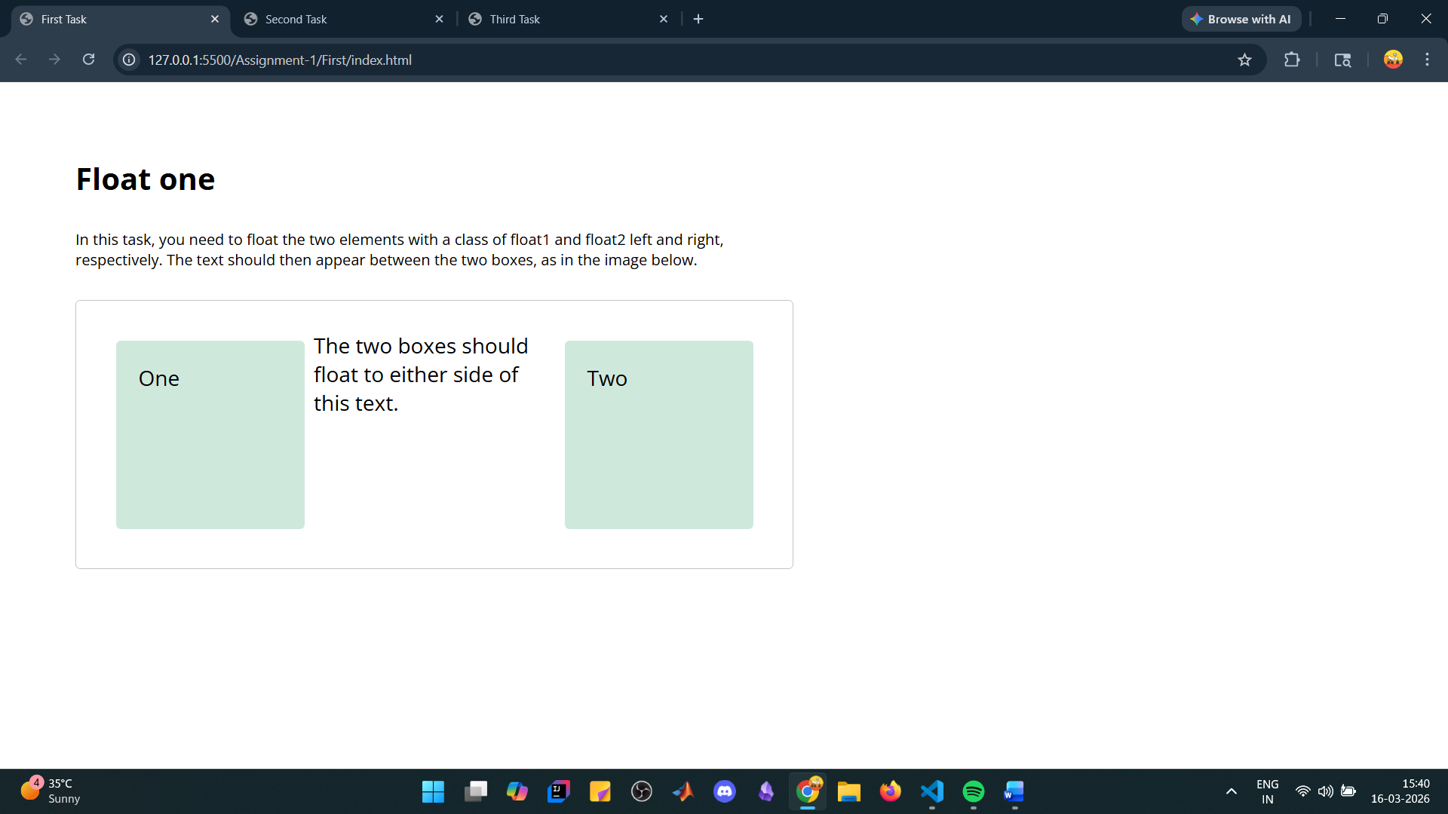

Task Two:
(index.html)
<!doctype html>
<html lang="en">
<head>
<meta charset="UTF-8" />
<meta name="viewport" content="width=device-width, initial-scale=1.0" />
<title>Second Task</title>
<link rel="preconnect" href="https://fonts.googleapis.com" />
<link rel="preconnect" href="https://fonts.gstatic.com" crossorigin />
<link
href="https://fonts.googleapis.com/css2?family=Open+Sans:ital,wght@0,300..800;1,300..800&display=swap"
rel="stylesheet"
/>
<link rel="stylesheet" href="styles.css" />
</head>
<body>
<div class="outer">
<div class="inner">
<h1>Float two</h1>
<p>
In this example, the element with a class of float should be floated
left. Then we want the first line of text to display next to that
element, but the following line of text (which has a class of .below)
to display underneath it. You can see the desired result in the image.
</p>
<div class="playground">
<div>
<div class="float">Float</div>
<p>This sentence appears next to the float.</p>
</div>
<div class="below">
Cause this sentence to appear below that float.
</div>
</div>
</div>
</div>
</body>
</html>

(styles.css)
* {
margin: 0;
padding: 0;
box-sizing: border-box;
font-family: "Open Sans", sans-serif;
}

.outer {
background-color: #4f3755;
padding: 2rem;
width: 100vw;
height: 100vh;
}

.inner {
background-color: #fff;
width: 100%;
height: 100%;
padding: 5rem 20rem;
display: flex;
gap: 3rem;
flex-direction: column;
}

.inner p {
line-height: 2em;
}

.playground {
border: 1px solid #3232324a;
border-radius: 5px;
padding: 2.5rem;
width: 100%;
height: 100%;
font-size: 1.25rem;
}

.float {
background-color: #cfe8dc;
float: left;
border-radius: 5px;
padding: 1.25rem;
width: 150px;
height: 150px;
margin-right: 2rem;
margin-bottom: 1rem;
}

.below {
clear: left;
}

(output)
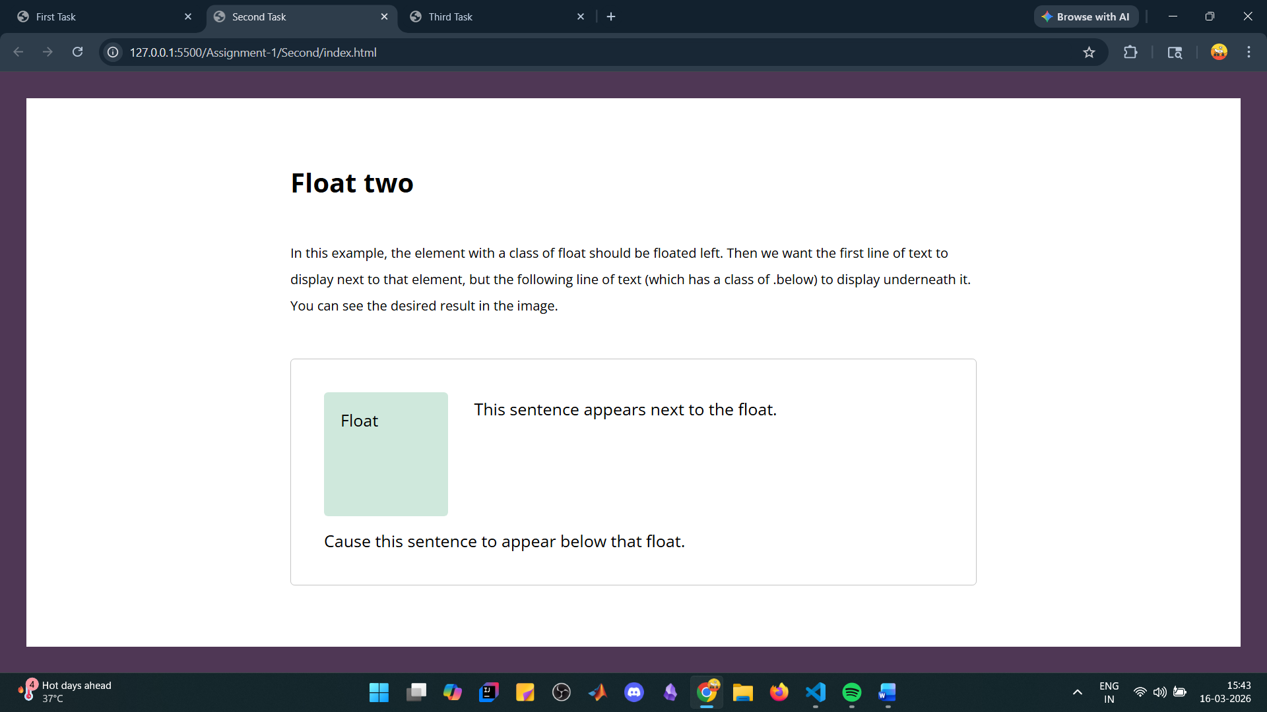

Task Three:
(index.html)
<!doctype html>
<html lang="en">
<head>
<meta charset="UTF-8" />
<meta name="viewport" content="width=device-width, initial-scale=1.0" />
<title>Third Task</title>
<link rel="preconnect" href="https://fonts.googleapis.com" />
<link rel="preconnect" href="https://fonts.gstatic.com" crossorigin />
<link
href="https://fonts.googleapis.com/css2?family=Open+Sans:ital,wght@0,300..800;1,300..800&display=swap"
rel="stylesheet"
/>
<link rel="stylesheet" href="styles.css" />
</head>
<body>
<div class="outer">
<div class="inner">
<h1>Float three</h1>
<p>
Finally, we have a floated element in this example. The box wrapping
the float and text is displaying behind the float. Use the most
up-to-date method available to cause the box background to extend to
below the float, as in the image.
</p>
<div class="outerMain">
<div class="innerMain">
<div class="float">Float</div>
<p>This sentence appears next to the float.</p>
</div>
</div>
</div>
</div>
</body>
</html>

(styles.css)
* {
margin: 0;
padding: 0;
box-sizing: border-box;
font-family: "Open Sans", sans-serif;
}

.outer {
background-color: #5e7b82;
padding: 2rem;
width: 100vw;
height: 100vh;
}

.inner {
background-color: #fff;
width: 100%;
height: 100%;
padding: 5rem 20rem;
display: flex;
gap: 3rem;
flex-direction: column;
}

.inner p {
line-height: 2em;
}

.outerMain {
border: 1px solid #3232324a;
width: 100%;
padding: 0.6rem;
font-size: 1.8rem;
color: #fff;
}

.innerMain {
background-color: #4fb9e3;
padding: 1rem;
width: 100%;
display: flow-root;
}

.float {
background-color: #cfe8dc;
border-radius: 6px;
padding: 1.25rem;
float: right;
width: 200px;
height: 200px;
margin-left: 1rem;
}

(output)
