**Assignment-1**

**Simple SQL Query with a single table with where clause**

**1. Write a query to get a Product list (id, name, unit price) where current products cost**

**less than $20.**

select ProductID, ProductName, UnitPrice from Products WHERE UnitPrice < 20

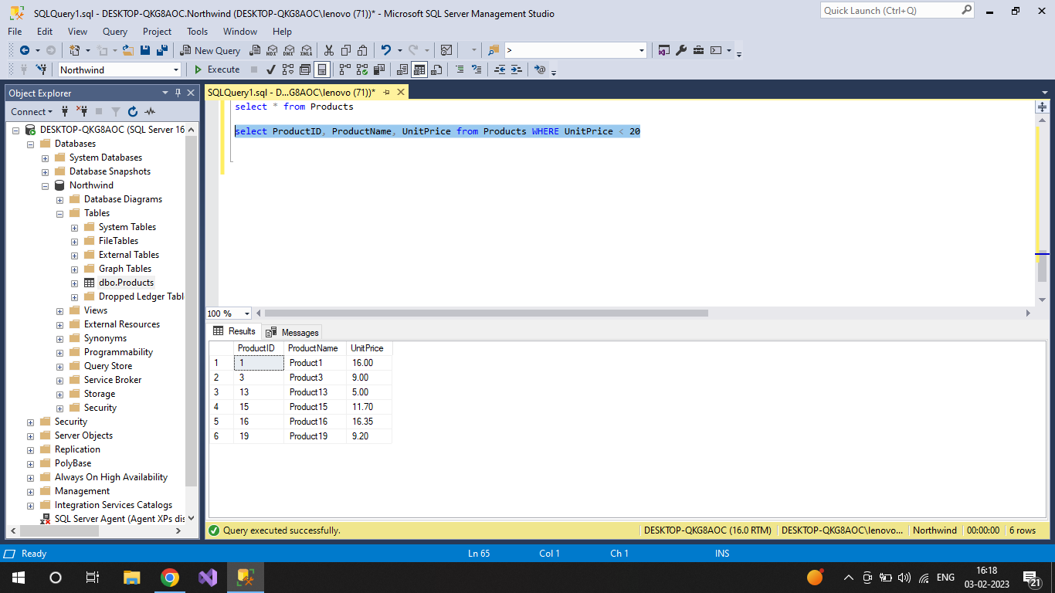

**2. Write a query to get Product list (id, name, unit price) where products cost between**

**$15 and $25**

select ProductID ProductName, UnitPrice from Products WHERE UnitPrice >= 15 AND

UnitPrice <= 25

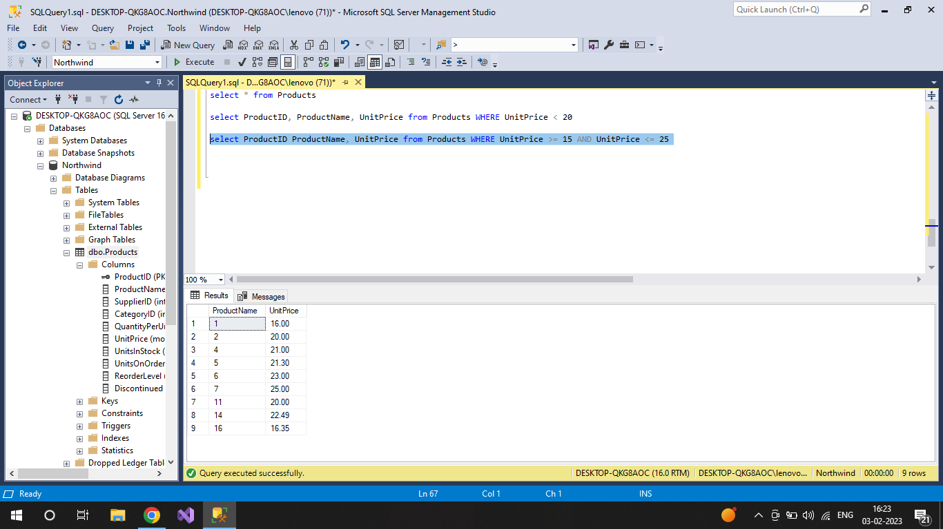

**3. Write a query to get Product list (name, unit price) of above average price.**

select DISTINCT ProductName, UnitPrice from Products WHERE UnitPrice > (SELECT avg(UnitPrice) FROM Products)

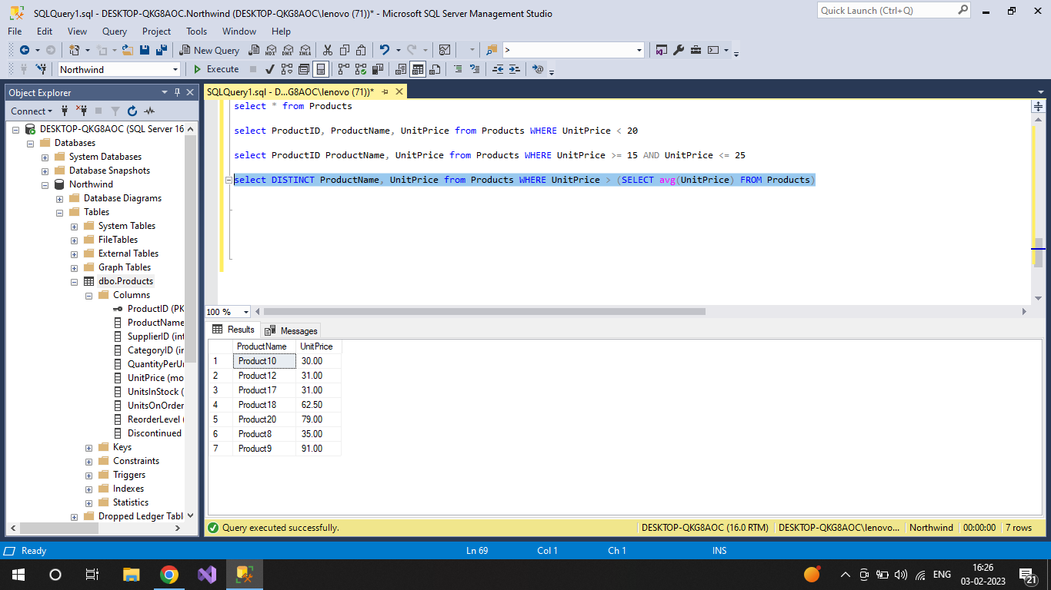

**4. Write a query to get Product list (name, unit price) of ten most expensive products**

select DISTINCT ProductName as Ten_most_expensive_products, UnitPrice from Products AS a

where 10 > (select COUNT(DISTINCT UnitPrice) from Products AS b where b.UnitPrice >= a.UnitPrice)

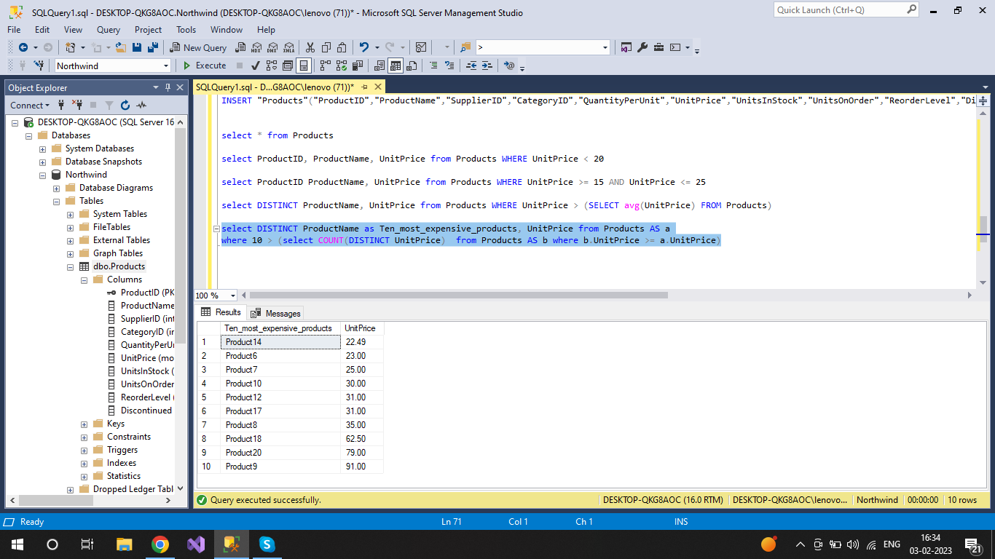

**5. Write a query to count current and discontinued products**

select Count(ProductName) as current_and_discontinued_products from Products GROUP BY Discontinued;

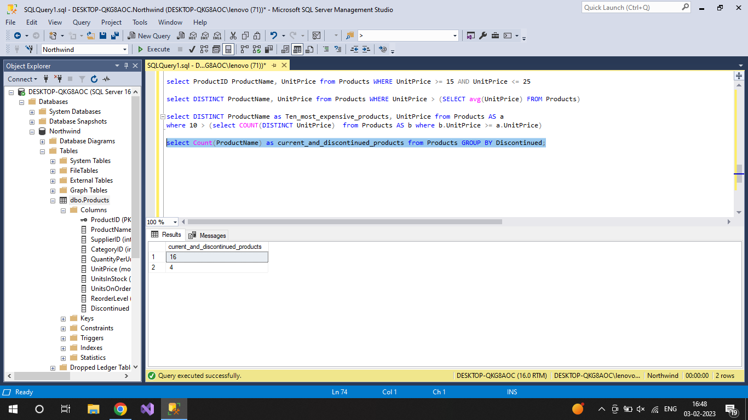

**6. Write a query to get Product list (name, units on order , units in stock) of stock is less**

**than the quantity on order**

select ProductName,UnitsOnOrder,UnitsInStock from Products where UnitsInStock < UnitsOnOrder

