**RESULT AND DISCUSSION**

1. **Result**

The given program provides the Minimum and Maximum Expenses for Room, Flats & Houses in a particular area which helps user decide to the choose the living space for them.

It helps user to find appropriate place according their needs and reduces their effort and time.

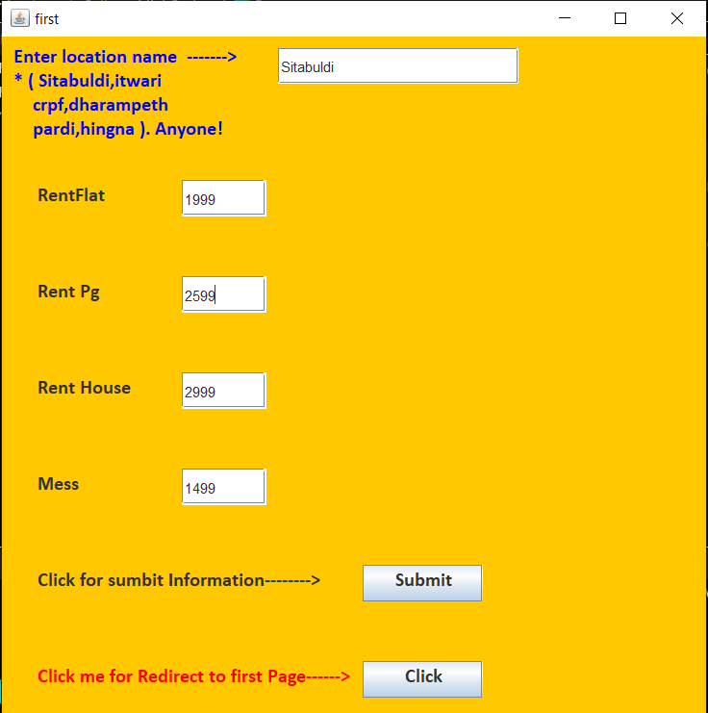

Fig 1.7 (Data Insert Price)

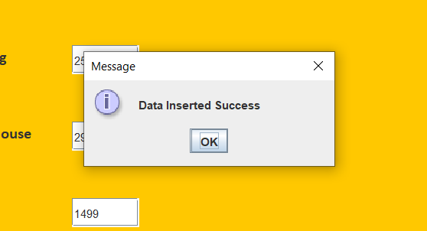

Fig 1.8 (Data Inserted Msg)

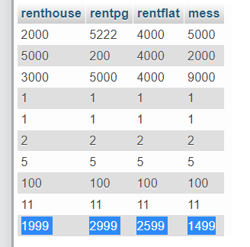

Fig 1.9 (SQL Data Base)

Here inserted value entered in insert window after clicking the ‘Submit’ button Sql query fire and updated in sql database.