# Project and Developer Details

**Project Name**: E-Commerce Website for Sporty Shoes

# Project Details:

This project aims to design and develop a backend administrative portal for the Sport Shoes using Java EE technologies. I developed it as a project of phase 3 for the Implement the framework using Devops. The goal of this project is to apply Springs, Spring MVC, Spring Boot ,JSP and JDBC concepts.

# Developer Name: Vinita Kale

**Sprints and the User Stories:**

**Sprint-1: (One week)**

* **User Story-1:** As an Administrator, I want to have an option to create Users, so that I can set up a master list of Users
* **User Story-2:** As an Administrator, I want to have an option to create Products, so that i can set up a master list of Products
* **User Story-3:** As an Administrator, I want to have an option to view Users, so that i can view a User by Id and also a list of Users.
* **User Story-4:** As an Administrator, I want to have an option to view Products, so that i can view a Product by Id
* **User Story-5:** As an Administrator, I want to have an option to view Products, so that i can view a list of Products.
* **User Story-6:** As an Administrator, I want to have an option to view Users, so that i can view a User by Id..
* **User Story-7:** As an Administrator, I want to have an option to view Users, so that i can view a list of Users.
* **User Story-8:** As an Administrator, I want to have an option to view Products, so that i can view a Product by Category.
* **User Story-9:** As an Administrator, I want to have an option to update Users, so that i can modify a User by Id.
* **User Story-10:** As an Administrator, I want to have an option to update Products, so that i can modify a Product by Id.

# Sprint-2:(one week)

* **User Story-1:** As an Administrator, I want to have an option to delete Users, so that i can remove Users whenever they are not required.
* **User Story-2:** As an Administrator, I want to have an option to delete Products, so that i can remove Products whenever they are not required.
* **User Story-3:** As an Administrator, I want to have an option to map Products to Users via purchase, so that i can map Products to Users whenever the User purchases Products.
* **User Story-4:** As an Administrator, I want to have an option to reset or change my password, so that i can change or update password whenever required.
* **User Story-5:** As an Administrator, I want to have an option to view purchase report by Date, so that i can see the purchase reports for analysis.
* **User Story-6:** As an Administrator, I want to have an option to view purchase report by Category, so that i can see the purchase reports for analysis by Category.

# Technologies and tools Used

Java concepts implemented in this application:

* Springs: to do the business logic and works a controller for the project.
* JSP: to handle the presentation view.
* SQL: to create and manage the database.
* JDBC: to make operations on the database for the project.
* CSS: to format the contents.
* MySql: to administrate and manage the database manually.
* Eclipse: to write and run the code.
* Tomcat: to run and deploy servlet application.

# Flow Chart

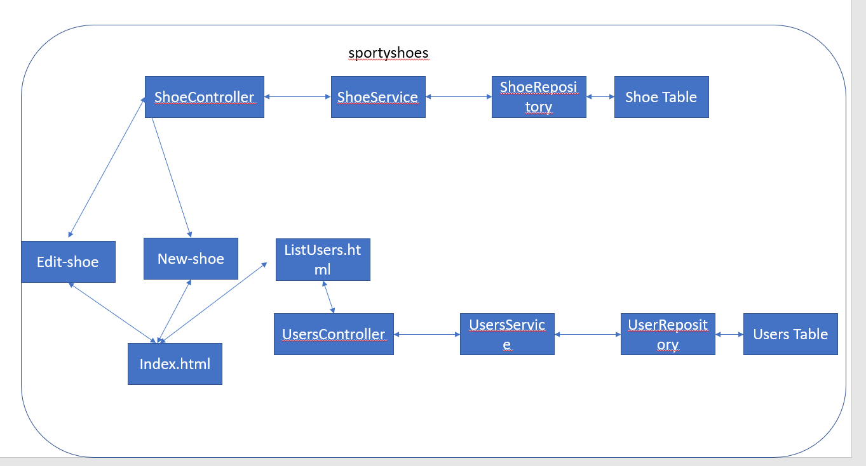

**How to run the program**

* clone project
* Import the “database\database.sql” file to your database administration tool.
* Go to “\src\main\webapp\META-INF\context.xml” file and open it.
* Edit the database’ properties such as username, password and driverClassName to be suit to your database administration tool.
* Now run program on a server.
* To login you must enter admin for both username and password.

# Links to the GitHub repository to verify the project completion

https://github.com/sangeetha-vishwakarma/E-commerce-Website-for-Sporty- Shoes

# Pushing the code to GitHub Repository

* + Open your command prompt and navigate to the folder where you have created your files.

# cd <folder path>

* + Initialize repository using the following command:

# git init

* + Add all the files to your git repository using the following command:

# git add .

* + Commit the changes using the following command:

# git commit . -m <commit message>

* + Push the files to the folder you initially created using the following command:

# git push -u origin master