**CHAPTER II**

**LITERATURE SURVEY**

**2.1 Related Works on security Systems**

In the present day, researchers and developers have come up with a wide range of surveillance systems that are used for remote monitoring, alerting as well as controlling tasks through affordable and easy to implement hardware systems. Some have so far been realized while others still remain a proposition.

An embedded home surveillance system which assesses the implementation of a cost effective alerting system based on small motion detection was presented by Padmashree A. Shake and Sumedha S. Borde. They worked on implementing cheap in price, low power consumption; well utilize resources and efficient surveillance system using a set of various sensors. Their system helps to monitor the household activities in real time from anywhere and based on microcontroller which is considered nowadays as a limited resource and an open source solution compared to SBC.

D. Jeevanand worked on designing of a networked video capture system using Raspberry Pi. The proposed system works on capturing video and distributing with networked systems besides alerting the administration person via SMS alarm as required by the client. Their system was designed to work in a real-time situations and based on Raspberry Pi SBC. Contrasting to other embedded systems their real-time application offers client video monitor with the help of alerting module and SBC platform. Sneha Singhd and his team described IP Camera Video Surveillance system using Raspberry Pi technology.

Sneha Singhd and his team described IP Camera Video Surveillance system using Raspberry Pi technology. The Researchers aimed at developing a system which captures real time images and displays them in the browser using TCP/IP. The algorithm for face detection is being implemented on Raspberry Pi, which enables live video streaming along with detection of human faces. The research did not include any of surveillance reactions.

Mahima F. Chauhan and Gharge Anuradha offered to design and develop a real time video surveillance system based on embedded web server Raspberry PI B+ Board. Their system has low cost, good openness and portability and is easy to maintain and upgrade. Thus this application system provides better security solutions. This system can be used to effect security in banking halls, industry, and environment and in military arts.

Jadhav G. J evaluates in 2014 the use of various sensors, wireless module, microcontroller unit and finger print module to formulate and implement a cost effective surveillance system. He and his team adopted an ARM core as a basis processor of the system. PIR sensor is used to detect motion in the vision area, while vibrating sensor is used to sense any vibration events such as sound of breaking. The intruder detection technique is proposed by using the PIR sensor that detect motion and trigger a system of alerting and sending short message service through GSM module for a specified phone number. Their work can be featured by adopting numerous diverse kinds of demanding database and thus it will be more secure and difficult to hack.

In 2014, Sanjana Prasad and his colleagues worked on developing a mobile smart surveillance system based on SBC of Raspberry Pi and motion detector sensor PIR. Their development boosts the practice of portable technology to offer vital safety to our daily life and home security and even control uses. The objective of their research is to develop a mobile smart phone home security system based on information capturing module combined with transmitting module based on 3G technology fused with web applications. The SBC will control the PIR sensor events and operates the video cameras for video streaming and recording tasks. Their system has the capability to count number of objects in the scene.

Uday Kumar worked on implementation of a low cost wireless remote surveillance system using Raspberry Pi. Conventional wireless CCTV cameras are widely used in surveillance systems at a low cost. He and his team implemented a low cost and secure surveillance system using a camera with Raspberry Pi and the images acquired have to be transferred to the drop box using a 3G internet dongle. This was successfully implemented using Raspberry Pi and 3G dongle.

**2.2 Evolution of Security**

With the invention of electricity, the art of home protection was greatly improved. In 1853, the first patent on electro-magnetic alarms meant that businesses and wealthy residents could secure valuables. Magnetic contacts were installed on the windows and doors that, when tripped, would send a signal through the electromagnetic wiring and sound an alarm. These ground-breaking security systems were effective in deterring break-ins from occurring.

According to Cisco Expo, major strides have been made with regards to surveillance systems. After the alarm system, analog video camera with Video Cassette Recorder evolved. It had poor imaging and no remote access. To overcome the drawbacks of this system, digital video recorders evolved. They gave good quality pictures and enable for transmission of video signals through data networks and thus allowed for remote monitoring.

Network Video Recorder then emerged. They have the advantages of the DVRs but have other merits over DVRs. They give more storage options and network connection. The most superior version is the type that uses Cisco Video Surveillance Platform. They give secure remote access and control from anywhere, fail-safe redundant storage, easy integration with other systems and enterprise class storage and support.

**2.3 Security System Definition**

**Security** literally means a way or method by which something is secured through a system ofinterworking components and devices. On the other hand, **security systems** are networks of integrated electronic devices working together with a central control panel to protect against burglars and other potential intruders. Security systems work on the simple concept of securing entry points into a home with sensors that communicate with a control panel or command centre installed in a convenient location. The sensors are typically placed in entrances as well as easily accessible windows. A typical home security system has the following components: A control panel, which is the primary controller of a security system, door and window sensors, motion sensors, wired or wireless security cameras, high-decibel siren or alarm and window stickers.

They give secure remote access and control from anywhere, fail-safe redundant storage, easy integration with other systems and enterprise class storage and support.

**2.4 Current Security Technologies**

**2.4.1 Arduino Based Home Security System**

This security system project deals with the design and development of a theft control system for home, which is being used to prevent/control any theft attempt. The developed system makes use of an embedded system comprising of an open hardware microcontroller (Arduino) and a modem based on Global System for Mobile communication (GSM) technology.

The designed and developed system can be installed in the home. An interfacing intrusion - detector unit is also connected to the microcontroller-based security system. The system thus incorporates a passive infrared sensor (PIR) for motion detection

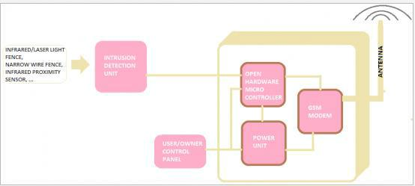

**Figure 2.1: Arduino based home security system block diagram**

In case of an intrusion attempt, a warning message is being transmitted by the system (as an sms) to the owner’s mobile phone, or to any pre-configured mobile phone number for further processing.

The security system comprises of an Arduino Uno microcontroller, a standard SIM900A based GSM/GPRS modem and PIR sensor. The whole system can be powered from any 12VDC/2A power supply unit/battery.

**2.4.1.1 How it works**

Its working principle can be analysed from the block diagram of fig 1.1. When input power is applied to the system, the system goes into standby mode. However, when the terminals of connector joining PIR with the Arduino microcontroller are short circuited, the preprogramed warning message is automatically transmitted to the concerned mobile number. This system however does not transmit the image of the intruder. It only conveys a notification message.

**2.4.2 Closed-circuit television (CCTV) Security System**

**Video surveillance** is the use of [video cameras](https://en.wikipedia.org/wiki/Video_camera) to transmit a signal to a specific place, on a limited set of monitors. It differs from [broadcast television](https://en.wikipedia.org/wiki/Broadcast_television) in that the signal is not openly transmitted, though it may employ point to point (P2P), point to multipoint, or mesh wireless links. In the U.S. the first commercial closed-circuit television system became available in 1949, called Vericon. A warning message is being transmitted by the system (as an sms) to the owner’s mobile phone, or to any pre-configured mobile phone number for further processing.

**2.4.2.1 Operation of a CCTV Security System**

The simplest system is a camera connected directly to a monitor by a coaxial cable with the power for the camera being provided from the monitor. The outdoor or indoor camera take several images per second and thus cannot be differentiated by human eye. The images are then transferred via a coaxial cable or optic fibre to a computer placed in a secure location. This computers are monitored by security personnel and responds to any improper behaviors. These systems have been incorporated with alarm systems so as to send out an alert in case of a security bridge.

Two types of CCTV storage exist; VCR and DVR. The DVR system is more superior as it can be able to transmit digitized video signals over the data networks and thus can allow for remote control and monitoring of the system.

**2.4.3 Remote Surveillance IP System**

IP surveillance is a digitized and networked version of closed-circuit television (CCTV). In an IP surveillance system, an IP camera records video footage and the resulting content is distributed over an IP (Internet protocol) network. Adding networking capability to digital CCTV provides additional benefits, including:

* Improved ability for remote viewing and control. Anyone on the network can potentially see video from any camera connected to the network.
* [IP storage](http://searchstorage.techtarget.com/definition/IP-storage) makes it possible to store data in any geographic location.
* Greater ease of distribution. An image of a crime suspect, for example, can be immediately distributed to officials.
* The ability to connect to email and other communications systems so that alerts can be sent automatically.

**2.4.4 Raspberry Pi Based Surveillance System**

A raspberry pi can be used to implement a security system with motion detection, image processing and alert mechanism. The alert ought to contain a time lapse photo or video and transmitted over the internet. This thus will enable the users to monitor the homes from anywhere in the world.

As shown in the figure above, the whole architecture of the system is composed of five modules namely:

* Raspberry Pi SBC model
* Pi camera/USB Camera
* PIR sensor
* Wi-Fi Dongle
* Monitor/laptop

The role of each module shall be discussed in detail later in this chapter.

**2.4.4.1 Why Raspberry Pi based Security Systems for Homes?**

Several criteria have been used to select a security system required to safeguard a facility. The chief among all these has been the cost of implementation of such a system. The Raspberry Pi is also a very versatile device whose functionality is not limited. It can be extended from being merely a security device to temperature control device, automatic lighting and proxy server.

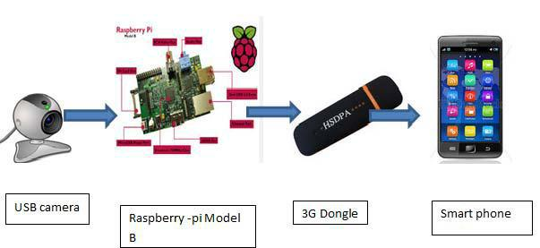

**Figure 2.2: Raspberry Pi based Security System**

The following reasons explain the need to have your home security system based on Raspberry Pi:

* An IP Camera system has the ability to distribute alarm messages over the internet as well as the Raspberry Pi based security system. However, the cost of an IP Camera makes it not easily affordable to small home owners.(insert cost plus citation) Thus they can be deployed in large industrial set ups, defence forces, police departments etc.
* Arduino microcontroller based security system can be relatively cheaper to implement as compared to Raspberry Pi based system but its memory capacity renders it more ineffective especially when trying to interface with other modules e.g. camera, monitors, motion sensors, mouse and keyboard.

* Raspberry Pi has an extendable SD card storage and can be expanded to suit the needs of an individual. Moreover Arduino, microcontroller requires a GSM modem to enable it transfer information through the internet. The Raspberry Pi has a port to connect it to the internet.
* A CCTV surveillance system is expensive to purchase and install compared to the system in question. It requires a DVR system to connect it to the data networks through TNP/IP. A DVR on its own is very expensive. Hence such a system may not be afforded by low income home owners.

**2.5 Image Processing**

Image Processing is a technique to enhance raw images received from cameras/sensors placed on satellites, space probes and aircrafts or pictures taken in normal day-to-day life for various applications. Most importantly, this technology is used in surveillance. Gaussian smoothing is also used as a pre-processing stage in computer vision algorithms in order to enhance image structures at different scales. There are two methods available in Image Processing.

**2.5.1 Image Processing Techniques**

**2.5.1.1 Image Blurring**

**Gaussian blur** (also known as Gaussian smoothing) is the result of blurring an image by a Gaussian Function. It is a widely used to reduce noise and detail. The visual effect of this blurring technique is a smooth blur resembling that of viewing the image through a translucent screen, distinctly different from the bokeh effect produced by an out-of-focus lens or the shadow of an object under usual illumination. Gaussian smoothing is also used as a pre-processing stage in computer vision algorithms in order to enhance image structures at different scales. The equation of a Gaussian function in one dimension is:

 ……………….. (1)

**2.5.1.2 Grayscalling**

Grayscale is a range of shades of grey without apparent colour. The darkest possible shade is black, which is the total absence of transmitted or reflected light. The lightest possible shade is white, the total transmission or reflection of light at all visible wavelengths. Intermediate shades of grey are represented by equal brightness levels of the three primary colors (red, green and blue) for transmitted light, or equal amounts of the three primary pigments (cyan, magenta and yellow) for reflected light.

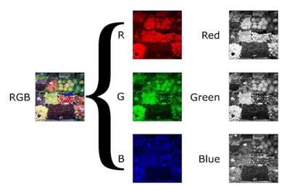In the case of transmitted light (for example, the image on a computer display), the brightness levels of the red (R), green (G) and blue (B) components are each represented as a number from decimal 0 to 255, or binary 00000000 to 11111111. For every pixel in a red-green-blue (RGB) grayscale image, R = G = B. The lightness of the grey is directly proportional to the number representing the brightness levels of the primary colours. Black is represented by R = G = B = 0 or R = G = B = 00000000, and white is represented by R = G = B = 255 or R = G = B = 11111111. Because there are 8 bits in the binary representation of the grey level, this imaging method is called 8-bit grayscale.

**Figure 2.3: Original and gray images**

**2.5.1.3 Thresholding**

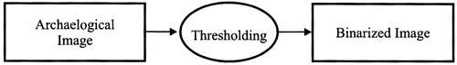

**Figure 2.4: Thresholding**

Thresholding is a process of converting a grayscale input image to a bit-level image by using an optimal threshold. The purpose of thresholding is to extract those pixels from some image which represent an *object* (either text or other line image data such as graphs, maps). Though the information is binary the pixels represent a range of intensities. Thus the objective of binarization is to mark pixels that belong to true foreground regions with a single intensity and background regions with different intensities.

**2.5.2 Object Detection and Tracking**

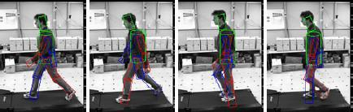

**Figure 2.5: Detecting moving object**

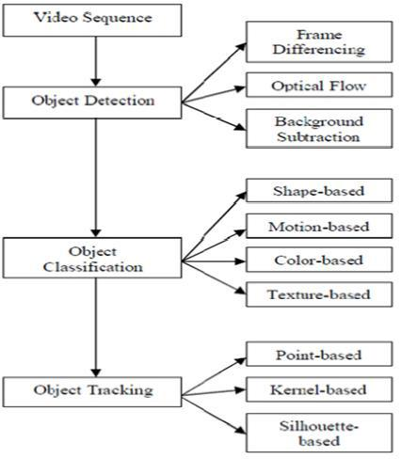

**Figure 2.6: Video analysis**

**2.5.3 Methods of Detection and Tracking**

**2.5.3.1 Background Subtraction Method**

A very widely used method which is simple to implement by just subtracting the current frame from previous frame and obtaining threshold value of difference between given pixel value and obtained pixel value. If threshold value is greater than the given the pixel it is considered as foreground. Thus the objective of binarization is to mark pixels that belong to true foreground regions with a single intensity and background regions with different intensities. This method is not as appropriate as it is highly inaccurate and gives false rate detection.

**2.5.3.2 Real time Background Subtraction and shadow Detection Technique Theory:**

It describes two type of distortion namely brightness distortion and chromaticity distortion based on RGB values of pixels in given image. This method is accurate up to some extends as it also detect the shadow part of object.

**2.5.3.3 Template Matching**

Template Matching is probably the best method for some specific environment. It's the most accurate although sometimes there is lack of originality in object detected. Object can be detected for one specific video using a template cropped from the video. However, there is no guaranteed accuracy because all that is known is the best match for each frame; no scanning is done on the percentage template matches the frame. It only works if the object is always in the video, otherwise it will create a false detection.

**2.5.3.4 Shape Based**

Shape based method is used to detect objects in real-world images. The shape features are more striking as compared to local features like SIFT because most object categories are better described by their shape then texture, such as cows, horses and cups and also for wiry objects like bikes, chair or ladders, local features contain large amount of background noise. Thus shape features are often used as a replacement to local features.

**2.5.3.5 Optical Flow Method**

Sequences of ordered images allow the estimation of motion as either instantaneous image velocities or discrete image displacements. The optical flow methods try to calculate the motion between two image frames which are taken at times *t* and  at every voxel position.

For a 2D+*t* dimensional case (3D or *n*-D cases are similar) a voxel at location (*x , y ,t* ) with intensity (*x, y, t* ) will have moved by, and  between the two image frames, and the following *brightness constancy constraint* can be given:



From these equations it follows that:



Or

This results in



Thus:



Or



Or

These methods are called differential since they are based on local Taylor series approximations of the image signal; that is, they use partial derivatives with respect to the spatial and temporal coordinates.