**Phase 5: Project Documentation & Submission**

**Public Transportation Optimization**

**Abstract:**

Efficient and sustainable public transportation systems are critical for addressing urban congestion and environmental concerns. This abstract of presents an overview of strategies and technologies aimed at optimizing public transportation. It explores the implementation of intelligent transportation systems, data analytics, and eco-friendly vehicles to enhance the reliability and sustainability of public transit. Additionally, it discusses the integration of multi-modal transportation options and the role of user-centric solutions in improving the overall passenger experience. This research emphasizes the significance of public transportation optimization in fostering eco-friendly, accessible, and efficient urban mobility solutions for the future.

**Introduction:**

In today's rapidly urbanizing world, the efficient and sustainable functioning of public transportation systems has become paramount. As cities continue to expand and environmental concerns intensify, the optimization of public transportation stands as a vital solution to address these challenges. This document is dedicated to exploring the multifaceted strategies and cutting-edge technologies that are poised to revolutionize the landscape of public transportation.

From the integration of intelligent transportation systems to the deployment of data analytics and eco-friendly vehicles, we delve into the myriad avenues of improving the reliability and sustainability of public transit. Moreover, we investigate the seamless amalgamation of multi-modal transportation options and the pivotal role of user-centric solutions in enhancing the overall passenger experience. In essence, this research underscores the critical role of public transportation optimization in shaping a future where urban mobility is synonymous with eco-friendliness, accessibility, and efficiency.

**Literature Review: Public Transportation Optimization**

Public transportation serves as a cornerstone of urban mobility, offering efficient and sustainable solutions for the ever-growing urban populations. To meet the increasing demand and address challenges related to congestion and environmental concerns, research in public transportation optimization has gained significance. In this literature review, we summarize key findings and trends from relevant studies in this field, focusing on strategies and technologies that enhance efficiency, sustainability, and the passenger experience.

**Working Principle of Public Transportation Optimization**

Public transportation optimization is a multifaceted process aimed at improving the efficiency, sustainability, and overall performance of public transit systems. It involves the integration of various strategies and technologies to enhance the quality of service for passengers while reducing environmental impacts and operational costs.

**Data Collection and Analysis:**

The process begins with the collection of data related to passenger demand, vehicle locations, traffic conditions, and other relevant factors. Advanced technologies such as GPS, sensors, and passenger smart cards provide real-time data. This data is then analyzed to gain insights into trends, patterns, and areas that require improvement.

**Intelligent Transportation Systems (ITS):**

One key component of public transportation optimization is the implementation of ITS. These systems use the collected data to manage and control the transit network efficiently. ITS can optimize routes, adjust schedules, and provide real-time information to passengers about bus or train arrivals. This leads to reduced wait times and more reliable services.

**Eco-Friendly Vehicles and Sustainable Practices:**

Another aspect involves the use of eco-friendly vehicles, such as electric buses or those powered by alternative fuels. Sustainable practices like transit-oriented development and green infrastructure are integrated to reduce the environmental impact of public transit while improving its long-term sustainability.

**Multi-Modal Integration:**

To cater to diverse transportation needs, different modes of transit are integrated seamlessly. Passengers can transfer easily between buses, trams, trains, and other transit options, reducing the need for private cars and mitigating congestion.

**User-Centric Solutions:**

The passenger experience is at the core of optimization efforts. User-centric solutions include the development of user-friendly mobile apps, contactless payment systems, and accessible infrastructure. These enhancements make public transportation more convenient and attractive to passengers, leading to increased ridership.

**Continuous Improvement:**

Public transportation optimization is an ongoing process. Regular assessments and updates are made based on data analysis and passenger feedback. This iterative approach ensures that transit systems remain responsive to changing needs and technological advancements.

**ARCHITECTURE OF THE PROPOSED SYSTEM:**

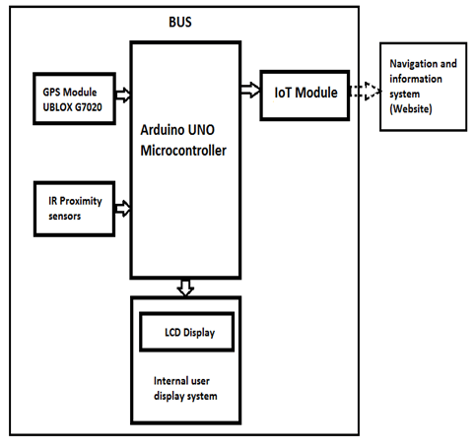

**FLOW CHART OF BUS LOCATION PREDICTION**

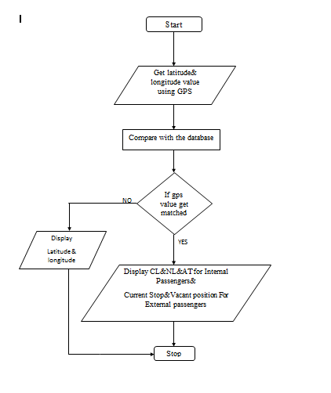

**APPARATUS REQUIRED**

1. GPS Receivers.

2. Telematics Units.

3. Cellular Modems.

4. Sensors.

5. Onboard Computer or Controller.

6. Central Server .

7. Cloud Infrastructure.

8. Mobile Applications.

9. User Interfaces.

10. Power Supplies.

11. Security Measures.

12. IoT Gateway.

13. IoT Platform.

**Arduino IDE**

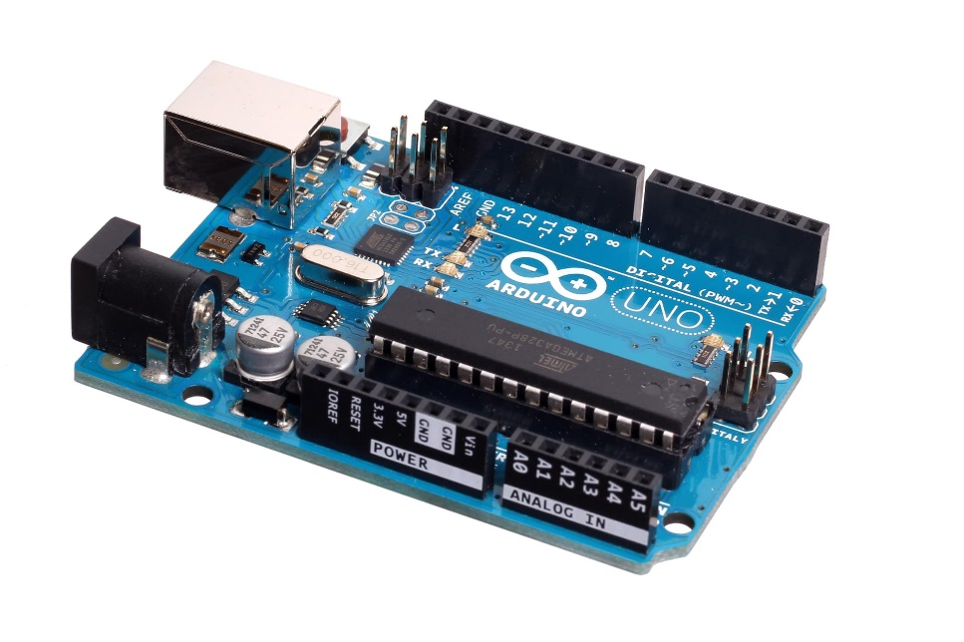

**GPS Module**

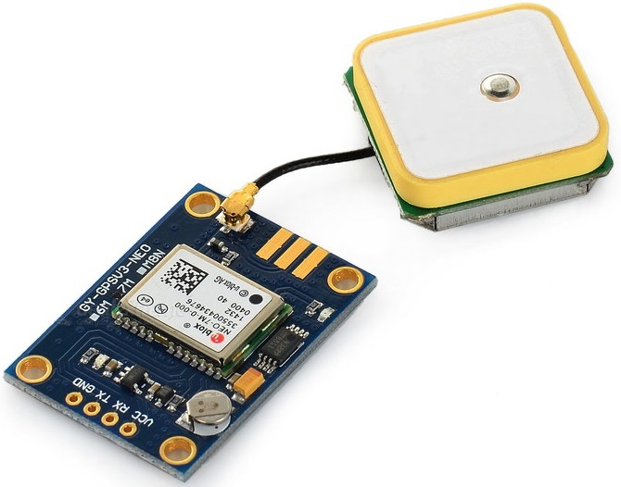

**Vechile Tracking Online Simulation**

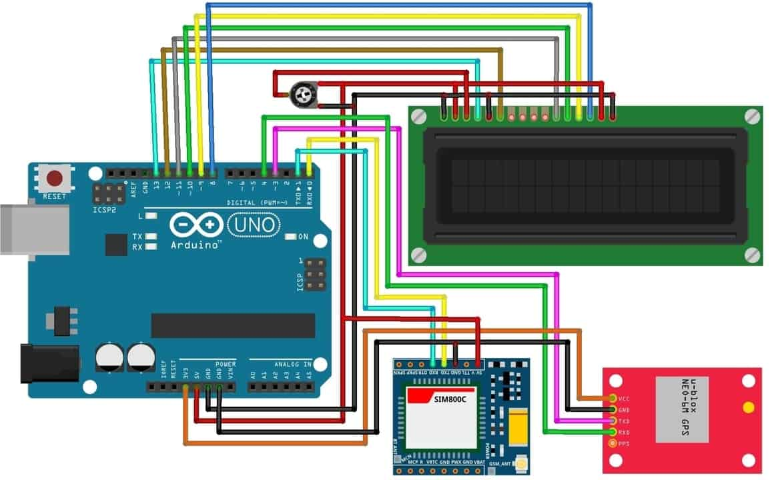

**CODE IMPLEMENTATION**

import pandas as pd

from sklearn.model_selection import train_test_split

from sklearn.linear_model import LinearRegression

from sklearn.metrics import mean_absolute_error

# Load your preprocessed data

data = pd.read_csv('bus_data.csv')

# Split the data into training and testing sets

X = data[['Feature1', 'Feature2', ...]] # Features relevant to the prediction

y = data['BusLocation'] # Target variable (location)

X_train, X_test, y_train, y_test = train_test_split(X, y, test_size=0.2, random_state=42)

# Create a linear regression model (you can choose other models)

model = LinearRegression()

# Train the model

model.fit(X_train, y_train)

# Make predictions

y_pred = model.predict(X_test)

# Evaluate the model

mae = mean_absolute_error(y_test, y_pred)

print(f"Mean Absolute Error: {mae}")

class Bus:

def init(self, bus_id, x, y):

self.bus_id = bus_id

self.x = x

self.y = y

def move(self):

# Simulate bus movement

self.x += random.uniform(-0.01, 0.01)

self.y += random.uniform(-0.01, 0.01)

def get_location(self):

return self.x, self.y

def simulate_bus_locations(bus_count):

buses = [Bus(i, random.uniform(0, 100), random.uniform(0, 100)) for i in range(bus_count)]

while True:

for bus in buses:

bus.move()

x, y = bus.get_location()

print(f"Bus {bus.bus_id}: Location ({x:.2f}, {y:.2f})")

time.sleep(1)

if name == "main":

bus_count = 5 # Number of buses to simulate

simulate_bus_locations(bus_count)

**Conclusion**

The optimization of public transportation systems plays a pivotal role in addressing the multifaceted challenges faced by modern cities. By adopting a holistic approach that encompasses route planning, infrastructure improvements, technology integration, and user-centric incentives, cities can achieve a variety of benefits.

These benefits include reduced traffic congestion, decreased greenhouse gas emissions, improved air quality, enhanced accessibility for all citizens, and a more sustainable urban environment. As we move towards a future characterized by rapid urbanization and increasing environmental concerns, investing in and continuously improving public transportation remains a cornerstone of creating livable, efficient, and eco-friendly urban spaces. It is imperative that governments, transportation authorities, and communities collaborate to make these optimizations a reality for the well-being and prosperity of all.