Data Driven Energy Economy Prediction for Electric City Buses Using Machine Learning

Now-a-days all vehicles are running on battery power but recharging battery will take more time comparing to refuelling fuel. So author of this paper employing machine and deep learning algorithms to predict energy consumption between routes and based on predicted energy then refuelling can be schedule with nearest service station.

In propose paper author using dataset to calculate routes using latitude and longitude.

Calculated routes, battery level and other dataset values will be input to Neighbourhood features selection algorithm to select relevant features from the dataset

Selected features will get trained with various machine learning algorithms like Linear Regression, Random Forest, SVM, ANN, Gaussian regression process. Each algorithm performance is evaluated in terms of R2SCORE, RMSE (root mean square error) and MAP (mean absolute error).

R2SCORE refers to accuracy of correctly predicted data from test data

RMSE and MAP refers to difference between original test values and predicted test values so the lower the RMSE and MAP the better is the algorithm. Among all algorithms Linear Regression is giving high R2SCORE

To train above algorithms author has used Real Vehicle dataset from some company but not publish on internet so we downloaded vehicle energy consumption dataset from KAGGLE repository. In below screen showing dataset details.

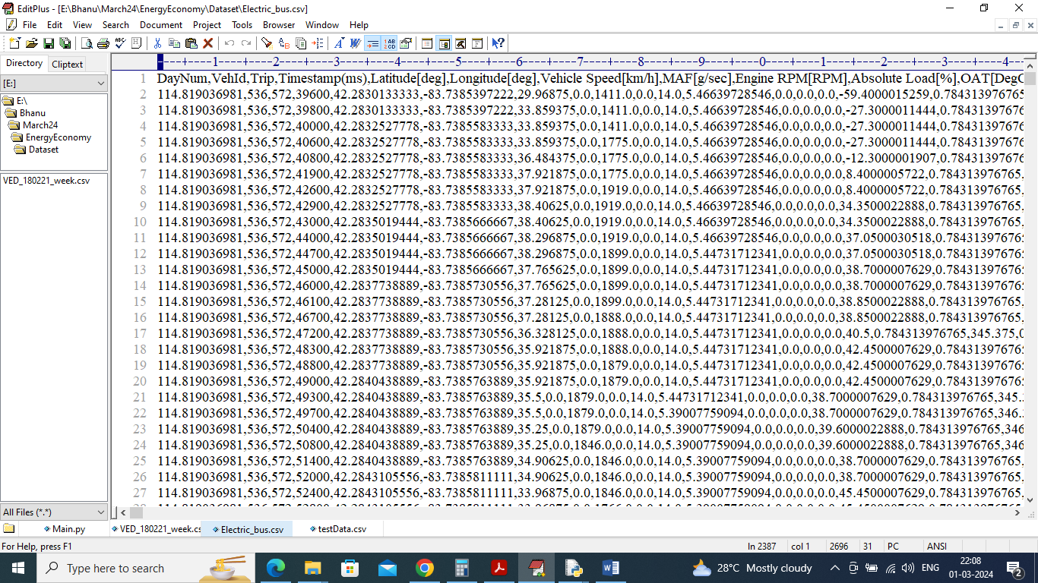

In above dataset screen first row contains dataset column names and remaining rows contains dataset values and by using above dataset will train and test all algorithm performances

Extension Concept

In propose paper author has used all traditional machine learning algorithms so as extension we have experimented with advance CNN2D (convolution neural network) which will filtered dataset with multiple layers and neurons which can help in better prediction of energy consumption while increasing R2SCORE and reducing RMSE and MAP.

To implement this project we have designed following modules

1. Upload Electric Bus Dataset: using this module will upload dataset to application
2. Pre-process Dataset: this module will remove missing values and the n normalize and shuffle dataset values and then apply Neighbourhood features selection algorithm to select relevant features and then split dataset into train and test where application using 80% dataset for training and 20% for testing
3. Run Multivariate Linear Regression: 80% processed data will be input to linear regression algorithm to train a model and then model will be on 20% test data to calculate prediction RMSE error and R2SCORE
4. Run Random Forest: 80% processed data will be input to Random Forest algorithm to train a model and then model will be on 20% test data to calculate prediction RMSE error and R2SCORE
5. Run SVM: 80% processed data will be input to SVM algorithm to train a model and then model will be on 20% test data to calculate prediction RMSE error and R2SCORE
6. Run ANN: 80% processed data will be input to ANN algorithm to train a model and then model will be on 20% test data to calculate prediction RMSE error and R2SCORE
7. Run Gaussian Process Regression: 80% processed data will be input to Gaussian Process algorithm to train a model and then model will be on 20% test data to calculate prediction RMSE error and R2SCORE
8. Run Extension CNN2D: 80% processed data will be input to CNN algorithm to train a model and then model will be on 20% test data to calculate prediction RMSE error and R2SCORE
9. Comparison graph: will plot comparison graph between all algorithms
10. Predict Energy Consumption using Test Data: using this module will upload test data and then CNN will predict energy consumption

SCREEN SHOTS

To run project double click on run.bat file to get below screen

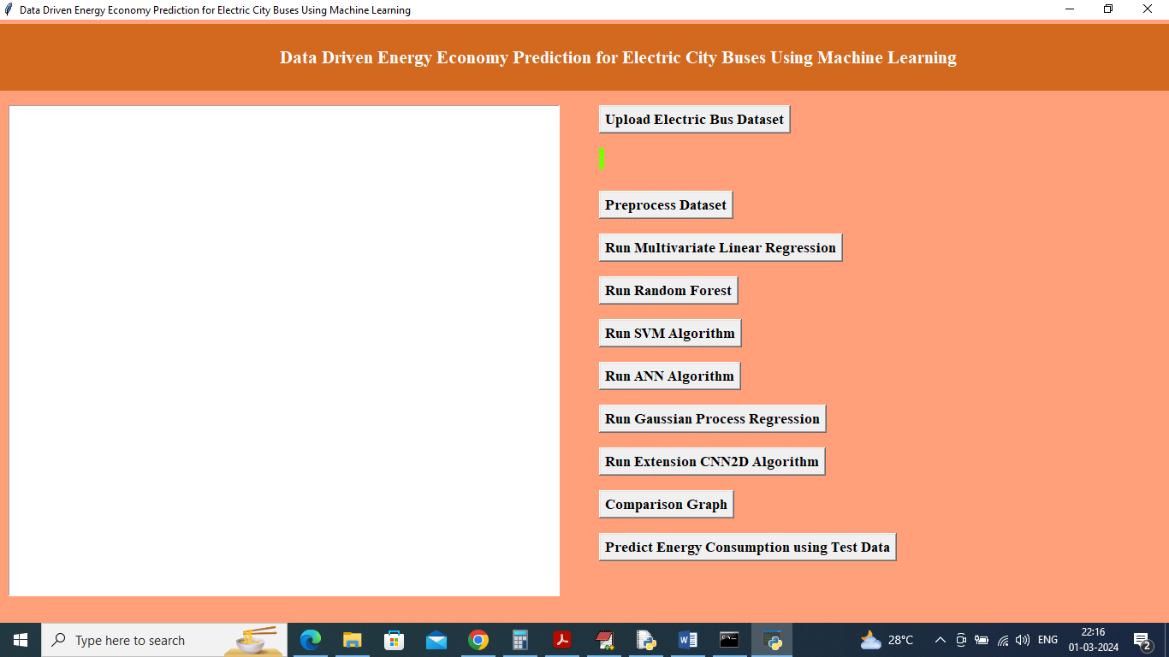

In above screen click on ‘Upload Electric Bus Dataset’ button to upload dataset and get below page

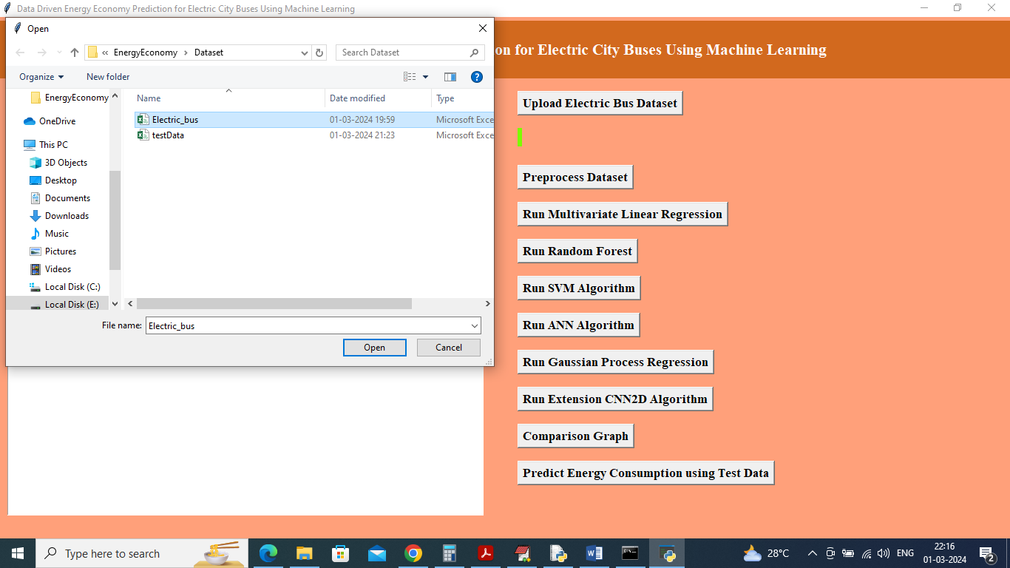

In above screen selecting and uploading dataset and then click on ‘Open’ button to load dataset and get below page

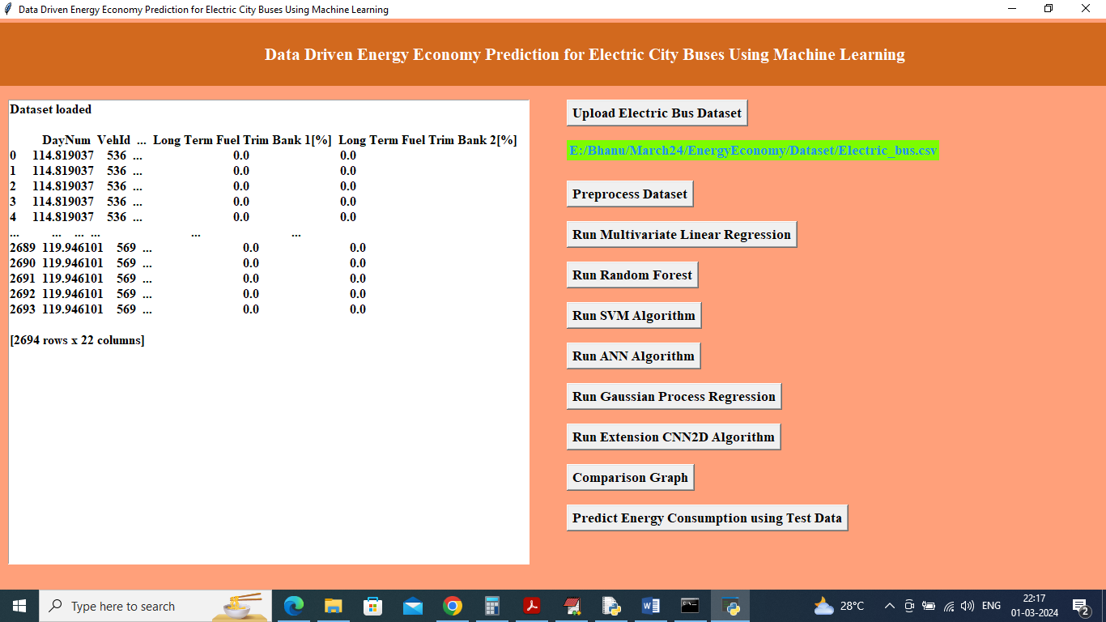

In above screen dataset loaded and now click on ‘Pre-process Dataset’ button to clean dataset and then select features using Neighbourhood and then split to train and test

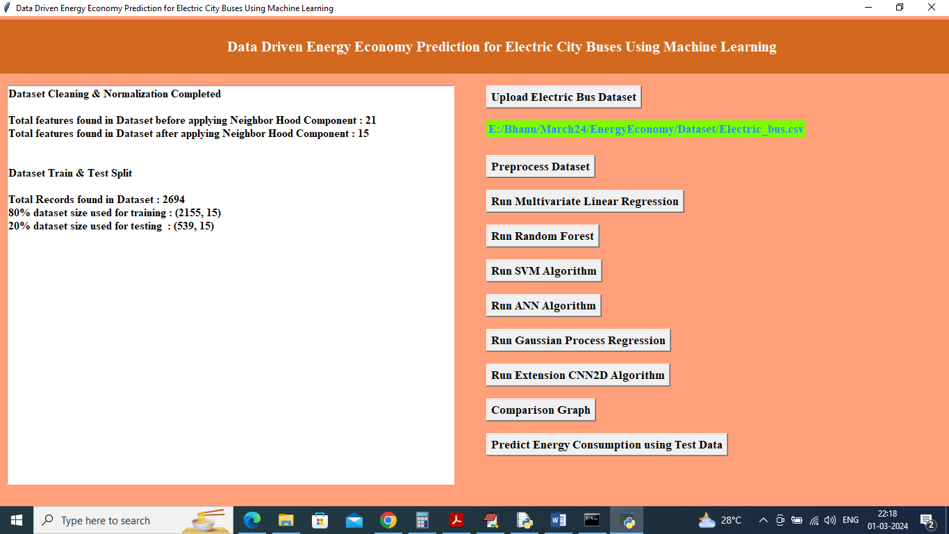

In above screen can see before applying Neighbourhood dataset having 21 features and after applying we got 15 selected relevant features and then can see train and test dataset size and now click on ‘Run Multivariate Linear Regression’ button to train model and get below page

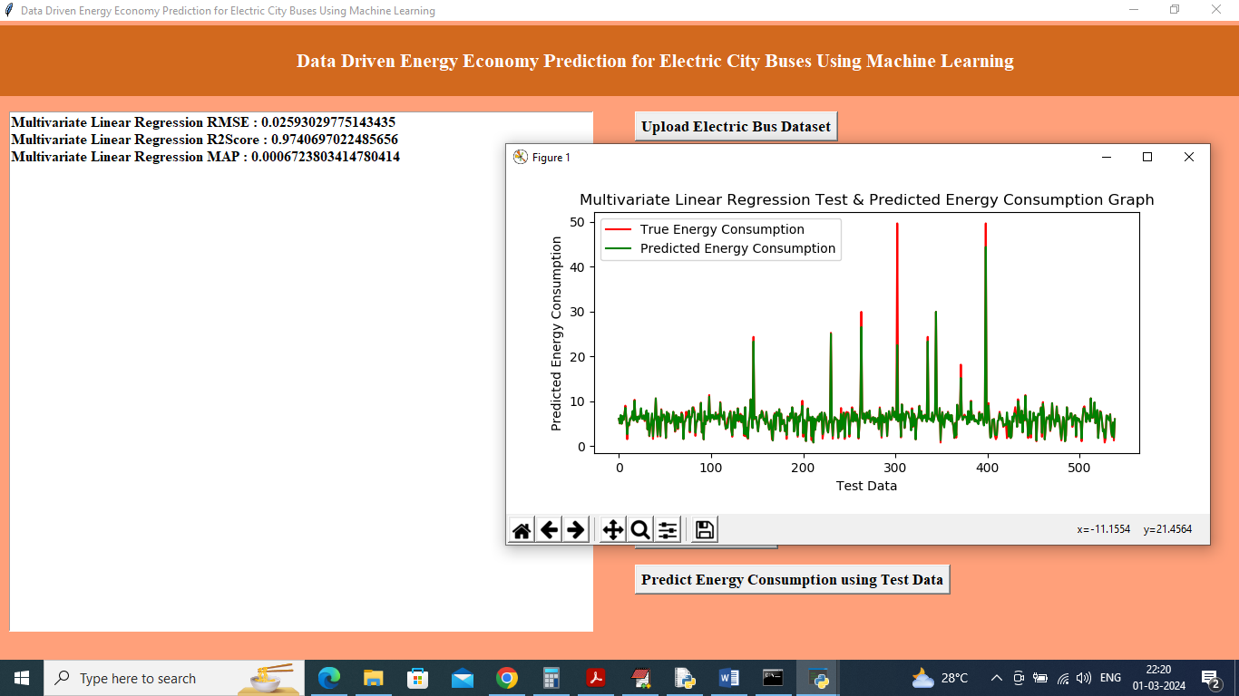

In above screen Linear Regression got 97% R2Score and can see RMSE and MAP error values and in graph x-axis represents Test data and y-axis represents energy consumption values where green line represents predicted energy and red line represents True energy test data values and can see both lines are fully overlapping with tiny gap so we can say linear regression is accurate and now click on ‘Run Random Forest’ button to get below output

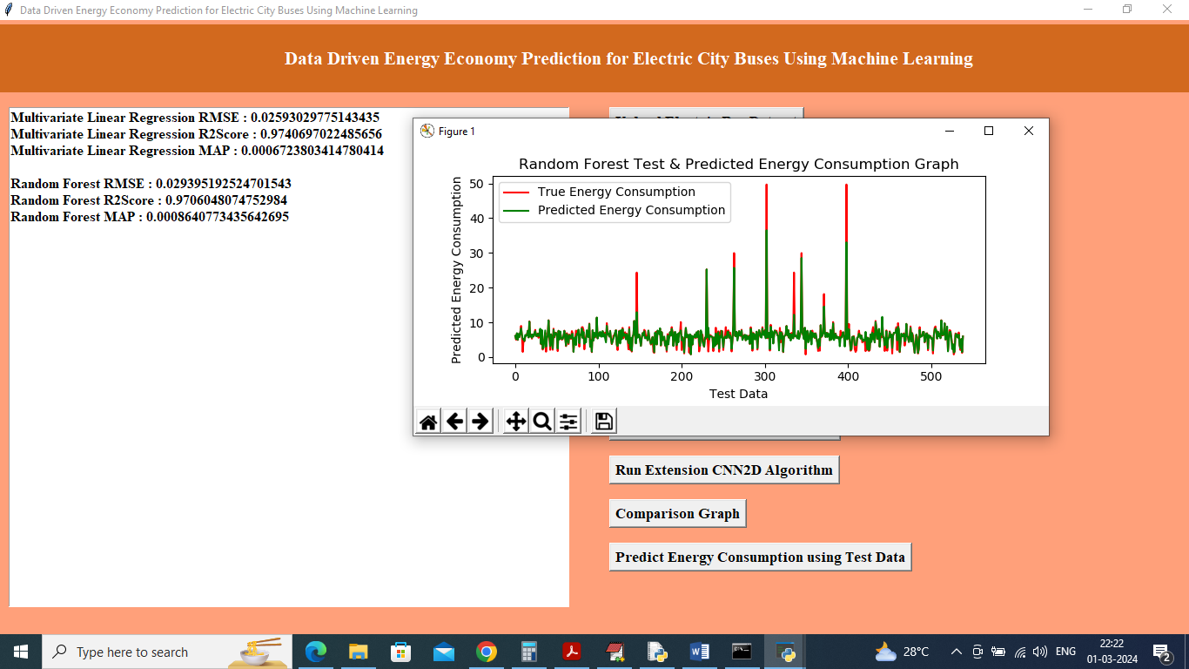

In above screen Random Forest also got same 97% score but error values are high and now run SVM algorithm

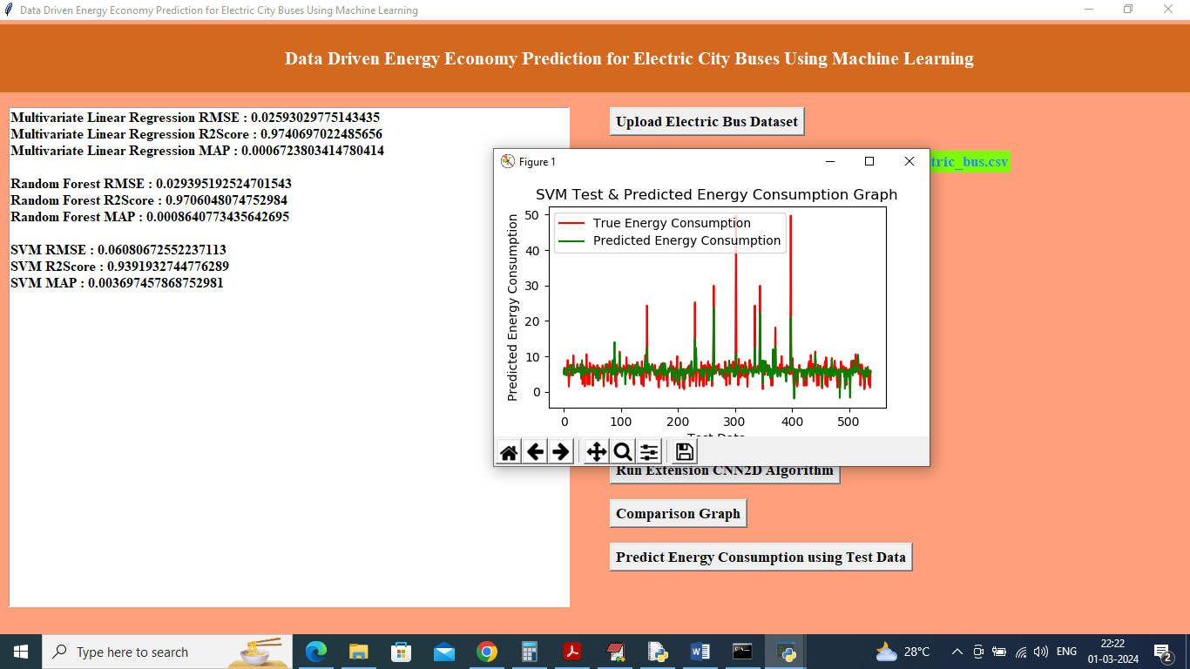

In above screen can see SVM performance output and now click on ‘Run ANN algorithm’ button to get below output

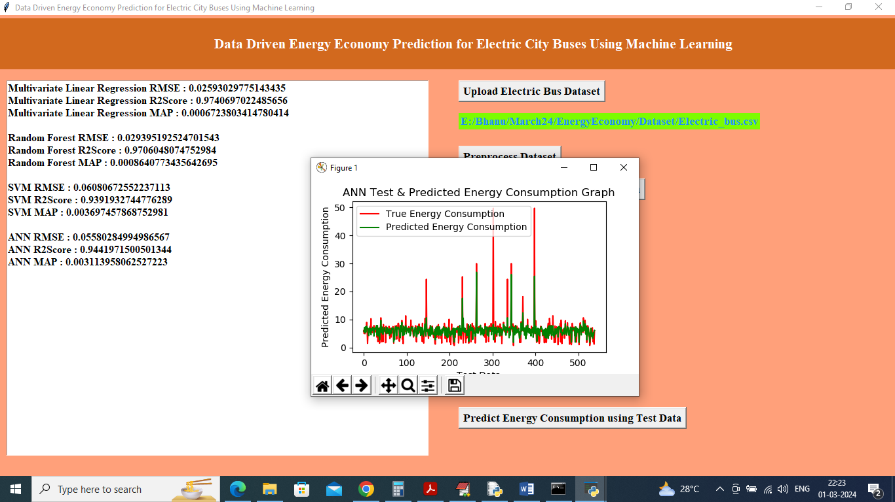

In above screen can see ANN output and now click on ‘Run Gaussian Process’ button to get below output

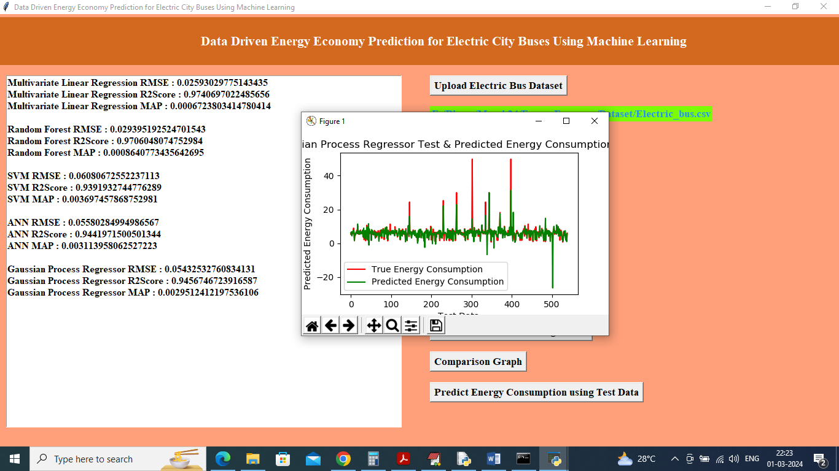

In above screen can see Gaussian Process Regression output and now click on ‘Run Extension CNN2D algorithm’ button to get below output

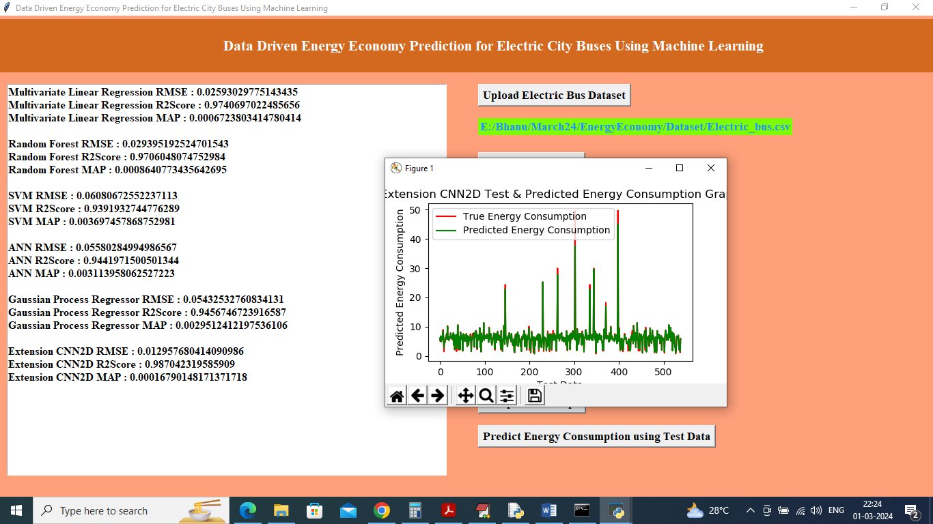

In above screen extension CNN2D got highest R2SCORE as 98% and now click on ‘Comparison Graph’ button to get below graph

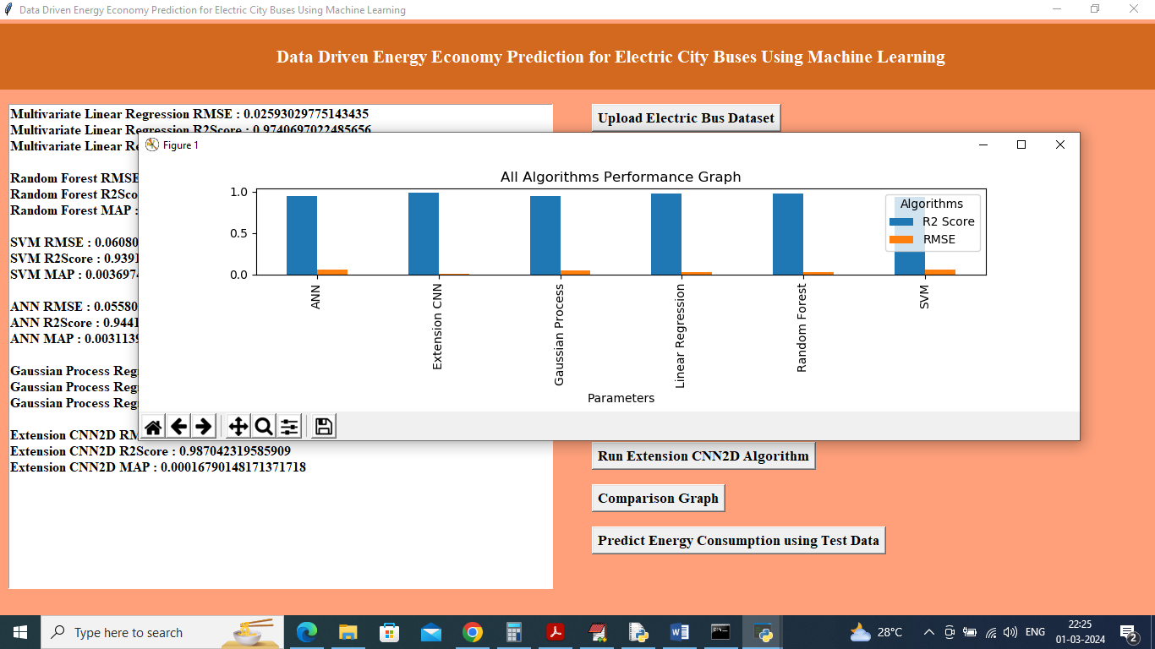

In above screen x-axis represents algorithm names and y-axis represents R2SCORE and RMSE and blue line represents R2score and orange bar represents RMSE and can see extension CNN2d got high R2 and less RMSE error and now click on ‘Predict Energy Consumption using Test Data’ button to upload test data and get below page

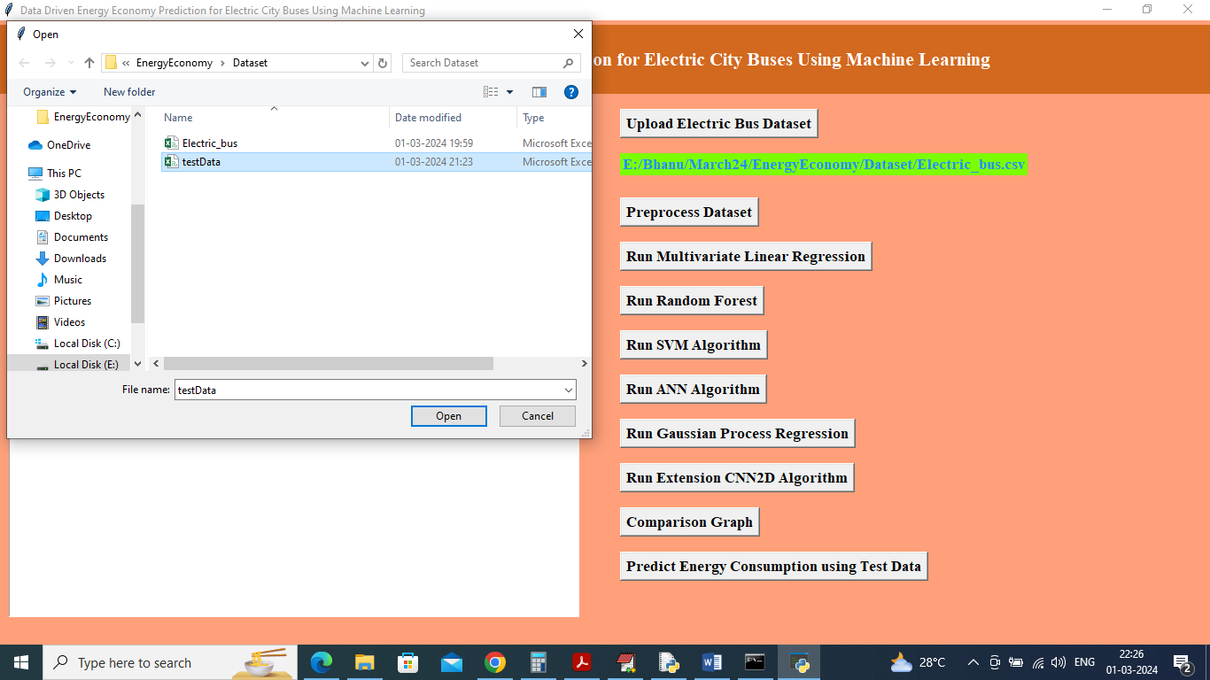

In above screen selecting and uploading test data file and then click on ‘Open’ button to get below output

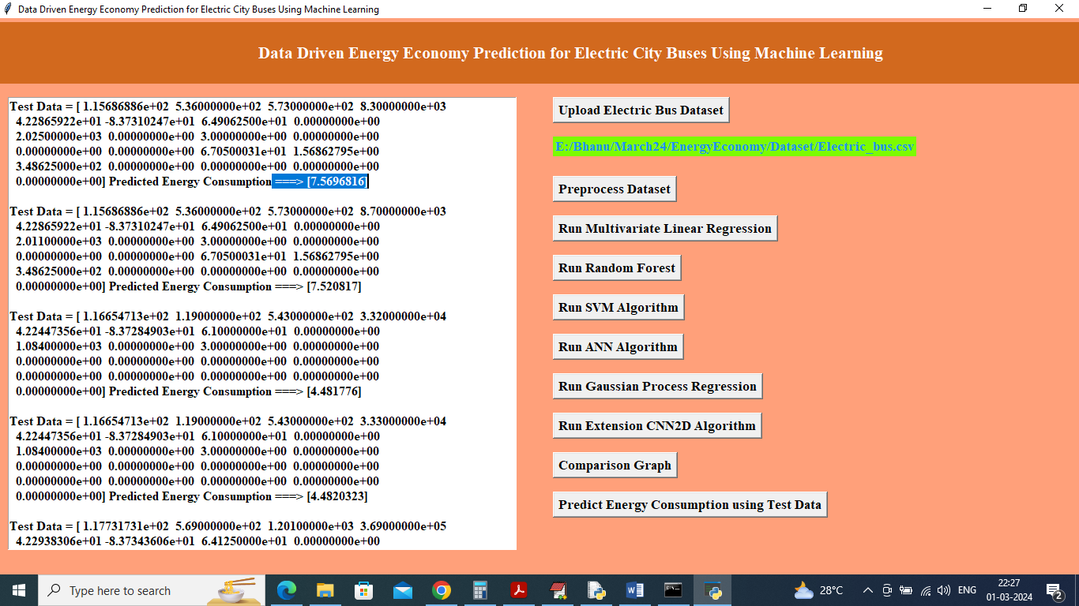

In above screen in square bracket can see vehicle energy Test data and then after =🡺 arrow symbol can see predicted energy consumption.