Class :01 Vinitha

Wireshark :
Wireshark is a free, open-source network protocol analyzer used to capture, inspect, and troubleshoot live traffic traveling across a network, that lets you capture and inspect data packets traveling through a computer network.

A packet entry may contain:
Go to search (Testfire.net)
Click --->Altoro Mutual
Set --> login and password

What can Wireshark do?
- Capture packets: Records small units of data traveling across a network.
- Analyze network traffic: Shows how computers, servers, and other devices communicate.
- Troubleshoot problems: Helps identify slow connections, failed requests, and network errors.
- Inspect protocols: Lets you examine protocols such as TCP, UDP, DNS, HTTP, and TLS.
- Support cybersecurity investigations: Helps analysts investigate suspicious network activity.

How to use Wireshark for the first time
- Download Wireshark from the official website: wireshark.org .
- Install it, including the packet-capture component offered for your operating system.
- Open Wireshark and select your active interface, such as Wi-Fi or Ethernet.
- Double-click the interface to start capturing packets.
- Open a website in your browser and watch the packets appear.
- Enter dns in the display-filter bar to view DNS packets, then press Enter.
- Press the red square Stop button when you finish capturing.

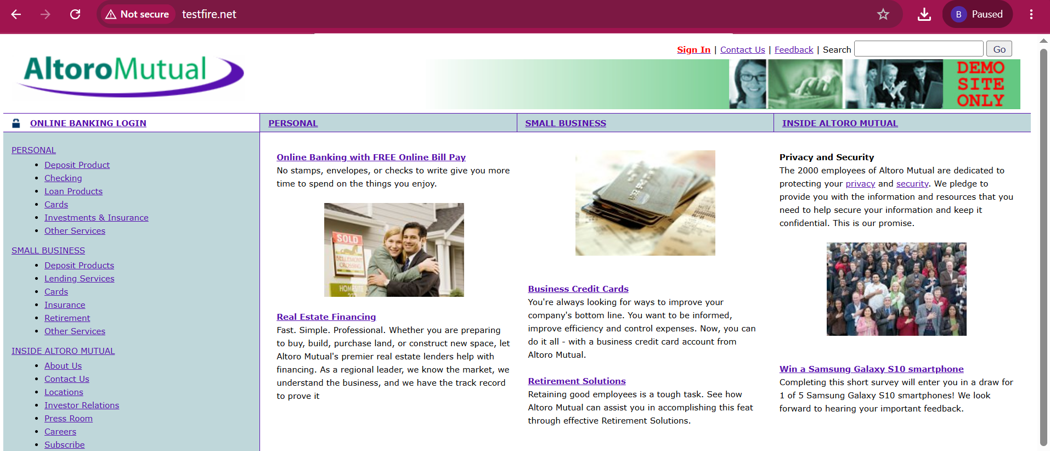

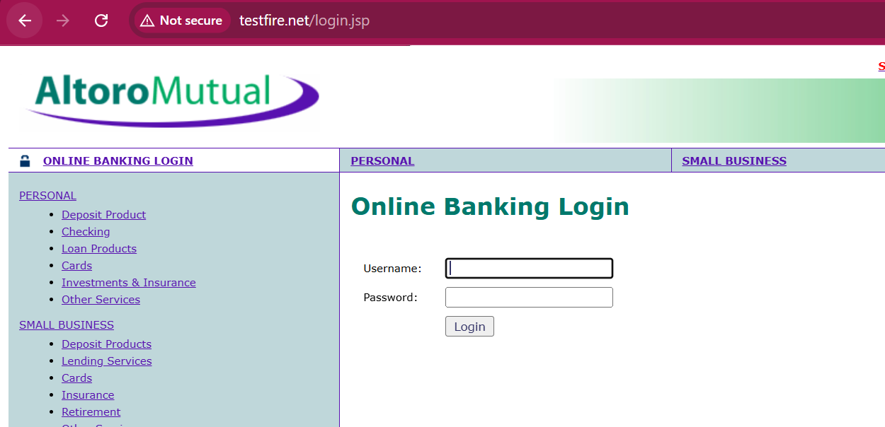

Follow these steps:
- Open Wireshark.
- Select your active Wi-Fi or Ethernet interface.
- 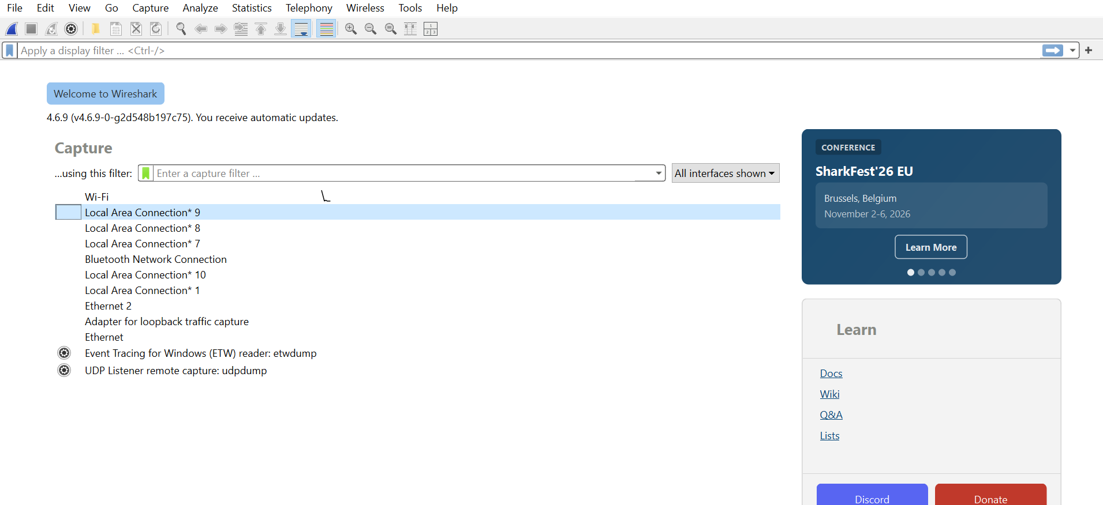

- Start capturing packets.
- Open a 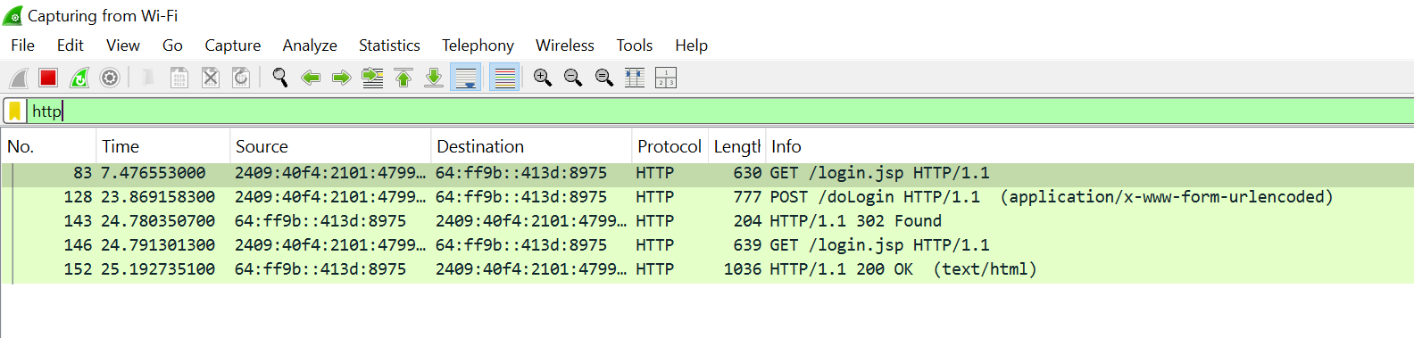website or generate some network traffic.
- Click any packet in the top packet list.
- 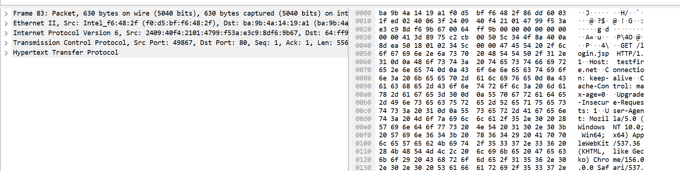
- Look at the Packet Details pane in the middle.
- 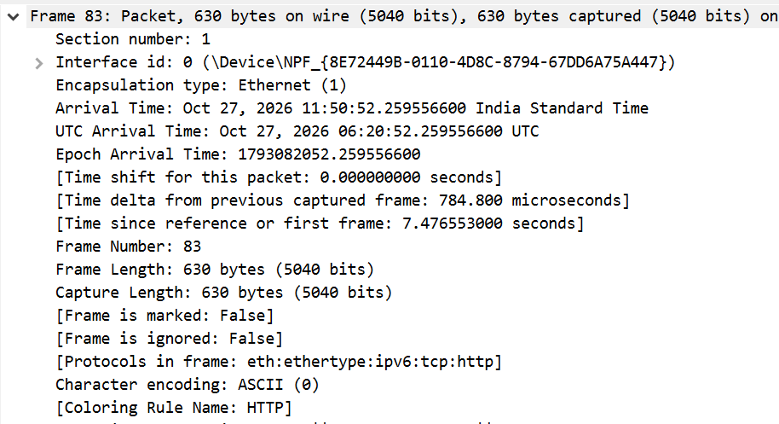

- Expand the sections to inspect the frame, Ethernet, IP, TCP/UDP, and application protocol details.
- 