Fertility and Life Expectancy (2021
7COM1079 FINAL REPORT
2025-12-11

R Markdown
# Run the next line ONCE if you don't have ggplot2 and dplyr:
# install.packages(c("ggplot2","dplyr"))
library(ggplot2)
library(dplyr)
##
## Attaching package: 'dplyr'
## The following objects are masked from 'package:stats':
##
## filter, lag
## The following objects are masked from 'package:base':
##
## intersect, setdiff, setequal, union
# 1) Read your CSV file
data <- read.csv("C:/Users/DELL/Downloads/all_indicators.csv")
# 2) Look at the structure (names of columns)
names(data)
## [1] "economy" "Pop.YR2002" "Pop.YR2021" "Pop."
## [5] "Life.YR2002" "Life.YR2021" "Life." "Fer.YR2002"
## [9] "Fer.YR2021" "Fer." "Death.YR2002" "Death.YR2021"
## [13] "Death." "Birth.YR2002" "Birth.YR2021" "Birth."
## [17] "Med_Age.YR2002" "Med_Age.YR2021" "Med." "Pop_Gro.YR2002"
## [21] "Pop_Gro.YR2021"
head(data)
## economy Pop.YR2002 Pop.YR2021 Pop. Life.YR2002 Life.YR2021 Life.
## 1 ABW 91781 106537 0.16077402 73.72600 74.62600 0.012207362
## 2 AFE 422741118 702977106 0.66290213 52.54079 62.45459 0.188687587
## 3 AFG 21000256 40099462 0.90947491 56.45400 61.98200 0.097920431
## 4 AFW 284952322 478185907 0.67812602 50.92785 56.98866 0.119007746
## 5 AGO 17516139 34503774 0.96982760 47.38600 61.64300 0.300869455
## 6 ALB 3051010 2811666 -0.07844746 75.89000 76.46300 0.007550402
## Fer.YR2002 Fer.YR2021 Fer. Death.YR2002 Death.YR2021 Death.
## 1 1.763000 1.180000 -0.3306863 6.42000 11.235000 0.7500000
## 2 5.430475 4.354709 -0.1980979 13.30959 8.036899 -0.3961572
## 3 7.339000 4.643000 -0.3673525 11.28000 7.344000 -0.3489362
## 4 5.967267 4.978662 -0.1656712 15.00691 10.678952 -0.2883975
## 5 6.567000 5.304000 -0.1923253 17.27500 8.009000 -0.5363821
## 6 2.036000 1.390000 -0.3172888 5.95300 11.325000 0.9024022
## Birth.YR2002 Birth.YR2021 Birth. Med_Age.YR2002 Med_Age.YR2021 Med.
## 1 12.99200 7.19300 -0.4463516 33.9 41.2 0.21533923
## 2 40.04732 33.54627 -0.1623344 NA NA NA
## 3 48.20100 35.84200 -0.2564055 14.0 16.7 0.19285714
## 4 42.92712 36.23703 -0.1558476 NA NA NA
## 5 47.44800 38.80900 -0.1820730 15.7 16.2 0.03184713
## 6 15.20900 10.24000 -0.3267144 27.3 37.3 0.36630037
## Pop_Gro.YR2002 Pop_Gro.YR2021
## 1 1.1947181 -0.04504462
## 2 2.6065980 2.60747169
## 3 6.4493215 2.85135765
## 4 2.8114527 2.57337740
## 5 3.3351316 3.16602986
## 6 -0.2998767 -0.92691806
summary(data)
## economy Pop.YR2002 Pop.YR2021 Pop.
## Length:266 Min. :0.000e+00 Min. :0.000e+00 Min. :-0.3587
## Class :character 1st Qu.:1.300e+06 1st Qu.:1.672e+06 1st Qu.: 0.1031
## Mode :character Median :8.272e+06 Median :1.046e+07 Median : 0.2505
## Mean :2.518e+08 Mean :3.213e+08 Mean : 0.3232
## 3rd Qu.:5.080e+07 3rd Qu.:6.254e+07 3rd Qu.: 0.5229
## Max. :6.308e+09 Max. :7.888e+09 Max. : 2.7693
## NA's :1
## Life.YR2002 Life.YR2021 Life. Fer.YR2002
## Min. : 0.00 Min. : 0.00 Min. :-1.00000 Min. :0.000
## 1st Qu.:59.18 1st Qu.:65.05 1st Qu.: 0.02081 1st Qu.:1.751
## Median :69.97 Median :71.75 Median : 0.04777 Median :2.550
## Mean :65.50 Mean :68.96 Mean : 0.06068 Mean :3.043
## 3rd Qu.:74.58 3rd Qu.:76.40 3rd Qu.: 0.08840 3rd Qu.:4.103
## Max. :81.69 Max. :85.49 Max. : 0.33212 Max. :7.671
## NA's :8
## Fer.YR2021 Fer. Death.YR2002 Death.YR2021
## Min. :0.000 Min. :-0.54094 Min. : 0.000 Min. : 0.000
## 1st Qu.:1.568 1st Qu.:-0.25827 1st Qu.: 5.958 1st Qu.: 6.705
## Median :2.027 Median :-0.17783 Median : 8.269 Median : 8.309
## Mean :2.466 Mean :-0.14605 Mean : 8.630 Mean : 8.591
## 3rd Qu.:3.232 3rd Qu.:-0.07106 3rd Qu.:11.011 3rd Qu.: 9.895
## Max. :6.820 Max. : 0.66000 Max. :18.670 Max. :21.700
## NA's :8
## Death. Birth.YR2002 Birth.YR2021 Birth.
## Min. :-0.60459 Min. : 0.00 Min. : 0.00 Min. :-1.0000
## 1st Qu.:-0.18327 1st Qu.:13.04 1st Qu.:10.50 1st Qu.:-0.2848
## Median : 0.06055 Median :21.06 Median :15.92 Median :-0.2082
## Mean : 0.07248 Mean :23.10 Mean :18.41 Mean :-0.1931
## 3rd Qu.: 0.29093 3rd Qu.:31.26 3rd Qu.:25.80 3rd Qu.:-0.1250
## Max. : 1.32303 Max. :51.84 Max. :45.29 Max. : 0.5370
## NA's :6 NA's :5
## Med_Age.YR2002 Med_Age.YR2021 Med. Pop_Gro.YR2002
## Min. :13.80 Min. :14.50 Min. :-0.07547 Min. :-2.9586
## 1st Qu.:18.00 1st Qu.:21.60 1st Qu.: 0.11122 1st Qu.: 0.5414
## Median :23.80 Median :30.00 Median : 0.18333 Median : 1.3588
## Mean :25.37 Mean :30.24 Mean : 0.19444 Mean : 1.4364
## 3rd Qu.:32.75 3rd Qu.:38.25 3rd Qu.: 0.26037 3rd Qu.: 2.4189
## Max. :45.00 Max. :54.50 Max. : 0.62766 Max. : 6.4493
## NA's :43 NA's :43 NA's :43
## Pop_Gro.YR2021
## Min. :-4.2566
## 1st Qu.: 0.1766
## Median : 0.9016
## Mean : 0.8987
## 3rd Qu.: 1.7892
## Max. : 3.7074
##
# Select variables
analysis_data <- data %>%
select(Med_Age.YR2021, Death.YR2021) %>%
na.omit()
head(analysis_data)
## Med_Age.YR2021 Death.YR2021
## 1 41.2 11.235
## 3 16.7 7.344
## 5 16.2 8.009
## 6 37.3 11.325
## 7 42.5 0.000
## 9 32.8 1.874
summary(analysis_data)
## Med_Age.YR2021 Death.YR2021
## Min. :14.50 Min. : 0.000
## 1st Qu.:21.60 1st Qu.: 6.593
## Median :30.00 Median : 8.100
## Mean :30.24 Mean : 8.561
## 3rd Qu.:38.25 3rd Qu.: 9.966
## Max. :54.50 Max. :21.700
ggplot(analysis_data, aes(x = Med_Age.YR2021, y = Death.YR2021)) +
geom_point(color = "blue") +
geom_smooth(method = "lm", color = "red") +
labs(
title = "Correlation Between Median Age (2021) and Death Rate (2021)",
x = "Median Age (2021)",
y = "Death Rate (2021)"
) +
theme_minimal()
## `geom_smooth()` using formula = 'y ~ x'
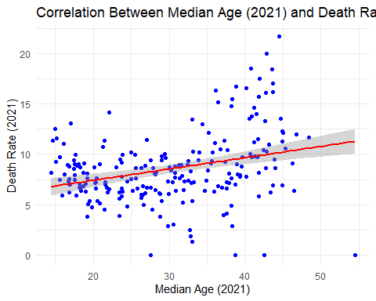
ggplot(analysis_data, aes(x = Med_Age.YR2021)) +
geom_histogram(binwidth = 2, fill = "skyblue", color = "black") +
labs(
title = "Distribution of Median Age (2021)",
x = "Median Age (2021)",
y = "Frequency"
) +
theme_minimal()
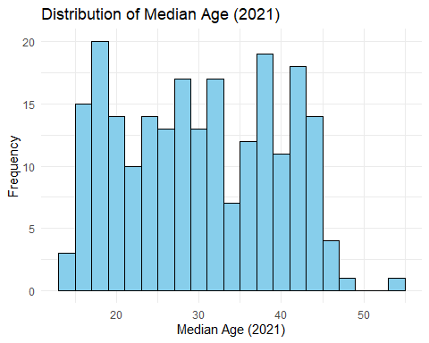
# Correlation test
cor_test_result <- cor.test(
analysis_data$Med_Age.YR2021,
analysis_data$Death.YR2021,
method = "pearson"
)
cor_test_result
##
## Pearson's product-moment correlation
##
## data: analysis_data$Med_Age.YR2021 and analysis_data$Death.YR2021
## t = 4.7332, df = 221, p-value = 3.945e-06
## alternative hypothesis: true correlation is not equal to 0
## 95 percent confidence interval:
## 0.1791490 0.4180979
## sample estimates:
## cor
## 0.3033854
model <- lm(Death.YR2021 ~ Med_Age.YR2021, data = analysis_data)
summary(model)
##
## Call:
## lm(formula = Death.YR2021 ~ Med_Age.YR2021, data = analysis_data)
##
## Residuals:
## Min 1Q Median 3Q Max
## -11.281 -1.734 -0.140 1.472 11.540
##
## Coefficients:
## Estimate Std. Error t value Pr(>|t|)
## (Intercept) 5.16949 0.75015 6.891 5.70e-11 ***
## Med_Age.YR2021 0.11214 0.02369 4.733 3.94e-06 ***
## ---
## Signif. codes: 0 '***' 0.001 '**' 0.01 '*' 0.05 '.' 0.1 ' ' 1
##
## Residual standard error: 3.318 on 221 degrees of freedom
## Multiple R-squared: 0.09204, Adjusted R-squared: 0.08793
## F-statistic: 22.4 on 1 and 221 DF, p-value: 3.945e-06
ggsave("scatterplot_corr.png", width = 7, height = 5)
ggsave("histogram_median_age.png", width = 7, height = 5)
write.csv(analysis_data, "cleaned_dataset.csv", row.names = FALSE)

