**Machine learning Assignmnet – 2**

**Github link:** <https://github.com/Vinithapatel1211/Machine_Learning_Assignments/tree/main/Icp2_Vinitha>

**Description 1:**

Using Python code to display star pattern by using for loop.

**Description 2:**

Using looping to output the elements from a given list present at odd indexes.

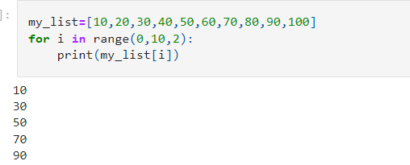

**Description 3:**

Writing code that appends the type of elements from a given list.

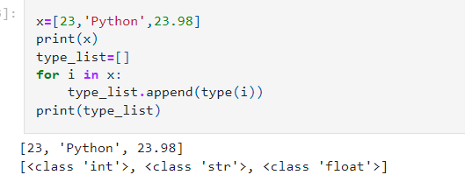

**Description 4:**

Writing a function that takes a list and returns a new list with unique items of their fist list.

Sample list [1, 2, 3, 3, 3, 3, 4, 5]

Unique list [1, 2, 3, 4, 5]

**Description 5:**  Writing a function that accepts a string and calculates the number of upper case letters and lower case letters.

