**RESUME**

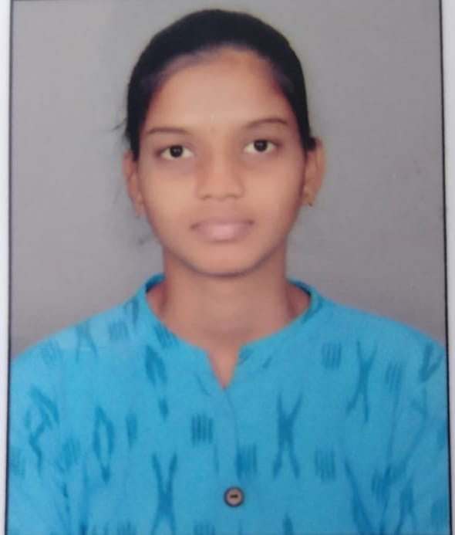

**RUDROJU VINITHA**

6303270300 rudrojuvinitha@gmail.com

|  |
| --- |
| Career Objective |

To pursue a challenging career and be a part of a progressive organization that gives scope to my knowledge, skills which can be better utilized for the organizational growth as well as personal growth.

|  |
| --- |
| **Educational Details** |

* B.Tech(ECE) from **Balaji Institute of Technology& Science, Narsampet** during 2021-2025.
* Board of Intermediate Education (**B.I.E**) from **Kakatiya junior college** during 2019-2021.
* Secondary school of education (**S.S.C**) from **Kakatiya brillant stars high school** during 2018-2019

.

|  |
| --- |
| **CERTIFICATION** |

* Infosys springboard – Beginning of python
* Skill India
* Infosys springboard – JAVA fundamentals

|  |
| --- |
| **Technical Skills** |

* Soft wares : Auto CAD,MAT Lab,MS-Office
* Programming Languages : C, Python , Basics in Java

|  |
| --- |
| Strengths |

* Self Confident.
* Positive Thinking.
* Working Under Stress.

|  |
| --- |
| **Personal Details** |

* Name : Vinitha Rudroju
* Father’s Name : Srinivas Rudroju
* Hobbies : Listening music,Reading Books
* Date of birth : 28-08-2003
* Gender : FeMale
* Languages known : English, Telugu
* Marital Status : UnMarried
* Nationality : Indian
* Address : Vinitha Rudroju

D/O Srinivas Rudroju

Village: DwarakaPet

Mandal:Narsampet

Dist:Warangal

Pin:506132

|  |
| --- |
| **Declaration** |

I hereby declare that the above written particulars made are true to the best of my knowledge and belief.

**(Vinitha Rudroju)**