MYSQL AND HTML

TABLE CREATIONS:1

QUERY:

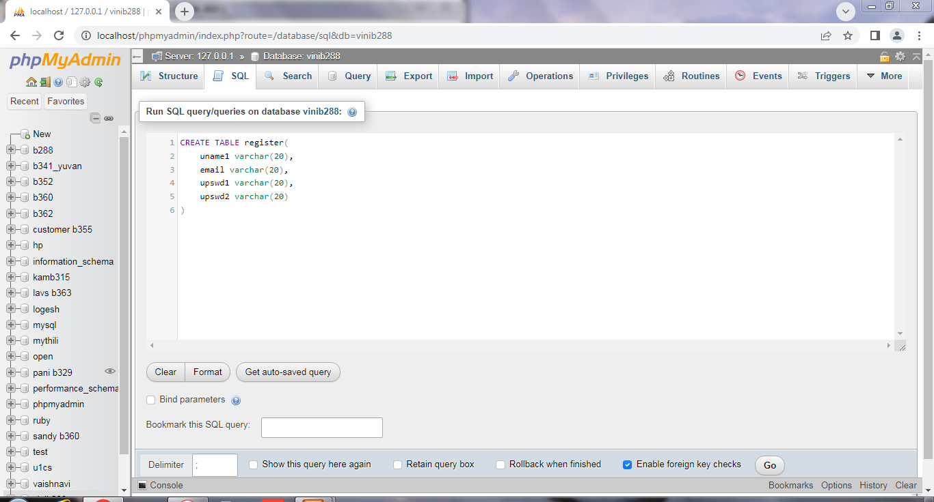

OUTPUT:

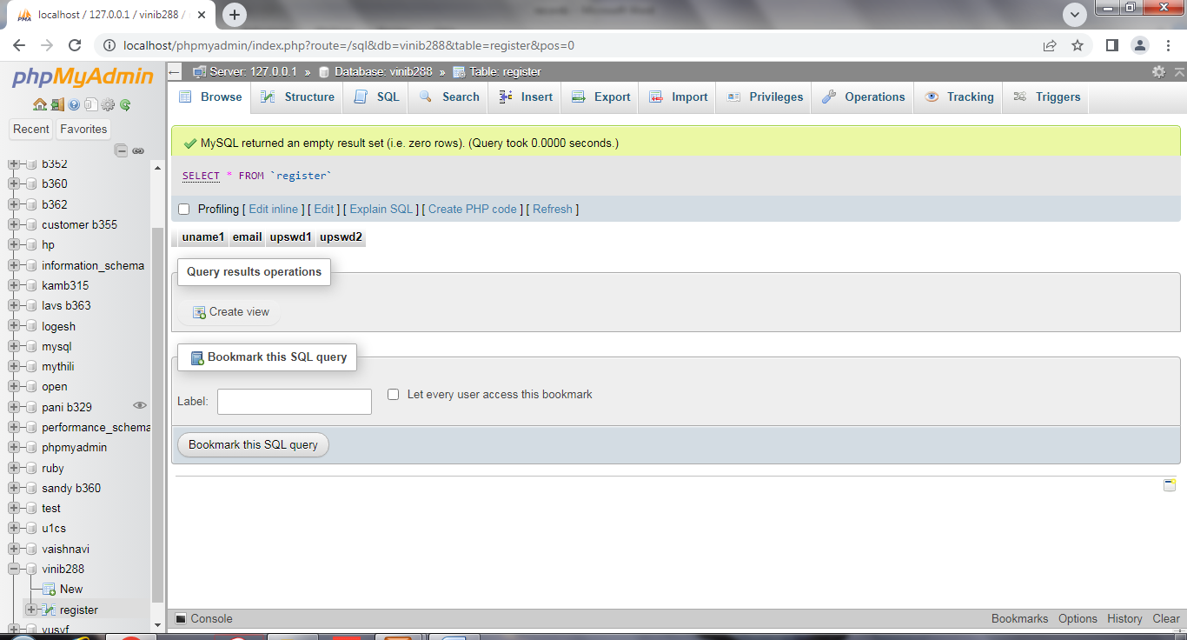

INDEX HTML :2



REGISTER HTML:3



Login php:4