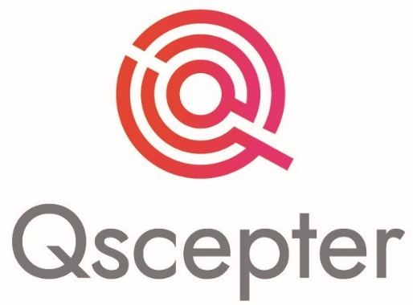

Web Development Proposal (Phase -2) New Additions

*Prepared for:*



*Prepared by:***Qscepter MMC**

[info@qscepter.com](mailto:info@qscepter.com)

Dated: 9th Nov 2020

Greetings from **Qscepter**.

As per current requirement from client (MakroMedicine), below mentioned are the status and details which we received through our information gathering phase.

**About Client:** MakroMedicine.

MakroMedicine is a pharmaceutical organization involved in consulting service for pharmaceutical companies.

Aims to provide convenient ways of providing medicines across many countries an also to develop fastest and easiest way of connection and cooperation between pharmaceutical companies.

**Client Location**: Azerbaijan.

**Website**: www.makromedicine.com

**Phase 2 Addition - Requirement** (from client-side)

This proposal is made base on the additional requirement for phase 2 and the financials and timeline are subject to the additions and changes mentioned by the client.

**Deliverables**:

1. Frontend design conversion of new product design. – Məhsulun iç səhifəsinin yeni dizaynının html-ə konvert olunması
2. Develop backend for new product design – Məhsulun iç səhifəsinin yeni dizaynının proqramlaşdırılması.
3. Employ search design (frontend) – İşçi axtarışının html-ə convert olunması
4. Employ search design (backend) – İşçi axtarışının proqramlaşdırılması
5. Develop backend and logic for one user can apply for multiple companies. – Bir işçinin bir neçə şirkətə müraciət edə bilməsi
6. Company page admin can change name of the page. – Admin şəxs şirkət adını dəyişə bilməsi
7. MakroMedicine admin can approve the name change of the company – Şirkət adı dəyişikliyi sayt adminin təsdiqindən sonra mümkün olacaq.
8. Splitting user table and company table. – users table-sinin böləndən sonra aşağıdakı düzəlişlər olacaq.

* This will affect - user company relationship table, edit, company profile
* Edit user profile.
* Edit company information
* Company public view.
* User public view.
* Add product.
* Add news. **Backend Process.**
* Edit product.
* Edit news.
* View product.
* View news.
* Admin backend edit.

1. Company Search.

* Change backend for company changes (After splitting it should search in Company tables) – Cədvəli böləndən sonra company search back-end də dəyişiklik olacaq.

1. Following and followers list design convention and connect to backend. – Follower yeni dizaynın kəsilməsi və proqramlaşdırılması.

**Qscepter** in its project/product development follows proper Software Development Life Cycle and Scrum Agile Process for managing complex software development task.

**Development Phases**

* Planning
* Research/Outreach
* Design
* Consultation
* Development
* Testing
* Deployment

**Deliverables**

* Design
* Development
* Testing
* Deployment

**Pricing** (Phase 2 new additions):

To receive the utmost value from your investment in the product. This budget breakdown is based on the project outline.

|  |  |
| --- | --- |
| Standard |  |
| Standard design |  |
| Structured Backend |  |
| Compatible with multiple device |  |
| Support |  |
|  |  |
| Total (exc tax) | **800 Azn** |

**Duration:** Approximately 3 weeks.

*Note: The above-mentioned timeline and cost may vary if requirement changes from client side or addition in mentioned changes or delay in coordination with the client.*

**Agreement**

By signing below, you agree to accept this proposal for the development and any modifications already agreed upon with **Qscepter.**

|  |  |
| --- | --- |
| **Qscepter MMC** | **Client: MakroMedicine** |
| Signed by: | Signed by: |
| Date: | Date: |