A

Report on

To Study the consumption pattern of consumer of products of suhas enterprises

Submitted by: Vinit Vijay Vanpartiwar

Roll No. : 3096

Year : TYBBA

Semester: VI

Under the guidance of:

Prof. Shilpa Kulkarni

Submitted to:



Sir Parashurambhau College (Autonomous), affiliated to

Savitribai Phule Pune University.

In the partial fulfillment of:

BACHELORS OF BUSINESS ADMINISTRATION

2022-23

**CERTIFICATE**

This is to certify that , Vinit vijay vanpartiwar is a bonafied student of, Sir Parashurambhau College, Pune for BBA program (2020-2023), affiliated to University Of Pune. The Project entitled “**To Study The Consumer pattern of consumer of products of suhas enterprises.”** is the original work student has carried out on the basis of authentic information under my guidance**.**

(Prof. Shilpa Kulkarni) ____________

Project Guide Head Of the Department

Name: Prof. Shilpa Kulkarni Name:

(Internal Examiner) (External Examiner)

Signature: _______ Signature: __________

Date: Date:

COMPANY CERTIFICATE

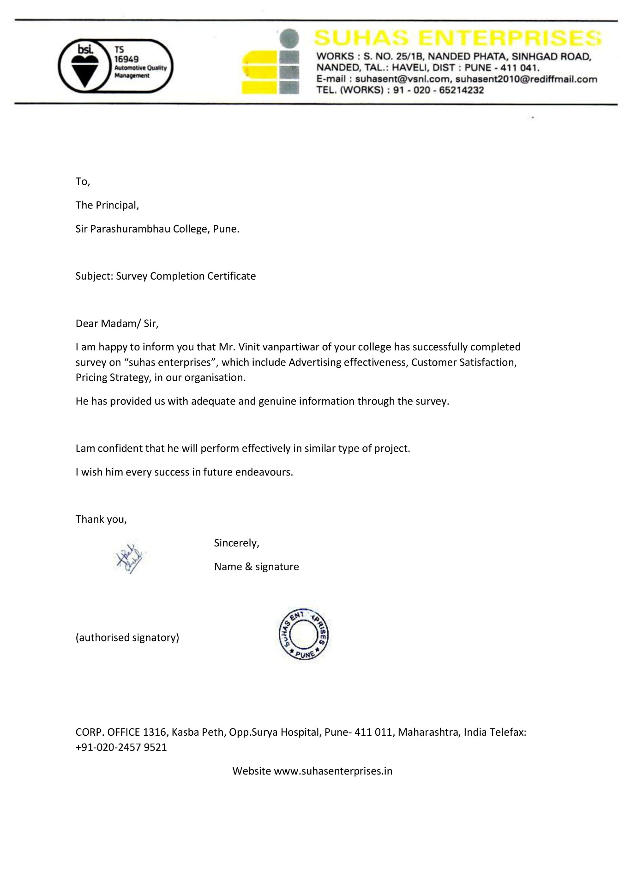

INDEX

|  |  |  |
| --- | --- | --- |
| **Sr.no** | **Topic** | **Page no.** |
| **1.** | **Chapter 1: Introduction** | **1** |
| **2.** | **Chapter 2: Company Profile** | **3** |
| **3** | **Chapter 3: Objective of Study** | **6** |
| **4.** | **Chapter 4: Review of Literature** | **8** |
| **5** | **Chapter 5: Research Methodology** | **16** |
| **6.** | **Chapter 6: Data Analysis and Data interpretation** | **21** |
| **7.** | **Chapter 7: Observation and Finding** | **36** |
| **8.** | **Chapter 8: Suggestions** | **39** |
| **9.** | **Chapter 9: Conclusion** | **41** |
| **10.** | **Chapter 10: Bibliography** | **43** |
| **11.** | **Chapter 11: Annexures** | **45** |

CHAPTER 1

INTRODUCTION

INTRODUCTION

Suhas Enterprises is a reputable company that specializes in the design, manufacturing, and supply of high-quality gear box parts for a variety of industrial applications. With a wealth of experience in the industry, Suhas Enterprises has established itself as a trusted supplier of gear box parts to clients across India and beyond.

The company has a strong commitment to innovation and quality, which is reflected in their use of advanced technologies and materials to manufacture their products. They have a team of skilled engineers and technicians who work tirelessly to ensure that their products meet the highest standards of performance, durability, and reliability.

In this marketing research paper, we will explore the history and background of Suhas Enterprises, including their mission, vision, and core values. We will also examine their current product offerings and any recent developments or innovations in their manufacturing processes. Additionally, we will look at their customer base and any notable clients or partnerships that they have established.

By studying Suhas Enterprises and their approach to the gear box parts market, we hope to gain valuable insights into the industry as a whole. We will identify potential areas for growth and expansion, as well as ways to better serve the needs of customers and improve overall performance. This research will help us to develop a better understanding of the gear box parts market and how Suhas Enterprises can continue to be a leading player in this space

CHAPTER 2

COMPANY PROFILE

SUHAS ENTERPRISES

Suhas enterprises is manufacturer of auto components of various types with ISO / TS: 16949: 2000 certifications. Working in Steel, Investment Casting, Aluminium Casting, C.I., S.G.Iron, Forging, Gun metal and Brass, Plastic Moulding.

All above material is procured from approved and reliable source. working in a plant admeasuring around 25000Sq. ft has been built on Pune municipal corporation limit & also have HT connection . We have also area for extension . suhas enterprises aslo working in a plant admeasuring around 40000Sq. Ft. has been built in dharrwad

We have also Induction Hardening machines at our end for all types of fork. Cylindrical Grinding, Centerless Grinding and trob facility is also available with us. We have also available out-sourcing CMM facility for checking of all critical parameters.

SUHAS ENTERPRISES established in the year 1985. and is an ISO/TS 16949: 2002 certified company catering major automobile. OEM for precision machined components. The SUHAS ENTERPRISES team consists of technically sound and experienced Employees, dedicated to providing high quality services to our esteemed customers. Shortly converting from SI unit to Private Limited firm.

The working Culture of SUHAS ENTERPRISES involves defect prevention, Promotion of continual Improvement, Reduction in variation & Waste elimination in the organization.Equipped with Good Supplier Chain to be a Full Service Suppliers for our customers.

We are planning to be a full service supplies by installing Induction Hardening & Assembly facilities.Induction Hardening Setup is built in-house to satisfy customer requirements.

PRODUCTS AND SERVICES

Suhas Enterprises offers a wide range of products and services related to gear box parts.

Some of their key products include:

1. Gears: Suhas Enterprises produces a wide range of gears for use in various types of gear boxes. Their gears are available in different sizes, materials, and configurations to meet the specific needs of different applications.

2. Shafts: The company manufactures high-quality shafts that are designed to withstand heavy loads and high-speed rotation. Their shafts are available in different lengths and diameters to meet the specific requirements of different gear boxes.

3. Bearings: Suhas Enterprises produces a range of bearings that are designed to reduce friction and wear in gear boxes. Their bearings are made from high-quality materials and are available in different sizes and types to suit various applications.

4. Housings: The company also produces gear box housings that are designed to protect the gears and other components from damage. Their housings are available in different materials and designs to meet the specific needs of different applications.

In addition to these products. Suhas Enterprises also offers a range of services related to gear box parts. These services include:

1. Gear Box Parts: Suhas Enterprises manufactures and supplies a comprehensive range of gear box parts, including gears, shafts, bearings, and housing. They offer both standard and custom-made parts to meet the specific requirements of their customers.

2. Gear Box Assembly: Suhas Enterprises also provides gear box assembly services, where they assemble all the necessary parts into a complete gear box. This ensures that the gear box is ready for installation and meets the required specifications.

3. Design and Development: The company has a team of experienced engineers who specialize in the design and development of gear box parts. They work closely with customers to understand their requirements and provide customized solutions to meet their needs.

4. Testing and Quality Control: Suhas Enterprises conducts rigorous testing and quality control procedures to ensure that all their products meet the required standards. They use advanced testing equipment and techniques to verify the performance, durability, and reliability of their gear box parts.

5. Technical Support and Consultation: The company provides technical support and consultation services to customers who require assistance with their gear box parts. Their team of experts is available to answer any technical questions and provide advice on the best solutions for specific applications.

CHAPTER 3

OBJECTIVES

OBJECTIVES

1. To identify the demographic characteristics of consumers of Suhas Enterprises

2. To analyse the factors that influence the purchasing decisions of consumers of Suhas

Enterprises

3. To determine the consumption patterns and preferences of consumers.

4. To identify any changes or trends in consumer behaviour over time

5. To provide recommendations for Suhas Enterprises on how they can improve them

products and services to better meet the needs and preferences of their consumers.

CHAPTER 4

Review of literature

REVIEW OF LITRATURE

Marketing

Marketing is the process of identifying, anticipating, and satisfying customer needs and wants through the creation, promotion, and delivery of products and services. It involves understanding the target market, developing and promoting products that meet their needs, pricing products appropriately, and making them available through effective distribution channels. Marketing also involves building and managing relationships with customers, using various tactics such as branding, advertising, and customer service. The ultimate goal of marketing is to create customer satisfaction, build brand loyalty, and generate revenue for the organization.

Importance of marketing

1. Customer satisfaction: Marketing helps companies understand customer needs and preferences, and develop products and services that meet those needs. By creating and promoting products that customers want, companies can increase customer satisfaction and loyalty.

2. Revenue generation: Marketing helps companies promote and sell their products and services, which generates revenue and helps the business grow.

3. Competitive advantage: Marketing helps companies differentiate their products and services from those of competitors, which can create a competitive advantage and lead to increased market share.

4. Brand recognition and reputation: Marketing helps companies build and promote their brand, which can increase brand recognition and build a positive reputation. in the marketplace.

5. Market research: Marketing involves conducting market research to better understand customer needs and preferences, as well as market trends and competitors. This information can be used to develop new products and services, improve existing products, and make more informed business decisions.

Overall, marketing is critical for businesses to understand their customers, develop products that meet their needs, and promote those products to generate revenue and build a positive brand reputation in the marketplace.

Consumption

In marketing, consumption refers to the process by which individuals or organizations acquire, use, and dispose of products and services. Consumption is a crucial aspect of marketing because it is the ultimate goal of all marketing efforts. The success of a marketing campaign is determined by how much of the product or service is consumed by the target market.

Consumption involves several stages, including:

1. Acquisition: The process by which consumers obtain the product or service.
2. Usage: The way in which consumers use the product or service.
3. Maintenance: The process of keeping the product or service in good condition.
4. Disposal: The process of getting rid of the product or service when it is no longer useful or desirable.

Consumption patterns can be influenced by a variety of factors, including cultural, social, psychological, and economic factors. Marketers study these factors in order to better understand consumer behaviour and develop strategies to encourage consumption of their products or services. Understanding consumption patterns is important for marketers because it can help them create products that better meet consumer needs, develop effective advertising and promotional campaigns, and improve customer satisfaction and loyalty.

Consumption pattern of consumer

Consumer consumption patterns are influenced by various factors, including personal preferences, lifestyle, cultural norms, economic factors, social influences, and marketing efforts.

Studying consumption patterns is essential for marketers as it can help them to:

1. Understand consumer behaviour: Analysing consumption patterns can help marketers to better understand consumer behaviour, preferences and trends, which is essential in developing effective marketing strategies.
2. Develop targeted marketing campaigns: Understanding consumption patterns can help marketers to tailor their marketing campaigns to target specific segments of consumers.
3. Develop effective pricing strategies: Studying consumption patterns can help marketers to set prices that are competitive, attractive and profitable.
4. Create products that meet consumer needs: Understanding consumer consumption patterns can help marketers to develop products that meet the needs and preferences of their target consumers.

FACTOR AFFECTING CONSUMPTION

1. PERSONAL FACTOR

Personal factors are one of the primary factors that can influence the consumption pattern of consumers. These factors are often unique to an individual and can include characteristics such as age, gender, income, education, and lifestyle. Understanding how these factors impact consumer behaviour is essential for businesses to develop effective marketing strategies that target specific consumer segments and encourage the consumption of their products. In this section, we will explore the impact of personal factors on the consumption pattern of consumers in more detail.

* 1. Age is one of the most significant personal factors that can influence consumer behaviour. Younger consumers may have different consumption patterns than older consumers due to their varying needs and preferences. For example, younger consumers may be more likely to purchase trendy and innovative products, while older consumers may prefer traditional and established products. As consumers age, their consumption patterns may shift, and they may become more interested in products that meet their changing needs
  2. Gender is another personal factor that can influence consumer behaviour. Men and women often have different preferences when it comes to products, and this can impact their consumption patterns. For example, men may be more interested in products that are marketed as masculine, such as sports equipment or grooming products. Women, on the other hand, may be more interested in products that are marketed as feminine, such as beauty and fashion products.
  3. Income level is also a crucial personal factor that can impact consumer behaviour. Consumers with higher incomes may be more willing to spend money on luxury or premium products, while consumers with lower incomes may prioritize value or affordability. Businesses can use this information to tailor their marketing strategies to target consumers in specific income brackets.
  4. Education level can also impact consumer behaviour, as consumers with higher levels of education may be more interested in products that are marketed as sophisticated or high-end. They may also be more likely to seek out information about products before making a purchase decision.
  5. Finally, lifestyle is a personal factor that can impact consumer behaviour. Consumers with active lifestyles may be more interested in products that cater to their needs, such as athletic wear or sports equipment. Consumers with busy lifestyles may prefer products that save them time or make their lives easier, such as meal delivery services or household cleaning products.

1. SOCIAL FACTOR

Social factors are another important set of factors that can influence the consumption patterns of consumers. Social factors refer to the influence of social groups, family, and social norms on consumer behaviour. In this section, we will explore the impact of social factors on consumer behaviour in more detail.

* + 1. Family is one of the primary social factors that can influence consumer behaviour. Family members often share common values, interests, and preferences, and this can impact their consumption patterns. For example, families with young children may be more interested in purchasing products that are safe and child-friendly, while families with older children may be more interested in purchasing products that cater to their children's interests and hobbies.
    2. Social norms are another social factor that can influence consumer behaviour. Social norms refer to the unwritten rules and expectations that guide behaviour in social groups. For example, certain social groups may place a high value on environmentalism, and members of these groups may be more likely to purchase products that are environmentally friendly. Similarly, some social groups may place a high value on luxury or status, and members of these groups may be more likely to purchase high-end products.
    3. Culture is also an essential social factor that can influence consumer behaviour. Culture refers to the shared values, beliefs, and customs of a particular group of people. Culture can impact consumer behaviour in several ways, including influencing the types of products that are preferred, the way products are consumed, and the role of advertising and branding in the purchase decision process.
    4. Social class is another social factor that can impact consumer behaviour. Social class refers to a person's position in society, based on factors such as income, occupation, and education. Consumers from different social classes may have different consumption patterns and preferences, and businesses can use this information to develop marketing strategies that target specific social classes.

1. ECONOMIC FACTOR
   1. Income is one of the most important economic factors that can influence consumption patterns. Consumers with higher incomes are generally able to afford more expensive products, and they may be more likely to purchase luxury or high-end goods. On the other hand, consumers with lower incomes may be more price-sensitive and may prioritize basic needs such as food, shelter, and clothing.
   2. Another economic factor that can impact consumption patterns is employment. Consumers who are employed may feel more secure in their financial situation and may be more likely to make discretionary purchases. In contrast, consumers who are unemployed or underemployed may be more cautious with their spending and may prioritize essential items.
   3. Inflation is another economic factor that can impact consumer behavior. When prices for goods and services rise, consumers may be more likely to cut back on discretionary spending or seek out lower-priced alternatives. Inflation can also impact the perception of value for certain products, as consumers may be more likely to purchase products that they perceive as providing better value for their money.
   4. Interest rates can also impact consumer behavior, particularly when it comes to big-ticket items such as homes and cars. When interest rates are low, consumers may be more likely to make large purchases, as they can borrow money at a lower cost. Conversely, when interest rates are high, consumers may be more hesitant to take on debt and may delay making major purchases.

4.MARKETING EFFORTS

Marketing efforts refer to the actions and strategies that businesses use to promote their products and services to consumers. These efforts can include advertising, sales promotions, personal selling, public relations, and direct marketing. In this section, we will explore the impact of marketing efforts on consumer behavior.

Advertising is one of the most common marketing efforts used by businesses. Advertising involves using various media channels to promote products and services to a target audience. The content and tone of advertising can significantly influence consumer behavior. For example, humorous and emotionally resonant advertisements can create positive associations with a product, while negative or controversial ads can turn off consumers.

Sales promotions are another popular marketing effort. Sales promotions can include discounts, coupons, free samples, contests, and other incentives designed to encourage consumers to purchase a product or service. These promotions can create a sense of urgency among consumers, which can increase sales in the short term.

Personal selling is a marketing effort that involves face-to-face communication between a salesperson and a potential customer. Personal selling can be particularly effective in selling high-end or complex products, where consumers may require more information or reassurance before making a purchase.

Public relations refer to the efforts businesses make to create a positive image of their brand in the eyes of the public. This can include activities such as sponsoring events, participating in charitable causes, or responding to customer complaints in a prompt and professional manner. Positive public relations can create a sense of goodwill among consumers, which can increase their likelihood of purchasing from the business.

Direct marketing is a marketing effort that involves targeting specific individuals with personalized messages. This can include direct mail, email marketing, or telemarketing. Direct marketing can be particularly effective in reaching niche audiences with specific interests or needs.

ABOUT COMPANY

The literature review section of the marketing research paper on the consumption pattern of d3 P consumers of Suhas Enterprises gear box parts manufacturing company would involve an overview of the gear box parts market and industry trends, as well as an analysis of the factors that influence consumer behaviour in this market.

The gear box parts market is a highly competitive industry that is driven by factors such as technological advancements, product innovation, and changing consumer preferences. In recent years, there has been a growing demand for gear box parts due to the increasing use of machinery and equipment in various industries such as automotive, manufacturing, and construction

Consumer behaviour in the gear box parts market is influenced by a variety of factors, including price, quality, brand reputation, availability, and convenience. Consumers tend to place a high value on product quality and reliability, as gear box parts are critical components of machinery and equipment. Brand reputation also plays an important role, as consumers are often willing to pay a premium for products from well-known and trusted brands.

The availability of gear box parts is another important factor that influences consumer behavior, as consumers often prioritize convenience and timely delivery when making purchasing decisions. In recent years, online channels have become an increasingly popular distribution channel for gear box parts, as consumers seek more convenient and accessible ways to purchase these products.

Overall, the literature review section would provide a comprehensive overview of the gear box parts market and the factors that influence consumer behavior in this market, providing a foundation for the research

CHAPTER 5

RESEARCH METHODOLOGY

RESEARCH METHODOLOGY

One can define Research as

“Research is a careful investigation or inquiry specifically through search for new facts in any

branch of knowledge,” It is an original contribution to the existing stock of knowledge

making for its advancement.

Research can simply be defined a task of searching from available data to modify a certain

result or theory. As term research refers to the systematic method.

Methodology is the systematic, theoretical analysis of the methods applied to a field of study.

It comprises theoretical analysis of the body of methods and principles associated with a

branch of knowledge. Typically, it encompasses concepts such as paradigm, theoretical

model, phases and quantitative or qualitative techniques.

Research Methodology is a way to systematically solve a research problem. It is a science

of studying how research is done scientifically. Essentially it is the procedure by which the

researcher goes about their work of describing, evaluating and predicting phenomenon. It

aims to give the work plan of research. It provides training in choosing methods materials,

scientific tools and techniques relevant for the solution of the problem.

Research methodology refers to;-

* A systematic study.
* Defining a problem.
* Formulating a hypothesis.
* Collecting and analyzing data .
* Deductions and conclusions.

What makes people do research?

* Desire to get a research degree
* Desire to solve unsolved and challenging problems.
* Desire to be of services to the society.
* Desire for innovation and recognition.

Data collection is the process of gathering and measuring information on targeted variables

in an established systematic fashion, which then enables one to answer relevant questions and

evaluate outcomes. The data collection component of research is common to all fields of

study including physical and, social sciences, humanities and business .It help scientists and

analysts to collect the main points as gathered information. While methods vary by discipline,

the emphasis on ensuring accurate and honest collection remains the same. The goal for all

data collection is to capture quality evidence that then translates to rich data analysis and

allows the building of a convincing and credible answer to questions that have been posed.

Regardless of the field of study or preference for defining data (quantitative or qualitative),

accurate data collection is essential to maintaining the integrity of research. Both the selection

of appropriate data collection instruments (existing, modified, or newly developed) and

clearly delineated instructions for their correct use reduce the likelihood of errors occurring.

A formal data collection process is necessary as it ensures that the data gathered are both

defined and accurate and that subsequent decisions bas embodied in the findings are valid.

The process provides both a baseline from which to measure and in certain cases a target on

what to improve.

**Primary Data**

The data that is being collected for the first time or to particularly fulfill the objectives of the

project is known as primary data. Primary data is usually known as the original data.

Primary data are the data that the researcher collects through various methods like

interviews, surveys, questionnaires, etc.

Questionnaire

The most commonly used methods of Primary data in research are Questionnaires The

questionnaire contains all multiple-choice questions. Where questionnaire for this research has one is open-ended question and the remaining are close-ended question

**Sample Size**

61 people have been selected as the sample size for the research.

**Sample Technique**

Random sampling and convenience are used for a research project. There is an equal level of interaction for all.

respondents.

**Data representation techniques & tools**

Pie charts and Bar Graphs are used for data representation.

**Secondary Data**

Secondary data is the type of data that is collected from different sources that as from the

internet or from the company’s Official site. Secondary data is data collected by someone

other than the host user. Secondary Data is easiest and the cheapest way to get the data.

Secondary Data used was

**Internet Websites**

The internet was the most helpful part of getting the information. The internet websites

provided lot of information for the research project regarding the consumer behavior process.

**Books**

Books helped me to understand Consumer Buying Behavior, Advertising,

Management. It provides information on some factors that are responsible for affecting.

the purchase decision of the consumer.

CHAPTER 6

DATA ANALYSIS AND INTERPRETATION

1. AGE

Analysis: -

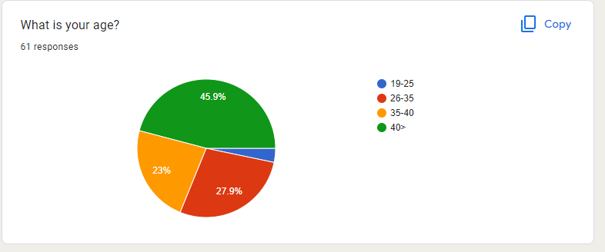

**INTERPRETATION**

This is the generalized distribution of age, where 18.2% population is of the age group 19-25, 27.9% population of the age group26-35, 23% population of the age group 35-40, 45.9% of age the group 40>, , the researcher has covered responses from ages 16-55.

1. GENDER

Analysis: -

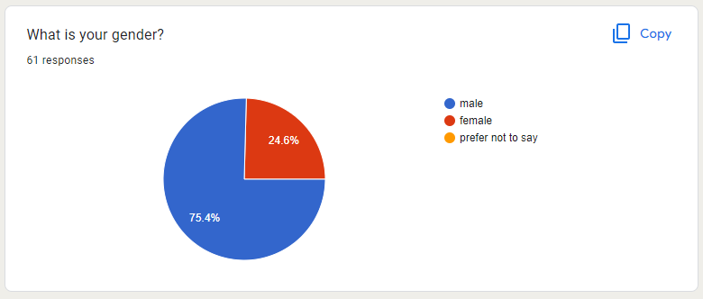

**INTERPRETATION:**

This is the generalized distribution of gender where 75.5% of the sample size is male and 24.6% is female. From this, we can conclude that from this sample size males are using laptops more than females.

1. OCCUPATION

Analysis: -

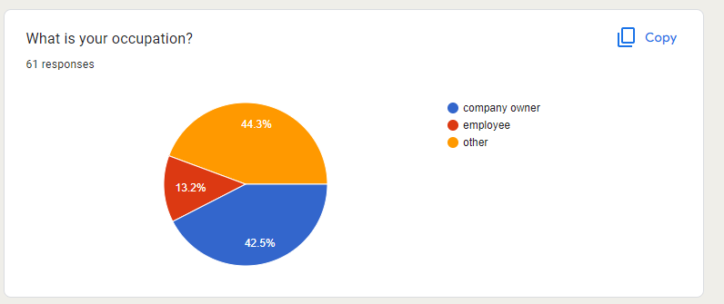

**INTERPRETATION:**

The above analysis indicates that from the entire sample population, 42.5% is company owner, 13.2% is employee, 44.3% are an other than mentioned one.

1. WHAT IS YOUR MONETHLY INCOME?

Analysis: -

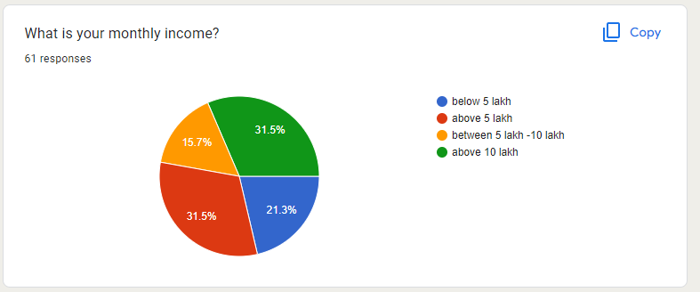

**INTERPRETATION:**

The above analysis indicates that from the entire sample population income , 21.3% is below 5 lakh, 31.5% is above 5 lakh, 15.7% is between 5-10 lakh and 31.5% is above 10 lakh

1. WHICH PRODUCT DO YOU BUY THE MOST

Analysis: -

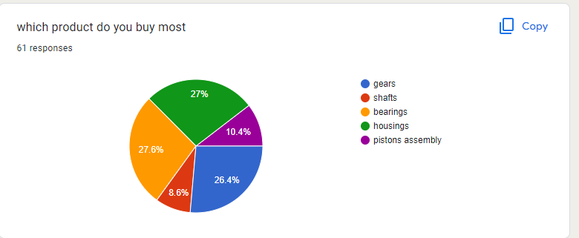

**INTERPRETATION:**

The above analysis indicates that from the entire sample population buy 26.4% buy gears most, 8.6% buy shafts most, 27.6% buy bearings most and 27% buy housing most and 10.4 bus piston assembly.

1. HOW OFTEN DO YOU PURCAHSE GEAR BOX PARTS FROM SUHAS ENTERPRISES

Analysis: -

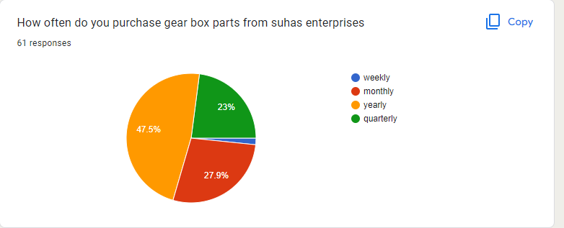

**INTERPRETATION:**

The above analysis indicates that from the entire sample population, 47.5% is yearly, 23% quarterly, 27.9% monthly and

1. WHY DO YOU PREFER PURCHASING GEAR BOX PARTS FROM SUHAS ENTERPRISES?

Analysis: -

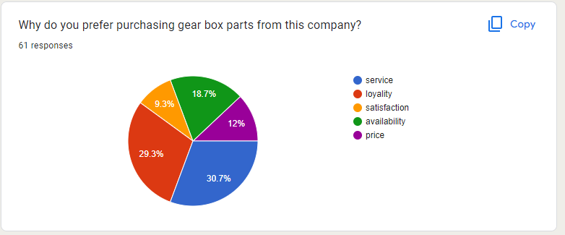

**INTERPRETATION**

from the above responses by the respondents it clearly states that they prefer suhas enterprises that 37.7% of respondents service 29.3% are loyalty 9.3% are of satisfaction 18..7% availability and 12% of people prefer of price .

1. HOW DO YOU USUALLY PURCHASE GEAR BOX PARTS FROM SUHAS ENTERPRISES?

Analysis: -

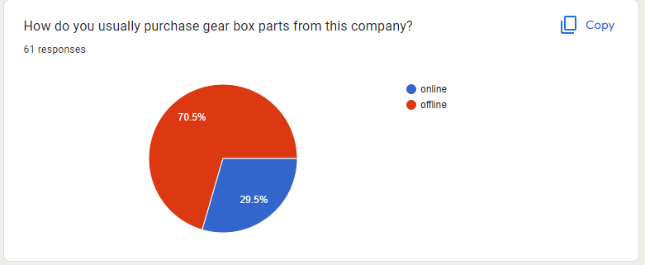

INTERPRETION

the above analysis indicates that 70.5% of respondents prefer offline purchase and 29.5% prefer online purchase.

1. WHAT ARE THE FACTORS THAT INFLUENCE YOUR DECISION TO PURCHASE GEAR BOX PARTS FROM THIS COMPANY?

Analysis: -

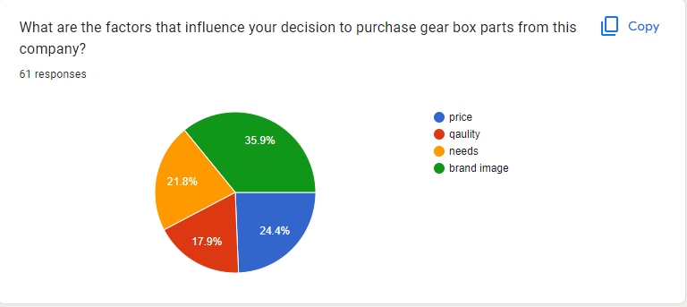

**INTERPRETATION**

the above analysis indicates that 24.4% of respondents price, 17.9% of quality, 21.8% of needs, 35.9% of brand image

1. WHAT ARE THE OTHER BRAND THAT YOU USUALLY CONSIDER WHILE PURCHASING GEAR BOX PARTS?

Analysis: -

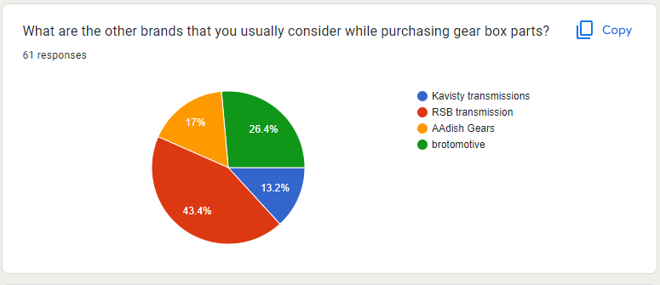

**INTERPETION**

the above analysis indicates that 13.2% CONSIDER KAVISTY transmissions 43.4% consider RSB transmission 17% consider aadish gears 26.4% consider brotomotive

1. HAVE YOU FACED ANY ISSUES WITH THE PRODUCTS?

Analysis: -

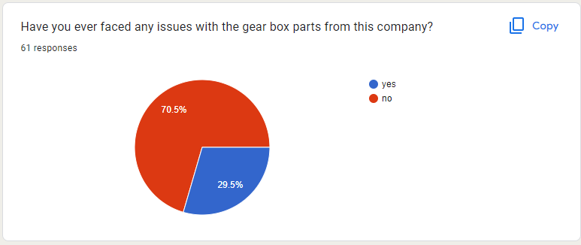

**INTERPRETATION**

the above analysis indicates that 70.5% of respondents answer is no and 29.5% faced issues with the purchase

1. HOW SATISFIED ARE YOU WITH THE QUALITY OF PRODUCTWHICH U BAUGHT FROM THIS COMPANY?

Analysis: -

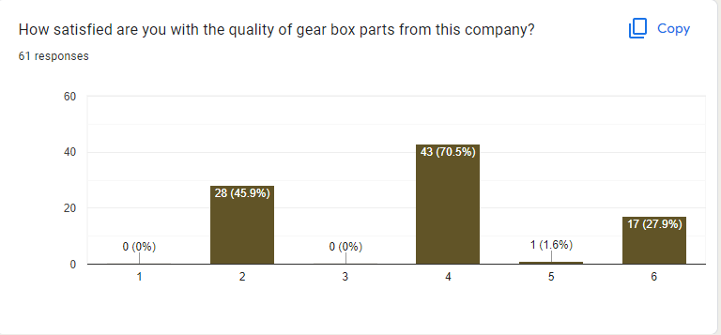

**INTERPRETATION**

the above analysis indicates one the scale of 1 to 6 customers satisfied averagely on scale 1 0.0% on scale 2 45.9% of customers satisfied on 3 0% customer on scale of 4 there are 70.5% customer satisfied on scale of 51.6% customer are satisfied on scale of 6 27.9% are satisfied

1. HAVE YOU EVER RECOMMENDED PRODUCTS TO SOMEONE ELSE?

Analysis: -

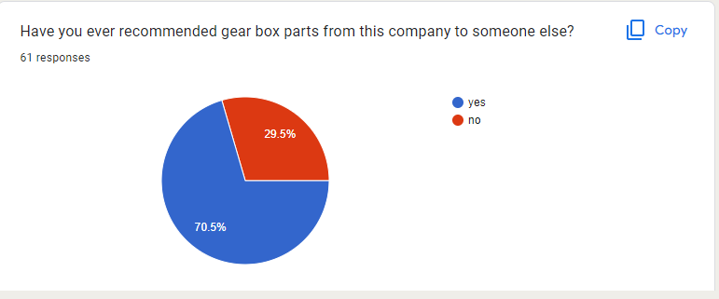

**INTERPRETATION**

the above analysis indicates that 70.5% of respondents recommended and 29.5% did not recommended

1. IS THE WARRENTY PERIOD IMPORTANT FOR GEAR BOX PARTS FOR YUU?

Analysis: -

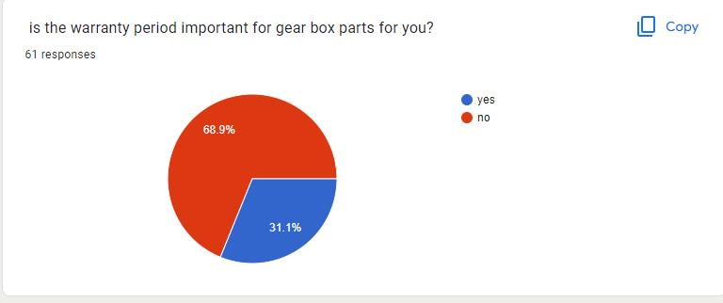

INTERPRETION

From Above Pie Chart There Are 31.1% Of Respondents Think Warranty Period Is Important Where 68.9% Think Warranty Period for Particular Product Is Not Important

CHAPTER 7

OBSERVATION AND FINDINGS

OBSERVATION AND FINDINGS

* 1. Majority of the respondents are 40 and above: The largest percentage of respondents, 45.9%, fall into the "40 and above" age range.
  2. The survey results show that the majority of the respondents, 75.4%, identify as male, while 24.6% identify as female. This suggests that the survey population has a higher representation of males.
  3. The largest percentage of respondents, 42.5%, identified as company owners. This suggests that the survey population may include a higher representation of entrepreneurs or business owners.
  4. The largest percentage of respondents, 31.5%, reported an income above 5 lakhs. This suggests that the survey population may have a relatively high income level. The "between 5 lakhs - 10 lakh" and "above 10 lakh" categories, which represent 15.7% and 31.5% of respondents,
  5. The responses show that the largest percentage of respondents, 27.6% and 27%, respectively, buy bearings and housings the most. These are followed by gears at 26.4%. The percentage of respondents who buy shafts the most, at 8.6%, is relatively low compared to the other response options.
  6. The responses suggest that purchases of gearbox parts from Suhas Enterprises are relatively infrequent, with almost half of respondents (47.5%) reporting that they purchase these parts yearly. While a significant portion of respondents reported purchasing gearbox parts either monthly (27.9%) or quarterly (23%), these percentages are still lower than the percentage of respondents who reported purchasing yearly.
  7. The largest percentage of respondents (30.7%) reported that they prefer purchasing gearbox parts from Suhas Enterprises because of the company's service, while 29.3% reported loyalty as the reason. These two factors together represent more than half of the responses. While satisfaction (9.3%) and availability (18.7%) were still cited as reasons for preferring Suhas Enterprises Only 12% of respondents reported that price was the reason for preferring Suhas Enterprises.
  8. The majority of respondents (70.5%) reported that they usually purchase gearbox parts from Suhas Enterprises offline, indicating that they may visit a physical store or make their purchase through other offline means. While offline purchasing is more popular, a significant portion of respondents (29.5%) reported that they usually purchase gearbox parts from Suhas Enterprises online.
  9. The majority of respondents (35.9%) reported that the brand image of Suhas Enterprises is the most influential factor in their decision to purchase gear box parts from the company. This suggests that the company's reputation and perception in the market is an important consideration for customers when making their purchasing decisions.
  10. The responses suggest that customers are sensitive to the price of gear box parts from Suhas Enterprises. Only a small portion of respondents (13.6%) reported being willing to pay more than 1 lakh for the parts, while the majority (70.2%) reported being willing to pay less than 50,000. A significant portion of respondents (28.2%) reported being willing to pay between 50,000 and 1 lakhs for gear box parts from Suhas Enterprises.
  11. The responses suggest that Suhas Enterprises is not the only company in the market for gear box parts. Respondents reported considering other brands, such as RSB Transmission (43.4%) and Brotomotive (26.4%).
  12. The fact that 70.5% of respondents said they have not faced any issues with gear box parts from Suhas Enterprises could indicate a high level of customer satisfaction with the company's products. The 29.5% of respondents who said they have faced issues with gear box parts from Suhas Enterprises could provide valuable feedback to the company about areas for improvement.
  13. The finding is that 70.5% of the respondents answered "yes", indicating that they have recommended gearbox parts from the company to someone else, while 29.5% answered "no", indicating that they have not made such a recommendation.
  14. The finding is that 31.1% of the respondents answered "yes", indicating that the warranty period is important for them when it comes to gearbox parts, while 68.9% answered "no", indicating that the warranty period is not important for them. This suggests that the majority of the respondents may prioritize other factors, such as the quality or brand reputation of the gearbox parts, over the length of the warranty period.

CHAPTER 8

SUGGESTION

SUGGESTION

1. Enhance the product quality: Suhas Enterprises can focus on improving the quality of their gear box parts. By providing high-quality products, they can gain a reputation for reliability and durability, which can attract more customers.
2. Competitive Pricing: Suhas Enterprises can evaluate the pricing of their gear box parts in comparison to their competitors. They can then set competitive pricing that is attractive to customers while maintaining their profit margin.
3. Expand Product Range: Suhas Enterprises can consider expanding their product range to cater to a wider customer base. This could include developing gear box parts for different types of vehicles or industrial machinery.
4. Online Presence: Suhas Enterprises can establish an online presence by creating a website and social media pages to promote their products. They can also consider selling their products online, which can increase their reach and accessibility to customers.
5. Collaborate with Distributors: Suhas Enterprises can collaborate with distributors to increase their reach in the market. They can identify key distributors in their region and work with them to distribute their products.
6. Customer Service: Suhas Enterprises can provide excellent customer service to retain their existing customers and attract new ones. This could include providing technical support, offering a warranty on their products, and responding promptly to customer queries and complaints.
7. Marketing and Advertising: Suhas Enterprises can invest in marketing and advertising their products to increase brand awareness and attract new customers. This could include participating in trade shows, running ads in industry publications, and promoting their products on social media.

CHAPTER 8

CONCLUSION

CONCLUSION

Firstly, consumers prioritize quality and durability when purchasing gear box parts. They want products that will last long and perform well, even under harsh conditions.

Secondly, pricing is an important factor that affects the purchase decision of consumers. While they want to buy high-quality products, they also want to ensure that they are getting the best value for their money.

Thirdly, brand reputation is important to consumers, as they want to purchase gear box parts from a reliable and trustworthy company that has a good reputation in the market.

Fourthly, compatibility with the vehicle or machinery is a crucial factor that influences the purchase decision of consumers. They want to ensure that the gear box parts they purchase are compatible with their vehicle or machinery.

Fifthly, customer service and technical support are important factors that consumers consider while making a purchase. They want to ensure that they can get help if they face any issues with the product.

Based on these conclusions, gear box manufacturers can focus on improving the quality of their products, setting competitive pricing, building a strong brand reputation, ensuring compatibility, providing excellent customer service, and investing in marketing and advertising to increase their reach and awareness. By doing so, manufacturers can cater to the needs of consumers and increase their sales in the market.

CHAPETER 10

BIBLIOGRAPHY

BIBLIOGRAPHY

1. Marketing management 15th edition- Philip Kotler and kevin lane keller()

2. Research Methodology: methods and techniques

3.Advertising and sales promotion- shaila bootwala and mohd. Faiz shareef ()

WEBSITES

1. <https://www.pearson.com/us/higher-education/product/Kotler-Marketing-Management-15th-Edition/9780133856460.html>

2. <https://www.britannica.com/topic/marketing/Sales-promotion>

3. https://www.gescer.in/research-publications/research/list-research-books/

CHAPTER 11

ANNEXURES

ANNEXURES

1. What is your age?
2. 19-25
3. 26-35
4. 35-40
5. 40>

1. What is your gender?
2. Male
3. Female
4. prefer not to say
5. What is your occupation?
6. company owner
7. employee
8. other
9. What is your monthly income?
10. below 5 lakh
11. above 5 lakh
12. between 5 lakh -10 lakh
13. above 10 lakh
14. which product do you buy most
15. gears
16. shafts
17. bearings
18. housings
19. pistons assembly

1. How often do you purchase gear box parts from suhas enterprises?
2. weekly
3. monthly
4. yearly
5. quarterly
6. Why do you prefer purchasing gear box parts from this company?
7. service
8. loyalty
9. satisfaction
10. availability
11. price
12. How do you usually purchase gear box parts from this company?
13. Online
14. Offline
15. What are the factors that influence your decision to purchase gear box parts from this company?
16. price
17. quality
18. needs
19. brand image
20. How much are you willing to pay for gear box parts from this company?
21. <50000
22. 50000
23. >50000
24. 10000
25. What are the other brands that you usually consider while purchasing gear box parts?
26. Kavisty transmissions
27. RSB transmission
28. AAdish Gears
29. brotomotive
30. Have you ever faced any issues with the gear box parts from this company?
31. yes
32. no
33. How satisfied are you with the quality of gear box parts from this company?

* 1
* 2
* 3
* 4
* 5

1. Have you ever recommended gear box parts from this company to someone else?
2. Yes
3. no
4. is the warranty period important for gear box parts for you?
5. yes
6. no